An assessment of the causes of the errors
in the 2015 UK General Election opinion polls

Patrick Sturgis
University of Southampton, UK

Jouni Kuha
London School of Economics and Political Science, UK

Nick Baker
Quadrangle, UK

Mario Callegaro
Google, UK

Stephen Fisher
University of Oxford, UK

Jane Green
University of Manchester, UK

Will Jennings
University of Southampton, UK

Benjamin E. Lauderdale
London School of Economics and Political Science, UK

Patten Smith
Ipsos-MORI, UK
An assessment of the causes of the errors
In the 2015 UK General Election opinion polls

Abstract
The opinion polls undertaken prior to the 2015 UK General Election under-estimated the Conservative lead over Labour by an average of 7 percentage points. This collective failure led politicians and commentators to question the validity and utility of political polling and raised concerns regarding a broader public loss of confidence in survey research. In this paper, we assess the likely causes of the 2015 polling errors. We begin by setting out a formal account of the statistical methodology and assumptions required for valid estimation of party vote shares using quota sampling. We then describe the current approach of polling organisations for estimating sampling variability and suggest a new method based on bootstrap re-sampling. Next, we use poll micro-data to assess the plausibility of different explanations of the polling errors. Our conclusion is that the primary cause of the polling errors in 2015 was unrepresentative sampling.

1. Introduction
The result of the 2015 UK General Election came as a shock to most observers. During the months and weeks leading up to election day on the 7th of May, the opinion polls consistently indicated that the outcome was too close to call and the prospect of a hung parliament therefore appeared almost inevitable. Although there was some variation across polling companies in their estimates of the party vote shares, their estimates of the difference between the Conservative and Labour Parties exceeded two percentage points in only 19 out of 91 polls during the short campaign from the 30th of March, with zero as the modal estimate of the Conservative lead.
The poll-induced expectation of a dead heat undoubtedly informed party strategies and media coverage during the campaign and may ultimately have influenced the result itself, albeit in ways that are difficult to determine satisfactorily. In the event, the Conservative Party won a narrow parliamentary majority, taking 37.7% of the popular vote in Great Britain (and 330 of the 650 seats in the House of Commons), compared to 31.2% for the Labour Party (232 seats; see Hawkins, et al. 2015 for the official results). The magnitude of the errors on the Conservative lead, as well as the consistency of the error across polling companies (henceforth referred to as “pollsters”) strongly suggests that systematic factors, rather than sampling variability, were the primary causes of the discrepancy.
Table 1 presents the final published vote intention estimates for the nine pollsters that were members of the British Polling Council (BPC) at the time of the election, plus three non-members who published estimates. These are estimates for Great Britain excluding Northern Ireland, which is the usual population of inference for election polls in the UK. The estimates for the smaller parties are close to the election result, with mean absolute errors (MAE) of 0.9%, 1.4%, 1.3%, and 1.1% for the Liberal Democrats, UKIP, Greens and other parties (combined) respectively, all of which are within the pollsters’ notional margins of error for party shares due to sampling variability (which are usually stated as +/– 3% for point estimates). However, for the crucial estimate of the difference between the two main parties, eleven of the twelve Great Britain polls in Table 1 were some way from the true value, and attention has naturally focused on this error. While the election result saw Labour trail the Conservatives by 6.5 percentage points, five polls in the final week reported a dead heat, three reported a 1% lead for the Conservatives, two a 1% lead for Labour, and one a 2% lead for Labour. For all nine BPC members, the notional +/- 3% margin of error does not contain the true election result. SurveyMonkey published the only final poll to estimate the lead correctly, although their estimates were too low for both the Conservatives and Labour and, indeed, had higher MAE across all parties than the average of the other polls.
----- [Table 1 here] -----
In Scotland, the three polls conducted in the final week over-estimated the Labour vote share by an average of 2.4 and under-estimated the SNP share by 2.7 percentage points. The average error of 5.1 percentage points on the lead of the SNP over Labour in Scotland was only slightly smaller than the average error on the lead of the Conservatives over Labour in the polls for Great Britain.
These errors were not just a cause of embarrassment for the pollsters. Media sponsors publicly questioned the quality and value of the research they had commissioned, with at least one national newspaper stating that it would afford less prominence to election polling in its political coverage in the future. Politicians and peers suggested that the polling inaccuracies had affected the outcome of the election, speculating that Labour might have done better had the polls been accurate. A private members’ bill was introduced in the House of Lords on the 28th of May 2015, proposing state regulation of the polling industry (Regulation of Political Opinion Polling Bill [HL] 2015-16). Concern was also expressed by social and market research industry professionals; as the most direct way the public encounters survey and opinion research, it was feared that the failure of the polls might have negative consequences for public confidence in social and market research and official statistics more generally.
It is therefore important that we understand what went wrong with the general election opinion polls in 2015, in order that the risks of similar failures in the future are reduced. This is our objective in this paper. Similar investigations have been carried out in the aftermath of previous historical polling errors, both in the UK (Market Research Society, 1994) and in the United States (Crossley, 1936; Mosteller et al, 1949; Traugott et al, 2009; Kennedy et al, 2016) and have resulted in important changes to the conduct and reporting of polls (Converse, 1987).
We draw here upon the findings and conclusions set out in the report of the inquiry into the failure of the polls in 2015 that was established by the British Polling Council and Market Research Society (Sturgis et al 2016). In addition to the material contained in that report, we provide a more detailed and formal account of the methodology of vote share estimation using opinion polls, drawing out the key assumptions upon which the methodology is based and using this to structure our presentation and interpretation of findings. We also set out a new procedure which can be used to produce estimates of the sampling variability of opinion polls collected using quota sampling, which better reflects their design than the (sample size invariant) +/- 3% rule of thumb for the ‘margin of error’.
The remainder of the paper is structured as follows. In section 2 we describe the methodology of the 2015 opinion polls, the assumptions required for valid point estimation, and the new methodology we propose for variance estimation. The data we used to evaluate the causes of the polling errors is described in Section 3 and the results and interpretation of our analyses are in Section 4, where we focus on the three key potential factors: late swing, turnout weighting, and sampling. Our conclusion from these analyses is that the polling miss in 2015 occurred primarily because the procedures used by the pollsters to recruit respondents produced samples which were unrepresentative of the target population’s voting intentions. These biases were not mitigated by the statistical adjustments that pollsters applied to the raw data. Other factors made, at most, a very modest contribution. Concluding remarks are given in Section 5.

2. The methodology of pre-election polls
2.1 Point estimation of vote shares
The polls conducted before the 2015 general election employed one of two data collection modes: online self-completion or computer assisted telephone interviewing. For the selection of respondents, all of the polls employed nonprobability (quota) rather than probability sampling, so for estimation they cannot directly apply the well-established theory for probability sampling (Kish 1965; Groves et al. 2009). The operational procedures employed to recruit respondents were diverse and incorporated a range of random and purposive selection mechanisms (see Sturgis et al 2016 for a more detailed account of these procedures). All GB pollsters, however, took a common general approach to sampling and estimation: they assembled a quota sample of eligible individuals, calculated a weight to match the sample to known population distributions for a set of auxiliary variables and a weight to account for differential likelihood of voting. They then combined these two weights and produced weighted estimates of vote intention for the population of voters from the sample data.
It is useful for our later evaluation of the potential causes of the polling errors to describe this general approach in more formal terms. Our specification here draws on previous treatments of the assumptions required for the validity of point estimation using quota sampling (Smith 1983; Deville 1991), extended to accommodate the inclusion of turnout probabilities. It is important to note that we do not claim that this is how the pollsters explicitly motivate their methodology. It is, nonetheless, implicit in the procedures as they are implemented.
We first define a set of variables which are relevant for the estimation of party vote shares for the target population. These are all characteristics of individuals and are, in practice, treated as categorical variables, whatever their natural metric. We denote by X auxiliary variables which will be used to derive weights to match population distributions, and by L additional variables which will be used to predict the probability that an individual will vote in the election. In a typical poll, X includes characteristics such as sex, age, region, and social class, as well as measures of party identification or vote in a previous election, while L is an individual’s self-assessment of how likely he or she is to vote in the election. Further, let V denote the party the individual reports he or she intends to vote for (after “Don’t know” answers and refusals have been dropped or imputed to specific parties), T an indicator of whether the individual actually voted in the election (with T=1 for yes and T=0 for no), P the party (if any) they actually voted for, and S an indicator of whether or not an individual is included in the sample (S=1 for yes and S=0 for no).
The target population of the poll should be such that it includes all individuals who are eligible and registered to vote in the election (but it can also include people who are not, assuming that they will be filtered out later by being assigned turnout probabilities of zero), and that distributions of weighting variables in the population are known. In the polls considered here, this population is typically that of adult residents of Great Britain (even though this has the shortcoming that it omits voters who live abroad). Consider X partitioned as (X₍₁₎,…,X_{(p)}), where the subsets X_{(j)} are such that their distributions p(X_{(j)}) in the population are assumed known from the census or other sources (we denote marginal and conditional distributions of variables by p(.) and p(.|.)). The X_{(j)} are typically univariate, although with some exceptions (e.g. age distribution may be specified separately by sex).
When interviews have been completed, weights are created in such a way that the weighted distributions of all X_{(j)} in the sample match their population distributions p(X_{(j)}). This step is similar to calibration weighting of probability samples (Deville and Särndal 1992), so we refer to the resulting weights as calibration weights. In the election polls considered below all the weighting variables X_{(j)} were categorical, in which case calibration is equivalent to raking and it can be carried out using, for example, the iterative proportional fitting algorithm (Deming and Stephan 1940).
By way of illustration, suppose that X consists of age by sex (X₍₁₎), region of residence (X₍₂₎) and vote in the most recent previous election (X₍₃₎), and that X₍₁₎ and X₍₂₎ are used also as quota variables, with p(X₍₁₎) and p(X₍₂₎) as their target distributions. In quota sampling, the aim is then to obtain a sample where the distribution of age by sex and the marginal distribution of region of the sample match the target distributions, at least to a close approximation (an exact match is often not achieved in practice). Next, a raking algorithm is applied to this sample, with X as the weighting variables. The resulting calibration weights will be such that the weighted distributions of age by sex, region, and past vote match their population distributions p(X₍₁₎), p(X₍₂₎) and p(X₍₃₎) exactly.
The goal of a vote intention poll is to estimate p(V|T=1) in the population, i.e. the distribution of responses to the question on party choice among those members of the population who will turn out to vote. This can be expressed as
$p\left(V | T=1\right)= \frac{\sum_{X,L}{p\left(T=1 | V,L,X\right) p\left(V,L | X) p(X\right)}}{p(T=1)} (1)$
where the sum is over the possible values of L and X. Here p(X), p(V,L|X) and p(T=1|V,L,X) describe the population distribution of the weighting variables, distribution of voting intention and stated likelihood to vote, and probability of turnout respectively. To estimate this quantity, a poll draws a sample of respondents (S=1), selected through quota sampling with quota targets defined by a subset of X, and elicits values of (X, L, V) from the sampled respondents via questionnaire. Turnout T is not known at the time of the poll, except for respondents who have already voted by post. Letting $i=1, …, n$ index the sampled respondents, the calibration weights $w_{i}^{*}$ are then calculated. The distribution of $(V_{i}, L_{i}, X_{i})$ in the sample, with weights $w_{i}^{*}$, is used as an estimate of p(V,L,X)=p(V,L|X)p(X) in the population. Next, let $p_{Ti}$ denote values of $p(T_{i}=1|V_{i}, L_{i},X_{i})$ assigned for each respondent from an assumed model for the turnout probabilities, and define $w_{i}=p_{Ti}w_{i}^{*}$. Letting $I(V_{i}=v)$ be an indicator variable for any particular party $v$ which is 1 if a respondent’s stated vote intention is $V_{i}=v$ and 0 otherwise, the vote intention proportions for the parties are estimated by the weighted proportions
$$\hat{p}(V=v|T=1)=\frac{\sum_{i=1}^{n}{I(V_{i}=v)w_{i}}}{\sum_{i=1}^{n}{w_{i}}}. (2)$$
Using (2) to estimate p(V=v|T=1) implies a number of assumptions about the quantities on the right-hand side of (1). First, it is assumed that the $p_{Ti}$ assigned to respondents are equal to the probabilities $p(T_{i}=1|V_{i}, L_{i},X_{i})$ under the conditional distribution of turnout given (V,L,X) in the population. Second, it is assumed that $p\left(V,L | X,S=1\right)=p\left(V,L | X\right)$, i.e. that the ${(V}_{i}, L_{i})$ in the sample (unweighted, since the weights $w_{i}^{*}$ are constant given X) can be treated as random variables drawn from their distribution in the population, at each level of the variables X which are used to derive the calibration weights. We refer to this as the assumption of representative sampling. It is weaker than the requirement of representativeness given only the quota variables, which are typically only a subset of X.
These two assumptions are still not sufficient for valid estimation of p(V=1|T=1) because the calibration weights ensure only that the weighted distributions in the sample match the population distributions for the marginal distributions of X_{(j)} but not for the joint distribution p(X) in (1). This weighted joint distribution of X in the sample matches the full $p(X)$, only if the sample is (fortuitously) representative in the higher-order associations among the X which have not been fixed to match population totals. Alternatively, estimation with (2) is also valid if the true conditional distributions of (V,L) and T are such that only the $p(X_{(j)})$ actually contribute to (1). This is the case, for example, if both $p\left(T=1 | V,L,X\right)$and $p\left(V,L | X\right)$ are linear functions of their explanatory variables and the product of these functions does not involve any products of X_{(j)} and X_{(k)} ($j≠k$). This is true, for instance, in cases where $p\left(V,L | X\right)$ does not depend on interactions among the X_{(j)} and $p\left(T=1 | V,L,X\right)=$ $p\left(T=1 | V,L\right)$ does not depend on X.
If these assumptions hold, it is possible to estimate the distribution of stated vote intentions V among eventual voters. What commissioners and consumers of polls really want to know, however, is not the distribution of V but the distribution of actual votes in the election, which we denote by P. A pre-election poll cannot, however, provide direct information about P because P does not exist (except for postal voters) until election day. To interpret the poll estimates using (2) as actual vote shares, it must also be assumed that $p\left(V | T=1\right)=p\left(P | T=1\right)$. This will be true if $V_{i}=P_{i}$ for every individual, but also if individual-level changes between $V_{i}$ and $P_{i}$ are self-cancelling in the aggregate.
In summary, the key assumptions which underlie the estimates of pre-election polls as they were conducted for the 2015 UK General Election are the following:
(A1) Representative sampling: Given any value of the weighting variables X, observations $(V_{i}, L_{i})$ in the poll can be treated as a random sample (with equal inclusion probabilities) from $p\left(V,L | X\right)$ in the population;
(A2) Correct model for turnout probabilities: The assigned turnout weights $p_{Ti}$ are equal to the probabilities $p(T_{i}=1|V_{i}, L_{i},X_{i})$ from the conditional distribution of T which holds in the population;
(A3) Agreement between stated vote intention and actual vote: $p\left(V | T=1\right)=p\left(P | T=1\right)$ , i.e. there is no difference between the stated vote intention in the final poll and the choice made in the election, or where such discrepancies do exist they are self-cancelling in the aggregate;
together with the additional conditions on the distributions of X, (V,L), and T that were discussed above. If assumptions (A1) and (A2) hold, (2) provides consistent estimates of the vote intentions p(V|T=1), and if (A3) holds as well, of the actual vote shares p(P|T=1). It is unlikely in practice that these assumptions will be exactly satisfied, so it is better to regard them as ideal conditions that the polls should aim to be as close to as possible in order to produce reasonable estimates.
These assumptions are stringent. (A1) requires that the samples are representative given the weighting variables, even though in quota sampling the sampling probabilities are not known and will likely be zero for some members of the population, and robust population data for weighting is limited. Assumption (A1) will be violated if, over hypothetical repetitions of the sampling process, the distribution of vote intention, given the weighting variables, is different from the corresponding population distribution. For instance, in the example that we introduced earlier this would occur if, for some combinations of the weighting variables age-by-sex, region and past vote, the respondents are more educated than the target population, and education is associated with vote even given the weighting variables. Assumption (A2) requires that turnout probabilities can be modelled to a high degree of accuracy, even though there is little in the way of evidence on which to base such a prediction. (A3) requires that respondents’ reported pre-election vote intentions accurately represent their actual votes, so this can fail if there is missing data or measurement error in the stated vote intention, or if reported vote intentions change between the poll and the election. All of these conditions are prone to violation at any given election and may fail in ways that cause large errors in estimated vote shares. In section 4 we examine evidence of such failures in the 2015 polls for each of the assumptions.

2.2 Sampling variability of point estimates
We concluded from Table 1 that the 2015 polling miss was not due to random sampling error. However, this conclusion is based on the rather unsatisfactory notion of a +/- 3% ‘margin of error’ applied to any point estimate for a proportion, which is currently used by UK pollsters. This rule of thumb is derived under an “as if” assumption of simple random sampling for a sample of size of 1000, a common sample size for opinion polls. This heuristic is clearly not appropriate for the sample designs of the 2015 polls. Yet, ignoring their sampling variability is clearly unsatisfactory and, indeed, the recent American Association of Public Opinion Research (AAPOR) Task Force on non-probability sampling recommended that “… users of non-probability samples should be encouraged to report measures of the precision of their estimates” (Baker, et al. 2013). Here, we propose a method of calculating the precision of poll estimates from quota samples, which better reflects the nature of the sampling and estimation procedures in the election polls.
We propose a bootstrap re-sampling method which involves the following three steps: (i) draw M independent samples by sampling respondents from the full achieved sample, with replacement and in a way which matches the quota sampling design; (ii) for each sample thus drawn, calculate the point estimates of interest in the same way as for the original sample, including calibration and turnout weighting; and (iii) use the distribution of the estimates from the M re-samples to quantify the uncertainty in the poll estimates. This draws on the basic ideas of bootstrap estimation in general (Davison and Hinkley 1997) and for probability samples in particular (Wolter 2007) and it is worth emphasising that a key part of the procedure is that the calibration weights are calculated afresh for each bootstrap sample in step (ii) (Rust and Rao 1996). For non-probability samples, a comparable approach has been proposed by de Munnik et al. (2013), although they used it to assess the quality of a sampling design by re-sampling from a simulated population, rather than the sample itself. An alternative approach to estimating uncertainty would be to adapt variance formulas that are used with probability sampling under approximate assumptions about the nature of the quota samples (Deville 1991; Rivers 2013). It would be more difficult using this approach, however, to accommodate specific features of the poll estimation, such as calibration and turnout weighting, which are easily accounted for in the bootstrap method.
The intuitive idea of the bootstrap method is that the samples from step (i) are used to represent the variation from one sample to the next that would be observed if the quota sampling procedure were implemented repeatedly. Applying the estimation procedure to each of the bootstrap samples then represents the sample-to-sample variation in the resulting estimates. It is important to note that bootstrapping thus produces an estimate of sampling variance and not of the variability of estimates around their true values (i.e. mean squared errors), unless the assumptions stated in Section 2.1 are satisfied and the estimates are thus approximately unbiased.
A challenge for the resampling step (i) is that the sampling quota do not define a partitioning of the population, so the re-sample cannot be implemented within the quota as if they were sampling strata. Instead, the quota form a set of separate targets for different variables, all of which should have been reached when the sampling has been completed. To implement the re-sampling in this situation, the analyst would ideally know the exact procedures through which the quota sampling was implemented, but these specific details are not available to us. In our calculations for the 2015 polls, we have therefore used the following algorithm which represents the generic features of quota sampling. First, we set the quota targets to be the realised sample distributions of the quota variables that were used by a given pollster. In the first iteration of the resampling, the pool of potential respondents is the full observed sample, from which we draw a sample of the same size as the full sample, but with replacement. We then drop from this first iteration sample any observations which overfill a quota category, and retain the rest. For the next iteration of the sampling, the pool of potential respondents now consists only of those that are in quota categories which remain to be filled. The sample size of the second iteration is now the number of observations that need to be added in order to reach the original sample size. In other words, at each iteration the retained sample is ‘topped up’ through a resample drawn from the quota categories which are not yet full. Additional iterations continue until all the quotas are full, or until there are no respondents in the original sample who belong to all the incomplete quota categories at once. In the latter case we could run the algorithm again, or use the sample obtained at this point, even though it is slightly smaller than the observed sample. For the estimates presented here, we used the latter strategy. A more detailed statement of the algorithm, computer code and an example are included in the supplementary materials to this article.
Results from the bootstrap estimation of sampling variability in the final polls are presented in Table 2, based on 10,000 bootstrap samples. It shows point estimates and 95% interval estimates of the Conservative-Labour difference in vote shares. These are adjusted percentile intervals (Davison and Hinkley, 1997), although standard percentile intervals and symmetric normal intervals give similar results. None of the intervals in Table 2 includes the election result of a 6.5-point Conservative lead. We can therefore be confident in our initial conclusion that the polling miss was not due to sampling variability.
----- [Table 2 here] -----
Table 2 also shows bootstrap standard errors of the estimated vote shares for the Conservatives and for Labour. We can compare these with the notional “margin of error” obtained if the poll sample is treated as a simple random sample (SRS), where the sampling variance for an estimated vote share p from a sample of size n is given by p(100-p)/n. Table 2 shows estimated design effects (d²) for the vote shares, calculated by dividing the bootstrap variance by the variance under SRS, with p as the estimated share and n the number of respondents who gave a vote intention (this n ignores the variability in the turnout probabilities, so likely underestimates the design effect). Most of the design effects are less than 1, indicating that the sampling variability is smaller than would be expected under simple random sampling. When this is the case, the conventional margins of error somewhat overestimate the sampling variability in the poll estimates. The increased efficiency of the estimates is mainly due to calibration on variables measuring party affiliation or past voting, which are strongly correlated with current vote intention (all pollsters except Ipsos-MORI used this type of variable in their calibration weighting). If these variables are omitted from the quotas and weighting, all design effects in Table 2 are greater than 1, with values between 1.04 and 1.68.
3. Data
Our main evidence for assessing the source of the polling errors in 2015 is data from the polls themselves. Each of the nine BPC members provided respondent-level micro-data, together with documentation on their methodology, including fieldwork procedures, quota targets and weighting. These data were provided for the first, penultimate, and final polls conducted during the short campaign but almost all of the analyses reported in this article use the final polls (i.e. the nine polls conducted by the BPC members in Table 1). The six pollsters who carried out surveys where respondents were re-contacted after the election also provided these data sets (these are discussed in Section 4.2). We were able to replicate all published estimates for these 27 pre-election polls, enabling us to exclude the possibility that flawed analysis or use of inaccurate weighting targets contributed to the polling miss.
We also analysed data from the 2015 rounds of the British Election Study (BES) and the British Social Attitudes Survey (BSA) in order to benchmark the poll estimates against surveys which use random probability sample designs. The methodology of these surveys is described in detail elsewhere (Fieldhouse, et al. 2015; Clery et al. 2016), but, in brief (and for both surveys), a multi-stage, stratified probability sample of addresses is drawn from the Post Office Address File and an interview is attempted with a randomly selected eligible adult at each eligible address. Multiple calls are made to each selected address at different times of day and on different days of the week in order to achieve an interview. Substitutions for sampled respondents who were not reached or who declined to be interviewed are not permitted. Interviews are carried out face-to-face by trained interviewers via questionnaires loaded onto laptop computers. The BES and BSA attained response rates of 56% and 51% (AAPOR Response Rate 1), respectively, which though not especially high in historical terms, are good by contemporary standards. The interviews were carried out after the election, in May-October 2015.

4. Assessment of potential causes of the polling errors
In this section we assess the evidence in support of the different potential causes of the errors in the 2015 polls. The discussion is structured around the three core assumptions set out in Section 2, with assumption (A3) considered in Section 4.1, turnout weighting (A2) in Section 4.2, and representative sampling (A1) in Section 4.3.
In the polling inquiry report, the following more minor factors were also considered and dismissed as contributory causes of the polling errors: treatment of postal voters, overseas voters, voter registration, question wording and order, and mode of interview. While we do not consider these factors directly in this paper, it should be noted that each can be understood as violations of the three key assumptions that are covered in the following sections. For instance, errors due to omission of overseas and postal voters would be violations of assumption A1 on representative sampling. Errors due to question wording or measurement mode would fall under violation of assumption A3 which stated that vote intention is equal to the actual vote. Likewise, un-registered voters would be a particular violation of assumption A2, that the turnout probabilities are correct. More detail on the specific reasons for ruling out these factors is provided in Sturgis et al (2016). Neither do we discuss here the phenomenon of ‘herding’, which is when there is more consensus across poll estimates than would be expected under random sampling because it relates to the variability of estimates across polls, rather than to bias in poll estimates (Sturgis et al 2016).

4.1 Differences between reported vote intention and actual vote (‘late swing’)
Some voters agree to take part in opinion polls but do not disclose the party they intend to vote for. Others do not know who they will support, or they deliberately misreport their vote intention, or report their intention truthfully but then change their minds after the poll. If a sufficient number of these types of voters move disproportionately to different parties between the polls and election day, vote shares estimated from the polls will differ from the election result. This discrepancy will not be due to inaccuracy of the polls as estimates of the stated vote intentions, but to inadequacy of the assumption (A3) that the stated intentions (V) can be treated as a measure of the actual vote (P). Following the convention in the polling literature, we refer to a difference between V and P as late swing. The term refers most naturally to a switching from one party to another, but we also include movement from non-substantive responses (Don’t Knows and refusals) to a party choice.
Reports into the polling failures at the 1970 (Butler and Pinto-Duschinsky 1971) and 1992 (Market Research Society 1994) elections both attributed a prominent role to late swing. This was particularly so for the 1970 report, which concluded that late swing was almost entirely to blame for the failure to predict the Conservative victory in that election. It has also been identified as a contributory factor for polling misses in the United States (AAPOR 2009; Keeter, et al. 2016). There are, therefore, good prima facie grounds for assuming that late swing may have contributed to the polling miss in 2015.
The most direct way of assessing late swing is to examine data from re-contact surveys, where the same respondents have been interviewed both before and after the election. Six pollsters carried out such surveys, although one proved to be unusable for our purposes because fieldwork outcomes did not distinguish between refusals and non-voters. For the analysis of late swing we use only the samples of voters who reported after the election that they had voted, which means that turnout weights are not needed and that assumption A2 is not required. Because not all respondents that were re-contacted provided an interview, the estimates are weighted by the product of the pre-election calibration weight and an attrition weight. The attrition weight was calculated as the inverse of the predicted probability of responding to the re-contact survey, derived from a logistic regression model where the predictor variables were all the variables used for weighting in the final poll, plus the question on likelihood to vote if used for the poll. For two pollsters the sample sizes for the re-contact surveys were very small but in these cases it was possible to include respondents who were interviewed in earlier polls for the same company during the short campaign.
----- [Table 3 here] -----
Table 3 shows point estimates of the Conservative lead over Labour for these five samples, from the pre-election polls and the re-contact surveys. In four of the five polls the post-election estimates move in the direction of a larger lead for the Conservatives, and in one poll (the one with the largest sample size) in the opposite direction. The average change toward the Conservatives weighting all five polls equally is +1.8 points and -0.4 points if only respondents from the final polls are included. An average of the five estimates (for all respondents) weighted by sample size is +0.6 points, with a 95% confidence interval (obtained using bootstrap estimates of the standard errors of the estimates) is -0.2% to +1.6%. Regardless of which of these estimates one prefers, none of them is nearly enough to explain the total error in the polls.
Some part of these changes may be due to measurement effects in the pre-election responses such as the treatment of refusals and “Don’t know” responses. Pollsters used different combinations of ‘squeeze’ questions (where initially non-disclosing respondents are pushed to provide a vote intention) and imputation to allocate vote intentions for these respondents. However, the aggregate impacts of these procedures on the final vote intention estimates were small (Sturgis et al 2016).
A frequently advanced explanation of polling errors by media commentators is deliberate misreporting, which is when respondents knowingly tell pollsters that they will vote for a particular party when they actually intend to vote for a different one. This is generally considered to occur, not out of capriciousness or spite against pollsters, but due to processes of social desirability. For example, in the UK, deliberate misreporting has been invoked to explain the tendency of polls to under-estimate the Conservative vote as a result of respondents being unwilling to admit to voting Conservative – so-called ‘shy Tories’. But the same phenomenon could apply to any party that voters feel embarrassed to admit to supporting due to there being some sort of social stigma associated with it.
A response pattern of deliberate misreporting of voting intention is indistinguishable from late swing; the individual tells the pollster they will vote for party A but subsequently votes for party B. Whether their initial report was a deliberate misreport is neither here nor there with regard to the pattern of response that is observed. Our conclusions about late swing therefore also enable us to rule out deliberate misreporting as a cause of the polling miss. A limitation to this conclusion is that actual vote could also be deliberately misreported in the re-contact surveys; that is respondents could lie both before and after the election. It is very difficult to definitively rule out this possibility, but indirect evidence suggests that it is unlikely. In particular, the two post-election random probability surveys – the British Election Study and the British Social Attitudes survey - got the election result about right (as discussed in Section 4.3), with both producing estimates of the Conservative vote share that were actually slightly above the result. We see no reason to assume that respondents should choose to deliberately misreport their past vote in some post-election surveys but not in others. In summary then, we rule out violations of assumption A3 such as late swing and deliberate misreporting, as having made any notable contribution to the polling miss.
4.2 Turnout weighting
The pollsters used a range of different methods for constructing turnout weights $p_{Ti}$. Most relied on responses to a self-reported likelihood-to-vote (LTV) question such as, "how likely is it that you will vote in the general election on 7th May?", to which responses were recorded on scales of between four and eleven points. Some pollsters used the question as a binary filter (so that those below a threshold on the LTV question received a turnout weight of zero and those above a weight of one) and others in a smoother manner (e.g. by dividing a 0-10 LTV response by 10). Some turnout weights were based only on an LTV question, while others used additional information such as age or past voting. The models used to generate the turnout weights were educated guesses, with the exception of TNS UK who used a model fitted to data from the 2010 British Election Study (which includes both an LTV question and a measure of validated vote).
Recall that assumption A2 requires that probabilities of voting in the election are allocated to the respondents based on an accurate model for turnout, conditional on self-assessed likelihood of voting (L), voting intention (V) and auxiliary variables (X). Specifically, the weights should accurately describe these probabilities in the population of voters. This presents a problem for assessing the adequacy of the turnout model, because this should ideally be done using a high quality pre-election probability sample in which LTV, intended vote, and turnout after the election are observed. Unfortunately, no such study was undertaken in 2015. What can be examined, though, is how well $p_{Ti}$ approximated $p(T=1|V, L,X,S=1)$, i.e. the turnout probabilities in the poll samples. This is not conclusive evidence to make this assessment, because it requires the additional assumption that the model for these probabilities should be approximately the same for the poll respondents and the target population. The validity of this assumption cannot be directly assessed.
----- [Figure 1 here] -----
Figure 1 provides information about the accuracy of the turnout weights as estimates of turnout probabilities for respondents in the five re-contact surveys. The solid lines show the probability of turnout as a smoothed function of the turnout weights, so the accuracy of the weights as probabilities of voting can be judged by the proximity of the solid lines to the dashed lines (on which the reported turnout rate is equal to the actual turnout weight). For all but one of the pollsters it is clear that actual turnout was higher, sometimes substantially higher, than the turnout weights implied, except where the weight was close to 1 (the partial exception to this pattern was TNS UK, for whom turnout weights of less than 0.5 overestimated subsequent turnout). Some, though not all, of this inaccuracy in the turnout weights may be accounted for by over-reporting of turnout in the re-contact surveys.
The bar chart at the bottom of each plot in Figure 1 shows the relative frequency of respondents with different values of the turnout weights. It is clear that a large majority of the respondents received a weight of one. Almost all of such respondents also reported after the election that they had voted. Thus, while the calibration of turnout weights was poor across the full range of probabilities, for most of the poll respondents the weights were quite accurate because the vast majority reported that they would vote and they were allocated a turnout probability of 1.
The accuracy of the turnout weights are of little substantive interest in themselves but matter insofar as they affect estimated vote shares. Whether this was the case for the 2015 polls may be assessed by calculating vote intention estimates under different specifications for the turnout weights. First, we can use the re-contact polls to examine if the estimated shares would have been different if turnout weights had not been needed at all, that is, if the pollsters had known who would and would not turn out to vote. This is done by calculating estimates using pre-election vote intention only for those respondents who are known (by self-report in the re-contact surveys) to have voted in the election; these respondents can be assigned a turnout probability of 1. Estimates for the difference in the Conservative-Labour vote share using this approach are shown in the first row of Table 3. They are between -2.1 and +0.5 percentage points, compared to -2.7 to +0.7 points for the final polls (the latter for all nine BPC members). There is, thus, no evidence that the poll estimates would have been more accurate, even had the pollsters known before the election which respondents would and would not turn out to vote.
----- [Figure 2 here] -----
We can also examine the sensitivity of vote intention estimates by calculating the party shares with different specifications for the turnout weights, keeping all other elements of the weighting unchanged. An example is presented in Figure 2, which shows estimates of the Conservative lead for the final polls, with four different turnout weights (from left to right): (1) using only those respondents who said they were certain to vote, i.e. who gave the highest response to the LTV question; (2) the turnout weights that were used for the published estimates; (3) transformed weights (p+p*(1-p) where p is the original turnout weight) which would have been closer to the true turnout probabilities in Figure 1; and (4) giving every respondent a turnout probability of 1. These rather different specifications do not change the estimates in any substantial way. We have also used a range of turnout weights from a model-based approach applied to the 2010 and 2015 British Election Studies (of the kind used by TNS UK). These alternative probabilities also have no notable effect on the vote share estimates.
It is worth noting that none of the pollsters included vote intention in their models for turnout probability, so they implicitly assumed that the probability does not depend on the party the respondent intends to vote for, once LTV and other variables are controlled. If this assumption fails, supporters of one party would be more likely than another to vote, given their reported pre-election LTV. We refer to this possibility, which has the potential to cause biases in poll estimates of vote shares, as ‘differential turnout misreporting’. We can assess whether this occurred in 2015 by including vote intention as a predictor in a model predicting turnout probability. Using this specification the party variable is statistically significant for only one pollster, and here the effect is in the opposite direction to what would be required to explain the polling miss; those who said they intended to vote Labour were more likely to vote, given their answer to the LTV question. The re-contact surveys therefore show no evidence of differential turnout misreporting.
In summary, there were notable inaccuracies in the turnout weights as estimates of actual turnout probabilities for the respondents to the 2015 election polls. However, this made little difference to the final vote shares; estimates of the Conservative lead would not have been more accurate, even if the turnout weights had been based on self-reported vote after the election, or if they had been assigned in a very different set of ways. Neither is there evidence that respondents who reported intending to vote Labour may have overestimated their future likelihood of turnout more than Conservative intenders. We conclude, on this basis, that violations of assumption A2 on turnout weighting were not responsible for the 2015 polling miss.
4.3 Representative sampling
We have concluded that violations of assumptions A2 and A3 relating to late swing and turnout weighting made little or no contribution to the 2015 polling error. By a process of elimination, then, we are led to conclude that violation of assumption A1 - representative sampling - must have been the primary locus of the 2015 polling miss: the polls systematically over-represented Labour voters and under-represented Conservative voters in their weighted estimates.
In this section, we examine what direct evidence there is to support the judgement that the polling miss was due to unrepresentative samples. We first consider a comparison with two surveys that were undertaken shortly after the election and which used probability sampling designs: the British Election Study (BES) and the British Social Attitudes (BSA) survey. We then examine estimates of vote shares by sub-groups defined by the weighting variables, and then biases in estimates of other variables which are likely to be related to voting. While none of these lines of evidence can be considered conclusive in themselves, collectively they provide consistent evidence to support the conclusion that the poll samples were systematically biased in their composition relative to the target population.
The BES and BSA employ what can be considered ‘gold standard’ procedures at all stages of their design but are most notably different to the polls in that they employ probability sampling rather than quota sampling. It is important to be clear that probability sampling does not on its own guarantee accuracy of survey estimates; these types of surveys are themselves subject to various errors of observation and non-observation (Groves 1989). In particular, when a substantial proportion of the eligible sample fails to complete the survey, either through refusal to participate or failure to be contacted, there is a risk that estimates will be biased due to differential nonresponse (although recent research has shown the correlation between response rate and nonresponse bias to be considerably weaker than has historically been assumed; see Groves and Peytcheva 2008; Sturgis et al 2016). As we shall see, however, in 2015 the BES and BSA were far more accurate than the pre-election polls in their estimates of the vote distribution and, given the transparency and robustness of their underlying sampling procedures, it is reasonable to use them as a lens through which to assess the quality of the poll samples which were obtained using quite different approaches.
The reported vote distributions for the BES and BSA are shown in Figure 3, alongside the average vote intention estimates for the final polls and the election result. It is immediately apparent that the BES and BSA produced more accurate estimates of the Conservative lead over Labour than the polls, with the BES showing a 7 point lead and the BSA a 6 point lead for the Conservatives. Neither of these surveys were themselves completely accurate, with both significantly under-estimating the UKIP share, the BES over-estimating the Conservative share, and the BSA over-estimating the Labour share.
----- [Figure 3 here] -----
This comparison is suggestive that the polls underestimated the Conservative lead as a result of their sampling procedures. However, it is inconclusive on this point because the BES and BSA differ from the polls in other respects, beyond their sample designs. Most importantly, both were undertaken after the election had taken place. This means that there was no uncertainty (at least by self-report) about whether the respondents had voted or not when they reported their vote choice, while the polls had to factor in whether a respondent would actually vote or not to their pre-election estimates. The reported votes of the BES/BSA respondents might also have been influenced by their knowledge of the election result, which could not have been the case for the pre-election polls. Previous research has shown a tendency for respondents to disproportionately recall having voted for the winning party – so called ‘bandwagoning’ (Nadeau, et al. 1993) and such effects might plausibly have contributed to the difference in the lead estimates between the surveys and the polls in 2015 (we note that this might also have affected the re-contact polls discussed in Section 4.1, in which case bandwagoning would have exaggerated the before-after differences reported in Table 3).
Another potentially consequential difference is the mode of interview, with the BES and BSA using face-to-face interviews and the polls using either telephone interviews or online self-completion. Although face-to-face interviewing is generally acknowledged to be the gold-standard for survey modes (Couper, 2011), this does not imply that it will produce more accurate self-reports of vote choice than the other modes. Indeed, the survey methodological literature suggests that the face-to-face interviewing is more prone to measurement error due to socially desirable responding than telephone and self-completion modes (Tourangeau, et al. 2000). Nonetheless, these factors all render the headline comparison between the polls and BES/BSA ambiguous with regard to the underlying cause of the difference.
Fortunately, we can effectively rule out the two most important of these design differences by considering the reported vote distributions for the polls that undertook re-contact surveys. Because the re-contact surveys were carried out after the election, we can exclude timing relative to the election as a potential confounder. Table 3 shows that there is only a very modest improvement in poll estimates (weighted for attrition) of the Conservative lead when the polls are undertaken after the election and respondents are reporting their actual, rather than their intended vote. These comparisons, then, support the conclusion that the differences between the BES and BSA and the polls were due to differences in their sampling procedures, rather than to whether they were undertaken before or after the election. A caveat to this conclusion is that the fieldwork periods were much shorter for the re-contact polls than for BES and BSA, so ‘bandwagoning’ may have been more prevalent in the latter than the former case. However, Mellon and Prosser (2017) demonstrate that this possibility has little empirical support, for the BES at least.
----- [Figure 4 here] -----
Recall that assumption A1 for representative sampling requires that for any given value of the weighting variables X, observations $(V_{i}, L_{i})$ in a poll are a random sample from $p\left(V,L | X\right)$ in the population. It is informative, therefore, to assess the extent to which the polls were in error not only in the aggregate but also across the weighting cells used by the pollsters. Figure 4 presents estimates of the Conservative-Labour difference by exemplar weighting variables, compared with the actual election result (for region) or with estimates from the BES/BSA (combined where both are available, due to small sample sizes by weighting cells for each survey on its own). It can be seen that there is no apparent difference in the polling error between men and women. When considered by age band, however, the polls substantially under-estimate the Conservative lead amongst those aged 45-64 and, to a lesser extent, those aged 55-64. Here, of course, we must assume that the BES/BSA distribution is approximately correct within age-bands, although this does not seem unreasonable given that both surveys got the population estimate of the Conservative lead approximately correct.
Considered by self-reported vote in the 2010 General Election, the pattern in Figure 4 suggests that the polls were most inaccurate for those who voted for the two main parties in 2010. Finally, at the Government Office Region level the results suggest that the polls particularly under-estimated the Conservative lead in regions where the Conservative vote share was higher than the national average; the East, East Midlands, South West, and South East. In sum, these analyses clearly demonstrate that the key assumption of representativeness of vote intention within weighting cells was strongly and consistently violated in the 2015 polls. The pattern that we observe in these charts also suggests a systematic tendency for the polls to under-estimate Conservative support in sub-groups where the Conservative lead over Labour is highest, e.g. older people, southern counties, and people who voted Conservative in 2010. We are not able to pursue this further empirically given the data available to us, but it seems likely that a key reason that the polls underestimated the Conservative lead over Labour is that their sampling procedures systematically under-represented Conservative voters within these kinds of Conservative supporting demographic groups.
A third type of comparison is informative about the representativeness of the poll samples; how accurate the poll estimates are for other variables that were measured in the polls and which are themselves related to vote choice. Consider, for example, sector of employment; it is known that, broadly, public sector workers are more likely to vote Labour and private sector workers are more likely to vote Conservative (Dunleavy 1980). If polls that do not weight to population totals for employment sector were found to have over-estimated the proportion of voters who work in the public sector, then this would not only constitute evidence that the poll samples were unrepresentative with regard to employment sector, it would also suggest a potential cause of the bias in the vote choice estimate. That is to say, by over-representing public sector workers in their samples, the polls would have over-estimated support for Labour and under-estimated support for the Conservatives. This approach is appealing because it indicates ways in which poll samples might be improved in the future, either through changes to sample recruitment procedures or through improvements to quota and weighting targets (see for example Mellon and Prosser 2017; Rivers and Wells 2015).
Unfortunately, the extent to which we are able to implement this strategy is constrained by the paucity of candidate variables in the poll samples for which gold standard estimates are also available. Variables which meet these twin criteria are, almost by definition, scarce. If they had been collected, the pollsters would likely already be using them in their sampling and weighting procedures. Nonetheless, some variables are available which enable us to consider the polls from this perspective, albeit in a more limited manner than we would ideally like.
The first example relates to the continuous age distribution within banded age ranges. All pollsters weight their raw sample data to match the distribution of age by banded ranges in the population census. Three of the BPC members also recorded continuous age, making it possible for us to assess the age distribution within age bands and compare this to the distribution from the census and the BES/BSA (the three BPC member polls were all conducted online, so we cannot conclude that the same effect is apparent in phone samples). Figure 5 displays this comparison for the oldest age band, those aged 65 years and older. It shows that the polls substantially over-represent people under the age of 70 and under-represent those aged 75 and older within this age band, while the BES and BSA do not. Indeed, the three polls included here contain almost no respondents aged 90 or above. It is easy to see how this kind of imbalance could arise in the quota sampling used for the polls, where the oldest age group for the quota targets was typically 65 and older. If individuals toward the younger end of this age band were easier to include in the poll, the ‘oldest old’ would end up being under-represented in the sample.
----- [Figure 5 here] -----
This is itself direct evidence that poll samples can produce quite biased estimates of population characteristics. However, it also indicates the kinds of selection mechanism which might, in part, have led to the 2015 polling miss. If the Conservative lead over Labour was bigger amongst voters aged over 74 than those aged between 65 and 74 years, then under-representing the older age group would have biased the estimate of the Conservative lead toward zero. In fact, the 2015 BES shows that the Conservatives held a 21 point lead over Labour amongst those aged over 74 and a 22 point lead amongst those aged 64-74. So the under-representation of voters aged 75 and over in the poll samples seems unlikely to have made a notable contribution to the 2015 polling miss.
A second example of biased estimates in the poll samples relates to reported turnout in the 2010 General Election. Figure 6 plots self-reported 2010 turnout by age band for the 2015 polls and for the BES. With one exception, the polls consistently over-estimate turnout in the 2010 election (even compared to the BES, where turnout may also be over-reported), with a particularly large bias amongst those aged 18-24. Given that only around a third of this cohort would even have been eligible to vote in 2010, these are very substantial over-estimates of the true proportion. A similar pattern has been observed in pre-election polls for other indicators of political engagement (Rivers and Wells 2015; Mellon and Prosser 2017).
----- [Figure 6 here] -----
In section 2 we identified assumption A1 of representative sampling to be a particularly strong one. In this section we have assessed the empirical evidence that this assumption was violated in the 2015 polls. We have shown that estimates from surveys using random probability sampling produced accurate estimates of the Conservative lead over Labour (and that this difference cannot be attributed to their having been undertaken after the election), that the polls exhibited substantial biases within weighting cells, and that biases were evident on other variables in addition to vote intention. Individually and collectively these findings support the conclusion that unrepresentativeness of the poll samples on vote intention was the key contributory factor in the 2015 polling miss.

6. Discussion
In the months and weeks leading up to the 2015 general election the polls told a consistent story; the Conservatives and Labour were in a dead heat in the popular vote. This led media commentators, party strategists, and the public to focus attention on the likely composition of a coalition, rather than on a single-party government led by the Conservatives who, of course, ultimately won the election with a 6.5% lead over Labour and an absolute majority in the House of Commons. The expectation of a hung parliament in the final days and weeks of the campaign was so strong and widely held that the sense of shock and disbelief was palpable when the result of the exit poll was announced at 10pm on May 7th.
Having considered a range of plausible contributory factors and data sources, our analyses lead us to conclude that the primary cause of the polling miss was that the samples were unrepresentative of the population of voters. In short, the methods used to collect samples of voters systematically over-represented Labour supporters and under-represented Conservative supporters. The statistical adjustment procedures applied to the raw data did not mitigate this basic problem to any notable degree.
We came to this conclusion partly by elimination of other putative causes of the error. The discrepancy between the point estimates of the Conservative lead in the polls and the election result cannot be attributed to sampling error. Using a new procedure for calculating the precision of vote share estimates from quota samples, we have shown that none of the BPC pollsters’ estimates contained the true lead of the Conservatives over Labour within the 95% confidence interval. We recommend that pollsters move to adoption of this, or a similar approach to estimating the sampling variance of party vote shares . We were also able to replicate all published estimates for the first, the penultimate, and the final published polls using the raw micro-data provided by the BPC pollsters, enabling us to rule out the possibility that some of the errors were due to flawed analysis or use of inaccurate weighting targets.
We found some evidence that there may have been a modest shift in vote share toward the Conservatives between the final polls and election day, although this can have contributed at most around one and a half percentage points to the mean error on the Conservative lead. The widely held view that the polling miss was due to deliberate misreporting - ‘shy Tories’ telling pollsters they intended to vote for other parties – is very difficult to reconcile with the results of the re-contact surveys carried out by the pollsters and with the British Election Study and British Social Attitude survey undertaken after the election using random probability sample designs. Ruling out this kind of shift also enables us to discount measurement error arising from question wording and order as a possible cause, because this is a special case of the same over-arching phenomenon.
Differential turnout was also pointed to after the election as a likely cause of the errors; so-called ‘lazy Labour’ supporters telling pollsters they would vote Labour but ultimately not turning out to vote. Data from a number of sources shows no support for differential turnout misreporting, or errors in predicted probabilities of turnout in general, making anything but a very small contribution to the polling errors. This means that we can also reject the possibility that un-registered voters made any contribution to the polling errors because this would manifest as an error of turnout weighting.
If the potential causes considered above are found to have made, at best, marginal contributions to the polling error, we are left to conclude that unrepresentativeness in the samples must have been the primary cause of the polling miss in 2015. On its own, a strategy which reaches a conclusion through elimination of alternative explanations is not very satisfactory, particularly when the evidence on which the preliminary eliminations are based is imperfect, as is the case here. Had we been drawn, by a process of elimination, to conclude that the polling miss was due to a prima facie implausible explanatory factor - such as overseas voters - then we would question the validity of the process that led us to this inference. But this is not the case here; we identified sampling and weighting procedures as representing inherent weaknesses in our description of the assumptions underlying the methodology of polling.
We have also provided empirical evidence in support of the conclusion that the sampling procedures employed by the pollsters produced biased estimates of vote intentions. Random probability samples undertaken shortly after the election produced accurate estimates of the Conservative lead over Labour, suggesting that the less robust sampling procedures used by the polls were responsible for the under-estimation of this key parameter. The difference in the estimate of the Conservative lead between the probability samples and the polls is still evident using the re-contact surveys that were undertaken by a subset of pollsters, indicating that the sampling procedures rather than the timing of the fieldwork was the cause of the difference in the estimates of the lead. Additionally, we showed that the polls strongly violated the core assumption required for representative sampling; that the estimates of vote intention should be accurate conditional on the variables used for calibration weighting. It was particularly suggestive that the polls under-estimated the Conservative lead most in areas and sub-groups where the true Conservative lead was largest. Finally, we presented specific examples of two other variables in the poll samples, age and turnout in the 2010 election, on which biases were also evident. Taken together, these findings lead us to conclude that violation of the representative sampling assumption was the primary cause of the 2015 polling miss.
What can be done to improve the representativeness of poll samples in the future? The answer to this question depends on whether the pollsters continue to employ quota methods, or switch to random probability sampling. Due to the high cost of probability sampling, we expect the vast majority of opinion polls to continue using non-random sampling methods for the foreseeable future. The aim then must be to do them as well as possible, a point not limited to election polls but refers to the increasing volume of research being undertaken using online non-probability samples (for an introduction to the growth of non-probability sampling, see the AAPOR report by Baker et al 2013, and its references and associated discussion),
Continuing with non-random sampling in the election polls means there are only two broad strategies that can be pursued to improve sample representativeness. Pollsters can take measures to increase the representativeness of respondents recruited to existing quota and weighting cells, or they can incorporate new variables into their weighting schemes which are related to both the probability of selecting into poll samples and vote intention. These are not mutually exclusive strategies.
How this is done will depend, to an extent, on the mode of interview of the poll. For phone polls this is likely to involve (but will not be limited to) using longer fieldwork periods, more call-backs to initially non-responding numbers (both non-contacts and refusals), and ensuring a more representative mix of landline and mobile phone numbers. We recognise that, taken to their logical extreme, these procedures would be practically equivalent to implementing a random probability design and would therefore be expensive and time-consuming. While, as we will note shortly, we would very much welcome the implementation of truly random sample designs, we acknowledge that the cost restrictions of true random methods make them impractical for the vast majority of pre-election phone polls. The extended fieldwork periods required for high quality random samples also means they have obvious weaknesses for campaigns characterised by volatile voter preferences. Nevertheless, it would seem that there are gains to be made in quality without making the resultant design un-affordably expensive and lengthy. It may be that implementing procedures of this nature results in fewer polls being carried out than was the case in the last parliament, as the cost of undertaking each one would no doubt increase. This would, in our view be no bad thing, so long as the cost savings that accrue from doing fewer polls are invested in quality improvements.
For online polls the procedures required to yield more representative samples within weighting cells are also likely to involve longer field periods, more reminders, as well as differential incentives for under-represented groups, and changes to the framing of survey requests. We encourage online pollsters to experiment with these and other methods in order to increase the diversity of their respondent pools.
The second strategy pollsters can pursue to improve sample representativeness is to modify the variables used for the weighting of the poll data. Here, there is not such a clear trade-off between expense and quality as there is with obtaining more representative samples. If variables that are correlated with self-selecting into opinion polls and vote intention were readily available, pollsters would already be using them. We also recommend caution in the use of variables for calibration weighting which do not have well defined and correctly known population totals.
Despite its limitations, polling remains the primary means of estimating likely vote shares in elections and this, we contend, is likely to remain the case for the foreseeable future. While polls rarely produce exactly correct vote share estimates and sometimes produce substantial errors, the historical record shows that the final polls are usually within a few percentage points of the actual party shares in elections (Sturgis et al, 2016). Yet, it must be better acknowledged that accurately predicting vote shares in an election is a very challenging task (Hillygus, 2011). A representative sample of the general population must be obtained and accurate reports of party choice elicited from respondents. An approximately accurate method of determining how likely respondents are to cast a vote must be implemented and the sample of voters must not change their minds between taking part in the poll and casting their ballots. What is more, the entire procedure must usually be carried out and reported on within a very short space of time and at very low cost. Given these many potential pitfalls, it should come as no surprise that the historical record shows polling errors of the approximate magnitude of 2015 occur at not infrequent intervals.

References
AAPOR (2009). An Evaluation of the Methodology of the 2008 Pre-Election Primary Polls. American Association for Public Opinion Research. (Available from https://www.aapor.org/AAPOR_Main/media/MainSiteFiles/AAPOR_Rept_FINAL-Rev-4-13-09.pdf.)
Baker, R., Brick, J. M., Bates, N. A., Battaglia, M., Cooper, M. P., Dever, J. A., Gile, K, J., and Tourangeau, R. (2013). Summary report of the AAPOR task force on non-probability sampling. Journal of Survey Statistics and Methodology, 1, 90–143.
Butler, D. and Pinto-Duschinsky, M. (1971). The British General Election of 1970. London: Macmillan.
Converse, Jean (1987) Survey Research in the United States: Roots and Emergence 1890–1960. Berkeley and Los Angeles: University of California Press.
Crossley, A. (1937) ‘‘Straw Polls in 1936.’’ Public Opinion Quarterly 1(January):24–35
Davison, A. C. and Hinkley, D. V. (1997). Bootstrap Methods and their Application. Cambridge: Cambridge University Press.
Deming, W. E. and Stephan, F. F. (1940). On a least squares adjustment of a sampled frequency table when the expected marginal totals are known. The Annals of Mathematical Statistics, 11, 427-444.
Deville, J.-C. (1991). A theory of quota surveys. Survey Methodology, 17, 163-181.
Deville, J.-C. and Särndal, C.-E. (1992). Calibration estimators in survey sampling. Journal of the American Statistical Association, 87, 376-382.
Dunleavy, P. (1980). The political implications of sectoral cleavages and the growth of state employment: Part 1, the analysis of production cleavages. Political Studies, 28, 364-383.
Fieldhouse, E., Green, J., Evans, G., Schmitt, H., van der Eijk, C., Mellon, J., and Prosser, C. (2015). British Election Study, 2015: Face-to-Face Survey [computer file]. (Available from http://www.britishelectionstudy.com/bes-resources/f2f-v1-0-release-note/.)
Groves, R. M. (1989). Survey errors and survey costs, New York: Wiley.
Groves, R. M., Fowler, F. J., Couper, M. P., Lepkowski, J. M., Singer, E., and Tourangeau, R. (2009), Survey Methodology, 2nd ed. Hoboken, NJ: Wiley.
Groves, R. M. and Peytcheva, E. (2008). The Impact of Nonresponse Rates on Nonresponse Bias. Public Opinion Quarterly, 72, 167-189.
Hawkins, O., Keen, R., and Nakatudde, N. (2015). General Election 2015. House of Commons Library Briefing Paper Number CBP7186. (Available from http://researchbriefings.files.parliament.uk/documents/CBP-7186/CBP-7186.pdf.)
Hillygus, D. S. (2011). The Evolution of Election Polling In the United States. Public Opinion Quarterly, 75, 962–981.
Keeter, S., Igielnik, R., and Weisel, R. (2016). Can Likely Voter Models Be Improved? Evidence from the 2014 U.S. House Elections. Washington. D.C.: Pew Research Center. (Available from http://www.pewresearch.org/files/2016/01/PM_2016-01-07_likely-voters_FINAL.pdf.)
Kish, L. (1965). Survey Sampling. New York: Wiley.
Market Research Society (1994). The Opinion Polls and the 1992 General Election. London: Market Research Society.
Mellon, J. and Prosser, C. (2017). Missing Non-Voters and Misweighted Samples: Explaining the 2015 Great British Polling Miss. Public Opinion Quarterly, nfx015. doi: 10.1093/poq/nfx015.
Mosteller, Frederick, H. Hyman, P. McCarthy, E. Marks, and D. Truman. 1949. The Pre-Election Polls of 1948: Report to the Committee on Analysis of Pre-Election Polls and Forecasts. New York: Social Science Research Council.
de Munnik, D., Dupuis, D., and Illing, M. (2013). Assessing the accuracy of non-random business conditions surveys: a novel approach. Journal of the Royal Statistical Society, Series A, 176,371—388.
Nadeau, R., Cloutier, E., and Guay, J.-H. (1993). New Evidence About the Existence of a Bandwagon Effect in the Opinion Formation Process. International Political Science Review / Revue internationale de science politique, 14, 203-213.
Rivers, D. (2013). Comment on `Summary report of the AAPOR task force on non-probability sampling’. Survey Statistics and Methodology, 1, 111-117.
Rivers, D. and Wells, A. (2015). Polling Error in the 2015 UK General Election: An Analysis of YouGov’s Pre and Post-Election Polls. London: YouGov UK. (Available from https://d25d2506sfb94s.cloudfront.net/cumulus_uploads/document/x4ae830iac/YouGov%20%E2%80%93%20GE2015%20Post%20Mortem.pdf.)
Rust, K. F. and Rao, J. N. K. (1996). Variance estimation for complex surveys using replication techniques. Statistical Methods in Medical Research, 5, 283-310.
Smith, T. M. F. (1983). On the validity of inferences from non-random samples. Journal of the Royal Statistical Society, Series A, 146, 394-403.
Sturgis, P., Baker, N., Callegaro, M., Fisher, S., Green, J., Jennings, W., Kuha, J., Lauderdale, B., and Smith, P. (2016). Report of the Inquiry into the 2015 British General Election Opinion Polls. London: Market Research Society and British Polling Council. (Available from http://eprints.soton.ac.uk/390588/1/Report_final_revised.pdf).
Tourangeau, R., Rips, L., and Rasinski, K. (2000). The Psychology of Survey Response, New York: Cambridge University Press.
Traugott, Michael, Glenn Bolger, Darren W. Davis, Charles Franklin, Robert M. Groves, Paul J. Lavrakas, Mark S. Mellman, Philip Meyer, Kristen Olson, J. Ann Selzer, and Chris Wlezien. 2009. An Evaluation of the Methodology of the 2008 Pre-Election Primary Polls AAPOR Ad Hoc Committee on the 2008 Presidential Polling.
Wlezien, C. and Erikson, R. (2012) Markets vs. Polls as election predictors: An historical assessment, Electoral Studies, 31, 523-539.
Wolter, K. M. (2007). Introduction to Variance Estimation, Second Edition. New York: Springer.

Table 1. Published estimates of voting intention for different parties (as % of vote in Great Britain), from the final polls before the UK General Election on May 7th 2015.
 | Survey | Days of | Sample | Party‡
Pollster | mode† | fieldwork | size | Con | Lab | Lib | UKIP | Green | Other
Populus | O | 5–6 May | 3917 | 34 | 34 | 9 | 13 | 5 | 6
Ipsos-MORI | P | 5–6 May | 1186 | 36 | 35 | 8 | 11 | 5 | 5
YouGov | O | 4–6 May | 10307 | 34 | 34 | 10 | 12 | 4 | 6
ComRes | P | 5–6 May | 1007 | 35 | 34 | 9 | 12 | 4 | 6
Survation | O | 4–6 May | 4088 | 33 | 34 | 9 | 16 | 4 | 4
ICM | P | 3–6 May | 2023 | 34 | 35 | 9 | 11 | 4 | 7
Panelbase | O | 1–6 May | 3019 | 31 | 33 | 8 | 16 | 5 | 7
Opinium | O | 4–5 May | 2960 | 35 | 34 | 8 | 12 | 6 | 5
TNS UK | O | 30/4–4/5 | 1185 | 33 | 32 | 8 | 14 | 6 | 6
Ashcroft* | P | 5–6 May | 3028 | 33 | 33 | 10 | 11 | 6 | 8
BMG* | O | 3–5 May | 1009 | 34 | 34 | 10 | 12 | 4 | 6
SurveyMonkey* | O | 30/4-6/5 | 18131 | 34 | 28 | 7 | 13 | 8 | 9
Election result |  |  |  | 37.7 | 31.2 | 8.1 | 12.9 | 3.8 | 6.4
Mean absolute error |  |  |  | 3.9 | 2.7 | 0.9 | 1.4 | 1.3 | 1.1
† O=online, P=phone
‡ Conservative, Labour, Liberal Democrat, UK Independence Party, Green Party, all others combined
* Not members of the British Polling Council (BPC) in May 2015

Table 2. Measures of uncertainty in estimates of voting intention from the final polls: Point estimates and 95% interval estimates for the Conservative-Labour difference, and standard errors (s.e.) and estimated design effects (d²) for the Conservative and Labour vote shares.
Pollster | Survey mode† | Con-Lab (%)  (election result = +6.5%) |  | Con (%) |  | Lab (%)
 |  | Est. | 95% interval* | s.e. | d² | s.e. | d² | n
Populus | O | -0.1 | (-2.5; +2.0) | 0.7 | 0.82 | 0.7 | 0.73 | 3695
Ipsos-MORI | P | -0.3 | (-6.6; +6.1) | 1.8 | 1.37 | 1.9 | 1.40 | 928
YouGov | O | +0.4 | (-1.1; +1.8) | 0.4 | 0.76 | 0.4 | 0.76 | 9064
ComRes | P | +0.8 | (-4.6; +6.3) | 1.5 | 0.86 | 1.9 | 1.30 | 852
Survation | O | +0.1 | (-2.2; +2.5) | 0.7 | 0.79 | 0.7 | 0.85 | 3412
ICM | P | +0.0 | (-2.8; +3.1) | 0.9 | 0.53 | 1.0 | 0.68 | 1681
Panelbase | O | -2.7 | (-5.6; +0.2) | 0.9 | 1.17 | 0.9 | 1.16 | 3019
Opinium | O | +0.4 | (-1.8; +2.5) | 0.6 | 0.42 | 0.7 | 0.47 | 2498
TNS UK | O | +0.8 | (-3.6; +5.2) | 1.4 | 0.79 | 1.3 | 0.72 | 889
Note: The interval estimates and standard errors have been calculated from the microdata provided by the pollsters, using bootstrap resampling with 10,000 bootstrap samples. Some of these replicated estimates differ slightly from the published results in Table 1, mainly because of rounding and differences in algorithms used for calibration weighting.
* Adjusted percentile interval.
n = number of respondents who gave a voting intention for a party
d² = (s.e.)²/[p(1-p)/n] where p is the estimated vote share.
Table 3. Conservative lead over Labour (% for Great Britain), estimated from five post-election re-contact surveys and (for the same respondents, those who reported that they had voted) from polls before the election. The election result was a 6.5% Conservative lead.
 | Pollster
 | TNS | Populus | ICM | Survation | Yougov | Combined**
Before election | -2.1% | -1.3% | 0.0% | 0.3% | 0.5% | -0.2%
After election | 1.9% | -0.4% | 1.9% | 3.8% | -0.8% | +0.4%
Difference | +4.0% | +0.9% | +1.8% | +3.4% | -1.3% | +0.6%
95% interval* | (-0.5%;  +8.5%) | (-0.6%;  +2.4%) | (-0.9%;  +4.6%) | (+0.2%;  +6.6%) | (-2.3%;  -0.3%) | (-0.2%; +1.5%)
(Sample size) | (1477) | (3036) | (2480) | (1525) | (6712) | (15230)
* Symmetric 95% confidence intervals, using standard errors estimated from 10,000 bootstrap resamples for each pollster.
** Weighted average of the estimates for different pollsters, weighted by the sample sizes.

Figure 1. Probability of turnout, estimated from five re-contact surveys, as a smoothed function of turnout weights for the same respondents obtained from pre-election polls (solid lines, with 95% confidence bands in gray shading). The bar charts at the bottom of each plot show the relative frequencies of the values of the turnout weights.

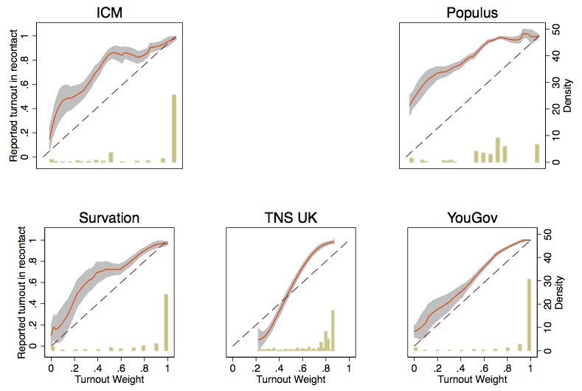

Figure 2. Conservative lead over Labour (% for Great Britain), estimated from the final polls by the nine BPC members with different specifications of the turnout weights. From left to right, these specifications are: using only the respondents who said they were certain to vote; the original (pollster-specific) turnout weights (p), weights of p+p*(1-p), and using all respondents with weight 1, irrespective of stated likelihood to vote. The green line shows the true election result (+6.5%) and the dark red line the unweighted average of the figures for the nine polls.
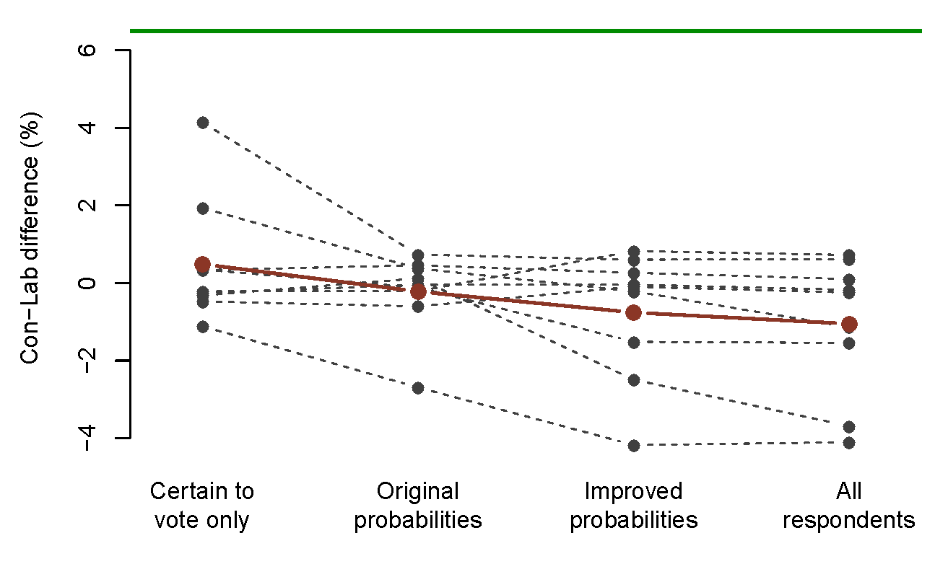

Figure 3. Estimates of voting intention for different parties (as % of vote in Great Britain): British Election Study (BES; gold bars), British Social Attitudes Survey (BSA; yellow [middle] bars), and the average of final polls by the nine members of the British Polling Council. The election results are shown by the green lines.
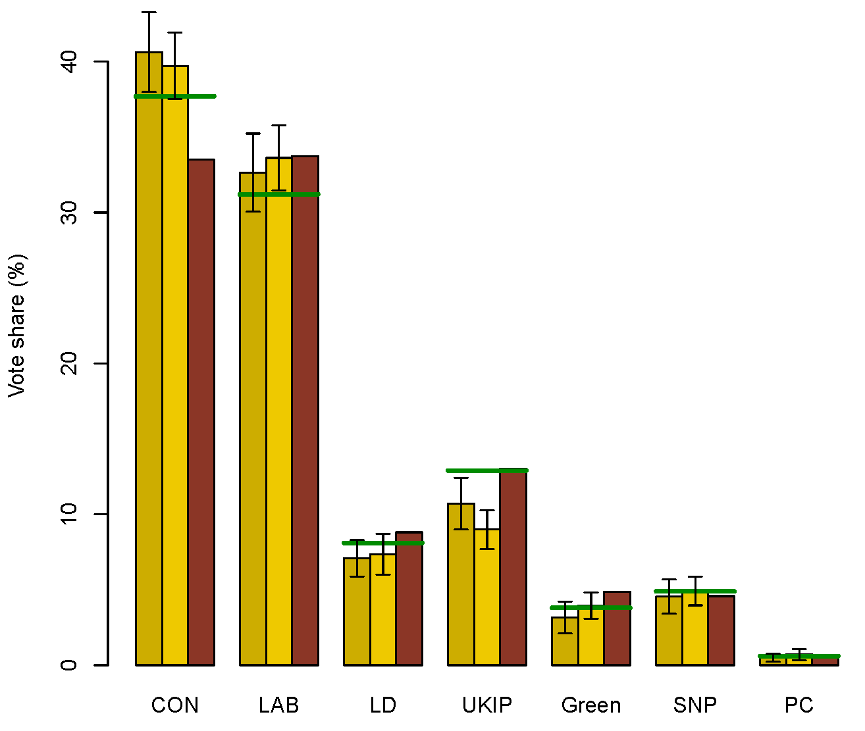
95% confidence intervals for BES and BSA estimates are also shown.

Figure 4. Conservative lead over Labour (% for Great Britain), estimated from nine final polls, separately by categories of some weighting variables (clockwise from top left: gender, age group, region, and party vote in the 2010 general election).
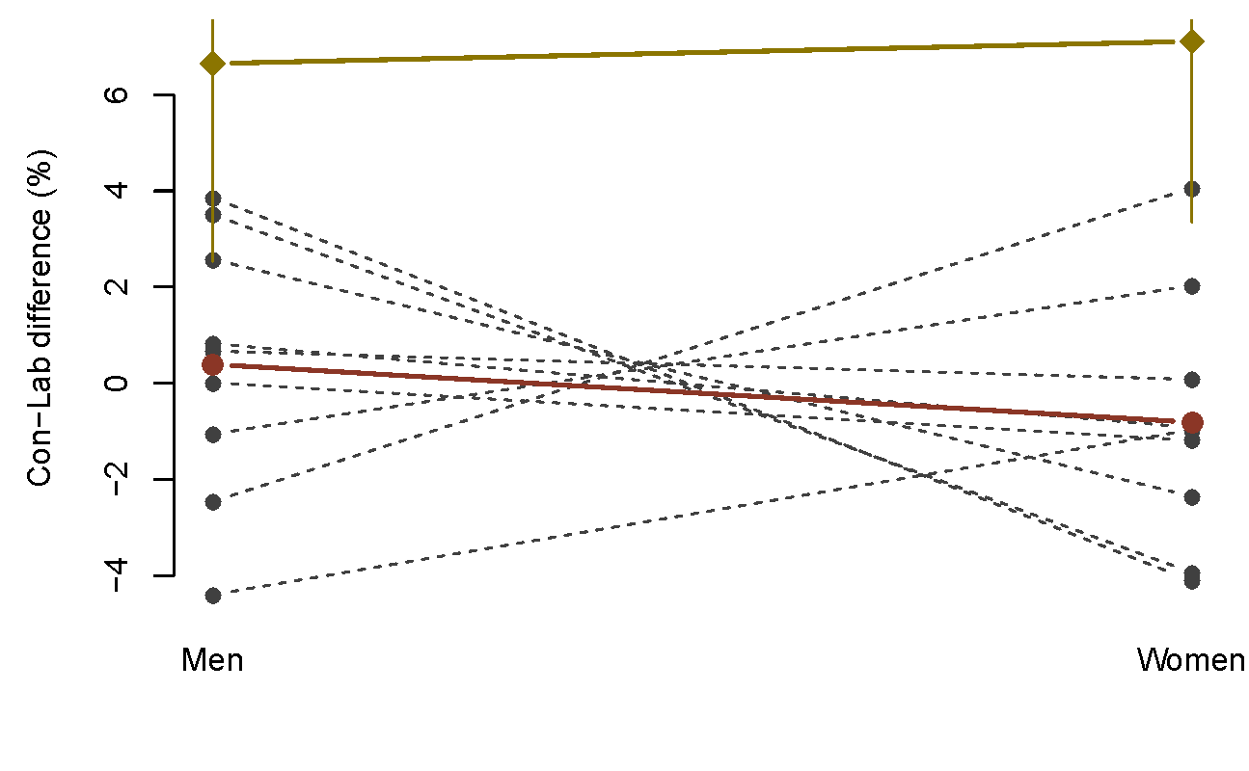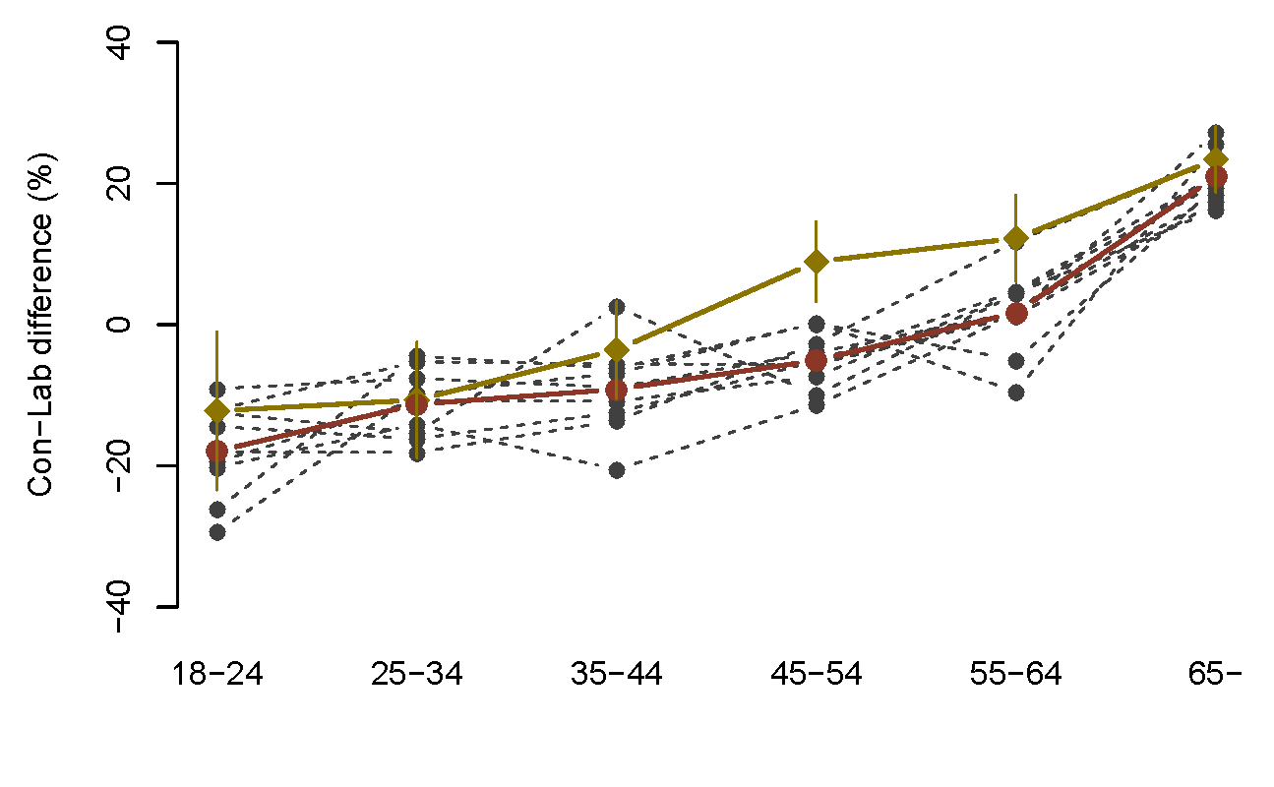
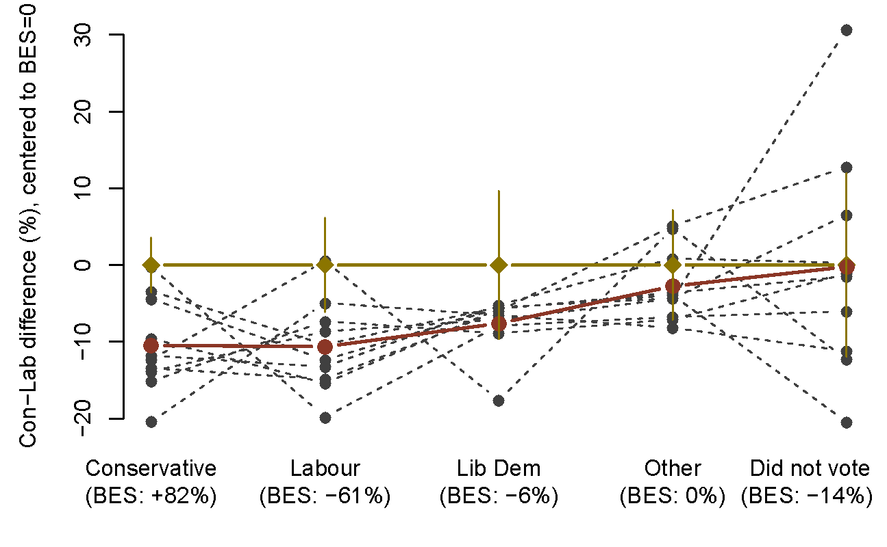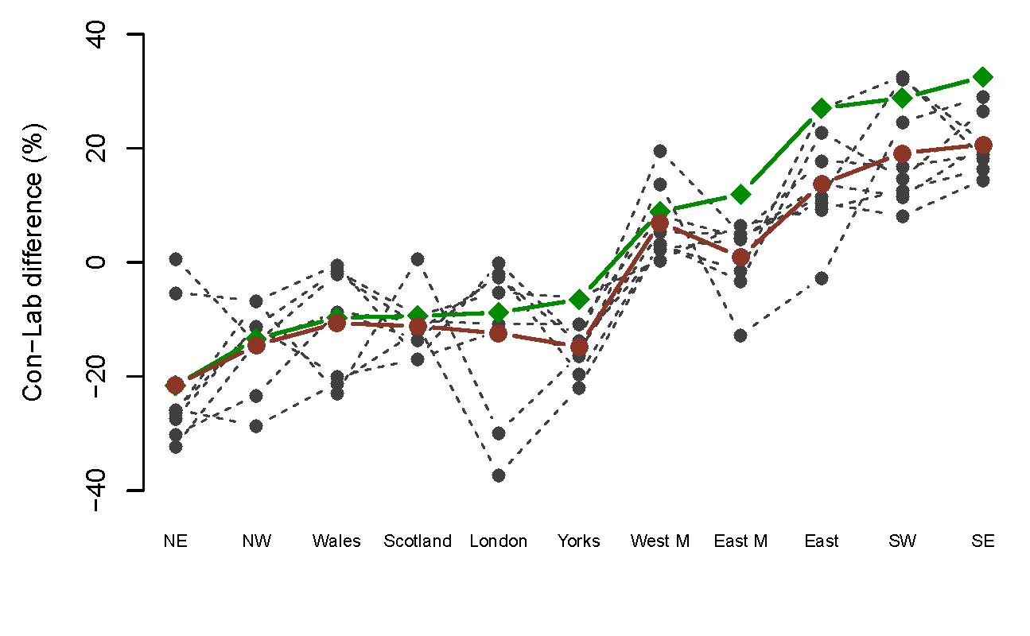
Dark red line: Average of the polls; Gold: Estimate from combined BES/BSA sample, with 95% confidence intervals (2010 vote from BES only); Green: 2015 election result. In the plot for the 2010 vote, the vertical axis is centered so that 0 represents the difference in the BES (which is shown on the horizontal axis; for example, among those who reported voting Conservative in 2010, the Con-Lab difference in the BES was +82%)

Figure 5. Age distribution of the respondents aged 65 or over in three final polls, compared with the distribution in the British Election Study and the British Social Attitudes survey (combined sample; gold line) and in the 2011 census (green).
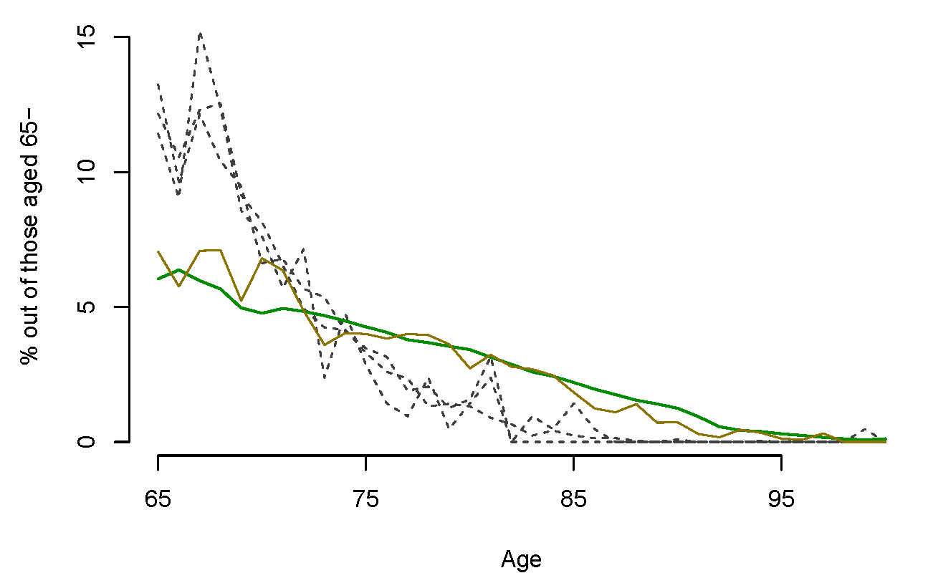

Figure 6. Proportion of individuals who report that they voted in the 2010 General Election, by age band (in 2015), estimated from nine final polls, compared to the estimates from the 2015 British Election Study (gold line, with 95 confidence intervals).

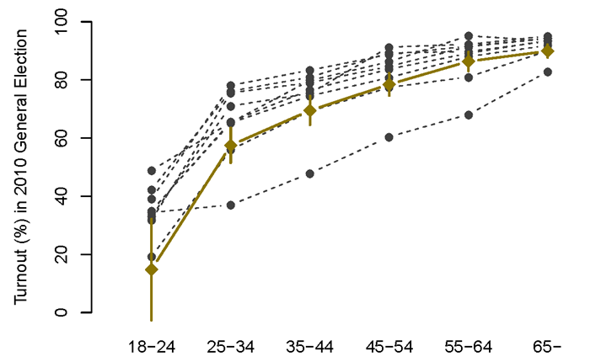

Address for correspondence: Social Statistics and Demography, University of Southampton, Southampton SO17 1BJ, UK. Email: P.Sturgis@soton.ac.uk

