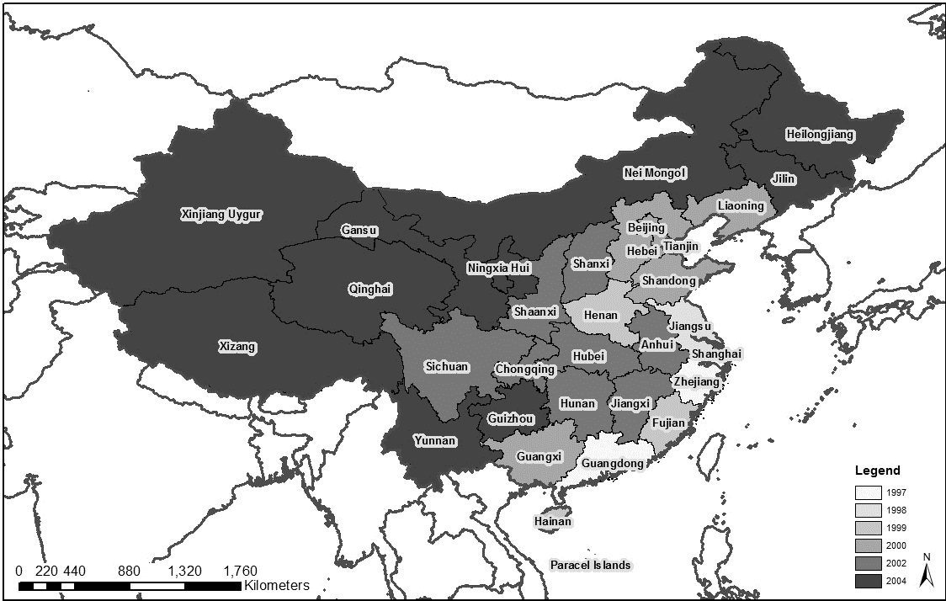
Figure 1 Geographical expansion of China Mobile
Source: Authors, based on data from China Mobile 20f forms 1998-2004

