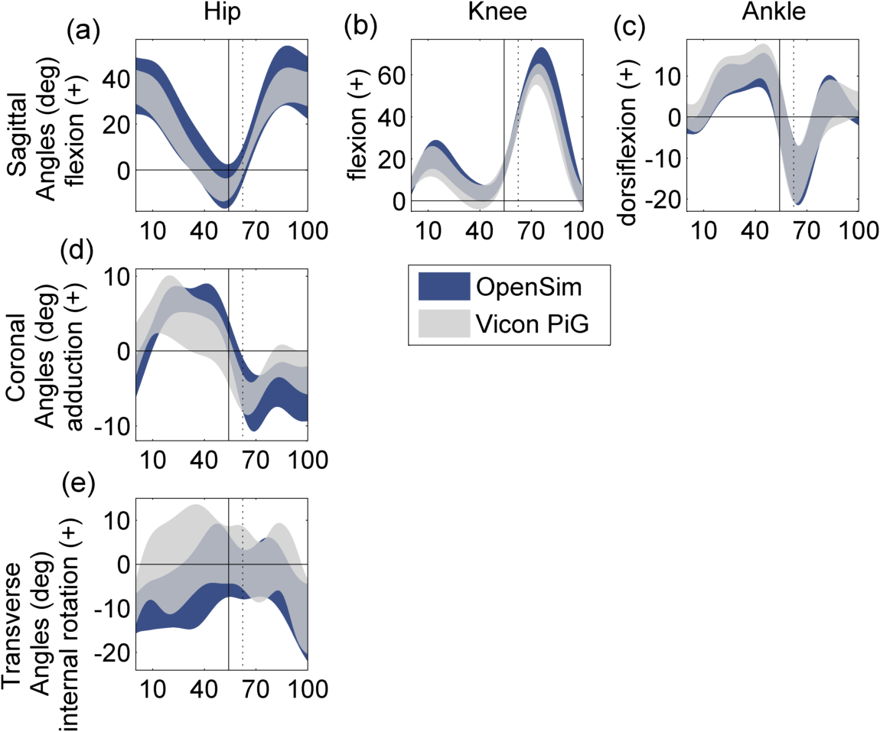
Supplemental Fig.1: Hip, knee, and ankle joint kinematics during straight walking (x–axis: 0–100% of the gait cycle) with solid and dashed vertical lines at ipsilateral foot-strike and contralateral foot-off, respectively. Standard deviation band of simulated (OpenSim) and experimental plug-in gait (Vicon PiG) kinematics shown. Only sagittal plane ankle and knee data presented as musculo-skeletal model subtalar joint was locked for simulation and knee has a single flexion/extension axis, respectively. Full gait cycle created by merging data from both limbs.
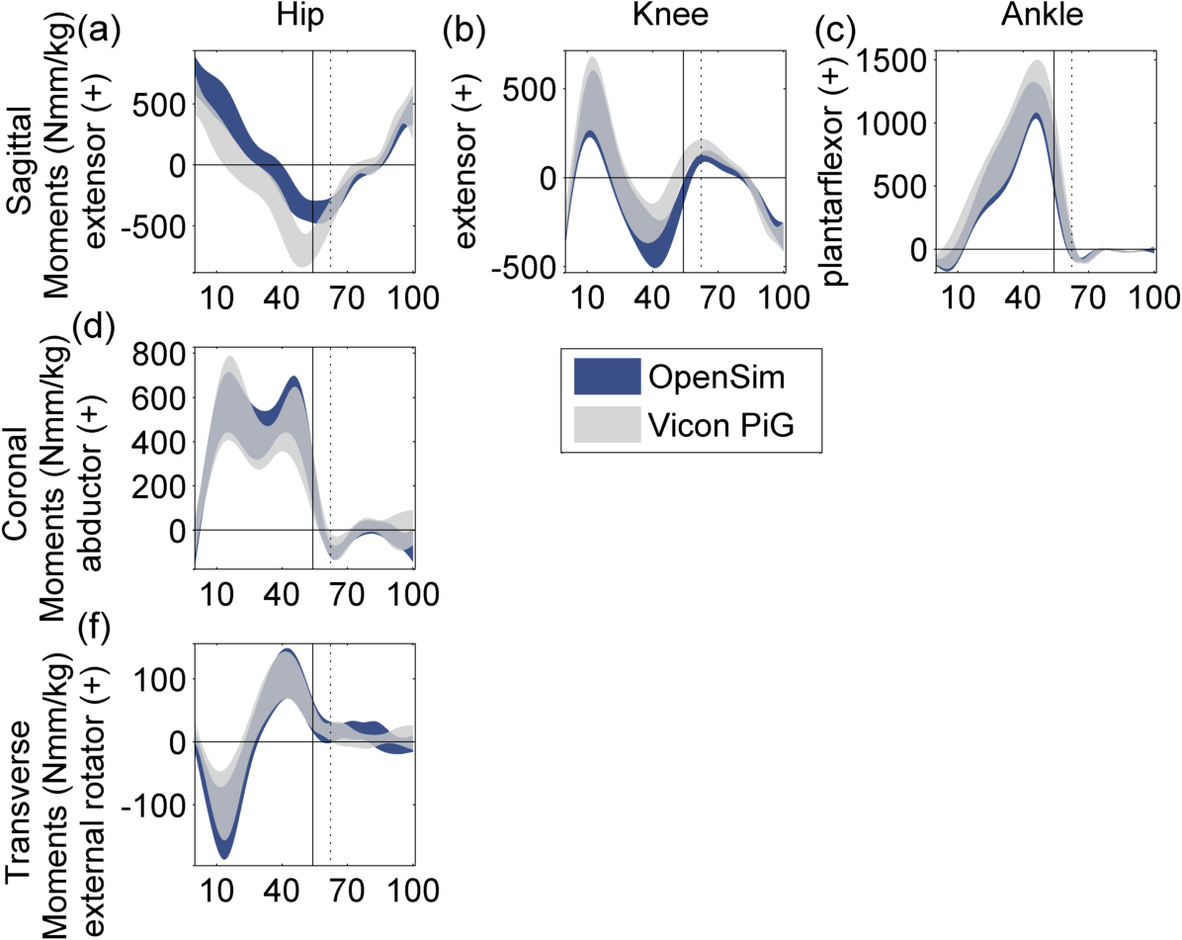
Supplemental Fig. 2: Hip, knee, and ankle joint moments during straight walking (x–axis: 0–100% of the gait cycle) with solid and dashed vertical lines at ipsilateral foot-strike and contralateral foot-off, respectively. Standard deviation band of simulated (OpenSim) and experimental plug-in gait (Vicon PiG) kinetics shown. Only sagittal plane ankle and knee data presented as musculo-skeletal model subtalar joint was locked for simulation and knee has a single flexion/extension axis, respectively. Full gait cycle created by merging data from both limbs.
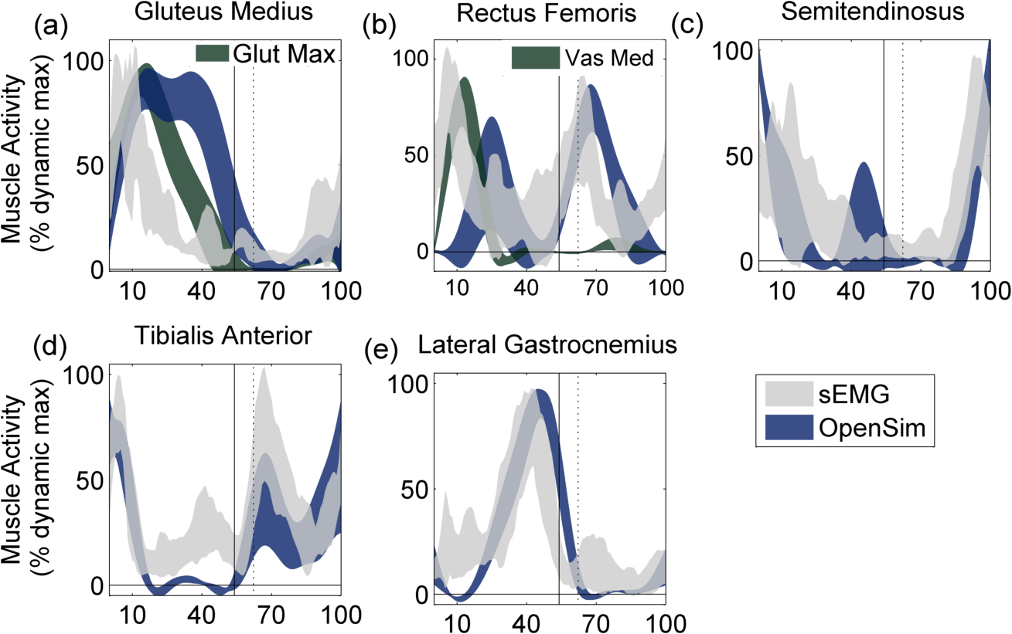
Supplemental Fig. 3: Muscle activity during straight walking (x–axis: 0–100% of the gait cycle) with solid and dashed vertical lines at ipsilateral foot-strike and contralateral foot-off, respectively. Standard deviation band of simulated (OpenSim) and processed surface electromyographic (sEMG) data presented for (a) Gluteus Medius, (b) Rectus Femoris, (c) Semitendinosus, (d) Tibialis Anterior, and (e) Lateral Gastrocnemius. For (a) and (b) Gluteus Medius (Glut Med) and Vastus Medialis (Vas Med) activity from OpenSim, respectively, also shown. Full gait cycle created by merging data from both limbs. Glut Med activity recorded for n = 4 subjects.
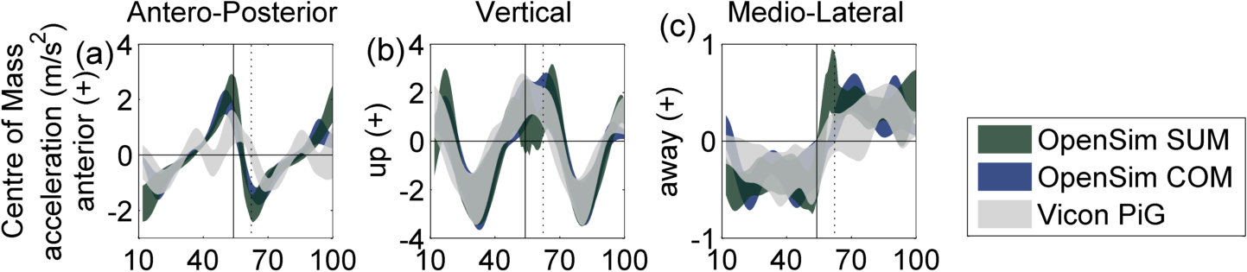
Supplemental Fig. 4: Centre of mass (COM) acceleration in the (a) antero-posterior, (b) vertical, and (c) medio-lateral direction during straight walking (x–axis: 12–100% of the gait cycle) with solid and dashed vertical lines at ipsilateral foot-strike and contralateral foot-off, respectively. Standard deviation band of sum of all muscle accelerations (OpenSim Sum), second derivative of COM position from simulations (OpenSim COM), and second derivative of plug-in gait model COM position (Vicon PiG) shown.
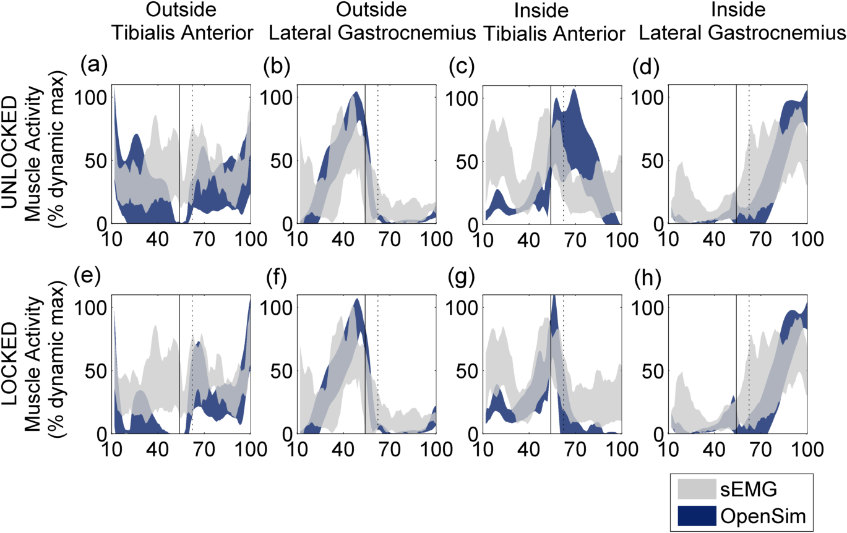
Supplemental Fig. 5: Muscle activity during spin turns (x–axis: 12–100% of the gait cycle) with solid and dashed vertical lines at inside foot-strike and outside foot-off, respectively. Standard deviation band of simulated (OpenSim) and processed surface electromyographic (sEMG) data presented for outside Tibialis Anterior (a and e), outside Lateral Gastrocnemius (b and f), inside Tibialis Anterior (c and g), and inside Lateral Gastrocnemius (d and h). Top and bottom row show effect of unlocking and locking the subtalar joint, respectively, on simulated muscle activity.
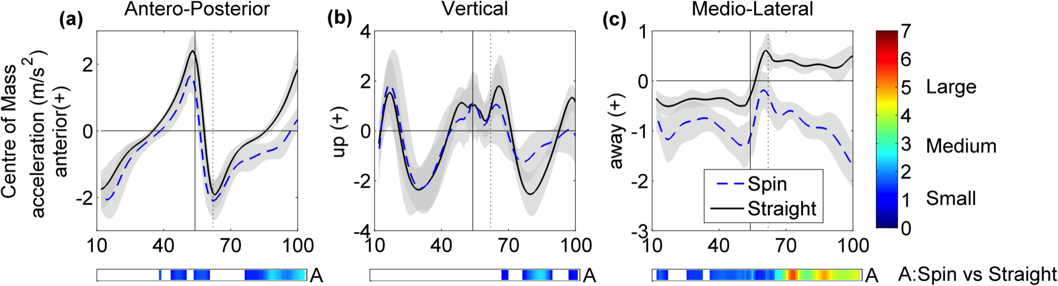
Supplemental Fig. 6: Centre of mass acceleration in the (a) antero-posterior, (b) vertical, and (c) medio-lateral direction during straight and spin turn conditions (x–axis: 12–100% of the gait cycle) with solid and dashed vertical lines at inside foot-strike and outside foot-off, respectively. Variability constructed from Bootstrap confidence bands (CB). Colorbars show areas where mean difference CBs revealed significant differences at α = 0.05 with intensity representing effect size of the differences varying from small (blue) to large (red). Zones of significant difference with changes of less than 5% of maximum CB width not shown. See (Dixon et al., 2013) for details of Bootstrap statistical analysis methodology.

