
Human DNA Cross-Link Repair 1A (DCLRE1A, SNM1A)

A Target Enabling Package

Gene ID / Uniprot ID | 9937 / Q6PJP8
Target Nominator | Peter McHugh (Oxford)
Authors | Joseph Newman, Opher Gileadi, Hazel Aitkenhead, Sook Lee, Peter McHugh, Christopher Schofield.
Target PI | Opher Gileadi (Oxford)
Therapeutic Area | Cancer
Disease Relevance | DCLRE1A is important in repair of DNA inter-strand crosslinks. Inhibition would enhance sensitivity to DNA-damaging agents (chemotherapeutics), and could hypothetically kill cancers with synthetic-lethal genetic background.
Date | 2nd June 2017

SUMMARY OF PROJECT
Cancer cells experience genomic instability, probably through a combination of excessive replicative activity and the loss of function of checkpoint and DNA repair pathways that may have contributed to the oncogenic transformation. Chemotherapy by DNA-damaging agents such as cisplatin and nitrogen mustards create DNA interstrand crosslinks (ICL), which can lead to double-strand breaks and cell death when the cells replicate their DNA. Genotoxic drugs are counteracted by the cell’s DNA damage response. Hence, it is expected that inhibiting DNA repair proteins would sensitise cells to chemotherapy.
Here we address an enzyme that participates in the repair of ICLs, DCLRE1A. The TEP includes expression clones and methods for producing the catalytic domain and high-throughput activity assays. Furthermore, we provide a crystallization system that generates thousands of reproducible crystals that allow soaking of small-molecule ligands. We provide crystal structures of several small molecule fragments and inhibitors, opening the way to development of more potent and selective inhibitors.

SCIENTIFIC BACKGROUND
DCLRE1A is a DNA exonuclease involved in the repair of DNA damage. DCLRE1A, and the related DCLRE1B, have the unique capability to digest through crosslinked nucleotides [1, 2]. This may underlie the observations that knocking down DCLRE1A expression sensitizes cells to chemotherapeutic agents such as cisplatins and mitomycin C [3, 4]. DCLRE1A has complex interactions with other components of the DNA repair machinery and with replication forks [2, 5, 6], including binding to (ubiquitylated) PCNA. Discovery of selective inhibitors of DCLRE1A may serve three purposes: as research tools, to understand the roles of DCLRE1A in genome maintenance and to identify vulnerability of different cell lines; in combination therapy, to increase the sensitivity of cancer cells to DNA-damaging chemotherapeutic agents; and, possibly, to selectively target cancer cells through synthetic lethal interactions. DCLRE1A is subject to intensive research by groups including our collaborators, P. McHugh and C. Schofield in Oxford. The collaborators have investigated the biology of DCLRE1A and its homologue in yeast, mapping structural and functional interactions with the replication and genome repair machineries.
Previously published work leading to this TEP included a crystal structure of DCLRE1A [7], the development of biochemical assays, and the identification of inhibitory molecules from a library of beta-lactam compounds [1, 8]. In this TEP, we provide a modified crystallization system that generates thousands of reproducible crystals that allow soaking of small-molecule ligands. We provide crystal structures of several small molecule fragments and inhibitors, opening the way to development of more potent and selective inhibitors.

RESULTS – The TEP
Proteins purified
The catalytic domain of DCLRE1A (aa 698-1040) is expressed from recombinant baculoviruses and purified from SF9 insect cells.

Structural data
Earlier crystal forms were unsuitable for medicinal chemistry because the active site was unavailable; within this TEP, we provide methods for obtaining a new crystal form that routinely generates data with resolution better than 1.8Å, and allows soaking of small molecules. A list of structures deposited in the PDB is provided below.

In vitro assays
In vitro assays were developed together with the McHugh lab. A primary HTS-ready assay detects the hydrolysis of the 5’-nucleotide from an oligonucleotide containing a donor/quencher pair. Secondary assays measure the processive degradation of oligonucleotide and plasmid templates using gel-based assays. More detailed mechanistic studies are done using DNA substrates containing damages sites. Assay methods and results have been published and are summarized in the methods document.

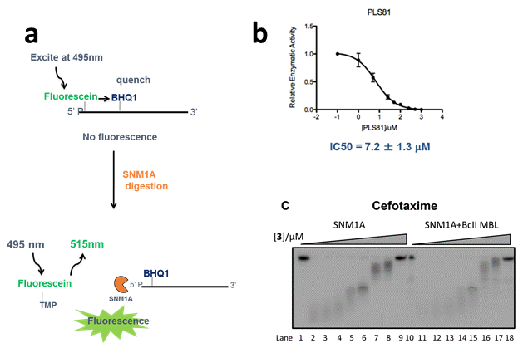
Fig. 1: Biochemical assays for DCLRE1A activity. (a) Fluorescence-based HTS assay, monitoring the removal of 5’-most nucleotides. (b) Inhibition curve. (c) Gel-based assays, which also monitor the processivity and substrate-selectivity of DNA degradation.

Chemical starting points
Chemical starting points emerged from two sources. The first was a library of β-lactamase inhibitors and substrates (based on the relation to bacterial metallo β-lactamases). Three Cephalosporins were identified as inhibitors: 7-ACA, Ceftriaxone, and Cefotaxime, with IC₅₀ of 7, 4 and 5 μM, respectively.

7-ACA | Ceftriaxone | Cefotaxime
IC₅₀ = 7µM | IC₅₀ = 4µM | IC₅₀ = 5µM
Ligand Efficiency = 0.42 | Ligand Efficiency = 0.20 | Ligand Efficiency =0.25
Lipophilic Ligand Efficiency= 6.8 | Lipophilic Ligand Efficiency = 6.1 | Lipophilic Ligand Efficiency = 5.4

Co-crystal structures revealed three binding sites: one site has the Ceftriaxone bound in a position to form a chelate with the active site metal (Fig.2). The other binding sites are located at some distance from the catalytic site, but may overlap with DNA-binding regions of the protein (Fig.2).
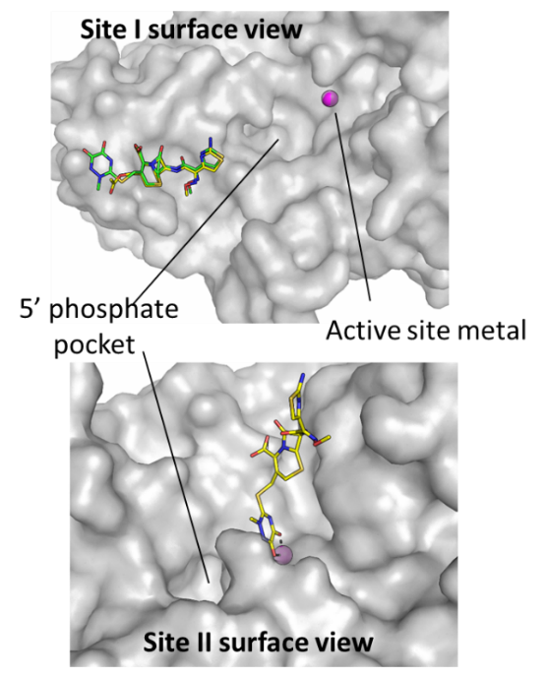
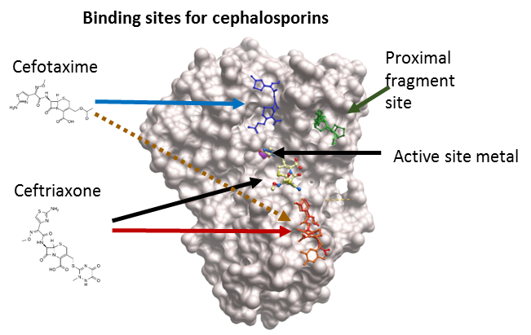

Fig 2: LEFT: Overlaid structures of cephalospirins bound at three sites. Ceftriaxone can bind directly to the active site metal, or at a proximal site (orange); Cefotaxime can bind at two proximal sites (Orange, Blue). The proximal fragment binding site (from panel A) is shown in green.
RIGHT: detailed views of the proximal and metal-binding sites of Ceftriaxone binding

A second set of chemical starting points was discovered by X-ray crystallography-based fragment screens, performed at the Diamond Light Source (I04-1). The screen identified 26 small molecules that cluster in two hotspots on the protein (fig. 3 and Table 2) ; a proximal pocket, located ~9 Å from the catalytic centre, and an opposite site, located at the back side of the protein.
Compounds targeting the proximal side may be expanded to improve the selectivity and potency of a chelating “warhead” that would occlude the active site. The utility of the opposite site is less clear, although targeting this allosteric site may affect aspects of SNM1A activity such as processivity on long DNA substrates.
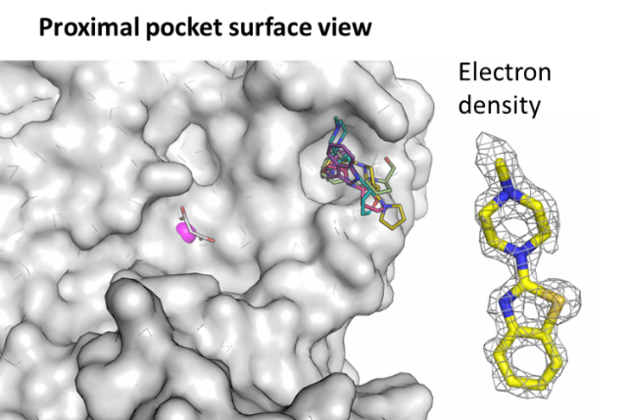
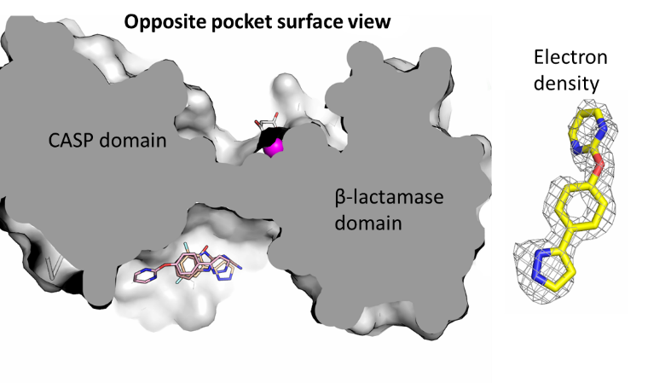

Fig. 3: Major binding sites of fragments. LEFT: Fragments clustering at a proximal pocket. Electron density map of a representative compound shown on the right. RIGHT: The location of the opposite pocket, shown on a cross-sectional view of the protein.

CONCLUSIONS
Genetic knockdown experiments have indicated that depletion of the DNA-repair exonuclease DCLRE1A sensitises cells to DNA crosslinking agents used in cancer chemotherapy. This makes DCLRE1A a potential target for cancer therapy, either in combination with chemotherapy, or in a synthetic-lethal genetic background. To investigate and exploit this therapeutic potential, it is essential to develop small-molecule inhibitors of DCLRE1A.

This target enabling package includes high-throughput and secondary assays for DCLRE1A activity, a robust crystallization method, and initial chemical hits from fragment screens as well as from an inhibition screen. Co-crystal structures identify a number of pockets on the protein surface in addition to the Zn-containing catalytic site, which may be used to develop highly specific inhibitors when combined with a metal-chelating moiety.

FUNDING INFORMATION
The work at the SGC has been funded by a grant from the Wellcome Trust [106169/ZZ14/Z].

ADDITIONAL INFORMATION
Materials & Methods | All proteins, structures and assays | Procedures for expression, purification, crystallization
Structure files | PDB codes  5NZW  5NZX  5NZY  Fragments bound at the proximal site:  5Q1V  5Q1U  5Q1T  5Q1R  5Q10  5Q22  Fragments bound at the opposite site  5Q1K  5Q1W  5Q1X | Ceftriaxone (metal site)  Ceftriaxone (alternative site)  Cefotaxime
Gene Knockouts | CRISPR/Cas9 knockout of DCLRE1A has been performed in the McHugh lab | Contact Prof. Peter McHugh, Oxford peter.mchugh@imm.ox.ac.uk for collaborative opportunities
Antibodies |  | We are not aware of antibodies that can detect the native levels of DCLRE1A in western/immunofluorescence.

Supplemental Information
References
1. Sengerova, B., et al., Characterization of the human SNM1A and SNM1B/Apollo DNA repair exonucleases. J Biol Chem, 2012. 287(31): p. 26254-67.
2. Wang, A.T., et al., Human SNM1A and XPF-ERCC1 collaborate to initiate DNA interstrand cross-link repair. Genes Dev, 2011. 25(17): p. 1859-70.
3. Cattell, E., B. Sengerova, and P.J. McHugh, The SNM1/Pso2 family of ICL repair nucleases: from yeast to man. Environ Mol Mutagen, 2010. 51(6): p. 635-45.
4. Hazrati, A., et al., Human SNM1A suppresses the DNA repair defects of yeast pso2 mutants. DNA Repair (Amst), 2008. 7(2): p. 230-8.
5. Iyama, T., et al., CSB interacts with SNM1A and promotes DNA interstrand crosslink processing. Nucleic Acids Res, 2015. 43(1): p. 247-58.
6. Yang, K., G.L. Moldovan, and A.D. D'Andrea, RAD18-dependent recruitment of SNM1A to DNA repair complexes by a ubiquitin-binding zinc finger. J Biol Chem, 2010. 285(25): p. 19085-91.
7. Allerston, C.K., et al., The structures of the SNM1A and SNM1B/Apollo nuclease domains reveal a potential basis for their distinct DNA processing activities. Nucleic Acids Res, 2015. 43(22): p. 11047-60.
8. Lee, S.Y., et al., Cephalosporins inhibit human metallo beta-lactamase fold DNA repair nucleases SNM1A and SNM1B/apollo. Chem Commun (Camb), 2016. 52(40): p. 6727-30.
9. Savitsky, P., et al., High-throughput production of human proteins for crystallization: the SGC experience. J Struct Biol, 2010. 172(1): p. 3-13.
10. Shrestha, B., C. Smee, and O. Gileadi, Baculovirus expression vector system: an emerging host for high-throughput eukaryotic protein expression. Methods Mol Biol, 2008. 439: p. 269-89.

Experimental procedures

Expression and purification of DCLRE1A catalytic domain.
Boundaries: residues 698-1040
Vector: pFB-LIC-Bse [9,10]
Tag and additions: TEV-cleavable His6 tag at the N-terminus
(MGHHHHHHSSGVDLGTENLYFQ*SM)
Expression cell: Sf9

Note that this is a different construct from that used to generate earlier crystal structures (PDB: 5AHR and 4B87) [7].

Baculoviruses were generated using the Bac to Bac system (Life Technologies) and used to infect 2-6 L of SF9 cells in Sf-900™ II SFM medium. The cells were collected after 72 hours at 27°C, suspended in a small volume of lysis buffer (50 mM HEPES, pH 7.5, 0.5 M NaCl, 5% glycerol, 10 mM imidazole, 1 mM TCEP; protease inhibitors were added during cell resuspension but were omitted from the subsequent steps) and frozen. After thawing, the cells were diluted to ~5 volumes (v/w) of lysis buffer, then batch-bound to 5 ml of Ni-loaded chelating sepharose beads (GE) for 1 hour. The beads were washed with lysis buffer containing 30 mM imidazole, and the protein was eluted with lysis buffer containing 300 mM imidazole.
The tag was cleaved by incubating the protein overnight at 4°C with TEV protease (1/40 (w/w)) in a dialysis tube placed in 1 L dialysis buffer (50 mM HEPES, 0.5 M NaCl, 5% glycerol and 1 mM TCEP). The protein was then passed through a 1-mL Ni-sepharose column, and the flowthrough fractions were collected. The protein was concentrated on a centrifugal concentrator (Centricon, MWCO 30 kDa) before loading on a Superdex S200 HR 16/60 gel filtration column in dialysis buffer, and separated at 1.2 mL/min. fractions containing purified DCLRE1A protein were identified by SDS-PAGE, pooled and concentrated to 9-10 mg/mL.

Protein crystallization and compound soaking
Protein crystallization was performed by vapour diffusion in sitting drops at 4°. A protein solution at 9-10 mg/mL was mixed at with an equal volume crystallization solution containing 30% PEG 1000, 0.1M MMT pH 6.0 (MMT is L-malic acid, MES, Tris buffer at a ratio of 1:2:2). The crystals contained malate bound to the active site. For fragment screening, concentrated solutions (0.5 M) of the fragments in DMSO were added to the crystallization drops using an Echo dispenser, up to 10% of the drop volume, at the Diamond light source XChem facility. Crystals were harvested after 1-4 hour of incubation, flash-cooled in liquid N2 without additional cryoprotectant. For the cephalosporin compound soaks, the crystals were first incubated overnight in malate-free liquor (30% PEG, 0.1 M HEPES, pH 7.0) to remove the malate at the active site; compounds were subsequently soaked overnight at a final concentration of approximately 20 mM before harvesting and cryo-cooling. Data was collected in Diamond light source beamline I04-1 (Fragments), I04 and ESRF beamline BM30B.

Activity assay
Real-time Fluorescence Assays: Real-time fluorescence assays were performed as described [1, 8] using the 20-mer oligonucleotide:
5’-phosphate-A-[fluorescein-T]-AATTTGATCA [BHQ1-T] CTATTAT
In this oligonucleotide, fluorescence from the fluorescein linked at position 2 is quenched by the BHQ1 group linked to position 13. When the first two nucleotides are hydrolysed, the unquenched fluorescence of the free fluorescein-TMP can be detected in real time (excitation at 495 nm, emission at 525 nm).
Reactions were carried out in black 384-well microplates, and measurements were made using a SpectraMax M2e fluorescent plate reader in fluorescent top read mode, with SoftMaxPro software (Molecular Devices, Sunnyvale, CA, USA) to control the settings. Reactions were performed in a total volume of 15 μL in nuclease buffer (20 mM HEPES pH 7.5, 50 mM KCl, 10 mM MgCl₂, 0.5 mM DTT, 0.05% Triton-X100, 0.1 mg/mL BSA, 5% glycerol) with varying concentrations of compound (for IC50 determinations) or DNA substrate (for kinetics assays) and 0.24 nM DCLRE1A (the Km for ssDNA oligo was < 5 nM). Each reaction was started by the addition of DCLRE1A, and the fluorescein emission spectra measured (ex. 495 nm, em. 525 nm and cutoff at 515 nm) with six readings taken at 7 s intervals for 6 min. The fluorescence intensity of each well was plotted against time, and the rate of increase was determined, plotted against compound or substrate concentration and fitted to a log(inhibitor)- response or Michaelis–Menten curve on Prism software (GraphPad Software, Inc., La Jolla, CA, USA) to determine IC50 or Km and Vmax.
For radioactive gel-based assays, similar reaction conditions were used, with substrate DNAs labelled at the 3’ end with α-[³²P]-dATP and terminal deoxynucleotidyl transferase. Reactions were stopped by boiling in sample buffer (95% formamide, 10 mM EDTA, bromophenol blue and xylene cyanol) and analysed by electrophoresis on 20% polyacrylamide, 0.5 x TBE and 7M urea.

IMPORTANT: Please note that the existence of small molecules within this TEP may only indicate that chemical matter can bind to the protein in a functionally relevant pocket. As such these molecules should not be used as tools for functional studies of the protein unless otherwise stated as they are not potent enough and not characterised enough to be used in cellular studies. A TEP's small molecule ligands are intended to be used as the basis for future chemistry optimisation to increase potency and selectivity and yield a chemical probe or lead series.

PDB ID | Compound structure
Fragments in proximal pocket
5Q1V
5Q1U
5Q1T
5Q1R
5Q10
5Q22
Fragments in opposite pocket
5Q1K
5Q1W
5Q1X
Cephalosporin inhibitors
5NZW, 5NZX: Ceftriaxone | 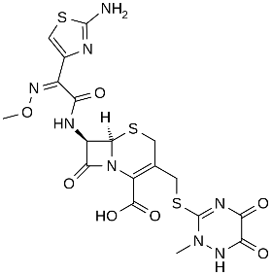
5NZY: Cefotaxime | 