Supplement

Supplemental Figure 1 Sleep Condition Indicator (SCI) distribution curves by sex and age decile
. 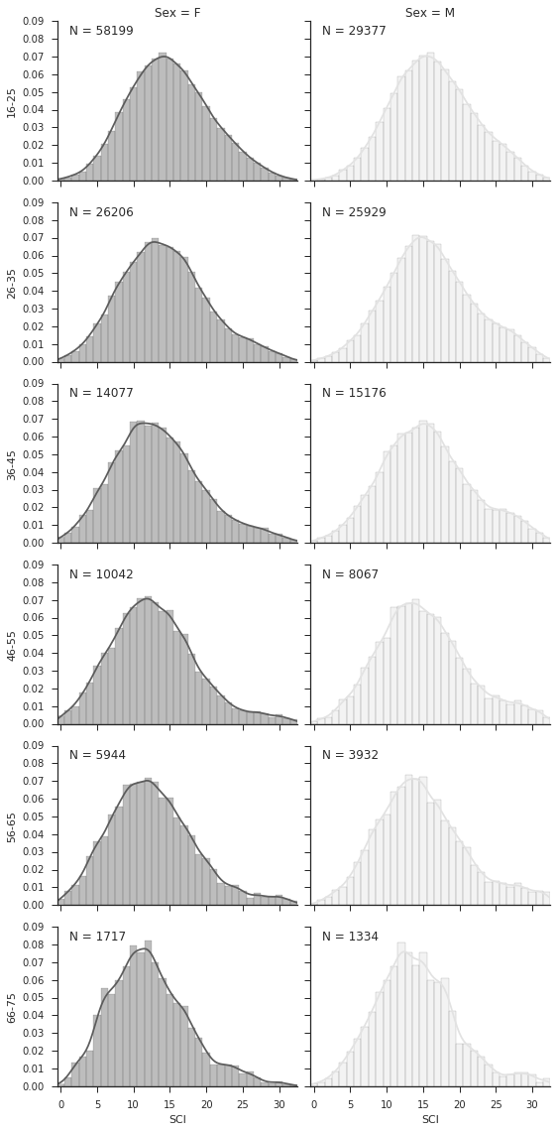

Supplemental Figure 2 Comparison of participants meeting minimal criteria for DSM-5 Insomnia Disorder (n=106,707) and healthy controls (n=93,293) on the SCI, demonstrating the reliability of the Sleep Condition Indicator (SCI) cut-off score of 16
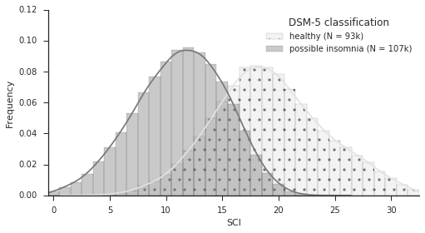

Supplemental Table 1 Psychometric properties of and Reliable Change Index (RCI) for the Sleep Condition Indicator (SCI)

Age group (years) | Sex | Cronbach’s α  (range of α-if-item-deleted) | Mean corrected item-total correlation (r) | RCI:  8 items | RCI:  7 items
16 – 25 | F  M | 0.714 (0.655 - 0.727)  0.713 (0.655 - 0.728) | 0.427  0.424 | 6.19  6.24 | 5.39  5.39
26 – 35 | F  M | 0.750 (0.690 - 0.764)  0.756 (0.700 - 0.769) | 0.473  0.476 | 6.54  6.58 | 5.87  5.73
36 – 45 | F  M | 0.746 (0.682 - 0.765)  0.770 (0.712 - 0.784) | 0.473  0.496 | 6.64  6.82 | 6.06  6.04
46 – 55 | F  M | 0.748 (0.685 - 0.769)  0.770 (0.712 - 0.784) | 0.477  0.498 | 6.53  6.77 | 6.09  6.11
56 – 65 | F  M | 0.750 (0.689 - 0.767)  0.775 (0.717 - 0.791) | 0.480  0.505 | 6.50  6.76 | 6.16  6.22
66 – 75 | F  M | 0.704 (0.632 - 0.730)  0.725 (0.656 - 0.746) | 0.428  0.449 | 6.07  6.24 | 5.87  5.85
All ages | F  M | 0.722 (0.657 - 0.734)  0.738 (0.677 - 0.750) | 0.443  0.458 | 6.43  6.56 | 5.71  5.74
 | All | 0.733 (0.671 - 0.744) | 0.454 | 6.54 | 5.79
F: female; M: male; RCI: reliable change index.

