Final submitted manuscript later published as: Dorling, D. and Hennig, B. D. (2015) Visualizing urban and regional worlds: power, politics, and practices, Environment and Planning A, 47, 1346-1350.

Visualizing urban and regional worlds: power, politics, and practices

Daniel Dorling and Benjamin D. Hennig
(both: School of Geography and the Environment, University of Oxford, UK)

In this series of papers, presented as a special issue of the journal E&PA, visualization has been used to explore a huge range of subjects. These range from trying to make clearer the powers that shape the urban landscape of the United States (Arribas-Bel and Gerritse, 2015) and further-a-field (Bieke, 2015; Charlton et al., 2015; Swords and Jefferies, 2015), through to better understanding the geographies of wealth and power worldwide (Graham, M., and De Sabbata, S. 2015; Hennemann et al., 2015), to rethinking old ways of mapping the flow of water (Hautdidier, B.).

So, how might all these issues be summed up in a conclusion? One answer is, of course to draw yet more images, in this case images ranging from the world to local scale, and combining topography with hydrology in a very simple but hopefully useful way to try to sum up how we are beginning to see better that which until now we have only imagined and tried to describe to others in words. Visualization is about making visible what you imagine an even what you barely imagine but that which is there in the data just waiting to be revealed.

Images are only images – but they linger in the mind and shape our thoughts in ways that are more obscure to unravel than arguments put in text. With text at least you know what is there and what is not said. With images you do not know which fraction of the impression each viewer chooses or is coerced into seeing. If two of us look at an image we can each come away from viewing, say, new pictures of the world with very different impressions from each other. This is no bad thing. It reduces the power of those who draw the visualizations. The visualizers can, of course, manipulate images and try to steer the graphic-reader’s interpretation in a particular direction, but they cannot know (as well as you know when putting an argument over in words) whether it is in one particular direction or towards some other angle or thought which each image might cause minds to wonder in.

Take a new map of the world, one never seen before (Figure 1). You are seeing this map for the first time. There is almost no way in which you could have seen it before, unless you had read the published thesis of the geographer who first drew the map (Hennig, B. D., 2013a), and even then this images differs from the prototype shown there. This map of the world shrinks the oceans down to take up hardly any space at all, leaving plenty of room for the land (Hennig, B. D., 2013b). It then re-projects the land so that area is proportional to population and drapes over that new projection an image of the elevation of the land so it is possible to see how many people live at each altitude and where, including how many live on land that is less than 50 metres above sea level (highlighted in blue):
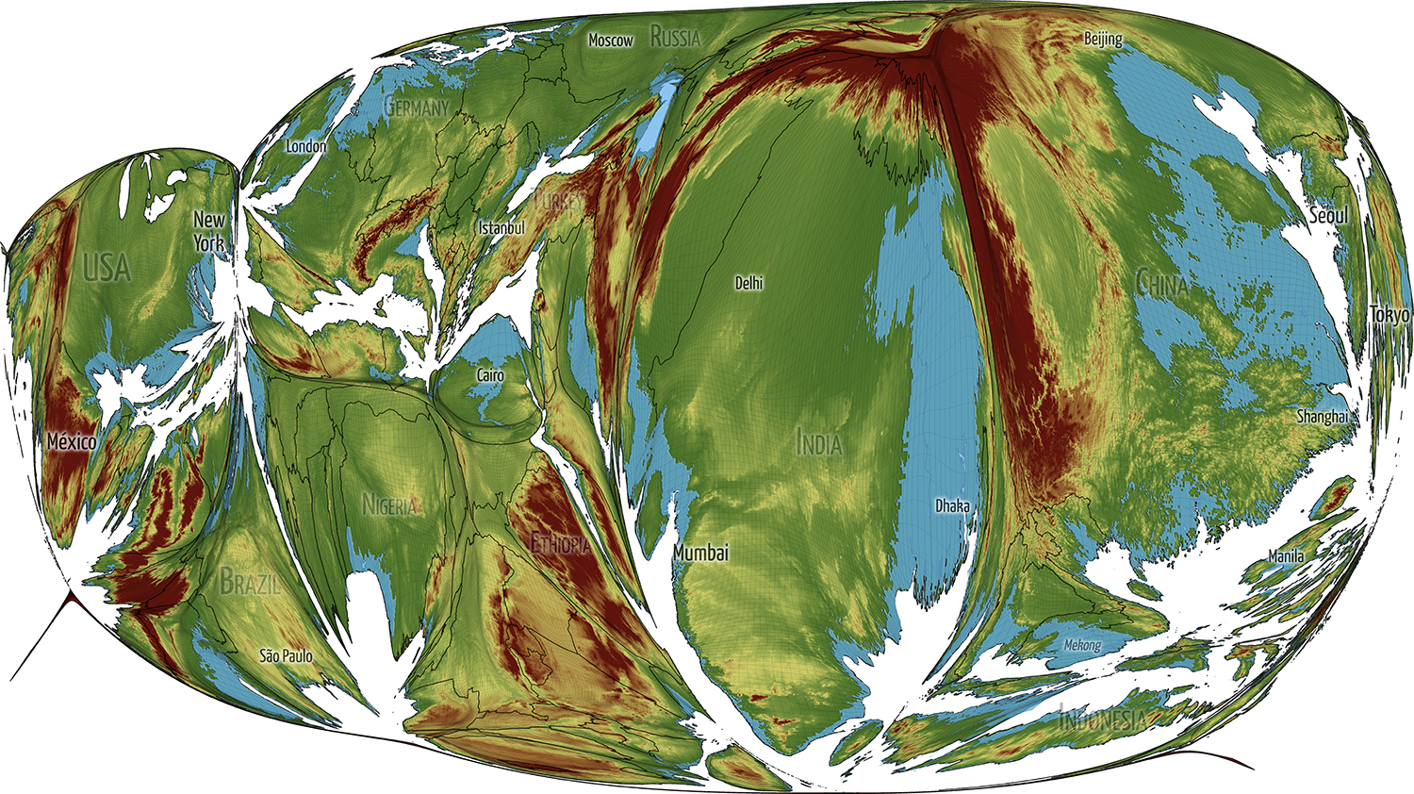
Figure 1: The World, with area proportion to population, highlighting low-lying areas

New images can help to concentrate attention. Eastern China, Bangladesh and parts of Western India, much of the Mekong Delta, the Nile Delta, North West Europe, the East and South Cast of the USA all contain relatively large populations living at relatively low altitudes. It may not be as much sea levels rising in future that matter here as water from storms draining more slowly when rainfall increases and land is low lying; but seen in this new way you see a picture that is almost entirely made up of people and where almost everywhere some are at greater risk than others as environmental circumstances change.

Now Zoom in and consider just one small continent, Europe. Zoom in on these kinds of image and the image re-forms, it is not quite the same shape as approximations have to be ironed out the further into the picture you look. Figure 2 shows elevation over Europe, with low-lying areas high-lighted. It may not show what you expect to see.

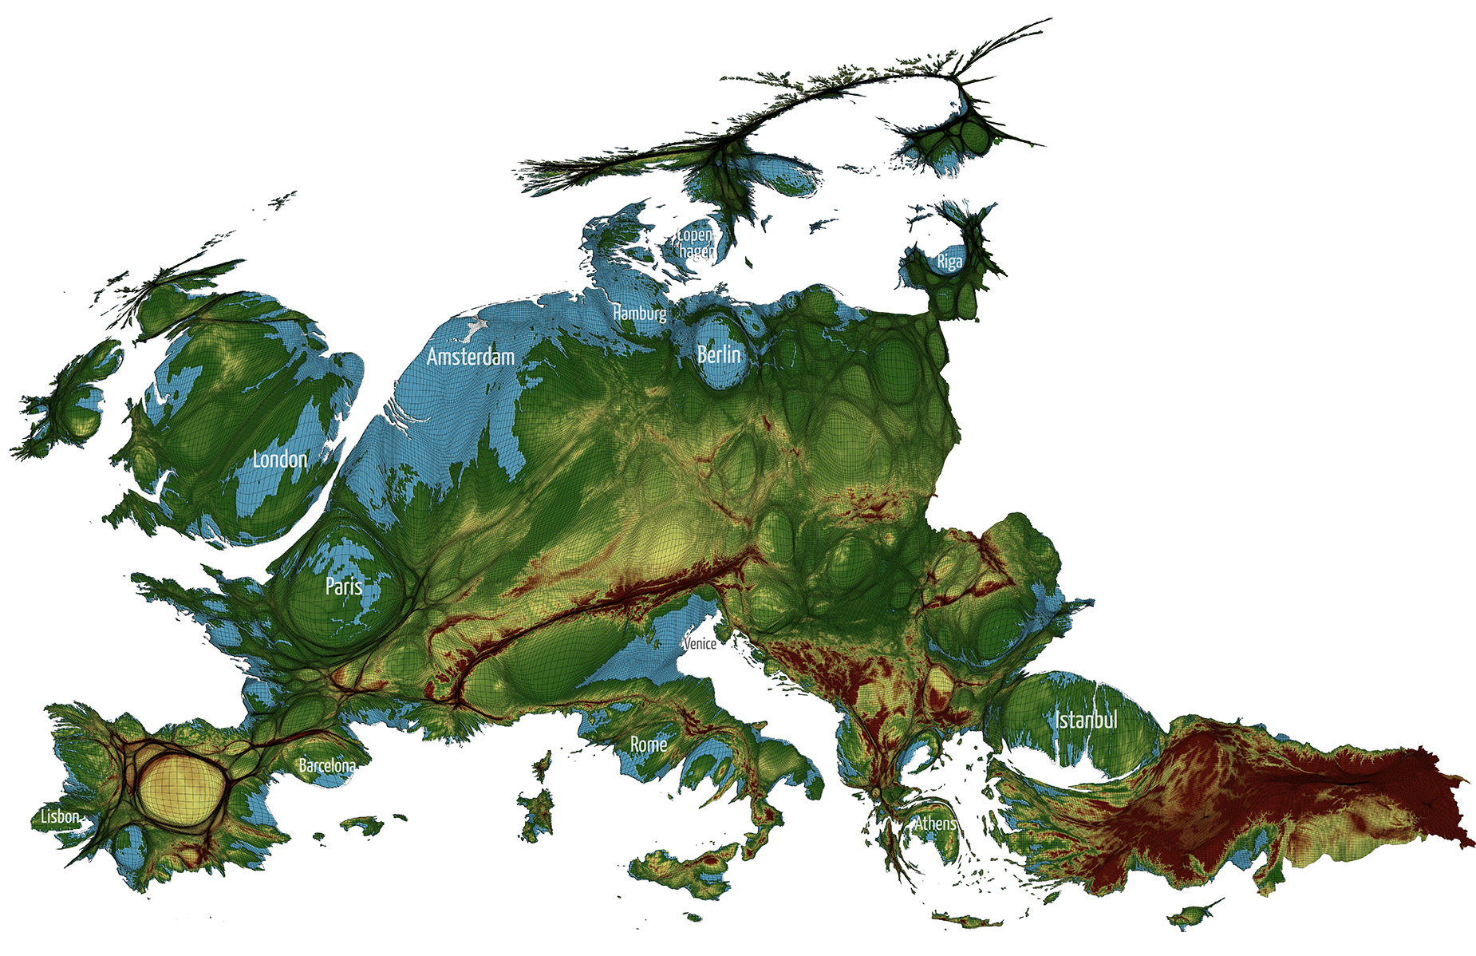
Figure 2: Europe, with area proportion to population, highlighting low-lying areas

Zoom in on Europe and again you see that it is far more than just the Netherland which are low lying once you enlarge places to show how many people life at low altitudes, not how much land. Many Scandinavian cities, much of England, The Po River Valley in Italy (with Venice just North of its estuary), parts of Paris along the River Seine and many highly populated coastal areas of Spain all have low draining land. Zoom in again on the United Kingdom (Figure 3).

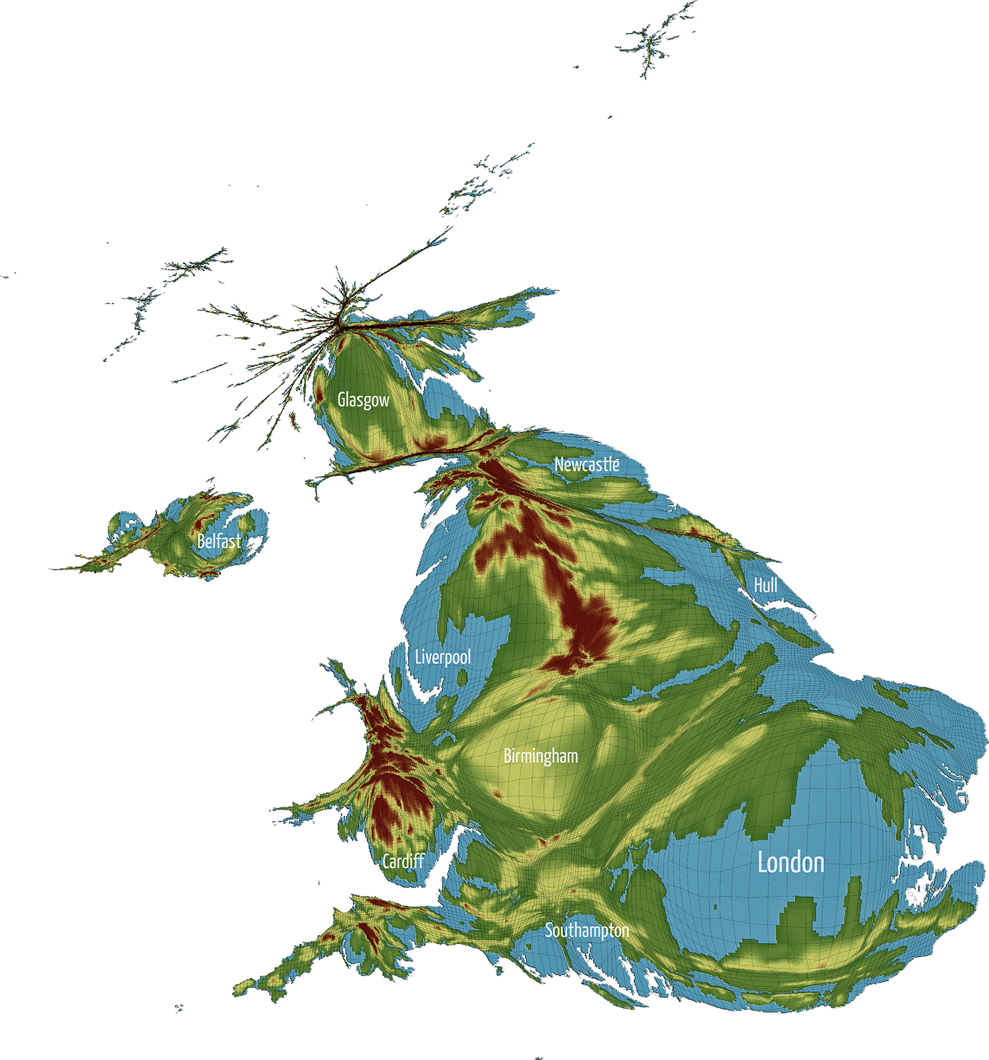
Figure 3: The UK, with area proportion to population, highlighting low-lying areas

The UK would be a very differently shaped set of islands if there were dramatic sea-level rise over the course of the global warming of the centuries to come. That projection of the most extreme long term possible change is even more dramatic when seen draped over the population distribution rather than the normal image. Again, new ways of visualizing help new kinds of thinking. So much of the sunk infrastructure is so near the water including every bridge built to span a river mouth and every tunnel driven under each estuary. We discover upon looking at the images above that as a species we have invested most in the land most likely to flood when and if the sea rises.

Let’s end with London and add another lower contour band, one at 25 metres above sea level. London is the richest city in the world. This global elevation model is crude at urban level, but the implications are clear. London already has a barrier built on the Thames to try to prevent high tides from the North Sea sweeping up the river. In the winter of 2013/2014 it received unprecedented floodwaters coming down from the Thames as standing rain pored on the higher ground of the upstream river catchments for days. How many Londoners live on low-lying land? (Figure 4).
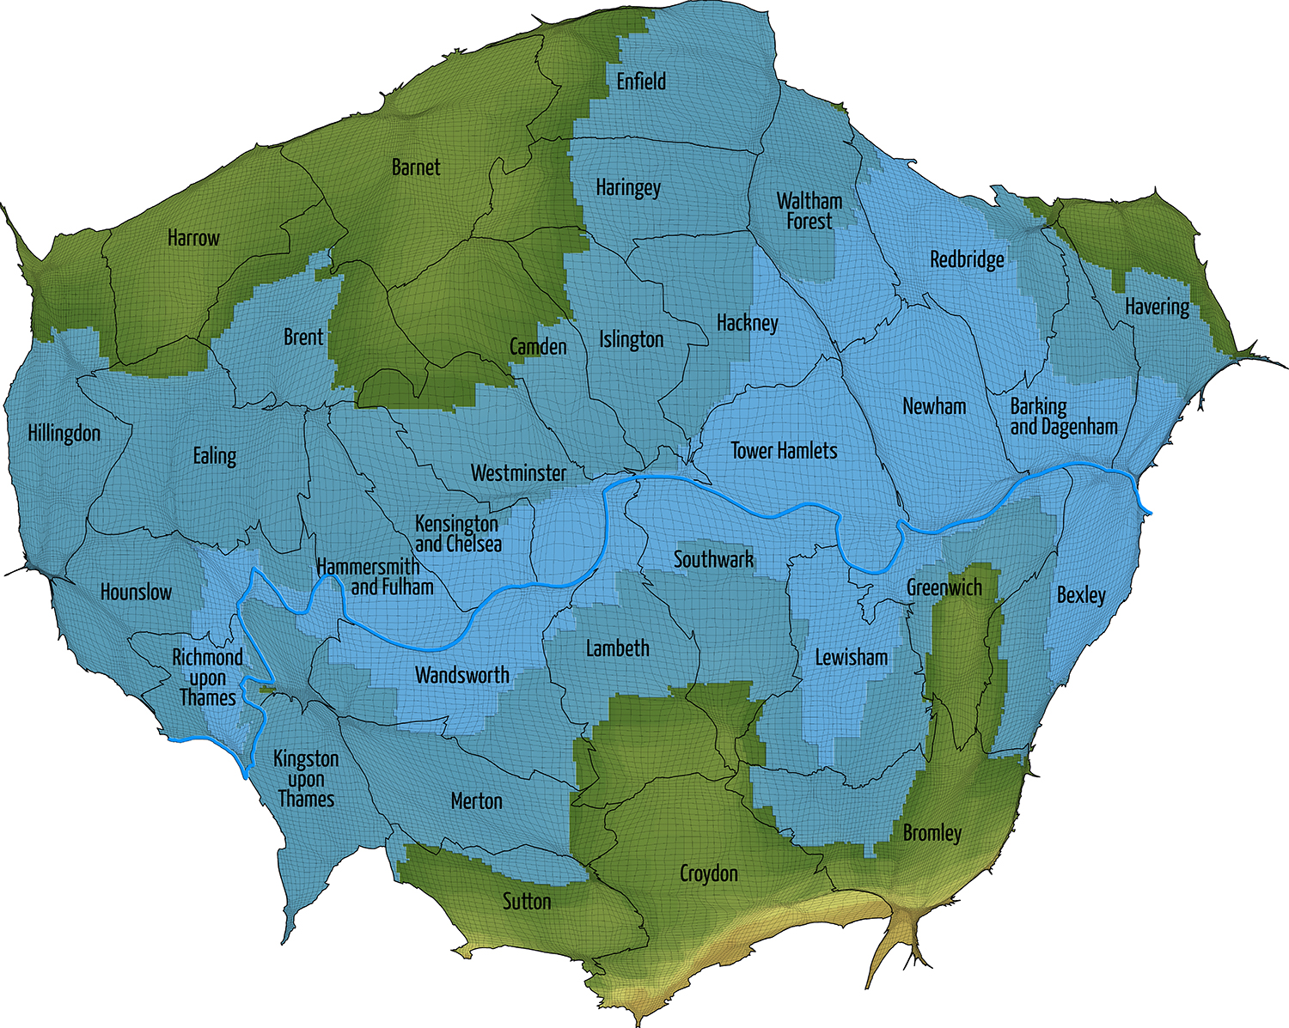
Figure 4: London, with area proportion to population, highlighting low-lying areas
The highest land in London is found along its southernmost edge. From there you get good views of a city, but much better views when the images are constructed digitally using data rather than trying to capture the working of the city through the graining analogue images that a camera might capture through the smog. At first we took hot air balloons a few dozens meters up to try to better see our human landscape. Today we are doing much the same again, trying to find batter vantage points to gain a better view. The papers in this special issue do this in many different ways and point towards a future of ever more imaginative, unusual and inspiring new images.

References

Arribas-Bel, D. and Gerritse, M. (2015) “From manufacturing belt to rust belt to college country” -
A Visual Narrative of the US Urban Growth, E&PA, 47 1241–1253

Cattoor, B. (2015) Designerly Research by Cartography: a Processual Account of Three 1 Re-cartographies of Southwest Flanders, E&PA, 47 1283–1297

Charlton, J., Horne, M., Giddings, B., Mine Thompson, E. and Peverett, I. (2015) Modelling the performance of urban spaces: integration with virtual city models, E&PA, 47, 1298-1312

Graham, M and De Sabbata, S. (2015) Mapping information wealth and poverty: The geography of gazetteers, E&PA, 47 1254-1264

Hautdidier, B. (2015) The comparative tableau of mountains & rivers: emulation and re-appraisal of a popular XIXth century visualization design, E&PA, 47, 1265-1282

Hennemann S, Derudder B, Taylor P, (2015) Cutting the Gordian knot of visualizing dense spatial
networks: the case of the world city network, 2013, E&PA, 47 1332–1340

Hennig, B.D. (2013a) Rediscovering the world. Map transformations of human and physical space. , Heidelberg / New York / Dordrecht / London (Springer).

Hennig, B.D. (2013b). The human planet. Environment and Planning A 45 (3): 489-491.

Swords, J. and Jeffries, M. (2015) Tracing Post-Representational Visions of the City – Representing the Unrepresentable Skateworlds of Tyneside, E&PA, 47, 1313-1331.

