Dietary niche constriction when invaders meet natives: evidence from freshwater decapods
Jackson et al.

Supporting Information

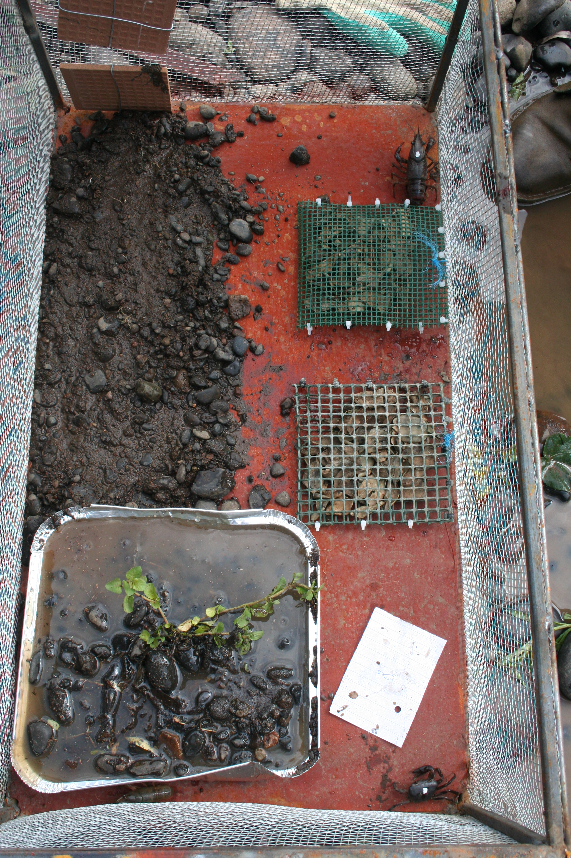
Figure S1. Design of the cage enclosures used in the field experiments.

Table S1. Results of PERMANOVA testing for an effect of survey site and year on the stable isotope signature of putative resources of crabs and crayfish.
Source of variation | df. | SS | MS | Pseudo-F | P
Species | 5 | 222.1 | 44.42 | 2.04 | 0.1
Site | 3 | 55.98 | 18.66 | 1.44 | 0.3
Year | 1 | 0.14 | 0.14 | 0.02 | 0.97
Species*Site | 4 | 50.78 | 12.7 | 3.31 | 0.06
Species*Year | 5 | 54.79 | 10.96 | 2.85 | 0.09
Site*Year | 3 | 11.77 | 3.92 | 1.07 | 0.45
Species*Site*Year | 4 | 15.35 | 3.84 | 1.82 | 0.1
Residual | 42 | 88.63 | 2.11

Table S2. Mean decomposition rates (n = 10), benthic invertebrate densities (n = 5), benthic invertebrate taxon richness (n = 5) and chlorophyll a concentrations on tiles (n = 4) in each treatment across both field experiments.
Treatment | Decomposition (k) | Invertebrate density (number/20cm²) | Invertebrate taxon richness | Chlorophyll a (mg/cm²)
Crayfish only | 0.91 ± 0.11 | 14.33 ± 2.79 | 2.83 ± 0.48 | 0.39 ± 0.05
Crabs only | 0.23 ± 0.03 | 22.20 ± 4.29 | 3.40 ± 0.68 | 0.50 ± 0.11
Both Crayfish and Crabs | 0.56 ± 0.09 | 10.4 ± 1.89 | 2.20 ± 0.20 | 0.37 ± 0.05
Neither Crayfish or Crabs | 0.10 ± 0.01 | 27.33 ± 6.21 | 4.17 ± 0.65 | 0.42 ± 0.10

Table S3. Carbon (CR_{b}) and nitrogen (NR_{b}) ranges of crayfish and crab populations in each experimental enclosure (Field Experiment 2).
Population | CR_{b} | NR_{b}
Crayfish (crabs absent) | 0.70 | 2.24
Crayfish (crabs absent) | 0.16 | 1.11
Crayfish (crabs absent) | 0.83 | 1.65
Crayfish (crabs absent) | 0.71 | 2.14
Crayfish (crabs absent) | 1.06 | 0.71
Crayfish (crabs absent) | 0.54 | 0.83
Crayfish (crabs present) | 0.26 | 0.23
Crayfish (crabs present) | 1.25 | 1.61
Crayfish (crabs present) | 0.11 | 0.83
Crayfish (crabs present) | 0.35 | 1.42
Crayfish (crabs present) | 0.46 | 0.51
Crabs (crayfish absent) | 0.46 | 1.91
Crabs (crayfish absent) | 0.90 | 0.51
Crabs (crayfish absent) | 0.44 | 1.96
Crabs (crayfish absent) | 1.24 | 1.10
Crabs (crayfish absent) | 0.53 | 0.78
Crabs (crayfish present) | 0.63 | 1.15
Crabs (crayfish present) | 0.41 | 0.96
Crabs (crayfish present) | 0.63 | 0.36
Crabs (crayfish present) | 2.38 | 0.28
Crabs (crayfish present) | 0.45 | 0.59

Table S4. Change in crayfish and crab individual body mass in the experimental treatments (mean ± s.e.).
Population | Change in mass (g)
Crayfish (crabs absent) | 1.70 ± 0.35
Crayfish (crabs present) | 0.97 ± 0.43
Crabs (crayfish absent) | 0.55 ± 0.31
Crabs (crayfish present) | 0.08 ± 0.15

Table S5. Crayfish and crab catch per unit effort (CPUE), carbon (CR_{b}) and nitrogen (NR_{b}) range in the field survey.
Site | Year | Crayfish CPUE | Crab CPUE | Crayfish CR_{b} | Crayfish NR_{b} | Crab CR_{b} | Crab NR_{b}
1 | 2008 | 38.0 | 0 | 2.57 | 1.92 | - | -
1 | 2009 | 18.3 | 0 | 2.90 | 0.92 | - | -
1 | 2010 | 2.9 | 0 | 2.62 | 1.78 | - | -
2 | 2008 | 0.3 | 0.1 | 3.44 | 0.75 | 1.15 | 0.90
2 | 2009 | 0.3 | 0.003 | 3.97 | 0.89 | 1.79 | 0.89
2 | 2010 | 2.4 | 0 | 2.53 | 4.45 | - | -
3 | 2008 | 0 | 0.6 | - | - | 2.15 | 1.25
3 | 2009 | 0.5 | 0.5 | 2.33 | 0.72 | 2.04 | 1.77
3 | 2010 | 2.8 | 0.05 | 2.29 | 2.66 | 1.11 | 1.48
4 | 2008 | 0 | 0.4 | - | - | 2.36 | 0.65
4 | 2009 | 0 | 0.3 | - | - | 2.02 | 0.81
4 | 2010 | 0 | 0.5 | - | - | 4.14 | 1.86

