Supporting Information
(R2-1) Supersonic Cold Spraying for Zeolitic Metal-Organic Frameworks Films
Do Yeon Kim,^{1,†} Bhavana N. Joshi,^{1,†} Jong Gun Lee,¹ Jong Hyuk Lee¹, Young Kyu Hwang,^{2,} Jong-San Chang,^{2,3} Salem Al-Deyab,⁴ Jin-Chong Tan,^{5,*} Sam S. Yoon^{1,*}

¹School of Mechanical Engineering, Korea University, Seoul 136-713, Republic of Korea
²Res. Group for Nanocatalysts, Korea Res. Inst. of Chem. Tech., Daejeon 305-600, Republic of Korea
³Dept of Chem., Sungkyunkwan University, Suwon 440-476, Republic of Korea
⁴Petrochem. Research Chair, Dept. of Chem., King Saud Univ., Riyadh 11451, Saudi Arabia
⁵Department of Engineering Science, University of Oxford, Parks Road, Oxford OX1 3PJ, United Kingdom

†Equal contribution

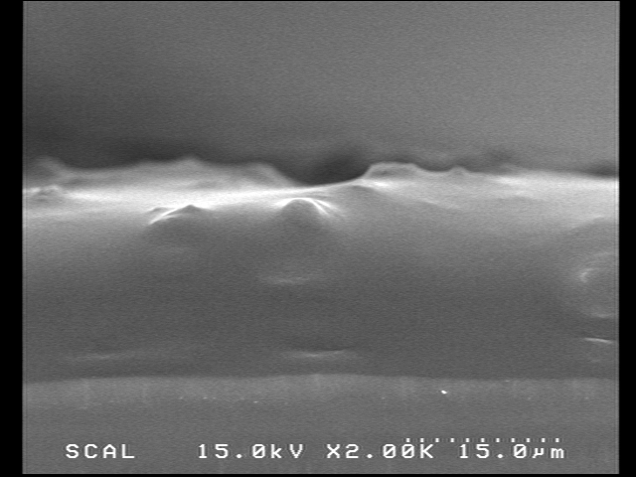
20 µm

Figure S1. The cross-ectional view of the cold sprayed ZIF-8 film at P₀ = 4 bar and T₀ = 250˚C. DMF was included in the ZIF-8 precursor.

Figure S2. XRD pattern of ZIF-8 coated on glass with DMF in solution

