APPENDIX
Appendix 1: details of the search strategy
To identify different types of spin we first searched Medline and the Cochrane methodology register.
In medline advanced searched with the following equation: ("Meta-Analysis as Topic"[Mesh]) AND (bias[MeSH Terms] OR bias[Title/Abstract] OR biased[TIAB] OR misconduct*[TIAB] OR mislead*[TIAB] OR misinterpretat*[TIAB] OR over-interpretat*[TIAB] OR under-interpretat*[TIAB] OR over-estimat*[TIAB] OR under-estimat*[TIAB] OR interpretat*[TIAB] OR influenc*[TIAB] OR distort*[TIAB] OR omission*[TIAB] OR omitted[TIAB] OR discord*[TIAB] OR altered[TIAB] OR altered[TIAB] OR altering[TIAB] OR error*[TIAB] OR erroneous*[TIAB] OR fail[TIAB] OR failure[TIAB] OR flaw*[TIAB] OR inappropriate[TIAB] OR irrelevant[TIAB] OR inadequate[TIAB] OR indue[TIAB] OR incomplete[TIAB] OR (low[TIAB] OR methodogical[TIAB] OR "quality"[TIAB] OR inconsisten*[TIAB] OR discredit*[TIAB]) OR mistake*[TIAB]) th at retrieved 3648 results on October 2011. From these results we filtered with the subset limit “core clinical journal” that retrieved 560 results.
In the Cochrane Methodology Register we did an advanced search with the key word: meta-analysis AND (misconduct OR biased OR mislead) in records title or abstract.
Our inclusion criteria were: 1) commentaries, letters or editorials about misleading or biased or misconduct or misinterpreted meta-analysis 2) all clinical trial about biased interpretation of meta-analysis 3) main articles with recommendation about meta-analysis interpretation. ¹²³⁴⁵⁶⁷
The reference lists in selected of trials and method articles selected.
In a second step, we identified misconduct or misleading process as described in the Cochrane Handbook, part 2: “general methods for Cochrane review”⁸ and in the Methodological standards for conduct of Cochrane Intervention Review version 2⁹.
Then, we developed a primary version of classification scheme of spin in meta-analysis.
We tested our primary version of classification scheme with a sample of meta-analyses published in general medical or specialist journal. This classification scheme was then improve following discussion and agreement among the authors.
We apply a language restriction to English and French.

Appendix 2: details of the Q sorting
Dear “first name” “Family name”,

We are contacting you knowing your expertise in systematic reviews and meta-analysis to invite you to participate in a study on “spin” in abstract.
We are conducting this study in collaboration with the other co-convenors of the Bias Methods Group (Doug Altman, Asbjørn Hrobjartsson, David Moher) and Toby Lasserson from the Cochrane Editorial Unit.
Spin is defined as a specific way of reporting (deliberate or not) to convince the reader that the beneficial effect of the experimental treatment is greater than that shown by the results.
Based on a systematic review, we identified 21 different types of spin that could occur in abstracts of systematic reviews. Our objective is to classify the different types of spin according to their severity (i.e., likelihood of distorting readers’ interpretation).
For this purpose, we are using the Q-sort methodology. In a Q-sort, we ask you to sort the 21 different types of spin. For this purpose, we ask you to 1) place the spin types in order of severity according to your opinion and then 2) sort them relative to each other in terms of severity on a score sheet representing a quasi-normal distribution ranging from -3 (less severe) to +3 (more severe). This is achieved in 4 steps through user-friendly online software. The task should take about 15 minutes of your time. Your answers will be treated confidentially.
Unfortunately the Q-sorting software does not allow you to save and finish later, so the sorting has to be done in one sitting. Furthermore, the online Q-Sort runs with Flash Player and please use the most recent version for your browser.
To complete the survey, please click here, or copy and paste the following link into your browser: http://www.qsort.fr/SPIN_Cochrane/Flashq/

If you have any questions or need technical help, please email me at amelie.yavchitz@cochrane.fr

We very much appreciate your participation in this project and we look forward to your answer.

Yours faithfully,

Dr Amélie YAVCHITZ, Pr Isabelle BOUTRON, Pr Philippe RAVAUD
Centre d’Epidémiologie Clinique
Université Paris Descartes
INSERM U1153
French Cochrane center
Hôpital Hôtel Dieu, Aile A2 1er étage
1, Place du parvis Notre Dame
75181 Paris Cedex 4
E-mail : amelie.yavchitz@cochrane.fr or ayavchitz@gmail.com
Tel : 01 42 34 89 32
Fax : 01 42 34 87 90
If you prefer not to receive future reminders regarding this study, please contact Amélie Yavchitz at amelie.yavchitz@cochrane.fr or ayavchitz@gmail.com

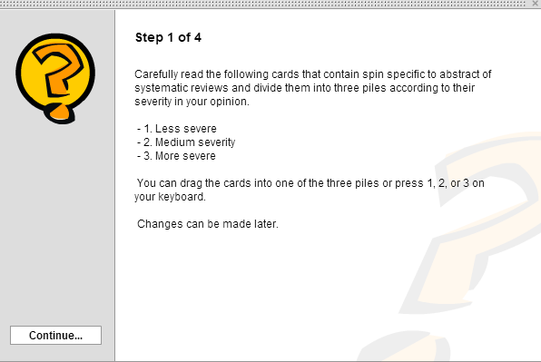

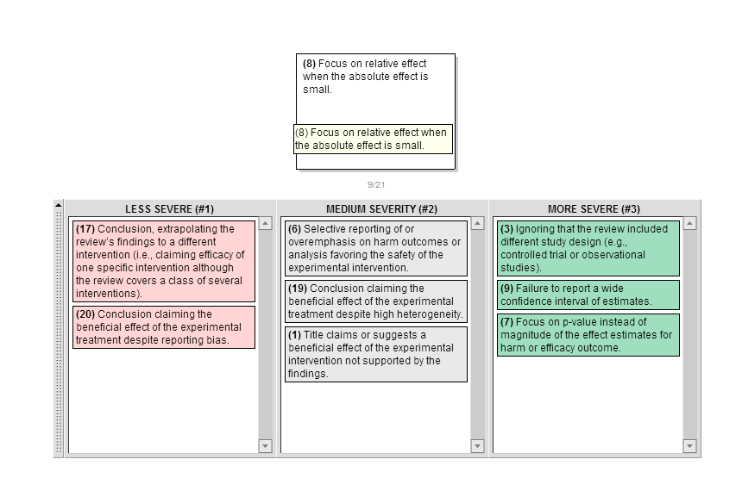
Step 1: Read the cards with the different type of spin and divide the cards into three piles according to their severity

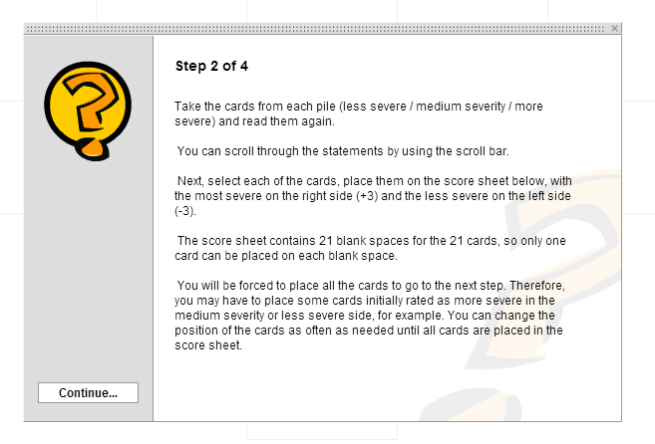

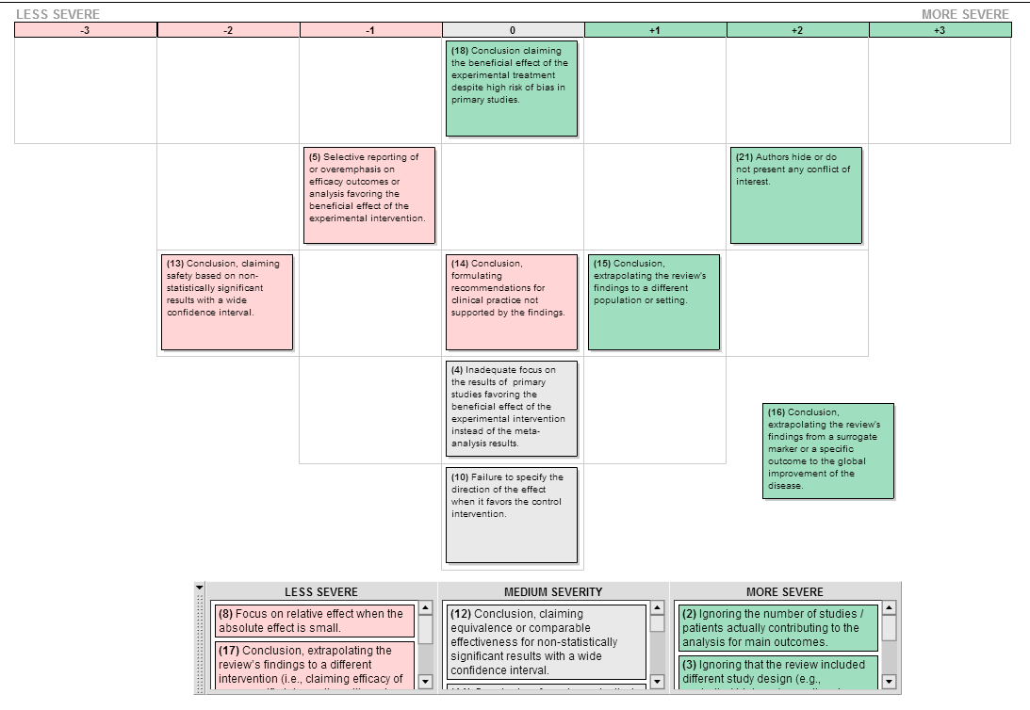
Step 2: take the cards from each pile, read them again and place them on a score sheet representing a normal distribution ranging from -3, less severe, to +3, more severe.

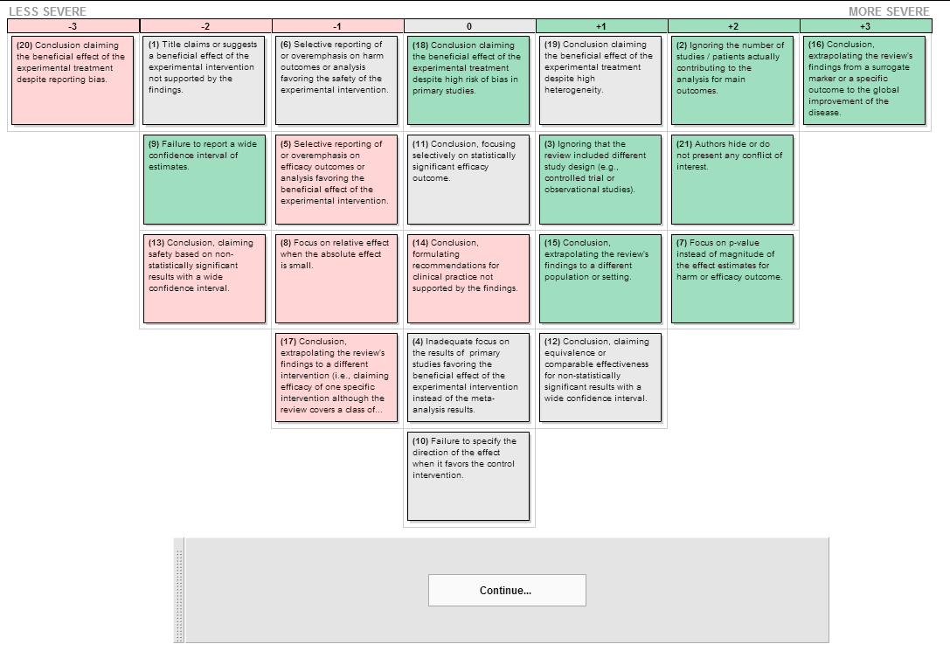

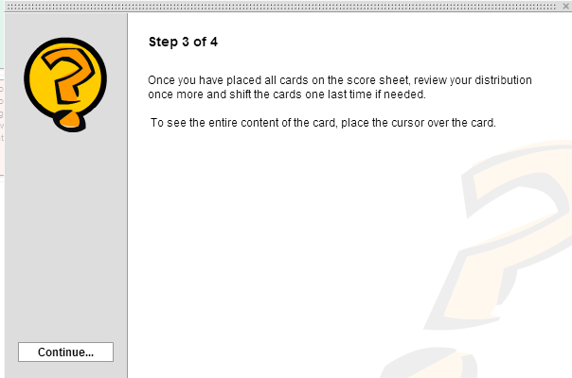

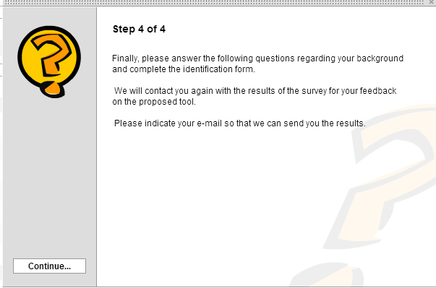

Appendix 3: Distribution of responses of the Q-Sort
Vertical axis: number of participant

