Title: Boosting MAIT cells as immunotherapy: context is everything

Authors: Timothy SC Hinks BMBCh MRCP PhD¹
Affiliation
- Respiratory Medicine Unit and National Institute for Health Research (NIHR) Oxford Biomedical Research Centre (BRC), Nuffield Department of Medicine Experimental Medicine, University of Oxford, OX3 9DU, Oxfordshire, UK

Contact information:
Corresponding author: timothy.hinks@ndm.ox.ac.uk
Funding: Dr Hinks is supported by a Wellcome Trust Career Development Fellowship (211050/Z/18/z).
Conflicts of interest: Dr Hinks declares he has no relevant conflicts of interest.
Word count:1517
References: 10

Introduction

The abundance of mucosal associated invariant T (MAIT) cells, their strong evolutionary conservation and innate-like effector functions have made them a focus of much research attention over the past decade. However, this biology has yet to see clinical translation. Sakai et al¹ present exciting murine data showing a differential effect of enhancing MAIT cells at different stages of infection with Mycobacterium tuberculosis (M.tb), with a tantalising suggestion of how MAIT cells could be modulated therapeutically.

Unanswered questions in MAIT biology
MAIT cells are innate-like lymphocytes which express a semi-invariant T-cell receptor allowing them to recognise small molecule derivatives of the riboflavin biosynthetic pathway, which is widely expressed in bacteria, mycobacteria and yeasts². They are particularly characterised by evolutionary conservation in a wide range of species spanning 150 million years of mammalian evolution, by the capacity for rapid pro-inflammatory and cytotoxic effector functions, and by an abundance in tissues. This includes the lung where they typically comprise 1-4% of T cells in humans³, whilst in C57BL/6 mice they are more abundant in the lungs than any other organ.
What are MAIT cells there for? The first role identified has been detection of bacteria and mycobacteria, particularly intracellular pathogens, including Salmonella Typhimurium⁴, and the atypical lung pathogens Francisella tularensis and Legionella species against which they have been shown to enhance immune protection^{5,6}. However two other roles have since been discovered, each linked to the activation of distinct transcriptional programmes. One is a contribution to defence against viruses including influenza A, mediated in a TCR-independent manner by cytokines such as interleukin (IL)-12, -15, -18⁷. Most recently a third transcriptional programme has been described with the capability to promote tissue repair^{8,9}. This programme is triggered by TCR stimulation, likely from ligands derived from commensal microbes presented on major histocompatibility complex, class I-related protein (MR1), and suggests MAIT cells are capable of a responding with a wide range of different functions according to differing specific inflammatory contexts.
Three central questions remain, as yet, unanswered: i) what is the main evolutionary driver which has maintained the MR1-MAIT cell axis, ii) what are their most important immune functions, and iii) how can their biology be harnessed for therapeutic benefit? Several obstacles have hindered finding answers to the first two questions. Perhaps as a result of their ancient evolutionary origins, and the shared capability of other innate-like cells to express the same transcriptional programmes, MAIT cell functions are often masked by multiple layers of immunological redundancy, making it hard to tease apart their unique contributions. Furthermore, although MAIT cell deficiency has been described clinically as part of broader primary immune deficiencies, individuals with selective MR1-MAIT cell dysfunction have not been described. For these reasons it has been hard to identify major human pathogens for which MAIT cells play a key, non-redundant role.
M. tuberculosis is an attractive candidate. Pathogenic mycobacteria are an evolutionarily ancient foe, having co-evolved with mammals over millions of years, and affecting a wide range of species. A selection pressure persists as invasive disease remains widespread today. Nearly 2 billion people may be latently-infected with M.tb, maintaining a state of chronic infection which depends on effective control by multiple components of innate and adaptive immunity. M.tb expresses the relevant components of the riboflavin pathway, and without prior infectious exposure M.tb-reactive MAIT cells capable of cytokine production are found in cord blood. M.tb infected lung epithelial cells can activate MAIT, and human MR1 polymorphisms are associated with susceptibility to M.tb. Even so, a clear role for MAIT cells has not previously been shown in experimental M.tb infection.

MAIT cell ‘boosting’ as host-directed therapy
The study by Sakai et al describes the kinetics and consequences of MAIT cell dynamics in a chronic murine aerosolised M.tb infection¹. Although MAIT cells outnumber conventional antigen-specific αβ T cells for the first 4 weeks of infection, M.tb did not induce a strong expansion in MAIT cell frequencies. Indeed MR1^{-/-} mice, which lack MAIT cells, were not susceptible to a higher pulmonary bacterial load during acute or chronic infection. Instead, paradoxically, during the earliest phase of infection MAIT cell activity actually slowed the development of an adaptive immune response as they reduced the bacillary load reaching the draining lymph node.
A fascinating property of MAIT cells is that, despite low background frequencies of MAIT cells in specific pathogen-free mice, a massive expansion of MAIT cell numbers – up to 100 fold within 7 days – can be induced easily by intranasal administration of a pure synthetic MR1 ligand such as 5-(2-oxopropylideneamino)-6-D-ribitylaminouracil (5-OP-RU) in conjunction with certain Toll-like receptor (TLR) agonists[REFS]. The selectivity and simplicity of this approach is clearly appealing for those wanting to translate basic MAIT cell biology into new therapies.
In this case such ‘boosting’ of MAIT cell frequencies during acute infection reduced bacterial load in the draining lymph nodes by TGFβ-mediated inhibition of the migration of infected CCR2⁺Ly6C⁺ monocytes, with a consequent reduction in expansion of conventional M.tb-specific αβ CD4+ T cells. However, somewhat surprisingly, in the different context of chronic infection the effect of MAIT cell boosting was markedly different. When MAIT cell boosting occurred 5 months after initial infection it induced a 30-fold increase in pulmonary MAIT cells, particularly of interferon-γ producing MAIT1 cells, which was associated with a 1 log reduction in pulmonary mycobacterial load. Cytokine blocking experiments suggested this was mediated by IL-17.
This result is intriguing, although there are some limitations to the generalisability of the findings. The mouse is not an ideal model as during chronic infection there is not full formation of the granulomas which characterise human tuberculosis, so further confirmation in rabbits or preferably in non-human primates will be essential. The antibody blocking experiments are also limited by the widespread expression of TGFβ and IL-17 by other cell types. The findings are unlikely to simply translate to other chronic intracellular infections: for instance enhanced protection has been shown with MAIT cell boosting prior to acute infection with Legionella⁶, and in that instance it was IFN-γ rather than IL-17 which mediated the key effects. Importantly the phenotype of MAIT cells changes markedly from the context of an acute infection when they closely resemble invariant natural killer T cells, to the resolution stage of infection when they phenotypically resemble γδ T cells⁸. Therefore in such a complex system as chronic tuberculosis infection, where a single host cell type may have different effects at different stages of infection, and potentially at different doses of bacteria, it is hard to predict how the relative balance between beneficial and detrimental effects of MAIT cells may play out in natural human disease. In this balancing act, context may be everything.

Hopes for clinical translation
How might these findings lead to clinical translation (Figure 1)? New vaccines and therapeutics are urgently needed for M.tb. MAIT cell’s abundancy and the invariant nature of their TCR imply that synthetic MAIT cell ligands might act as effective, and non-toxic components of biological adjuvants for novel B cell or T cell vaccines. Whilst this should certainly be explored in other infectious diseases, the inhibition of initial T cell priming observed by Sakai et al raise doubts about this approach, particularly for M.tb.
The current lack of a prophylactic vaccine for tuberculosis and the emergence of multidrug resistance mean that there is also a need for therapeutic vaccines against M.tb. The simplicity of a MAIT cell approach is attractive, either as a monotherapy or as a component or a more complex traditional vaccine. To do this delivery methods would need to be tailored for humans such as development of pressurised inhalers or nebulisers. A significant challenge would be the low stability of 5-OP-RU which is a transient molecule unless stabilised by MR1. This could be overcome by synthesis of more stable related synthetic compounds. Alternatively MAIT cell ligands could be synthesised in vivo, for instance in the form of M.bovis Bacillus Calmette-Guérin (BCG) engineered to over-express the riboflavin pathway. Already rBCG vaccines have been in development, although MAIT cells could equally be stimulated by inhalation of a short-lived, non-pathogenic bacterium, as has been demonstrated with the S.Typhimurium model in mice⁴.
Riboflavin-synthesising commensal microbes might also be of use therapeutically for triggering the MAIT cell tissue repair programme to accelerate wound healing. For instance healing can be slow in chronic skin wounds such as burns, pressure sores or leg ulcers. Traditionally bacteria are decolonised with topical or systemic antibacterials, but this might not be the most rational approach. It might well be preferable to stimulate wound healing by topical application of commensals with low pathogenicity which could boost MAIT cells locally and potentially stimulate other aspects of non-classical MHC restricted mucosal immunity, as has been observed with N-formyl methionine-containing (fMet) peptides¹⁰.
Making the step from basic science to clinical translation is challenging and requires carefully constructed clinical trials based on solid experimental in vivo data. We’re not yet there with MAIT cell-specific host-directed therapies, and there is much work still to do. Nonetheless the field of MAIT cell biology has already come a long way in two decades and studies such as these suggest a line-of sight to future therapies on the horizon.

References

1. Sakai, S., et al. MAIT cell-directed therapy of Mycobacterium tuberculosis infection. Mucosal immunology In press(2020).
2. Kjer-Nielsen, L., et al. MR1 presents microbial vitamin B metabolites to MAIT cells. Nature 491, 717-723 (2012).
3. Hinks, T.S., et al. Innate and adaptive T cells in asthmatic patients: Relationship to severity and disease mechanisms. J Allergy Clin Immunol 136, 323-333 (2015).
4. Chen, Z., et al. Mucosal-associated invariant T-cell activation and accumulation after in vivo infection depends on microbial riboflavin synthesis and co-stimulatory signals. Mucosal immunology 10, 58-68 (2017).
5. Meierovics, A., Yankelevich, W.J. & Cowley, S.C. MAIT cells are critical for optimal mucosal immune responses during in vivo pulmonary bacterial infection. Proc Natl Acad Sci U S A 110, E3119-3128 (2013).
6. Wang, H., et al. MAIT cells protect against pulmonary Legionella longbeachae infection. Nature communications 9, 3350 (2018).
7. van Wilgenburg, B., et al. MAIT cells contribute to protection against lethal influenza infection in vivo. Nature communications 9(2018).
8. Hinks, T.S.C., et al. Activation and In Vivo Evolution of the MAIT Cell Transcriptome in Mice and Humans Reveals Tissue Repair Functionality. Cell Rep 28, 3249-3262 e3245 (2019).
9. Leng, T., et al. TCR and Inflammatory Signals Tune Human MAIT Cells to Exert Specific Tissue Repair and Effector Functions. Cell Rep 28, 3077-3091 e3075 (2019).
10. Linehan, J.L., et al. Non-classical Immunity Controls Microbiota Impact on Skin Immunity and Tissue Repair. Cell 172, 784-796 e718 (2018).

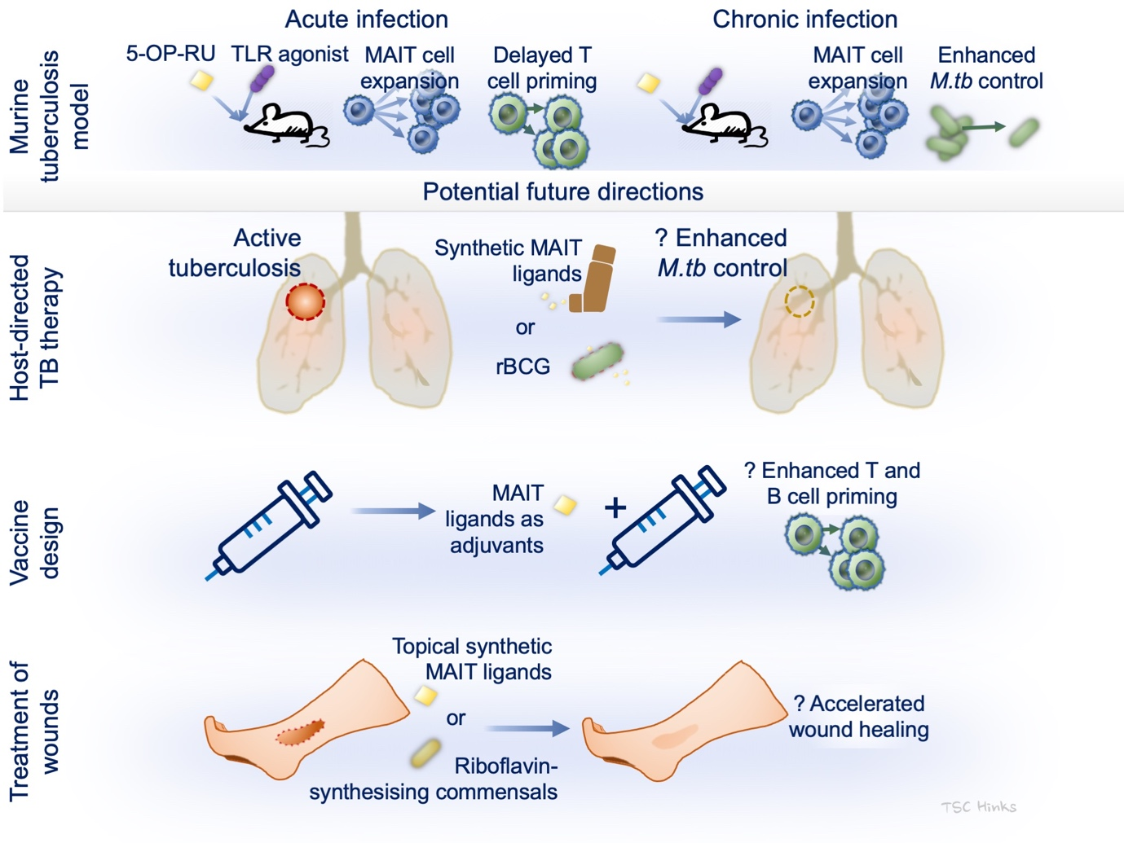Figure 1 Graphical summary and potential future clinical translation of MAIT cell biology.
5-OP-RU, 5-(2-oxopropylideneamino)-6-D-ribitylaminouracil; MAIT cell, mucosal associated invariant T cell; rBCG, recombinant M.bovis Bacillus Calmette-Guérin; TLR, Toll-like receptor.

