Islamic Calligraphy and its Spread in Asia

By Alain George

In cities in the Islamic world, calligraphy is woven into the fabric of everyday life. From Rabat to Karachi, it can be seen at every corner, on mosques, in shops, on street walls, but also on newspapers, websites, and in countless other forms. If the Muslim call to prayer, uttered five times a day from every mosque, is a unifying feature of soundscape across these regions, then the same can be said about the visual impact of calligraphy, in its various shades and textures, on their streetscape. This essay will sketch out, in brief outline, the emergence of this art form, its key principles, and some major stylistic developments in Asia.

The Emergence and Codification of Islamic Calligraphy
To seek the origins of Islamic calligraphy is to seek the roots of Islam. The monotheist religion proclaimed by the Prophet Muhammad (d. 632) in Arabia, at the very western end of Asia, initially arose from a culture of orality. Poetry was the primary art form of the pre-Islamic Arabs. It expressed the genius of language, of words arranged in a strictly codified manner to evoke a multiplicity of images, with a profound effect on the listener. In a population that was mostly nomadic, its verses were carried “in the breasts of men,” as the Arabic language has it, without the burden of objects.
The Qur’an was perceived by the first Muslims as surpassing every previous linguistic achievement; and like poetry, it was initially committed to human memory. But with the passing of the Prophet, then of his Companions, came the risk of losing parts of the sacred text, and of seeing conflicting variants enter into circulation. It is at this point that a canonical text of the Qur’an, the so-called “Uthmanic recension,” is said to have been issued; and it is here that the history of Arabic calligraphy begins.
The earliest extant manuscripts of the Qur’an, which are also the oldest known Arabic books, are datable to the ensuing period, around the second half of the 7th century. They were written on large parchment leaves, but their script remained akin to individual handwriting, with its natural flaws and irregularities. While accurate, it could not fully match the majesty of the age-old scribal traditions of Christians and others religious groups of western Asia – what we call the Middle East today.

By the 690s, the empire of Islam had spectacularly expanded to the regions between North Africa and Iran, and successful military campaigns were soon launched into the northwestern corner of India, Central Asia and Spain. It is during these crucial decades of the late 7th to early 8th centuries, less than a century after the death of the Prophet, that the caliphs of the Umayyad dynasty (661-750) built the first great monuments of Islam, widely recognized as masterpieces of world architecture: the Dome of the Rock (692 AD), built on Temple Mount in Jerusalem; and the Great Mosque of Damascus (completed in 715 AD), set within the colossal walls of a Roman temple of Jupiter. Through these realizations, Muslims were asserting their symbolical appropriation of lands steeped in centuries of civilization. As part of the same process, Arabic calligraphy was deployed in the public sphere, from the large scale of inscriptions to the minute one of coins, thereby proclaiming in visual terms the identity of the new faith to a world hitherto dotted with Christian crosses and icons.

Before becoming an iconic Word, however, calligraphy had to undergo a seminal reform that made geometry (for letter forms) and proportion (for the relationships between these forms) its cornerstones. These principles devised at the turn of the 8th century found a natural resonance in the Qur’an and its praise of the harmony of God’s Creation, but also in classical antiquity. One work by Plato is particularly significant in this respect: Timaeus, his allegorical account of how the world came to be. In this work, which would later be translated into Arabic, Plato asserts that the Demiurge, the Creator, used geometry and proportion as the founding principles of the physical world, from the microcosmic level of atoms to the macrocosmic level of the planets. In Plato’s perspective, proportion was not a mere synonym for “harmony,” but a scientific concept based on quantifiable musical intervals. The notion was ultimately derived from the striking observation, made in earlier generations and confirmed by modern physics, that musical consonance is underlied by simple numerical ratios.

These concepts had a profound influence on Mediterranean civilization. Proportion was notably a key principle of Graeco-Roman, Byzantine and Islamic architectural design. But early Muslims were the first to systematically transpose them to script and page layout. To this day, geometry and proportion remain the theoretical cornerstones of Arabic calligraphy, although the practicalities of their application have changed. The title Music for the Eyes, chosen by a contemporary American calligrapher, Mohamed Zakariya, for a recent exhibition pamphlet (Los Angeles County Museum of Art, 1998), may well have been met with the approval of Qur’anic scribes at Baghdad a millennium ago.

Leaf from a Qur'an manuscript in “Kufic” script, 9th century, probably Iraq, Iran or Syria. Parchment and ink. Object No: 2988/1

Once its founding principles had been established under the Umayyad dynasty, Arabic calligraphy went on to flourish for some three centuries into a wide range of angular styles known collectively as “Kufic.” Then, between the 10th and 13th centuries, it underwent a radical transformation: the highly formalized Kufic styles, which had been reserved for the copy of the Qur’an, were merged with cursive tendencies derived from the chancery and from ordinary handwriting. Geometrical codifications were still applied, but with more flexibility. During this period, as a result of a gradual process of conversion, Muslims were also coming to form the majority of the population in societies from Iran to Spain. In that context, the new cursive scripts had the added advantage of being more easily legible without specialized training.

Two names were associated, in Islamic tradition, with the onset of these trends: Ibn Muqla (d. 940), a prominent official in Baghdad at the court of the Abbasid caliphs, the most potent Islamic dynasty of its time (750-1258); and in the next generation, Ibn al-Bawwab (d. 1022 or 1031), who worked at the court of the Buyid sultans, between Baghdad and Shiraz. The actual role of both figures is debated by modern scholars, but it is remarkable that already in their own period, calligraphy was becoming the subject of art-historical writing and collecting, centuries before painting or any other arts. Like their counterparts in the European renaissance, Islamic writers on the subject tended to emphasize the role of the individual genius as the catalyst of major artistic leaps forward, whereas modern studies tend to reveal more incremental processes.

The Six Pens and the Age of Yaqut
By the end of the 13th century, after some three hundred years of experimentation, the six classical styles that remain predominant to this day had been formed: naskh, thuluth, rayhani, muhaqqaq, riqa’ and tawqi’. To these, the Iranian world added in the late 14th century a seventh style: nasta’liq. Each of these styles obeyed strict letter codifications measured by rhomboid dots reflecting the thickness of the pen nib. These rules were not ossified, and they continued to be refined and transformed by subsequent generations. Today, the most widespread styles in the Arab world are naskh and thuluth, which follow definitions reached by Ottoman calligraphers at Istanbul in the 16th and 17th centuries. Further east, nasta’liq is predominantly used to write Persian and Urdu; its most revered masters were active in the 15th and 16th centuries, notably at Tabriz (Iran), Herat (Afghanistan) and Bukhara (Uzbekistan).

The establishment of the Six Pens, as the above styles came to be known, was ascribed by Arabic and Persian writers to a single figure: Yaqut al-Musta’simi. Yaqut is reputed to have brought them to perfection by establishing a canon of forms and proportions, as well as modulations of thick and thin strokes. His realizations were regarded as a source of emulation by later calligraphers, many of whom also traced their living artistic heritage to him through chains of master-pupil transmissions. Dozens of manuscripts ascribed to Yaqut exist in collections worldwide today; but most are forgeries, or copies made out of reverence for the master. The nature of his actual accomplishments thus remains, at present, something of an enigma.

Yaqut had begun his career at the service of the last Abbasid caliph, al-Mu’tasim, to whose patronage he owed his last name, al-Musta’simi. In 1258, al-Mu’tasim was killed at the hands of the Mongol conquerors of the eastern Islamic world, thereby bringing half a millennium of Abbasid rule to an end. Yaqut continued to practice his art under a new empire that nominally stretched from Baghdad, where he resided, to Beijing. Muslims were widely employed in the Mongol administration of China, and the oldest remaining Chinese mosques and inscriptions date to this period, which also saw the development of Islamic calligraphy in China.

The Spread of Islamic Calligraphy across Asia
This eastward movement was, however, not an entirely new phenomenon, as Islamic calligraphy had already been spreading for centuries beyond the core historical regions of the Islamic world, between the Nile and Oxus rivers. The textual and archaeological record shows that organized Muslim merchant communities began to emerge in East Africa, western India, Southeast Asia and southern China in the first two centuries of Islam, long before the year 1000. It is likely that calligraphy travelled along with them, although early remains of this diffusion are rare. The trends that eventually came to predominate in these regions marked a break from the highly codified scripts of the central Islamic lands.

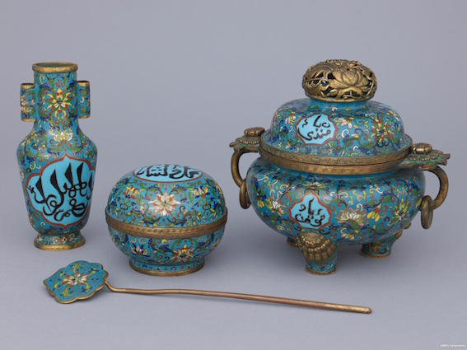
Incense set, 1800-1900, China, brass metal and enamel, with inscriptions in Sini script. Object nos: 2988/5, 2988/4 a-b, 2988/3 a-b and 2988/6

Chinese Qur’ans were copied, since at least the 15th century, in a script best described as Chinese muhaqqaq, because it bears features of classical muhaqqaq, one of the Six Pens, but is less polished in form and more expansive in articulation. While Chinese muhaqqaq was written with a reed pen, the normal instrument for Islamic calligraphy, Chinese Muslim calligraphers also developed a monumental style written with the brush. This style, called sini (the Arabic word for “Chinese”) in modern times, looks winding and twisted by the standards of classical Islamic calligraphy, but is also less effusive than Chinese calligraphy, which makes it a true cultural hybrid. It was traditionally written for display pieces in mosques, on large paper sheets, painted wooden panels, or on ceramics, and remains practiced to this day.

In the Indian Subcontinent, a distinctive style of Islamic calligraphy had emerged by the 14th century: Bihari. This style has a distinctive boldness reflecting its angularity and strong contrasts between thick and thin strokes. It is based on less precise letter definitions than the Six Pens, but this also gave its practitioners more freedom of expression, often with a palpable sense of playfulness. Bihari remained a living tradition for half a millennium, until the 19th century. But from the 16th century onwards, under the Mughal empire, classical styles were increasingly adopted, as calligraphy in India converged with mainstream developments in Iran. Such was the circulation of craftsmen and styles that it can be difficult to distinguish a manuscript produced in either country during the early modern period.

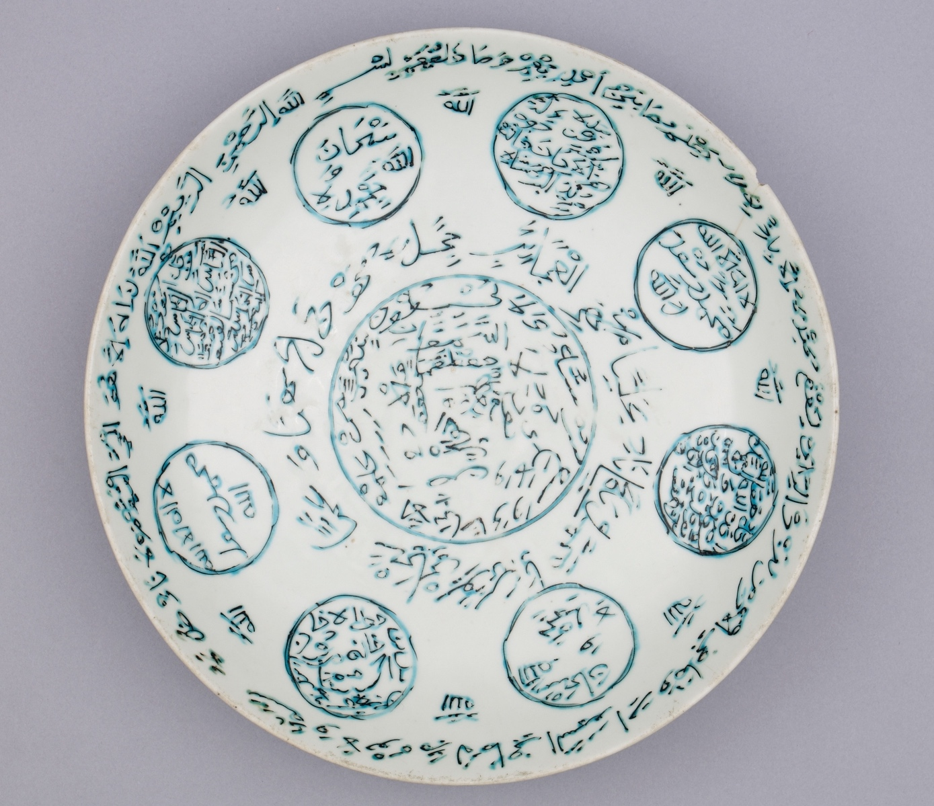
Dish, 1600–1700, Zhangzhou, Fujian, China and Indonesia, clay, glaze, paint, 8.0 cm x 35.5 cm. Object no: 2988/2

Maritime Southeast Asia, known in Malay as Nusantara, is the coastal region between Thailand, the Malay Peninsula, Indonesia and the southern Philippines. Here, Islamic calligraphy was typically written in forms derived from naskh, the most common bookhand in the central Islamic lands, with more or less marked departures from established norms. The earliest preserved Islamic manuscripts from these regions date to the 17th century, even though the tradition they represent must have started earlier. The Arabic alphabet was also used to write local languages, as in many other pre-modern societies across the Old World, notably in Sub-Saharan Africa.

Just as in early modern times, calligraphy was evolving into myriad forms in South and East Asia, it reached peaks of refinement and creativity in the central Islamic lands, particularly at Istanbul, the capital of the Ottoman empire; but also in such centers as Isfahan and Shiraz in Iran, or Lahore, Delhi and Golconda in India. Traditional styles, such as naskh, were refined, and the illumination reached fresh expressions in every period. New forms also evolved, and one generalized trend was the development of large display pieces in monumental script. These could be composed as words set in an invisible geometrical frame; or, for instance, as mirror writing, whereby a word or phrase is replicated symmetrically across a vertical axis. There was also a shared interest, across the early modern empires of Islam, in pictorial calligraphy, in which the contours of letters and words form an image, for example of a lion, a pear, or a man in prayer.

Calligraphy in Modern and Contemporary Times
Standing in any part of the Islamic world in the 19th century, an observer would have seen calligraphy as a vibrant, revered and apparently immovable tradition. But its transmission and renewal were challenged by the growing cultural hegemony of European modernity. The traditional modes of learning with which it was associated were gradually eroded by modern science, just as Arabic printed books, which had existed since the 16th century, were becoming so widespread as to encroach on the prerogatives of scribes. Then, towards the early 20th century, the Arabic script was replaced, in many countries, by European alphabets: Latin in Sub-Saharan Africa, Southeast Asia, and the Republic of Turkey; and Cyrillic in Soviet Central Asia. This combination of factors led to a decrease in its teaching at school level, a decline of its status, and a loss of institutional support for training at higher levels.

Even though calligraphy receded in this period, it was perpetuated in different local contexts. Its recent history in Istanbul encapsulates many of these trials. In the 1920s, the city went from being arguably the foremost center for calligraphy in the world to one in which its most renowned practitioners had to work with little recognition, mostly in the private sphere. By the second half of the 20th century, as a renewed interest in their art began to surface, these Ottoman masters were still alive, and available to pass on their skills to the next generation. The last of them died in the 1980s, and today Istanbul is a thriving center that perpetuates skills and a tradition with living roots in the Ottoman era. In the present age of globalization, it attracts students from the four corners of the world, from Morocco to Pakistan, but also from the United States to Japan, to receive advanced training in classical calligraphy.

It takes several years of full-time study to master one of the Six Pens, a process is still sanctioned today by the award of a traditional “license” (Ar. ijaza) at Istanbul. The pupil begins by learning single letters, each with its particular articulation of forms, set of proportions, and variations of stroke width, based on exemplars set by a master (these are commonly available as printed booklets today, although original works were used historically). The pupil then moves on to combinations of letters and eventually to whole words. At every step, his or her practice sheets are corrected by the teacher. Once fully trained, the student prepares a formal composition, usually in a set rectangular format. If approved, it is endorsed in writing by one or several masters and retained as a diploma (ijaza) which confers formal permission to sign one’s work in this style.

In addition to traditional expressions, the late 20th and early 21st centuries have witnessed a burgeoning of creation merging calligraphy with contemporary art. This phenomenon with origins in 20th-century Arab modernist painting and Iranian art movements encompasses such diverse forms as canvas painting, compositions on paper, photography, installation art and sculpture. Islamic calligraphy also remains as ubiquitous as ever in everyday life. Graphic designers and typographers have brought it into their work with increasing sophistication, while more traditional commercial workshops continue to produce street banners, shop signs, film posters, and truck decorations, amongst other outputs. In the last decades, graffiti artists like eL Seed, Yazan Halwani and Shamsia Hassani have also embraced calligraphy with exuberant vitality in such cities as Tunis, Cairo, Beirut, Kabul and Tehran.

Thus, just as the modern art form finds an enthusiastic response in a globalized art market, the core roots represented by its traditional forms are enjoying some measure of renewal. In the same societies, from Morocco through Egypt to Pakistan, different people thus produce or appreciate calligraphy in a wide variety of ways, and for different reasons: pious and spiritual, notably amongst traditional calligraphers, but also some artists working with modern forms; as a revitalization of cultural values challenged and often sidelined in the past century, particularly in street art and graphic design; as an identity marker that singles out work from the Middle East and Islamic world in the contemporary art market; and so on. The borders between these broad categories are naturally porous.

Persian calligraphy, before 2002, Iran, ink on paper, 23.2 cm x 14.8 cm; 27.6 cm x 17.0 cm. Object no. 2645/3

From Ancient Roots to the 21st Century
As has become apparent, the roots of Islamic civilization plunge into late antique Arabia, the Graeco-Roman world, and also Iran. Islamic calligraphy reflects this heritage, being a rationalized art form executed in slow, controlled motions. It presents a fundamental contrast, in this respect, to the flow of energy channelled through the brush in Chinese and Japanese calligraphy. But the hand movements of an Islamic calligrapher are also meditative, and these boundaries sometimes become blurred, as with the ample but relatively restrained curves of sini script in China, or with the most free-flowing expression of Persian calligraphy, called shikasta nasta’liq. The connections between calligraphy and Islamic spirituality, particularly Sufism, run deep, but they have mostly conveyed through oral teachings. A few treatises that express this dimension of the art exist, notably the Adab al-Mashq (“Manners of Practice”) by Baba Shah, a calligrapher active at Isfahan in the late 16th century.

For over a millennium, Islamic calligraphy has retained a unique status in the diverse cultures of the Islamic world because of its innate association with the Qur’an and of its inherent plastic qualities. These were appreciated even in medieval and renaissance Europe, where motifs inspired by Kufic calligraphy frequently found their way into decorative arts. Today, its deceptively simple elegance continues to garner a universal appeal. Only time will tell where the current burgeoning of new and old forms will lead its evolution into the next century.

Further reading
Blair, Sheila. 2006. Islamic Calligraphy. Edinburgh: Edinburgh University Press.
Brac de La Perrière, Éloïse. 2016. “Manuscripts in Bihari Calligraphy: Preliminary Remarks on a Little-Known Corpus.” Muqarnas 33 (forthcoming).
Derman, Ugur. 1998. Letters in Gold. Ottoman Calligraphy from the Sakip Sabanci Collection, Istanbul. New York.
Ernst, Carl W. 1992. “The Spirit of Islamic Calligraphy: Bābā Shāh Iṣfahānī’s Ādāb Al-Mashq.” Journal of the American Oriental Society 112 (2): 279–86.
Ettinghausen, Richard. 1984. “Kufesque in Byzantine Greece, the Latin West and the Muslim World.” In Islamic Art and Archeology: Collected Papers. Berlin.
Gallop, Annabel Teh. 2005. “Islamic Manuscript Art of Southeast Asia.” In Crescent Moon: Islamic Art & Civilisation in Southeast Asia = Bulan Sabit: Seni Dan Peradaban Islam Di Asia Tenggara, edited by James Bennett, 158–83. Adelaide: Art Gallery of South Australia.
George, Alain. 2010. The Rise of Islamic Calligraphy. London: Saqi.
Moustafa, Ahmed, and Stefan Sperl. 2014. The Cosmic Script: Sacred Geometry and the Science of Arabic Penmanship. London: Thames & Hudson.
Safwat, Nabil. 1996. The Art of the Pen. Calligraphy of the 14th to 20th Centuries. London: Nour Foundation.
Schimmel, Annemarie. 1990. Calligraphy and Islamic Culture. London: I.B. Tauris & Co Ltd.
Zakariya, Mohamed. 1998. Music for the Eyes: An Introduction to Islamic and Ottoman Calligraphy. Los Angeles: Los Angeles County Museum of Art.

