Supplementary material

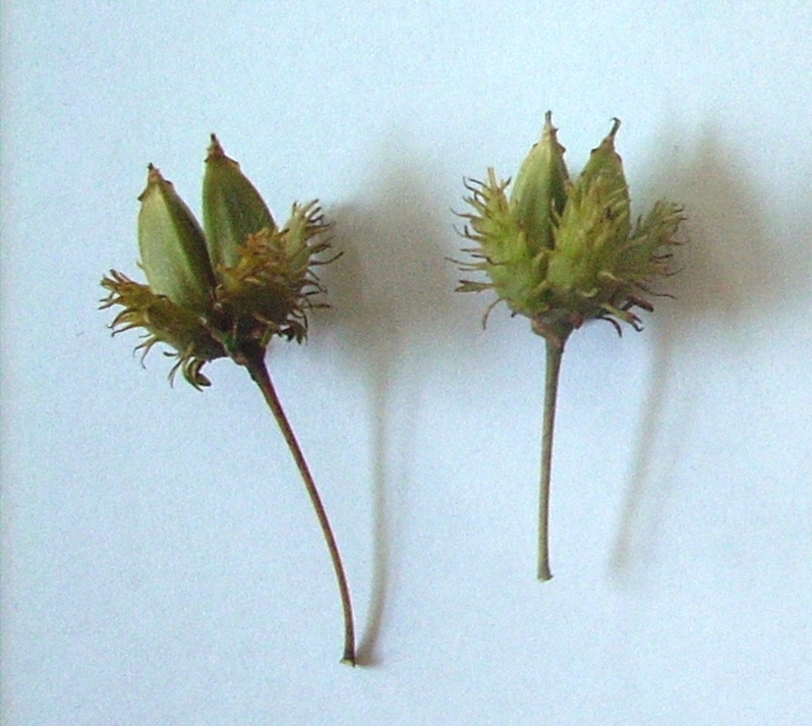
Fig. A.1. Fruits of the Chinese beech (Fagus engleriana).

Provisioning station (1200)
450+400+350

Removal (154)
85+39+30
Survival (3)
1+1+1
Eaten in situ (1043)
364+360+319

Primary caches (27)
15+10+2
Missing (31)
13+12+6
Eaten elsewhere (96)
57+17+22

Removal (8)
3+4+1
Survival (6)
4+2+0
Eaten in situ (13)
8+4+1

Secondary caches (2)
1+1+0
Missing (2)
1+1+0
Eaten elsewhere (4)
1+2+1

Eaten in situ (1)
0+1+0
Survival (1)
1+0+0

Fig. A.2. Seed fate for the Chinese beech (Fagus engleriana) as a function of distances to road of 10 m (red), 100 m (purple) and 200 m (blue), respectively. Rectangles represent dispersal processes, and numbers within the parentheses within rectangles represent the total numbers of seeds that reached a given process.

