Supplementary materials

Copper concentration in multiple sclerosis: a systematic review and meta-analysis

Mohammad Sarmadi, Zeinab Bidel, Fereshteh Najafi, Rema Remakrishnan, Farshad Teymoori, Hassan Azhdari Zarmehri, Milad Nazarzadeh

Contents
Supplementary materials 1
Supplementary Table S1. Risk of bias for nonrandomized studies based on Newcastle–Ottawa Quality assessment scale 2
Supplementary Figure S1. Funnel plot for visual inspection of publication bias. 4

Supplementary Table S1. Risk of bias for nonrandomized studies based on Newcastle–Ottawa Quality assessment scale
First author | Selection |  |  |  | Comparability |  | Exposure |  |  | Total Score
First author | 1 | 2 | 3 | 4 | 1 | 2 | 1 | 2 | 3 | Total Score
Masoud SA | A* | B | A* | A* | A* | B* | A* | A* | B | 7
Harbige LS | B | B | C | B | A* | B* | A* | A* | B | 4
Socha K | A* | A* | A* | A* | A* | B* | A* | A* | B | 8
Giacoppo S | A* | B | A* | A* | A* | B* | A* | A* | B | 7
Ghazavi A | A* | B | A* | A* | A* | B* | A* | A* | B | 7
Ghoreishi A | A* | B | C | B | A* | B | A | A* | B | 3
Melo TM | A* | B | C | A* | A* | B* | A* | A* | B | 6
Forte G | A* | B | A* | A* | A* | B* | A* | A* | B | 7
Wikstrom J | B | B | A* | A | A* | B* | A* | A* | B | 5
Ristori G | A* | B | A* | A* | A* | B* | A* | A* | B | 7
Plum CM | B | B | C | B | A* | - | A* | A* | B | 3
Gellein K | A* | A* | A* | A* | A* | B* | A* | A* | B | 8
Rieder HP | A* | A* | A* | A* | A* | - | A* | A* | B | 7
Palm R | A* | B | A* | A* | A* | B* | A* | A* | B | 7
Kapaki E | A* | B | C | A* | A* | B* | A* | A* | B | 6
Smith DK | A* | B | A* | A* | A* | B* | A* | A* | B | 7
Iranmanesh M | B | B | A* | A* | A* | B* | A* | A* | B | 6
Janghorbani M | A* | B | B | A* | A | B | C | A* | B | 3
De Riccardis L | A* | A* | A* | A* | A* | B* | A* | A* | B | 8
Siotto M | A* | A* | A* | A* | A* | B* | A* | A* | B | 8
A, B, and C are the options of each question based on the Newcastle-Ottawa Scale (NOS). Please see below image for details.

Details of the Newcastle-Ottawa Scale (NOS) checklist for assessing the quality of nonrandomized studies in meta-analyses presented in the below image (Wells et al., 2000). The image derived from the NOS website at http://www.ohri.ca/programs/clinical_epidemiology/oxford.asp

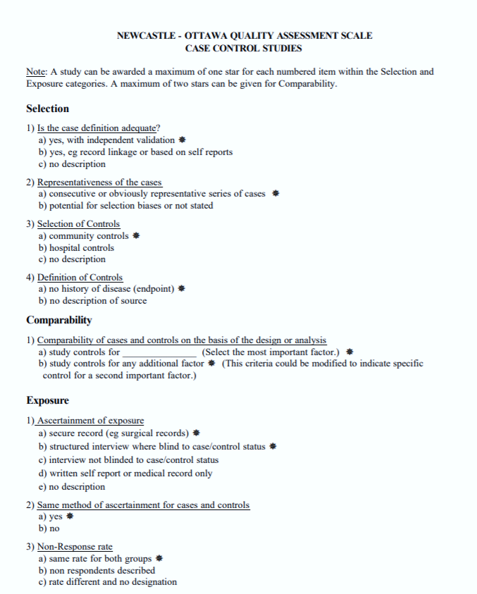

Supplementary Figure S1. Funnel plot for visual inspection of publication bias.

Alternative hypothesis: asymmetry in the funnel plot; bias: -1.31, standard error of bias:3.1, slope: 0.68, P-value=0.68

References
Wells, G., Shea, B., O’Connell, D., Peterson, J., 2000. The Newcastle-Ottawa Scale (NOS) for assessing the quality of nonrandomised studies in meta-analyses [WWW Document]. Ottawa, ON: Ottawa Hospital Research Institute. URL http://www.ohri.ca/programs/clinical_epidemiology/oxford.asp (accessed 7.11.20).

