The global distribution of tetrapods reveals a need for targeted reptile conservation - supplementary material
Uri Roll, Anat Feldman, Maria Novosolov, Allen Allison, Aaron M. Bauer, Rodolphe Bernard, Monika Böhm, Fernando Castro-Herrera, Laurent Chirio, Ben Collen, Guarino R. Colli, Lital Dabool Indraneil Das, Tiffany M. Doan, Lee L. Grismer, Marinus Hoogmoed, Yuval Itescu, Fred Kraus, Matthew LeBreton, Amir Lewin, Marcio Martins, Erez Maza, Danny Meirte, Zoltán T. Nagy, Cristiano de C. Nogueira, Olivier S.G. Pauwels, Daniel Pincheira-Donoso, Gary Powney, Roberto Sindaco, Oliver Tallowin, Omar Torres-Carvajal, Jean-François Trape, Enav Vidan, Peter Uetz, Philipp Wagner, Yuezhao Wang, C David L Orme, Richard Grenyer, and Shai Meiri
Supplementary methods
Collecting and curating reptile distribution data
Data were obtained from the most recent sources available, with older data added when needed, after accounting for taxonomic changes (following the taxonomy of the Reptile Database¹). Sources included field guides and books of the reptilian fauna of various regions, museum specimen databases, online meta-databases (including the IUCN - http://www.iucnredlist.org/; GBIF - http://www.gbif.org/; and Vertnet - http://vertnet.org/), and the primary literature – especially, but not restricted to, taxonomic accounts such as systematic accounts, reviews and species descriptions, accounts of range extensions in journals such as Herpetological Review; Mesoamerican Herpetology and Check List, and herpetofaunal country and regional descriptions²⁻⁴. A full list of sources per species is presented in Supplementary Table 3. Where multiple sources were available for the distribution of a species in a region, we preferred polygonal data (e.g., IUCN Red List assessment maps and field guides e.g.⁵⁻⁸) over data on specimen localities (e.g., Vertnet, or published accounts^{2,4,9,10}), and those over data represented as presence in grid cells e.g.^{3,11-13}. We updated species distributions when consecutive editions of field guides were published. If the main source for distribution data for a region was published before the 21st century, and in some cases during the 21st century, we revised the maps internally using the expertise of the authors (e.g., D. Pincheira-Donoso verified, corrected and added to older distributional data from Chile¹⁴, A. Bauer and I. Das did the same for Indian data¹⁵). We supplemented regional data with data on specific taxa (e.g., venomous snakes¹⁶, Varanidae¹⁷, Cordylidae¹⁸, chameleons¹⁹). We used a mainly geographic approach, in which we identified the list of all species occurring in a certain country or region using a combination of data in field-guides, regional IUCN assessments, the Reptile Database (http://www.reptile-database.org) and new species descriptions, then verified species lists and mapped all the species in each region or country. Nevertheless, for several regions of the world comprehensive field guides or other exhaustive sources of distribution data for reptiles are unavailable. For these regions, we obtained data from Vertnet and GBIF, as well as from the primary literature, then had the authors who specialize in the faunas of these regions (e.g., the Sahel: J.-F. Trape, L. Chirio and M. LeBreton; Ecuador: O. Torres-Carvajal; Angola: A. Bauer; China: Y. Wang; Congo: D. Meirte and Z. Nagy; Brazil: G. Colli, MS. Hoogmoed, C. Nogueira and M. Martins; New Guinea and the Pacific Ocean islands: F. Kraus, O. Tallowin and A. Allison; The Malay-Thai Peninsula: L. Grismer and O. Pauwels; Colombia: F Castro-Herrera; Afghanistan: P. Wagner; Peru and Bolivia: T. Doan) draw polygon or gridded range maps based on the locality data, on their observations in the field and in museums, and on their knowledge of the species and their biology. This was done in a similar fashion to the process used by the IUCN to map species ranges or by authors of published field guides in drawing such ranges. We have made sure to update the taxonomy as needed to incorporate new species descriptions²⁰, elevation of subspecies to species rank, and the splitting of polytypic species into several narrow-ranged species e.g.²¹⁻²³. We have verified that countries had data for all the species listed for them in the Reptile Database, and P. Uetz updated the Reptile database when incongruences were found. Ranges were digitized in ArcGIS. For point locality data we preferred using latitude and longitude data over digitizing locations from an image. Brazilian snake ranges were based on data from the ongoing “Atlas of Brazilian Snakes”, coordinated by C. Nogueira et al. Snake distributions were collated as part of A. Feldman’s Ph.D. thesis²⁴; turtle distributions were collated as part of Y. Itescu’s M.Sc. thesis²⁵.
We divided the geographic data into four types: 1. Georeferenced point data that were derived from GPS measurements, direct estimates of the latitude and longitude of an observation (or, when numerical data were unavailable, finding the latitude and longitude of a locality in search engines such as Google Maps); 2. Point data that were derived from maps published as graphic objects, and digitized using ArcGIS; 3. Occurrence in grid cells; and 4. Polygonal images or shapefiles. We used a 4-fold scale to quantify the spatial precision of an observation: 1. Correct to within 0.25º (this was our highest level of precision, though we note that data are usually reported at a much higher precision and accounted for 95.1% of the polygonal information and 99.6% of the point information); 2 Correct to within 0.5º (which accounted for 1% of the polygonal information and 0.4% of the point information); 3 Correct to within 1º (which accounted for 3.8% of the polygonal information and 0.02% of the point information); and 4. Correct to within 2 degrees (which accounted for 0.02% of the polygonal information and 0.001% of the point information). We further ranked data in three levels of confidence: ‘Certain’ where we were sure of the identity of the species and its geographic origin (which accounted for 99.8% of the polygonal information and 99.9% of the point information), ‘Possible’ where we doubted either of these (which accounted for 0.21% of the polygonal information and 0.001% of the point information), and ‘Maybe’ where we were not sure (which accounted for 0.03% of the polygonal information and 0% of the point information). We were unable to find detailed geographic data for 101 species listed in the Reptile Database March 2015 edition – those were invariably either of doubtful taxonomic validity, or were based only on a type series, were described without a type locality, with an uncertain type locality, or the type locality was too vaguely defined (e.g., “South America” or “India”). See Supplementary Table 4 for a list of these species. We excluded from our analyses 17 species that were present in the March 2015 version of the Reptile Database but were designated as extinct or extinct in the wild in the July 2015 version of the IUCN Red List. Furthermore, we only attempted mapping the distributions of terrestrial reptiles (including the Marine Iguana; Amblyrhynchus cristatus), and did not attempt to map the distributions of the 7 species of marine turtles forming the families Cheloniidae, and Dermochelydae, the 62 species of sea snakes forming the sub-family Hydrophiinae and the 8 species of sea kraits forming the sub-family Laticaudinae.
Modelling of point localities – We used two approaches to incorporate point locality information into species distribution ranges: either placing a buffer around all point localities or modelling them using hull geometries (see below). All the analyses were conducted twice, once with point data buffered for all species and again with point data modelled. Results using buffered points were compared to the hull geometry models. No qualitative differences were found between the two approaches. We therefore present only the results of the analyses with the hull geometry models.
In the modelling procedure, species with any point localities (n = 5861 species) were treated in three different ways depending on number of unique point localities per species (rounded to four places after the decimal degree; ~10 meter resolution):
- Species with ≥ 6 unique points (2811 reptiles) – points were modelled using alpha hulls (see below for detailed explanation on the method).
- Species with 3-5 unique points and 5 species that failed to produce alpha hulls (1016 reptiles) – points were modelled using convex hulls (see below for detailed explanation on the method).
- Species with 1-2 unique points and 2 species that failed to produce convex hulls (2034 reptile species) – were only buffered.
Buffering points – applied to all points
- All points were buffered to create a circular area of 10 km² (similar to the mapping standards adopted for amphibians by the IUCN– www.amphibians.org/wp-content/uploads/2013/09/Red-List-Mapping-standards-ARLA-Jan2014-web-version.pdf) with a radius of 1.784 km. This was conducted for all point localities as the alpha hull procedure (see below) may exclude individual points from hulls, points that are nonetheless part of a species’ distributions.
- These points were then clipped to include only land regions using a Digital Chart of the World layer (dcw-complete - https://worldmap.harvard.edu/data/geonode:Digital_Chart_of_the_World). Those buffered points that resided completely outside the dcw-complete layer (for a few islands not included in this layer) were added again to the dataset after the clip as is, after verifying they do not represent errors.
- All buffered points were then dissolved based on species binomials.
Alpha hull method (applied to all species with ≥ 6, unique coordinates)
- All geographical coordinates of points were rounded to four digits after the decimal.
- Only unique coordinates were retained.
- Alpha hulls were created with:
alpha = sqrt((Longitudinal range + Latitudinal range)/4+0.5 degree)
- The parameters in the above equation were selected after sensitivity analysis in order to balance between distinguishing unique clusters of points as different polygons, and in order not to create too many separate polygons for each species.
- All resulting shapes were buffered outwards with a 10 km buffer to account for various potential measurement and spatial errors.
- These outputs were then clipped to the dcw-complete layer (see above).
- All the resulting polygons were then filtered so as to comprise only those landmass regions from which the original points for each species came from (based on the dcw-complete shapefile). For example, for an archipelago species with point localities in only three islands, only the polygon ranges created in these three islands were retained, and all ranges that may have been created in the process in adjacent islands, omitted.
- All polygons were dissolved based on species binomials.
Convex hulls – applied to all species with 3-5 unique coordinates
- Convex hulls were created for each species based on all points.
- After visual inspection, 68 species produced particularly elongated triangular ranges – in which two edges were at least 10 times larger than the third one. As these most-likely represent two disjunct regions where the species is found without a continuous presence in between, we opted to keep them only as buffered point localities rather than hulls. 2 species ranges in lesser-known regions were removed so as to avoid arbitrarily designating huge swaths as ranges for species known only from 3-5 vastly disjunct regions, without knowledge of occurrence in between. This filtering was done while comparing convex hull results to the other data types available for each species. After filtering, we maintained convex-hull predictions for 946 reptile species (of the 1016 we attempted to model using this method). For those species we opted to remove the polygons created by convex hulls (with the above criteria) as well as two species that failed to produce hulls (as they had three points that lay on a single line) their ranges were retained only as buffered points.
- All resulting shapes were buffered outwards with a 10 km buffer to account for various potential measurement and spatial errors.
- These outputs were then clipped to the dcw-complete layer.
- As above, all the resulting polygons were then filtered so as to comprise only those landmass regions from which the original points for each species came from (based on the dcw-complete shapefile).
- All polygons were then dissolved based on species binomials.
After these procedures all the three data sources were merged and then dissolved based on species binomials.
Analysis of richness patterns
For many of our tests we divided the reptiles into several groups – snakes, turtles, and lizards and allies - which included lizards (Sauria: 6145 species), Amphisbaenia (194 species) and Rhynchocephalia (1 species, Sphenodon punctatus), henceforth referred to as ‘lizards’. The paraphyletic grouping ‘lizards’ (lepidosaurs exclusive of snakes) are here contrasted with snakes for the purposes of analysis – to reflect the ecomorphological uniqueness of snakes vs. the diversity of ‘lizard-like’ taxa. We did not attempt to break lizards into several monophyletic clades, as even some of the largest lizard clades have biogeographically restricted distributions, for which global analyses and comparisons would prove problematic.
Data on the distributions of amphibians and terrestrial mammals were taken from IUCN²⁶. Data on bird distributions are from BirdLife International and NatureServe²⁷. These data were filtered to include only native distributions of species and their resident or breeding ranges (where designated as such).
Several of the analyses representing richness patterns were conducted by comparing richness of grid-cells. Any overlap of a species’ range with the grid-cell was treated as a presence. We conducted the analyses at both the 1 degree, and 0.5 degree Behrmann projection equal-area grid-cells. We compared the results of the two grid-cell sizes and they were qualitatively the same. We present only the results of the analyses with the 0.5 degree grid-cells.
Grid-cell correlations – We conducted spatially corrected correlations between the species numbers per grid-cell of the different tetrapod classes or reptile groups. This was done both for all species and just for range-restricted species (lower decile and quantile of ranges as measured by the number of occupied gridcells). Double zero cells were eliminated from all correlations. The correlations were conducted using a corrected Pearson’s correlation for spatial autocorrelation using the package ‘Spatialpack’²⁸ correcting the degrees of freedom of the analyses^{29,30}. We used a Bonferroni correction for multiple testing (of the different tetrapod classes or reptile group comparison combinations). The Bonferroni adjusted P-values to reject the null hypothesis were calculated at 0.00238.

Overlap analyses
Protected-areas analysis - For each species of terrestrial vertebrate we calculated the overlap over its distribution with protected areas (downloaded from The World Database on Protected Areas in July 2015, https://www.iucn.org/about/work/programmes/gpap_home/gpap_biodiversity/gpap_wdpa/). We lumped the IUCN protected area categories for three separate analyses. A) Category I (including categories Ia and Ib), which are strict nature reserves or wilderness areas, where human use and impacts are strictly controlled; B) Categories I-IV (categories Ia, Ib, II, III, and IV), which are well suited for protecting biological diversity and restrict human activities³¹; and C) all categories combined (categories Ia, Ib, II, III, IV, V, VI), as well as those regions where categories were designated as ‘not applicable’, ‘not assigned’, or ‘not reported’³². The protected-area data were spatially generalized at the 0.02 degree resolution. The protected area overlap per species values, in each of the three analysis categories, were then averaged per class or reptile group. In order to compare protected area overlap between the classes and reptile groups, we conducted a Kruskal-Wallis rank sum test. We then conducted a post-hoc test of pairwise comparisons between groups using a Tukey and Kramer (Nemenyi) test with Tukey-distribution approximation for independent samples³³.
Global priority schemes - we analyzed whether individual terrestrial tetrapod species’ distributions overlap to any degree with four recent global conservation prioritisation schemes - Conservation International’s Biodiversity Hotspots³⁴; the World Wildlife Fund’s Global 200 outstanding terrestrial ecoregions³⁵; BirdLife International’s Important Bird and Biodiversity Areas - IBAs³⁶; and plant endemicity regions³⁷. We then looked at the overall representation of species from each terrestrial vertebrate class or reptile group of these four schemes (i.e. the percentage of species that have any degree of overlap out of all the species in the group).
Opportunity cost - For each species of terrestrial tetrapod we calculated the conservation opportunity cost³⁸ in the distribution range it occupies. This was done by calculating a mean value of USA dollars per hectare overlapped over the range of each species and averaged over its entire range (all species were treated equally). The species values were then summed and averaged per class or reptile group. In order to compare opportunity cost between the classes of tetrapods or the groups of reptiles we conducted an ANOVA (after square root transformation of the opportunity cost data to normalize residuals). We then conducted a post-hoc Tukey HSD test to highlight the sources of the variation.
Prioritising cells for conservation was done using the ‘Zonation’ software³⁹. Zonation is a framework for conservation prioritisation and spatial conservation planning. It identifies areas simultaneously for multiple species (or any other biodiversity features), thus providing a quantitative method for enhancing persistence of biodiversity in the long term. We used this software to prioritise cells globally (on a 0.5 degree Behrmann grid) based on their complement of tetrapod, and of tetrapods excluding reptiles. We used the basic core-area ‘Zonation’, with the following parameters:
- Warp factor = 1 – a single cell is removed at each iteration.
- Edge removal = 0 – the program removes cells from anywhere in the landscape (thus not creating clumped regions for conservation and treating each cell individually).
- Use SSI = 0 – no Species of Special Interest are used in the analysis.
- Use planning unit layer = 0 – no planning units are used in the analysis.
- Use cost = 0 – no land cost layer is used in the analysis.
Cells were ranked by the Zonation software from 0- lowest (i.e. removed first) to 1- highest (i.e. retained until the end of the process). For convenience, our maps display ranks from 0 to 1000 (by multiplying the raw ranks by 1000). We then subtracted the ranks of the cells from the analysis of all tetrapods from the ranks of the cells for the analysis of tetrapods without reptiles. This enabled us to identify those cells that had the greatest change in rank due to the additional information on reptile distribution. We highlighted those cells that were in the top ten percentile of rank change when adding reptile information.
Cluster detection – We explored clusters of cells that greatly increased their ranks using the zonation prioritisation procedure. This was done using Anselin’s local Moran’s I values⁴⁰ calculated on the rank change using inverse Euclidian distances without standardization. Then only those cells that belonged to a significant spatial cluster (P <= 0.05) were further analyzed. We employed this procedure in order to identify fairly contiguous regions of change in faunal composition as opposed to single cells that may change rank (even greatly) due to relative composition changes of few species in the region. For example, if there are two neighboring cells with the same relative richness, one of them could be chosen to reflect it, and its neighbor would then have a low rank. If by chance due to the inclusion of reptiles the unchosen cell now had one additional reptile not found in its neighbor, its rank would greatly increase.

Supplementary tables

Table S1 - Correlations of species richness among tetrapods or reptile groups, using Pearson’s correlation corrected for spatial autocorrelation²⁹⁻³⁰. a-c) Correlation coefficients (R) in the bottom triangle. P-values the upper triangle. d-f) Degrees of freedom corrected for the spatial process in the bottom triangle, F-statistic for the modified t-test in the upper triangle. a, d) richness values for all species. b, e) Range-restricted species (in the bottom quartile of ranges). c, f) Range-restricted species (in the bottom decile of ranges).

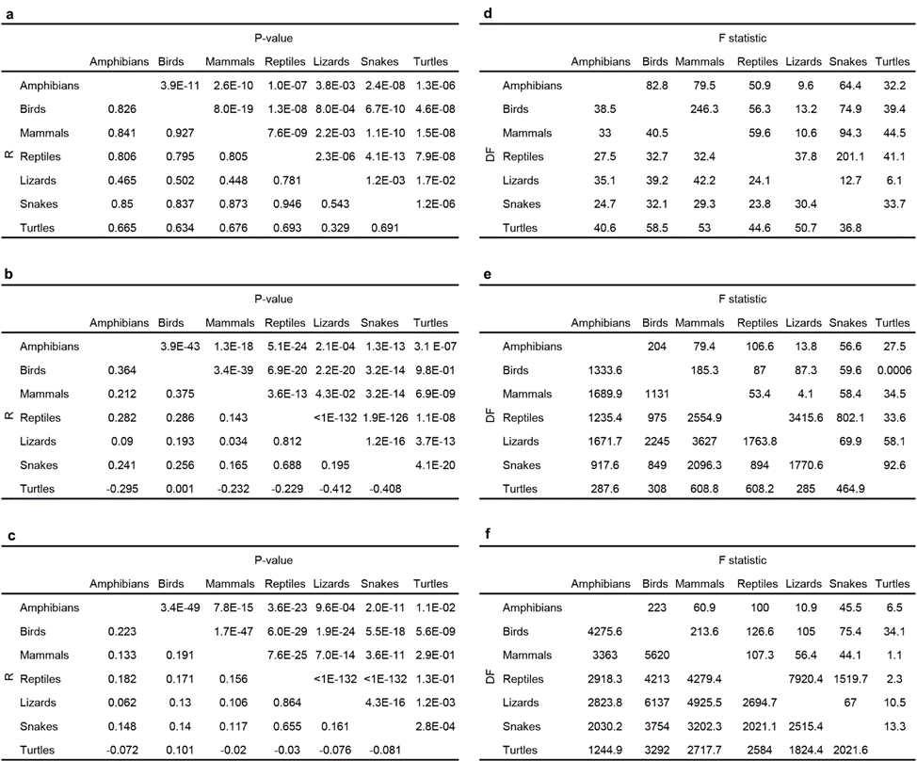

Table S2 - Overlap between protected areas and species ranges of tetrapods or reptile groups. Protected area overlap was analyzed three times for different categories assignments – strict nature reserves Cat. I, reserves designated for the protection of biological diversity – Cat I-IV, and all categories. a-f) Results of the Kruskal-Wallis rank-sum test to compare protected area overlap for the different tetrapod classes (a-c) or the different reptile groups (d-f). Also included are the P-values from a post-hoc test of pairwise comparisons using Tukey and Kramer (Nemenyi) test with Tukey-Distribution approximation for independent samples. g) Summary statistics of the overlap of protected areas with the distribution of each species. Median values are more useful as skewed distributions make mean values more difficult to interpret.
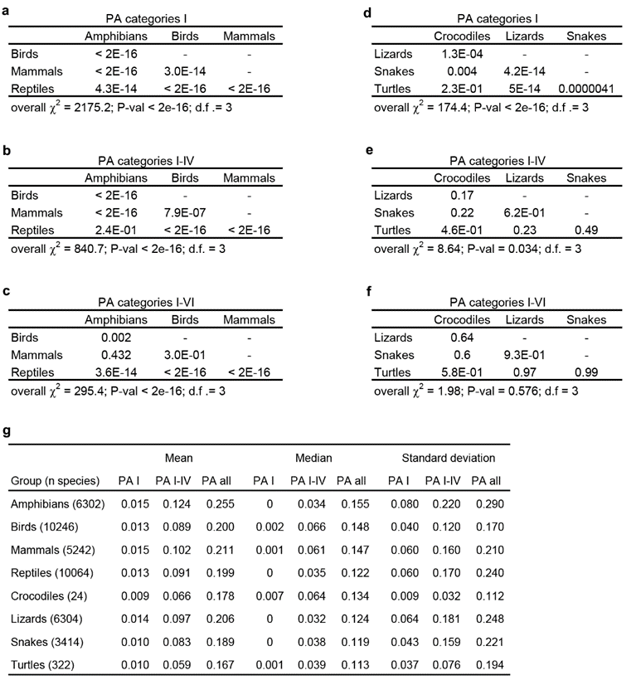

Supplementary figures
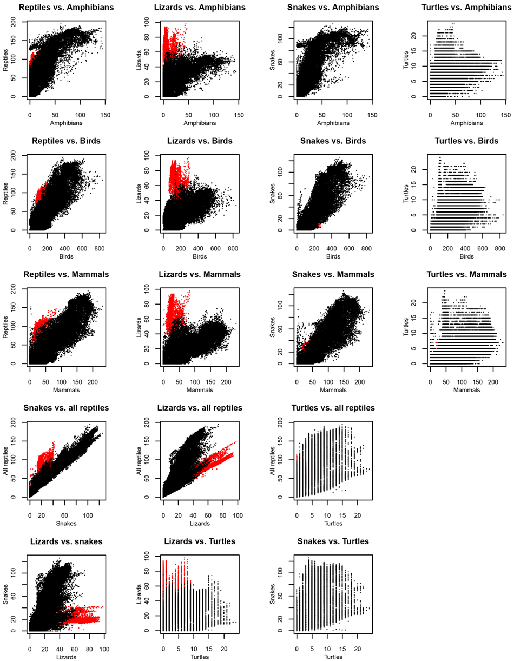
Figure S1 - Scatter plots comparing species richness of tetrapods. The plots compare reptiles or reptile groups and other terrestrial vertebrate classes, as well as, all reptiles to reptile groups and reptile groups amongst themselves. The scatter plots compare species richness values per grid-cell at a 0.5º grid-cell resolution (Australian cells in red, to mark the exceptional diversity of lizards there).
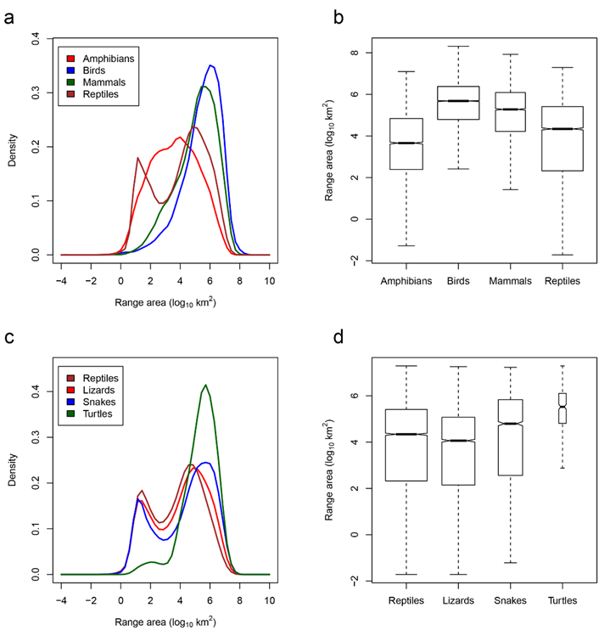

Figure S2 - Range sizes of tetrapods. Range size frequency distributions and box-plots (notches correspond to +/-1.58 IQR/sqrt[n]), for all tetrapod classes (a, b) and for all reptiles and major reptile groups (c, d).

Figure S3 - congruence in tetrapod hotspots. a) Cells with highest species richness when data from the four classes are combined, for the top 2.5%, 5%, 7.5%, 10% richest cells. b) Congruence between the designations of the hotspots of the four classes – i.e. regions that were designated as hotspots in a particular percentage for the four classes when analyzed separately. c) Overlap between the top 2.5%, 5%, 7.5% and 10% cells designated for all tetrapods combined and the cells designated in the same categories for each of the different tetrapod classes or reptile groups.
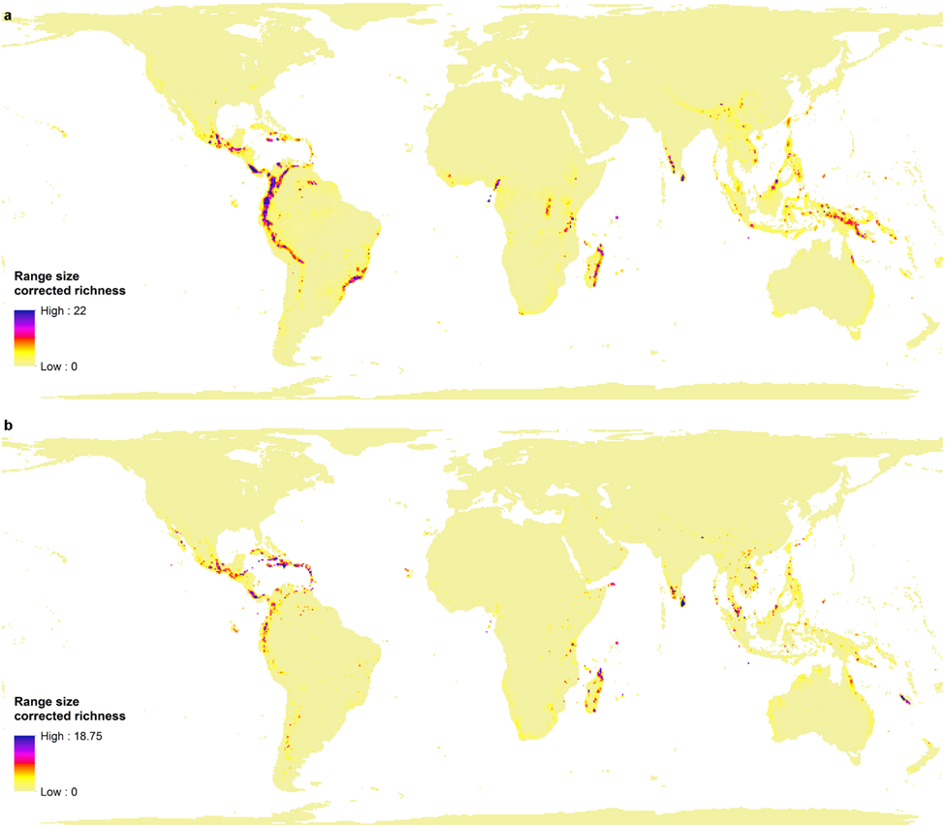
Figure S4 - Range size corrected richness maps. This measure is simply a sum over species of the fraction of species distributions occurring in the cell, also known as relative endemism. a) Non-reptilian tetrapods. b) Reptiles.

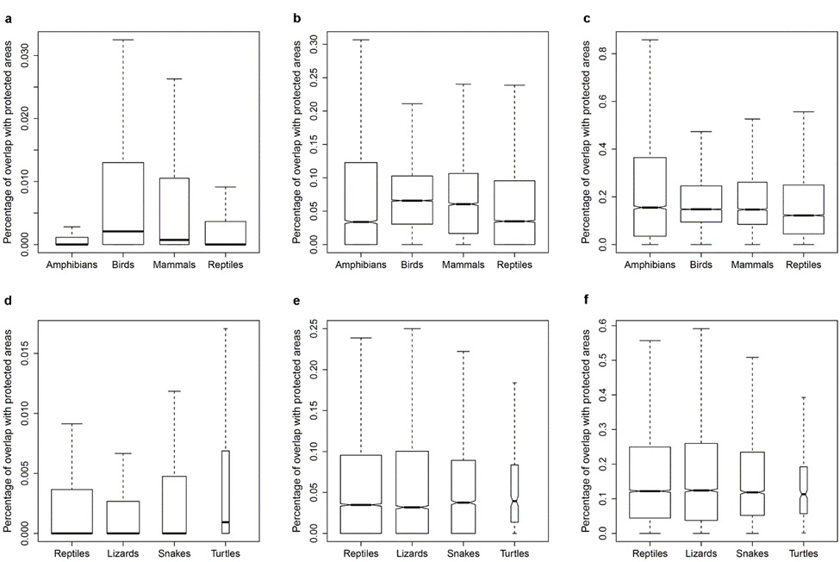
Figure S5 - Overlap of protected areas with the species ranges. Overlap in the four tetrapod classes (a-c), and reptiles and reptile groups (d-f). We present the average overlap of a species in a group. a,d- overlap with category I protected areas, b,e- overlap with protected areas in categories I-IV, c,f – overlap with protected areas in all categories (notches correspond to +/-1.58 IQR/sqrt[n]).

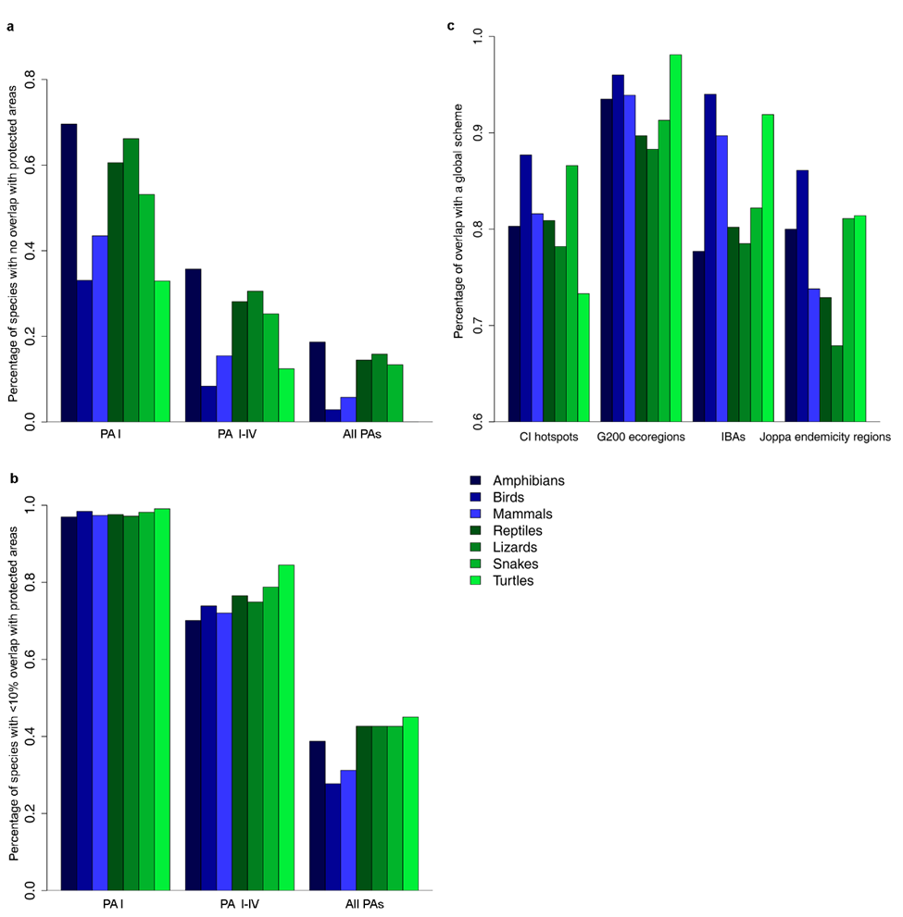
Figure S6 - Overlap of tetrapod class or reptile groups with protected areas or priority schemes. Overlap between tetrapod species and the three protected-area categories analyzed. a) The percentage of species per group that do not overlap at all with protected areas (have no protection in PAs) for the three protected-area categories analyzed. b) The percentage of species per group that have less than 10% of their area in protected areas. c) The percentage of species per class or group that have any overlap of their distribution with four priority-setting networks. Conservation International’s hotspots for conservation (CI hotspots), the World Wildlife Fund’s Global 200 outstanding terrestrial ecoregions (G200 ecoregions), BirdLife International’s network of Important Bird and Biodiversity Areas (IBAs) and a designation of endemicity regions for plants by Joppa et al. (2013). Note that the Y axis begins at 60%.
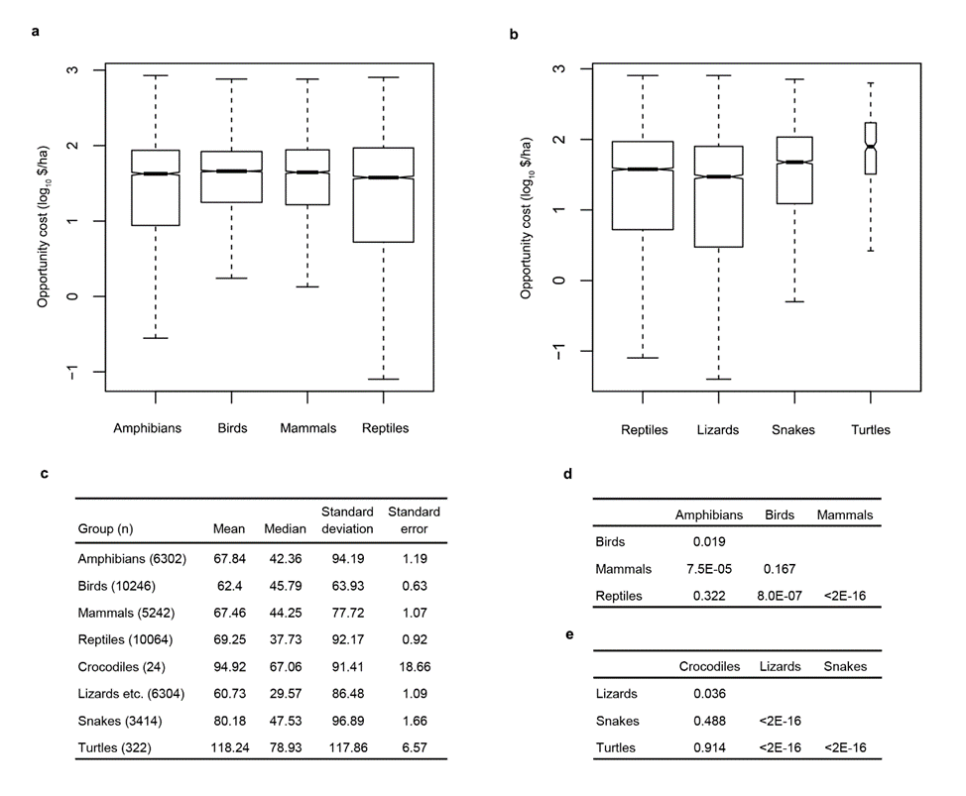
Figure S7 - Overlap between the species ranges and opportunity cost (in dollars per hectare) with different tetrapod classes or reptile groups. For each species of terrestrial vertebrate we calculated the conservation opportunity cost, based on Naidoo & Iwamura (2007)³⁸ in the distribution range it occupies. a) Box plots of the overlap between the species ranges and opportunity cost in the four tetrapod classes (notches correspond to +/-1.58 IQR/sqrt[n]). b) Similar box plots for reptiles and reptile groups. c) Summary statistics table of overlap values with species ranges, summed per class or reptile group. d-e) Results of ANOVA post-hoc tests comparing opportunity costs for the different tetrapod classes (d) or the different reptile groups (e). Results presented are of adjusted p-values using the Tukey honest significant differences.
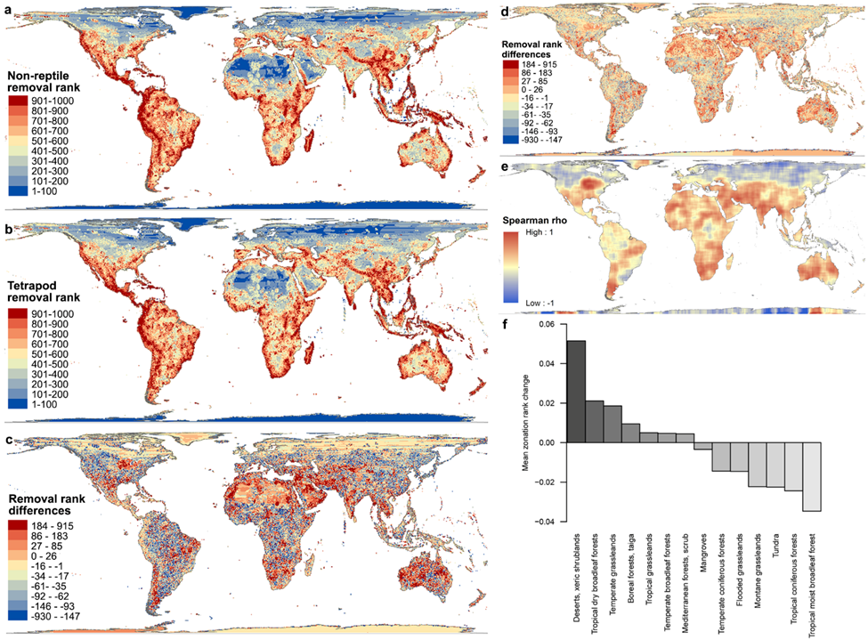

Figure S8 - Differences between prioritisation ranks for tetrapods, with and without reptiles. ‘Zonation’ removal ranks per grid-cell (see methods) for a) - all tetrapods without the reptile knowledge, and b) - all tetrapods combined. c) Shows the rank values of all tetrapods minus those of non-reptiles; positive values (warm colours) are cells ranked higher for all tetrapods including reptiles, negative values (cold colours) are cells ranked higher for tetrapods without reptiles. d) Rank differences between rankings with and without reptiles, when land conservation costs are included. e) Correlation coefficients from a local neighborhood Spearman correlation between the rank differences maps with and without a cost layer. f) The mean zonation rank change per biome (higher values is given to those biomes where the inclusion of reptiles increases importance).
Supplementary References
¹ Uetz, P. & Hošek, J., The Reptile Database, Available at http://www.reptile-database.org/, (2015).
² Brown, J.L., Cameron, A., Yoder, A.D., & Vences, M., A necessarily complex model to explain the biogeography of the amphibians and reptiles of Madagascar. Nature Communications 5, e5046 (2014).
³ Sillero, N. et al., Updated distribution and biogeography of amphibians and reptiles of Europe. Amphibia-Reptilia 35, 1-31 (2014).
⁴ Smid, J. et al., Annotated checklist and distribution of the lizards of Iran. Zootaxa 3855, 1-97 (2014).
⁵ Bar, A. & Haimovitch, G., A field guide to reptiles and amphibians of Israel. (Privately published, Herzlyia, 2013).
⁶ Cogger, H.G., Reptiles and amphibians of Australia, 7th ed. (CSIRO Publishing, Collingwood, 2014).
⁷ Jones, L. & Lovich, R., Lizards of the American southwest: a photographic field guide. (Rio Nuevo Publishers, Tuscon, 2009).
⁸ Rhodin, A.G.J. et al., Acanthochelys macrocephala (Rhodin, Mittermeier, and McMorris 1984) - Big-Headed Pantanal Swamp Turtle, Pantanal Swamp Turtle. Chelonian Research Monographs 5, 040.041-040.048 (2009).
⁹ Gardner, A.S., The amphibians and reptiles of Oman and the UAE. (Edition Chimaira, Frankfurt Am Main, 2013).
¹⁰ Savage, J.M., The amphibians and reptiles of Costa Rica. (The University of Chicago Press, Chicago, 2002).
¹¹ Bates, M.F. et al., Atlas and red list of the reptiles of South Africa, Lesotho and Swaziland. (South African National Biodiversity Institute, Pretoria, 2014).
¹² Sindaco, R., Venchi, A., & Grieco, C., The reptiles of the Western Palearctic, volume 2: annotated checklist and distributional atlas of the snakes of Europe, North Africa. Middle East and Central Asia, with an update to volume 1. (Edizioni Belvedere, 2013).
¹³ Trape, J.-F., Trape, S., & Chirio, L., Lezards, crocodiles et tortues d'Afrique Occidentale et du Sahara. (IRD Editions, Marseille, 2012).
¹⁴ Donoso-Barros, R., Reptiles de Chile. (Ediciones de la Universidad de Chile, Santiago de Chile, 1966).
¹⁵ Sharma, R.C., The fauna of India and the adjacent countries: Reptilia: Volume 2: Sauria. Fauna of India and the adjacent countries. (Zoological Survey of India, 2002).
¹⁶ Campbell, J.A. & Lamar, W.W., The Venomous Reptiles of the Western Hemisphere, 2 vols. (Comstock (Cornell University Press), Ithaca, NY, 2004).
¹⁷ Pianka, E.R. & King, D.R., Varanoid lizards of the world. (Indiana University Press, Bloomington, Indiana, 2004).
¹⁸ Reissig, J., Girdled lizards and their relatives. Natural history, captive care and breeding. (Edition Chimaira, Frankfurt am Main, 2014).
¹⁹ Tilbury, C., Chameleons of Africa. An atlas. Including the chameleons of Europe, the Middle East, and Asia. (Edition Chimaira, Frankfurt Am Main, 2010).
²⁰ Meiri, S., Small, rare and trendy: traits and biogeography of lizards described in the 21st century. Journal of Zoology (2016).
²¹ Metallinou, M. et al., Species on the rocks: Systematics and biogeography of the rock-dwelling Ptyodactylus geckos (Squamata: Phyllodactylidae) in North Africa and Arabia. Molecular Phylogenetics and Evolution 85, 208-220 (2015).
²² Stanley, E.L. & Bates, M.F., Here be dragons: a phylogenetic and biogeographical study of the Smaug warreni species complex (Squamata: Cordylidae) in southern Africa. Zoological Journal of the Linnean Society 172, 892-909 (2014).
²³ Welton, L.J., Travers, S.L., Siler, C.D., & Brown, R.M., Integrative taxonomy and phylogeny-based species delimitation of Philippine water monitor lizards (Varanus salvator Complex) with descriptions of two new cryptic species. Zootaxa 3881, 201-227 (2014).
²⁴ Feldman, A., Snake macroecology, Ph.D. thesis dissertation. (Tel Aviv University, Tel Aviv, Israel, 2015).
²⁵ Itescu, Y., A biogeographic perspective on turtle evolution, M.Sc. dissertation. (Tel-Aviv University, Tel-Aviv, Israel, 2012).
²⁶ IUCN, The IUCN Red List of Threatened Species. Version 2014.3, Available at www.iucnredlist.org, (2014).
²⁷ BirdLife International and NatureServe Bird species distribution maps of the world. Version 5.0 (BirdLife International, Cambridge, UK and NatureServe, Arlington, USA, 2015).
²⁸ Osorio, F. & Vallejos, R., SpatialPack: Package for analysis of spatial data (R package version 0.2-3, 2014).
²⁹ Clifford, P., Richardson, S., & Hemon, D., Assessing the significance of the correlation between two spatial processes. Biometrics 45, 123-134 (1989).
³⁰ Dutilleul, P., Modifying the t test for assessing the correlation between two spatial processes. Biometrics 49, 305-314 (1993).
³¹ Shafer, C.L., Cautionary thoughts on IUCN protected area management categories V-VI. Global Ecology and Conservation 3, 331-348 (2015).
³² Stolton, S., Shadie, P., & Dudley, N., IUCN WCPA Best Practice Guidance on Recognising Protected Areas and Assigning Management Categories and Governance Types in Guidelines for Applying Protected Area Management Categories, edited by N. Dudley (IUCN, Gland, Switzerland, 2013).
³³ Pohlert, T., PMCMR: Calculate Pairwise Multiple Comparisons of Mean Rank Sums (2015).
³⁴ Mittermeier, R.A. et al., Hotspots Revisited: Earth's Biologically Richest and Most Endangered Ecoregions. (CEMEX, Mexico City, Mexico, 2004).
³⁵ Olson, D.M. & Dinerstein, E., The global 200: A representation approach to conserving the Earth's most biologically valuable ecoregions. Conservation Biology 12 (3), 502-515 (1998).
³⁶ BirdLife International Important Bird and Biodiversity Area (IBA) digital boundaries. Version 2015_2 (BirdLife Intranational, Cambridge, UK, 2015).
³⁷ Joppa, L.N., Visconti, P., Jenkins, C.N., & Pimm, S.L., Achieving the Convention on Biological Diversity's goals for plant conservation. Science 341 (6150), 1100-1103 (2013).
³⁸ Naidoo, R. & Iwamura, T., Global-scale mapping of economic benefits from agricultural lands: implications for conservation priorities. Biological Conservation 140 (1), 40-49 (2007).
³⁹ Moilanen, A. et al., Prioritizing multiple-use landscapes for conservation: methods for large multi-species planning problems. Proceedings of the Royal Society of London B: Biological Sciences 272 (1575), 1885-1891 (2005).
⁴⁰ Anselin, L., Local indicators of spatial association - LISA. Geographical analysis 27 (2), 93-115 (1995).

