Hydroperoxide mediated degradation of acetonitrile in the Lithium-air battery
Rory C. McNulty,^{1,2,3} Kieran D. Jones,^{1,3} Conrad Holc,^{1,2,3} Jack W. Jordan,^{1,2,3,} Peter G. Bruce,^{2,4} Darren A. Walsh, ^{1,2,3} Graham N. Newton,^{1,2,3} Hon Wai Lam,³ Lee R. Johnson *^{1,2,3}
¹Nottingham Applied Materials and Interfaces Group, School of Chemistry, University of Nottingham, NG7 2TU, UK
²The Faraday Institution, Quad One, Harwell Science and Innovation Campus, Didcot, OX11 0RA, UK
³School of Chemistry, University of Nottingham, Nottingham, NG7 2TU, UK
⁴Department of Materials and Chemistry, Parks Road, University of Oxford, OX1 3PH, UK
*lee.johnson@nottingham.ac.uk

Experimental
Materials
Acetonitrile (MeCN, 99.999%, Aldrich) was dried for several days over freshly activated molecular sieves (type 4 Å, Aldrich) before use. Lithium perchlorate (LiClO₄, 99.99%, Aldrich) was used as supplied without further purification. The dry electrolyte H₂O content was 4 ppm, determined by Karl-Fischer titration. Wet electrolyte solutions were prepared using deionised H₂O (18.2 MΩ cm, MilliQ). All cell components were dried at temperature under vacuum and transferred to a N₂-filled glovebox without exposure to air. All materials were prepared and stored in an N₂-filled glovebox prior to use.
Pressure cell measurements
24 mm diameter Swagelok-type cells incorporating a pressure sensor (Omega Engineering) were used for in situ pressure analysis. Porous carbonaceous cathodes (H23, QuinTech) were paired with freestanding Li_{1−x}FePO₄ anodes (pre-oxidised to ca. 20% of total capacity) that were prepared by combining LiFePO₄ (MTI) with conductive carbon additive (Super P, Alfa Aesar) and 10% wt. PTFE in H₂O (Aldrich) in an 8:1:1 ratio. Two glass fibre separators (GF/F, Whatman) were used to separate the electrodes. Stainless steel mesh (316 garde, Advent) was placed on top of the cathode to ensure electrical contact. Electrolyte volume was 800 µL. Prior to discharge, the cell headspace was purged with pure O₂ for a total time of 3 minutes, alternating bypass and through cell to avoid MeCN evaporation. The cell was discharged at 20 °C. The cell volume was determined post-discharge against a calibration tube of known volume. The H₂O concentration of dry MeCN cells was determined to be ca. 151 ppm through Karl-Fischer titration of electrolyte extracted from a cell rested for 72 hours.
%Li₂O₂ yields
12 mm diameter Swagelok-type cells with a large headspace were used to prepare samples for Li₂O₂ yield analysis. Cells were assembled as described above for pressure cell measurements. Electrolyte volume was 200 µL. Prior to discharge, the cell headspace was purged as described above. The cell was then discharged at 20 °C to a capacity of 0.5 mAh. The quantity of Li₂O₂ formed was determined by UV-Vis spectrometry (Ocean Optics USB2000+ fiber optic spectrometer) using a UV-Vis titration method reported previously.¹ The discharged electrodes and separators were added to a vial containing a 1:1 mixture of H₂O: TiOSO₄ (2 wt.%) in 1 M H₂SO₄ (H₂O). The H₂O reacts with Li₂O₂ to form H₂O₂, which in turn reacts with TiOSO₄ to produce a yellow complex [Ti(O₂)]²⁺ (λ_{max} = 405.2 nm) The UV-Vis spectra were compared to a calibration curve, which was obtained by using known standards of H₂O₂.
Model Reactions and NMR spectroscopy
Model system reactions were carried out under inert atmosphere (N₂) and prepared by adding Li₂O₂ (10.7 mg, 0.23 mmol, 95%, Acros) to a 5 mL solution of anhydrous deuterated acetonitrile (d₃-MeCN, ≥99.8 atom%D, Aldrich) and H₂O (5 μL, 1000 ppm or 100 μL, 20000 ppm, 18.2 MΩ cm, MilliQ). The reaction mixture was left at rest for the annotated time periods before using a syringe filter (0.2 µm, Fisher) to extract ca. 1 mL of mixture into an airtight NMR tube fitted with a Young’s tap. Time-resolved ¹H NMR were recorded on a Bruker Ascend 400 MHz spectrometer with 128 scans. Analyte was re-incorporated into the mixture after analysis. Model system solution and acetamide reference ¹H and ¹³C NMR data were recorded on a Bruker AV(III)400 HD fitted with a 5mm BBFO probe and a Bruker AV(III)500 HD fitted with a 5mm Prodigy BBO probe, respectively. ¹H NMR were recorded at 400 MHz with 128 scans and ¹³C NMR were recorded at 126 MHz with 16384 scans. Chemical shifts in ¹H and ¹³C spectra were referenced to the residual (partially) non-dueterated solvent according to Fulmer et al.² Data was analysed using Bruker TopSpin software.
HPLC-MS
The cathode and separator were extracted from a cell discharged to ca. 3.25 mAh cm⁻² in a glovebox and the MeCN was allowed to evaporate. The components were then mixed with 2 mL of MilliQ H₂O and the resultant suspension was extracted using a syringe filter. Samples from the model chemical systems were prepared by extracting 1 mL of mixture using a syringe filter. Reference samples were prepared by mixing a small quantity of analyte with acetonitrile. HPLC experiments were carried out on a Thermo Ultimate 3000 HPLC, equipped with a 239 nm UV-Vis detector. For HPLC-MS measurements, a Bruker microTOF II spectrometer with an electrospray ionisation (ESI) source was connected to the HPLC outlet. 10 µL of sample was injected into an Accucore aQ (150 mm x 4.6 mm, 5 µm) column using a 100% MilliQ H₂O with 0.1% formic acid eluent at a constant flow rate of 0.5 mL min⁻¹. MS data were collected in positive ion mode.
Drying cell components
Cell components were dried at elevated temperatures under vacuum for a period of 24 hours prior to transport to a N₂-filled glovebox without exposure to air. The LFP anode, porous carbon cathode, and stainless steel mesh were dried at 120 °C. Glass fibre separators were dried at 300 °C. Swagelok cell parts were dried at 70 °C and transferred through atmosphere while hot to an N₂-filled glovebox and allowed to cool to ambient temperature before cell assembly.
Determining H₂O concentration of ‘dry’ cells
Multiple pressure cells were assembled as described above with an additional 800 µL (total 1600 µL) of dry electrolyte, initial H₂O content ca. 4 ppm. The headspace was purged with O₂ and the cells were held at 20 °C for 72 hours before excess electrolyte was extracted and analysed through Karl-Fischer titration. The reported H₂O content, 151 ppm, is the average result of these cells.

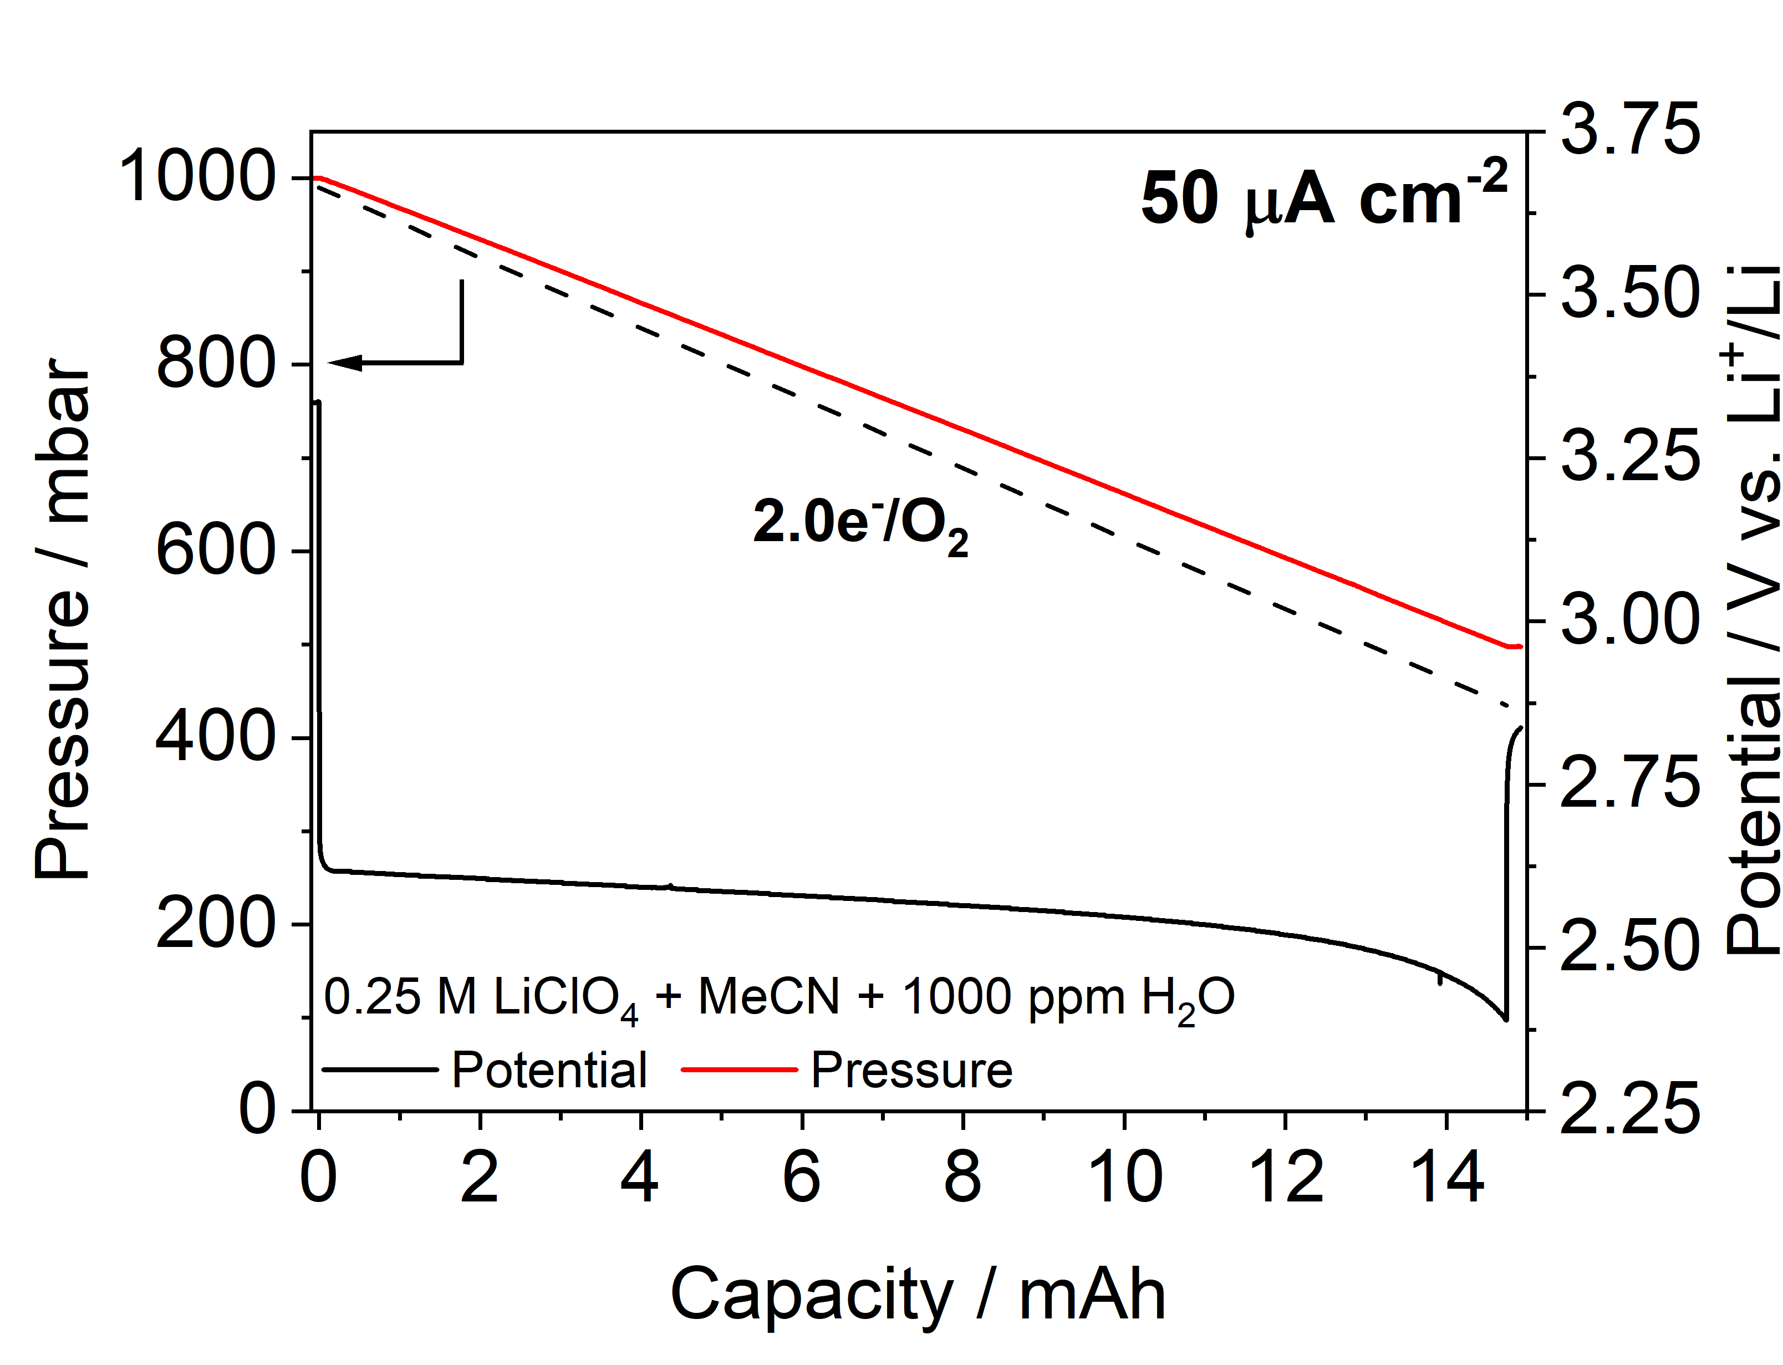
Figure S1. Pressure decay measurements during the first electrochemical discharge of a cell containing 0.25 M LiClO₄ in MeCN doped with 1000 ppm H₂O to 14.7 mAh (3.25 mAh cm⁻² for our cell design) at a rate of 50 µA cm⁻², compared to the ideal 2.0e⁻/O₂ (black dashed line) pressure decay gradient.
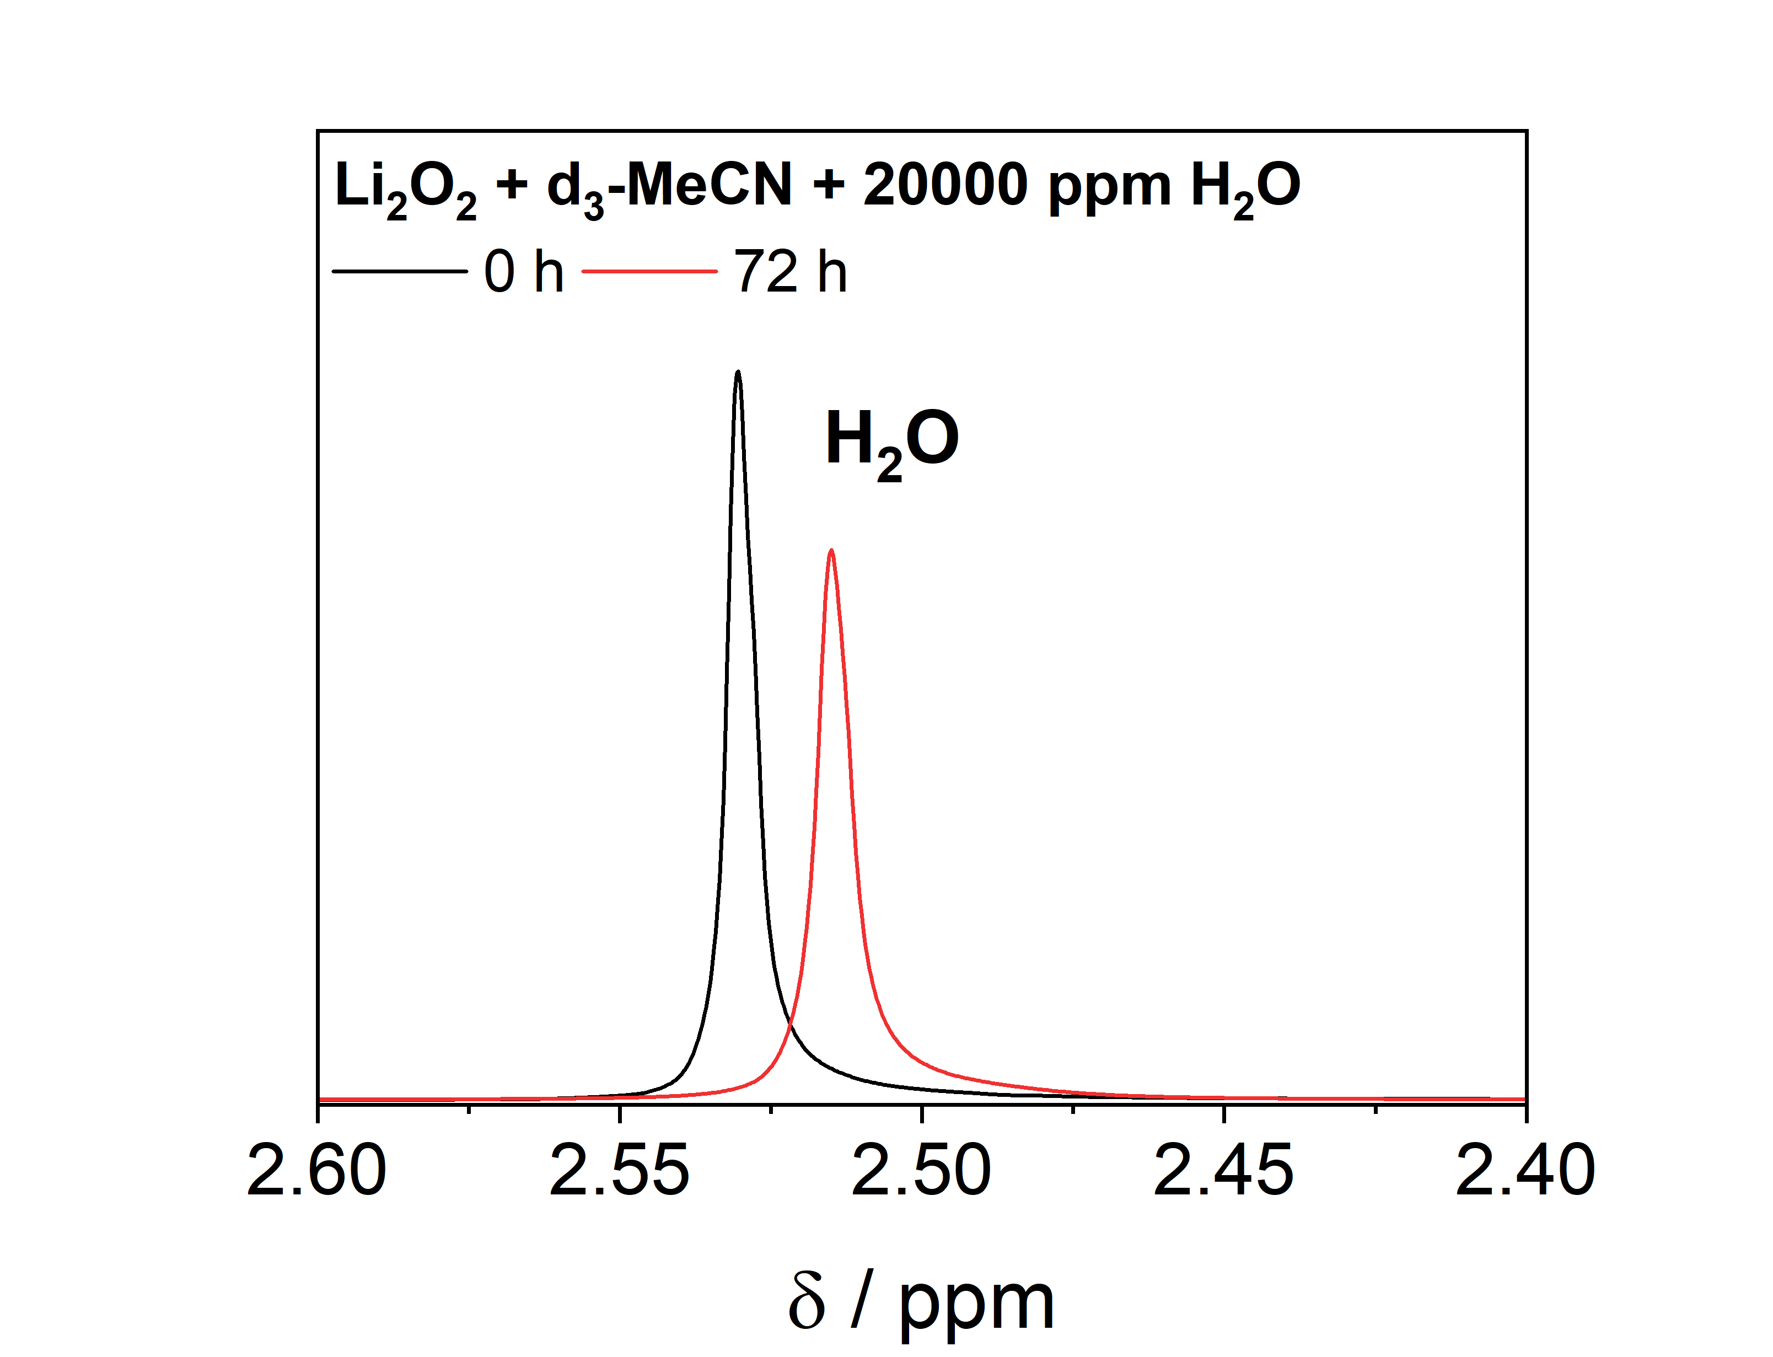
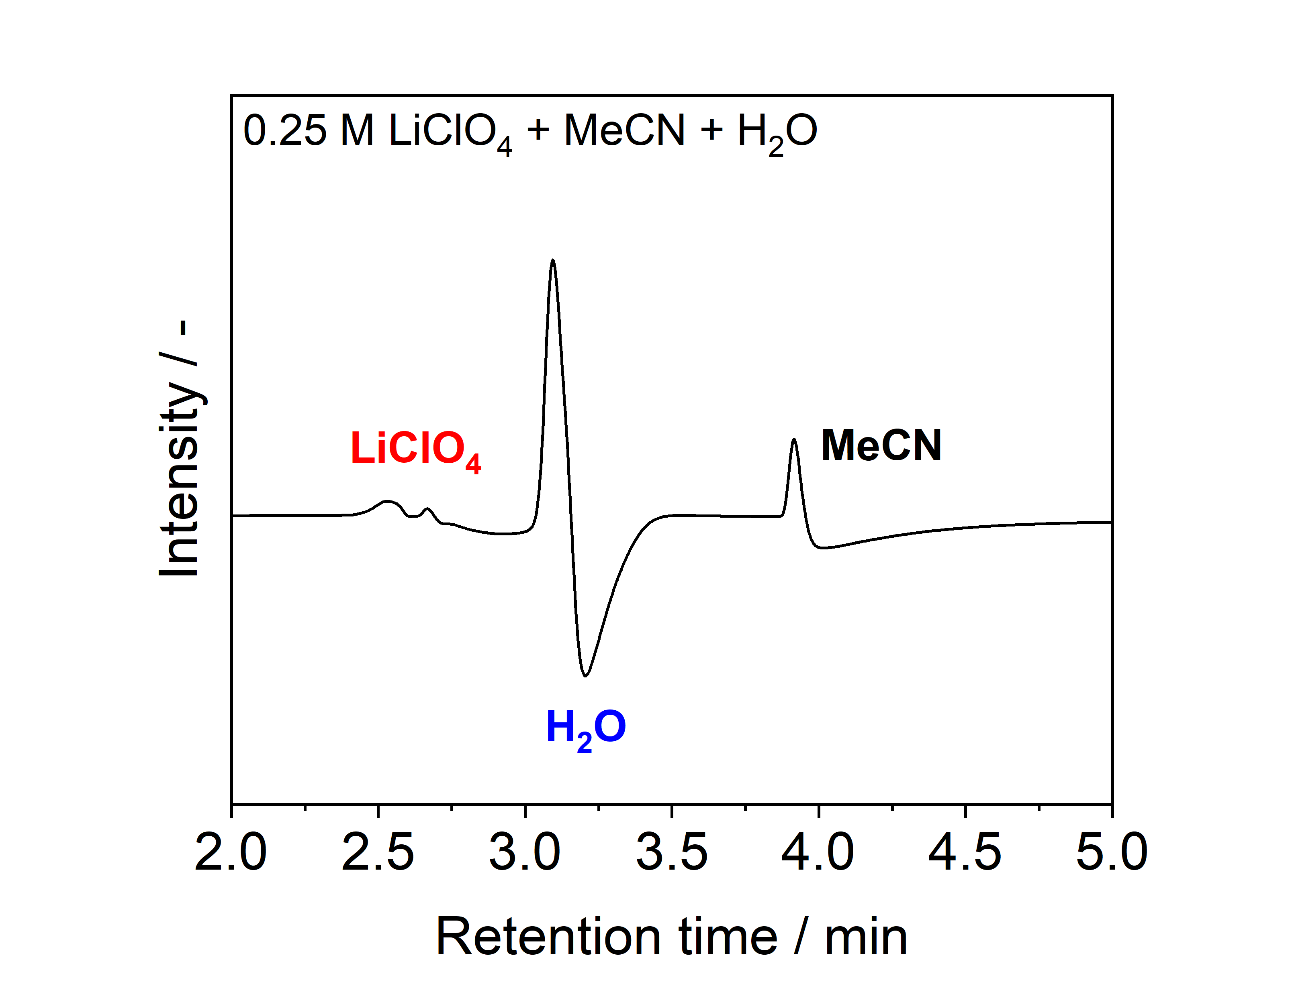
Figure S2. ¹H NMR spectra of a heterogeneous mixture of Li₂O₂ in d₃-MeCN with 20000 ppm H₂O taken at 0 h (black line) and 72 h (red line), showing the change ¹H chemical shift and intensity of the H₂O peak.

Figure S3. HPLC chromatogram of a 0.25 M LiClO₄ in MeCN electrolyte solution. The sample was added to H₂O before analysis.

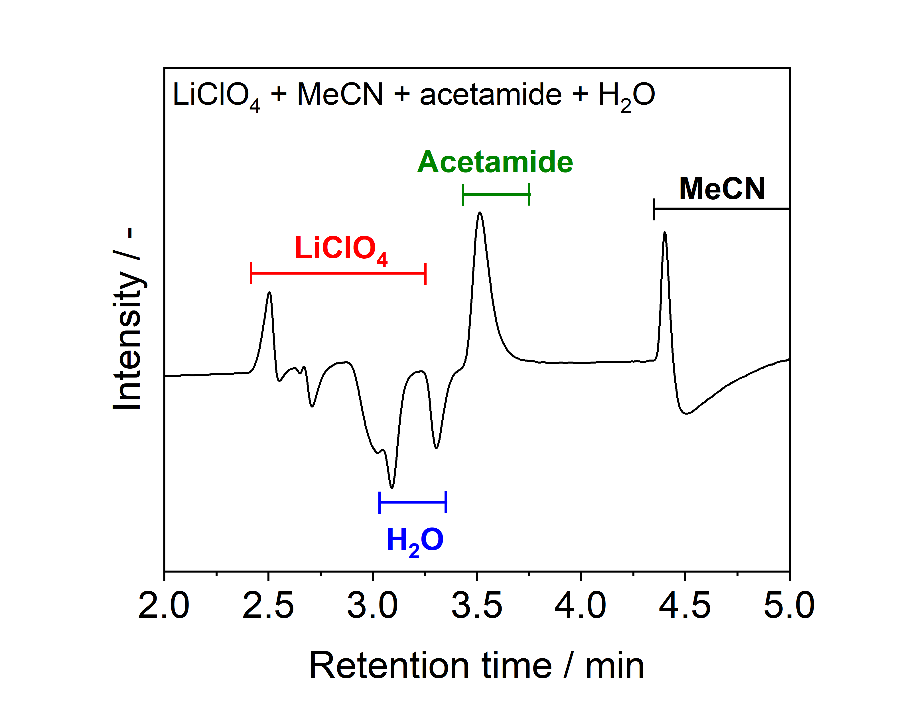
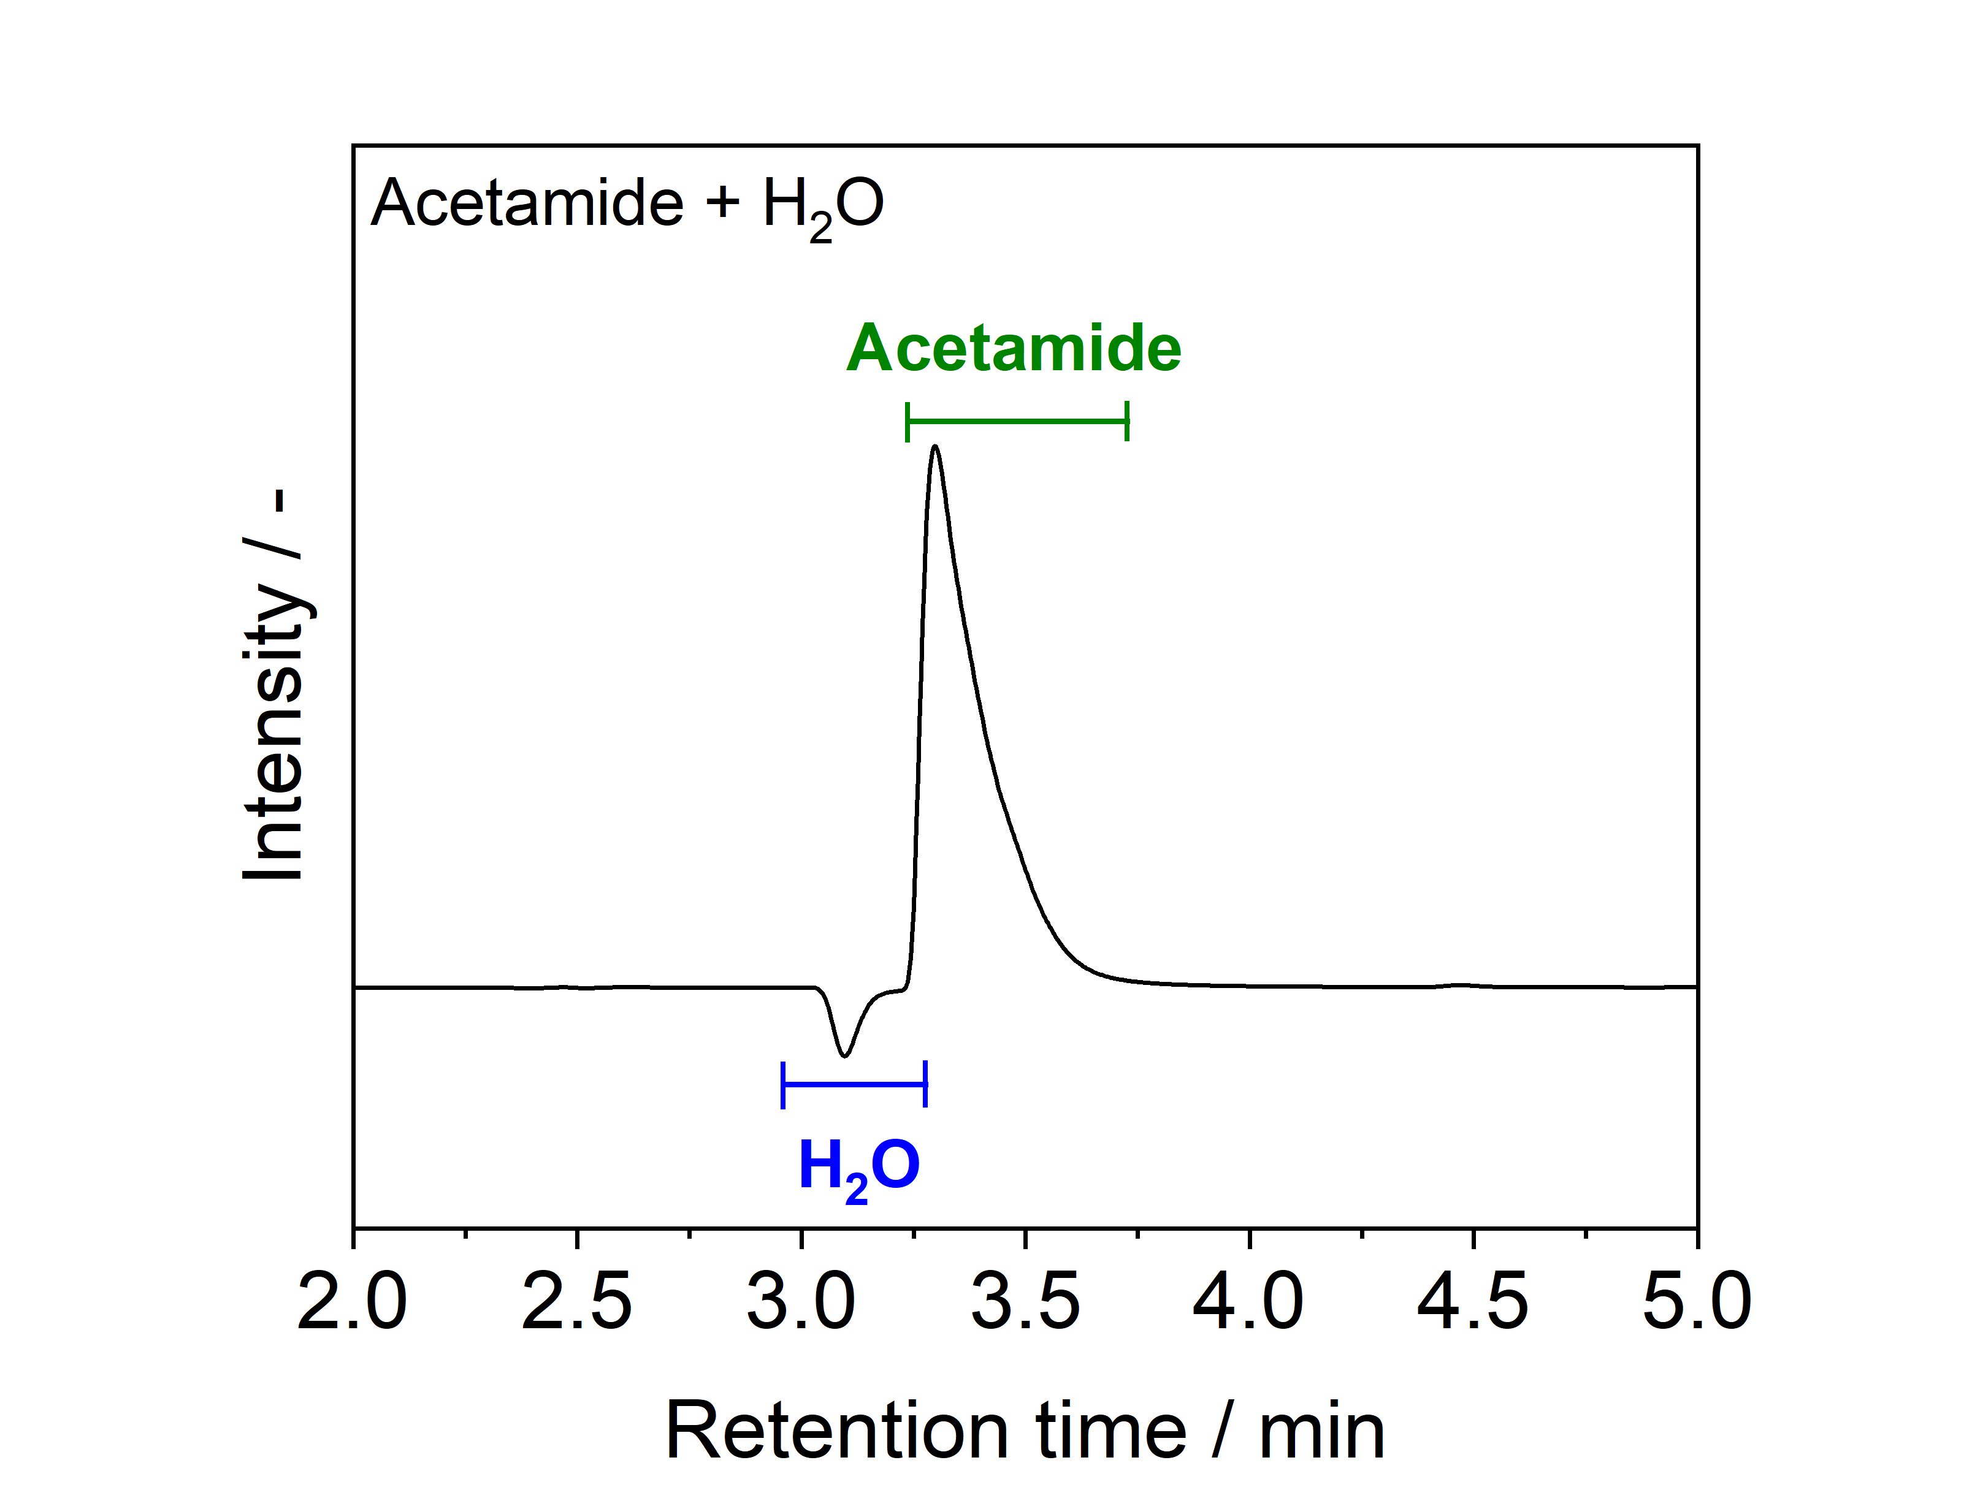
Figure S4. HPLC chromatogram of a solution of acetonitrile doped with LiClO₄ and acetamide. The sample was added to H₂O before analysis.
Figure S5. HPLC chromatogram of a solution of H₂O doped with acetamide.

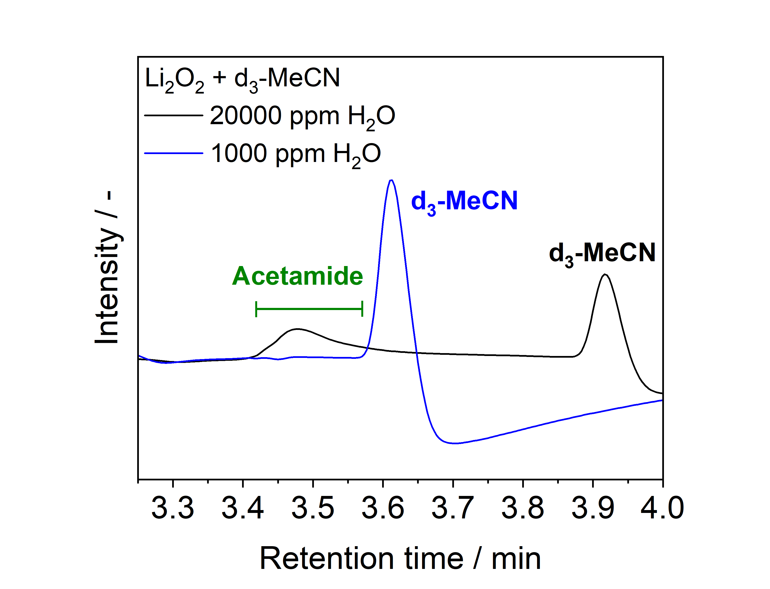
Figure S6. HPLC chromatograms collected from model chemical systems of Li₂O₂ in d₃-MeCN doped with either 20000 ppm (black line) H₂O, where a clear acetamide peak is observed, or 1000 ppm (blue line) H₂O, where no acetamide peak is observed 72 h after mixing. HPLC-MS analysis revealed the presence of acetamide in both samples, albeit low concentration with 1000 ppm H₂O. Samples were taken 72 h after the addition of H₂O. The samples were added to H₂O before analysis.
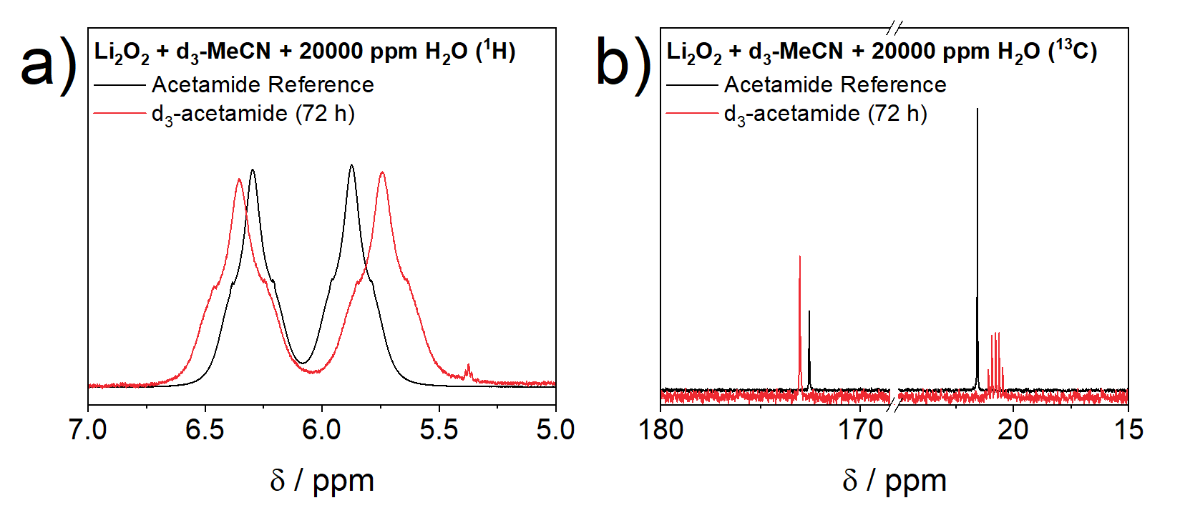
Figure S7. The regions of the a) ¹H and b) ¹³C NMR spectra where acetamide peaks are expected. A sample taken from a heterogeneous mixture of Li₂O₂ in d₃-MeCN doped with 20000 ppm H₂O after 72 h (red lines) is compared to reference acetamide spectra (black lines).

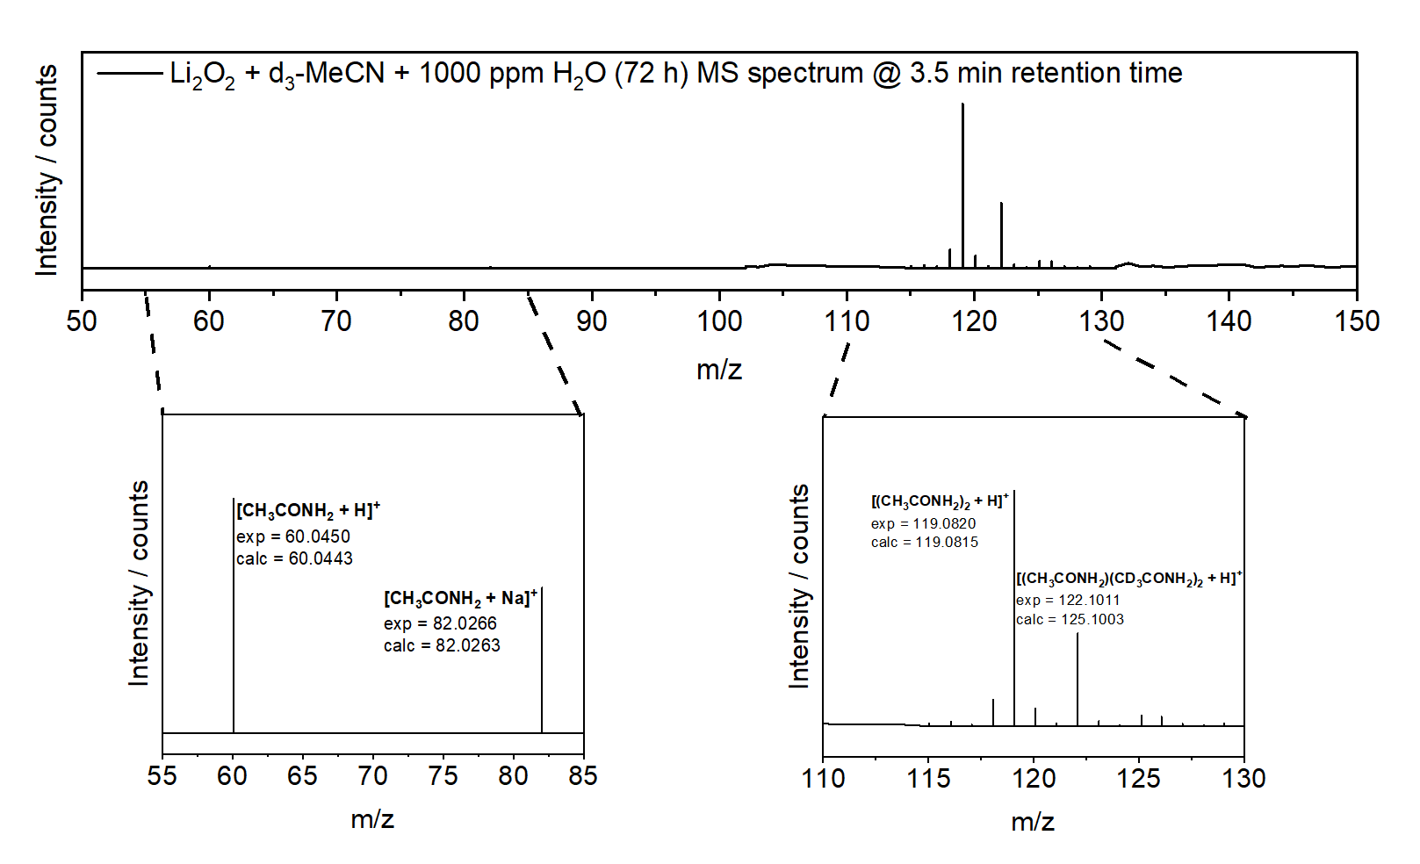
Figure S8. Mass spectrum collected through HPLC-MS of a H₂O solution doped with acetamide.

References
1 P. Hartmann, C. L. Bender, J. Sann, A. K. Dürr, M. Jansen, J. Janek and P. Adelhelm, Phys. Chem. Chem. Phys., 2013, 15, 11661–11672.
2 G. R. Fulmer, A. J. M. Miller, N. H. Sherden, H. E. Gottlieb, A. Nudelman, B. M. Stoltz, J. E. Bercaw and K. I. Goldberg, Organometallics, 2010, 29, 2176–2179.
3 J. Lai, Y. Xing, N. Chen, L. Li, F. Wu and R. Chen, Angew. Chem. Int. Ed., 2020, 59, 2974–2997.
4 T. Liu, J. P. Vivek, E. W. Zhao, J. Lei, N. Garcia-Araez and C. P. Grey, Chem. Rev., 2020, 120, 6558–6625.

