Supplementary materials
Alexithymia explains atypical spatio-temporal dynamics of eye gaze in autism
Table of Contents
Supplementary methods 2
Figure S.1. 2
Illustration of AOI discretization method 2
Figure S.2 3
Fourth order orthogonal (ot) time polynomials 3
Supplementary results 6
Table S.2 7
Zero-order correlations for aggregated data 7
Alexithymia x polynomial effects – timecourse analysis 13
Table S.4 14
Polynomial mixed model table for the final model (Alexithymia) 14
Control and additional analyses 16
Timecourse for the mouth AOI 18
Free-gaze condition: Effects of alexithymia and autism 18
Condition effects relative to the free-gaze baseline: Effects of alexithymia and autism 19
Entropy 20
Entropy checks 21
Aggregated fixation analyses – mouth AOI 22
Fixation count 23
Free-gaze condition: Effects of alexithymia and autism 23
Condition effects relative to the free-gaze baseline: Effects of alexithymia and autism 23
Free-gaze condition: Effects of alexithymia and autism 23
Condition effects relative to the free-gaze baseline: Effects of alexithymia and autism 23
Depression and anxiety 24
Age 24
Separate analyses by group 25
Additional data quality checks 27

Supplementary methods

Figure S.1.

Illustration of AOI discretization method
A B
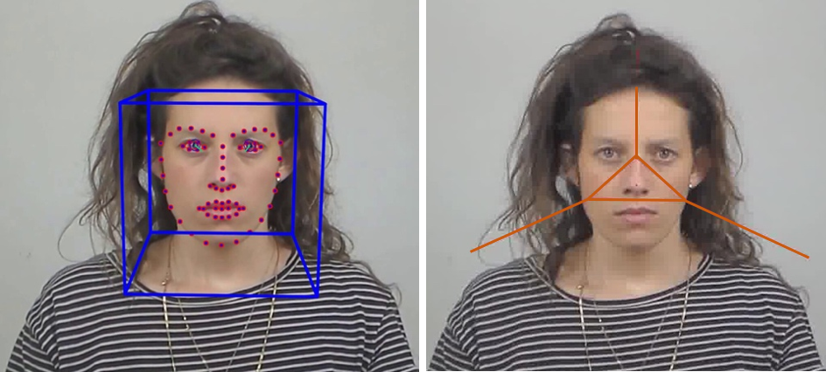
Notes.
A. Illustration of Openface facial landmarking (Baltrušaitis et al., 2016) on a sample stimulus used in the study (Yitzhak et al., 2017). This set was chosen as it contains subtle emotional displays which helps to avoid the recognition ceiling effects typically observed with high intensity expression datasets (Krumhuber, Kappas & Manstead, 2013).
B. Voronoi segmentation of AOIs using the Limited Radius Voronoi Tessellation method (LVRT method). Gaze points are assigned to the AOI with the minimum Euclidian distance from facial landmarks at every frame. Each AOI corresponded to approximately 200 pixels in radius (approximately 4° of visual angle; see Hessels et al., 2018 for more details on the method).

Figure S.2

Fourth order orthogonal (ot) time polynomials

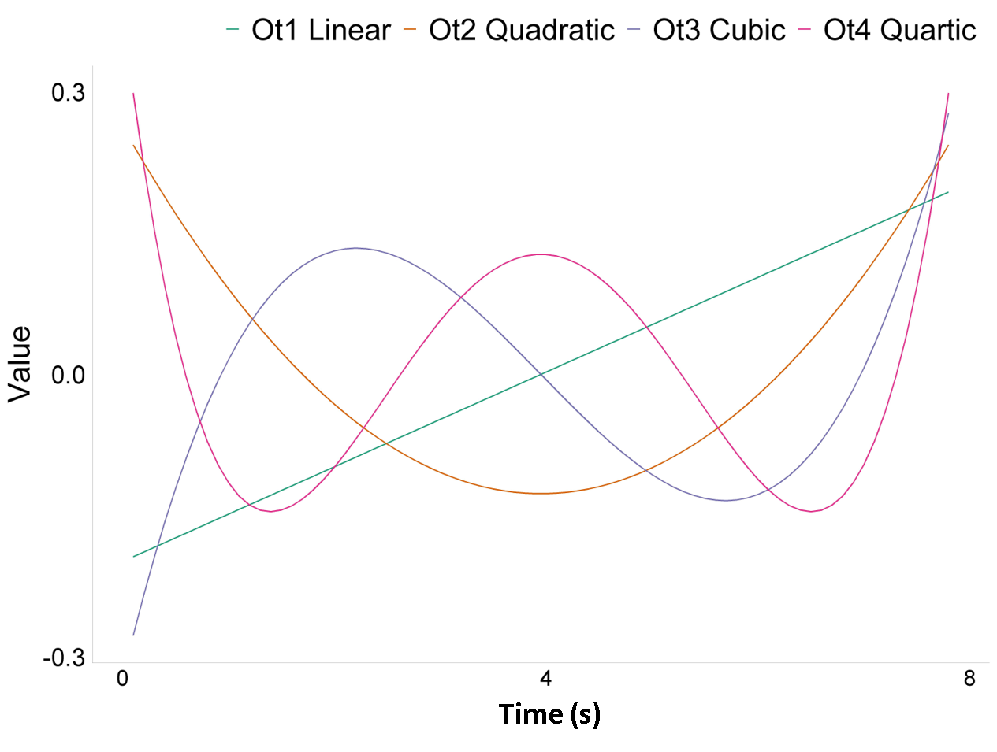
Notes. Fourth order orthogonal (ot) time polynomials were created based on the stimulus viewing window (7.8 seconds), and were used to model the non-linear trajectory of gaze points within each AOI over time. These polynomials were include as fixed effects as well as random slopes for participant and trial id (video stimulus). Additionally, the interaction between the polynomials and the other fixed effects of interest (autism, alexithymia, and condition) were also modelled.

Participants
A total of 90 participants were originally tested, 15 of whom took part in a pilot study, with 75 participants in the final study, of which 5 were excluded due to eye problems (e.g. severe cataract or extreme correction) or data quality issues, making a final sample of 70 participants whose data were analysed for the study. Statistical simulations for mixed models based on pilot data revealed that this sample size was sufficient to achieve 80% statistical power for our analyses.

Model building and model comparison
For timecourse analyses, free-gaze fitted models have the form:
Eye gaze proportion (elog) ~ 1 + Alexithymia * ot (overall effect of time - linear) + ot2(quadratic) + ot3(cubic) + ot4(quartic) + (1+ ot1 + ot2 + ot3+ot4 | Participant) + (1+ ot1 + ot2+ot3 + ot4 | Video id).
Where 1 is the overall intercept, Alexithymia and ot1 to ot4 terms are fixed effects, participant and video id are random intercepts. 1+ ot terms represent random slopes for participants and video id.
Condition models have the form:
Eye gaze proportion (elog) ~ 1 + Condition (reference = free-gaze) * Alexithymia (or group -5(ASC); +5 (NT) or Autistic traits) * (ot1+ot2+ot3+ot4)+ (1+ ot1 + ot2 + ot3 + ot4 | Participant) + (1+ ot1 + ot2 + ot3 + ot4 | Video id).
For the rest of the analyses (entropy and aggregated fixation), models have the form:
SGE/GTE (Shannon and conditional entropy in normalised bits) ~ 1+ Condition * Alexithymia (or group -5(ASC) +5 (NT) or Autistic traits) + (1 | Participant) + (1 |Video id) for free-gaze and alexithymia (see Table S.2 in Supplementary Materials for model building and comparison).

Random structure was simplified when near zero variance in random effects or convergence errors were identified. For model comparisons, each model of interest, for example, the alexithymia model containing alexithymia, condition, and its interactions with the polynomial time terms would be compared against the nested model without the effect of interest or its interactions (see Table S.3 & S.4 for details on model building, model comparison and the final model). The drop function in lmerTest package was also used to test for significant terms and the results were equivalent to the method above. For clarity of presentation, whenever models of interest performed better than random effects only, then results will normally be reported in relation to the simpler model (nested) not containing that term (e.g. alexithymia*condition vs. condition). This reflects the fact that if, for example, the condition model performs better than random effects only model, and the alexithymia by condition model outperforms the condition model, then it also outperforms the random effects model. To test the relative influence of alexithymia and autism on gaze patterns, models containing alexithymia and autism were also directly contrasted in a jointly fitted model which produced standardised estimates. Finally, although not a formal test, we estimated all models with Maximum Likelihood, and used the anova function to compare them based on AIC information criteria.

Supplementary results
Descriptive and correlational data are presented in Tables S.1 and S.2. Statistical detail for model building, model comparison and final models can be found in tables S.3 & S.4.
Table S.1
Descriptive aggregated data
Variable | NT  n = 45 |  | ASC  n = 25
 | M | SD | M | SD
Fixation
Fix dur (eyes) | 3457 | 1737.6 | 3307 | 1593.6
Fix count (eyes) | 7.72 | 3.92 | 6.97 | 3.30
Fix dur (mouth) | 1736.6 | 1217.6 | 1746.9 | 1253.5
Fix count (mouth) | 3.39 | 1.95 | 3.55 | 2.52
Entropy
SGE | .59 | .12 | .61 | .11
GTE | .28 | .03 | .29 | .04
ER Accuracy | .81 | .08 | .71 | .138
Notes. Fix dur (ms) = Fixation duration, calculated as the average of the total fixation durations to the AOI. Fix count = Fixation count, calculated as the average of the total number of fixations to the AOI. SGE = Stationary gaze entropy. GTE = Gaze transition entropy in normalised bits. ER = Emotion recognition.

Table S.2

Zero-order correlations for aggregated data
Variable | 1 | 2 | 3 | 4 | 5 | 6 | 7 | 8 | 9 | 10 | 11 | 12 | 13
1. TAS20 | 1
2. AQ28 | .4* | 1
3. DASS21 | .42* | .56*** | 1
4. IQ | .19 | .02 | .09 | 1
5. Age | .38 | .24 | .18 | .27 | 1
6. ER Acc | -.35 | -.2 | -.23 | -.05 | -.5** | 1
7. SGE | .16 | -.08 | .11 | -.07 | -.02 | -.04 | 1
8. GTE | .12 | -.02 | .18 | -.06 | -.06 | 0 | .92*** | 1
9. Fix dur eyes | -.22 | .05 | -.02 | .05 | -.13 | .09 | -.57*** | -.41* | 1
10. Fix dur mouth | .12 | -.05 | 0 | -.05 | .09 | -.14 | .32 | .27 | -.75*** | 1
11. Fix count eyes | -.22 | -.13 | -.18 | .03 | -.11 | .13 | -.4** | -.35** | .78*** | -.69*** | 1
12. Fix count mouth | .2 | -.09 | .01 | -.08 | .1 | -.1 | .34 | .21 | -.75*** | .84*** | -.59*** | 1
13. Sacc amp | .26 | -.02 | .27 | -.05 | .07 | -.26 | .3 | .27 | .01 | .08 | .05 | .19 | 1
Notes. * p < .05; ** p< .01, ***, p< .001. All correlations are Bonferroni-corrected. ER Acc: Emotion recognition accuracy; Fix dur: Fixation duration; Sacc amp: Saccade amplitude; GTE: Gaze transition entropy; SGE: Stationary gaze entropy.
Time course analysis

Model comparisons
For the free gaze, the alexithymia model also outperformed the autism model (ΔAIC = 63), and autistic traits model (modelling autistic traits as a continuous variable ΔAIC = 67; See Table S.2). Similarly, for the condition comparisons when directly contrasting the ML fitted models, the alexithymia model significantly outperformed the autism diagnosis (ΔAIC = 937) and traits (ΔAIC = 1671).
Table S.3
Model building and comparison
Sampling Units |  | N total obs = 509061  N Subjects = 70; N videos = 42
Model specification | Model name | Nested /  alternative | Fixed Effects added |  | Random Effects |  | Model fit |  |  |  | LRT Test against nested
 |  |  |  |  | Subjects | Items | AIC | BIC | LL | df | df | X2
Random Effects
RE | Null | - | - |  | Intercepts;  t to t³ poly slopes | Intercepts;  t to t² poly slopes | 1913907.6 | 1914152.7 | - 956931.8 | 28
Fixed Effects
FE  main effects | ots | Null | ot1+ot2+ot3+ot4 |  | Intercepts;  t to t³ poly slopes | Intercepts;  t to t² poly slopes | 1881964 | 1882320 | -940950 | 32 | 4 | 721.68  ***
FE  two-way interactions | Cond x  ots | ots | Cond*  (ot1+ot2+  ot3+ot4) |  | “ | “ | 1881606 | 1882130 | -940756 | 47 | 15 | 387.97  ***
FE  three-way interactions | Group x Cond x  ots | Cond x  ots | Group*  Cond*  (ot1+ot2+  ot3+ot4) |  | “ | “ | 1908570 | 1909205 | -954228 | 57 | 10 | nsª
FE  three-way interactions | AQ x  Cond x  ots | “ | AQ*  Cond*  (ot1+ot2+  ot3+ot4) |  | “ | “ | 1909304 | 1909939 | -954595 | 57 | 35 | 4629.60***
FE  three-way interactions | Alex x  Cond x  ots | “ | TAS*  Cond*  (ot1+ot2+ ot3+ot4) |  | “ | “ | 1907633 | 1908268 | -953760 | 57 | 35 | 6300.53***
FE  three-way interactions | Alexsplit x  Cond x  ots | “ | TASsplit*  Cond*  (ot1+ot2+ ot3+ot4) |  | “ | “ | 1908073 | 1908708 | -953980 | 57 | 0 | 496.58  ***

Sampling Units |  | N total obs = 509061  N Subjects = 70; N videos = 42
Model specification | Model name | Nested / alternative | Fixed Effects added |  | Random Effects |  | Model fit |  |  |  | LRT Test against nested
 |  |  |  |  | Subjects | Items | AIC | BIC | LL | df | df | X2
Model Comparisons (Three-way Interaction Models of Interest)
FE  three-way interactions | Alex  x  Cond x  ots | Group x Cond x  ots | TAS*  Cond*  (ot1+ot2+  ot3+ot4) |  | Intercepts;  t to t³ poly slopes | Intercepts;  t to t² poly slopes | 1907633 | 1908268 | -953760 | 57 | 0 | 936.65  ***
FE  three-way interactions | Alex  x  Cond x  ots | AQ x  Cond x  ots | TAS*  Cond*  (ot1+ot2+ ot3+ot4) |  | “ | “ | 1907633 | 1908268 | -953760 | 57 | 0 | 1670.93  ***
FE  three-way interactions | Alexsplit  x  Cond x  ots | Group x Cond x  ots | TASsplit*  Cond*  (ot1+ot2+ ot3+ot4) |  | “ | “ | 1908073 | 1908708 | -953980 | 57 | 0 | 496.58***
FE  three-way interactions | Alexsplit  x  Cond x  ots | AQ x  Cond x  ots | TASsplit*  Cond*  (ot1+ot2+ ot3+ot4) |  | “ | “ | 1908073 | 1908708 | -953980 | 57 | 0 | 1230.9***
FE  three-way interactions | Alexsplit  x  Cond x  ots | TAS x  Cond x  ots | TASsplit*  Cond*  (ot1+ot2+ ot3+ot4) |  | “ | “ | 1908073 | 1908708 | -953980 | 57 | 0 | ns

Sampling Units |  | N total obs = 509061  N Subjects = 70; N videos = 42
Model specification | Model name | Nested / simpler (or alternative) Model | Fixed Effects added |  | Random Effects |  | Model fit |  |  |  | LRT Test against nested
 |  |  |  |  | Subjects | Items | AIC | BIC | LL | df | df | X2
Additional Models with Control Variables
FE  three-way interactions +  Main effect | Alex x  Cond x  ots + Group | Cond x  ots | TAS*  Cond*  (ot1+ot2+ ot3+ot4)+  Group |  | Intercepts;  t to t³ poly slopes | Intercepts;  t to t² poly slopes | 1907635 | 1908281 | -953760 | 58 | 36 | 6300.7  ***
FE  three-way interactions +  Main effect | Alex x  Cond x  ots +  AQ | “ | TAS*  Cond*  (ot1+ot2+ ot3+ot4)+  AQ |  | “ | “ | 1907635 | 1908282 | -953760 | 58 | 36 | 6300.57  ***
FE  three-way interactions +  Main effect | Alex x  Cond x  ots + DepAnx | “ | TAS*  Cond*  (ot1+ot2+ ot3+ot4)+  DASS |  | “ | “ | 907635 | 1908282 | -953760 | 58 | 36 | 6300.5  ***
FE  three-way interactions +  Main effect | Alex x  Cond x  ots+  Age | “ | TAS*  Cond*  (ot1+ot2+ ot3+ot4)+  Age |  | “ | “ | 1908073 | 1908708 | -953980 | 57 | 35 | 5860.5  ***
FE  three-way interactions +  Main effect | Alex x  Cond x  ots +  IQ | “ | TAS*  Cond *  (ot1+ot2+ ot3+ot4)+  IQ |  | “ | “ | 1907633 | 1908279 | -953759 | 58 | 36 | 6302.7  ***

Sampling Units |  | N total obs = 509061  N Subjects = 70; N videos = 42
Model specification | Model name | Nested /  alternative | Fixed Effects added |  | Random Effects |  | Model fit |  |  |  | LRT Test against nested
 |  |  |  |  | Subjects | Items | AIC | BIC | LL | df | df | X2
Additional Models with Control Variables
FE  three-way interactions | DepAnx x  Cond x  ots | Cond x  ots | DASS*  Cond*  (ot1+ot2+ ot3+ot4) |  | Intercepts;  t to t³  poly  slopes | Intercepts;  t to t²  poly  slopes | convergence warning –  Recalculation of hessian gradient > tolerance
FE  three-way interactions | Age- Cond x  ots | “ | Age*  Cond*  (ot1+ot2+ ot3+ot4) |  | “ | “ | convergence warning –  Recalculation of hessian gradient > tolerance
FE  three-way interactions | IQ x  Cond x  ots | “ | IQ*  Cond*  (ot1+ot2+ ot3+ot4) |  | “ | “ | convergence warning –  Recalculation of hessian gradient > tolerance
Notes.
Alex – Alexithymia (measured with TAS20)  Alexsplit – Alexithymia, dichotomised by median spit  AIC – Aikake Information Criterion  AQ – Autistic traits measured by AQ28  BIC – Bayesian Information Criterion  Cond – Conditions (free-gaze, emotion recognition, cued and intensity judgment conditions)  DepAnx – Depression and anxiety measured by DASS21  df – degrees of freedom | FE – Fixed effects  IQ – Intelligence Quotient measured by WASI  LL – LogLikelihood  LRT – Likelihood Ratio Test  X2 – Chi-square  RE - Random effects  ots – orthogonal time polynomials ( up to the quartic);  Poly – Polynomials.
Note that the LRT test (LL, Chi-square) is provided in all models for completeness sake, yet they are only valid for nested comparisons. In non-nested cases, the assessment of the models relied on AIC and joint estimated standardised estimates.

Alexithymia x polynomial effects – timecourse analysis
Free-gaze: There was a main-effect of the quartic polynomial, indicating that a quartic function best describes eye gaze over time (Estimate = -.54, SE = .15, p < .001). This reflects the pattern of small gaze changes between different AOIs and reduced eye attention at the beginning and end of the time window. Alexithymia interacted with the cubic (Estimate = - .27, SE = .04, p < .001), and quartic terms (Estimate = .23, SE = .04, p < .001), suggesting that the rate of gaze changes differs throughout the timecourse as a function of alexithymia, with highly alexithymic individuals reaching near asymptote after reduced attention to the eyes early in the trial.
Condition vs free-gaze baseline: Alexithymia had a significant effect on the quadratic polynomial term for the emotion recognition (Estimate = -.45, SE = .05, p < .001) and intensity judgement (Estimate = -.27, SE = .05, p < .001) but not the cued conditions (Estimate = .057, SE = .05, ns). There was also a significant interaction between alexithymia and condition on the cubic term for the emotion recognition (Estimate = .49, SE = .054, p < .001), cued (Estimate = .32, SE = .054, p < .001) and intensity judgement conditions (Estimate = .31, SE = .053, p < .001). Finally, the interaction between alexithymia and condition was also significant for the quartic time term, showing that relative to free-gaze, there was a significant interaction effect during the emotion recognition (Estimate = -.45, SE= .054, p < .001), cued (Estimate = -.37, SE = .053, p < .001) and intensity judgement conditions (Estimate = -.37, SE = .053, p <.001). See full details in Table S.4.

Table S.4

Polynomial mixed model table for the final model (Alexithymia)
Fixed Effects
Terms | Estimate  /Beta | 95CI | SE | t | p
Main Effects
(Intercept) | 2.80 | 2.59 - 3.02 | 0.10 | 25.96 | < .001***
Alexithymia | -0.49 | -0.69 - -0.28 | 0.10 | 25.96 | < .001***
Recognition | 0.35 | 0.34 - 0.36 | 0.01 | -4.66 | < .001***
Cued | 0.33 | 0.32 - 0.34 | 0.01 | 55.78 | < .001***
Intensity | 0.31 | 0.29 -0.32 | 0.01 | 52.77 | < .001***
ot | -0.30 | -0.62 - 0.02 | 0.16 | -1.85 | 0.067^{ns}
ot² | -0.06 | -0.36 - 0.25 | 0.16 | -0.38 | 0.706 ^{ns}
ot³ | 0.15 | -0.03 - 0.33 | 0.09 | 1.64 | 0.104 ^{ns}
ot⁴ | -0.59 | -0.66 - -0.51 | 0.04 | -15.38 | <0.001***
Two-way Interactions
Alexithymia:Recognition | 0.21 | 0.20 - 0.23 | 0.01 | 34.30 | <0.001***
Alexithymia:Cued | 0.15 | 0.14 - 0.166 | 0.01 | 25.24 | <0.001***
Alexithymia:Intensity | 0.23 | 0.21 - 0.24 | 0.01 | 36.94 | <0.001***
Alexithymia:ot | 0.12 | -0.15 - 0.39 | 0.14 | 0.88 | 0.382
Alexithymia:ot² | 0.13 | -0.15 - 0.41 | 0.14 | 0.91 | 0.366
Alexithymia:ot³ | -0.36 | -0.53 - 0.18 | 0.09 | -3.97 | <0.001***
Alexithymia:ot⁴ | 0.27 | 0.19 - 0.34 | 0.04 | 7.22 | <0.001***
Recognition:ot | 0.64 | 0.53 - 0.75 | 0.05 | 11.70 | <0.001***
Cued:ot | 0.19 | 0.07 - 0.29 | 0.06 | 3.36 | 0.001**
Intensity:ot | 0.37 | 0.26 - 0.47 | 0.05 | 6.77 | <0.001***
Recognition:ot2 | -0.59 | 0.70 - -0.48 | 0.06 | -10.70 | <0.001***
Cued:ot2 | -0.29 | -0.40 - -0.18 | 0.06 | -5.27 | <0.001***
Intensity:ot2 | -0.36 | -0.47 - -0.25 | 0.05 | -6.64 | <0.001***
Recognition:ot3 | 0.46 | 0.35 - 0.56 | 0.06 | 8.39 | <0.001***
Cued:ot3 | 0.27 | 0.16 - 0.37 | 0.06 | 4.83 | <0.001***
Intensity:ot3 | 0.21 | 0.10 - 0.31 | 0.05 | 3.88 | <0.001***
Recognition:ot4 | -0.06 | -0.17 - 0.04 | 0.05 | -1.11 | 0.265
Cued:ot4 | 0.20 | 0.08 - 0.30 | 0.06 | 3.56 | <0.001***
Intensity:ot4 | 0.21 | 0.10 - 0.32 | 0.05 | 3.91 | <0.001***
Cont…

Fixed effects
Terms | Estimate  /Beta |  | SE | t | p
Three-way Interactions
Alexithymia:Recognition:ot1 | 0.11 | 0.003 - 0.22 | 0.05 | 2.02 | 0.043
Alexithymia:Cued:ot1 | -0.14 | -0.24 - -0.033 | 0.05 | -2.58 | 0.01*
Alexithymia:Intensity:ot1 | -0.23 | -0.33- -0.12 | 0.05 | -4.22 | <0.001***
Alexithymia:Recognition:ot2 | -0.45 | -0.56 - -0.34 | 0.05 | -8.24 | <0.001***
Alexithymia:Cued:ot2 | 0.06 | -0.05 - 0.16 | 0.05 | 1.06 | 0.290
Alexithymia:Intensity:ot2 | -0.28 | -0.38 - -0.17 | 0.05 | -5.19 | <0.001***
Alexithymia:Recognition:ot3 | 0.49 | 0.38 - 0.59 | 0.05 | 8.92 | <0.001***
Alexithymia:Cued:ot3 | 0.32 | 0.21 - 0.42 | 0.05 | 5.87 | <0.001***
Alexithymia:Intensity:ot3 | 0.31 | 0.20 - 0.41 | 0.05 | 5.79 | <0.001***
Alexithymia:Recognition:ot4 | -0.46 | -0.56 - -0.35 | 0.05 | -8.48 | <0.001***
Alexithymia:Cued:ot4 | -0.37 | -0.47 - -0.26 | 0.05 | -6.88 | <0.001***
Alexithymia:Intensity:ot4 | -0.37 | -0.47 - -0.2 | 0.05 | -6.95 | <0.001***
Random effects
 |  |  | Variance | SD | Correlation
Participant(intercept) |  |  | 0.79 | 0.89
ot1 | Participant (intercept) |  |  | 1.23 | 1.11 | 0.25
ot2 (slope) | Participant (intercept) |  |  | 1.35 | 1.16 | 0.02
ot3 (slope) | Participant (intercept) |  |  | 0.47 | 0.69 | ..1414
Videos (intercept) |  |  | 0.01566 | 0.1251
ot1 | Video (intercept) |  |  | 0.30671 | 0.5538 | -0.16
ot2 | Video (intercept) |  |  | 0.13793 | 0.3714 | -0.02
Model fit
R² |  |  |  | Marginal | Conditional
 |  |  |  | .04 | .29
Key: p-values for fixed effects calculated using Satterthwaite’s approximations. Confidence Intervals have been calculated using profile confidence intervals.
Model equation: Eye gaze elog ~ Alexithymia * Condition * (ot1+ot2+ot3+ot4) + (1 + ot1 + ot2 | Video) + (1 + ot1 + ot2 + ot3 | Participant). Condition is a factor referenced against free-gaze.
Notes. * p < .05; ** p< .01, ***, p< .001, ns = non-significant. ot to ot⁴ = orthogonal polynomial time terms included in the model. The table shows only critical interactions terms for the models of interest. All continuous predictors where mean centred and scaled.

Post-hoc tests on each condition separately revealed that alexithymia still predicted reduced eye gaze throughout the timecourse for all conditions including the emotion recognition (Estimate = -.16 [95CI: -0.49 - -0.09], SE = .004, t = -2.81, p< .001), cued (Estimate = -.20[95%CI: -0.49 - -0.12], SE = .04, t = -3.25, p< .001) and intensity judgement (Estimate = -.13 [95%CI = -0.49 - -0.03] ; SE = .004, t = -2.19,p < .001) conditions.

Control and additional analyses
Time course analyses excluding the first .05 seconds

There is a valid concern that the fast orientation to eyes in the first few milliseconds, may make it so that one requires high-order polynomials to describe the time course of eyegaze proportions appropriately, even if the measure at this period may be relative and unreliable. The visualisation and analyses below excluded the first 500 ms. Overall there is still an effect of alexithymia and condition on both the offset and eye gaze and the overall shape that describes eye gaze allocation overtime, with marked non-linear trends in free-gaze compared to recognition, cue and intensity conditions (See Figure S3 and Table S5).

Figure S3.
Time course model of eyegaze without the first 500ms
Notes: Alexithymia predicted reduced eyegaze over time and the nonlinear trends in eye gaze probabilities as a function of condition. Alexithymia was used as a continuous predictor; the split high vs low is simply for visualisation purposes.

Table S.5

Polynomial mixed model table for the final model (Alexithymia) without the first 500 ms

 | Elog
Predictors | Estimates | CI | p
Main Effects
(Intercept) | 2.81 | 2.60 – 3.03 | <0.001
condition [2. Reco] | 0.38 | 0.31 – 0.44 | <0.001
condition [3. Cued] | 0.34 | 0.28 – 0.41 | <0.001
condition [4. Inten] | 0.32 | 0.26 – 0.39 | <0.001
Alexithymia | -0.50 | -0.71 – -0.29 | <0.001
poly1 | -0.41 | -0.73 – -0.09 | 0.011
poly2 | 0.23 | 0.04 – 0.42 | 0.015
poly3 | -0.31 | -0.38 – -0.24 | <0.001
poly4 | -0.00 | -0.08 – 0.07 | 0.911
Two-way interactions
condition [2. Reco] *Alexithymia | 0.23 | 0.22 – 0.25 | <0.001
condition [3. Cued] *Alexithymia | 0.16 | 0.15 – 0.17 | <0.001
condition [4. Inten] *Alexithymia | 0.23 | 0.22 – 0.25 | <0.001
condition [2. Reco] *poly1 | 0.25 | -0.04 – 0.53 | 0.094
condition [3. Cued] *poly1 | 0.06 | -0.22 – 0.35 | 0.667
condition [4. Inten] *poly1 | 0.20 | -0.08 – 0.49 | 0.166
condition [2. Reco] *poly2 | -0.22 | -0.48 – 0.05 | 0.107
condition [3. Cued] *poly2 | -0.20 | -0.47 – 0.06 | 0.131
condition [4. Inten] *poly2 | -0.20 | -0.47 – 0.06 | 0.132
condition [2. Reco] *poly3 | 0.26 | 0.15 – 0.37 | <0.001
condition [3. Cued] *poly3 | 0.39 | 0.29 – 0.50 | <0.001
condition [4. Inten] *poly3 | 0.31 | 0.21 – 0.42 | <0.001
condition [2. Reco] *poly4 | 0.02 | -0.08 – 0.13 | 0.696
condition [3. Cued] *poly4 | -0.10 | -0.21 – 0.00 | 0.058
condition [4. Inten] *poly4 | -0.04 | -0.14 – 0.07 | 0.483
Alexithymia * poly1 | 0.31 | 0.06 – 0.56 | 0.015
Alexithymia * poly2 | -0.12 | -0.20 – -0.05 | 0.001
Alexithymia * poly3 | -0.11 | -0.19 – -0.04 | 0.002
Alexithymia * poly4 | 0.24 | 0.16 – 0.31 | <0.001
Three-way Interactions
(condition [2. Reco] *Alexithymia) * poly1 | -0.22 | -0.33 – -0.12 | <0.001
(condition [3. Cued] *Alexithymia) * poly1 | -0.24 | -0.34 – -0.14 | <0.001
(condition [4. Inten] *Alexithymia) * poly1 | -0.39 | -0.49 – -0.29 | <0.001
(condition [2. Reco] *Alexithymia) * poly2 | 0.04 | -0.06 – 0.15 | 0.428
(condition [3. Cued] *Alexithymia) * poly2 | 0.31 | 0.21 – 0.41 | <0.001
(condition [4. Inten] *Alexithymia) * poly2 | 0.04 | -0.07 – 0.14 | 0.481
(condition [2. Reco] *Alexithymia) * poly3 | 0.09 | -0.02 – 0.19 | 0.109
(condition [3. Cued] *Alexithymia) * poly3 | 0.08 | -0.02 – 0.18 | 0.133
(condition [4. Inten] *Alexithymia) * poly3 | 0.09 | -0.01 – 0.19 | 0.077
(condition [2. Reco] *Alexithymia) * poly4 | -0.15 | -0.26 – -0.05 | 0.004
(condition [3. Cued] *Alexithymia) * poly4 | -0.27 | -0.37 – -0.17 | <0.001
(condition [4. Inten] *Alexithymia) * poly4 | -0.31 | -0.41 – -0.20 | <0.001
Random Effects
σ² | 2.40
τ₀₀ _{video_condition} | 0.02
τ₀₀ _{participantname} | 0.80
τ₁₁ _{video_condition.poly1} | 0.39
τ₁₁ _{v video_condition.poly2} | 0.32
τ₁₁ _{participantname.poly1} | 1.06
ρ₀₁ _{video_condition.poly1} | 0.10
ρ₀₁ _{video_condition.poly2} | -0.17
ρ₀₁ _{participantname} | 0.14
ICC | 0.26
N _{video_ondition} | 168
N _{participantname} | 70
Observations | 469326
Marginal R² / Conditional R² | 0.047 / 0.297

Notes. All continuous predictors where mean centred and scaled. Condition was referenced on free-gaze. Random slope structure was simplified due to convergence errors and near zero variance.

We also ran the same analyses excluding the first second, and the results were consistent with the main difference being that the model did not need a quartic term to be well fitted, nonetheless, the higher order terms (quadratic and cubic) provided improved fit compared to only the linear term (χ² = 376, ΔAIC = 353 p < .001).

Timecourse for the mouth AOI

Free-gaze condition: Effects of alexithymia and autism
For the free-gaze condition, none of the models of interest (alexithymia, autism diagnosis or autistic traits) improved model fit compared to the polynomial model, which outperformed the random effects only model in predicting the timecourse of mouth attention (χ² = 476, ΔAIC = 31, p < .001). Therefore, only the polynomial model was interpreted.
This model indicates that mouth gaze trajectory in free-viewing was described well by fourth order terms. There was a significant effect of the linear term (Estimate = .84, SE= .34, p = .02), indicating an increase of attention to the mouth over time, and a negative effect of the quadratic term (Estimate = -.71, SE = .28, p = .01), indicating that attention to the mouth is low at the start and at the end of the stimulus, and a significant effect of the quartic term (Estimate = .8, SE = .13, p < .001) indicating nonlinear changes in the probability of mouth gaze throughout the timecourse. No other effects were significant.

Condition effects relative to the free-gaze baseline: Effects of alexithymia and autism
As with eye gaze, the alexithymia model outperformed the condition model (χ² = 13909, ΔAIC = 13869, p < .001). Alexithymia also provided improved fit over the autism diagnosis (ΔAIC = 12953) and traits models (ΔAIC = 13550), in predicting how the timecourse of gaze to the mouth was changed by task. The alexithymia model revealed a significant interaction between alexithymia and condition on the quartic term during the intensity judgement condition only (Estimate = -.029, SE = .08, p < .001).

The time-based cluster analysis of the mouth gaze timecourse suggested only two small significant time windows at the extremes of the stimulus window, spanning the first 300 ms and the last 800 ms. The bootstrapping procedure indicated that these clusters were not significant (p > .05). This suggests that taking into account individual differences in alexithymia or autism and autistic traits might result in overfitting for the mouth gaze timecourse, and that simpler models including task manipulations and polynomials likely suffice.

Entropy
The distribution of entropy was zero inflated, i.e. continuous apart from a spike (a second mode) in zero. This resulted from trials with no gaze transitions (e.g. where only one region of the face was looked at) leading to zero entropy. Therefore, these models were refitted with zero truncated Poisson distribution as well as excluding the zero cases, and results remained unchanged.
Entropy was used to assess the level of complexity underlying the distribution of fixations and the efficiency of scanning behaviour. To confirm that entropy measures were meaningful, the relationship between entropy and a standard gaze metric, fixation duration, was assessed. Longer fixations should, in general, produce minimal entropy, due to a less complex pattern of fixations. This is because longer fixations should be inversely related to the chance of transitioning between multiple gaze targets. As expected, fixation duration correlated negatively with SGE (r = -.82, p < .001) and GTE (r = - .31, p < .01). This relationship was mainly driven by fixation duration to eyes with SGE (r_{eyes} = -.57, p < .001) and GTE (r_{eyes} = -.41 p < .05), whereas fixation duration to the mouth was not significantly related to SGE (r_{mouth} = .32, ns) or GTE (r_{mouth} = .34, ns). Following a visual inspection however, it became evident that the relationship between fixation duration and entropy is non-linear (see Figure S.4).

Figure S.4

Entropy checks

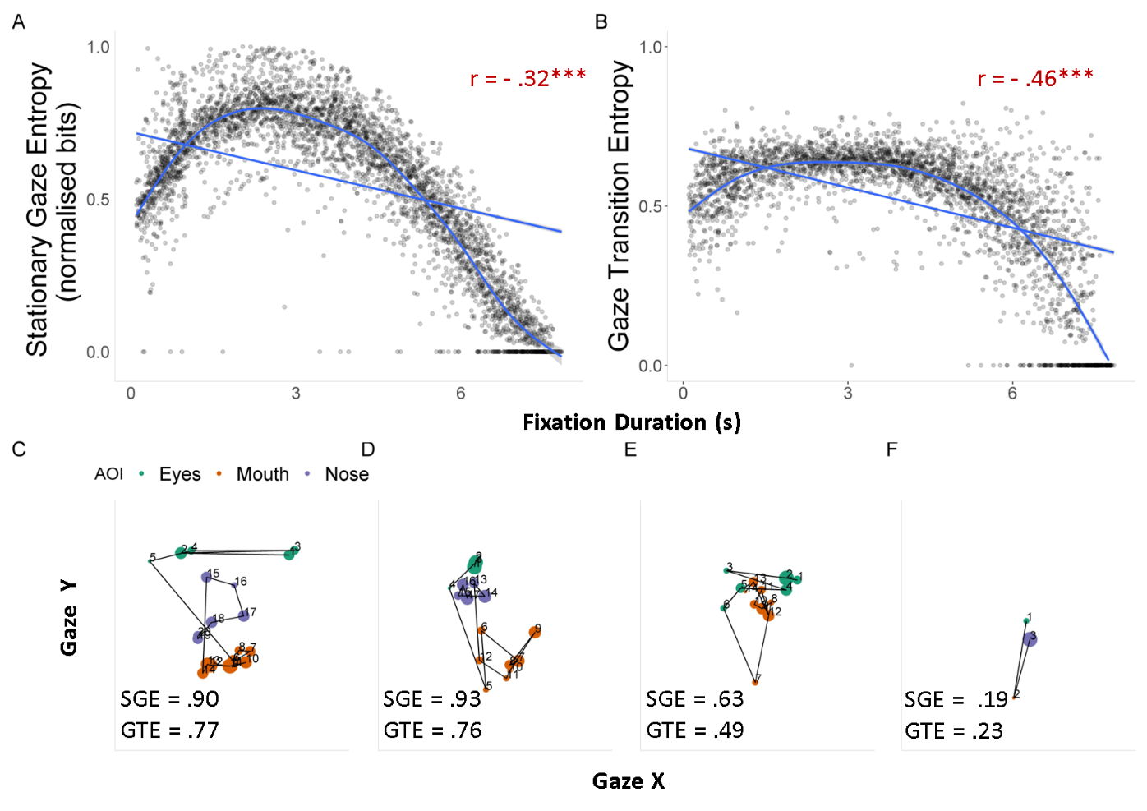
Notes.
A & B: Scatterplots indicate a nonlinear yet largely negative relationship between entropy and fixation duration.
C & F: Ordered sample scanpaths and entropy scores (in normalised bits) for a sample participant (NT) viewing a happy expression in the emotion recognition condition.
D & E: Ordered sample scanpaths and entropy scores for an autistic participant viewing disgust and anger expressions in the emotion recognition and cued conditions. The size of the circles represent duration of the fixation, larger circles indicate increased fixation duration. High values of entropy indicate increased fixation dispersion (SGE) or transitions (GTE), which suggests increased randomness and reduced predictability in gaze behaviour. Entropy data includes fixation to all areas of interest (eyes, nose and mouth).

Like longer fixations, shorter fixations also lead to reduced entropy. This pattern was not anticipated, but suggests shorter total fixation durations also imply less chance of transitioning between different state spaces. Overall, however, these checks suggest that the entropy metrics are appropriately capturing the dispersion of gaze data as well as the complexity of transitions.

SGE & GTE model comparisons
When directly contrasting ML fitted models for SGE, the alexithymia model provided a better fit than the autism diagnosis (ΔAIC = 21) and traits (ΔAIC = 14) models. Similarly, for GTE, alexithymia provided a better fit than the autism diagnosis (ΔAIC = 12) and traits (ΔAIC = 5) models, indicating that alexithymia is a better predictor of the complexity of fixation dispersion and transitions.

Aggregated fixation analyses – mouth AOI
Fixation count was calculated as the average of the total number of fixations to an AOI per trial. Fixation duration was calculated as the sum of the durations of all fixations to an AOI per trial.

Fixation count

Free-gaze condition: Effects of alexithymia and autism
For mouth fixations during the free-gaze condition, none of the models provided a significant improvement in fit compared to the random effects only model, or relative to one another, therefore, they were not further interpreted.

Condition effects relative to the free-gaze baseline: Effects of alexithymia and autism
For the condition analysis, model selection indicated that all models had a worse fit than the baseline null models (χ² = 6.5, ΔAIC = -2, ns) and so these higher-level models were also not further interpreted.
Fixation duration

Free-gaze condition: Effects of alexithymia and autism
None of the regressors improved model predictions for duration of mouth fixations in the free-gaze condition beyond the random effects models. Therefore none of these models were interpreted further, as this suggests that duration of mouth fixations is not explained beyond variability in participants and stimuli.

Condition effects relative to the free-gaze baseline: Effects of alexithymia and autism
For the analysis including all conditions, fixation duration to the mouth was best predicted by the autism model when compared to the alexithymia model (ΔAIC = 8). However, compared to condition and random effects models the autism model was significantly penalised for complexity under the BIC criteria, which suggests overfitting. This suggests that experimental manipulations may be a better predictor of mouth fixation duration. The condition model (χ² = 51.15, ΔAIC = 45, p < .001) indicates a significant decrease in fixation duration to mouth for the recognition (Estimate = -.11, SE = .02, p < .001), and intensity judgement conditions (Estimate = -.09, SE = .02) but not the cued condition (Estimate = -.009, SE = .1, p = .6).

Depression and anxiety
The autistic group had a range of other clinical traits/symptoms that were not the focus of this study, particularly depression and anxiety (as measured by the DASS21), as is typically observed in autistic populations (Lugo-Marín et al., 2019). To check for any confounding effect of these traits, a model with DASS scores was fitted and compared to the alexithymia model. The results showed that the alexithymia model outperformed the Depression-Anxiety-Stress model in terms of fit (ΔAIC = 9975), with small but significant effect on eye gaze (std estimate = -.276, std SE = .06, p< .001), compared to a nonsignificant effect of Depression-Anxiety-Stress (std estimate = -.02, std. SE = .06, ns). Crucially, effects could not have been driven by depression and anxiety in the autistic group, as the strength of the correlation between alexithymia and DASS scores was similar and non-significant in both groups separately (r_{autism} = .10, ns; r_{NT} = .18, ns; see also separate analyses by group below). DASS scores were therefore not further considered for analysis, to prevent overparametisation and overfitting of models. Although it is desirable that future studies with larger ASC samples attempt to achieve full orthogonality of clinical predictors, it is worth noting that this usually comes at the cost of representativeness and generalisability.

Age
A further control analysis was conducted to ensure that age was not a contributing factor in the eye gaze results as the autistic group, although matched to the NT group in terms of IQ and gender, was on average older. This issue was addressed in two ways. First, a separate model for age was fitted and model selection once again favoured Alexithymia (χ² = 11629; AIC = 11629, p < .001). Similarly, when jointly estimated, alexithymia showed a larger and significant effect (std estimate = -.32, std SE = .06, p< .001) than age (Std. estimate = .07, Std. SE = .06, ns). Second, a variation of the main timecourse analysis was conducted using a subsample of the groups selected to match on age. This sample had 37 NT (M_{age} = 27.68, SD = 6.21) and 15 ASC (M_{age} = 29.76, SD = 6.03; F_{(1,50)} = 1.12, MSE = 39.45, p = .30) participants. Using this subsample we found results consistent with the main analysis, the alexithymia model outperformed all models, including age (ΔAIC = 6660; see also separate analyses by group).

Separate analyses by group
It may also be argued that comparing the autism model (based on diagnosis) to alexithymia is not sensitive to variance in autistic traits or symptom severity, and that trait or symptom severity models may be better predictors of eye gaze than a binary diagnosis variable. As detailed in the main text, autistic trait models usually performed worse than or similar to the autism diagnosis model which were usually eliminated in a refitted backwards selection when estimated jointly with Alexithymia. However, to guard against potential confounds of group differences in score ranges and variance, timecourse analyses were re-fitted separately for each group, while controlling for autistic traits and alexithymia in neurotypical controls and the autistic group separately. In addition to these analyses, the effect of ADOS scores was also examined in the autistic group. Results were consistent with previous analyses. As shown in Table S.5, alexithymia outperformed all models in predicting eye gaze behaviour in both autistic and neurotypical control individuals.

Table S.5.
Model comparison by group
Group | Condition | AQ | ADOS | Alexithymia
Autism
Δ -2LL | 742491 | 738507 | 738290 | 737317
Χ² | 3102 | 881 | 216.94 | 972.64
ΔAIC | 3073 | 841 | 217 | 973
ΔBIC | 2920 | 640 | 217 | 972
p < .001 | *** | *** | *** | ***
Neurotypicals
Δ -2LL | __ | 1197091 | __ | 1196668
Χ² (1) | __ | 548.34 | __ | 422.27
ΔAIC | __ | 508 | __ | 423
ΔBIC | __ | 294 | __ | 422
p < .001 | __ | *** | __ | ***
Notes. All models were fitted with an interaction to the fourth order polynomials and random effects for participants and video. Note that likelihood tests are only valid for nested models. Non-nested model comparisons were restricted to AIC and BIC comparisons only. .

Additional data quality checks
In a series of additional control analyses, it was confirmed that the results reported above could not be explained by differences in data quality parameters such as precision, measured as the RMS of successive gaze samples (t_{(1,68)} = 1.44, ns), nor fixation kinematics assessed by the standard deviation in point of gaze indicating the relative dispersion or stability of each fixation (F_{Group(1,68)} = 0.11, ns, F_{Condition (2.14,145)} = 1.11, ns, F_{Group*Condition(2.14, 145)} = 0.57, ns).
References
Baltrušaitis, T. & Robinson, P. Openface: an open source facial behavior analysis toolkit.2016 IEEE Winter (2016).
Hessels, R. S., Benjamins, J. S., Cornelissen, T. H. W. & Hooge, I. T. C. A Validation of Automatically-Generated Areas-of-Interest in Videos of a Face for Eye-Tracking Research. Front. Psychol. 9, 1367 (2018).
Krumhuber, E. G., Kappas, A. & Manstead, A. S. R. Effects of dynamic aspects of facial expressions: A review. Emot Rev 5, 41–46 (2013).
Meteyard, L., & Davies, R. A. (2020). Best practice guidance for linear mixed-effects models in psychological science. Journal of Memory and Language, 112, 104092.
Yitzhak, N., Giladi, N., Gurevich, T., Messinger, D. S., Prince, E. B., Martin, K., & Aviezer, H. (2017). Gently does it: Humans outperform a software classifier in recognizing subtle, nonstereotypical facial expressions. Emotion, 17(8), 1187.

