Structural Imaging of the Cervical Spinal Cord with Suppressed CSF Signal Using DANTE Pulse Trains

Linqing Li^{a,*}, Yazhuo Kongª, Yuri Zaitsuª, Lucy Matthews^{b}, Jacqueline Palace ^{b}, Peter Jezzardª

ªFMRIB Centre, Nuffield Department of Clinical Neurosciences, University of Oxford, Oxford, UK
^{b}Nuffield Department of Clinical Neurosciences, University of Oxford, Oxford, UK

Tables:1
Figures:7

*Manuscript Correspondence:

Linqing Li, PhD
FMRIB Centre, University of Oxford
John Radcliffe Hospital
Oxford
OX3 9DU
UK
Phone: +44 [0] 1865 222488
Fax: +44 [0] 1865 222717

E-mail address: linqing@fmrib.ox.ac.uk

Funding support: NIHR Oxford Biomedical Research Centre for grant funding and British Heart Foundation (BHF) for grant funding

Manuscript Type: Full paper

Word count: 3870

Keyword: Cervical spinal cord, DANTE pulse, CSF Flow suppression, Neuroimaging.

Abstract
Purpose: In this study, we propose the use of DANTE (Delays Alternating with Nutation for Tailored Excitation) moving fluid attenuation preparation pulse trains, in conjunction with T₁, T₂, and proton-density-weighted fast spin-echo (T1w-TSE, T2w-TSE and PDw-TSE) imaging readout, and 3D fast low flip angle shots (3D-FLASH) T₁ weighted imaging readout in order to achieve CSF-suppressed high-spatial resolution multi-contrast cervical spinal cord images.
Methods: DANTE pulse trains, consisting of a rapid series of low flip angle RF pulses interspersed with gradients, were used to substantially attenuate the longitudinal magnetization of flowing spins relative to static tissue/fluid, whose longitudinal magnetization is mostly preserved. We hypothesized that the contrast between spinal cord and CSF could be maximized due to moving CSF signal suppression.
Results and Conclusion: Our results demonstrate that metrics of contrast-to-noise ratio between spinal cord, nerve root and CSF regions (CNR_{cord-CSF} and CNR_{nerve-CSF}) are improved by at least a factor of 2 when compared with images acquired with non-prepared approaches and with 2D multiple-echo data image combination (MEDIC) imaging. In addition, we find that sagittal image quality can be significantly improved due to flow suppression effects from the DANTE preparation pluses.
Keyword: Cervical spinal cord, DANTE pulse, CSF Flow suppression, Neuroimaging.

Introduction
Magnetic resonance imaging (MRI) of the cervical spinal cord should ideally show
anatomical detail through the cervical spinal canal, which is small in diameter and is surrounded by vertebrae, thus requiring high spatial resolution. For routine assessment of the cervical spine, a combination of conventional MR images, T₁ weighted turbo spin echo (T1_{W}-TSE) and T₂ weighted turbo spin echo (T2w-TSE) sequences, is typically utilized [1, 2, 3]. Proton density weighted (PD_{W}) imaging is sometimes added for the assessment of demyelinating disease. However, the image quality resulting from these conventional techniques can often be compromised by flow artefacts, arising from cerebrospinal fluid (CSF) flow pulsation in the subarachnoid space and even inside the cervical spinal cord. This prevents good definition of subarachnoid structural abnormalities such as the determination of nerve root compression, identification of intradural extramedullary tumors, and cervical spinal cord lesions such as those observed in multiple sclerosis.
Some imaging techniques have been reported to generate excellent CSF-to-cord contrast, and have been used to detect intradural extramedullary lesions [1, 4, 5]. For example, despite its lack of multi-contrast readout capability, 2D multiple-echo data image combination (MEDIC) imaging is an effective cervical spine imaging technique that provides topographical information on extradural and intradural pathology [6, 7]. However, due to the hyper-intense or only partially suppressed signal of CSF, this technique is suboptimal in showing structure in the subarachnoid space, including abnormalities of the nerve roots, particularly at the cervicothoracic junction. In addition, due to CSF-related truncation artefacts in the image acquisition, the quality of sagittal images from these techniques can also be compromised.
Constructive interference in the steady state (CISS or 3D b-SSFP) can also be employed as an alternative method for myelography and can show lesions in the CSF space. However, the contrast inside the cervical spinal cord for this method is poor and the acquisition time is too long to be used as a screening approach [8]. Fluid attenuated inversion recovery (FLAIR) can be used to null CSF and reduce image artefacts in the brain, but lacks sensitivity for lesions in the cervical spinal cord compared with standard TSE [9]. In addition, FLAIR or T₁ weighted TSE may not be able to differentiate signal between moving CSF and static fluid, such as syringomyelia or intra-axial and extra-axial cystic abnormalities.
In this study, we implemented a newly developed imaging scheme consisting of preparation modules that are played out before each of the imaging readout segments to achieve moving CSF suppressed cervical spinal cord structural images. Conventionally there are two types of preparation module that can be applied for moving-spin-suppressed multi-contrast imaging. The double inversion recovery (DIR) module comprises two inversion recovery pulses and relies on out-flowing of unaffected moving spins and in-flowing of inversion recovery-nulled flowing spins to achieve its moving spin suppression [10, 11]. However, although successfully used for black-blood imaging, this method is not effective for CSF signal suppression due to the slow (about 3-7 cm/s [12]) movement of CSF. Motion sensitive driven equilibrium (MSDE) [13, 14] preparation may also be employed for CSF signal suppression utilizing a pseudo-diffusion suppression of the moving CSF spins; however, a large gradient moment is required for suppressing the slow motion of CSF signal. The consequent long duration of the MSDE preparation of at least 30-40 ms may then introduce at least 30-50% T₂ signal attenuation per module, which leads to a poor SNR of the cervical spinal cord.

Delays Alternating with Nutation for Tailored Excitation (DANTE) pulse trains are an alternative new approach, consisting of a rapid series of low flip angle RF pulses interspersed with gradient pulses. It has been demonstrated previously that during the application of DANTE pulses the longitudinal magnetization of flowing spins is largely attenuated regardless of spin velocity, while the longitudinal magnetization of static spins is mostly preserved [15, 16]. Therefore, we hypothesized that a good image contrast between cervical spinal cord and CSF could be achieved using the DANTE method of CSF suppression, and that the cervical spinal cord signal itself and the subarachnoid space structures might be better visualized and more free of artifact, whilst maintaining adequate grey matter and white matter contrast.

In this study, DANTE-prepared multi-contrast CSF-suppressed 2D and 3D sequences were implemented to image the spinal cord. The results were compared to standard 2D-TSE and 2D-MEDIC sequences.
Materials and Methods

MR imaging
The proposed DANTE-prepared imaging sequence is shown in Fig. 1, indicating both the DANTE preparation module itself, as well as the proposed method for embedding it within an imaging readout method, such as a multislice 2D-TSE sequence. T_{D} in Fig. 1b represents the inter-DANTE module delay time, which can be either equal to or longer than the time required for the respective segment of the readout module, depending on the imaging TR and the number of segments measured in each TR. Fig. 1a shows a train of N_{p} low flip angle non-selective DANTE RF pulses of flip angle α, interspersed with gradient pulses of amplitude G_{x,} G_{y} and G_{z}.
Ten healthy volunteers (male, ages 24-35 years) underwent cervical spinal cord MR imaging. Written informed consent was obtained from all subjects and the study was carried out with the ethical approval of the institutional review board.
A 3 Tesla Siemens Verio scanner (Siemens Healthcare, Erlangen, Germany) with a high performance gradient system (maximum gradient amplitude, 40 mT/m; maximum slew rate, 200 mT/m/msec) was employed to study all subjects. A standard Siemens 4-channel neck coil was employed for healthy volunteer subject scans. The DANTE preparation modules consisted of non-selective low-flip-angle RF pulses trains, interspersed with gradient pulses in the direction of flow, with short interpulse repeat times. These were embedded just before each of the imaging readout segments, similar to reference [15]. DANTE-prepared T1w, T2w and PDw 2D-TSEs, including non-prepared 2D-TSEs and MEDIC images of the cervical spine, were acquired in all subjects. Two versions of DANTE prepared PDw protocols were implemented. The first version targeted maximization of imaging speed. The second version targeted maximization of the contrast between grey and white mater. MEDIC was acquired as a standard comparison for evaluation of the subarachnoid space structure. As an additional approach, the DANTE preparation module may be combined with 3D fast low flip angle shot (3D-FLASH) for high resolution T1w image acquisition. This 3D DANTE prepared FLASH sequence is denoted 3D-DASH [16]. All imaging protocols are summarized in Table 1.

DANTE simulations
To evaluate the effect of the DANTE parameters on both static tissue and moving CSF, Bloch equation numerical simulations were performed without considering the relaxation weighting from the readout module. Code was written using MATLAB (Natick, MA). A representative proton density weighting was simulated according to the DANTE protocols in Table 1. For the CSF spins a T₁ value of ~3500 ms was used, corresponding to values relevant for CSF at 3 Tesla [17]. For the static tissue, T₁ and T₂ values of 1000 ms and 70 ms were used [16]. Note that the average CSF flow velocity in cervical spinal cord ranges from1cm/s to about 7cm/s [18]. DANTE pulse trains have been shown to be sensitive to any velocities larger than 2-3 mm/s [15]. Therefore, the assumption was made in the simulation that the CSF magnetization was always largely spoiled in the transverse plane, independent of velocity.

Image analysis

Image signal-to-noise ratio (SNR) was defined as SNR=0.695 S/σ [13], where S is the signal intensity and σ is the standard deviation of the noise chosen from an artifact-free background region. Contrast-to-noise ratio (CNR) between a spine region of interest (ROI) and a CSF ROI was defined as CNR_{tissue_CSF} = SNR_{tissue} – SNR_{CSF}. The ‘tissue’ ROIs studied included total spinal cord, grey matter in spinal cord, white matter in spinal cord, and nerve roots. The definition for CNR_{eff} is then given by CNR_{eff} = CNR_{tissue_CSF} / S_{th}(T_{SA})^{1/2} where T_{SA} is the average scan time for each slice in units of minutes and S_{th} is the slice thickness in millimetres [19, 20]. In this work, CNR_{tissue_CSF} is used for comparisons between images from identical readout sequences. CNR_{eff} is used for comparisons between images from different readout sequences. Calculated CNRs were then compared between grey matter and white matter, between grey matter and CSF, and between white matter and CSF. Continuous slices of DANTE-2D-TSE or 3D-DASH were reconstructed into a 3D image using multiple planar reconstruction (MPR) for sagittal viewing of the spinal cord. All MPRs were generated with the 3D viewing tool of Osirix (GNU General Public License). The CNR between nerve and CSF for the MEDIC sequence was also compared with that of 3D-DASH.
Statistical Analysis
The significance of differences in cervical spinal cord CNR_{eff} was assessed using nonparametric unpaired t-tests. Statistical significance was defined at the p<0.05 level.

Results

Simulations of the longitudinal magnetization of static tissue (white line) and moving CSF (red line) are shown in Fig. 2, based on the DANTE prepared proton density weighted imaging protocol parameters (protocol No. 4) in Table 1. It is shown that after two or three DANTE modules, both static tissue and moving CSF reach a steady state in which the CSF signal is effectively suppressed.

Figure 3 shows imaging data from a volunteer for comparison between non-prepared 2D T1w-TSE shown in Fig. 3a, where the moving CSF signal is only partially suppressed, and DANTE-prepared 2D T1w-TSE shown in Fig. 3b, where the CSF signal is largely suppressed. Figs 3a and 3b show a substantial improvement in CNR_{cord_CSF} for the DANTE-prepared 2D T1w sequence versus the non-prepared sequence (whose partially suppressed CSF is approximately iso-intense with the spinal cord tissue in the example shown in Fig. 3). Across all subjects the CNR_{cord_CSF} for the DANTE-prepared sequence was 22.3±X versus −11.0±X for the non-prepared sequence (unpaired test p<0.0001, comparison of unsigned CNR values). Imaging data comparisons between non-prepared 2D T2w-TSE and DANTE-prepared 2D T2w-TSE data are shown in Fig. 3c and Fig. 3d. Across all subjects the CNR_{cord_CSF} for the DANTE-prepared sequence was 9.0±X versus −3.8±X for the non-prepared sequence (unpaired test p<0.0001, comparison of unsigned CNR values). . Figure 4 shows example imaging data from a DANTE-prepared PDw-TSE sequence (protocol No. 3 in Table 1 optimized for extended imaging coverage). Fig. 4a shows an MPR sagittal image reconstructed from 44 slices, acquired in 4 minutes. Fig. 4b shows the MPR coronal image sampled from the location marked with a dotted line in Fig. 4a. Axial views of three slices are shown in Fig. 4c. These slices were sampled from Positions 1, 2 and 3, in Fig. 4b, respectively. Nerve roots in this case can be clearly observed from Fig. 4b and Fig. 4c.

Figure 5 shows sagittal images acquired from the same healthy subject at the same cervical spinal cord location using imaging protocols No. 1, 2, 4 and 5 from Table 1. The non-prepared T2w sequence acquisition was implemented using a DANTE flip angle of 0°. It should be noted that for sagittal and coronal imaging acquisitions, DANTE gradients were applied along all the directions (X, Y and Z) between individual DANTE pulses to remove the CSF signal in the imaging plane. DANTE-prepared T1w, PDw and 2D T2w-TSE datasets are shown in Fig. 5a, 5b, and 5c, respectively. Non-prepared T2w and MEDIC images are shown in Fig. 5d and 5e. Dura mater (arrows in Fig. 5a) of the cervical spinal cord is clearly observed from the DANTE-prepared images due to the suppression of CSF signal. Although flow compensation was applied for the non-prepared T2w TSE and MEDIC sequences, some lesion-like artefacts can still be observed, indicated by arrows.

It is well known that excellent grey matter and white matter contrast (G/W) can be achieved from images acquired with the MEDIC sequence. For comparison, one of the MEDIC axial images from protocol No. 5 in Table 1 is shown in Fig. 6a, exhibiting a hyper-intense CSF signal and good contrast between grey and white matter. An image from the same location as Fig. 6a that uses a DANTE-prepared PDw TSE sequence (protocol No 4 from Table 1, optimized for maximal contrast of grey and white matter) is shown in Fig. 6b demonstrating largely suppressed CSF and good contrast between grey and white matter. A non-prepared PDw TSE image is shown for comparison in Fig. 6c. The results of a quantitative comparison of CNR across five healthy subjects in Fig. 6d indicate that the DANTE prepared PDw images are able to achieve comparable G/W contrast to the MEDIC sequence, and with a similar CNR_{eff}. Note that although the CNR_{eff} between the sequences is similar, the CSF contrast is reversed, with the desired suppression of CSF being achieved in the case of the DANTE sequence (low SNR_{CSF}).

Fig. 7a shows one slice from a 3D-DASH sagittal image acquisition with resolution 0.6×0.6×1 mm, 80 slices coverage and scan time 4 mins. Fig. 7b is one of the slices from the axial image acquisition with resolution 0.6×0.6×1 mm, 80 slices coverage and scan time 4 mins. In this case, DANTE preparation demonstrates excellent ability to achieve CSF suppression in 3D-DASH. The comparison of CNR_{eff} for nerve root to CSF between the 2D MEDIC and 3D-DASH sequences shows better contrast for 3D-DASH than MEDIC (p<0.001).

Discussion
The contrast weighting introduced into the static tissue by the DANTE modules is mainly related to spin density and to $\sqrt{T_{1}/T_{2}}$, similar to the contrast weighting of an unbalanced steady-state free precession (SSFP) sequence [15 Appendix online]. Because of a similar T1/T2 ratio for grey matter and white matter in the spinal cord [16] the DANTE preparation module will not generate much additional imaging signal contrast between grey matter and white matter. This is the reason that DANTE-prepared spin density 2D TSE, especially PDw imaging, can inherit the good G/W contrast from its non-prepared version, as demonstrated in Fig. 6. Although flow compensation may help to minimize flow artefacts, pulsatile flow and hyper-intense signal from CSF may still cause artefacts when acquiring images in the sagittal plane. The MEDIC sequence seems to be even more vulnerable to these kinds of artefact, as demonstrated in Fig. 5e. Conversely, DANTE preparation allows the boundary between the spinal cord or nerve root and the subarachnoid space to be better visualized, without CSF flow artefact and with minimal loss of static tissue signal. The nerve root is observed clearly with 3D-DASH and with a CNR between the nerve root and CSF regions that is improved by a factor of at least 2. This improvement would be expected to enhance the detectability of abnormalities in the subarachnoid space in a clinical setting.
DANTE preparation can also provide a number of additional advantages. One is the simplicity and time efficiency of the method. No extra hardware, and minimal additional sequence coding or restrictive timing is required in order to incorporate the preparation in combination with almost all standard readout sequences. When considering RF heating effects, the DANTE method is less affected by specific absorption rate (SAR) restrictions than other moving spin suppression approaches, especially at higher magnetic field (3T and 7T), because of the application of multiple low flip angle pulses, rather than the higher flip angle pulses used in conventional moving spin suppression methods. When the T₁ of CSF is shortened due to the injection of a contrast agent, the suppression effect from the DANTE preparation can be compromised. However, the DANTE protocol can be easily modified by changing the pulse train flip angle, α, number of pulses, N_{p}, or inter-pulse repeat time, t_{D}.
CSF signal suppression with DANTE preparation provides a new routine MR imaging protocol for detecting abnormalities in both the cervical spinal cord and the subarachnoid space. There is one point to note in terms of the acquisition of sagittal planes. Should the sagittal view be required, additional G_{x} and G_{y} gradients should be used between the DANTE pulses to maintain effective CSF suppression. In this case, the gradient moment between the DANTE pulses should be larger than 2π/(γΔr), where γ is gyromagnetic ratio and Δr is the in-plane pixel size, in order to achieve banding-artefact-free images (i.e. to ensure that in-plane banding is sub-voxel in extent).
DANTE pulse trains have been shown to be sensitive to any velocities larger than 2-3 mm/s [15]. Although it was suggested that a potential spinal cord movement may reach 5 mm/s or even higher [21] introduced by the cardiac cycle, apparent signal attenuation was not observed from our experiments. A potential reason is that the DANTE technique for flow spin attenuation is effectively a steady-state motion-induced contrast, which requires relatively continuous motion for effective signal suppression. The overall signal attenuation in cervical spinal cord introduced from pulsatile motion during contraction of the heart, and with zero net motion, may be too small to be detected.
In summary, the DANTE preparation approach is well adapted to interleaved multi-slice 2D acquisition and 3D acquisition of the cervical spinal cord. DANTE offers a simple and low SAR flowing spin preparation module for moving CSF signal suppression in 2D-TSE and 3D-FLASH. The image quality in the cervical spinal cord has been improved due to less flow artefact, especially when comparing sagittal images between DANTE 2D TSE and MEDIC. The CNR between the nerve root and CSF regions has been improved by a factor of at least two. The DANTE preparation technique (steady-state motion-induced contrast) may also be further combined with any readout for cervical spinal cord image quality improvement.

Table 1
Imaging protocals
Common parameters for all 2D TSE and MEDIC image protocols FOV = 150 × 150 mm, matrix size 256 × 252, interpolated to 512 × 512, slice thickness = 3mm, in plain resolution 0.6*0.6 mm,
No | Sequence type | TR/TE  (ms/ms) | Bandwidth  (Hz/Pixel) | Averages | TurboFactor | Number of slices | Concatenation | Acq time, (mins) | DANTE module, non-prepared sequences flip angle (FA) α = 0°
1 | T1w 2DTSE | 1000/13 | 130 | 2 | 7 | 20/ no gap interleaved | 4 | 4.8 | flip angle (FA) α = 7°-9°; N_{p}=64; time duration between DANTE pulses, t_{D}=1ms; G_{z}=18mT/m; gradient duration≈1 ms.
2 | T2w 2D TSE | 4000/82 | 130 | 1 | 13 | 16/ no gap interleaved | 2 | 3 | flip angle (FA) α = 3°-5°; α = 0 for non-prepared sequence, N_{p}=300; time duration between DANTE pulses, t_{D}=1 ms; G_{z}=18mT/m; gradient duration≈1 ms.
3 | PDw 2DTSE (1) | 4000/13 | 130 | 1 | 7 | 44/no gap interleaved | 2 | 4.8 | flip angle (FA) α = 7°-9°; N_{p}=64; time duration between DANTE pulses, t_{D}=1 ms; G_{z}=18mT/m or G_{z,x,y}=20mT/m; gradient duration≈1 ms.
4 | PDw 2DTSE (2) | 4000/13 | 130 | 1 | 9 | 16/no gap interleaved | 2 | 4 | flip angle (FA) α = 7°-9°; N_{p}=250; time duration between DANTE pulses, t_{D}=1 ms; G_{z} or G_{z,x,y}=20mT/m; gradient duration≈1 ms.
5 | MEDIC | 470/17 | 260 | 2 | N/A | 30/no gap interleaved | 2 | 4.5 | 2D FLASH readout flip angle (FA) α = 30°, iPat=2; Combined echoes = 4
6 | 3D-DASH | 1160/5.04 | 80 | 2 |  | 80 | 1 | 4.1 | 3D FLASH readout flip angle (FA) α = 10°, iPat=2; DANTE parameters: flip angle (FA) α = 10°-15°; N_{p}=150; time duration between DANTE pulses, t_{D}=1 ms; G_{z,x,y}=20mT/m; gradient duration≈1 ms.
FOV, field of view; TSE, turbo spin echo; TR, repetition time; TE, echo time; Acq time, Imaging acquisition time; G_{z}, gradient along slice direction for axial imaging acquisition; G_{x,y,z}, gradient along read, phase and slice directions for sagittal or coronal imaging acquisition. DANTE, delay alternating with nutation for tailored excitation; N_{p}, number of pulses; t_{D}, time duration between DANTE pulses. DASH, DANTE prepared FLASH.

References:

- Meindl T, Wirth S, Weckbach S, Dietrich O, Reiser M, Schoenberg SO. Magnetic resonance imaging of the cervical spine: comparison of 2D T₂-weighted turbo spin echo, 2D T₂*weighted gradient-recalled echo and 3D T₂-weighted variable flip-angle turbo spin echo sequences. Eur Radiol 2009;19 (3): 713-21.
- Hittmair K, Mallek R, Prayer D, Schindler EG, Kollegger H. Spinal cord lesions in patients with multiple sclerosis: comparison of MR pulse sequences. Am J Neuroradiol 1996;17(8):1555-65.
- Poonawalla AH, Hou P, Nelson FA, Wolinsky JS, Narayana PA. Cervical Spinal Cord Lesions in Multiple Sclerosis: T₁-weighted Inversion-Recovery MR Imaging with Phase-Sensitive Reconstruction. Radiology 2008;246(1):258-264.
- Held P, Seitz J, Fründ R, Nitz W, Lenhart M, Geissler A. Comparison of two-dimensional gradient echo, turbo spin echo and two-dimensional turbo gradient spin echo sequences in MRI of the cervical spinal cord anatomy. Eur J Radiol 2001;38 (1):64-71.
- Keiper MD, Grossman RI, Brunson JC, Schnall MD. The low sensitivity of fluid-attenuated inversion-recovery MR in the detection of multiple sclerosis of the spinal cord. Am J Neuroradiol 1997;18(6):1035-9.
- White ML, Zhang Y, and Healey K, Cervical spinal cord multiple sclerosis: evaluation with 2D multi-echo recombined gradient echo MR imaging, J Spinal Cord Med. 2011, 34(1) : 93-98.
- Bao YF, Tang WJ, Zhu DQ, et al. Sensory neuronopathy involves the spinal cord and brachial plexus: a quantitative study employing multiple-echo data image combination (MEDIC) and turbo inversion recovery magnitude (TIRM). Neuroradiology DOI 10.1007/s00234-012-1085-x, Aug 26, 2012.
- Ramli N, Cooper A, Jaspan T. High resolution CISS imaging of the spine. Br J Radiol 2001;74(885):862-73.
- Stevenson VL, Gawne-Cain ML, Barker GJ, Thompson AJ, Miller DH. Imaging of the spinal cord and brain in multiple sclerosis: a comparative study between fast FLAIR and fast spin echo. J Neurol, 1997 Feb; 244 (2): 119-24.
- Edelman RR, Mattle HP, Wallner B, Bajakian R, Kleefield J, Kent C, Skillman JJ, Mendel JB, Atkinson DJ. Extracranial carotid arteries: evaluation with ‘Black-Blood’ MR angiography. Radiology 1990; 177:45-50.
- Edelman RR, Chien D, Kim D. Fast selective black-blood MR imaging. Radiology 1991; 181:655-660.
- Shan S, Haughton V and Muñoz del Río. CSF Flow through the Upper Cervical Spinal Canal in Chiari I Malformation. AJNR Am J Neuroradiol 2011; 32: 1149–53.
- Wang J, Yarnykh VL, Hatsukami T, Chu B, Balu N, Yuan C. Improved suppression of plaque-mimicking artifacts in black-blood carotid atherosclerosis imaging using a multislice motion-sensitized driven-equilibrium (MSDE) turbo spin-echo (TSE) sequence. Magn Reson Med. 2007; 58:973–981.
- Wang J, Yarnykh VL, Yuan C. Enhanced image quality in black-blood MRI using the improved motion-sensitized driven-equilibrium (iMSDE) sequence. J Magn Reson Imaging. 2010; 31:1256-1263.
- Li L, Miller KL and Jezzard P, DANTE Prepared Pulse Trains: A novel approach to motion sensitized and motion suppressed quantitative magnetic resonance imaging. Magn Reson Med. 2012; 68:1423-1438.
- Li L, Chai, JT, Biasiolli L, Robson MD, Choudhury RP, Handa AI, Near J, Jezzard P. Black-Blood Multi-Contrast Imaging of Carotid Arteries Using DANTE-Prepared 2D and 3D MRI, Radiology, 2014; in press, DOI: http://dx.doi.org/10.1148/radiol.14131717.
- Smith SA, Edden RAE and Farrell JAD, et al. Measurement of T₁ and T₂ in the Cervical Spinal Cord at 3 Tesla, Magn Reson Med. 2008; 60:213-219.
- Pahlavian SH, Yiallourou T, Tubbs RS, Bunck AC, Loth F, Goodin M, Raisee M and Marti BA. The Impact of Spinal Cord Nerve Roots and Denticulate Ligaments on Cerebrospinal Fluid Dynamics in the Cervical Spine. PLoS ONE; 9: e91888.
- Luk-Pat GT, Gold GE, Olcott EW, Hu BS, Nishimura DG. High-resolution three-dimensional in vivo imaging of atherosclerotic plaque. Magn Reson Med 1999; 42:762–771.
- Mani V, Itskovich VV, Szimtenings M, et al. Rapid extended coverage simultaneous multisection black-blood vessel wall MR imaging. Radiology 2004; 232:281–288.
- Summer P, Staempfli P, Jaermann T, Kwiecinski S and Kollias S. A Preliminary Study of the Effects of Trigger Timing on Diffusion Tensor Imaging of the Human Spinal Cord. AJNR Am J Neuroradiol 2006; 27: 1952–61.

Acknowledgments
We thank the NIHR Oxford Biomedical Research Centre and the British Heart Foundation (BHF) for grant funding.

Figure. 1

Figure 2

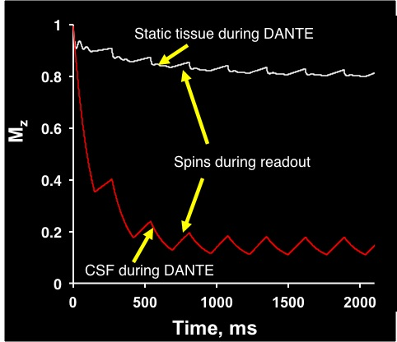

Figure. 3

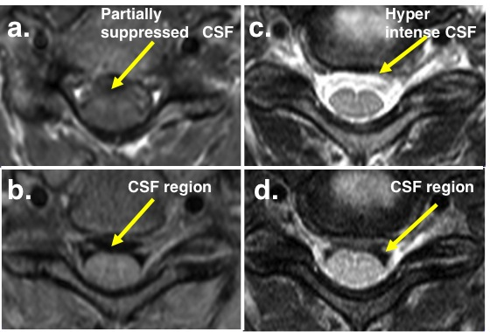

Figure. 4

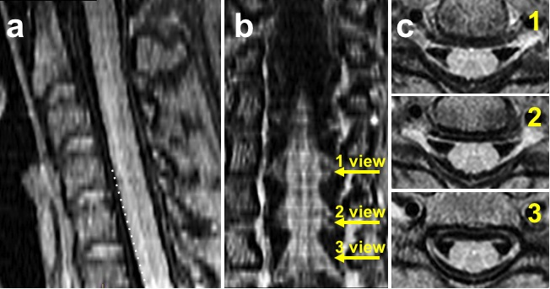

Figure. 5
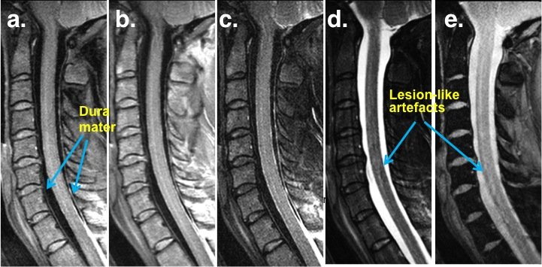

Figure. 6
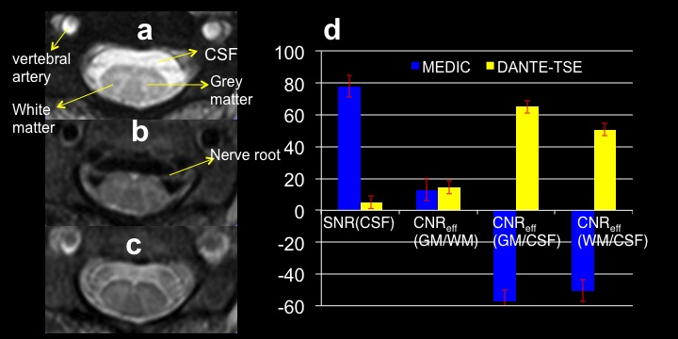

Figure. 7
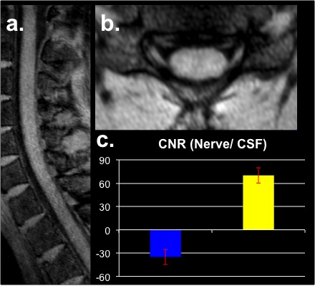

Table 1
Imaging protocols
Common parameters for all 2D TSE and MEDIC image protocols FOV = 150 × 150 mm, matrix size 256 × 252, interpolated to 512 × 512, slice thickness = 3mm, in plain resolution 0.6*0.6 mm,
No | Sequence type | TR/TE  (ms/ms) | Bandwidth  (Hz/Pixel) | Averages | TurboFactor | Number of slices | Concatenation | Acq time, (mins) | DANTE module, non-prepared sequences flip angle (FA) α = 0°
1 | T1w 2DTSE | 1000/13 | 130 | 2 | 7 | 20/ no gap interleaved | 4 | 4.8 | flip angle (FA) α = 7°-9°; N_{p}=64; time duration between DANTE pulses, t_{D}=1ms; G_{z}=18mT/m; gradient duration≈1 ms.
2 | T2w 2D TSE | 4000/82 | 130 | 1 | 13 | 16/ no gap interleaved | 2 | 3 | flip angle (FA) α = 3°-5°; α = 0 for non-prepared sequence, N_{p}=300; time duration between DANTE pulses, t_{D}=1 ms; G_{z}=18mT/m; gradient duration≈1 ms.
3 | PDw 2DTSE (1) | 4000/13 | 130 | 1 | 7 | 44/no gap interleaved | 2 | 4.8 | flip angle (FA) α = 7°-9°; N_{p}=64; time duration between DANTE pulses, t_{D}=1 ms; G_{z}=18mT/m or G_{z,x,y}=20mT/m; gradient duration≈1 ms.
4 | PDw 2DTSE (2) | 4000/13 | 130 | 1 | 9 | 16/no gap interleaved | 2 | 4 | flip angle (FA) α = 7°-9°; N_{p}=250; time duration between DANTE pulses, t_{D}=1 ms; G_{z} or G_{z,x,y}=20mT/m; gradient duration≈1 ms.
5 | MEDIC | 470/17 | 260 | 2 | N/A | 30/no gap interleaved | 2 | 4.5 | 2D FLASH readout flip angle (FA) α = 30°, iPat=2; Combined echoes = 4
6 | 3D-DASH | 1160/5.04 | 80 | 2 |  | 80 | 1 | 4.1 | 3D FLASH readout flip angle (FA) α = 10°, iPat=2; DANTE parameters: flip angle (FA) α = 10°-15°; N_{p}=150; time duration between DANTE pulses, t_{D}=1 ms; G_{z,x,y}=20mT/m; gradient duration≈1 ms.
FOV, field of view; TSE, turbo spin echo; TR, repetition time; TE, echo time; Acq time, Imaging acquisition time; G_{z}, gradient along slice direction for axial imaging acquisition; G_{x,y,z}, gradient along read, phase and slice directions for sagittal or coronal imaging acquisition. DANTE, delay alternating with nutation for tailored excitation; N_{p}, number of pulses; t_{D}, time duration between DANTE pulses. DASH, DANTE prepared FLASH.

