

Human RECQL5 helicase

A Target Enabling Package

Uniprot ID/EC | O94762/ 3.6.4.12
Target Nominator
Authors | Joseph A Newman, Hazel Aitkenhead, Pavel Savitsky, Opher Gileadi
Target PI | Opher Gileadi (Oxford)
Therapeutic Area | Cancer
Disease Relevance | RECQL5 is a validated synthetic lethal target in myeloproliferative neoplasms
Date | 17th June 2016; updated 23rd May 2017

SUMMARY OF PROJECT
RECQL5 is a member of the RecQ family of helicase which have important functions in DNA repair pathways and maintenance of genome integrity. RECQL5 has recently been identified as a synthetic lethal candidate in various haematological malignancies and has been verified by knockdown to sensitize myeloproliferative neoplasms (MPN) to DNA damaging agents. In this TEP we have expressed purified and determined the first ever crystal structures of RECQL5, in both APO and ADP/Mg²⁺ bound forms which crystallize in two distinctly different conformations. In vitro DNA stimulated ATPase assays suitable for high throughput screening have been developed as well as lower throughput orthogonal assays to verify potential hits. A fragment screening campaign has been initiated and single fragment hit has identified a potential allosteric site that may be targeted to block the transition between conformations that it thought to be part of the helicase mechanism. Finally included as part of the package we present 3 validated RECQL5 binding nanobodies, one of which is a potent inhibitor of RECQL5 ATPase activity and is suitable for use as a tool reagent to investigate inhibition of RECQL5 and its complexes in vitro.

SCIENTIFIC BACKGROUND
Background
Although the generally considered to be tumour suppressors, a number of recent studies have identified possible synthetic lethal relationships for RecQ helicases (1-3). A recent analysis of expression data in haematological malignancies found abnormal expression of at least one RecQ helicase was found in each of the cancer types studied (2). For RECQL5 significant overexpression, was found in patients with acute myeloid leukemia (AML), with expression being linked to poor prognosis in these patients.

Therapeutic rationale
Another recent study identified a strong synthetic lethal relationship between RECQL5 and with patients with myeloproliferative neoplasms (MPN), carrying an activating V617F mutation in the JAK2 non-receptor tyrosine kinase (4). MPNs are rare bone marrow disorders that cause an overproduction of one of various types of blood cells, and although not generally considered immediately life threatening there is a significant mortality risk associated with increased incidence of vascular events and a significantly higher risk of transformation to a more aggressive disease in the form of AML. Expression of JAK2V617F (by far the most common oncogenic lesion in MPN) has been associated with increased DNA damage yet paradoxically long term analysis MPN patients show remarkable long term genomic stability, indicating a possible dependence on a compensatory DNA repair protein for their survival. RECQL5 was the only helicase to be overexpressed in these cells and depletion of RECQL5 (via shRNA) leads to increased replication stress, double strand breaks, replication fork collapse and sensitization to hydroxyurea (4). The hypersensitivity could be complemented by the addition WT RECQL5, but not a RECQL5 K58R which is mutated in the highly conserved helicase motif I and is indispensable for helicase or ATPase activity.

Despite their importance in DNA repair pathways and emerging prominence as synthetic lethal targets, very few compounds targeting helicases have been developed to date, and none of these compounds have accompanying structural data showing binding modes. Thus there exists an urgent need to identify compounds, tools and modes of inhibition that may have relevance to the wider human helicase family.

Objectives of this TEP:
-Overexpress and purify RECQL5 constructs and determine the first ever crystal structure of RECQL5
-Generate suitable assays to probe RECQL5 function and enable high throughput screening
-Generate initial chemical matter, and inhibition strategies.

RESULTS – The TEP
Purified proteins
RECQL5-11-526 (construct used for APO crystals), RECQL5-11-453 (construct used for ADP crystals), RECQL5-nanobody D6 (binder), RECQL5-nanobody D10 (binder), RECQL5-nanobody D9 (inhibitor).

Structures
The first ever structures of human RECQL5 are presented as part of the TEP. The structures were determined in two distinctly different conformations in the absence and presence of ADP/Mg2+ to 3.2Å and 1.8Å respectively. Prominent differences can be seen between the two with maximal displacements of equivalent residues of up to 30Å (Fig. 1). Solution studies, comparisons with other enzymes and site directed mutagenesis have established that both conformations are relevant in solution and represent distinct states in the RECQL5 catalytic cycle. Thus molecules preventing this transition may be of therapeutic interest.
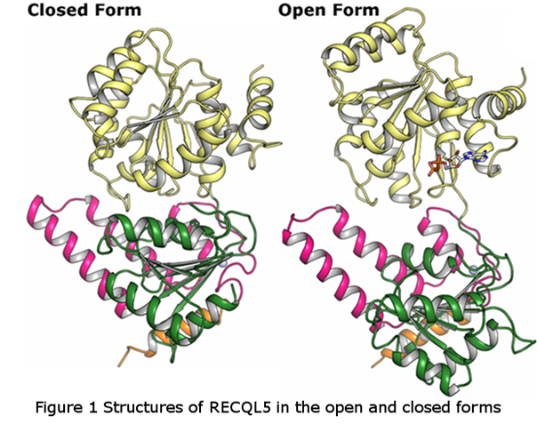
Assays
The primary assay suitable for use in high throughput screening is measurement of DNA stimulated ATPase activity using the readily commercially available ADP-Glo system (Promega). This assay features very high signal to noise (Z-factor >0.6), low compound interference and protein consumption (screening possible at just 20nM) (Fig. 2). Due to the stimulation of ATPase activity by (>100 fold for RECQL5) this assay is also sensitive to compounds interfering with DNA binding, although we also provide an orthogonal DNA binding assay in the form of fluorescence polarization assays which also features high signal to noise and are suitable for high throughput. We have also developed conditions suitable for testing higher order functions of RECQL5 such as helicase and strand annealing activity (Fig. 2). These assays are better suited as low throughput orthogonal assays for verification and characterization of potential inhibitors found in high throughput screening.
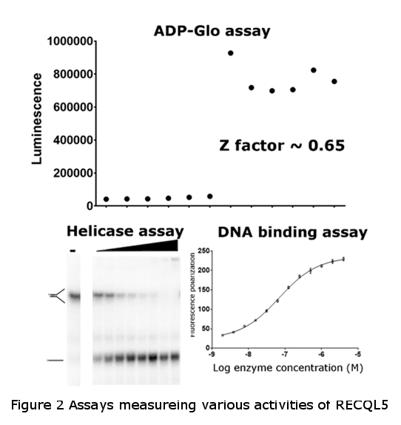
Chemical Matter
In addition to the ADP/Mg2+ bound to the ADP form crystals at 1.8Å, we have also initiated a crystallographic fragment screening campaign to identify possible additional chemical matter. Due to the low resolution of the APO form crystals it was decided to focus on the ADP from with a view to identifying possible allosteric binders. So far a single fragment hit has been obtained at 2.4Å (Fig.3) which localizes to a deep pocket formed by the cleft between the N and C-terminal helicase lobes. This pocket is extensive, with a relatively hydrophobic character (DMSO also binds to the pocket in some datasets), and importantly is the closed APO form this pocket is no longer present. Potential steric clashes with main chain and side chain residues indicate that binding to this site would prevent the transition from open to closed forms, potentially inhibiting the enzyme.
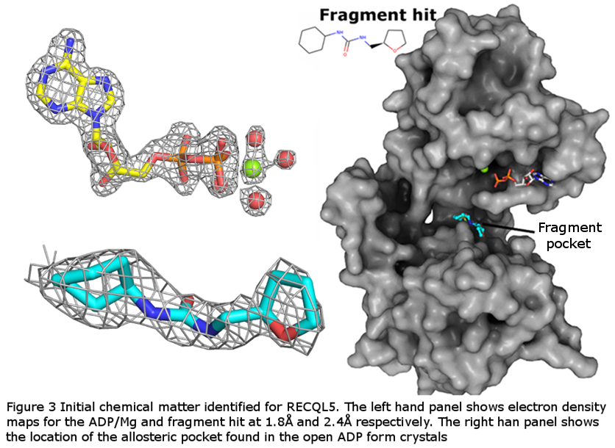
IMPORTANT: Please note that the existence of a small molecule within this TEP indicates that chemical matter can bind to the protein in a functionally relevant pocket. As such these molecules should not be used as tools for functional studies of the protein unless otherwise stated as they are not sufficiently potent or well-characterised to be used in cellular studies. The small molecule ligands are intended to be used as the basis for future chemistry optimisation to increase potency and selectivity and yield a chemical probe or lead series.

We also include three RECQL5 specific single domain camelid antibodies “nanobodies” as part of the package that we have validated as potent binders of RECQL5 catalytic domain. In addition to use as reagents in pull down experiments, one of these nanobodies has been demonstrated to be a potent inhibitor (inhibition is retained down to limit of enzyme concentration used in assay) of RECQL5 ATPase activity (Fig. 4), and thus may also be useful as a tool compound to investigate inhibition of RECQL5 and its complexes in vitro.
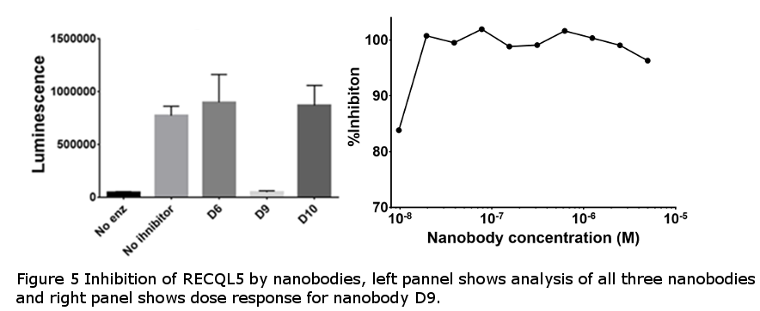

Future work
We intend to continue to work on RECQL5 with a view to finding more fragment hits and verify fragment binding using biophysical assays and investigate effect of compounds binding to the allosteric site on enzyme activity. We also intend to initiate enzymatic screening against helicase focussed compound libraries, with a view to developing RECQL5 specific small molecule inhibitors.

CONCLUSION
This work describes the structure determination of a novel target. Enzymatic assays suitable for high throughput screening have been developed and fragment screening has identified a potential allosteric pocket that is thought to be a possible route to inhibition by preventing conformational changes that occur as part of the RECQL5 catalytic cycle.

A paper describing the structural, enzymatic and mechanistic characterization of RECQL5 helicase has been published. (PMID: 28100692 Newman JA, Aitkenhead H, Savitsky P, and Gileadi O. (2017) Insights into the RecQ helicase mechanism revealed by the structure of the helicase domain of human RECQL5. Nucl Acids Res. 45:4231-4243.)

FUNDING INFORMATION
The work at the SGC has been funded by a grant from the Wellcome [106169/ZZ14/Z].

ADDITIONAL INFORMATION
Structure files | 5LB8 | RECQL5 APO form
Structure files | 5LB3 | RECQL5 ADP/Mg²⁺ complex P2₁ xtal form
Structure files | 5LB5 | RECQL5 ADP/Mg²⁺ DMSO complex P1 xtal form
Structure files | 5LBA | RECQL5 ADP/Mg²⁺ Fragment complex P1 xtal form

Supplemental Information
Procedure for protein purification of RECQL5

RECQL5 constructs were cloned in to the pNIC28-Bsa4 vector for histidine tagged overexpression in E.coli. The RECQL5 11-526 variants were generated from the WT construct by a site directed mutagenesis strategy. For purification cell pellets were thawed and resuspended in buffer A (50 mM HEPES pH 7.5, 500 mM NaCl, 5% glycerol, 10 mM imidazole, 0.5 mM Tris (2-carboxyethyl) phosphene (TCEP). Cells were lysed using sonication and cell debris pelleted by centrifugation. Lysates were applied to a Ni-IDA IMAC gravity flow column, washed with 2 column volumes of wash buffer (buffer A supplemented with 45 mM imidazole), and eluted with the addition of 300 mM imidazole in buffer A. The purification tag was cleaved with the addition of 1:20 mass ratio of His-tagged TEV protease during overnight dialysis into buffer B (20 mM HEPES, pH 7.5, 500 mM NaCl, 5 % glycerol, 0.5 mM TCEP). TEV was removed by IMAC column rebinding and final protein purification was performed by size exclusion chromatography using a HiLoad 16/60 Superdex 200 column at 1 ml/min in buffer B. Protein concentrations were determined by measurement at 280nm (Nanodrop) using the calculated molecular mass and extinction coefficients.

Procedure for expression purification of RECQL5 Nanobodies (biotinylated)

Rozetta-BirA was transformed by OG-NB1-CTBH constructs. 1ml cultures were grown overnight and used to inoculate 50 ml of TB+Kan100+Chlor37.5+Strep50 supplemented with 100 uM biotin. Cultures were grown to OD600 of 3 at 37 C and 180 rpm. Then temperature was shifted down to 18 and media were allowed to cool for 1 hour. Cells were induced by 0.2 mM IPTG overnight. Cell pellets ware resuspended in 150ml of sucrose buffer (200 mM Hepes pH 7.5, 500 mM Sucrose, 0.5 mM EDTA) per litre overexpression and left one ice for 1 hour with occasional stirring. 150ml of water was then added to each sample and left on ice for another hour with occasional stirring. The samples were then centrifuged for 40min at 5000 rpm and 10°C. The supernatants were applied to Ni-IDA IMAC gravity flow column, washed with 2 column volumes of wash buffer (buffer A supplemented with 45 mM imidazole), and eluted with the addition of 300 mM imidazole in buffer A.

Procedure for crystallization of RECQL5

For crystallization of the APO form (construct RECQL5 11-526) proteins were concentrated to 20 mg/ml using a 50,000 m.w.c.o. centrifugal concentrator and crystals were obtained in conditions containing 20% PEG 3350, 0.2M potassium thiocyanate. The monoclinic ADP form (construct RECQL5 11-453) was crystallized at 15 mg/ml by sitting drop vapour diffusion from conditions containing 19 % Peg 6K, 0.25 M Lithium Chloride and 10% ethylene glycol, 5mM ADP, 5mM MgCl. The triclinic ADP form was crystallized by sitting drop vapour diffusion from conditions containing 0.1 M Tris pH 7.5, 23% PEG3350 and 0.1 M NaCl.

References

1. Sanada, S., Futami, K., Terada, A., Yonemoto, K., Ogasawara, S., Akiba, J., Yasumoto, M., Sumi, A., Ushijima, K., Kamura, T., Furuichi, Y., and Yano, H. (2013) RECQL1 DNA repair helicase: a potential therapeutic target and a proliferative marker against ovarian cancer. PLoS One 8, e72820
2. Viziteu, E., Kassambara, A., Pasero, P., Klein, B., and Moreaux, J. (2016) RECQ helicases are deregulated in hematological malignancies in association with a prognostic value. Biomark Res 4, 3
3. Aggarwal, M., and Brosh, R. M., Jr. (2009) Hitting the bull's eye: novel directed cancer therapy through helicase-targeted synthetic lethality. J Cell Biochem 106, 758-763
4. Chen, E., Ahn, J. S., Sykes, D. B., Breyfogle, L. J., Godfrey, A. L., Nangalia, J., Ko, A., DeAngelo, D. J., Green, A. R., and Mullally, A. (2015) RECQL5 Suppresses Oncogenic JAK2-Induced Replication Stress and Genomic Instability. Cell Rep 13, 2345-2352

