Imminent risk of osteoporotic fracture: a multi-national multi-cohort observational study using routinely collected real-world data

Osteoporosis International

AUTHORS

Sara Khalid¹, Carlen Reyes ^{2,3}, Martin Ernst⁴, Antonella Delmestri¹, Emese Toth⁵, Cesar Libanati⁵, Bo Abrahamsen ^{1,6,7}, Daniel Prieto-Alhambra ^{1,2,3,8}

Affiliations

- Nuffield Department of Orthopaedics, Rheumatology and Musculoskeletal Sciences, Centre for Statistics in Medicine, Nuffield Orthopaedic Centre, Oxford, UK.
- Fundació Institut Universitari per a la recerca a l'Atenció Primària de Salut Jordi Gol i Gorina (IDIAPJ Gol), CIBERFES, Barcelona, Spain.
- Universitat Autònoma de Barcelona, Bellaterra (Cerdanyola del Vallès), Spain.

- Department of Public Health, Clinical Pharmacology and Pharmacy, University of Southern Denmark, Odense, Denmark
- UCB Biopharma Sprl, Brussels, Belgium

- Open Patient Data Explorative Network, University of Southern Denmark and Odense University Hospital, Odense, Denmark.
- Department of Medicine, Holbæk Hospital, Holbæk, Denmark

- MRC Lifecourse Epidemiology Unit, University of Southampton, Southampton General Hospital, Southampton

Corresponding author

Daniel Prieto-Alhambra,

e-mail: Daniel.prietoalhambra@ndorms.ox.ac.uk

Online Resource 1. Definition of cohort and index date

Cohort Definition | Index Date Definition
NDO : Newly diagnosed osteoporotic patients | At the time of first ‘osteoporosis’ coded diagnosis
OFx: Patients with incident fracture of osteoporotic sites | At first documented incident fracture (no fracture at the  same site in the prior 6 month). Sites are: any, except face, skull and digit
BP: Patients with incident use of oral OBP | At first oral OBP therapy prescription/dispensation
FWOT: Patients with incident fracture of osteoporotic sites while on treatment with oral OBP therapy | At first documented incident fracture. Sites are: any, except face, skull and digit. The fracture has to have occurred after oral OBP therapy start and before cessation (defined by a prescription/dispensation/refill gap of 3+  months)

Online Resource 2. Diagnosis and Medication Codes

 | DHR | SIDIAP | CPRD
OP diagnosis | Pre-specified ICD10 codes |  | pre-specified  READ/OXMIS codes
Incident fracture of osteoporotic sites | Pre-specified ICD10 codes (Pages- Castella A. BMC MSK Disord) |  | CPRD GOLD (pre-  specified READ/OXMIS codes) or linked HES (pre-  specified ICD-10 codes)
Oral biphosphonates | ATC codes group M05BA |  | pre-specified  BNF/PRODCODES

Online Resource 3 One-year IR of fracture among individuals with a previous
fracture in the BP cohort

Legend: Grey: CPRD; Black: SIDIAP; Slash: DHR
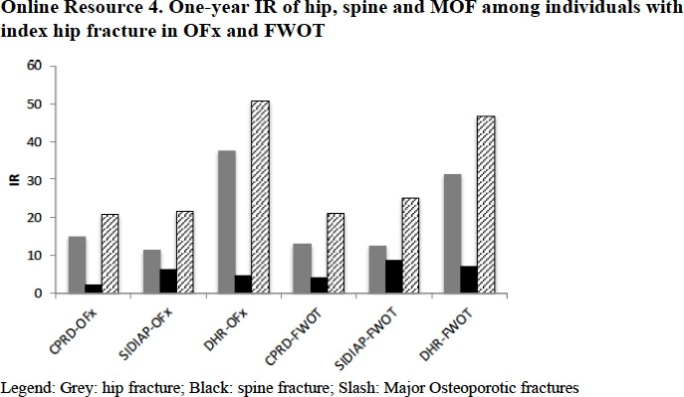

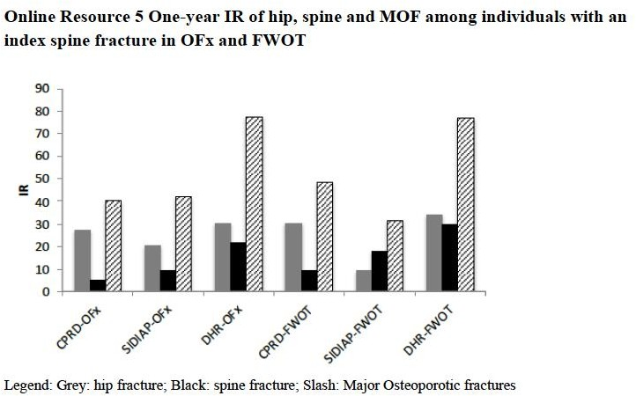

Online Resource 6. Differences in the databases

 | Spain (SIDIAP) | UK (CPRD) | Denmark (DHR)
Medications captured | All filled irrespective of issuer (public primary health care centers or  hospitals) | All issued if originated in primary care | All filled irrespective of issuer
Fractures captured | All that required  hospitalization | All | All
Comorbid conditions  captured | All | All | Only when requiring  hospital contact
NDOª | All | All | Only when requiring  hospital contact
OFx^{b} | All | All | All
FWOT^{c} | All | All | All
- Newly diagnosed osteoporosis, b- Incident Osteoporotic fracture, c-Fractures while on treatment with bisphosphonates

Online Resource 7. One-year incidence rate of major osteoporosis fracture in men and women in each cohort

 | CPRD |  | SIDIAP |  | DHR
 | IR (95%CI) |  | IR (95%CI) |  | IR (95%CI)
Cohorts | Female | Male | Female | Male | Female | Male
Newly diagnosed osteoporosis | 16.31 (12.67-19.92) | 9.07 (7.07-11.08) | 17.50 (15.69-19.33) | 15.40 (10.13-21.50) | 123.32 (120.63-126.01) | 150.07 (143.33-156.82)
Incident Osteoporosis fracture | 9.16 (5.98-12.34) | 13.90 (10.74-17.04) | 41.42 (38.52-44.34) | 30.85 (26.75-34.92) | 44.35 (43.44-45.25) | 36.80 (35.48-38.11)
Incident Bisphosphonate use | 12.61 (10.28-14.93) | 15.44 (13.61-17.28) | 22.68 (18.26-24.60) | 14.13 (10.79-17.46) | 49.78 (48.35-51.21) | 43.44 (40.39-46.49)
Fracture while on treatment with bisphosphonates | 45.13 (28.88-61.38) | 38.65 (30.11-47.19) | 42.98 (29.21-56.74) | 19.73 (4.08-60.89) | 49.50 (45.93-53.07) | 48.37 (37.89-58.87)

