Appendix

Instructions

Welcome. You are now taking part in an economic experiment about decision-making financed by research foundations.

These instructions are solely for your private use. It is prohibited to communicate with other participants during the experiment. Should you have any questions, please ask the administrator.
If you violate this rule, you will be dismissed from the experiment and forfeit all payments.

During the experiment we will not speak in terms of Pound but in ‘Token’. During the experiment, your entire earnings will be calculated in ‘Token’. At the end of the experiment the total amount of ‘Tokens’ which you have earned will be converted to Pounds at the following exchange rate:

100 Tokens = 7 pence

At the end of the experiment, your entire earning from the experiment plus the 3 Pounds on-time show-up fee will be paid to you in cash in private.

In the following pages, we describe the experiment in detail.
Detailed Information of the Experiment

At the beginning of the experiment, all participants will each be given an initial lump sum of 3,000 Tokens. Furthermore, in this experiment there is an additional allocation decision, which can earn you and other participants extra payment. Please note that you are not allocating these initial 3,000 Tokens. You will be given a separate set of allocation options where each allocation option will either add to or subtract from the initial lump sum. You will only make this allocation decision ONCE.

In this experiment, participants are randomly divided into sets of seven participants whose identity you will never find out either before, during or after the experiment. In each set, four participants will be randomly grouped together to form a group called ‘GROUP A’ and three other participant will be grouped together to form ‘GROUP B’. Within GROUP A, the group members will be assigned one of the following roles: A1, A2, A3, or A4.

Each member of GROUP A will make an allocation decision which can affect the incomes of the other GROUP A’s members and the members of GROUP B. Each member of GROUP A will make this decision only ONCE.

The members of GROUP B will make no allocation decision, but will be asked to do different tasks which will be explained below. The role you are assigned will be shown on your screen at the beginning of the experiment.

For example if you are assigned to be in GROUP A and member no. A1, you will see the following screen.

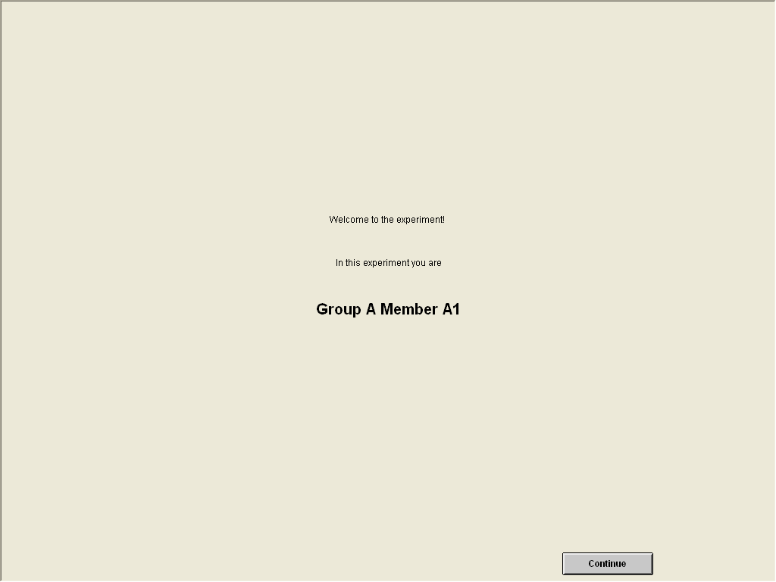

Members of Group A
If you are assigned to be in GROUP A, you will be asked to complete the following TWO tasks.

TASK 1: In task 1, on the screen you will see a set of eight different allocation options (an example of the allocation options is shown below). Each option allocates Tokens between your fellow GROUP A’s members (excluding you) and the members of GROUP B. To indicate your decision, mark an ‘x’ (it does not matter whether it’s lower or upper case) in the box under the option that you would like to choose. Please choose only ONE option and please remember that you will only make this decision ONCE.

TASK 2: In task 2, after you have made the decision, you are asked to RATE EACH option using the following scale: 1 (Dislike very much), 2 (Dislike), 3 (Like), 4 (Like very much), or 0 (Indifferent).

Example of Allocation Options

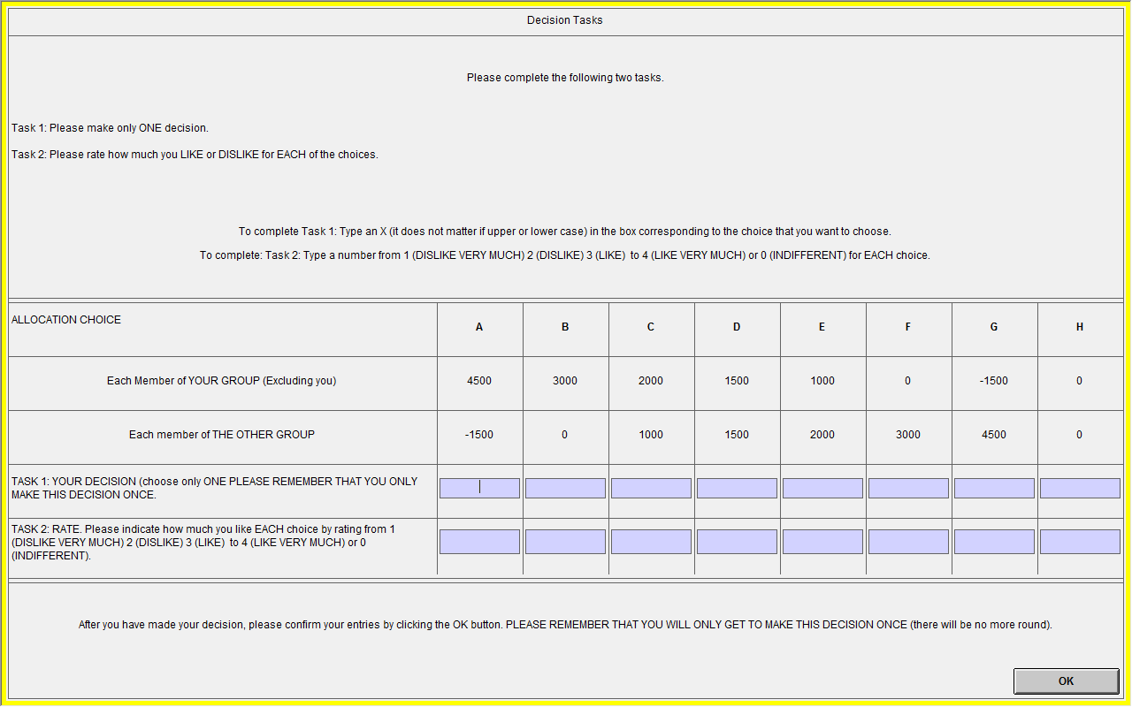

You and your fellow GROUP A members will each make the decision, but only ONE of the four decisions will be randomly selected. Once all the GROUP A members have completed both tasks and confirmed their decisions and ratings by clicking the OK button, the administrator will throw a dice which will determine whose decision will be selected:

If the dice shows number 1, the decision of GROUP A’s member A1 will be selected.
If the dice shows number 2, the decision of GROUP A’s member A2 will be selected.
If the dice shows number 3, the decision of GROUP A’s member A3 will be selected.
If the dice shows number 4, the decision of GROUP A’s member A4 will be selected.

If the dice shows numbers 5 or 6, no decision will be selected and the dice will be thrown again until it shows the numbers between 1 and 4.

The payoff of the GROUP A member whose decision is selected will not be affected by his/her decision. Instead, he/she will be given a fixed payment of 4,500 Tokens and his/her decision will be kept confidential. The payoff of the GROUP A members whose decision are not chosen, their payoff will be determined by the selected decision.

For example, if you are assigned a role of A1 and your decision is chosen (the dice shows number 1) your payoff will not be affected by your decision. However, if you are assigned a role of A1 but your decision is not chosen, your payoff will be affected by the decision made by the GROUP A member whose decision is chosen.

Once the decision is determined, you can see your payoff on the screen.

Members of Group B
If you are assigned to be in GROUP B, you will be asked to complete TWO tasks:

TASK 1: You will be asked to select an option which you think the decision-maker in GROUP A is most likely to choose. To indicate your decision, mark an ‘x’ (it does not matter whether it’s lower or upper case) in the box under the option that you think the decision-maker in GROUP A is most likely to choose. Please choose only ONE option and you can only make this decision ONCE.

TASK 2: Suppose that you were in the position to decide how to allocate the Tokens between the members of your group (GROUP B) and the other group (GROUP A). Which option would you choose? To indicate your decision, mark an ‘x’ (it does not matter whether it’s lower or upper case) in the box under the option you would like to choose. Please choose only ONE option. Examples of the decision screens for members of GROUP B are shown below.
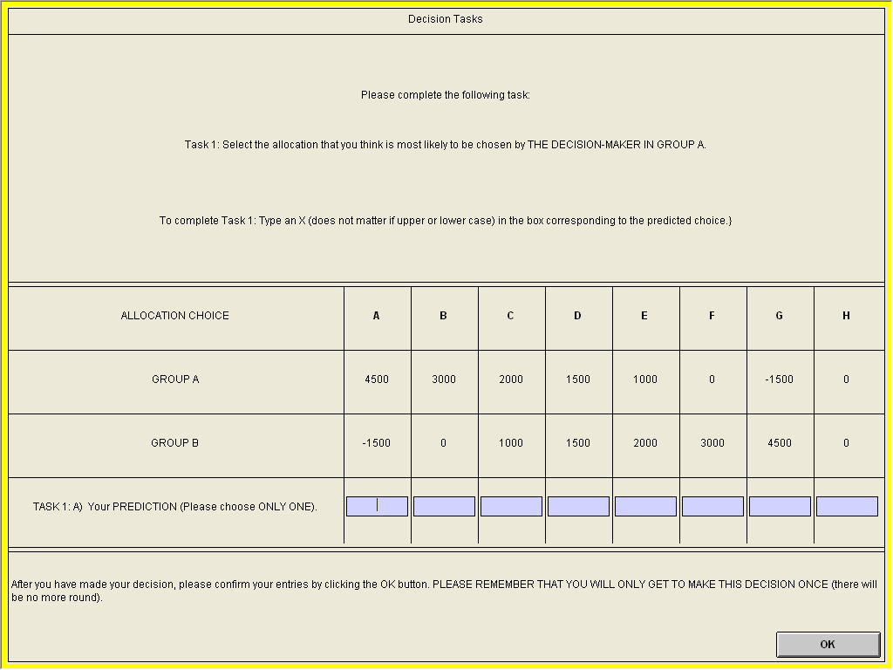
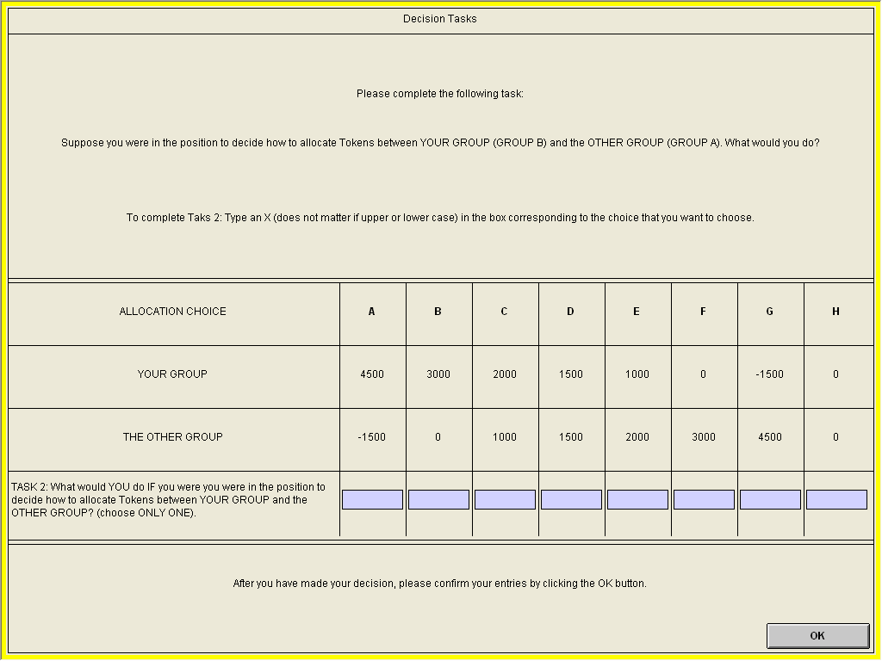
Once the dice is thrown and the decision is determined, the members of GROUP B will also see their payoffs on the screen.

After all players have completed their tasks, the administrator will ask you to complete a short questionnaire and will also distribute a document which you will need for the questionnaire.

After you have completed the questionnaire, the administrator will come over to your seat and give you the payment in private.

How the payment for each player is calculated is shown below:

Your payment

Members of GROUP A

If you are in GROUP A and your decision is chosen, your payment will be:
3,000 Tokens + 4,500 Tokens + £3 (on-time show-up fee)
----------------------------------------------------------------------------------------------------------------------------
If you are in GROUP A, but your decision is not chosen, your payment will be:
3,000 Tokens + the amount allocated to you by the decision-maker + £3 (on-time show-up fee)
----------------------------------------------------------------------------------------------------------------------------

Members of GROUP B

If you are in GROUP B, your payment will be:
3,000 Tokens + the amount allocated to you by the decision-maker in GROUP A + £3 (on-time show-up fee)

Now if you have any question, please raise your hand and the administrator will come and assist you.

