Supplementary Material for the article
Lack of attentional retraining effects in cigarette smokers attempting cessation: a proof of concept double-blind randomised controlled trial
Rachna Begh¹*, Marcus R Munafò2, Saul Shiffman3, Stuart G Ferguson4, Linda Nichols5, Mohammed A Mohammed6, Roger L Holder5, Stephen Sutton7, Paul Aveyard¹
¹UK Centre for Tobacco and Alcohol Studies, Nuffield Department of Primary Care Health Sciences, University of Oxford, Oxford, OX2 6GG, UK
2UK Centre for Tobacco and Alcohol Studies, School of Experimental Psychology, MRC Integrative Epidemiology Unit (IEU), University of Bristol, Bristol, BS8 2BN, UK
3Department of Psychology, University of Pittsburgh, Sennott Square, 3rd Floor, 210 South Bouquet Street, Pittsburgh, PA 15260, USA
4School of Medicine, University of Tasmania, Private Bag 26, Hobart, TAS 7001, Australia
5Primary Care Clinical Sciences, University of Birmingham, Birmingham, B15 2TT, UK
6School of Health Studies, University of Bradford, Bradford, BD7 1DP, UK
7 Behavioural Science Group, Institute of Public Health, University of Cambridge, Cambridge, CB2 1TN, UK
*Corresponding author:
Rachna Begh, University of Oxford, Nuffield Department of Primary Care Health Sciences, Radcliffe Observatory Quarter, Woodstock Road, Oxford, OX2 6GG. T: +44 (0)1865 617191; E: rachna.begh@phc.ox.ac.uk
This material supplements, but does not replace, the peer-reviewed article in
Drug and Alcohol Dependence.

Table S1. Pre-training and post-training visual probe bias scores at 4 weeks, 8 weeks, 3 months and 6 months by group
 | Attentional retraining (n=60) | Placebo training (n=58)
 | M (SD) | M (SD) | Mean difference
Pre-training
RT for smoking stimuli | 684.4 (153.5) | 684.7 (130.6) | -0.3
RT for neutral stimuli | 685.3 (158.8) | 690.2 (133.8) | -4.8
Attentional bias | 1.0 (24.3) | 5.5 (34.5) | -4.5
Post-training +4 week
RT for smoking stimuli | 688.5 (134.4) | 655.0 (136.5) | 33.5
RT for neutral stimuli | 683.0 (126.0) | 658.3 (141.0) | 24.8
Attentional bias | -5.5 (28.1) | 3.3 (21.0) | -8.8
Post-training +8 week
RT for smoking stimuli | 672.1 (130.0) | 657.2 (117.1) | 15.0
RT for neutral stimuli | 672.9 (125.2) | 651.8 (116.8) | 21.1
Attentional bias | 0.7 (25.0) | -5.4 (24.4) | 6.1
Post-training 3 months
RT for smoking stimuli | 683.6 (156.0) | 666.7 (135.5) | 16.9
RT for neutral stimuli | 683.0 (156.5) | 668.8 (135.3) | 14.2
Attentional bias | -0.6 (29.9) | 2.1 (22.9) | -2.7
Post-training 6 months
RT for smoking stimuli | 694.4 (120.1) | 669.6 (115.7) | 24.8
RT for neutral stimuli | 699.0 (120.2) | 676.2 (123.5) | 22.9
Attentional bias | 4.7 (25.3) | 6.6 (26.8) | -1.9
RT - reaction time (milliseconds)

Table S2. Pre-training and post-training Stroop bias scores at 4 weeks, 8 weeks, 3 months and 6 months by group
 | Attentional retraining (n=60) | Placebo training (n=58)
 | M (SD) | M (SD) | Mean difference
Pre-training
RT for smoking stimuli | 834.2 (154.7) | 801.4 (131.8) | 32.8
RT for neutral stimuli | 824.3 (160.1) | 801.7 (129.3) | 22.6
Attentional bias | 9.9 (62.9) | -0.3 (59.1) | 10.2
Post-training +4 week
RT for smoking stimuli | 838.8 (133.5) | 792.6 (148.9) | 46.2
RT for neutral stimuli | 837.3 (144.9) | 796.8 (148.4) | 40.5
Attentional bias | 1.5 (55.1) | -4.1 (40.0) | 5.6
Post-training +8 week
RT for smoking stimuli | 828.3 (145.9) | 807.2 (148.4) | 21.1
RT for neutral stimuli | 831.0 (150.9) | 822.6 (143.5) | 8.4
Attentional bias | -2.7 (45.1) | -15.4 (64.4) | 12.7
Post-training 3 months
RT for smoking stimuli | 838.5 (129.7) | 810.3 (148.9) | 28.2
RT for neutral stimuli | 834.0 (139.7) | 793.9 (138.9) | 40.2
Attentional bias | 4.5 (58.6) | 16.5 (63.2) | -12.0
Post-training 6 months
RT for smoking stimuli | 847.9 (154.5) | 810.9 (185.3) | 37.0
RT for neutral stimuli | 845.9 (139.1) | 805.2 (158.3) | 40.7
Attentional bias | 0.7 (56.9) | 7.2 (58.1) | -6.5
RT - reaction time (milliseconds)

Figure S1. Attentional bias scores (ms) with 95% CI by abstinence status in the attentional retraining group and placebo training group at 4 weeks post-quit

Figure S2. Attentional bias scores (ms) with 95% CI by strength of attentional bias in the attentional retraining group and placebo training group at 4 weeks post-quit

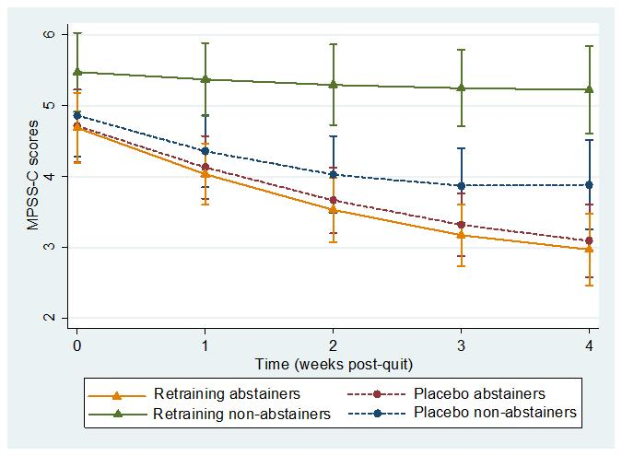
Figure S3. Mood and Physical Symptoms Score-Craving (MPSS-C; 95% CI) for an average patient by group and abstinence status from quit day to 4 weeks
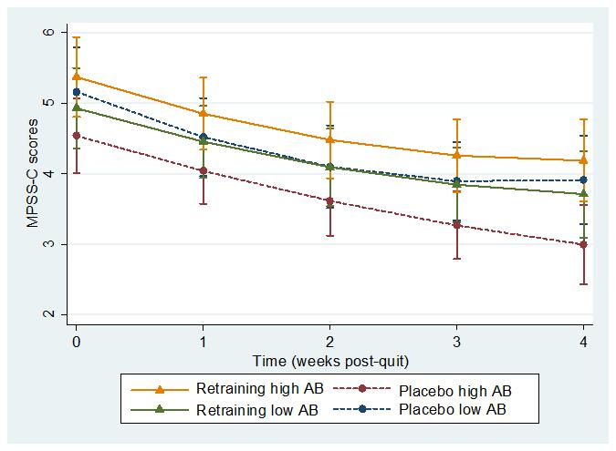
Figure S4. Mood and Physical Symptoms Score-Craving (MPSS-C; 95% CI) for an average patient by group and strength of attentional bias from quit day to 4 weeks
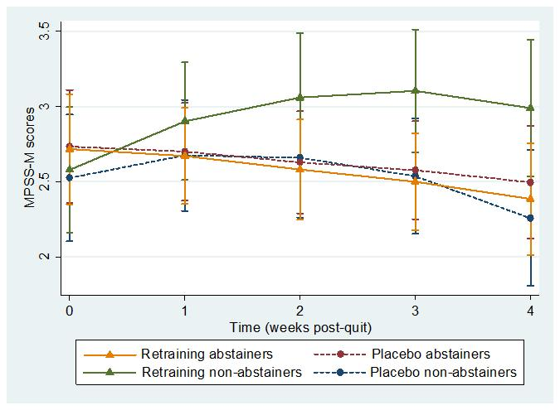
Figure S5. Mood and Physical Symptoms Score-Mood (MPSS-M; 95% CI) for an average patient by group and abstinence status from quit day to 4 weeks
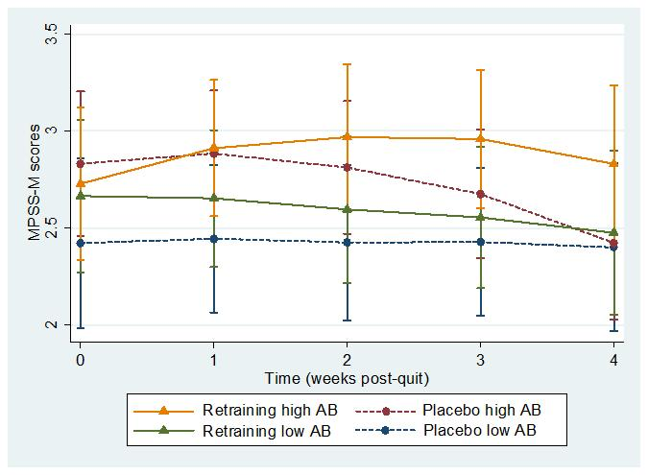
Figure S6. Mood and Physical Symptoms Score-Mood (MPSS-M; 95% CI) for an average patient by group and strength of attentional bias from quit day to 4 weeks

