Supporting Information

Quantum funneling in blended multi-band gap core/shell colloidal quantum dot solar cells

Darren C. J. Neo¹,Samuel D. Stranks², Giles Eperon², Henry J. Snaith², Hazel E. Assender¹, Andrew A. R. Watt^{1,a}
¹ Department of Materials, University of Oxford, 16 Parks Road, OX1 3PH, Oxford, United Kingdom
² Department of Physics, Clarendon Laboratory, Parks Road, OX1 3PU, Oxford, United Kingdom
This section includes:
Detailed nanocrystal synthesis and device fabrication
Fig. S1. UV-Vis-NIR absorption and photoluminescence spectrum of PbS, PbS/CdS colloidal quantum dot (CQD) and their blends.
Fig. S2. J-V curves of ZnO heterojunction devices
Fig. S3. TEM images
Fig. S4. EQE comparison
Table ST1. Performance comparison of PbS and PbS/CdS sandwich devices

Materials
Lead oxide yellow (PbO, 99.9%) was purchased from Acros Organics. Oleic acid (OA, 90%), 1-octadecene (ODE, 90%), bis(trimethylsilyl) sulfide ((TMS)₂S, synthesis grade), cadmium acetate hydrate (Cd(Ac)₂, 99.99%), Poly(3,4-ethylenedioxythiophene)-poly(styrenesulfonate) (PEDOT:PSS, 1.3wt% in water, conductive grade ,Aldrich), 1,2-ethanedithiol (EDT, >98%), cetyltrimethylammonium bromide (CTAB, >98% ) were purchased from Sigma Aldrich. Hexane (98.25%), acetone (99.98%), methanol (99.99%) and toluene (99.99%) were purchased from the Fischer Scientific. All chemicals were used as-received.
PbS CQD synthesis
This procedure was adapted from Hines et al.¹ The synthesis of PbS CQD with mean band-gap of 1.3 eV is as follows: 0.46 g (2 mmol) of PbO, 2 g of oleic acid (OA) and 10 g of octadecene (ODE) were added into a 25 mL three-neck flask and the mixture was heated and stirred continuously under vacuum at 90 °C for at least 2 hours, yielding a clear lead-oleate solution. 210 μL of (TMS)₂S (1 mmol) was carefully mixed with 5 g ODE in a dry N₂ filled glovebox and loaded into a syringe. Caution: (TMS)₂S is extremely reactive and it reacts with moisture in air rapidly to produce H₂S. The Schlenk line was switched to Argon flow from vacuum and the temperature of lead-oleate solution was raised to 120 °C. Then (TMS)₂S was rapidly injected into the flask and the solution turned dark within 3 s, indicating a nucleation burst. After injection, the heating mantle was switched off immediately (but leaving the stirring on) and the solution was allowed to cool naturally over the course of 10-15 mins in order to let the nanocrystals grow slowly, which aids focusing of the size distribution. To remove unreacted reagents, the CQDs mixture was first separated into two batches and 30 ml of acetone added to each batch to precipitate out the PbS CQDs. The suspension was then centrifuged at 6000 rpm for 10 minutes and the supernatant was discarded. 4 mL of hexane was subsequently added to individual batches to re-dissolve the CQDs and 20 mL of methanol were added to precipitate the CQDs again. The resultant suspension was then centrifuged at 4000 rpm for 4 min. Hexane/methanol washing step could be repeated once or twice more. The PbS CQDs were finally dissolved in toluene, made up to a concentration of 50 mg/mL and stored in a N₂ filled glovebox till further use.
PbS/CdS core/shell CQD synthesis
The synthesis of PbS/CdS core/shell CQD is adapted, with modifications, from the procedure developed by M. S. Neo et al.² To prepare 0.1 nm (one monolayer) CdS shell-thick PbS/CdS core/shell CQD, 0.395 mL of ODE, 0.115mL of OA and 0.030 g of Cd(Ac)₂, were mixed in a 25 mL three-neck flask, connected to a Schlenk line assembly. The mixture was heated and stirred continuously under vacuum at 100°C for at least 1 hour, forming a clear cadmium-oleate solution. The temperature was then reduced to 80°C and the vacuum environment was swapped to an argon atmosphere. 2 mL of the prepared PbS 50 mg/mL solution was swiftly injected into the flask and allowed to react under stirring for 10 minutes. The heating was then turned off and the reaction was quenched by adding 5ml of cold hexane and the resultant solution was then added to 30 mL of acetone to precipitate out the CQDs. The same washing step for PbS CQDs was applied and the prepared CQDs were re-dissolved in toluene to a concentration of 50 mg/mL.

ZnO nanoparticles synthesis
ZnO nanoparticles were synthesized using the method from Pacholski et al.³, with slight modification. Briefly, 2.95 g of Zinc acetate dihydrate was dissolved in 125 ml of methanol and kept stirring a 60⁰C. A solution of potassium hydroxide (1.48 g in 65 ml of methanol) was then added dropwise at 60⁰C over a period of 10 minutes and the reaction mixture was left to stir for 2.5 h at 60⁰C. After cooling to room temperature, the supernatant was decanted and the precipitate washed twice with methanol and finally dispersed in methanol (10 ml) and chloroform (10 ml) mixture, to yield a ZnO nanoparticle solution with a concentration of about 50 mg/ml.
Device fabrication
For CQD film formation, all CQD solutions were standardized and diluted to 40mg/ml in toluene and CQD blends were prepared by mixing 1:1 volume ratio of 1.2eV and 1.4eV CQD solution. Blends were treated in the same way as CQD solution with single-sized particles. Patterned indium tin oxide coated glass was used for substrates and they were coated with 50 ± 8 nm of PEDOT:PSS by spin coating at 5000rpm, and then annealed at 150⁰C for 10mins. Next, to form the active layer, on a constantly spinning substrate, 20 μL of CQD solution was dispensed through a 0.45 μm PTFE membrane filter and spun dry at 2000rpm. While stationary, the film is exposed to 10 mg/ml of cetyltrimethylammonium bromide (CTAB) in methanol for 30 seconds and subsequently spun at the same speed and washed with methanol. This is followed by twice dispensing 20 μL of 2 vol% 1,2-ethandithiol (EDT) in methanol and the film was washed with methanol and then toluene. The above cycle was repeated eight times in total, forming a 200 ± 17 nm thick film. To the CQD films, ZnO nanoparticle solution was spin-cast at 1500rpm, forming a 100± 22nm thick film. Finally top electrodes were formed by depositing aluminum by thermal evaporation in an Edwards 306 evaporator at 10⁻⁶ Torr to a thickness of 100 nm, with an evaporation rate of 0.1 nm/s. A shadow mask was used to pattern the electrodes.

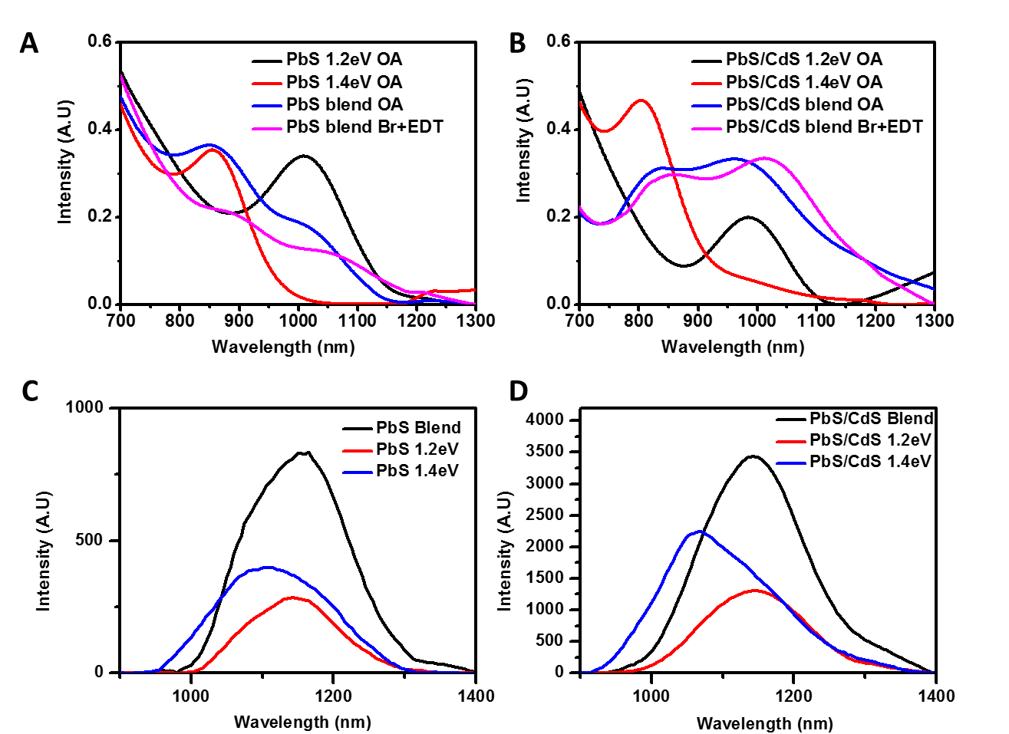

Figure S1. (a), (b) UV-Vis absorption spectra of PbS, PbS blend films and PbS/CdS, PbS/CdS blend films respectively. Normalized photoluminescence spectra of (c) pure phases and blends of PbS, (d) pure phases and blends of PbS/CdS, films prepared with the same thickness and treated with CTAB and EDT ligands. The disappearance of 1.4eV peak showed that charges have been funneled to 1.2eV phase in the blends.
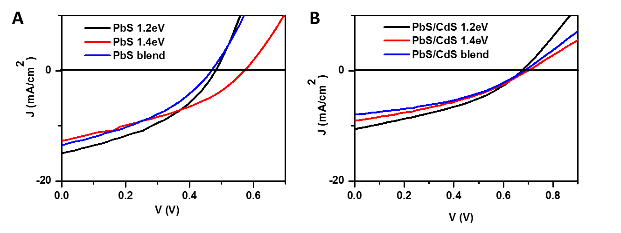

Figure S2. Photovoltaic performance of the best devices with 200nm thick CQD films, comprising of (a) PbS and (b) PbS/CdS, with a top layer of n-type ZnO film.

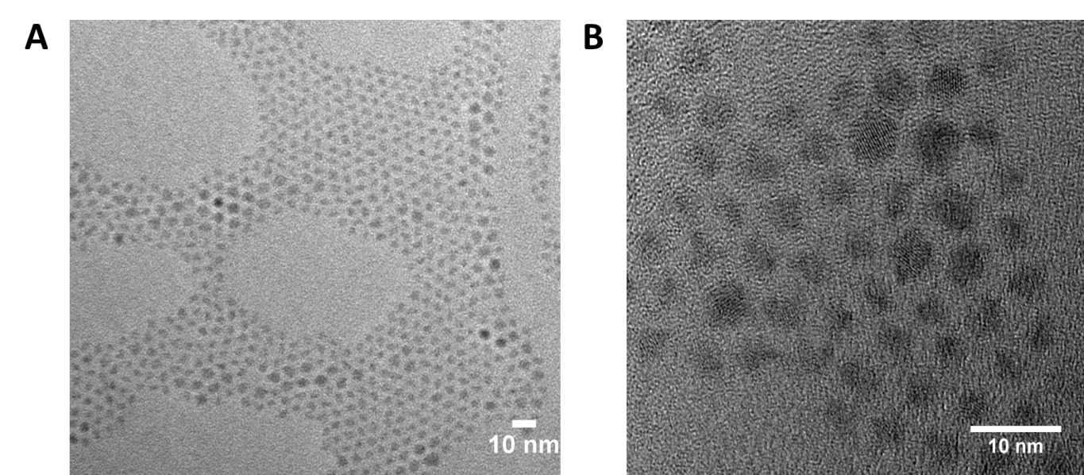
Figure S3. (a)Low magnification and (b) high magnification transmission electron microscope (TEM) images of 1.2eV and 1.4eV PbS/CdS core/shell CQD blends. JEOL 2010 TEM, operating at 200 kV, was used to obtain these images.

Integration of EQE for J_{sc} gives
using the website:
http://opvap.com/eqe.php
PbS blend: 8.3 mA/cm²
PbS/CdS blend: 6.1 mA/cm²
PbS/CdS sandwich: 6.8 mA/cm²

Figure S4. A comparison of EQE of the blended devices and PbS/CdS device with a sandwich configuration.

We note that the calculated J_{sc} (for AM 1.5 spectrum) is lower than the J_{sc} recorded in the J-V curve. This could be due to the slight degradation of devices as they are tested in a nitrogen environment in J-V testing but not in the EQE testing set up. Secondly, it is also due to the effect of nitrogen gas on trap filling and improvement of devices as noted by Leschkies et al.⁴

 | J_{sc} (mA/cm²) | V_{oc} (V) | FF | PCE
PbS/CdS sandwich | 13.5±0.5 | 0.661±0.02 | 0.422±0.04 | 3.77±0.06%
PbS sandwich | 8.1±0.6 | 0.527±0.02 | 0.344±0.02 | 1.47±0.08%

Table ST1. Device performance average over 18 samples across 6 separate substrates. Sandwich structure refers to the optimized PEDOT:PSS/50nm 1.4eV CQD/ 100nm CQD blend/ 50nm 1.2eV CQD/ ZnO/Al structure

References
¹ M.A. Hines and G.D. Scholes, Adv. Mater. 15, 1844 (2003).
² M.S. Neo, N. Venkatram, G.S. Li, W.S. Chin, and W. Ji, J. Phys. Chem. C 114, 18037 (2010).
³ C. Pacholski, A. Kornowski, and H. Weller, Angew. Chem. Int. Ed Engl. 41, 1188 (2002).
⁴ K.S. Leschkies, M.S. Kang, E.S. Aydil, and D.J. Norris, J. Phys. Chem. C 114, 9988 (2010).

