WYTHAM WOODS RESEARCH
Research Group
Long-term vegetation monitoring: The Wytham Ecological Survey (WES) plot by Three Pines Ride.
Current contact: K J Kirby, Department of Plant Sciences.
Introduction
There were three elements to this study which was written up in Mihok et al (2009) (Mihók et al., 2009), extracts from which are presented below. The data are included as Annexes to the account and as separate Excel files (Annexes 2-9).
(a) A comparison of aerial photographs from 1961 and 1999 for a c.4 ha block at grid reference SP461086. The earlier photograph appeared on the cover of Charles Elton’s The pattern of animal communities (1966) with a key to tree species on page 195 (figure 20).
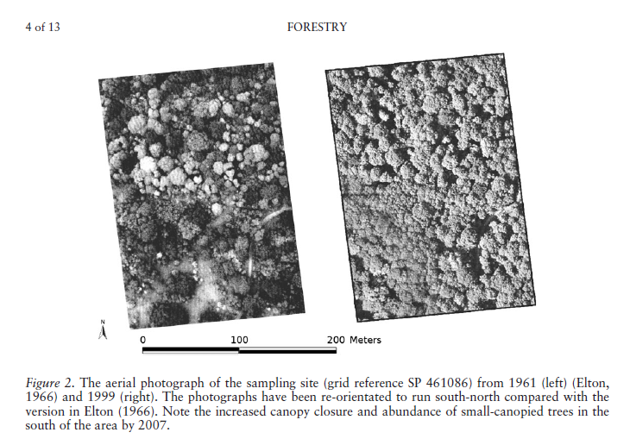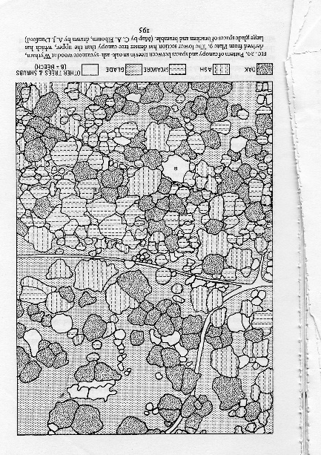
(b) A detailed record for trees and regeneration was made for the north-east corner of the area shown on the photograph by Dr Kitty Paviour-Smith (Kitty Southern) in 1068. The area was divided into 20x20 m squares, which were then further divided into 4 10x10 m plots (Annex 1). A rough canopy map was also produced.
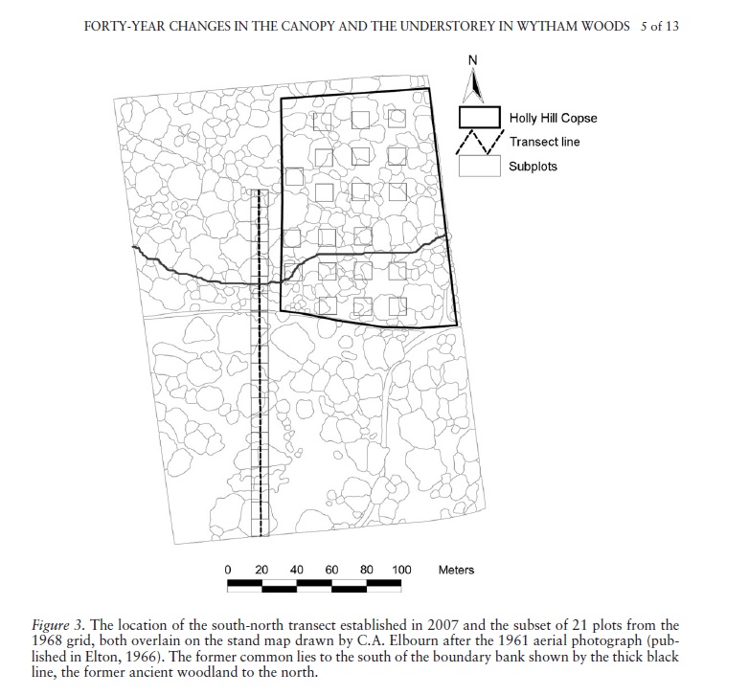
Within each 10x10 m plot each canopy tree was plotted and numbered (see Annex 1) and its girth measured (numbers above 104 appear to have been shrubs). In 2007 Dr Barbara Mihok retraced the grid: the 104 mature trees were relocated (if surviving) and remeasured. Additional trees that formed part of the main canopy but had not been measured in 1968 (because they were part of the understorey) were recorded by 10x10 m plot. These data are presented in Annex 2.
In 1968 understorey – regeneration and shrubs - was assessed in each 10x10m plot, with each stem being put into one of five diameter classes: 0 = 1-2 cm diameter, 1 = 2.1-5 cm, 2 = 5.1-10 cm, 3 10.1-15 cm, 4 >15 cm. The numbers of stems of each species in each diameter class in 1968 are given in Annex 3.
In 2007 there was not the time to record the understorey across the whole area, so a subset of 20 10x10 m plots were sampled spread systematically across the area. The results are in Annex 4.
In 2007 the basal area by tree species for the surroundings of each plot was estimated from relascope sweeps at the north-west and south-east corners. The results are in Annex 5.
(c) A 10 × 200 m transect was established running south-north through the area covered by the Elton aerial photograph. This was mainly in the former common, but a quarter was in ancient woodland, with the centre point located at the National Grid Reference grid point SP461086. From this point, ten 10 × 10 m adjacent sections were recorded in a northerly direction and ten 10 × 10 m sections to the south – the plots were then renumbered 1 – 20, starting at the southern end of the transect. The plots lie to the west of the transect line.
Within each plot the location of each tree with a diameter larger than 2.5 cm was recorded and its diameter measured at breast height (dbh.) (1.3 m) (Annex 6). Basal area of trees in the vicinity was estimated by taking a relascope sweep at 10 m intervals along the transect from the south-east corner (Annex 7). Percentage vegetation cover was estimated by eye along the SW-NE diagonal in three layers (0-0.5m; 0.5-2.5 m; >2.5 m), with the uppermost layer then being split by species (Annex 8).
Species in the ground flora were listed and their cover abundance recorded on the Domin scale (Annex 9). This included seedlings and small saplings.
Domin Scores and % cover range equivalent
1 = <4% 1 plant
2 = <4% 2 plants
3 = <4%, several plants
4 = 4-10%
5 =11-25%
6 = 26-33%
7 = 34-50%
8 = 51-75%
9 =76-90%
10 = 91-100%
Current Research
The research is mothballed.
Current Papers
MIHÓK, B., KENDERES, K., KIRBY, K. J., PAVIOUR-SMITH, K. & ELBOURN, C. A. 2009. Forty-year changes in the canopy and the understorey in Wytham Woods. Forestry, 82, 515-527.
Links
Contact Details
Keith Kirby, Department of Plant Sciences, South Parks Road, OX1 3RB, UK
Keith.kirby@plants.ox.ac.uk
Annex 1. Map of the Paviour-Smith plot
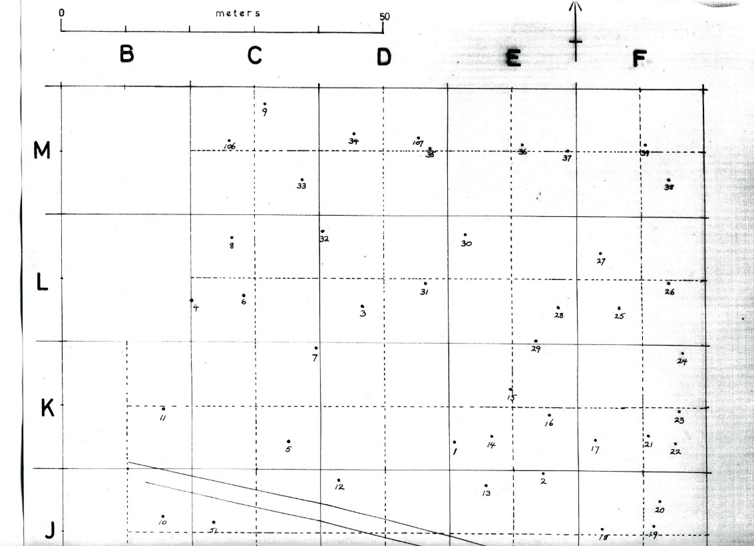
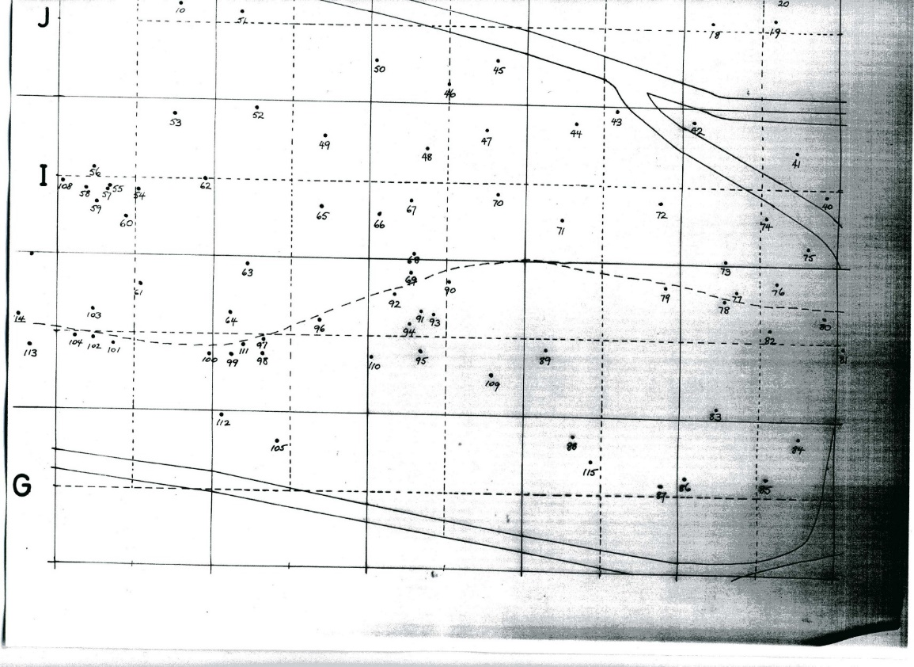

Tree canopy map of area surveyed by Kitty Southern in 1968
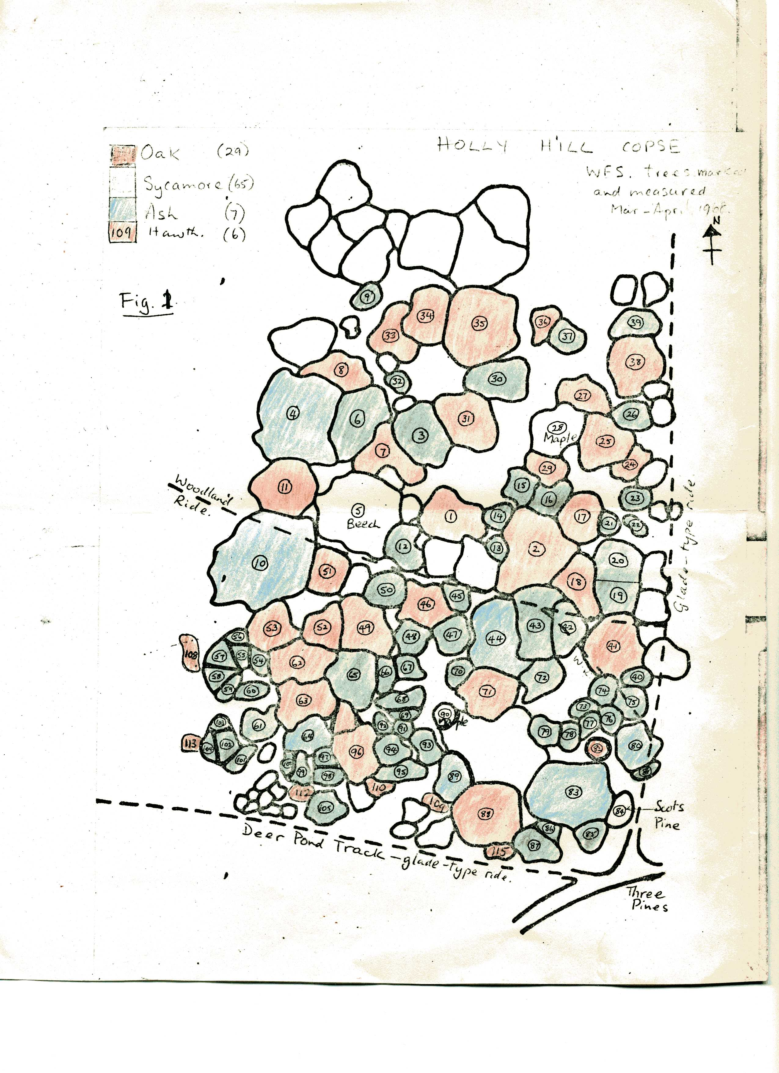
Annex 2. Girths of mature trees present in 1968 and remeasured in 2007.
Tree no (see map) | species | girth (cm) 1968 | girth (cm) 2007 |  | Dead
1 | Quercus robur | 194 | dead (166) |  | 1
2 | Quercus robur | 268 | 295 |  | 0
3 | Acer pseudoplatanus | 224 | 265 |  | 0
4 | Fraxinus excelsior | 379 | 469 |  | 0
5 | Fagus sylvatica | 283 | 317 |  | 0
7 | Quercus robur | 312 | 305 |  | 0
9 | Quercus robur | 120 | 141 |  | 0
10 | Fraxinus excelsior | 379 | 391 |  | 0
11 | Quercus robur | 238 | 261 |  | 0
12 | Acer pseudoplatanus | 116 | 115 |  | 0
13 | Acer pseudoplatanus | 86 | 97 | ride widening? | 0
14 | Acer pseudoplatanus | 103 | 143 | ride widening? | 0
15 | Acer pseudoplatanus | 137 | not found | ride widening? | 1
16 | Acer pseudoplatanus | 114 | not found | ride widening? | 1
17 | Quercus robur | 214 | 234 | ride widening? | 0
18 | Quercus robur | 202 | 209 |  | 0
19 | Acer pseudoplatanus | 133 | not found |  | 1
20 | Acer pseudoplatanus | 158 | not found | ride widening? | 1
21 | Acer pseudoplatanus | 113 | not found |  | 1
22 | Acer pseudoplatanus | 102 | not found |  | 1
23 | Acer pseudoplatanus | 105 | not found |  | 1
24 | Quercus robur | 178 | fallen |  | 1
25 | Quercus robur | 219 | 238 |  | 0
26 | Acer pseudoplatanus | 135 | not found |  | 1
27 | Quercus robur | 160 | 176 | ride widening? | 0
28 | field maple | 200 | 203 |  | 0
29 | Quercus robur | 111 | 126 | ride widening? | 0
30 | Acer pseudoplatanus | 237 | 276 |  | 0
31 | Quercus robur | 176 | 209 |  | 0
32 | Acer pseudoplatanus | 103 | 138 |  | 0
33 | Quercus robur | 169 | 183 |  | 0
34 | Quercus robur | 179 | 195 |  | 0
35 | Quercus robur | 278 | 309 |  | 0
36 | Quercus robur | 315 | fallen |  | 1
37 | Acer pseudoplatanus | 114 | 159 |  | 0
37 | Acer pseudoplatanus | 114 | 158 |  | 0
38 | Quercus robur | 216 | 245 |  | 0
39 | Acer pseudoplatanus | 114 | 176 |  | 0
40 | Acer pseudoplatanus | 87 | not found |  | 1
41 | Quercus robur | 208 | 222 |  | 0
42 | Acer pseudoplatanus | 117 | not found |  | 1
43 | Acer pseudoplatanus | 228 | 260 |  | 0
44 | Fraxinus excelsior | 253 | fallen |  | 1
45 | Acer pseudoplatanus | 97 | not found |  | 1
46 | Quercus robur | 185 | 207 |  | 0
47 | Acer pseudoplatanus | 106 | not found |  | 1
49 | Quercus robur | 208 | 221 |  | 0
50 | Acer pseudoplatanus | 128 | not found |  | 1
51 | Quercus robur | 155 | 163 | ride widening? | 0
52 | Quercus robur | 167 | 199 |  | 0
53 | Quercus robur | 203 | 253 |  | 0
54 | Fraxinus excelsior | 108 | 141 |  | 0
55 | Acer pseudoplatanus | 110 | 145 |  | 0
56 | Acer pseudoplatanus | 76 | 71 |  | 0
57 | Acer pseudoplatanus | 92 | 123 | ride widening? | 0
58 | Acer pseudoplatanus | 87 | 118 | ride widening? | 0
59 | Acer pseudoplatanus | 120 | 148 |  | 0
60 | Acer pseudoplatanus | 92 | 127 |  | 0
61 | Acer pseudoplatanus | 108 | 144 |  | 0
62 | Quercus robur | 263 | 284 | ride widening? | 0
63 | Quercus robur | 167 | 181 |  | 0
64 | Fraxinus excelsior | 170 | fallen |  | 1
65 | Acer pseudoplatanus | 198 | 219 |  | 0
66 | Acer pseudoplatanus | 104 | 161 |  | 0
67 | Acer pseudoplatanus | 108 | not found |  | 1
69 | Acer pseudoplatanus | 88 | 127 |  | 0
70 | Acer pseudoplatanus | 102 | 173 |  | 0
71 | Quercus robur | 205 | 219 |  | 0
72 | Acer pseudoplatanus | 140 | not found |  | 1
73 | Acer pseudoplatanus | 83 | 105 |  | 0
74 | Acer pseudoplatanus | 93 | not found |  | 1
75 | Acer pseudoplatanus | 98 | 119 |  | 0
76 | Acer pseudoplatanus | 81 | 106 |  | 0
77 | Acer pseudoplatanus | 90 | 119 |  | 0
78 | Acer pseudoplatanus | 100 | not found |  | 1
79 | Acer pseudoplatanus | 114 | not found |  | 1
80 | Fraxinus excelsior | 151 | not found |  | 1
81 | Acer pseudoplatanus | 82 | not found |  | 1
82 | Quercus robur | 115 | 133 |  | 0
83 | Fraxinus excelsior | 332 | 372 |  | 0
84 | Pinus sylvestris | 173 | 191 |  | 0
85 | Acer pseudoplatanus | 110 | not found |  | 1
86 | Acer pseudoplatanus | 80 | 107 |  | 0
87 | Acer pseudoplatanus | 175 | 243 |  | 0
88 | Quercus robur | 223 | 278 |  | 0
89 | Fraxinus excelsior | 183 | fallen |  | 1
91 | Acer pseudoplatanus | 84 | 117 |  | 0
92 | Acer pseudoplatanus | 79 | 114 |  | 0
93 | Acer pseudoplatanus | 141 | 194 |  | 0
94 | Acer pseudoplatanus | 119 | not found |  | 1
95 | Acer pseudoplatanus | 125 | 184 |  | 0
96 | Quercus robur | 217 | 236 |  | 0
97 | Acer pseudoplatanus | 95 | 143 |  | 0
98 | Acer pseudoplatanus | 107 | 145 |  | 0
99 | Acer pseudoplatanus | 118 | not found |  | 1
100 | Acer pseudoplatanus | 100 | 134 |  | 0
101 | Acer pseudoplatanus | 84 | 103 |  | 0
102 | Acer pseudoplatanus | 133 | 175 |  | 0
103 | Acer pseudoplatanus | 78 | not found |  | 1
104 | Acer pseudoplatanus | 77 | not found | dead stem | 1

Annex 3. Number of understorey stems >1 cm diameter for each 10x10 m plot, 1968
 |  |  | Number of stems in each size class
20x20 m section | 10x10 m plot | Species | Class 0 | Class1 | Class2 | Class3 | Class4
 |  | 1968 records | 1-2 cm diam. | 2.1-5 cm diam | 5.1-10 cm diam. | 10.1-15 cm diam | >15 cm diam
GB | NW | Acer pseudoplatanus | 1 | 2 | 0 | 0 | 0
GB | NW | Fraxinus excelisor | 13 | 17 | 3 | 2 | 0
GB | NW | Salix spp | 1 | 3 | 0 | 0 | 1
GB | NE | Acer pseudoplatanus | 8 | 5 | 1 | 5 | 0
GB | NE | Fraxinus excelisor | 30 | 17 | 2 | 2 | 0
GB | NE | Euonymus europaeus | 1 | 0 | 1 | 0 | 0
GC | NW | Acer pseudoplatanus | 1 | 0 | 0 | 3 | 0
GC | NW | Crataegus monogyna | 0 | 0 | 0 | 1 | 0
GC | NW | Fraxinus excelisor | 39 | 18 | 2 | 0 | 0
GC | NW | Euonymus europaeus | 0 | 1 | 0 | 0 | 0
GC | NE | Fraxinus excelisor | 6 | 15 | 1 | 0 | 0
GC | NE | Salix spp sppsp? | 0 | 0 | 1 | 0 | 0
GC | NE | Euonymus europaeus | 1 | 3 | 3 | 2 | 0
GC | SE | Fraxinus excelisor | 4 | 1 | 0 | 0 | 0
GC | SE | Salix spp | 0 | 1 | 0 | 0 | 0
GC | SE | Euonymus europaeus | 1 | 0 | 0 | 0 | 0
GD | NW | Acer pseudoplatanus | 9 | 3 | 1 | 1 | 1
GD | NW | Crataegus monogyna | 1 | 3 | 1 | 0 | 0
GD | NW | Fraxinus excelisor | 5 | 5 | 0 | 0 | 0
GD | NW | Euonymus europaeus | 4 | 1 | 1 | 0 | 0
GD | NE | Acer pseudoplatanus | 13 | 1 | 2 | 3 | 4
GD | NE | Crataegus monogynao | 2 | 0 | 0 | 0 | 0
GD | NE | Fraxinus excelisor | 10 | 0 | 0 | 0 | 0
GD | NE | Sambucus nigra | 0 | 0 | 1 | 0 | 0
GD | NE | Euonymus europaeus | 1 | 1 | 0 | 0 | 0
GD | SW | Crataegus monogynao | 1 | 1 | 0 | 0 | 0
GD | SW | Fraxinus excelisor | 2 | 10 | 0 | 0 | 0
GD | SW | Salix spp | 3 | 3 | 1 | 0 | 0
GD | SW | Unknown | 1 | 1 | 0 | 0 | 0
GD | SE | Acer pseudoplatanus | 4 | 0 | 0 | 4 | 0
GD | SE | Fraxinus excelisor | 23 | 12 | 3 | 0 | 0
GD | SE | Quercus robur | 1 | 0 | 0 | 0 | 0
GD | SE | Euonymus europaeus | 3 | 2 | 0 | 0 | 0
GE | NW | Acer pseudoplatanus | 0 | 2 | 5 | 3 | 0
GE | NW | Fraxinus excelisor | 6 | 2 | 0 | 0 | 0
GE | NE | Acer pseudoplatanus | 1 | 6 | 1 | 1 | 0
GE | NE | Corylus avellana | 1 | 0 | 0 | 0 | 0
GE | NE | Fraxinus excelisor | 40 | 13 | 0 | 0 | 0
GE | SW | Acer pseudoplatanus | 3 | 0 | 4 | 0 | 0
GE | SW | Crataegus monogynao | 1 | 1 | 0 | 0 | 0
GE | SW | Fraxinus excelisor | 31 | 6 | 5 | 1 | 0
GE | SW | Quercus robur | 0 | 1 | 0 | 0 | 0
GE | SW | Euonymus europaeus | 7 | 2 | 0 | 0 | 0
GE | SE | Acer pseudoplatanus | 1 | 6 | 2 | 0 | 0
GE | SE | Crataegus monogynai | 0 | 1 | 0 | 0 | 0
GE | SE | Fraxinus excelisor | 24 | 13 | 3 | 0 | 0
GE | SE | Quercus robur | 1 | 0 | 0 | 0 | 0
GE | SE | Salix spp | 0 | 1 | 0 | 0 | 0
GE | SE | Euonymus europaeus | 15 | 5 | 1 | 0 | 0
GF | NW | Acer pseudoplatanus | 0 | 5 | 1 | 0 | 0
GF | NW | Cornus sanguineus | 7 | 0 | 0 | 0 | 0
GF | NW | Corylus avellana | 1 | 0 | 0 | 0 | 0
GF | NW | Crataegus monogynao | 2 | 3 | 0 | 0 | 0
GF | NW | Fraxinus excelisor | 62 | 28 | 2 | 0 | 0
GF | NW | Horse chestn | 0 | 0 | 1 | 0 | 0
GF | NW | Quercus robur | 1 | 0 | 0 | 0 | 0
GF | NW | Sambucus nigra | 1 | 0 | 0 | 0 | 0
GF | NE | Acer pseudoplatanus | 1 | 4 | 10 | 4 | 0
GF | NE | Corylus avellana | 1 | 1 | 0 | 0 | 0
GF | NE | Fraxinus excelisor | 11 | 3 | 1 | 0 | 0
GF | SW | Acer pseudoplatanus | 1 | 2 | 0 | 0 | 0
GF | SW | Corylus avellana | 2 | 1 | 0 | 0 | 0
GF | SW | Fraxinus excelisor | 26 | 8 | 9 | 3 | 0
GF | SW | Quercus robur | 3 | 0 | 0 | 0 | 0
GF | SW | Euonymus europaeus | 8 | 3 | 2 | 0 | 0
GF | SE | Acer pseudoplatanus | 3 | 6 | 9 | 0 | 0
GF | SE | Cornus sanguineus | 1 | 0 | 0 | 0 | 0
GF | SE | Fraxinus excelisor | 9 | 11 | 0 | 2 | 0
GF | SE | Sambucus nigra | 2 | 1 | 0 | 0 | 0
GF | SE | Euonymus europaeus | 1 | 0 | 0 | 0 | 0
HB | NW | Fraxinus excelisor | 33 | 11 | 0 | 0 | 0
HB | NE | Acer campestre | 1 | 0 | 0 | 0 | 0
HB | NE | Acer pseudoplatanus | 2 | 1 | 2 | 0 | 0
HB | NE | Fraxinus excelisor | 12 | 6 | 0 | 0 | 0
HB | NE | Euonymus europaeus | 0 | 0 | 1 | 0 | 0
HB | SW | Acer pseudoplatanus | 2 | 0 | 1 | 0 | 1
HB | SW | Fraxinus excelisor | 8 | 4 | 4 | 0 | 0
HB | SW | Sambucus nigra | 2 | 0 | 0 | 0 | 0
HB | SE | Acer pseudoplatanus | 9 | 4 | 0 | 4 | 1
HB | SE | Crataegus monogynao | 0 | 1 | 0 | 0 | 0
HB | SE | Fraxinus excelisor | 20 | 2 | 1 | 0 | 0
HB | SE | Euonymus europaeus | 1 | 0 | 0 | 0 | 0
HC | NW | Acer campestre | 2 | 0 | 0 | 0 | 0
HC | NW | Acer pseudoplatanus | 0 | 2 | 1 | 0 | 0
HC | NW | Crataegus monogynao | 8 | 0 | 0 | 0 | 0
HC | NW | Fraxinus excelisor | 30 | 3 | 0 | 0 | 0
HC | NE | Acer pseudoplatanus | 3 | 1 | 0 | 0 | 0
HC | NE | Fraxinus excelisor | 83 | 17 | 0 | 0 | 0
HC | NE | Euonymus europaeus | 1 | 0 | 0 | 0 | 0
HC | SW | Acer pseudoplatanus | 4 | 0 | 0 | 0 | 0
HC | SW | Fraxinus excelisor | 22 | 2 | 1 | 0 | 0
HC | SW | Euonymus europaeus | 2 | 0 | 0 | 0 | 0
HC | SE | Acer pseudoplatanus | 7 | 0 | 0 | 3 | 0
HC | SE | Fraxinus excelisor | 32 | 4 | 0 | 0 | 0
HC | SE | Euonymus europaeus | 3 | 4 | 0 | 2 | 0
HD | NW | Acer pseudoplatanus | 6 | 0 | 0 | 0 | 0
HD | NW | Crataegus monogynao | 2 | 0 | 0 | 0 | 0
HD | NW | Fraxinus excelisor | 71 | 21 | 2 | 0 | 0
HD | NE | Acer pseudoplatanus | 6 | 2 | 7 | 0 | 0
HD | NE | Crataegus monogynao | 0 | 1 | 0 | 0 | 0
HD | NE | Fraxinus excelisor | 31 | 13 | 8 | 0 | 0
HD | NE | Quercus robur | 1 | 0 | 0 | 0 | 0
HD | SW | Acer pseudoplatanus | 0 | 0 | 0 | 1 | 0
HD | SW | Fraxinus excelisor | 23 | 2 | 0 | 0 | 0
HD | SE | Acer pseudoplatanus | 8 | 5 | 2 | 3 | 0
HD | SE | Crataegus monogynao | 1 | 0 | 0 | 0 | 0
HD | SE | Fraxinus excelisor | 17 | 9 | 0 | 0 | 0
HD | SE | Euonymus europaeus | 0 | 1 | 0 | 0 | 0
HE | NW | Acer pseudoplatanus | 4 | 6 | 3 | 0 | 13
HE | NW | Fraxinus excelisor | 37 | 7 | 17 | 3 | 64
HE | NW | Quercus robur | 1 | 0 | 0 | 0 | 0
HE | NE | Acer pseudoplatanus | 1 | 5 | 2 | 4 | 1
HE | NE | Fraxinus excelisor | 12 | 13 | 12 | 0 | 0
HE | NE | Euonymus europaeus | 0 | 0 | 1 | 0 | 0
HE | SW | Acer pseudoplatanus | 3 | 6 | 4 | 1 | 0
HE | SW | Fraxinus excelisor | 20 | 11 | 6 | 0 | 0
HE | SW | Euonymus europaeus | 1 | 0 | 0 | 0 | 0
HE | SE | Acer pseudoplatanus | 2 | 3 | 1 | 4 | 1
HE | SE | Fagus sylvatica | 1 | 0 | 0 | 0 | 0
HE | SE | Fraxinus excelisor | 79 | 24 | 0 | 0 | 0
HE | SE | Euonymus europaeus | 1 | 0 | 0 | 0 | 0
HE | SE | Quercus robur | 3 | 0 | 0 | 0 | 0
HF | NW | Acer pseudoplatanus | 2 | 10 | 3 | 1 | 0
HF | NW | Crataegus monogynao | 2 | 0 | 0 | 0 | 0
HF | NW | Fraxinus excelisor | 42 | 9 | 0 | 0 | 0
HF | NE | Acer campestre | 1 | 0 | 2 | 0 | 0
HF | NE | Acer pseudoplatanus | 2 | 8 | 1 | 0 | 0
HF | NE | Cornus sanguineus | 0 | 1 | 0 | 0 | 0
HF | NE | Crataegus monogynao | 2 | 1 | 0 | 0 | 0
HF | NE | Fraxinus excelisor | 73 | 14 | 0 | 0 | 0
HF | NE | Euonymus europaeus | 1 | 0 | 0 | 0 | 0
HF | SW | Acer pseudoplatanus | 2 | 6 | 6 | 1 | 0
HF | SW | Corylus avellana | 3 | 1 | 0 | 0 | 0
HF | SW | Crataegus monogynao | 1 | 4 | 0 | 0 | 0
HF | SW | Fraxinus excelisor | 57 | 24 | 0 | 0 | 0
HF | SW | Euonymus europaeus | 0 | 2 | 0 | 0 | 0
HF | SE | Acer campestre | 1 | 0 | 0 | 0 | 0
HF | SE | Acer pseudoplatanus | 1 | 6 | 12 | 3 | 0
HF | SE | Crataegus monogynao | 0 | 1 | 0 | 0 | 0
HF | SE | Sambucus nigra | 7 | 1 | 0 | 0 | 0
IB | NW | Acer campestre | 2 | 0 | 0 | 0 | 0
IB | NW | Acer pseudoplatanus | 1 | 0 | 0 | 0 | 0
IB | NW | Fraxinus excelisor | 7 | 0 | 0 | 0 | 0
IB | NE | Acer campestre | 1 | 0 | 0 | 0 | 0
IB | NE | Acer pseudoplatanus | 1 | 4 | 0 | 0 | 0
IB | NE | Corylus avellana | 2 | 0 | 0 | 0 | 0
IB | NE | Crataegus monogynao | 3 | 0 | 0 | 0 | 0
IB | NE | Fagus sylvatica | 1 | 0 | 0 | 0 | 0
IB | NE | Fraxinus excelisor | 42 | 16 | 0 | 0 | 0
IB | SW | Acer pseudoplatanus | 11 | 1 | 0 | 0 | 0
IB | SW | Fraxinus excelisor | 5 | 2 | 0 | 0 | 0
IB | SE | Acer pseudoplatanus | 3 | 5 | 2 | 0 | 0
IB | SE | Fraxinus excelisor | 24 | 5 | 0 | 0 | 0
IC | NW | Acer campestre | 1 | 0 | 0 | 0 | 0
IC | NW | Acer pseudoplatanus | 4 | 0 | 0 | 0 | 0
IC | NW | Crataegus monogynao | 3 | 0 | 0 | 0 | 0
IC | NW | Fraxinus excelisor | 46 | 2 | 0 | 0 | 0
IC | NW | Euonymus europaeus | 1 | 0 | 0 | 0 | 0
IC | NE | Acer pseudoplatanus | 1 | 0 | 3 | 0 | 0
IC | NE | Fraxinus excelisor | 38 | 2 | 0 | 0 | 0
IC | SW | Crataegus monogynao | 1 | 0 | 0 | 0 | 0
IC | SW | Fraxinus excelisor | 91 | 2 | 0 | 0 | 0
IC | SE | Fraxinus excelisor | 72 | 19 | 0 | 0 | 0
ID | NW | Acer pseudoplatanus | 1 | 6 | 0 | 0 | 0
ID | NW | Crataegus monogynao | 1 | 0 | 0 | 0 | 0
ID | NW | Fraxinus excelisor | 48 | 18 | 2 | 0 | 0
ID | NE | Acer pseudoplatanus | 7 | 4 | 2 | 0 | 0
ID | NE | Crataegus monogyna | 1 | 0 | 0 | 0 | 0
ID | NE | Fraxinus excelisor | 74 | 13 | 1 | 0 | 0
ID | SW | Acer pseudoplatanus | 7 | 6 | 2 | 0 | 0
ID | SW | Crataegus monogynao | 1 | 0 | 0 | 0 | 0
ID | SW | Fagus sylvatica | 0 | 1 | 0 | 0 | 0
ID | SW | Fraxinus excelisor | 39 | 21 | 4 | 0 | 0
ID | SW | Euonymus europaeus | 1 | 0 | 0 | 0 | 0
ID | SE | Acer pseudoplatanus | 10 | 6 | 2 | 0 | 0
ID | SE | Crataegus monogynao | 2 | 0 | 0 | 0 | 0
ID | SE | Fraxinus excelisor | 52 | 39 | 4 | 0 | 0
IE | NW | Acer campestre | 1 | 1 | 0 | 0 | 0
IE | NW | Acer pseudoplatanus | 3 | 6 | 1 | 0 | 0
IE | NW | Crataegus monogynao | 2 | 2 | 0 | 0 | 0
IE | NW | Fraxinus excelisor | 33 | 6 | 0 | 0 | 0
IE | NE | Crataegus monogynao | 1 | 0 | 0 | 0 | 0
IE | NE | Fraxinus excelisor | 29 | 1 | 0 | 0 | 0
IE | NE | Euonymus europaeus | 1 | 0 | 0 | 0 | 0
IE | SW | Acer campestre | 1 | 0 | 0 | 0 | 0
IE | SW | Acer pseudoplatanus | 0 | 2 | 1 | 0 | 0
IE | SW | Cornus sanguineus | 2 | 0 | 0 | 0 | 0
IE | SW | Fraxinus excelisor | 71 | 10 | 2 | 0 | 0
IE | SE | Acer pseudoplatanus | 0 | 2 | 0 | 0 | 0
IE | SE | Cornus sanguineus | 2 | 0 | 0 | 0 | 0
IE | SE | Crataegus monogynao | 1 | 0 | 0 | 0 | 0
IE | SE | Fraxinus excelisor | 30 | 11 | 6 | 0 | 0
IF | NW | Acer pseudoplatanus | 5 | 3 | 0 | 0 | 0
IF | NW | Fraxinus excelisor | 15 | 5 | 7 | 0 | 0
IF | NW | Sambucus nigra | 1 | 0 | 0 | 0 | 0
IF | NE | Acer pseudoplatanus | 0 | 20 | 6 | 0 | 0
IF | NE | Fraxinus excelisor | 15 | 3 | 1 | 0 | 0
IF | SW | Acer pseudoplatanus | 0 | 1 | 1 | 0 | 0
IF | SW | Fraxinus excelisor | 3 | 16 | 17 | 0 | 0
IF | SE | Acer pseudoplatanus | 3 | 2 | 0 | 0 | 0
IF | SE | Fagus sylvatica | 1 | 0 | 0 | 0 | 0
IF | SE | Fraxinus excelisor | 5 | 8 | 0 | 0 | 0
JB | NE | Acer pseudoplatanus | 0 | 8 | 6 | 1 | 0
JB | SE | Acer pseudoplatanus | 2 | 2 | 8 | 3 | 0
JB | SE | Fraxinus excelisor | 11 | 2 | 0 | 0 | 0
JC | NW | Acer pseudoplatanus | 0 | 7 | 4 | 1 | 0
JC | NW | Fraxinus excelisor | 1 | 0 | 0 | 0 | 0
JC | NE | Acer pseudoplatanus | 0 | 2 | 1 | 3 | 0
JC | NE | Corylus avellana | 4 | 0 | 0 | 0 | 0
JC | NE | Fraxinus excelisor | 8 | 1 | 0 | 0 | 0
JC | NE | Sambucus nigra | 1 | 0 | 0 | 0 | 0
JC | SW | Acer pseudoplatanus | 1 | 12 | 11 | 2 | 0
JC | SW | Fraxinus excelisor | 2 | 1 | 0 | 0 | 0
JC | SE | Acer pseudoplatanus | 1 | 8 | 3 | 3 | 0
JC | SE | Corylus avellana | 3 | 0 | 0 | 0 | 0
JC | SE | Fraxinus excelisor | 15 | 2 | 0 | 0 | 0
JD | NW | Acer pseudoplatanus | 0 | 4 | 3 | 2 | 1
JD | NW | Fraxinus excelisor | 14 | 3 | 3 | 0 | 0
JD | NE | Acer pseudoplatanus | 1 | 6 | 15 | 2 | 0
JD | NE | Crataegus monogynao | 1 | 0 | 0 | 0 | 0
JD | NE | Fraxinus excelisor | 1 | 1 | 2 | 1 | 2
JD | NE | Salix spp | 2 | 0 | 0 | 0 | 0
JD | SW | Acer pseudoplatanus | 1 | 3 | 1 | 0 | 0
JD | SW | Fagus sylvatica | 1 | 0 | 0 | 0 | 0
JD | SW | Fraxinus excelisor | 33 | 6 | 4 | 0 | 0
JD | SE | Acer pseudoplatanus | 2 | 4 | 1 | 0 | 0
JD | SE | Fraxinus excelisor | 25 | 4 | 1 | 0 | 0
JE | NW | Acer pseudoplatanus | 1 | 9 | 13 | 1 | 1
JE | NW | Fraxinus excelisor | 3 | 2 | 4 | 3 | 0
JE | NW | Salix spp | 1 | 0 | 0 | 0 | 0
JE | NE | Acer pseudoplatanus | 0 | 12 | 8 | 0 | 1
JE | NE | Fraxinus excelisor | 22 | 3 | 0 | 0 | 0
JE | SW | Acer pseudoplatanus | 0 | 4 | 1 | 0 | 0
JE | SW | Fraxinus excelisor | 11 | 4 | 1 | 0 | 0
JE | SE | Crataegus monogynao | 1 | 0 | 0 | 0 | 0
JE | SE | Fraxinus excelisor | 27 | 0 | 0 | 0 | 0
JF | NW | Acer pseudoplatanus | 11 | 13 | 3 | 1 | 0
JF | NW | Fraxinus excelisor | 14 | 10 | 1 | 1 | 0
JF | NE | Acer pseudoplatanus | 9 | 7 | 3 | 2 | 0
JF | NE | Fraxinus excelisor | 12 | 1 | 4 | 0 | 0
JF | SW | Acer pseudoplatanus | 2 | 1 | 0 | 0 | 0
JF | SW | Fraxinus excelisor | 15 | 12 | 7 | 0 | 0
JF | SE | Acer pseudoplatanus | 0 | 8 | 5 | 2 | 0
JF | SE | Fraxinus excelisor | 4 | 3 | 4 | 1 | 0
KB | NE | Acer campestrep | 1 | 1 | 0 | 0 | 0
KB | NE | Acer pseudoplatanus | 3 | 1 | 6 | 1 | 0
KB | NE | Corylus avellana | 2 | 3 | 0 | 0 | 0
KB | NE | Crataegus monogyna | 1 | 4 | 0 | 0 | 0
KB | NE | Fraxinus excelisor | 4 | 2 | 1 | 0 | 0
KB | NE | Salix spp | 0 | 1 | 0 | 0 | 0
KB | NE | Sambucus nigra | 2 | 0 | 0 | 0 | 0
KB | SE | Acer campestrep | 1 | 0 | 0 | 0 | 0
KB | SE | Acer pseudoplatanus | 5 | 7 | 2 | 0 | 0
KB | SE | Corylus avellana | 1 | 0 | 0 | 0 | 0
KB | SE | Crataegus monogyna | 0 | 1 | 0 | 0 | 0
KB | SE | Sambucus nigra | 3 | 0 | 0 | 0 | 0
KB | SE | Euonymus europaeus | 1 | 0 | 0 | 0 | 0
KC | NW | Acer pseudoplatanus | 4 | 5 | 4 | 2 | 3
KC | NW | Fagus sylvatica | 0 | 1 | 0 | 0 | 0
KC | NW | Fraxinus excelisor | 2 | 0 | 0 | 0 | 0
KC | NW | Salix spp | 0 | 1 | 0 | 0 | 0
KC | NE | Acer pseudoplatanus | 0 | 1 | 1 | 2 | 0
KC | NE | Fraxinus excelisor | 3 | 0 | 0 | 0 | 0
KC | SW | Acer campestre | 0 | 1 | 0 | 0 | 0
KC | SW | Acer pseudoplatanus | 0 | 1 | 5 | 1 | 0
KC | SW | Corylus avellana | 0 | 4 | 1 | 0 | 0
KC | SW | Fraxinus excelisor | 0 | 1 | 0 | 0 | 0
KC | SW | Euonymus europaeus | 2 | 0 | 0 | 1 | 0
KC | SE | Acer pseudoplatanus | 0 | 0 | 0 | 2 | 0
KD | NW | Acer pseudoplatanus | 7 | 8 | 5 | 3 | 0
KD | NW | Crataegus monogynao | 1 | 0 | 0 | 0 | 0
KD | NW | Fraxinus excelisor | 9 | 4 | 4 | 0 | 0
KD | NW | Salix spp | 0 | 1 | 1 | 0 | 0
KD | NE | Acer pseudoplatanus | 5 | 6 | 5 | 1 | 0
KD | NE | Fraxinus excelisor | 2 | 1 | 1 | 0 | 0
KD | SW | Acer pseudoplatanus | 10 | 11 | 4 | 3 | 1
KD | SW | Fraxinus excelisor | 4 | 9 | 0 | 0 | 0
KD | SW | Euonymus europaeus | 1 | 0 | 0 | 0 | 0
KD | SE | Acer pseudoplatanus | 0 | 4 | 10 | 0 | 1
KD | SE | Fraxinus excelisor | 1 | 11 | 1 | 0 | 0
KE | NW | Acer pseudoplatanus | 4 | 8 | 12 | 1 | 3
KE | NE | Acer campestrep | 1 | 0 | 0 | 0 | 0
KE | NE | Acer pseudoplatanus | 14 | 5 | 4 | 2 | 1
KE | NE | Fraxinus excelisor | 8 | 4 | 1 | 0 | 0
KE | SW | Acer campestrep | 1 | 0 | 0 | 0 | 0
KE | SW | Acer pseudoplatanus | 3 | 12 | 8 | 3 | 0
KE | SW | Fraxinus excelisor | 6 | 2 | 0 | 0 | 0
KE | SE | Acer campestrep | 1 | 0 | 0 | 0 | 0
KE | SE | Acer pseudoplatanus | 3 | 12 | 8 | 3 | 0
KE | SE | Corylus avellana | 2 | 0 | 0 | 0 | 0
KE | SE | Crataegus monogynao | 1 | 0 | 0 | 0 | 0
KE | SE | Fraxinus excelisor | 26 | 3 | 1 | 0 | 0
KE | SE | Euonymus europaeus | 1 | 0 | 0 | 0 | 0
KF | NW | Acer campestrep | 3 | 1 | 0 | 0 | 0
KF | NW | Acer pseudoplatanus | 12 | 11 | 15 | 1 | 1
KF | NW | Fraxinus excelisor | 2 | 1 | 2 | 0 | 1
KF | NE | Acer pseudoplatanus | 8 | 17 | 14 | 4 | 0
KF | SW | Acer pseudoplatanus | 7 | 15 | 6 | 1 | 0
KF | SW | Corylus avellana | 4 | 1 | 0 | 0 | 0
KF | SW | Crataegus monogynao | 0 | 1 | 0 | 0 | 0
KF | SW | Fraxinus excelisor | 14 | 9 | 4 | 0 | 0
KF | SE | Acer pseudoplatanus | 20 | 18 | 7 | 0 | 0
KF | SE | Crataegus monogynao | 1 | 0 | 0 | 0 | 0
KF | SE | Fraxinus excelisor | 3 | 4 | 2 | 0 | 0
LC | NW | Acer pseudoplatanus | 1 | 2 | 1 | 0 | 0
LC | NW | Crataegus monogynao | 1 | 0 | 0 | 0 | 0
LC | NE | Acer pseudoplatanus | 14 | 15 | 4 | 2 | 0
LC | NE | Fraxinus excelisor | 5 | 0 | 0 | 0 | 0
LC | SW | Acer pseudoplatanus | 0 | 1 | 2 | 0 | 0
LC | SW | Corylus avellana | 1 | 1 | 0 | 0 | 0
LC | SW | Crataegus monogynao | 1 | 0 | 0 | 0 | 0
LC | SW | Fraxinus excelisor | 0 | 0 | 1 | 0 | 0
LC | SW | Sambucus nigra | 0 | 0 | 0 | 0 | 1
LC | SW | Euonymus europaeus | 0 | 1 | 0 | 0 | 0
LC | SE | Acer campestrep | 1 | 0 | 0 | 0 | 0
LC | SE | Acer pseudoplatanus | 4 | 5 | 2 | 0 | 0
LC | SE | Fagus sylvatica | 0 | 1 | 0 | 0 | 0
LC | SE | Fraxinus excelisor | 9 | 4 | 0 | 0 | 0
LD | NW | Acer pseudoplatanus | 26 | 17 | 11 | 0 | 1
LD | NW | Fraxinus excelisor | 0 | 0 | 1 | 0 | 0
LD | NE | Acer pseudoplatanus | 12 | 14 | 14 | 3 | 0
LD | NE | Fraxinus excelisor | 4 | 1 | 0 | 0 | 0
LD | SW | Fraxinus excelisor | 2 | 3 | 0 | 0 | 0
LD | SE | Acer pseudoplatanus | 3 | 5 | 0 | 1 | 0
LD | SE | Fraxinus excelisor | 2 | 4 | 0 | 0 | 0
LE | NW | Acer campestrep | 0 | 0 | 1 | 0 | 0
LE | NW | Acer pseudoplatanus | 16 | 19 | 7 | 0 | 0
LE | NW | Fraxinus excelisor | 0 | 0 | 2 | 0 | 0
LE | NE | Acer pseudoplatanus | 2 | 2 | 5 | 1 | 0
LE | NE | Fraxinus excelisor | 2 | 2 | 2 | 0 | 0
LE | SW | Acer campestrep | 0 | 1 | 0 | 0 | 0
LE | SW | Acer pseudoplatanus | 8 | 14 | 8 | 1 | 0
LE | SW | Fraxinus excelisor | 2 | 3 | 1 | 0 | 0
LE | SE | Acer pseudoplatanus | 0 | 1 | 2 | 0 | 1
LE | SE | Fraxinus excelisor | 4 | 2 | 0 | 0 | 0
LF | NW | Acer campestrep | 1 | 4 | 3 | 0 | 0
LF | NW | Acer pseudoplatanus | 7 | 7 | 2 | 0 | 0
LF | NW | Fraxinus excelisor | 5 | 5 | 1 | 0 | 0
LF | NE | Acer campestrep | 2 | 3 | 0 | 0 | 0
LF | NE | Acer pseudoplatanus | 9 | 15 | 4 | 1 | 0
LF | NE | Betula pendula | 1 | 0 | 0 | 0 | 0
LF | NE | Crataegus monogynao | 0 | 1 | 0 | 0 | 0
LF | NE | Fraxinus excelisor | 11 | 7 | 2 | 0 | 0
LF | NE | Salix spp | 0 | 0 | 0 | 1 | 0
LF | SW | Acer pseudoplatanus | 3 | 5 | 6 | 2 | 1
LF | SW | Fraxinus excelisor | 2 | 4 | 0 | 0 | 0
LF | SE | Acer campestrep | 1 | 0 | 0 | 0 | 0
LF | SE | Acer pseudoplatanus | 8 | 16 | 5 | 2 | 0
LF | SE | Fraxinus excelisor | 1 | 3 | 5 | 0 | 0
LF | SE | Salix spp | 0 | 0 | 0 | 1 | 0
MC | NW | Acer campestrep | 0 | 1 | 0 | 0 | 0
MC | NW | Acer pseudoplatanus | 7 | 5 | 4 | 0 | 0
MC | NW | Fraxinus excelisor | 1 | 1 | 2 | 1 | 0
MC | NE | Acer pseudoplatanus | 1 | 4 | 10 | 1 | 0
MC | NE | Fraxinus excelisor | 1 | 4 | 2 | 0 | 0
MC | SW | Acer pseudoplatanus | 8 | 4 | 9 | 2 | 0
MC | SW | Fraxinus excelisor | 4 | 1 | 2 | 0 | 0
MC | SW | Quercus robur | 1 | 0 | 0 | 0 | 0
MC | SW | Euonymus europaeus | 4 | 0 | 0 | 0 | 0
MC | SE | Acer pseudoplatanus | 15 | 23 | 10 | 1 | 1
MC | SE | Fraxinus excelisor | 1 | 0 | 0 | 0 | 1
MD | NW | Acer campestrep | 0 | 1 | 0 | 0 | 0
MD | NW | Acer pseudoplatanus | 0 | 0 | 0 | 1 | 0
MD | NW | Fraxinus excelisor | 2 | 0 | 0 | 0 | 0
MD | NE | Acer pseudoplatanus | 0 | 1 | 0 | 0 | 1
MD | NE | Fraxinus excelisor | 4 | 0 | 0 | 0 | 0
MD | SW | Acer pseudoplatanus | 2 | 11 | 11 | 2 | 0
MD | SW | Fraxinus excelisor | 5 | 9 | 1 | 0 | 0
MD | SE | Acer pseudoplatanus | 15 | 4 | 3 | 2 | 0
MD | SE | Fraxinus excelisor | 9 | 5 | 2 | 0 | 0
ME | NW | Acer pseudoplatanus | 15 | 22 | 17 | 0 | 0
ME | NW | Fraxinus excelisor | 1 | 1 | 1 | 0 | 0
ME | NE | Acer campestrep | 0 | 0 | 1 | 0 | 0
ME | NE | Acer pseudoplatanus | 1 | 4 | 3 | 1 | 0
ME | NE | Fraxinus excelisor | 12 | 15 | 8 | 1 | 0
ME | SW | Acer campestrep | 0 | 1 | 0 | 0 | 0
ME | SW | Acer pseudoplatanus | 20 | 31 | 7 | 2 | 1
ME | SW | Crataegus monogyna | 0 | 1 | 0 | 0 | 0
ME | SW | Fraxinus excelisor | 7 | 8 | 1 | 0 | 0
ME | SE | Acer campestrep | 3 | 1 | 0 | 0 | 0
ME | SE | Acer pseudoplatanus | 0 | 8 | 13 | 3 | 0
ME | SE | Fraxinus excelisor | 6 | 7 | 1 | 1 | 0
MF | NW | Acer pseudoplatanus | 13 | 6 | 4 | 1 | 0
MF | NW | Betula pendula | 1 | 0 | 0 | 0 | 0
MF | NW | Fraxinus excelisor | 2 | 5 | 8 | 0 | 0
MF | NE | Acer pseudoplatanus | 0 | 3 | 1 | 3 | 1
MF | NE | Fraxinus excelisor | 2 | 3 | 1 | 0 | 0
MF | NE | Euonymus europaeus | 1 | 0 | 0 | 0 | 0
MF | SW | Acer campestrep | 3 | 6 | 1 | 0 | 0
MF | SW | Acer pseudoplatanus | 7 | 7 | 4 | 2 | 0
MF | SW | Betula pendula | 0 | 3 | 2 | 0 | 0
MF | SW | Fraxinus excelisor | 20 | 6 | 7 | 0 | 0
MF | SW | Salix spp | 0 | 0 | 1 | 1 | 0
MF | SE | Acer pseudoplatanus | 9 | 3 | 6 | 1 | 0
MF | SE | Fraxinus excelisor | 8 | 4 | 0 | 0 | 0

Annex 5. 2007 Basal Area estimates based on relascope sweeps from south-east and north-west corners of the plots
2007 records |  |  | Relascope tallies for each species; factor 2 used, so combining the totals for the two corners of each plot gives the basal area.
20x20 m section | 10x10m plot | corner | Quercus robur | Acer pseudoplatanus | Fraxinus excelsior | Fagus sylvatica | Salix spp. | Acer campestre | Crataegus monogyna | Pinus sylvestris
CM | SE | nw | 10 | 7 | 10
CM | SE | se | 8 | 5 | 10 | 1
DM | SE | nw | 9 | 5 | 5
DM | SE | se | 8 | 6 | 3 | 1
EM | SE | nw | 6 | 5 | 17 |  | 1 | 2
EM | SE | se | 9 | 5 | 7 |  |  | 1
CL | SE | nw | 4 | 9 | 2 | 3
CL | SE | se | 7 | 9 | 4 | 2
DL | SE | nw | 10 | 6 | 9 | 1 |  | 1
DL | SE | se | 5 | 8 | 7 | 1
EL | SE | nw | 8 | 6 | 1 |  |  | 1
EL | SE | se | 8 | 8 | 5 | 1 |  | 1
EK | SE | nw | 6 | 10 | 3 |  |  | 1
EK | SE | se | 7 | 17 | 11 | 1
DK | SE | nw | 6 | 9 | 11 | 1 |  | 1
DK | SE | se | 5 | 10 | 15 | 1
CK | SE | nw | 7 | 5 | 8 | 1
CK | SE | se | 11 | 6 | 3 | 1
BK | NE | nw | 5 | 12 | 2 | 2
BK | NE | se | 2 | 12 | 8 | 1
 | NE
BI | NE | nw | 10 | 11 | 3 | 2
BI | NE | se | 6 | 14 | 2 | 1
CI | NE | nw | 9 | 9 | 7 | 3
CI | NE | se | 7 | 4 | 3 | 1 |  |  | 1
DI | NE | nw | 7 | 5 | 6 | 1 |  |  | 1
DI | NE | se | 7 | 11 | 7 | 1
BH | NE | nw | 6 | 17 | 1 | 1
BH | NE | se | 5 | 14 | 4
CH | NE | nw | 8 | 8 | 7 |  |  |  | 1
CH | NE | se | 5 | 13 | 5
DH | NE | nw | 7 | 11 | 11
DH | NE | se | 4 | 12 | 8
EH | NE | nw | 5 | 12 | 8 |  |  |  | 1
EH | NE | se | 2 | 9 | 11
EG | NE | nw | 2 |  | 11 |  |  |  | 2 | 2
EG | NE | se | 1 | 6 | 11 |  | 1 |  |  | 2
DG | NE | nw | 1 | 16 | 12
DG | NE | se | 1 | 11 | 14
CG | NE | nw | 2 | 15 | 10 |  |  |  | 1
CG | NE | se | 2 | 15 | 10

Annex 6. Location and diameters of trees in the 200m transect.

Transect trees: 0,0 point is SP461085 | Easting | Northing | Species | Diameter Breast Height
 | 0.5 | 8.8 | Acer pseudoplatanus | 13
 | 0.5 | 8.8 | Acer pseudoplatanus | 18
 | 3.2 | 6.5 | Betula pendula | 38.5
 | 0.4 | 8 | Fraxinus excelsior | 15.5
 | 7 | 12 | Acer pseudoplatanus | 19.5
 | 2 | 10.2 | Acer pseudoplatanus | 20
 | 2 | 10.2 | Acer pseudoplatanus | 17.5
 | 1.3 | 12 | Betula pendula | 38.5
 | 8.1 | 17.4 | Crataegus monogyna | 7
 | 7.5 | 17.9 | Fagus sylvatica | 9.5
 | 7 | 28.1 | Betula pendula | 36
 | 0.9 | 28.1 | Fagus sylvatica | 30
 | 9 | 25 | Sambucus nigra | 11
 | 1 | 38.3 | Betula pendula | 24
 | 0.4 | 38.8 | Betula pendula | 17
 | 9 | 39 | Crataegus monogyna | 20.5
 | 7.5 | 39.4 | Crataegus monogyna | 21
 | 5.8 | 38.4 | Crataegus monogyna | 16.8
 | 9.7 | 34.4 | Crataegus monogyna | 22
 | 9.3 | 34.6 | Crataegus monogyna | 12
 | 2.8 | 32 | Fraxinus excelsior | 44.5
 | 1.2 | 34.5 | Quercus robur | 23
 | 2.1 | 31.6 | Quercus robur | 24.5
 | 3.4 | 42.8 | Crataegus monogyna | 15
 | 3.4 | 42.8 | Crataegus monogyna | 13
 | 3.4 | 42.8 | Crataegus monogyna | 17.5
 | 3.1 | 47 | Crataegus monogyna | 17
 | 5.6 | 40.2 | Cornus sanguineus | 11.5
 | 7.6 | 51 | Crataegus monogyna | 12
 | 2.5 | 53 | Prunus spinosa | 13
 | 1.2 | 52.8 | Prunus spinosa | 11.2
 | 1.4 | 52.9 | Prunus spinosa | 10.5
 | 7.2 | 51.2 | Prunus spinosa | 7.5
 | 8.6 | 77.6 | Crataegus monogyna | 4.5
 | 7.9 | 76.7 | Crataegus monogyna | 16.8
 | 7 | 73.2 | Crataegus monogyna | 15
 | 3 | 76 | Crataegus monogyna | 18
 | 9 | 73.7 | Crataegus monogyna
 | 9.7 | 77.3 | Fraxinus excelsior | 7.5
 | 8.3 | 75.2 | Fraxinus excelsior | 8
 | 9.7 | 74.4 | Fraxinus excelsior | 5
 | 7.5 | 74.6 | Fraxinus excelsior | 32.2
 | 6.8 | 74.5 | Fraxinus excelsior | 21
 | 7.5 | 73 | Fraxinus excelsior | 7
 | 8.2 | 72.5 | Fraxinus excelsior | 7.5
 | 8.6 | 72.3 | Fraxinus excelsior | 5.5
 | 9.3 | 71 | Fraxinus excelsior | 9
 | 0.4 | 72.8 | Fraxinus excelsior | 29
 | 0.8 | 73.1 | Fraxinus excelsior | 30
 | 0.9 | 78.9 | Fraxinus excelsior | 8
 | 0.6 | 79.7 | Fraxinus excelsior | 5
 | 5.4 | 78.9 | Fraxinus excelsior | 24
 | 5.4 | 78.9 | Fraxinus excelsior | 31
 | 8.5 | 80.9 | Crataegus monogyna | 10
 | 8.3 | 87.5 | Fraxinus excelsior | 12.1
 | 7.2 | 85 | Fraxinus excelsior | 34
 | 9 | 83.8 | Fraxinus excelsior | 7.5
 | 7.1 | 81 | Fraxinus excelsior | 7
 | 2 | 83 | Fraxinus excelsior | 20
 | 2.6 | 88 | Fraxinus excelsior | 12
 | 9 | 93 | Fraxinus excelsior | 54
 | 1.2 | 105.2 | Acer campestre | 14
 | 9.5 | 101.3 | Acer pseudoplatanus | 16
 | 6.6 | 103.9 | Acer pseudoplatanus | 13.5
 | 9.2 | 100.5 | Fraxinus excelsior | 16.6
 | 8.1 | 100.3 | Fraxinus excelsior | 21.7
 | 8.1 | 101.3 | Fraxinus excelsior | 6.6
 | 6.1 | 102.6 | Fraxinus excelsior | 22
 | 8.4 | 103.5 | Fraxinus excelsior | 20
 | 8.6 | 102.8 | Fraxinus excelsior | 10
 | 6.3 | 102.7 | Crataegus monogyna | 14.5
 | 7.2 | 103.3 | Crataegus monogyna | 9.5
 | 0.4 | 103.5 | Crataegus monogyna | 2.5
 | 1.8 | 103.8 | Crataegus monogyna | 6
 | 9.9 | 118.5 | Acer pseudoplatanus | 7.2
 | 7.3 | 118.8 | Acer pseudoplatanus | 16.5
 | 6.9 | 118 | Acer pseudoplatanus | 11.7
 | 5.2 | 119.5 | Fraxinus excelsior | 19
 | 3 | 117 | Fraxinus excelsior | 6.5
 | 1.4 | 114 | Fraxinus excelsior | 15.5
 | 0.2 | 120.8 | Acer pseudoplatanus | 17.5
 | 8.8 | 120.4 | Fraxinus excelsior | 15.3
 | 8.2 | 121.1 | Fraxinus excelsior | 5.5
 | 7.7 | 121 | Fraxinus excelsior | 19.7
 | 6.4 | 120.2 | Fraxinus excelsior | 16.8
 | 6 | 121.8 | Fraxinus excelsior | 18
 | 4.4 | 122.2 | Fraxinus excelsior | 9
 | 3.8 | 123 | Fraxinus excelsior | 7.5
 | 4.6 | 123 | Fraxinus excelsior | 9
 | 6.9 | 123.2 | Fraxinus excelsior | 12.3
 | 5.4 | 124.6 | Fraxinus excelsior | 16.5
 | 5.8 | 124.2 | Fraxinus excelsior | 33.2
 | 9.3 | 125 | Fraxinus excelsior | 10.3
 | 7.9 | 125.2 | Fraxinus excelsior | 14
 | 7.3 | 124.6 | Fraxinus excelsior | 5
 | 6.9 | 128.6 | Fraxinus excelsior | 7
 | 4.8 | 129.6 | Fraxinus excelsior | 9
 | 3.7 | 129.2 | Fraxinus excelsior | 8
 | 9.5 | 126.6 | Fraxinus excelsior | 16
 | 7.7 | 126.6 | Fraxinus excelsior | 21
 | 7.7 | 127.2 | Fraxinus excelsior | 11
 | 6 | 127 | Fraxinus excelsior | 4
 | 4 | 127.3 | Fraxinus excelsior | 19
 | 6.1 | 125.1 | Fraxinus excelsior | 6
 | 9.2 | 124.5 | Fraxinus excelsior | 3
 | 0.3 | 136.2 | Acer pseudoplatanus | 16
 | 7.2 | 135 | Acer pseudoplatanus | 54.5
 | 7.8 | 131.4 | Fraxinus excelsior | 24
 | 6.2 | 131.4 | Fraxinus excelsior | 9.6
 | 5.7 | 130.2 | Fraxinus excelsior | 23.3
 | 4 | 131.4 | Fraxinus excelsior | 29.5
 | 3.7 | 139.25 | Fraxinus excelsior | 32
 | 3.7 | 139.25 | Fraxinus excelsior | 31.8
 | 0.3 | 156.2 | Acer pseudoplatanus | 16
 | 7.2 | 155 | Acer pseudoplatanus | 54.5
 | 9 | 163.2 | Fraxinus excelsior | 10.4
 | 9.5 | 166.1 | Fraxinus excelsior | 15.3
 | 9.5 | 166.1 | Fraxinus excelsior | 12
 | 0.2 | 178.4 | Fraxinus excelsior | 18.9
 | 8 | 189 | Acer pseudoplatanus | 82
 | 0.1 | 196.7 | Corylus avellana | 6.5
 | 0.1 | 196.7 | Corylus avellana | 6.5
 | 0.1 | 196.7 | Corylus avellana | 4.7
 | 4.2 | 198.8 | Crataegus monogyna | 8
 | 0.5 | 198.1 | Fraxinus excelsior | 5.7
 | 5.1 | 198.8 | Quercus robur | 97

Annex 7. Basal area estimated along the 200 m transect.
Relascope tallies - multiply by two for basal area (m²/ha); data collected 2007
Distance (m) from southern end for the South-east corner | 0 | 10 | 20 | 30 | 40 | 50 | 60 | 70 | 80 | 90 | 100 | 110 | 120 | 130 | 140 | 150 | 160 | 170 | 180 | 190 | 200
Tree species
Fraxinus excelsion | 4 | 4 | 4 | 6 | 7 | 4 | 8 | 14 | 21 | 14 | 15 | 15 | 34 | 33 | 17 | 8 | 3 | 7 | 2 | 2 | 3
Acer pseudoplatanus | 3 | 2 | 2 | 1 |  |  |  | 0 | 4 | 1 | 1 | 3 | 4 | 4 | 7 | 12 | 12 | 9 | 11 | 11 | 9
Quercus robur | 5 | 5 | 5 | 3 | 4 | 6 | 6 | 7 | 4 | 6 | 3 | 3 | 3 | 2 | 2 | 2 | 1 | 2 | 3 | 2 | 3
Betula pendula | 1 | 2 | 2 | 1 | 3 |  |  |  |  |  |  |  |  |  |  |  |  |  |  |  | 1
Fagus sylvatica |  |  | 1 | 1
Acer campestre |  |  |  |  |  |  |  |  |  |  |  |  |  |  |  |  |  |  |  |  | 1
Trees total | 13 | 13 | 14 | 12 | 14 | 10 | 14 | 21 | 29 | 21 | 19 | 21 | 41 | 39 | 26 | 22 | 16 | 18 | 16 | 15 | 17
Shrubs
Crataegus monogyna | 1 |  |  | 2 | 8 | 4 | 3 | 6 | 6 |  |  | 2
Prunus spinosa |  |  |  |  |  | 1
Corylys avellana |  |  |  |  |  |  |  |  |  |  |  |  |  |  |  |  |  |  |  |  | 5
All stems | 14 | 13 | 14 | 14 | 22 | 15 | 17 | 27 | 35 | 21 | 19 | 23 | 41 | 39 | 26 | 22 | 16 | 18 | 16 | 15 | 22

Annex 8 % Cover along plot diagonal (nw to se); estimated by eye
Distance (m) from southern end for the South-east corner | 0 | 10 | 20 | 30 | 40 | 50 | 60 | 70 | 80 | 90 | 100 | 110 | 120 | 130 | 140 | 150 | 160 | 170 | 180 | 190
Ground layer (0-0.5 m) | 100 | 80 | 60 | 40 | 50 | 70 | 90 | 70 | 80 | 80 | 70 | 90 | 100 | 100 | 100 | 100 | 100 | 100 | 100 | 80
Shrub (0.5-2.5m) | 0 | 10 | 5 | 5 | 10 | 25 | 0 | 30 | 0 | 0 | 20 | 0 | 0 | 0 | 0 | 0 | 5 | 0 | 0 | 0
Top layer (>2.5m) | 40 | 90 | 90 | 95 | 90 | 60 | 80 | 70 | 70 | 70 | 90 | 90 | 90 | 80 | 70 | 90 | 95 | 95 | 100 | 95
Top layer composition
Open sky | 60 | 10 | 10 | 5 | 10 | 40 | 20 | 10 | 30 | 30 | 10 | 10 | 10 | 20 | 30 | 10 | 5 | 5 |  | 5
Fraxinus excelsior |  | 10 |  | 80 | 50 | 50 | 50 | 70 | 70 | 70 | 35 | 50 | 90 | 80 | 20 | 90 | 50 |  |  | 20
Acer pseudoplatanus | 20 | 30 |  |  |  |  |  |  |  | 10 | 25 | 50 | 10 |  | 50 |  | 60 | 95 | 100 | 10
Crataegus monogyna |  |  | 10 | 10 | 40 |  |  | 20 |  |  | 10
Quercus robur | 20 | 60 | 60 |  |  | 10 | 30 |  |  |  |  |  |  |  |  |  |  |  |  | 80
Prunus spinosa |  |  |  |  |  | 10
Fagus sylvatica |  |  | 40
Betula pendula | 10
Acer campestre |  |  |  |  |  |  |  |  |  |  | 25

Annex 9 Domin scores for ground vegetation in each 10x10 m plot
Distance (m) from southern end for the South-east corner | 0 | 10 | 20 | 30 | 40 | 50 | 60 | 70 | 80 | 90 | 100 | 110 | 120 | 130 | 140 | 150 | 160 | 170 | 180 | 190
Ajuga reptans | 1 |  |  |  |  |  |  |  |  |  |  |  |  | 3
Arum maculatum | 1 | 1 | 1 | 3 | 1 |  | 1 | 1 | 2 | 3 | 2 | 2 | 1 |  | 1 |  | 2 | 2
Brachypodium sylvaticum | 6 | 7 | 8 | 5 | 6 | 6 | 7 | 7 | 8 | 7 | 5 | 5 | 7 | 8 | 6 | 6 | 7 | 5 | 6 | 5
Cardamine pratense |  |  |  |  |  |  |  |  |  |  |  |  | 1 | 1
Carex pendula |  |  |  |  |  |  | 1 |  |  | 2 |  |  |  |  | 1 | 1
Carex remota |  |  |  |  |  |  |  |  |  |  |  |  | 1 |  | 1
Carex sylvatica |  |  |  |  |  | 1 |  |  |  |  |  |  | 1 |  |  | 1 | 1 |  | 2 | 2
Circaea lutetiana | 3 | 1 | 2 | 2 |  | 3 | 2 |  |  | 3 | 3 | 3 | 3 | 3 | 3 | 3 | 3 | 3 | 3 | 3
Conopodium majus |  |  |  |  |  |  |  |  |  |  | 1
Deschampsia cespitosa | 3 | 3 | 1 |  |  |  | 1 |  | 3 | 2 |  | 2 | 3 | 2 | 5 | 3 | 3 | 2 | 3
Dryopteris filix-mas | 2 |  | 2 | 2 |  |  |  |  | 1 |  |  |  | 3 | 2
Festuca gigantea |  |  |  |  |  |  |  |  |  |  |  |  |  | 1 |  |  | 2
Galeobdolon luteum |  |  |  |  |  | 2
Galium aparine | 4 | 1 |  | 1 | 1 |  | 2 |  | 2 | 2 | 2 |  | 1 | 4 | 3 | 4 | 4 | 4 | 3 | 4
Geum urbanum |  | 1 | 2 | 2 |  | 3 | 2 |  | 1 | 3 | 3 |  |  |  | 1 | 2 | 3 | 3 | 3
Glechoma hederacea | 1 |  |  |  |  | 3 | 2 |  |  |  |  |  |  | 2 | 3 | 3 |  | 2
Hyacinthoides non-scripta |  |  |  |  |  |  | 1 |  |  |  | 1 |  |  |  |  |  |  | 3 | 2 | 2
Lysimachia nemorum |  |  |  |  |  |  |  |  |  |  |  |  |  | 1
Mercurialis perennis | 3 |  |  | 5 | 3 | 3 |  | 4 | 5 | 6 | 4 | 5 | 4 | 5 | 4 | 4 | 5 | 8 | 7 | 6
Oxalis acetosella |  |  |  |  |  |  |  |  |  |  |  |  |  |  |  |  |  | 1
Poa trivialis | 1 | 5 | 3 | 4 | 5 | 4 | 4 | 5 | 4 | 4 | 6 | 7 | 6 | 4 | 4 | 5 | 5 | 8 | 7 | 6
Potentilla sterilis |  |  |  | 1
Primula vulgaris | 1 | 1 | 1 |  | 1 |  |  |  |  |  |  |  |  |  |  |  | 2
Pteridium aquilinum | 8 | 2 |  |  |  | 3 | 4 | 3 | 5 | 5 | 3 |  |  | 2 | 6 | 6 | 4 | 2 |  | 3
Ranunculus ficaria |  |  |  |  |  |  |  |  |  |  |  |  | 1 |  |  |  |  |  |  | 1
Rubus fruticosus | 2 | 2 | 1 | 1 |  | 2 | 3 | 2 | 2 | 3 | 2 |  | 2 |  | 2 |  | 2 | 2 | 1
Rumex sanguineus |  |  |  |  |  |  | 1 |  | 2 |  |  |  | 1 |  | 2 |  |  |  | 1
Tamus communis |  |  |  |  |  |  |  |  | 1
Urtica dioica | 5 | 4 | 1 | 2 | 2 | 4 | 4 |  | 2 | 2 | 3 | 2 | 1 | 5 | 4 | 6 | 5 | 8 | 5 | 4
Veronica chamaedrys |  |  |  | 1 |  | 1 |  |  |  | 1 |  |  | 3 | 2
Vicia sepium |  |  |  |  | 1 |  |  |  |  |  |  |  |  | 1
Viola riviniana |  |  |  |  |  |  |  |  |  |  |  |  |  |  |  |  | 2
Seedlings/saplings
Fraxinus excelsior | 3 | 3 | 3 |  |  | 1 | 2 |  | 3 |  | 1 |  | 1 |  |  |  | 2 | 2 | 3 | 3
Quercus robur |  |  |  |  |  |  |  | 1 |  |  |  | 1 |  |  |  |  |  | 1
Crataegus monogyna |  |  |  |  | 3 |  | 3 | 2 |  |  | 1 | 1 |  | 1 |  |  | 2
Prunus spinosa |  |  |  |  | 1 | 3 | 1
Acer pseudoplatanus |  | 2 |  |  |  |  |  |  |  |  |  |  | 1 |  |  |  | 2 | 3 |  | 3
Euonymus europaeus |  | 1
Domin Scores and % cover range equivalent
1 = <4% 1 plant
2 = <4% 2 plants
3 = <4%, several plants
4 = 4-10%
5 =11-25%
6 = 26-33%
7 = 34-50%
8 = 51-75%
9 =76-90%
10 = 91-100%

