The vegetation under plantations in Salcey Forest, Northamptonshire, in 2014 compared with that in 1982/3.

Keith J. Kirby, Department of Plant Sciences, South Parks Road, Oxford, OX1 3RB, UK. keith.kirby@bnc.oxon.org

Emma A. Goldberg, Nicola Orchard, Natural England, Suite D, Unex House, Bourges Boulevard, Peterborough, PE1 1NG, UK. Emma.Goldberg@naturalengland.org.uk, Nicola.Orchard@naturalengland.org.uk

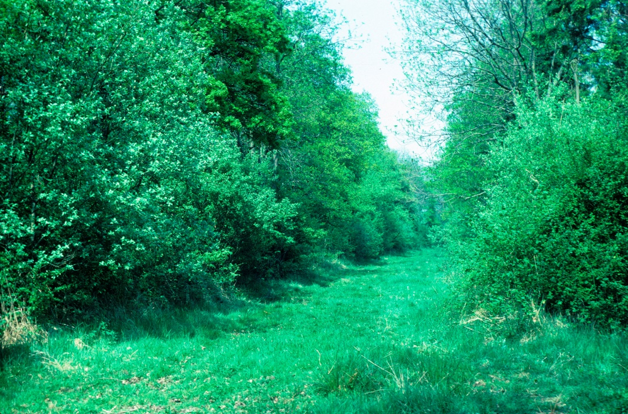

December 2015
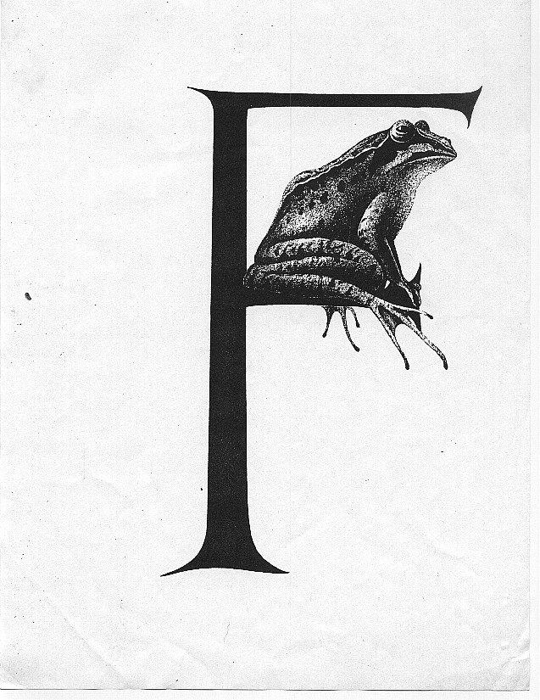
Studies of change in British woodland by K J Kirby

These data and the associated report form part of studies conducted over the course of my career with first the Nature Conservancy Council and then its successor bodies (English Nature and Natural England) and into my retirement as a visiting researcher with the Department of Plant Sciences.

The data are available for use by other researchers; while I live I would suggest that potential users contact me before conducting their research in case there are factors that they should consider that are not obvious from the data itself.

Any use of the data should be credited using the following format:
I/We acknowledge the use of data collected by K J Kirby and colleagues from Natural England and its predecessors.

Contents
Summary 3
Acknowledgements 3
Introduction 4
Site 4
Methods 5
Changes in the age structure and broadleaved/conifer balance 5
Field surveys 5
Results 7
The changing composition and age structure 7
Main management interventions (1982/3-2014) 11
Effects on general stand structure 13
Main woody species changes 15
Ground flora changes- overall species richness by compartment 17
Changes in species occurrence and frequency 19
Did specialists change frequency more than other species? 24
Discussion 26
Changes in the ground flora 26
The rise of ash 27
Conclusion 27
References 28
Appendices 30
1. Changes in % cover by layers for individual compartments. 30
2. Cover of individual species in the tree layer 31
3. Cover of main species in the shrub layer 32
4. Listing of all ground flora species, their frequency and cover (* Brown et al.’s specialists) 33

Summary
Salcey Forest (c.500 ha) lies on the Northamptonshire/Buckinghamshire border, in central England. It is ancient woodland that has been replanted over the last 200 years with a variety of different crops. In about 1847 the former coppice with standards system was converted to oak high forest; from 1900 to 1940 some of these maturing oak stands were felled and replanted mainly with oak again; from 1940 onwards an increasing proportion of the remaining 1847 oak stands were replanted with broadleaved conifer mixtures, with Norway spruce as the main conifer component. Since 1985 many of these conifer nurse crops have been removed to restore largely oak-dominant woodland.

This report explores differences in the vegetation under crops of different species and ages through a comparison of the results from a survey carried out in 1982/3 with a similar set of records made in 2014

In 1982/83 60 quadrats (200m²) were recorded spread across oak plantations of different ages (from 13 to 130 yrs) and conifer/conifer-broadleaved crops from 5 to 40 years old. These stands were revisited and sampled in the same way in 2014. During the thirty-year interval two of the older oak stands had been either felled and replanted or heavily thinned. Most of the spruce had been removed from all but the most recent conifer/mixed stands.

The older oak stands were less rich in terms of vascular plant numbers per quadrat in 2014 than in 1982/3. Stands which had been quite open in 1982/3 either because of recent thinning (1940s oak-spruce mixes) or because they had not yet closed canopy (youngest oak and conifer stands) showed particularly large drops in species richness per quadrat. Stands which had been dense in 1982/3 but recently thinned in 2014, or felled and replanted during the intervening period maintained or increased in species richness compared to 1982/3.

Amongst the commoner species (recorded in more than 10 quadrats in total) two distinct groups emerged. Species whose frequency was similar in the two surveys tended to be more shade-tolerant; whereas light-demanding species were more likely to have declined in frequency by about 30-50%.

The results support other work suggesting that undisturbed broadleaved stands in lowland Britain have become less species-rich at the quadrat level and that periodic disturbance through management such as thinning and felling helps to maintain plant species diversity at this scale. This applied to woodland specialists in this survey as well as to woodland generalists. Encouraging a diversity of age classes across the Forest is therefore likely to be beneficial to maintaining floral richness.

Acknowledgements
We are grateful to a variety of former colleagues who helped with the recording in 1982, particularly Mark July, and to the Forestry Commission for permission to work on this site.

Introduction
In Britain forestry policy and practice tend to change faster than trees grow. The 1980s stock map for Salcey Forest, an ancient wood in lowland England, reflected this with stands ranging from mid-nineteenth century oak plantations, through early 20th century oak-beech stands, 1950s oak-Norway spruce mixes, to 1970s pure conifer stands. From the 1940s through to the mid-1980s there was a strong emphasis on timber production and hence conifers predominated in most plantations (Foot, 2010). Despite the predominance of plantations in British forestry there have not been many studies of long-term changes in their biodiversity (although see Humphrey et al., 2003; Quine, 2015).

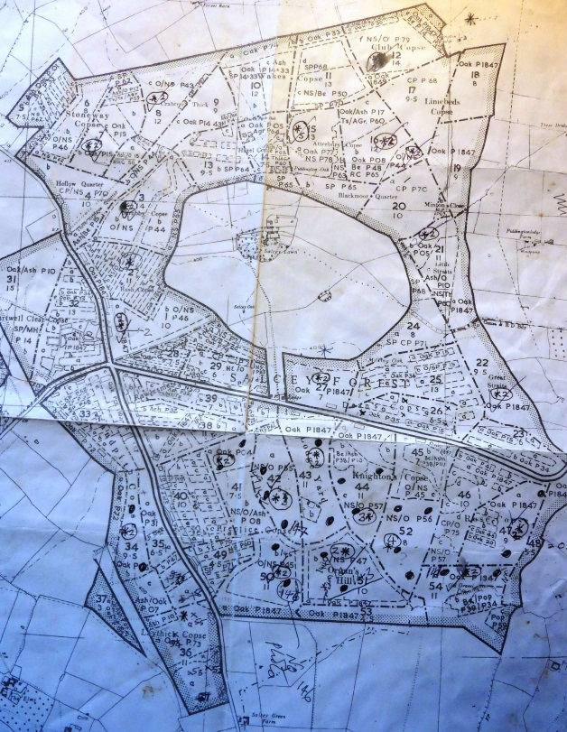
Annotated woodland stock used in the 1982 surveys.

A particular concern has been with the large areas of ancient semi-natural woodland that were converted to plantations, mainly of conifers or conifer-dominated mixtures (Spencer and Kirby, 1992). The introduction of a Broadleaves Policy (Forestry Commission, 1985) and later the UK Biodiversity Action Plan (Anon, 1994) led to a revival of interest in broadleaved woodland (Leslie, 2014), including in restoring broadleaved cover in formerly conifer-dominated plantations on ancient woodland sites (Goldberg, 2003; Thompson et al., 2003, 2005; Woodland Trust, 2005). Large areas on for example the Forest Enterprise estate and on land owned by NGOs such as the Woodland Trust are now included in such restoration programmes, but there has been little work on how successful such restoration is in terms of the ground flora (though see Brown et al. 2015 for a review).

This paper describes a re-survey in 2014 of different plantation stands in Salcey Forest where the vegetation had been first surveyed in 1982/3 (Kirby, 1988). This allowed us to see how the flora had developed under 30 years of further stand growth, but also the response of the vegetation to the removal of conifers from many of the stands.

Site
Salcey Forest is a large ancient wood straddling the Northamptonshire-Buckinghamshire county boundary (National Grid Reference SP 810513). The site is located on a gently undulating plateau at 100-130 m altitude. The solid geology is of the Jurassic oolitic limestone producing imperfectly-drained brown clay soils of moderate to high fertility.

Salcey was formerly a Royal Forest consisting of a series of coppices around a central deer lawn. In the mid-nineteenth century (nominally 1847) the coppices were planted with oak (Quercus robur) which developed into fairly uniform high forest stands of oak over hazel understorey (Corylus avellana). Some of these stands were felled and replanted, mainly with oak, sometimes also some beech (Fagus sylvatica), in the first decades of the twentieth century. The Forestry Commission initiated a more active programme of felling and replanting after the Second World War, with a particular emphasis on mixtures of oak and Norway spruce (Picea abies). The dominant vegetation type in the semi-natural stands is Ash-Field maple-Dog’s mercury woodland (W8) in the National Vegetation Classification (Rodwell, 1991).

Methods

Changes in the age structure and broadleaved/conifer balance

The change in the proportions of broadleaved and conifer crops in the wood was determined by comparing the extent of different crop types in c.1900, 1940, 1980 and 2010. The state of the wood in 1980 and 2010 was estimated from Forestry Commission stock maps which give the main tree species and compartment areas. The 1940 and 1900 estimates were based on back-extrapolation from the 1980 stock map, assuming that all twentieth century plantings were derived from felling of 1847 oak stands.

The area of stands shown as mixed on the stock maps were split equally between the broadleaves and conifers. This may overestimate the contribution of the broadleaves in young mixed crops which were planted with more conifer rows than broadleaves; also the faster growing conifers will tend dominate in the canopy in young crops. On the other hand most stands would also contain some remnant broadleaves from the previous crop or stump regrowth which may predate the planted crop and are recognised as distinct in the most recent stock map. In addition, during the2014 survey it was noted that some stands still classed as mixed had very little conifer left in them.

Field surveys

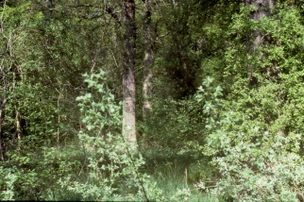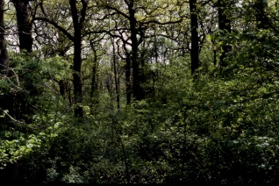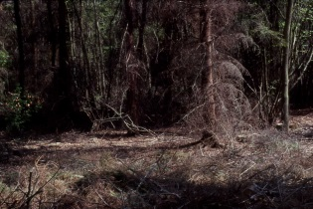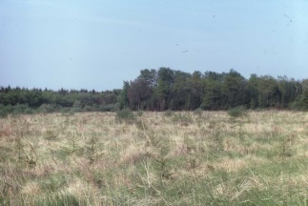
Pictures from 1982: 1847 oak stand; 1906 oak; 1950s oak/spruce mixture; 1977 oak/spruce mixture

In 1982 the first author and colleagues from the then Nature Conservancy Council recorded ten 14.1x14.1 m (200 m²) quadrats in each of five different crop types: 1847 oak, 1900s oak, 1940's oak-spruce, 1950's oak-spruce, 1970's oak-spruce stands (Figure 1, Table 1). Where only two compartments were available for a particular crop type five quadrats were recorded in each; where there were more compartments of a type up to five were sampled with two quadrats in each, with the sampled compartments chosen from across the Forest as much as possible. In 1983 five quadrats each were recorded in compartments planted with oak in 1935 and in a 1971 oak stand to complement the previous year's work. In 2014 the authors repeated the 1980's survey. The original quadrat positions were not marked but the same stands were sampled with the same number and size of quadrats as in 1982/3.

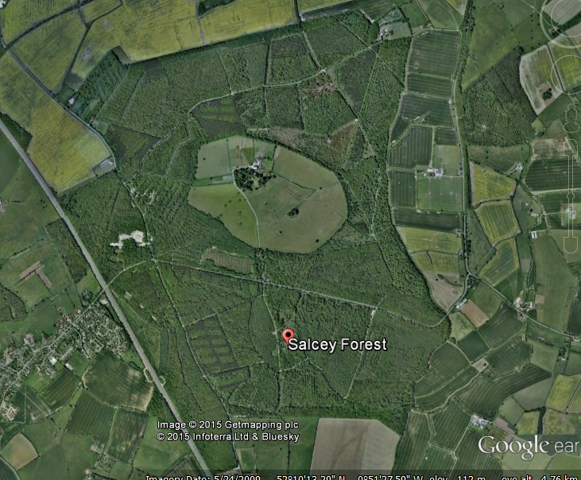

Figure 1. Distribution of compartments used according to 1982 numbering (Table 1, column 2) and recent image: source Google Earth, © 2015 Getmapping plc, Infoterra Ltd & Bluesky.

Within each quadrat all vascular plant species were listed and assigned a cover score using the 10-point domin scale. Estimates of the overall percentage cover of the ground flora layer, the shrub layer (roughly 2-5m high), tree layer (>5m high) and ‘open sky’ (= how much openness is left with the tree and shrub layer combined).

Throughout this report the 1982/3 compartment numbers are used; the 2014 equivalents are given in Table 1.

In the analyses of the ground flora tree and shrub regeneration was excluded and the following simplifications of the data were made account for potential differences between the two survey campaigns (Kirby et al., 1986):
- The 1980 surveys were done in May-June, whereas the 2014 survey was in August to fit in with other work. Records for early spring species that were not detected at all in 2014 were therefore excluded from the analyses (Conopodium majus 2 records, Ranunculus auricomus 10, Ranunculus ficaria 27). Records for Arum maculatum and Hyacinthoides non-scripta were retained in the analysis because these species were detectable in 2014 from the dead flower stalks, but their abundance may have been underestimated.
- The different surveyors may not have recorded species consistently across the two surveys. Records for the following species pairs were amalgamated as follows (number of records involved): Hypericum maculatum combined with H. tetrapterum (1), Holcus lanatus combined with H. mollis (9), Poa nemoralis combined with P. trivialis (9) Ribes nigrum combined with R. sylvestre (4) and Rubus caesius combined with R. fruticosus (4).
Between them these two adjustments affected only 66 out of over 2700 records.

Mean species richness per quadrat for each compartment was compared for 1982/3 and 2014. The frequency with which a species was recorded in 1982/3 was compared with that in 2014 and the characteristics of the commoner species (present with more than ten records across the two surveys) examined in relation to whether they had maintained their frequency or declined.

In some analyses the flora were classified as Non-woodland species, Woodland generalists, or Woodland specialists using the approach described by Kirby et al. (2012). Species were also assigned to different functional types using the Ellenberg scores for light (Hill et al., 2004) and Plant Strategy Types (Grime el al., 2007). These helped interpret the causes of the changes taking place.

Results

The changing composition and age structure

In 1900 the Forest would have been largely young (c53 year-old) oak stands. By 1940 the felling and replanting had affected about a third of the wood, but virtually all was still broadleaved (Figure 2). By 1980 only about a quarter of the original 1847 plantings survived (now quite mature) and young conifers covered about a third of the Forest.

Figure 2. The age structure and composition of Salcey Forest at different times, based on stock map data: solid bars conifers; open bars broadleaves.

By 2010 there had been a further slight decline in the extent of 1847 oak stands, the conifer area had reduced and there were far fewer young stands. A reasonably even age balance of broadleaves, mainly oak, has developed.
Table 1. Details of compartments used.
1982/3 planting year | Sub-cmpt no |  | No of quadrats | Cmpt grid ref | Description 1982/3 | Description 2014
 | 1982/3 | 2014
19th C plantations
1847 | 1a | 2037a | 2 | SP795514 | Mature oak over hazel | As 82
1847 | 22 | 2035b | 2 | SP812512 | Mature oak over hazel | As 82
1847 | 27 | 2039b | 2 | SP805512 | Mature oak over hazel | As 82
1847 | 47a | 2049c | 2 | SP814507 | Mature oak over hazel | Felled/replanted; oak-birch 1984
1847 | 54a | 2049b | 2 | SP810503 | Mature oak over hazel | As 82
1900s plantations
1915 | 7b | 2032c | 2 | SP793522 | Mature oak | Recent heavy thinning/part fell
1908 | 16b | 2033f | 2 | SP806523 | Mature oak, 1948 beech underplanting | Mainly mature oak
1905 | 21b | 2035g | 2 | SP809519 | Mature oak | As 82
1906 | 34b | 2042d | 2 | SP796505 | Mature oak | As 82
1904 | 41a | 2045g | 2 | SP801509 | Mature oak | As 82
1930s plantations
1931 | 35a | 2042c | 5 | SP798504 | Recently thinned oak, little understorey | Closed oak over hazel
1940s plantations
1944 | 3b | 2037b | 2 | SP795519 | Row mixture, oak/NS,part thinned | Spruce thinned out; now oak
1943 | 8c | 2032b | 2 | SP796525 | Row mixture, oak/NS part thinned | Spruce thinned out; now oak
1944 | 16a | 2033i | 2 | SP807522 | Row mixture, oak/NS part thinned | Spruce thinned out; now oak
1945 | 50b | 2046d | 2 | SP803504 | Row mixture, oak/NS part thinned | Spruce thinned out; now oak/hazel
1947 | 51b | 2047d | 2 | SP806504 | Row mixture, oak/NS unthinned | Spruce thinned out; now oak/hazel
1950s plantations
1955 | 42a | 2045b | 3 | SP803508 | Row mixture, oak/NS | Felled, replanted oak/pine, p98
1957 | 44c | 2047a | 3 | SP806507 | Row mixture, oak/NS | Felled, replanted ash p98.
1956 | 52 | 2047a | 4 | SP808505 | Row mixture, oak/NS | Felled, replanted ash p98.
1970s plantations
1979 | 12f | 2034a | 5 | SP807528 | Row mixture, oak/NS; pre canopy closure | Pole stage dense canopy; oak/NS
1977 | 15a | 2033e | 5 | SP803524 | Row mixture; oak/NS; pre canopy-closure | Pole stage dense canopy; oak/NS
1973 | 36a | 2042a | 5 | SP799500 | Pre canopy-closure oak. | Closed canopy

Main management interventions (1982/3-2014)
Four of the 1847 stands had been left largely undisturbed over the thirty years, but one, 47a had been felled and replanted mainly with oak in about 1984 (Table 1).
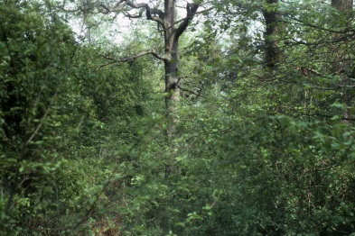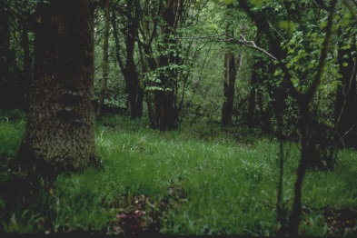
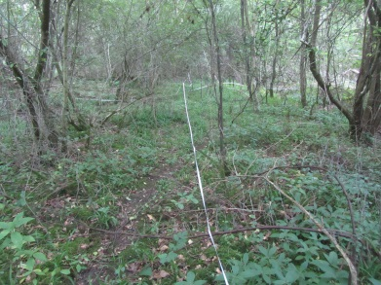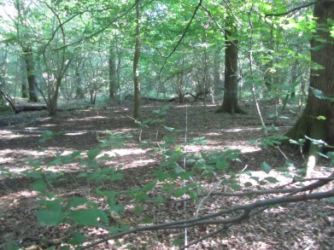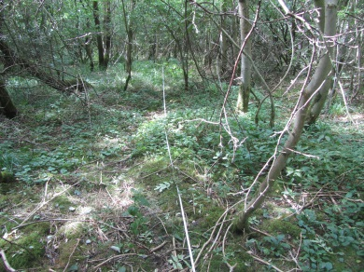
Top row: two 1847 oak stands in 1982 (cmpt not specified);
Bottom row: two 1847 stands in 2014 (cmpt 22, 1); cmpt 47, replanted in 1984.

The 1900s oak stands again appeared to have had little management except for compartment 7b which had been heavily thinned/selectively felled not long before the 2014 recording.

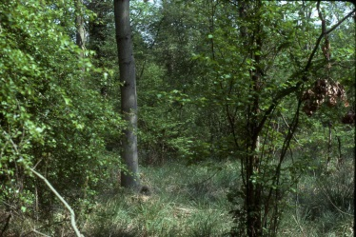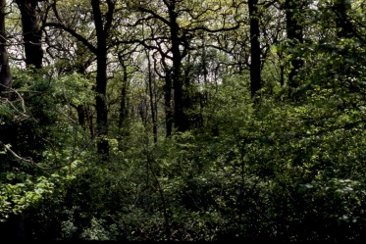
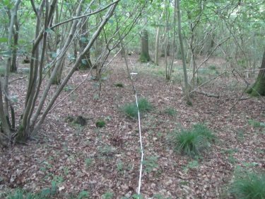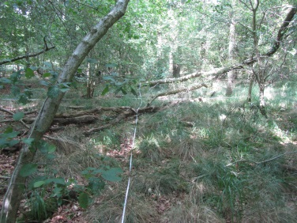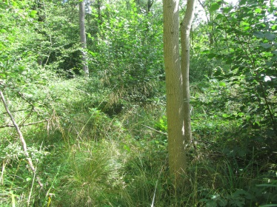

Top row: 1900s oak plantations (cmpt not specified) in 1982
Bottom row: 1900s oak plantations cmpts 34b, 41a and 7b (recently heavily thinned) in 2014

The 1930s oak stand was quite open in 1983 having been part thinned and the understorey largely cut-over: by 2014 the hazel had regrown forming a dense sub-canopy layer.

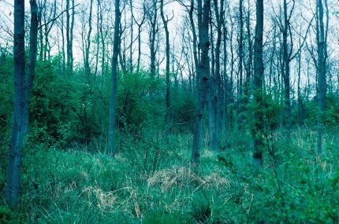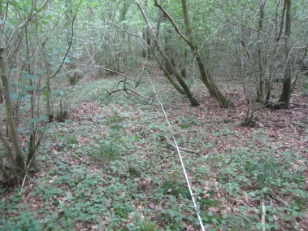
Cmpt 35 in 1983 and 2014

The 1970s oak compartment had grown up and closed canopy, but with a strong component of naturally regenerated ash Fraxinus excelsior amongst the oak.

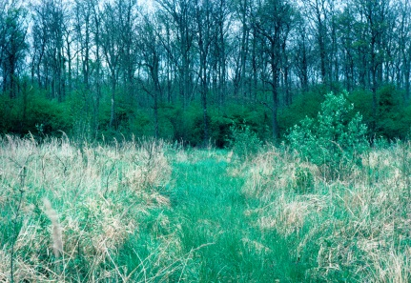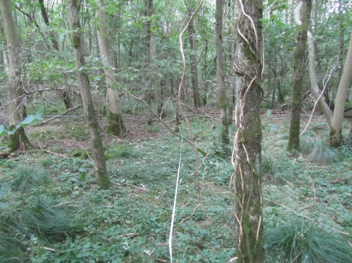
P73 oak plantation in 1983 and 2014

Four of the 1940s oak-Norway spruce mixture compartments (16a, 3b, 50b, 8c) had been partially thinned shortly before the 1982 recording and apart from the odd tree the spruce had gone from all of them by 2014. The oaks now form a more-or-less complete canopy cover.

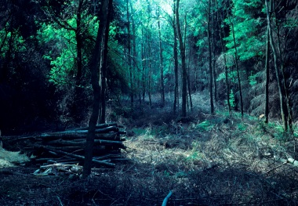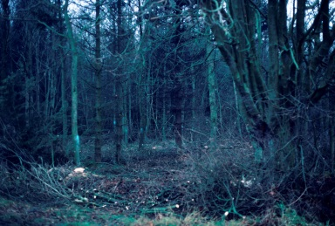
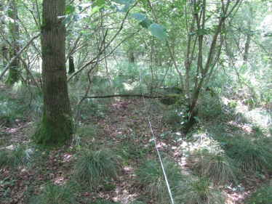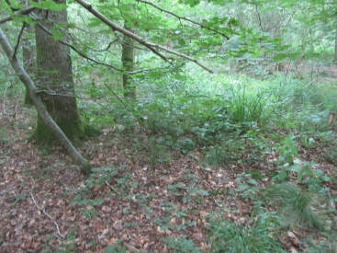
Top row: 1940s oak/NS mixtures, part thinned in 1982 (cmpts not specified)
Bottom row: Former oak/NS mixtures (cmpt 8, 50) in 2014.

The 1950s oak-Norway spruce stands had the densest shade of all the stands considered in the 1980s and the lowest survival of oak at that time; they were all felled and replanted in 1998, mainly with broadleaves but including some Corsican pine Pinus nigra.

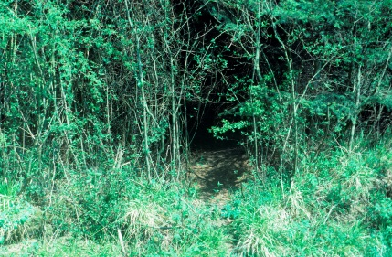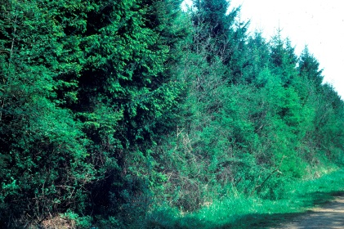
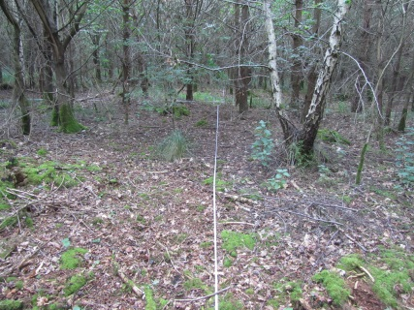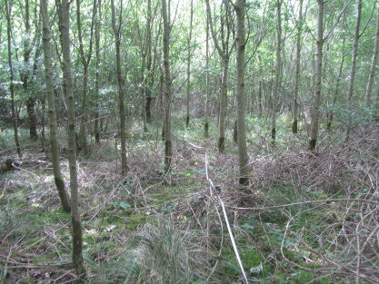
Top row: 1950s oak/NS mixtures in 1982 (too dark to film inside) (cmpt not specified)
Bottom row: 1998 replantings of broadleaves with some CP (cmpts 42, 52)

The two 1970s conifer compartments had grown up into closed pole-stage stands.

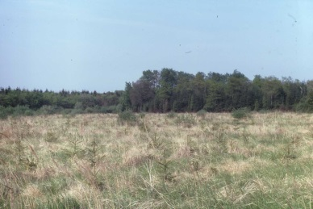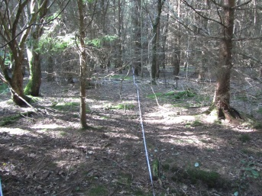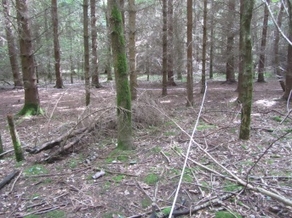
P1977 Oak/NS in 1982 (cmpt not specified); P1977/79 Oak/NS in cmpts 12 and 15 in 2014.

In addition to these structural changes the deer pressure is likely to have increased over this period, as over much of lowland England (Ward, 2005), although there is active deer management across the forest.

Effects on general stand structure

In 1982/3 the tree layer estimates differed little between crop types except for the youngest plantations (Table 2). The 1950s thicket stands tended to be denser, whilst the 1970s stands were still completely open. The shrub layers were lower in the spruce-oak stands, particularly in the 1950s thickets. The field layers were even more reduced in the 1950s thickets, but conversely covered most of the quadrat in the 1970s compartments.

By 2014, four of the five 1847 stands showed little change, apart from a slight trend to lower cover in the field layer. In compartment 47a which had been felled and replanted in 1984 the young regrowth had not developed a distinct shrub layer and the field layer cover was higher, a hangover from the expansion of the ground flora that would have happened immediately after it was felled.

Table 2.Changes in mean tree, shrub and field cover per 200m² quadrat (mean percentage cover, with standard errors in brackets)

Crop type (compartments) | No of quadrats | %Tree layer |  | % shrub layer |  | % field layer
 |  | 1982/3 | 2014 | 1982/3 | 2014 | 1982/3 | 2014
1847 oak (1a, 22, 27, 54) | 8 | 86 (4) | 74 (4) | 57 (2) | 52 (3) | 62 (5) | 49 (8)
1847oak, 1984 replant (47a) | 2 | 90 (10) | 92 (2) | 70 (15) | 0 | 65 (5) | 72 (12)
1900s oak plantation (16b. 21b, 34b, 41a) | 8 | 79 (3) | 80 (2) | 49 (6) | 52 (3) | 64 (7) | 40 (10)
1900s oak, recent heavy thin (7b) | 2 | 75 (5) | 25 (5) | 60 (0) | 22 (17) | 67 (7) | 95 (0)
1930s thinned oak, regrowth (35a) |  | 72 (2) | 72 (3) | 16 (6) | 69 (2) | 92 (2) | 28 (7)
1970s new plant b/l, now closed canopy(36a) | 5 | 0 | 79 (4) | 11 (2) | 40 (6) | 98 (1) | 75 (0)
1940s oak/NS mix (3b,8c,16a,50b, 51b) | 10 | 77 (5) | 75 (2) | 16 (3) | 44 (6) | 44 (8) | 65 (5)
1950s oak/NS mix, replant 1998 (42, 44, 52) | 10 | 93 (1) | 84 (2) | 4 (2) | 0 | 6 (1) | 54 (7)
1970s oak/NS now closed canopy (12f, 15a) | 10 | 0 | 95 | 0 | 3 (1) | 85 (3) | 4 (1)

The 1900s plantations showed a similar slight decline in field layer to the 1847 stands, except for compartment 7b where a marked increase followed the recent heavy thinning. In the 1930s oak stand the hazel coppice had shown vigorous regrowth, with a concomitant decline in the field layer. The 1970s oak stand similarly showed an increase in canopy and shrub layers and reduced field layer.

The 1940s stands maintained their field layer cover – the thinning out of the spruce in 1982 more than compensating for the increased shrub layer. The 1950s mixed crops, felled and replanted in 1998, had not yet developed a differentiated tree and shrub layer and the field layer was much higher than it had been in the preceding mixed crop. The 1970s spruce oak mixtures had by 2014 become a spruce-dominated dense pole stand with little in the way of shrub or field layers.

Overall the results are consistent with the dominance of canopy openness as a driver for the ground vegetation cover. This was significantly correlated (field layer= 27.5 + 1.82 open sky; p<0.001; R² = 31%) with the ‘open sky’ estimates for values of open sky up to about 50%; above 50% ‘open sky’ the relationship was not significant (Figure 3).
Figure 3. Relationship between field layer cover and ‘open sky’ estimates. Regressions were calculated separately for quadrats with less than 50% ‘open sky’ (black symbols) and more than 50% (open symbols).

Main woody species changes
The main changes are the elimination of spruce from the canopy of the 1940s mixtures through thinning and from the 1950s mixed stands as a result of felling and replanting (although partly replaced by pine in the latter case). In the 1970s plantings spruce remains dominant.

In the 1998 replantings and in the 1984 replanting after felling of 1847 oak (compartment 47a) willow (mainly Salix caprea) hazel Corylus avellana and thorns Crataegus monogyna, C. oxycanthoides, Prunus spinosa particularly are still mixed into the combined tree/shrub layer. Ash, largely natural regeneration, has increased its contribution in almost all compartments. In the shrub layer hazel has generally increased.

Details for individual compartments are given in the Appendix 1.

Table 3. Mean cover estimates for the major tree species by crop type in 182/3 and 2014
Crop type | no of quadrats | Mean oak % |  | Mean spruce % |  | Mean ash % |  | Mean willow % |  | Mean pine % |  |  | Mean other spp. %
 |  | 1982/3 | 2014 | 1982/3 | 2014 | 1982/3 | 2014 | 1982/3 | 2014 | 1982/3 | 2014 | 1982/3 |  | 2014
1847 oak | 8 | 80 | 53 | 0 | 0 | 7 | 21 | 0 | 0 | 0 | 0 | 0 |  | 5
1847 oak/replant1984 | 2 | 69 | 13 | 0 | 0 | 15 | 36 | 1 | 15 | 0 | 0 | 0 |  | 31
1900 oak plns | 8 | 70 | 61 | 0 | 0 | 3 | 18 | 0 | 0 | 0 | 0 | 5 |  | 6
1900soak plns, thinned | 2 | 63 | 18 | 0 | 0 | 8 | 9 | 0 | 0 | 0 | 0 | 0 |  | 0
1930s oak | 5 | 67 | 67 | 1 | 0 | 0 | 14 | 0 | 0 | 0 | 0 | 0 |  | 0
1940s oak/NS mix | 10 | 35 | 67 | 39 | 0 | 6 | 6 | 4 | 0 | 0 | 0 | 1 |  | 3
1950s oak/NS mix; 1998 replant | 10 | 15 | 15 | 66 | 2 | 1 | 36 | 0 | 13 | 0 | 11 | 0 |  | 22
1970 conifer | 10 | 0 | 3 | 0 | 89 | 0 | 0 | 0 | 3 | 0 | 0 | 0 |  | 2
1970s oak | 5 | 0 | 30 | 0 | 0 | 0 | 46 | 0 | 3 | 0 | 0 | 0 |  | 0
Table 4. Changes in the cover of the main shrub layer species

Crop type | no of quadrats | Mean hazel % |  | Mean hawthorn % |  | Mean blackthorn % |  | Mean Other %
 |  | 1982/3 | 2014 | 1982/3 | 2014 | 1982/3 | 2014 | 1982/3 | 2014
1847oak | 8 | 16.44 | 31.44 | 23.88 | 19.00 | 10.63 | 5.31 | 5.81 | 4.06
1847 oak/replant 1984 | 2 | 17.50 | 4* | 30.00 | 9* | 16.00 | 18* | 14.00 | N/A*
1900 oak plns | 8 | 24.88 | 33.94 | 7.06 | 14.25 | 9.69 | 0 | 12.88 | 0
1900s oak plns, thinned | 2 | 12.50 | 18.30 | 5.25 | 0.00 | 12.50 | 3.75 | 13.75 | 4.38
1930s oak | 5 | 3.70 | 51.80 | 6.60 | 20.50 | 1.00 | 0.00 | 3.60 | 3
1940s oak/NS mix | 10 | 2.65 | 23.55 | 7.75 | 6.25 | 1.40 | 1.75 | 3.30 | 5.35
1950s oak/NS mix; 1998 replant | 10 | 1.10 | 5* | 1.10 | 8* | 1.80 | 2* | 5.65 | N/A*
1970 conifer | 10 | 0.20 | 3.15 | 0.20 | 1.45 | 0.10 | 0.00 | 1.20
1970s oak | 5 | 2.0 | 15.50 | 1.0 | 6.0 | 0.60 | 3.50 | 16.90
*from combined tree/shrub layer; N/A not assessed

Ground flora changes- overall species richness by compartment

Overall the quadrats recorded in 1982/3 had a higher field layer cover and more species than in 2014 (Figure 4). There was also much more of a scatter about the line for the earlier recording.

Figure 4. Relationship between field layer cover and species richness across all quadrats: open circles 1982/3 records; solid circles 2014 records. Regression lines:
1982/3 No of spp.= 18.3+0.16*% field layer cover (R² =27%, p<0.001)
2014 No of spp.= 9.9+0.16*% field layer cover (R²=50%, p<0.001)

The undisturbed mature oak stands (both 1847 and 1900s plantations) had lower mean species richness per quadrat in 2014 than in 1982/3 (Figure 5). Mean species richness was similar in 2014 to 1982 in compartment 47a (1847 oak, felled and replanted in 1984) and in compartment 7b (1915 oak which had been recently heavily thinned).

Figure 5. Changes in mean species-richness per quadrat in mature oak stands (1982-2014): overall means for 1847 undisturbed compartments were 29.4 (s.e. 3) in 1982, 17.4 (s.e.3) in 2014; and for the undisturbed 1900s compartments 31.4 (s.e. 2) in 1982 and 16.4 (s.e. 2) in 2014.

The 1930s oak stand which had been recently thinned in 1983 had reduced richness by 2014 (mean species richness per quadrat 32.2 (s.e. 2) in 1983, 10.4 (s.e. 2) in 2014). By 2014 not only had the thinned oak canopy reformed, but the dense hazel understorey had also regrown and large areas of the stand showed just bare litter. A similar pattern was seen in the 1970s oak stand which in 1983 had not yet closed canopy (mean species-richness per quadrat 30.0 (s.e. 2) in 1983, 16.0 (s.e. 1) in 2014).

The four 1940s Oak/NS mixes that had been recently thinned in 1980s had reduced richness by 2014; the compartment that had been thinned increased in species richness (Figure 6). The 1950s oak/NS mixes, felled and replanted in 1998, had more species per quadrat than in the 1980s. The 1970s oak/NS mixtures which had been relatively rich in 1982 had declined to become the poorest by 2014.

Figure 7 summarises the changes in mean species richness by compartment across the two recording times.

Figure 6. Changes in mean species-richness per quadrat for spruce-oak mixtures by compartment and planting year.

Figure 7. Change in mean compartmental species richness, 2014 versus 1982/3: black squares the various oak stands; open circles the oak-Norway spruce mixtures.

Changes in species occurrence and frequency
100 species were recorded across all 60 quadrats in 1982/3 compared to 74 species in 2014 (Table 5). Most of the species recorded at one time only were present in 3 or fewer quadrats (22 out 34 in 1982/3; all 8 of the 2014 species). The three species commonly recorded in 1982/3 but not in 2014 were Taraxacum officinale (19 records), Chamaerion angustifolium (17 records) and Moehringia trinervia, (14 records) species often associated with disturbance and openness in woods. Overall the 1982/3 records showed more species characteristic of high light conditions (Figure 8).

Table 5. Species recorded at only time
 | 1982/3 records |  |  | 1982/3 records
Alopecurus pratensis | 1 |  | Cirsium vulgare | 4
Alliaria petiolata | 1 |  | Ranunculus acris | 4
Festuca rubra | 1 |  | Fragaria vesca | 5
Lapsana communis | 1 |  | Lotus uliginosus | 5
Mentha aquatica | 1 |  | Sonchus oleraceus | 5
Mentha arvensis | 1 |  | Heracleum sphondylium | 6
Plantago major | 1 |  | Juncus conglomeratus | 9
Potentilla erecta | 1 |  | Stellaria media | 9
Prunella vulgaris | 1 |  | Moehringia trinervia | 14
Rumex acetosa | 1 |  | Chamaerion angustifolium | 17
Senecio jacobaea | 1 |  | Taraxacum officinale | 19
Tussilago farfara | 1
Veronica beccabunga | 1
Veronica officinalis | 1
Carex flacca | 2 |  |  | 2014 records
Cerastium fontanum | 2 |  | Epipactis helleborine | 1
Juncus articulatus | 2 |  | Galium odoratum | 1
Lychnis flos-cuculi | 2 |  | Melica uniflora | 1
Senecio vulgaris | 2 |  | Potentilla reptans | 1
Stellaria graminea | 2 |  | Carex pilulifera | 2
Centaurea nigra | 3 |  | Dryopteris affinis | 2
Poa pratensis | 3 |  | Milium effusum | 2
Agrostis stolonifera | 4 |  | Rubus idaeus | 3

Figure 8. Ellenberg light scores for species for all species recorded.
A similar pattern emerged when the frequency of species with at least ten records across the two recording times was taken into account (Figure 9 and Table 6). One group of species were as common in 2014 as in the 1980s; the second were reduced in frequency by about a third to a half. The stable group were more likely to be relatively shade-tolerant (low Ellenberg light values (Hill et al. 2004), with also a slight but non-significant tendency to have more woodland specialists rather than generalists (Figure 10,11), and a higher stress-tolerator component.

Figure 9. Changes in individual species frequency for species with more than ten records in total: frequency stable over time (open circles); frequency reduced (closed circles).
Regression equations:
Stable species 2014 freq.= 2.54 + 0.737(1982/3 freq) P<0.001 R²=69.5
Declining species 2014 freq. = -2.21 + 0.613(1982/3freq ) P<0.001 R²= 73.8

Table 6. Stable and Declining Ground flora (excluding species with less than 10 records)
 |  | Species | 1982/3 frequency | 2014 frequency | Ellenberg light score | Plant strategy type
Declining species
 |  | Wodland specialists
 |  | *Arum maculatum | 43 | 18 | 4 | SR
 |  | Calamagrostis epigeos | 40 | 20 | 7 | C/SC
 |  | Holcus mollis | 48 | 16 | 6 | C/CSR
 |  | *Hyacithoides non-scripta | 7 | 4 | 5 | SR
 |  | Hypericum hirsutum | 28 | 13 | 6 | SC/CSR
 |  | Mercurialis perennis | 51 | 29 | 3 | SC
 |  | Moehringia trinerva | 14 | 0 | 4 | R/CSR
 |  | Myosotis spp (cf sylvatica) | 7 | 4 | 6 | R/CSR
 |  | Potentilla sterilis | 40 | 16 | 5 | SR/CSR
 |  | Scrophularia nodosa | 21 | 9 | 5 | C/CR
 |  | Stachys sylvatica | 38 | 12 | 6 | C/CR
 |  | Viola riviniana | 24 | 7 | 6
 |  | Woodland generalists
 |  | Angelica sylvestris | 33 | 13 | 7 | C/CR
 |  | Arctium minus | 24 | 6 | 6 | C/CR
 |  | Cardamine pratensis | 13 | 1 | 7 | R/CSR
 |  | Chamaerion angustifolium | 17 | 0 | 6 | C
 |  | Cirsium palustre | 27 | 5 | 7 | CR/CSR
 |  | Epilobium montanum | 23 | 1 | 6 | R/CSR
 |  | Filipendula ulmaria | 19 | 2 | 7 | C/SC
 |  | Galium aparine | 36 | 13 | 6 | CR
 |  | Glechoma hederacea | 41 | 27 | 6 | CR/CSR
 |  | Juncus effusus | 35 | 14 | 7 | C/SC
 |  | Ranunculus repens | 30 | 13 | 6 | CR
 |  | Rosa spp (cf canina) | 53 | 34 | 6 | SC
 |  | Rumex sanquineus | 45 | 17 | 5 | CR/CSR
 |  | Solananum dulcamara | 25 | 3 | 7 | C/CSR
 |  | Taraxacum officinale | 19 | 0 | 7 | R/CSR
 |  | Urtica dioica | 41 | 25 | 6 | C
 |  | Non-woodland species
 |  | Cirsium arvense | 19 | 3 | 8 | C
Stable species
 | Woodland specialists
 | Brachypodium sylvaticum |  | 36 | 40 | 6 | SC/CSR
 | Carex pendula |  | 20 | 26 | 5 | C/SC
 | Carex remota |  | 11 | 16 | 4 | CSR
 | Carex sylvatica |  | 51 | 51 | 4 | S/CSR
 | Festuca gigantea |  | 16 | 15 | 5 | CSR
 | Galeobdolon luteum |  | 14 | 19 | 4 | S/SC
 | Geranium robertianum |  | 13 | 18 | 5 | R/CSR
 | Lonicera periclymenum |  | 50 | 50 | 5 | SC
 | Oxalis acetosella |  | 29 | 28 | 4 | S/SR
 | Primula vulgaris |  | 41 | 40 | 5 | S/CSR
 | Ribes sylvestre |  | 7 | 6 | 5 | SC
 | Stellaria holostea |  | 11 | 7 | 5 | CSR
 | Tamus communis |  | 15 | 10 | 6 | C/CSR
 | Vicia sepium |  | 18 | 12 | 6 | C/CSR
 | Zerna ramosa |  | 24 | 17 | 4 | CSR
 | Woodland generalists
 | Ajuga reptans |  | 27 | 32 | 5 | R/CSR
 | Circaea lutetiana |  | 32 | 39 | 4 | CR
 | Desch cespitosa |  | 57 | 54 | 6 | SC/CSR
 | Dryopteris dilatata |  | 23 | 31 | 5 | SC/CSR
 | Dryopteris filix-mas |  | 35 | 40 | 5 | SC
 | Geum urbanum |  | 21 | 20 | 4 | CR/CSR
 | Poa trivialis |  | 24 | 20 | 7 | R/CSR
 | Rubus fruticosus |  | 49 | 40 | 6 | SC
 | Veronica chamaedrys |  | 26 | 20 | 6 | S/CSR

Ellenberg light scores (Hill et al. 2004): 3 shade plant; 4 between 3and 5; 5 semi-shade plant; 6 between 5 and 7; 7 plant generally within well-lit areas; 8 light-loving plant.
Plant Strategy Types (Grime et al. 2007): C competitor; S stress-tolerator; R ruderal; CR competitive ruderal; SR stress tolerant ruderal; SC stress tolerant competitor; CSR no dominant strategy type.
*Arum maculatum and Hyacinthoides non-scripta may have been under-recorded in 2014 because the surveys were in August after most of the leaves have died down.

Figure 10. Ellenberg light score distribution for ‘stable’ (solid bars), ‘declining’ (open bars) and ‘infrequent’ species (those with fewer than 10 records across both recording times) (hatched bars).

Figure 11. Distribution of species types amongst stable (solid bars), declining (open bars) and infrequent species (hatched bars) (Kirby et al. 2012).

Changes in deer pressure, though not as severe as at some other sites (bramble frequency and cover were maintained), might favour grasses and could also have contributed to the decline in Mercurialis perennis which is very shade-tolerant. There were more graminoids in the stable group including Brachypodium sylvaticum, Poa trivialis and Deschampsia cespitosa which from their Ellenberg light scores might otherwise have been expected to decline. The overall cover of Calamagrostis epigeos and Holcus mollis did decline – these species had been dominant in the open 1970s oak-Norway spruce stands but were reduced to isolated plants under the pole-stand shade.

Did specialists change frequency more than other species?

The proportion of specialists as a proportion of the total number of species recorded in a quadrat was the same at both recording times (Figure 12a) and the ratio of the change in the richness for specialists per compartment to that for other species was also the same across the range of richness found. This suggests that the specialists had not proved any more or less sensitive to management or neglect than the flora in general.
Figure 12a. No of woodland specialists recorded in the quadrats compared to the total number of species: open circles 1982/3 surveys; closed circles 2014 surveys.
1982/3 regression: No specialists = 2.1 + 0.37*No All species (R² = 76%)
2014 regression: No specialists = 1.6 + 0.41*No All species (R²=77%)
Figure 12b. Change in the mean number of woodland specialists per quadrat per compartment versus the change for other species. Closed circles = oak compartments; open circles oak-spruce mixtures
Change in other species = 0.45+1.58*Specialist change (R²= 67%)

Discussion

These surveys are based on a limited number of samples per compartment and their distribution was spatially constrained by the number and location of compartments with a particular crop type. Nonetheless the scarcity in lowland Britain of long-term comparisons of the changes in the vegetation within plantations makes them valuable.

Changes in the ground flora
The decline in species richness in the mature oak stands seems likely to be associated with increased shading – given an additional thirty years of basal area growth of the oaks, with no obvious increase in gaps from thinning or tree death. However the canopy and shrub layer estimates (Table 2) did not actually show any change. This may be a problem with the subjective nature of these estimates, particularly where the canopy is fairly closed to start with. In the younger oak stands the increase in cover was much more apparent.

The former mixed spruce-oak crops from the 1940s and 1950s were generally as rich by 2014 as the pure oak stands, suggesting that at least by this measure there is reasonable potential for restoration of plantations on ancient woodland sites through thinning and felling. This may have been facilitated at Salcey because of the row mixtures used. In the 1982 surveys species richness was greater within the oak component than under the spruce (Figure 13).

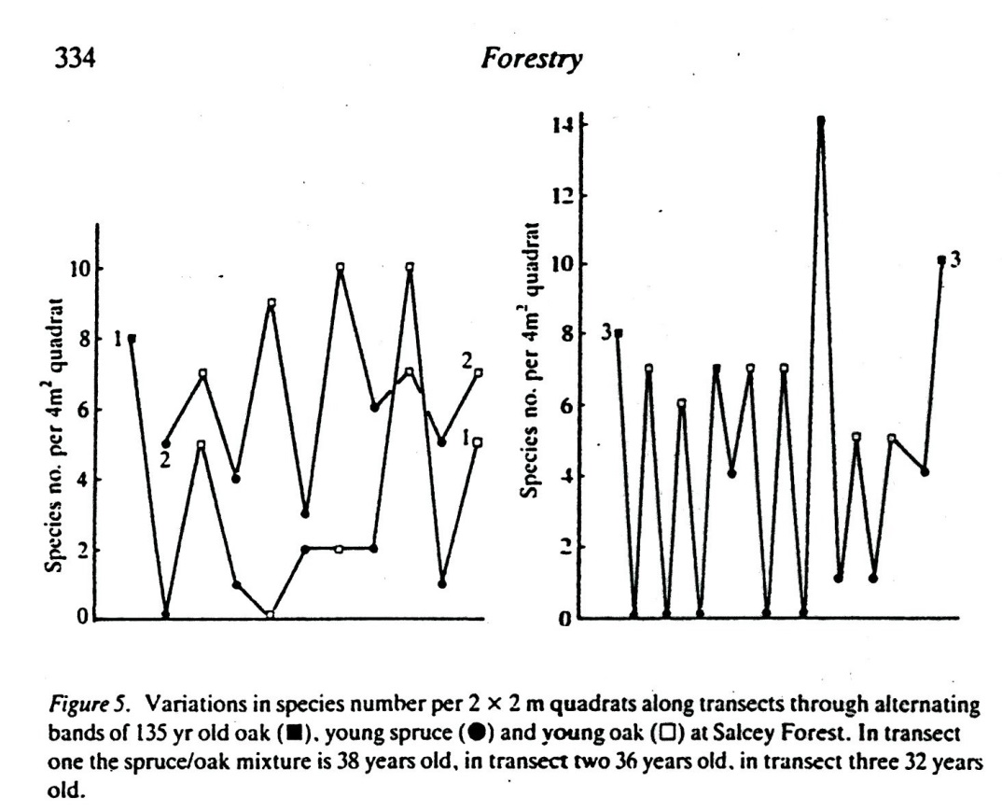

Figure 13. Species richness in 2x2 m quadrats in a transect across alternating bands of rows of oak and spruce (from Kirby, 1988 © Forestry, OUP.).

There is an argument that restoration of plantations on ancient woodland sites is best done gradually. Brown et al. (2015) looking across a number of sites found that woodland specialists were more likely to decline where clear-felling had taken place compared to where more gradual opening up of the canopy had occurred. In this study there was no indication that specialists fared better or worse than the bulk of the flora.

Part of the difference may be related to how woodland specialist plants were defined in each case: Brown et al. used a more restricted definition which focussed on species associated with closed canopy conditions whereas in this study the definition used included species that do occur in other more open habitats but none-the-less have a strong association with the gap phase in the woodland cycle. In addition no stands were available that had been ‘gradually restored’ for comparison. However, at Salcey Forest overall Brown et al.’s specialists tended to do slightly better (certainly no worse) than either the flora as a whole or woodland specialists as defined in this study. Four species did decline strongly, but for one of these Arum maculatum (43:18) this is probably because of the later timing of the 2014 survey. Of the other three Moehringia triverva (14:0), Potentilla sterilis (40:16), and Stachys sylvatica (38:12) tend to favour more open conditions in woodland, so it seems unlikely that disturbance during felling or thinning contributed to their decline, rather than more shaded conditions.

In general the results are consistent with trends seen in other long-term studies of British woodland more generally (Hopkins and Kirby, 2007; Kirby et al., 2005; Kirby, 2015):
- Declines in species richness under closed canopy mature broadleaved stands over the last four decades, largely due to a reduction in the more light-demanding woodland species;
- An increase in species-richness and ground vegetation cover associated with disturbance (thinning or felling and replanting) compared to closed canopy stands;
- Much of the change in species-richness during the cycle being amongst infrequent more light-demanding species.

The rise of ash

The focus of this study was on the ground flora but the increases in the proportion of ash Fraxinus excelsior in what might have been thought of as oak woods is worth noting because of concerns about ash dieback. Ash is also noted more frequently as a component of the canopy in the recent stock map compared to that for 1982.

An increase in ash has also been found elsewhere (Forestry Commission, 2012; Kirby et al., 2014), reflecting past favouring of oak as a timber tree or standard in coppice-with-standards systems whereas in recent times ash has shown a greater ability to regenerate in relatively small canopy gaps. The National Vegetation Classification type (W8, Rodwell, 1991) would strongly point to the potential of the site for ash. Whether that potential will be realised is however now in doubt because of the spread of ash dieback caused by Hymenoscyphus fraxineus (Pautesso et al., 2013).

Conclusion

In the early 1980s nature conservation was not seen as a particularly high priority for the management of Salcey Forest. The boundary of the Site of Special Scientific Interest was indeed reduced to the main surviving oak stands, because it was expected that over the rest of the Forest conifer crops would increase in dominance and the flora would be reduced as a consequence. Subsequent policy reversals have favoured an increase in the broadleaved component in the plantations. This repeat survey confirms that the vegetation of the forest has benefited as a result of such restoration work; it is likely that some other species groups will also have gained.

The vegetation at Salcey Forest will continue to change due to ongoing ‘external’ pressures. The most immediate, and ongoing external factor that affects the ground flora is the deer pressure; in the intermediate term there is the (almost) inevitable impact of ash dieback; in the longer term changes will be emerge due to climate change.

Superimposed on these trends will be the broadly cyclical responses of the ground flora to stand growth, felling and regeneration as seen in this resurvey. Losses as well as gains of species are almost inevitable at the compartment scale – the woodland species that thrive in the disturbed ground of a canopy gap or recently felled patch tend to decline most under the thicket stage and vice-versa.

The changing temporal pattern of species-richness at the stand level means that the spatial pattern of species-richness will also change over time. Compartments that were species-rich in 1982/3 were not necessarily so in 2014 and vice-versa (Figure 7).

In this study, over this period, most compartments lost species, but the pattern might be different in the next 30 years if the nett change is for more opening up and stand disturbance, either through management or the effects of disease and climate change. Assessments of the biodiversity value of stands in managed woodland, which are usually just a snapshot of the diversity pattern, need to assess such likely long-term temporal and spatial patterns through projecting forward stand growth effects. Management needs to maintain a spread of age classes across the forest.

References
ANON 1994. Biodiversity: the UK action plan. London, HMSO.
BROWN, N. D., CURTIS, T. & ADAMS, E. C. 2015. Effects of clear-felling versus gradual removal of conifer trees on the survival of understorey plants during the restoration of ancient woodlands. Forest Ecology and Management, 348, 15-22.
FOOT, D. 2010. Woods and people: putting forestry on the map. Stroud, The History Press.
FORESTRY COMMISSION 1985. The policy for broadleaved woodland. Edinburgh, Forestry Commission.
FORESTRY COMMISSION 2012. NFI preliminary estimates of quantities of broadleaved species in British woodlands, with special focus on ash. Edinburgh, Forestry Commission.
GOLDBERG, E. 2003. Plantations on ancient woodland sites. Quarterly Journal of Forestry, 97, 133-138.
GRIME, J. P., HODGSON, J. G. & HUNT, R. 2007. Comparative plant ecology (revised edition). Dalbeattie, Castlepoint Press.
HILL, M. O., PRESTON, C. D. & ROY, D. B. 2004. PLANTATT: attributes of British and Irish plants. Cambridge, Biological Records Centre (NERC).
HOPKINS, J. J. & KIRBY, K. J. 2007. Ecological change in British broadleaved woodland since 1947. Ibis (supplement), 149, 29-40.
HUMPHREY, J. W., FERRIS, R. & QUINE, C. P. 2003. Biodiversity in Britain's planted forests: results from the Forestry Commission's biodiversity assessment project.. Edinburgh, Forestry Commission.
KIRBY, K., BINES, T., BURN, A., MACKINTOSH, J., PITKIN, P. & SMITH, I. 1986. Seasonal and observer differences in vascular plant records from British woodlands. Journal of Ecology, 74, 123-131.
KIRBY, K. J. 1988. Changes in the ground flora under plantations on ancient woodland sites. Forestry, 61, 317-338.
KIRBY, K. J. 2015. Changes in the vegetation of clear-fells and closed canopy stands in an English oak wood over a 30-year period. New Journal of Botany, 5, 2-12.
KIRBY, K. J., BAZELY, D. R., GOLDBERG, E. A., HALL, J. E., ISTED, R., PERRY, S. C. & THOMAS, R. C. 2014. Changes in the tree and shrub layer of Wytham Woods (Southern England) 1974–2012: local and national trends compared. Forestry, 87, 663-673.
KIRBY, K. J., PYATT, D. G. & RODWELL, J. S. 2012. Characterization of the woodland flora and woodland communities in Britain using Ellenberg Values and Functional Analysis. In: ROTHERHAM, I. D., JONES, M. & HANDLEY, C. (eds.) Working and Walking in the Footsteps of Ghosts: volume 1 the wooded landscape. Sheffield: Wildtrack Publishing.
KIRBY, K. J., SMART, S. M., BLACK, H. J., BUNCE, R. G. H., CORNEY, P. M. & SMITHERS, R. J. 2005. Long-term ecological changes in British woodland (1971-2001). English Nature Research Report 653. Sheffield.
LESLIE, R. 2014. Forest Vision:transforming the Forestry Commission. Bristol, UK, New Environment Books.
PAUTASSO, M., AAS, G., QUELOZ, V. & HOLDENRIEDER, O. 2013. European ash (Fraxinus excelsior) dieback – A conservation biology challenge. Biological Conservation, 158, 37-49.
QUINE, C. P. 2015. The curious case of the even-aged plantation: wretched, funereal or misunderstood? In: J., K. K. & WATKINS, C. (eds.) Europe's changing woods and forests. Wallingford: CABI, pp207-223.
RODWELL, J. S. 1991. British plant communities: 1 woodlands and scrub. Cambridge, Cambridge University Press.
SPENCER, J. W. & KIRBY, K. J. 1992. An inventory of ancient woodland for England and Wales Biological Conservation, 62, 77-93.
THOMPSON, R., HUMPHREY, J. W., HARMER, R. & FERRIS, R. 2003. Restoration of native woodland on ancient woodland sites. Forest Practice Guide. Edinburgh, Forestry Commisson.
THOMPSON, R. N. & HOPE, J. C. E. 2005. Restoring planted ancient woodland sites — Assessment, silviculture and monitoring. Botanical Journal of Scotland, 57, 211-227.
WARD, A. I. 2005. Expanding ranges of wild and feral deer in Great Britain. Mammal Review, 35, 165-173.
WOODLAND TRUST 2005. The conservation and restoration of plantations on ancient woodland sites. Grantham, Woodland Trust.

Appendices

1. Changes in % cover by layers for individual compartments.

Sub-cmpt | No of quadrats | %Tree layer |  | %Shrub layer |  | %Field layer
 |  | 1982/3 | 2014 | 1982/3 | 2014 | 1982/3 | 2014
19th C plantns
1a | 2 | 75 (5) | 80 (0) | 60 (0) | 40 (0) | 65(15) | 37 (17)
22 | 2 | 95 (5) | 65 (5) | 62 (3) | 62 (2) | 47 (2) | 50 (25)
27 | 2 | 75 (5) | 65 (15) | 50 (0) | 60 (0) | 72 (2) | 37 (7)
47a | 2 | 90 (10) | 92 (2) | 70 (15) | 0 | 65 (5) | 72 (12)
54a | 2 | 97 (3) | 85 (5) | 55 (0) | 45 (5) | 65 (15) | 72 (2)
1900s plantns
7b | 2 | 75 (5) | 25 (5) | 60 (0) | 22 (17) | 67(7) | 95 (0)
16b | 2 | 65 (5) | 82 (2) | 30 (10) | 52 (3) | 62(2) | 70 (15)
21b | 2 | 87 (7) | 87 (2) | 55 (5) | 50 (0) | 42 (27) | 25 (15)
34b | 2 | 82 (3) | 75 (5) | 67 (7) | 65 (7) | 80 (0) | 17 (2)
41a | 2 | 80 (5) | 75 (5) | 42 (7) | 40 (0) | 72 (7) | 47 (27)
1930s plantns
35a | 5 | 72 (2) | 72 (4) | 16 (6) | 69 (2) | 93 (2) | 28 (7)
1940s plantns
3b | 2 | 65 (5) | 65 (5) | 8 (7) | 12 (7) | 70 (0) | 80 (0)
8c | 2 | 55(15) | 80 (0) | 10 (0) | 55 (5) | 67 (12) | 70 (0)
16a | 2 | 87 (3) | 82 (3) | 18 (7) | 40 (0) | 27 (2) | 70 (0)
50b | 2 | 85 (5) | 70 (10) | 30 (10) | 65 (5) | 47 (12) | 35 (5)
51b | 2 | 92 (3) | 80 (0) | 15 (5) | 50 (0) | 8 (7) | 72 (3)
1950s plantns
42a | 3 | 95 (3) | 93 (2) | 1 (0) | 0 | 7 (4) | 30 (10)
44c | 3 | 90 (10) | 75 (3) | 10 (5) | 0 | 5 (3) | 73 (10)
52 | 4 | 94 (3) | 85 (3) | 3 (2) | 0 | 6 (1) | 59 (7)
1970s plantns
12f | 5 | 0 | 95 (0) | 1 (.2) | 2 (1) | 84 (2) | 3 (1)
15a | 5 | 0 | 95 (0) | 0 (0) | 3 (1) | 86 (5) | 4 (3)
36a | 5 | 0 | 79 (4) | 11 (2) | 40 (6) | 98 (1) | 75 (0)

2. Cover of individual species in the tree layer
 | no of quadrats | oak % |  | Spruce % |  | Ash % |  | Willow % |  | Pine % |  | Other species %
compt |  | 1982/3 | 2014 | 1982/3 | 2014 | 1982/3 | 2014 | 1982/3 | 2014 | 1982/3 | 2014 | 1982/3 | 2014
19thC plantations
1a | 2 | 73 | 53 | 0 | 0 | 2 | 21 | 0 | 0 | 0 | 0 | 1 | 21
22 | 2 | 89 | 53 | 0 | 0 | 9 | 30 | 0 | 0 | 0 | 0 | 0 | 0
27 | 2 | 63 | 53 | 0 | 0 | 10 | 9 | 0 | 0 | 0 | 0 | 0 | 0
47a | 2 | 69 | 13 | 0 | 0 | 15 | 36 | 1 | 15 | 0 | 0 | 0 | 31
54 | 2 | 95 | 53 | 0 | 0 | 8 | 23 | 0 | 0 | 0 | 0 | 0 | 0
1900s plantations
7b | 2 | 63 | 18 | 0 | 0 | 8 | 9 | 0 | 0 | 0 | 0 | 0 | 0
16b | 2 | 63 | 63 | 0 | 0 | 2 | 9 | 1 | 0 | 0 | 0 | 0 | 18
21b | 2 | 73 | 83 | 0 | 0 | 9 | 13 | 0 | 0 | 0 | 0 | 10 | 0
34b | 2 | 83 | 53 | 0 | 0 | 0 | 25 | 0 | 0 | 0 | 0 | 9 | 4
41a | 2 | 63 | 46 | 0 | 0 | 0 | 25 | 0 | 0 | 0 | 0 | 0 | 4
1930s plantation
35a | 5 | 67 | 67 | 1 | 0 | 0 | 14 | 0 | 0 | 0 | 0 | 0 | 0
1940s plantations
3b | 2 | 30 | 63 | 29 | 0 | 0 | 0 | 2 | 0 | 0 | 0 | 0 | 8
8c | 2 | 23 | 73 | 40 | 0 | 0 | 0 | 0 | 0 | 0 | 0 | 0 | 0
16a | 2 | 63 | 63 | 36 | 0 | 3 | 18 | 5 | 0 | 0 | 0 | 2 | 9
50b | 2 | 29 | 63 | 36 | 0 | 15 | 0 | 13 | 0 | 0 | 0 | 1 | 0
51b | 2 | 30 | 73 | 53 | 0 | 13 | 15 | 1 | 0 | 0 | 0 | 4 | 0
1950s plantations
42 | 3 | 36 | 34 | 58 | 0 | 0 | 0 | 0 | 6 | 0 | 38 | 0 | 24
44c | 3 | 0 | 12 | 73 | 0 | 1 | 43 | 0 | 17 | 0 | 0 | 0 | 18
52 | 4 | 11 | 5 | 68 | 4 | 1 | 58 | 1 | 15 | 0 | 0 | 0 | 23
1970s plantations
12f | 5 | 0 | 3 | 0 | 95 | 0 | 1 | 0 | 4 | 0 | 0 | 0 | 0
15a | 5 | 0 | 3 | 0 | 84 | 0 | 0 | 0 | 3 | 0 | 0 | 0 | 3
36a | 5 | 0 | 30 | 0 | 0 | 0 | 46 | 0 | 3 | 0 | 0 | 0 | 0

3. Cover of main species in the shrub layer
 | Mean hazel % |  | Mean hawthorn % |  | Mean blackthorn % |  | Mean % other spp.
 | 1982/3 | 2014 | 1982/3 | 2014 | 1982/3 | 2014 | 1982/3 | 2014
19th C plantns
1a | 13 | 8 | 8 | 36 | 29 | 0 | 8 | 9
22 | 23 | 36 | 36 | 15 | 4 | 21 | 5 | 4
27 | 18 | 53 | 23 | 8 | 10 | 0 | 5 | 0
54 | 13 | 30 | 29 | 18 | 0 | 0 | 5 | 4
47a, 1984 replant | 18 | 0 | 30 | 0 | 16 | 0 | 14 | 0
1900s plantns
16b | 9 | 18 | 5 | 9 | 3 | 0 | 12 | 18
21b | 18 | 43 | 5 | 18 | 4 | 0 | 24 | 0
34b | 30 | 53 | 13 | 13 | 23 | 0 | 6 | 0
41a | 43 | 23 | 5 | 18 | 9 | 0 | 10 | 0
7b, heavily thinned | 13 | 18 | 5 | 0 | 13 | 4 | 14 | 0
1930 plantn
35a | 4 | 52 | 7 | 21 | 1 | 0 | 4 | 3
1940s plantn
3b | 2 | 4 | 1 | 0 | 1 | 0 | 3 | 13
8c | 3 | 43 | 3 | 4 | 3 | 9 | 3 | 2
16a | 2 | 23 | 13 | 13 | 2 | 0 | 5 | 4
50b | 5 | 30 | 5 | 8 | 0 | 0 | 4 | 9
51b | 3 | 18 | 18 | 8 | 2 | 0 | 3 | 0
1950s plantn, 1998 replant
42 | 0 | 0 | 0 | 0 | 1 | 0 | 3 | 0
44c | 1 | 0 | 2 | 0 | 2 | 0 | 8 | 0
52 | 2 | 0 | 2 | 0 | 2 | 0 | 7 | 0
1970s conifer plantn
12f | 0 | 2 | 0 | 2 | 0 | 0 | 2 | 1
15a | 0 | 4 | 0 | 1 | 0 | 0 | 0 | 0
1970s plantn, oak
36a | 2 | 16 | 1 | 6 | 1 | 4 | 17 | 7

4. Listing of all ground flora species, their frequency and cover (* Brown et al.’s specialists)
 | Frequency (out of 60 quadrats) |  | Mean cover in quadrats where species occurred |  | Total % cover across whole area (frequency*mean %)
Species | 1982/3 | 2014 | 1982 | 2014 | 1982/3 | 2014.0
agros sto | 4 | 0 | 2 | 0 | 0.1 | 0.0
ajuga rep* | 27 | 32 | 2 | 3 | 1.0 | 1.4
allia pet | 1 | 0 | 1 | 0 | 0.0 | 0.0
alope pra | 1 | 0 | 1 | 0 | 0.0 | 0.0
angel syl | 33 | 13 | 2 | 2 | 0.8 | 0.5
arcti min | 24 | 6 | 1 | 1 | 0.4 | 0.1
arum mac* | 43 | 18 | 2 | 1 | 1.3 | 0.4
athyr fil | 3 | 6 | 1 | 2 | 0.1 | 0.2
brach syl | 36 | 40 | 2 | 3 | 1.5 | 2.1
calam epi | 40 | 20 | 17 | 5 | 11.2 | 1.8
carda fle | 3 | 5 | 1 | 1 | 0.1 | 0.1
carda pra | 13 | 1 | 2 | 1 | 0.3 | 0.0
carex fla | 2 | 0 | 2 | 0 | 0.1 | 0.0
carex pen* | 20 | 26 | 2 | 6 | 0.7 | 2.4
carex pil | 0 | 2 | 0 | 1 | 0.0 | 0.0
carex rem* | 11 | 16 | 2 | 1 | 0.3 | 0.4
carex str | 5 | 3 | 1 | 7 | 0.1 | 0.3
carex syl* | 51 | 51 | 2 | 2 | 1.7 | 1.9
centa nig | 3 | 0 | 1 | 0 | 0.1 | 0.0
ceras vul | 2 | 0 | 1 | 0 | 0.0 | 0.0
chama ang | 17 | 0 | 1 | 0 | 0.4 | 0.0
circa lut | 32 | 39 | 3 | 2 | 1.6 | 1.2
cirsi arv | 19 | 3 | 2 | 1 | 0.6 | 0.1
cirsi pal | 27 | 5 | 1 | 2 | 0.6 | 0.2
cirsi vul | 4 | 0 | 1 | 0 | 0.1 | 0.0
clema vit* | 4 | 1 | 1 | 1 | 0.1 | 0.0
dacty glo | 8 | 2 | 2 | 2 | 0.3 | 0.1
desch ces | 57 | 54 | 13 | 11 | 12.8 | 9.7
dryop aff | 0 | 2 | 0 | 1 | 0.0 | 0.0
dryop dil | 23 | 31 | 1 | 2 | 0.6 | 1.0
dryop fil | 35 | 40 | 2 | 3 | 1.3 | 1.8
epilo hir | 3 | 2 | 1 | 3 | 0.1 | 0.1
epilo mon | 23 | 1 | 1 | 1 | 0.5 | 0.0
epipa hel | 0 | 1 | 0 | 1 | 0.0 | 0.0
festu gig | 16 | 15 | 2 | 1 | 0.4 | 0.3
festu rub | 1 | 0 | 1 | 0 | 0.0 | 0.0
filip ulm | 19 | 2 | 2 | 1 | 0.5 | 0.0
fraga ves | 5 | 0 | 1 | 0 | 0.1 | 0.0
galeo lut* | 14 | 19 | 4 | 9 | 0.9 | 2.7
galeo tet | 2 | 1 | 1 | 1 | 0.0 | 0.0
galiu apa | 36 | 13 | 2 | 2 | 1.3 | 0.4
galiu mol | 2 | 2 | 2 | 1 | 0.1 | 0.0
galiu odo* | 0 | 1 | 0 | 1 | 0.0 | 0.0
galiu pal | 6 | 3 | 2 | 1 | 0.2 | 0.1
geran rob | 13 | 18 | 1 | 3 | 0.3 | 0.8
geum urb* | 21 | 20 | 1 | 2 | 0.5 | 0.5
glech hed | 41 | 27 | 4 | 4 | 3.0 | 1.6
glyce spp | 1 | 0 | 1 | 0 | 0.0 | 0.0
heder hel | 3 | 7 | 1 | 2 | 0.1 | 0.2
herac sph | 6 | 0 | 1 | 0 | 0.1 | 0.0
holcu mol | 48 | 16 | 7 | 3 | 5.4 | 0.7
hyaci non | 7 | 4 | 2 | 1 | 0.3 | 0.1
hyper hir | 28 | 13 | 1 | 2 | 0.6 | 0.3
hyper tet | 6 | 1 | 1 | 1 | 0.1 | 0.0
juncu art | 2 | 0 | 1 | 0 | 0.0 | 0.0
juncu con | 9 | 0 | 9 | 0 | 1.3 | 0.0
juncu eff | 35 | 14 | 5 | 3 | 2.9 | 0.7
juncu inf | 8 | 1 | 4 | 1 | 0.5 | 0.0
lapsa com | 1 | 0 | 1 | 0 | 0.0 | 0.0
lathy pra | 6 | 1 | 1 | 1 | 0.1 | 0.0
ligus vul | 0 | 1 | 0 | 1 | 0.0 | 0.0
lonic per* | 50 | 50 | 3 | 2 | 2.3 | 1.9
lotus uli | 5 | 0 | 1 | 0 | 0.1 | 0.0
luzul pil | 1 | 1 | 1 | 1 | 0.0 | 0.0
lychn flo | 2 | 0 | 2 | 0 | 0.1 | 0.0
melic uni* | 0 | 1 | 0 | 1 | 0.0 | 0.0
menth aqu | 1 | 0 | 2 | 0 | 0.0 | 0.0
menth arv | 1 | 0 | 1 | 0 | 0.0 | 0.0
mercu per | 51 | 29 | 7 | 5 | 6.2 | 2.3
miliu eff* | 0 | 2 | 0 | 1 | 0.0 | 0.0
moehr tri* | 14 | 0 | 1 | 0 | 0.3 | 0.0
myoso spp | 7 | 4 | 1 | 1 | 0.1 | 0.1
oxali ace | 29 | 28 | 2 | 2 | 1.1 | 0.8
plant maj | 1 | 0 | 1 | 0 | 0.0 | 0.0
poa pra | 3 | 0 | 2 | 0 | 0.1 | 0.0
poa tri | 24 | 20 | 4 | 3 | 1.4 | 1.1
poten ere | 1 | 0 | 1 | 0 | 0.0 | 0.0
poten rep | 0 | 1 | 0 | 1 | 0.0 | 0.0
poten ste* | 40 | 16 | 2 | 1 | 1.1 | 0.4
primu vul | 41 | 40 | 2 | 2 | 1.1 | 1.2
prune vul | 1 | 0 | 1 | 0 | 0.0 | 0.0
ranun acr | 4 | 0 | 1 | 0 | 0.1 | 0.0
ranun rep | 30 | 13 | 2 | 1 | 1.1 | 0.3
ribes syl* | 7 | 6 | 1 | 2 | 0.1 | 0.2
rosa spp | 53 | 34 | 2 | 2 | 1.4 | 1.0
rubus fru | 49 | 40 | 4 | 3 | 2.9 | 2.2
rubus ida | 0 | 3 | 0 | 2 | 0.0 | 0.1
rumex ace | 1 | 0 | 1 | 0 | 0.0 | 0.0
rumex san | 45 | 17 | 2 | 1 | 1.3 | 0.4
scrop aqu | 1 | 1 | 1 | 1 | 0.0 | 0.0
scrop nod | 21 | 9 | 1 | 1 | 0.5 | 0.2
senec jac | 1 | 0 | 1 | 0 | 0.0 | 0.0
senec vul | 2 | 0 | 1 | 0 | 0.0 | 0.0
solan dul | 25 | 3 | 1 | 2 | 0.6 | 0.1
sonch ole | 5 | 0 | 1 | 0 | 0.1 | 0.0
stach syl* | 38 | 12 | 2 | 1 | 1.0 | 0.3
stell gra | 2 | 0 | 2 | 0 | 0.1 | 0.0
stell hol | 11 | 7 | 1 | 1 | 0.3 | 0.2
stell med | 9 | 0 | 2 | 0 | 0.3 | 0.0
tamus com* | 15 | 10 | 1 | 1 | 0.3 | 0.2
tarax off | 19 | 0 | 1 | 0 | 0.4 | 0.0
tussi far | 1 | 0 | 1 | 0 | 0.0 | 0.0
urtic dio | 41 | 25 | 2 | 3 | 1.5 | 1.1
valer off | 6 | 2 | 1 | 1 | 0.1 | 0.0
veron bec | 1 | 0 | 1 | 0 | 0.0 | 0.0
veron cha | 26 | 20 | 1 | 2 | 0.6 | 0.6
veron off | 1 | 0 | 1 | 0 | 0.0 | 0.0
vicia sep | 18 | 12 | 1 | 1 | 0.3 | 0.2
viola riv | 24 | 7 | 1 | 1 | 0.5 | 0.1
zerna ram* | 24 | 17 | 2 | 2 | 0.7 | 0.5

