Sheephouse Wood – variations in vegetation across the wood and over time.
K J Kirby, Department of Plant Sciences, Oxford, OX1 3RB, UK
keith.kirby@bnc.oxon.org

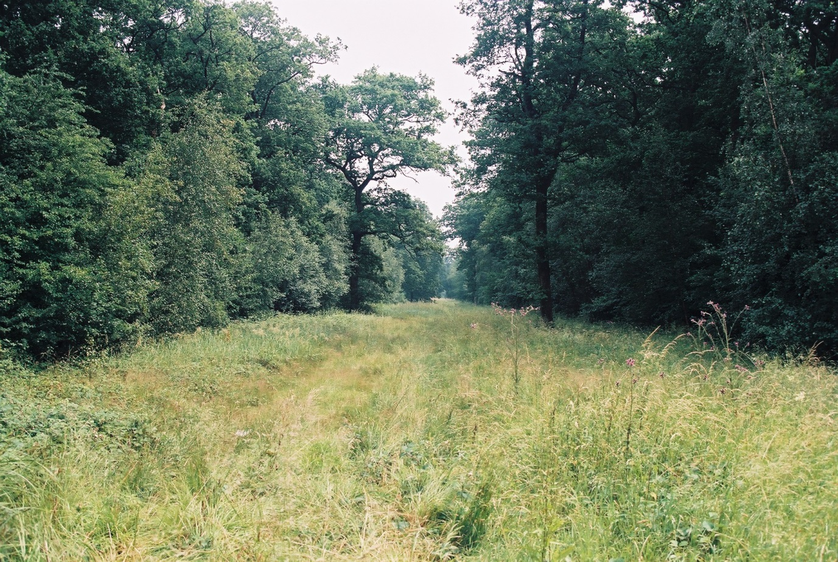

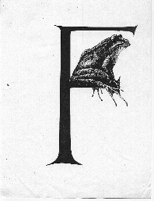
This report summarizes studies carried out between 1981 and 2012 while the author was employed by the Nature Conservancy Council and its successors (English Nature and Natural England) but the views are solely those of the author. A paper based on this work was published as:
Kirby, K.J. (1990) Changes in the ground flora of a broadleaved wood within a clear-fell, group-fells and a coppiced block. Forestry 63, 241-249.
http://forestry.oxfordjournals.org/content/63/3/241.full.pdf+html

Kirby, K.J. (2015) Changes in the vegetation of clear-fells and closed canopy stands in an English oak wood over a 30-year period. New Journal of Botany, 5, 1-12. http://www.tandfonline.com/doi/abs/10.1179/2042349715Y.0000000001

Contents
Summary 3
Background 4
Methods 6
Whole wood lists 6
‘Undisturbed oak woodland’ 7
Undisturbed ash-maple woodland 7
1984 Clear-fell 7
1988 Clear-fell 8
1984 ‘Coppice’ 8
Group-fells and ride scallops 8
Results 8
Whole wood lists 8
Changes in the undisturbed oak woodland 1981-2012 8
Undisturbed ash woodland 11
84 clear-fell 13
1988 clear-fell 15
1984 ‘coppice’ area 17
1986 Group fells 20
86 Ride widening plots 21
Differences in species composition of different areas and over time [Further analysis needed] 22
Discussion 23
Implications for management – a ground flora perspective 23
References 24
Annex 1. Summary of survey work carried out on the Claydon Estate in 1981 (unpublished) 25
Annex 2. Citation for Sheephouse Wood SSSI 29
Annex 3. Notes from Sir Ralph Verney on past management in Sheephouse Wood - 1981 30
Annex 4. Summary of 1986 butterfly survey. 33

Summary
Vegetation changes in Sheephouse Wood, Buckinghamshire are described, based on a mixture of temporary and permanent 10x10m plots recorded at various times between 1981 and 2012.
The bulk of the woodland consists of mature oak high forest. During the period considered the canopy cover has increased; the ground flora richness has declined. The key influence appears to be increased shading, but deer may also be having an effect particularly on ground flora cover, particularly of bramble, the dominant species.
The more mixed woodland in the north of the site, with more ash in the canopy, is also richer in its ground flora. Although the tree layer was also found to have increased, there was not the same species richness decline, possibly because ash is a much less heavy-shade caster.
Changes in two areas felled in 1984 and 1988 respectively showed similar patterns. Initially ground flora richness and cover increased and the areas became dominated by various grass species. Richness then dropped probably as a result of competition effects from the dominant grasses. The shrub and tree cover took longer than expected to establish and is now likely to have an increasing effect on the flora, which is expected to decline in richness and cover as the shade increases. Similar effects were seen in smaller areas cut as group-fells or rideside scallops.
An experimental coppice area was cut in 1984,but because the tree layer was not thinned it did not really function as a proper coppice cut. Increases in richness and cover of the vegetation occurred but not as great as in the clear-fell areas.
Overall the results show a strong correlation between the openness of the canopy and the species richness of the vegetation below. Hence where most of the wood has been left undisturbed the flora has tended to thin out. This suggests that from a ground flora conservation perspective more ‘disturbance’ for example by further small scale felling or ride widening would be desirable.
Concerns that the dominance of grasses and other competitive species might lead to subsequent losses of more specialist woodland flora are not supported in this study, at least if the open phase is less than ten years. While such species may form a smaller part of the total flora, in absolute terms they remain as common as in the undisturbed woodland. Further analysis of the changes in individual species is however needed.
The future management of the woodland needs however to take account of other interests, not all of which may be favoured by increased disturbance.

Background
In 1981 the Nature Conservancy Council (NCC) was reviewing the coverage of woodland within Sites of Scientific Interest (SSSI) in Buckinghamshire. The cluster of woods that form the Claydon Estate was surveyed as part of this review and Sheephouse Wood was selected as the site with highest nature conservation value amongst these.
Annex 1 gives a brief account of the survey; Annex 2 contains the SSSI description; Annex 3 has notes on the past management of Sheephouse Wood provided at the time by Sir Ralph Verney.
Sir Ralph Verney encouraged NCC to set up a monitoring programme within the wood. Unfortunately we did not have any separate funds for this so no formal programme was ever really established. However in 1984 Dr Rob Fuller of the British Trust for Ornithology started a long-running study of the bird populations and has also made periodic surveys of the structural changes in the wood (analysed and reported on separately eg Fuller 1988). A survey of the butterflies along the rides was carried out in 1986 (Steel 1986, Annex 4); more recently the bats have been studied (Hilary Phillips pers. com.).
My work has concerned variations in the ground flora across the wood and over time based on a mixture of permanent and temporary plots. Recording has been intermittent because of other work priorities. An initial account looked at changes up to 1988 (Kirby 1990). Sufficient additional data have now been collected (Table 1) to contrast the changes in the main, oak-dominated part of the woodland where no management has taken place, the two clear-fells established in 1984 and 1988, and to a more limited extent with other small scale interventions.

Table 1. Number of plots recorded in different parts of the wood in different years.
 |  | Plot no | 1981 | 1984 | 1985 | 1986 | 1987 | 1988 | 1989 | 1990 | 1991 | 1992 | 1993 | 1994 | 1996 | 1999 | 2000 | 2006 | 2008 | 2012
Undisturbed oak | Permanent | 7,9 |  | 2 | 2 | 2 | 2 | 2 | 2 |  |  |  | 2 |  | 2 |  |  |  | 2 | 2
 | Temporary |  | 6 |  |  |  |  | 3 |  |  |  |  |  |  | 6 | 6 | 8 | 7 | 6 | 6
84 clear fell | Permanent | 1-3 |  | 3 | 3 | 3 | 3 | 3 | 3 |  | 3 | 3 |  |  |  |  |  |  | 2 | 3
 | temporary |  | (1) |  |  |  |  | 3 | 3 |  |  |  |  |  | 4 | 6 | 6 | 6 | 6 | 3
84 copp | Permanent | 4-6 |  | 3 | 3 | 3 | 3 | 3 | 3 |  |  | 3 |  |  | 3 |  |  |  | 3 | 3
 | temporary |  |  |  |  |  |  | 3 | 3 |  |  |  |  |  |  |  |  | 3
88 clear fell | temporary |  |  |  |  |  |  | 6 | 6 | 6 |  | 6 |  | 6 | 6 | 6 | 6 | 6 | 6 | 6
86 rideside plots | Permanent | 8,10 |  | (2) | (2) | 2 | 2 | 2 | 2 |  |  | 2 |  |  | 2 |  |  |  | 2 | 2
86 group fell plots | Permanent | 13,14 |  |  |  | 2 | 2 | 2 | 2 |  |  | 2 |  |  | 2 |  |  |  |  | 2
Undisturbed ash | temporary |  | 1 |  |  |  |  | 3 |  |  |  |  |  |  |  |  | 1 | 1 |  | 1
 | permament | 11,12 |  | 2 | 2 | 2 | 2 | 2 | 2 |  |  |  | 2 |  | 2 |  |  |  | 2 | 2

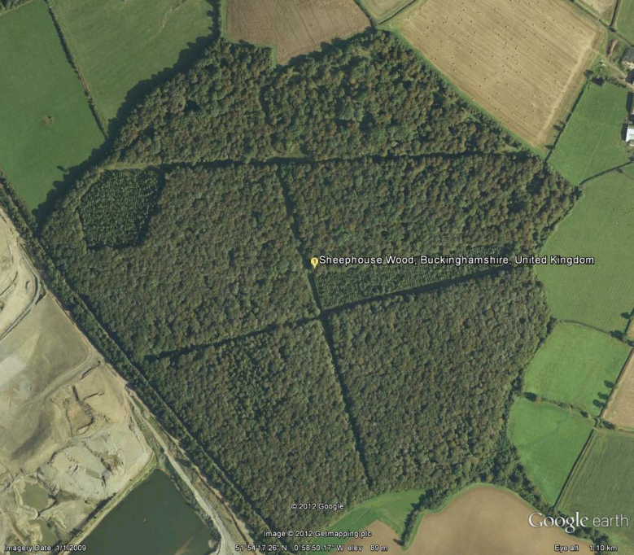
14
13
12
11
10
9
8
7
4-6
1-3

Approximate location of permanent plots referred to in Table 1.

Methods

Whole wood lists
The standard survey method to produce a basic description and vascular plant list for a woodland is based on a walk through the site – the surveyor aims to cover as much of the site as possible within 2-6 hrs (depending on the size of the site) and makes notes of the composition and structure of the woodland as they go. A species list and vegetation description for Sheephouse Wood produced in this way was available from the 1981 surveys; a similar survey walk was done in 2008 to see whether there was any indication of overall loss of species at the wood level.
The main variations in vegetation across the wood and the main management interventions that have taken place since are indicated on Figure 1. The recording within these areas is summarised in Table 1.
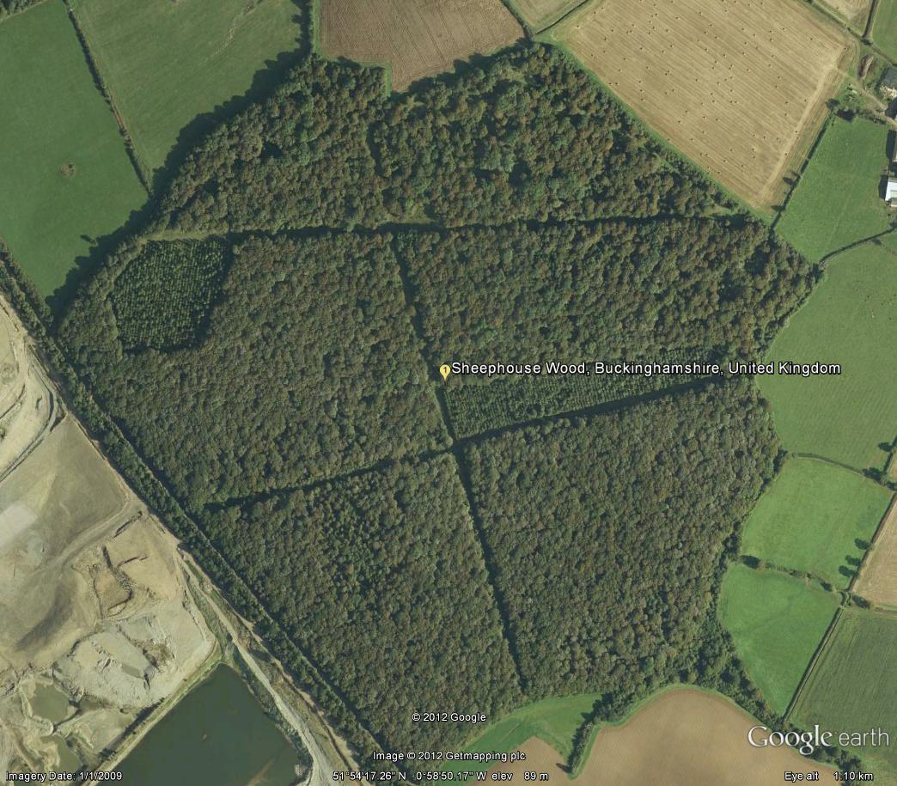
Undisturbed ‘ash’ woodland
Undisturbed ‘oak’ woodland
Undisturbed ‘oak’ woodland
Rideside clearance
1986 groups
1984 clearfell
1984 coppice
1988 clearfell
Figure 1. (a) The main variations in composition and management in the wood 1981-2012; (b) below, views of the wood in the 1980s. Source Google Earth, ©Getmapping plc.
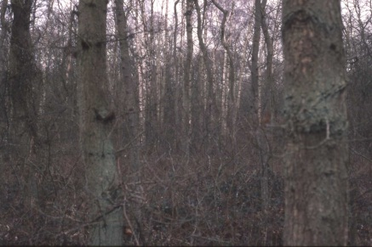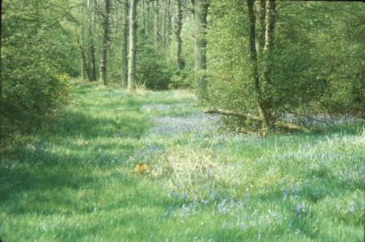
Table 2. 10x10 m quadrat /plot recording
Field layer – all vascular plants listed and given a cover score on the Domin scale (1-10). Wood species eg ash seedlings have been excluded from the analyses.
Cover across the plot estimated on a percentage basis for:
- Bare ground, Litter (and dead wood);
- Moss cover (generally very low);
- Field layer;
- Shrub/understorey 1-5m (excluding bramble and tall herbs);
- Tree/canopy cover (>5m high)
- Open sky, ie the light available to the ground flora.
The cover scores, except for the 1981 records, were all made by the same recorder. While they are highly subjective they can provide an indication of gross changes.

‘Undisturbed oak woodland’
In 1981 the walk survey was supplemented by eight quadrats (Table 2) randomly distributed across the wood. Six of these fell within the main oak-dominated area of the woodland and repeat surveys based on randomly placed quadrats but covering the spread across the wood have been carried out six times since. The 1981 quadrats were 14.1x14.1 m (200m²) but only data from the central 10x10 m (100m²) is used in the analyses below to be comparable with subsequent recordings that have used the smaller (10x10m) plot size.
Four permanent plots (7,9,11,12) were set up in the undisturbed woodland in 1984 and have been recorded nine times since. However two of the plot positions (11,12) proved to be in vegetation that was closer to the more species-rich ash-maple woodland in the north of the wood and have therefore been analysed with those data below.

Undisturbed ash-maple woodland
This is the least studied part of the woodland, although it has the richest flora, because originally little management was expected to take place in it. Apart from the two permanent plots established in 1984, one of the 1981 quadrats fell in this woodland type; three temporary plots were recorded in 1988 and single plots in 2006 and 2012. The two group fells (13,14) fall within this woodland type.

1984 Clear-fell
In 1984 a block of oak 2.x ha was clear-felled and replanted with mixed broadleaves at three metre spacing. One of the 1981 quadrats fell in this block and so provides evidence that this area was indeed similar to the surrounding undisturbed oak woodland. Three permanent plots (1-3) were established in 1984 and have been recorded ten times since. Temporary plots were also recorded on eight occasions up to 2012.

1988 Clear-fell
A second clear-fell was created in the autumn of 1988, again being planted with mixed broadleaves at three-metre spacing. This has been recorded using six temporary randomly placed plots on ten occasions from 1989 to 2012.

1984 ‘Coppice’
The intention in 1984 had been to create a coppice cycle so that changes under this could be contrasted with those under the clear-fell regime. The understorey in a block in the south-east of the wood was cut, but none of the canopy oaks were removed. So while the initial response was similar to that of a coppice cut, the retained canopy created too much shade for the understorey regrowth to be maintained. No further coppice cuts were made. Three permanent plots (4-6) were set out in 1984, which have been recorded on ten occasions and temporary plots on three.

Group-fells and ride scallops
Smaller clearings were also made in the wood from time to time, either as group fells within which trees were planted at wide spacing or as scallops to extend the rides. Two permanent plots (8,10) had their canopies partly cleared in 1986 and have effectively become rideside scallops; while two other permanent plots were established in group-fells (13,14) at the same time. These have been recorded on ten and seven occasions respectively.

Results

Whole wood lists
Walks of about 2-3 hours round the wood produced a list of about 88 and 80 vascular plants species in 1981 and 2008 respectively. As neither was a complete list there were, as expected, species recorded in 1981 but not in 2008. Of the 31 species from 1981 not picked up in 2008 27 were given a score of ‘rare’ in the wood in 1981 (most species recorded only in 2008 were similarly rated ‘rare’); at least 20 of the ‘missing’ species from the 1981 walk survey have however been seen recently. There is thus no indication that the richness of the wood – in terms of the overall species list - has changed substantially in the last three decades.

Changes in the undisturbed oak woodland 1981-2012
Overall species richness and field layer cover both declined (Figures 2,3), although there was more variation in change in field layer cover than richness. Species richness in particular was inversely correlated with the estimate of ‘open sky’ and inversely related to cover in the tree layer; there was little change in the estimate of shrub layer cover over this period (Figures 4,5,6, 7). The photographs below show plot 7 in August 1984, May 1988 and August 2012.
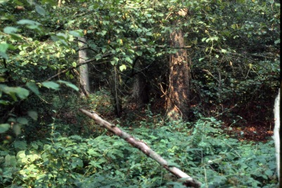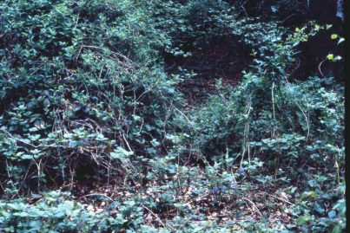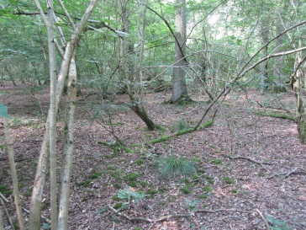
Figure 2. Species number per plot 1981 and 2012 in undisturbed oak woodland. Linear regression significant (p<0.001, r²=35%)

Figure 3. Field layer cover per plot 1981-2012 in undisturbed oak woodland. Linear regression significant (p<0.001; r²=22%)

Figure 4. Species richness and ‘open sky’. Linear regression significant (p<0.001; R²=29%)
Figure 5. Relationship between estimates of tree canopy cover and species richness per plot. Linear regression significant (p<0.001; r²=31%)

Figure 6. Changes in estimates of tree canopy cover 1981-2012. Linear regression significant (p<0.001; r²=35%)
Figure 7. Shrub layer cover estimates 1981-2012 – no trend

Undisturbed ash woodland
There are fewer plot records from this area and more species tended to be present in plots, often only as single plants. The results are more variable even from year to year in permanent plots. No trend was found in species richness over time, in field layer richness (Figures 8,9), or (as in the oak area) in shrub layer cover. Species richness was still correlated with ‘open sky’ estimates, but these showed no trend over the period, despite a rise in estimated tree cover (Figures 10,11). This may reflect the greater abundance of ash in the canopy in the northern part of the wood which is less of a shade caster than oak, or a greater role for the shrub layer in determining light to the field layer. The photographs show plot 11 in August 1984, May 1988 and August 2012
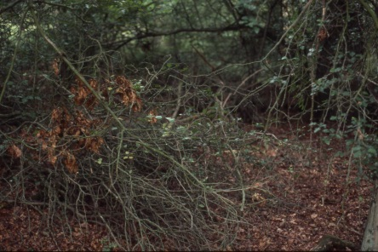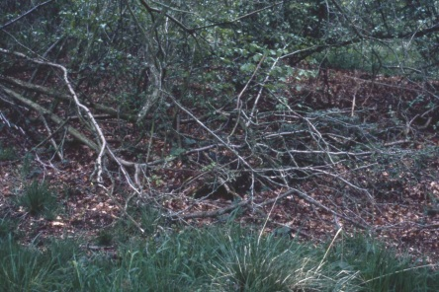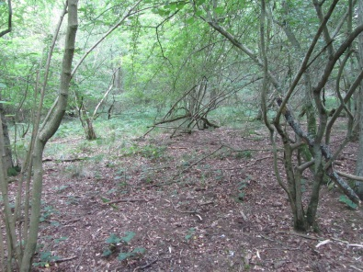

Figure 8. Species richness per plot in the undisturbed ash woodland 1981-2012. No trend.

Figure 9. Field layer cover in the undisturbed ash woodland 1981-2012. No trend.
Figure 10. Species richness versus ‘open sky’ estimates. Linear trend significant (p<0.05; r²=17%)

Figure 11. Increase in tree layer cover (%) in the undisturbed ash woodland 1981-2012 . Linear trend significant (p<0.001; r²=43%).

84 clear-fell
Following the clear-fell there was a rapid rise in species numbers and cover, followed by a decline over the next 5-10 yrs. Thereafter the species richness stayed more-or-less constant at about 15 species per plot (Figures 12,13). The trees took longer than expected to establish (not helped by a grass fire which killed some of the planted saplings). Mowing between the rows also limited the amount of natural regeneration that had been expected to supplement the wide-spaced planted trees. However their increasing contribution to the ‘shrub layer’ and then to the tree layer cover is apparent. (Figures 14,15). Now that the canopy is re-establishing a further decline in species richness is expected (through shading), as is already starting to happen with field layer cover.
The photographs below show plot 3 in August 1984, July 1992 and August 2012.
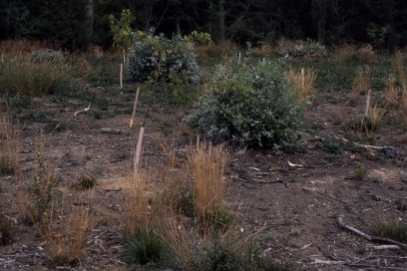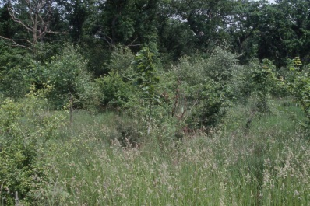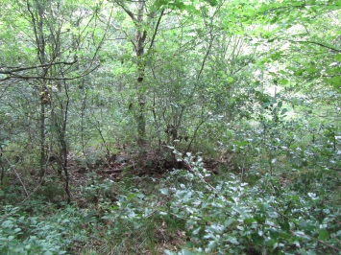
Figure 12. Change in species richness per plot in the 1984 clear-fell, 1981-2012.
Figure 13. Change in field layer cover in the 1984 clear-fell, 1981-2012.

Figure 14. Re-establishment of low shrubby cover (<5m high) as trees grew.

Figure 15. Re-establishment of tree layer (>5m high).

1988 clear-fell
Species richness increased following felling, as in the 1984 clearfell, but there has not been much of a subsequent decline (Figures 15,16). Similarly field layer cover increased after felling and has not yet started to decline. Although the trees established and grew better than in the 1984 clear-fell and so reformed first the shrub and then a tree layer quicker it is only in the last few years that the stands have approached full canopy (Figures 17,18), suggesting that, to date, light limitation by the woody species has not influenced species richness.
The photographs below illustrate the state of the clear-fell in May 1989 following felling in autumn 1988, in 1994 and in 2012 (not the same plots).
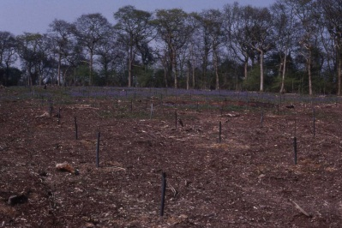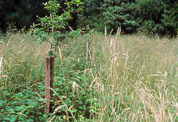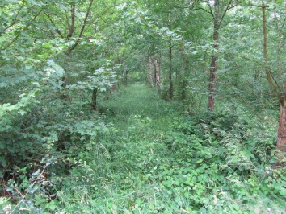

Figure 15 Change in species richness in the 1988 clear-fell (all temporary plots).

Figure 16 Change in the field layer cover in the 1988 clear-fell (all temporary plots)
Figure 17 Shrub layer cover in 1988 clear-fell (all temporary plots).
Figure 18 Growth of planted trees into a distinct tree layer (>5m) (all temporary plots).

1984 ‘coppice’ area
Clearance of the understorey led to an increase in species richness compared to the undisturbed oak woodland surrounding it but thereafter species richness declined. Field layer cover initially increased but subsequently dropped back down although it is still somewhat higher than in the undisturbed oak woodland (Figures 19,20). The shrub layer was eliminated through the coppice cut, but has since re-established. The tree layer was not cut in 1984 but has, as in the undisturbed woodland, tended to increase in cover (Figure 21, 22). The changes in species richness are correlated with changes in the estimate of ‘open sky’, as in the undisturbed woodland, but more strongly with the estimate of regrowth of the shrub layer (Figures 23, 24).
The photographs show plot 4 in August 1984, May 1989 and August 2012.
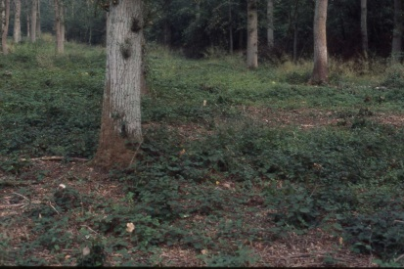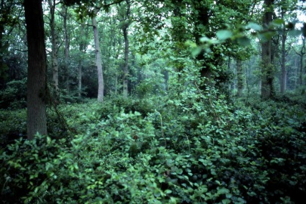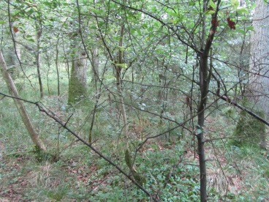
Figure 19. Changes in species richness in the ‘coppice’ area 1981-2012. Linear trend significant (p<0.001; r²=41%)

Figure 20. Field layer cover in the ‘coppice area’.
Figure 21 Shrub layer cover in the ‘coppice’ area

Figure 22. Changes in tree layer cover in the coppice area 1981-2012. Linear trend significant (p<0.001; r²=51%)

Figure 23. Species richness versus open sky in the ‘coppice area’. Linear trend significant (p<0.01; r²=25%)
Figure 24 Species richness change in relation to shrub layer cover in the ‘coppice area’. Linear trend significant (p<0.001; r²=40%)

1986 Group fells
These were felled areas about 30m across in which a few individual trees were planted. They have remained largely open throughout the period. The field layer remains more or less complete cover. After an initial rise in species richness in the first decade there was then a decline (Figure 25), although remaining at much higher levels than under shade.

Figure 25. Change in species richness in two group fells (based on two permanent plots).
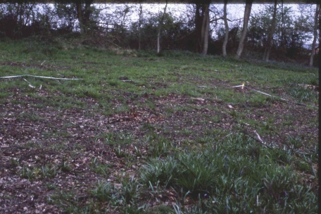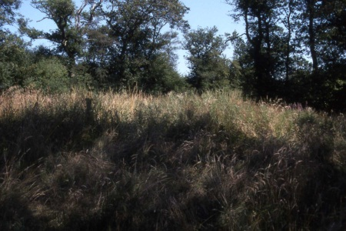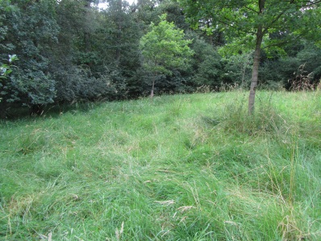
The photographs show plot 13 in May 1986,1995 and August 2012.

86 Ride widening plots
Two plots close to rides, but originally under full closed canopy were partially opened out in 1986 as part of scalloping of ride edges and have remained half closed woodland, have ride since. Their species richness increased substantially in the first few years, then dropped back (Figure 26). As with most other areas the species richness changes tend to be correlated with change in tree layer cover (Figure 27). The photographs show plot 10 in 1986 when it had been felled, in 1989 showing growth back into the ride scallop, and in August 2012 inside the developed scrub edge (the portion of the plot that remains open can be seen in the top left corner.
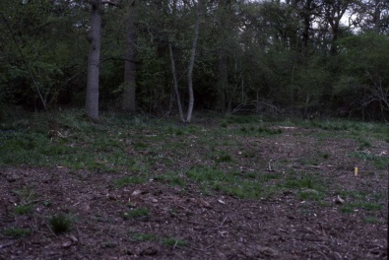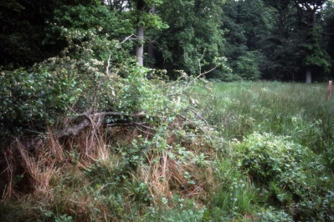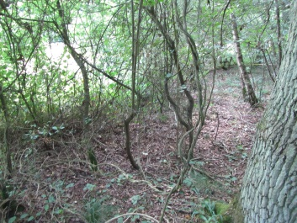
Figure 26. Change in species richness in rideside plots (based on 2 permanent plots)
Figure 27 Species richness versus tree cover for rideside plots (linear trend significant p<0.05; r²=29%)

Differences in species composition of different areas and over time [Further analysis needed]
The main part of the wood – the undisturbed oak woodland – has a relatively species-poor flora with bramble and honeysuckle the most frequent species. To the north a wider range of species occur on the more base-rich soils.
Where the canopy was cleared the increase in species richness is still very largely of generalist woodland species, particularly grasses (Calamagrostis, Holcus spp, Deschampsia cespitosa, Agrostis stolonifera, Dactylis glomerata). Non-woodland (grassland/disturbed ground species increase some of these then disappear in the face of competition from grasses in particular. Woodland specialists can still be found amongst dense vegetation, not least because they include grasses such as Anthoxanthum odoratum, Holcus mollis and Calamagrostis. Nevertheless even some of the woodland herbs (Primula vulgaris, Hyacinthoides non-scripta) could still be found in plots several years after clearance. Woodland specialists may form a slightly smaller proportion of the total flora in clearings than in the closed canopy woodland in absolute terms they occur as frequently.
Figure 28. No of woodland specialists versus total species richness for undisturbed oak woodland and 88 clear fell plots across all times.

Discussion

The method of recording – with low numbers of plots and combining permanent and temporary samples – is messy and will have introduced some biases. It was however a consequence of making the most of visits to the wood, sometimes for other purposes such as staff training. Nonetheless some general patterns emerge which are similar across both temporary and permanent plot records.
In the undisturbed woodland the canopy cover (>5m high) has tended to become denser and the ground more shaded, particularly in the oak dominated areas of the wood, although locally small gaps have started to occur recently as trees have died. The ground flora in the oak woodland, poor to start with, has become less rich and the cover of the ground flora has declined. Both cover and richness have however remained stable in the northern ash-dominant woodland. The correlation between species-richness and estimates of tree cover/open sky suggest that shading is a major driver of change, although an increase in deer pressure from the late 1980s onward may be contributing particularly to the decline of the bramble cover in the oak woodland.
Felling led to increases in both ground flora richness and cover. After an initial peak of species richness (in some cases over 30 species per plot) there is a decline, even before the canopy re-establishes - in some cases the felled areas have remained fairly open for twenty years. This reflects competition within the ground flora. The plots remain however richer than the closed canopy areas.
While some of the increase in species richness is from invasion by non-woodland species such as Cirsium arvense most of it is from woodland generalist species including various grasses such as Agrostis stolonifera, Dactylis glomerata, Deschampsia cespitosa. Woodland specialists also benefit, not surprisingly because some of these are also grasses of woodland clearings such as Calamagrostis epigeos. However typical woodland herbs can still be found 5-10 years after felling amongst the grasses. As the canopy re-establishes so these species should assume more prominence.
A major re-survey of woods in 2001 of 103 woods spread across Britain that had previously been looked at in 2001 found a decline in plant species richness which appeared to be linked to increases in shading (Kirby et al 2005). This study of one site but with a more continuous record over a similar time scale supports this finding.
There has been concern that clear-felling and the subsequent dominance of grasses may swamp more specialist woodland plants. The results from Sheephouse suggest this risk may be over-stated; while this element of the woodland flora may not increase as much as more generalist species they may still benefit from some opening up of the canopy.

Implications for management – a ground flora perspective
The ground flora would benefit from localised opening up of the canopy in the currently undisturbed oak areas. An ‘active’ and ‘passive’ approach to this are suggested below.
The Estate might, if it wished to realise some of the current timber potential from the wood, create small group fells. Grasses and bramble are still likely to rapidly form the bulk of the vegetation but if the gaps are kept reasonably small and dense regeneration is encouraged any competitive effect on woodland specialists should be minimised. Good regeneration will depend on deer numbers being kept low; even so some planting of oak is likely to be needed. Learning from past experience groups of close spaced trees, and not mowing the areas between the groups, should lead to better establishment and quicker canopy closure.
A more ‘passive’ approach would be to rely on an increase in gap creation as trees die to provide the increase in light to the ground flora. Deer control would still be desirable to allow for regeneration within the gaps, though as the gaps would probably be smaller than group fells the frequency of oak regeneration would be less. If this approach is taken it would be desirable to link it to some further opening up of rides through the wood which would locally increase the side light in to the stands.
This study has just been of the ground flora. There does need to be consideration of the other interests in the wood; for example while the key butterflies would probably benefit from active intervention there would probably be less dead wood in the longer term and this might impact on the bat populations (eg Murphy et al 2012). Leaving at least a quarter of the woodland undisturbed even if the more active approach to management is taken might therefore be advisable.

References

Fuller, R.J. 1988. A comparison of the breeding bird assemblages in two Buckinghamshire clay vale woods with different management histories of management. In Woodland conservation and research in the clay vale of Oxfordshire and Buckinghamshire, editors K J Kirby & F J Wright, Nature Conservancy Council, Peterborough, pp53-62.

Kirby, K J 1990. Changes in the ground flora of a broadleaved wood within a clear-fell, group-fells and a coppiced block. Forestry 63, 241-250.

Kirby, K.J., Smart, S.M., Black, H.I.J., Bunce, R.G.H.,Corney,P.M.and Smithers,R.J. (2005). Long term ecological change in British woodland (1971-2001). Peterborough: English Nature (Research Report 653).

Murphy, S.E., Greenaway, F. & Hill, D.A. 2012. Patterns of habitat use by female long-eared bats presage negative impacts of woodland conservation management. Journal of Zoology.

Steel,C. 1986. Butterfly recording in Sheephouse Wood. Chief Scientist Team report, Nature Conservancy Council, Peterborough.

Annex 1. Summary of survey work carried out on the Claydon Estate in 1981 (unpublished)
A survey was carried out in 1981 of the woods on the Claydon Estate:
- To record the species, communities and structure of the different woods;
- To identify those features/species within the semi-natural areas that are of particular importance for nature conservation;
- To determine the extent to which these species/features survive in the woods which have been partially or completely converted to plantations.
A mixture of structured walk and quadrat records were made and records from previous surveys for some of the woods were also available. Summaries of the results for each wood were prepared. That for Sheephouse is included below. The woods were then compared using the framework of the Nature Conservation Review criteria in the table below. It was clear that Sheephouse and Home Woods stood out as of significantly higher value than the others and this led to Sheephouse subsequently being notified as a Site of Special Scientific Interest.
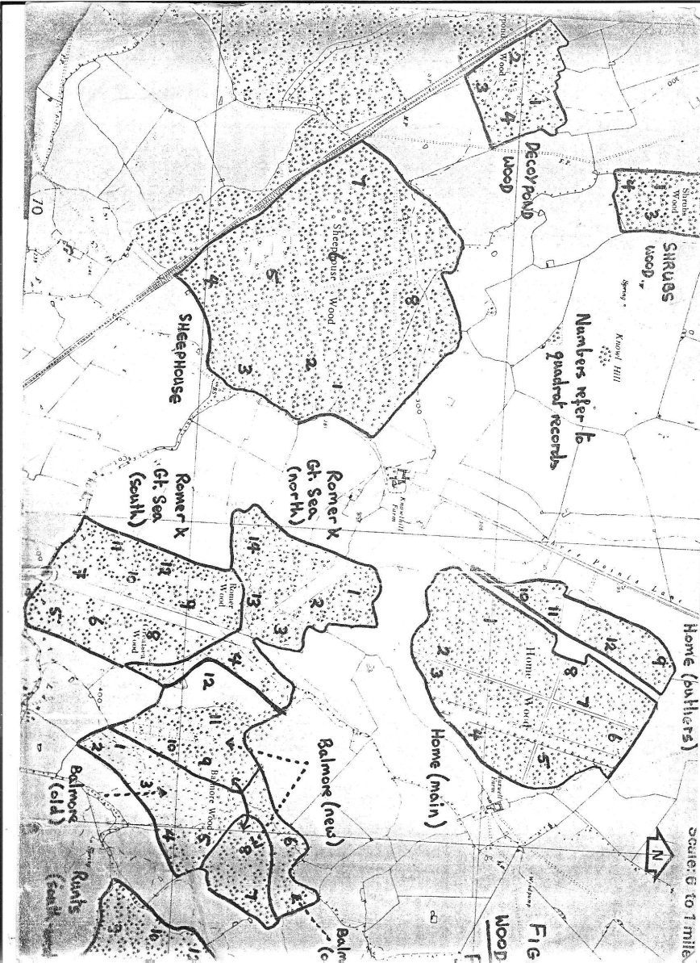

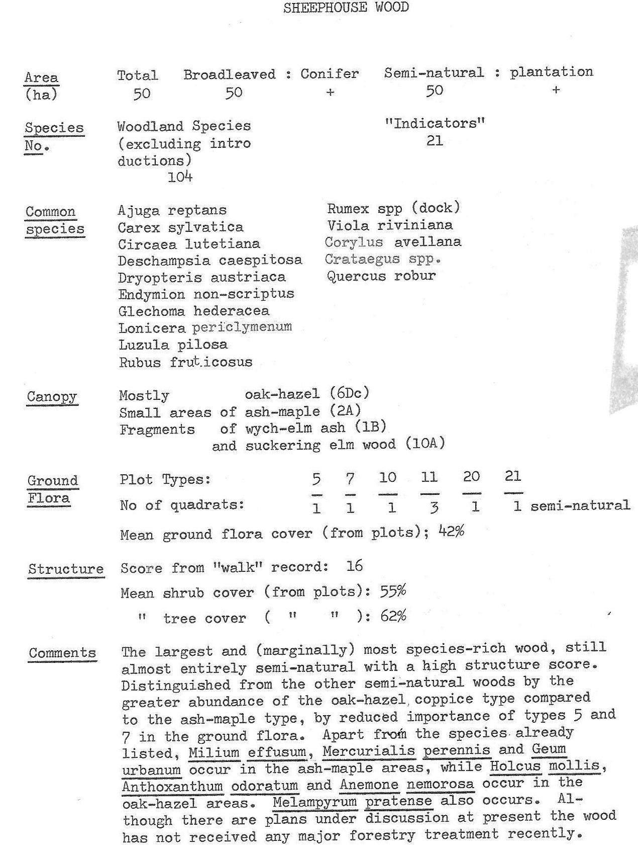
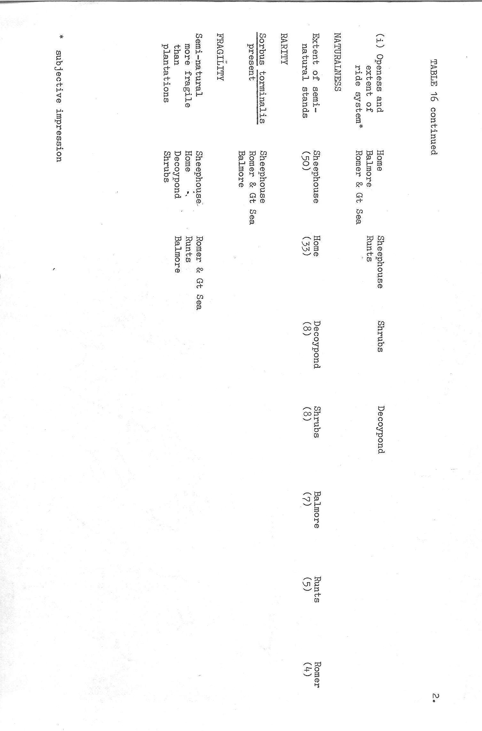
Annex 2. Citation for Sheephouse Wood SSSI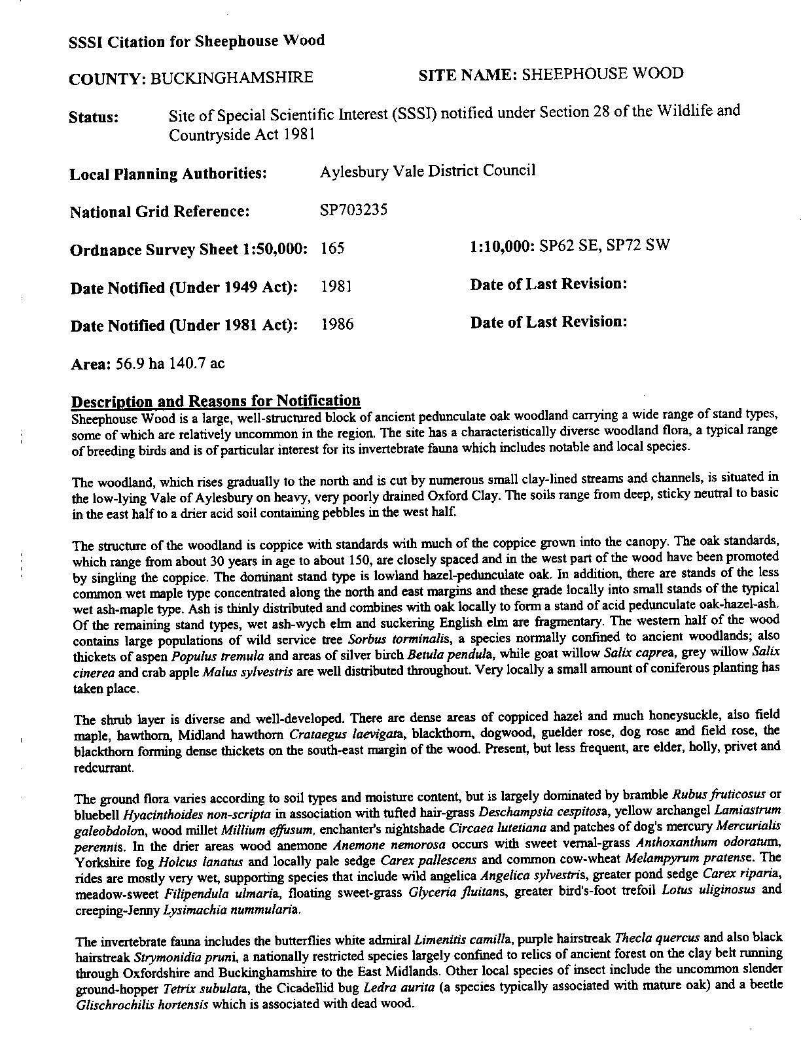

Annex 3. Notes from Sir Ralph Verney on past management in Sheephouse Wood - 1981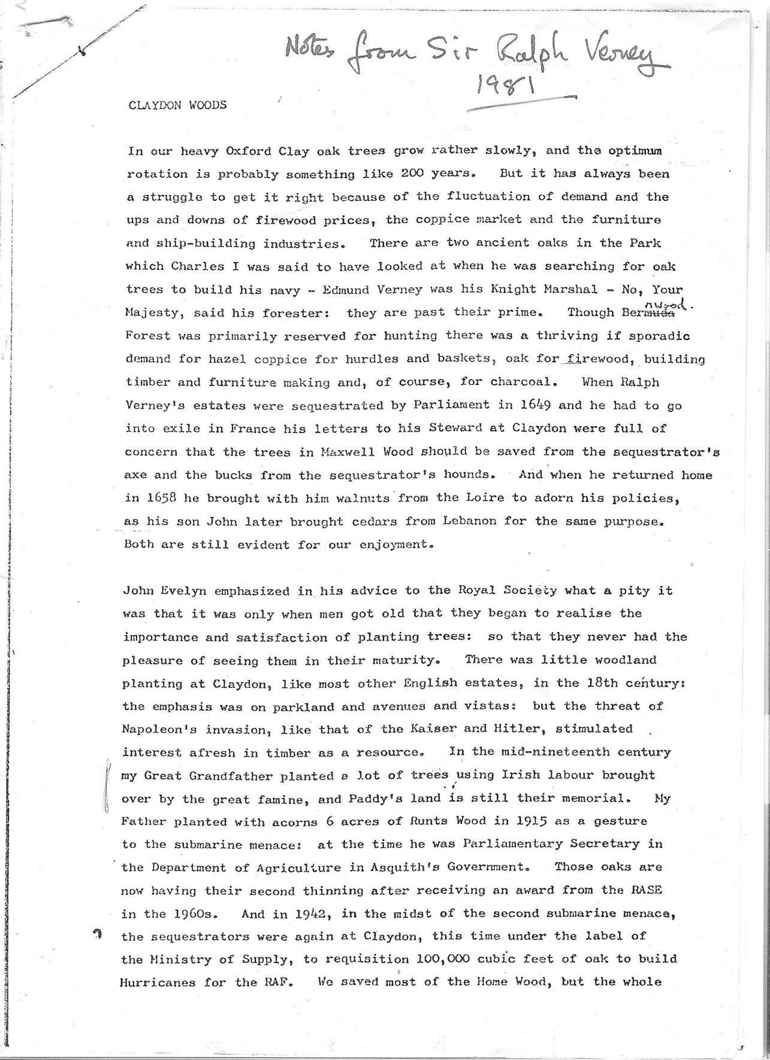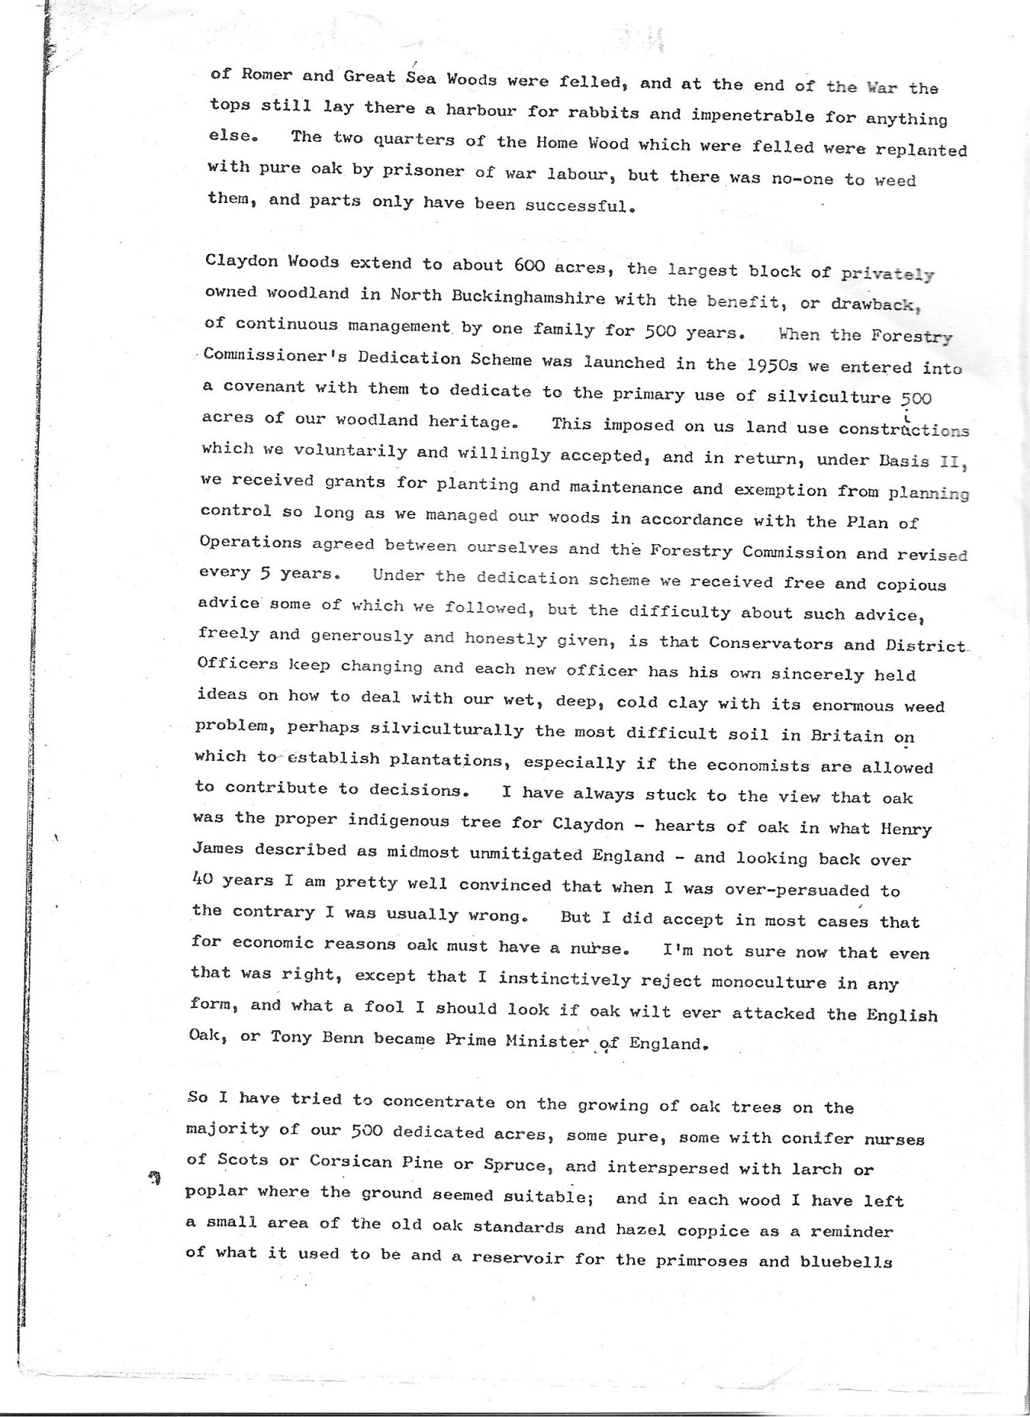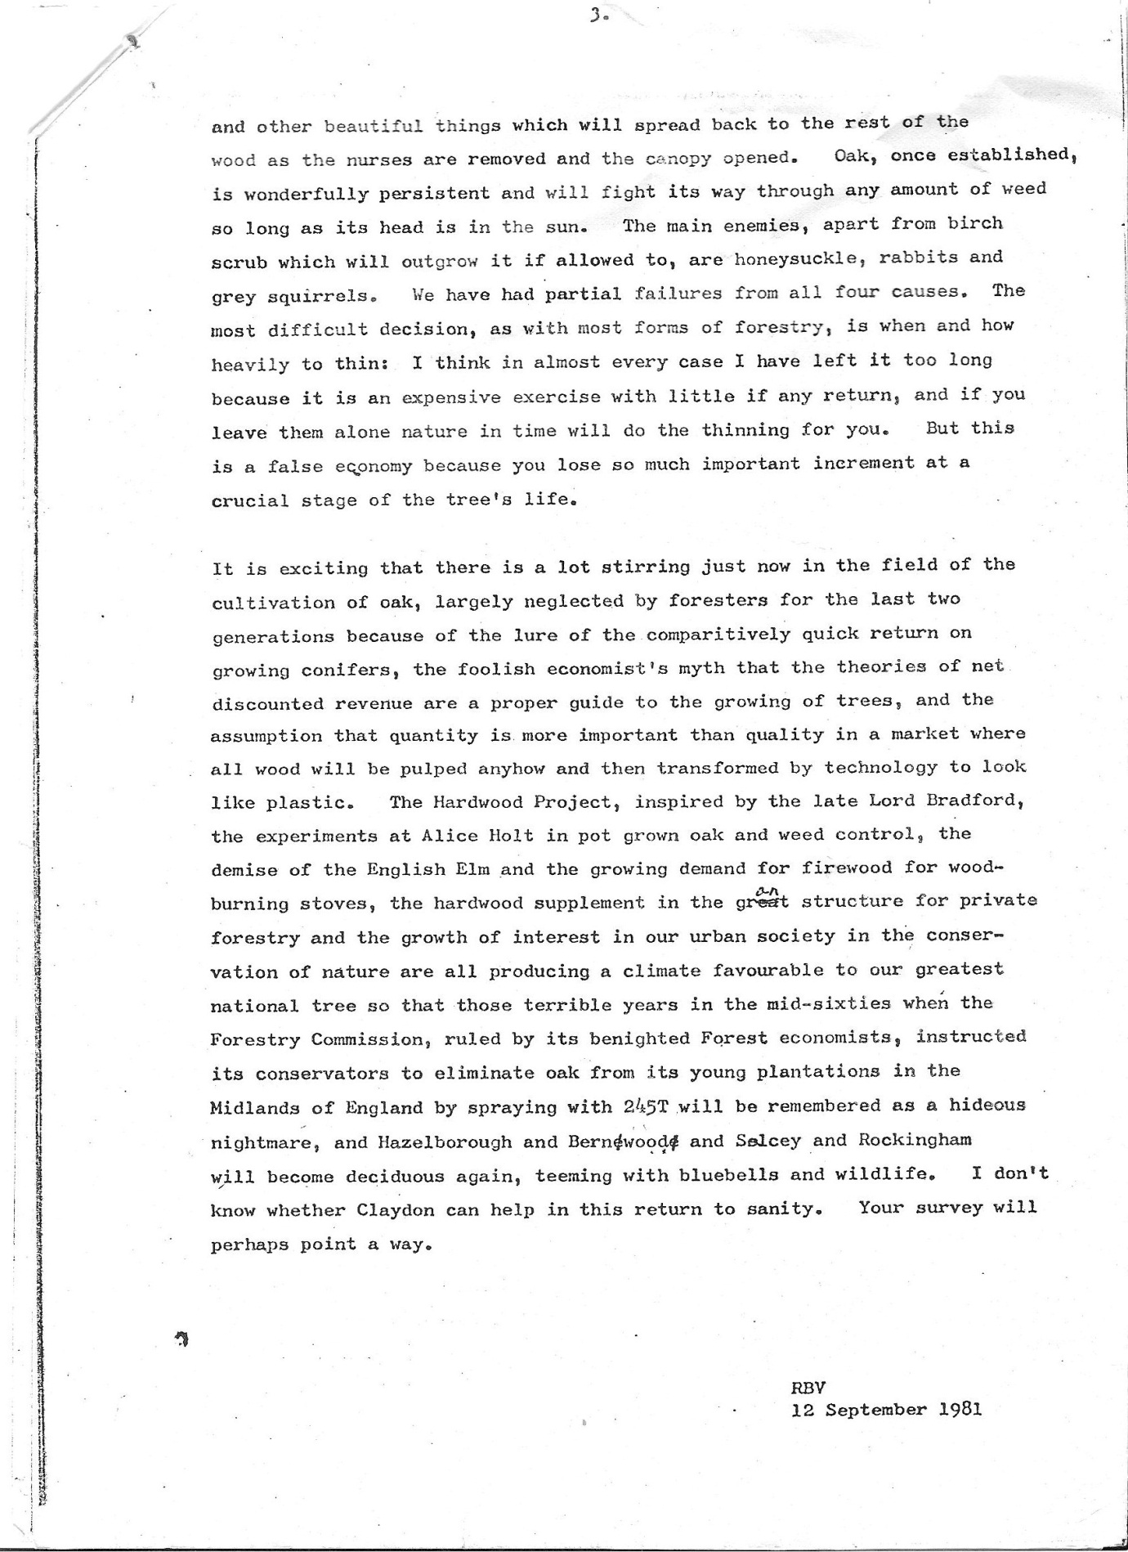

Annex 4. Summary of 1986 butterfly survey.
Steel,C. 1986. Butterfly recording in Sheephouse Wood. Chief Scientist Team report, Nature Conservancy Council, Peterborough.
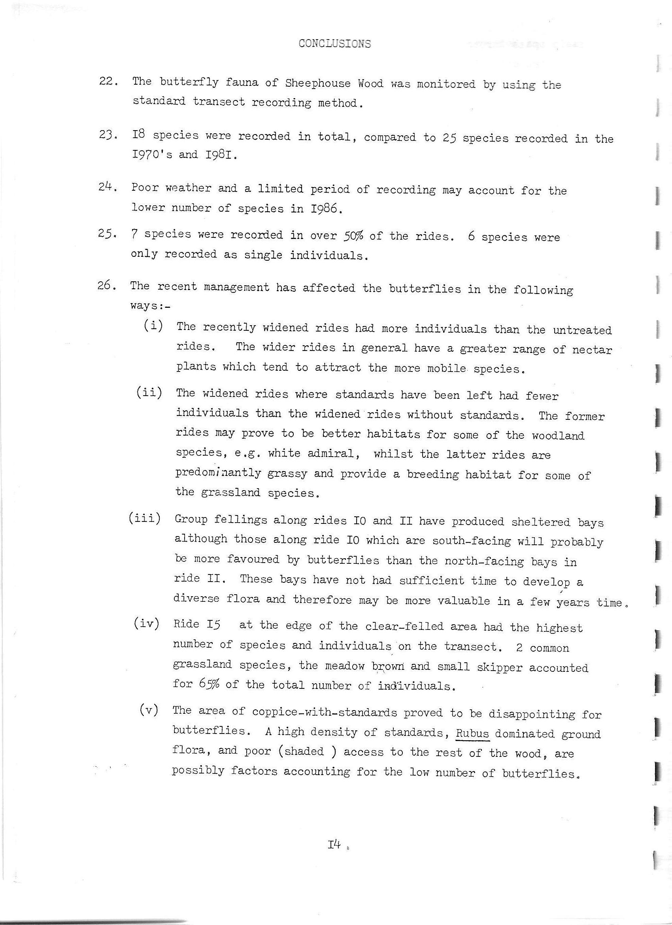

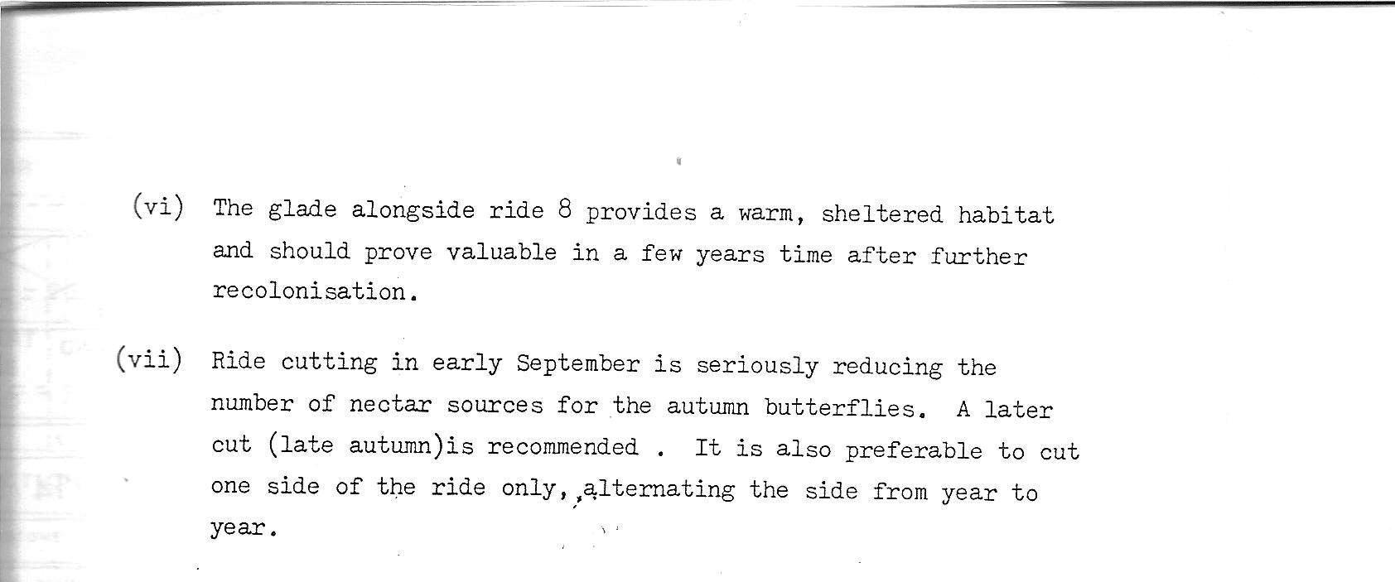
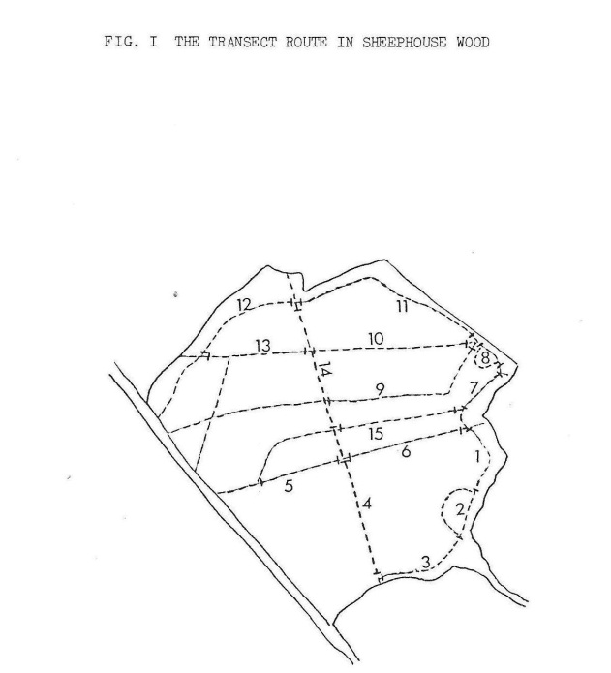
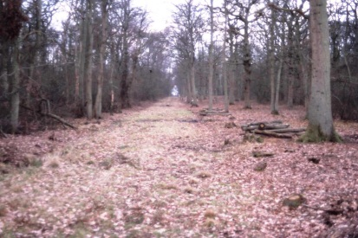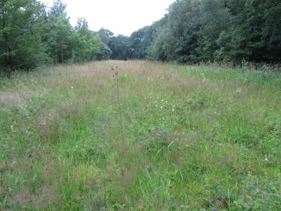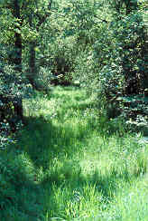
The photographs show the widening of section 5 in March 1985; flower-rich section 4 in July 2012; a shaded narrow ride, the westward extension of section 9 (taken in 1990)

