Supplementary information - The charging mechanism of Li₂MnO₃
Niccoló Guerrini‽, Liyu Jin‽, Juan G. Lozano†, Kun Luo†, Adam Sobkowiak, Kazuki Tsuruta‡, Felix Massel§, Laurent-Claudius Duda§, Matthew R. Roberts‽ and Peter G. Bruce*,†.
†Departments of Materials and Chemistry, University of Oxford, Parks Road, Oxford OX1 3PH, United Kingdom
‡Japan Synchrotron Radiation Research Institute (JASRI), 1-1-1 Kouto, Sayo, Hyogo 679-5198, Japan
§Department of Physics and Astronomy, Division of Molecular and Condensed Matter Physics, Uppsala University, Box 516, S-751 20 Uppsala, Sweden
″Etteplan Sweden AB, SE-171-54 Solna, Sweden
‽ Dyson Technology Ltd., Tetbury hill, Malmesbury, SN16 0RP, United Kingdom

PXRD
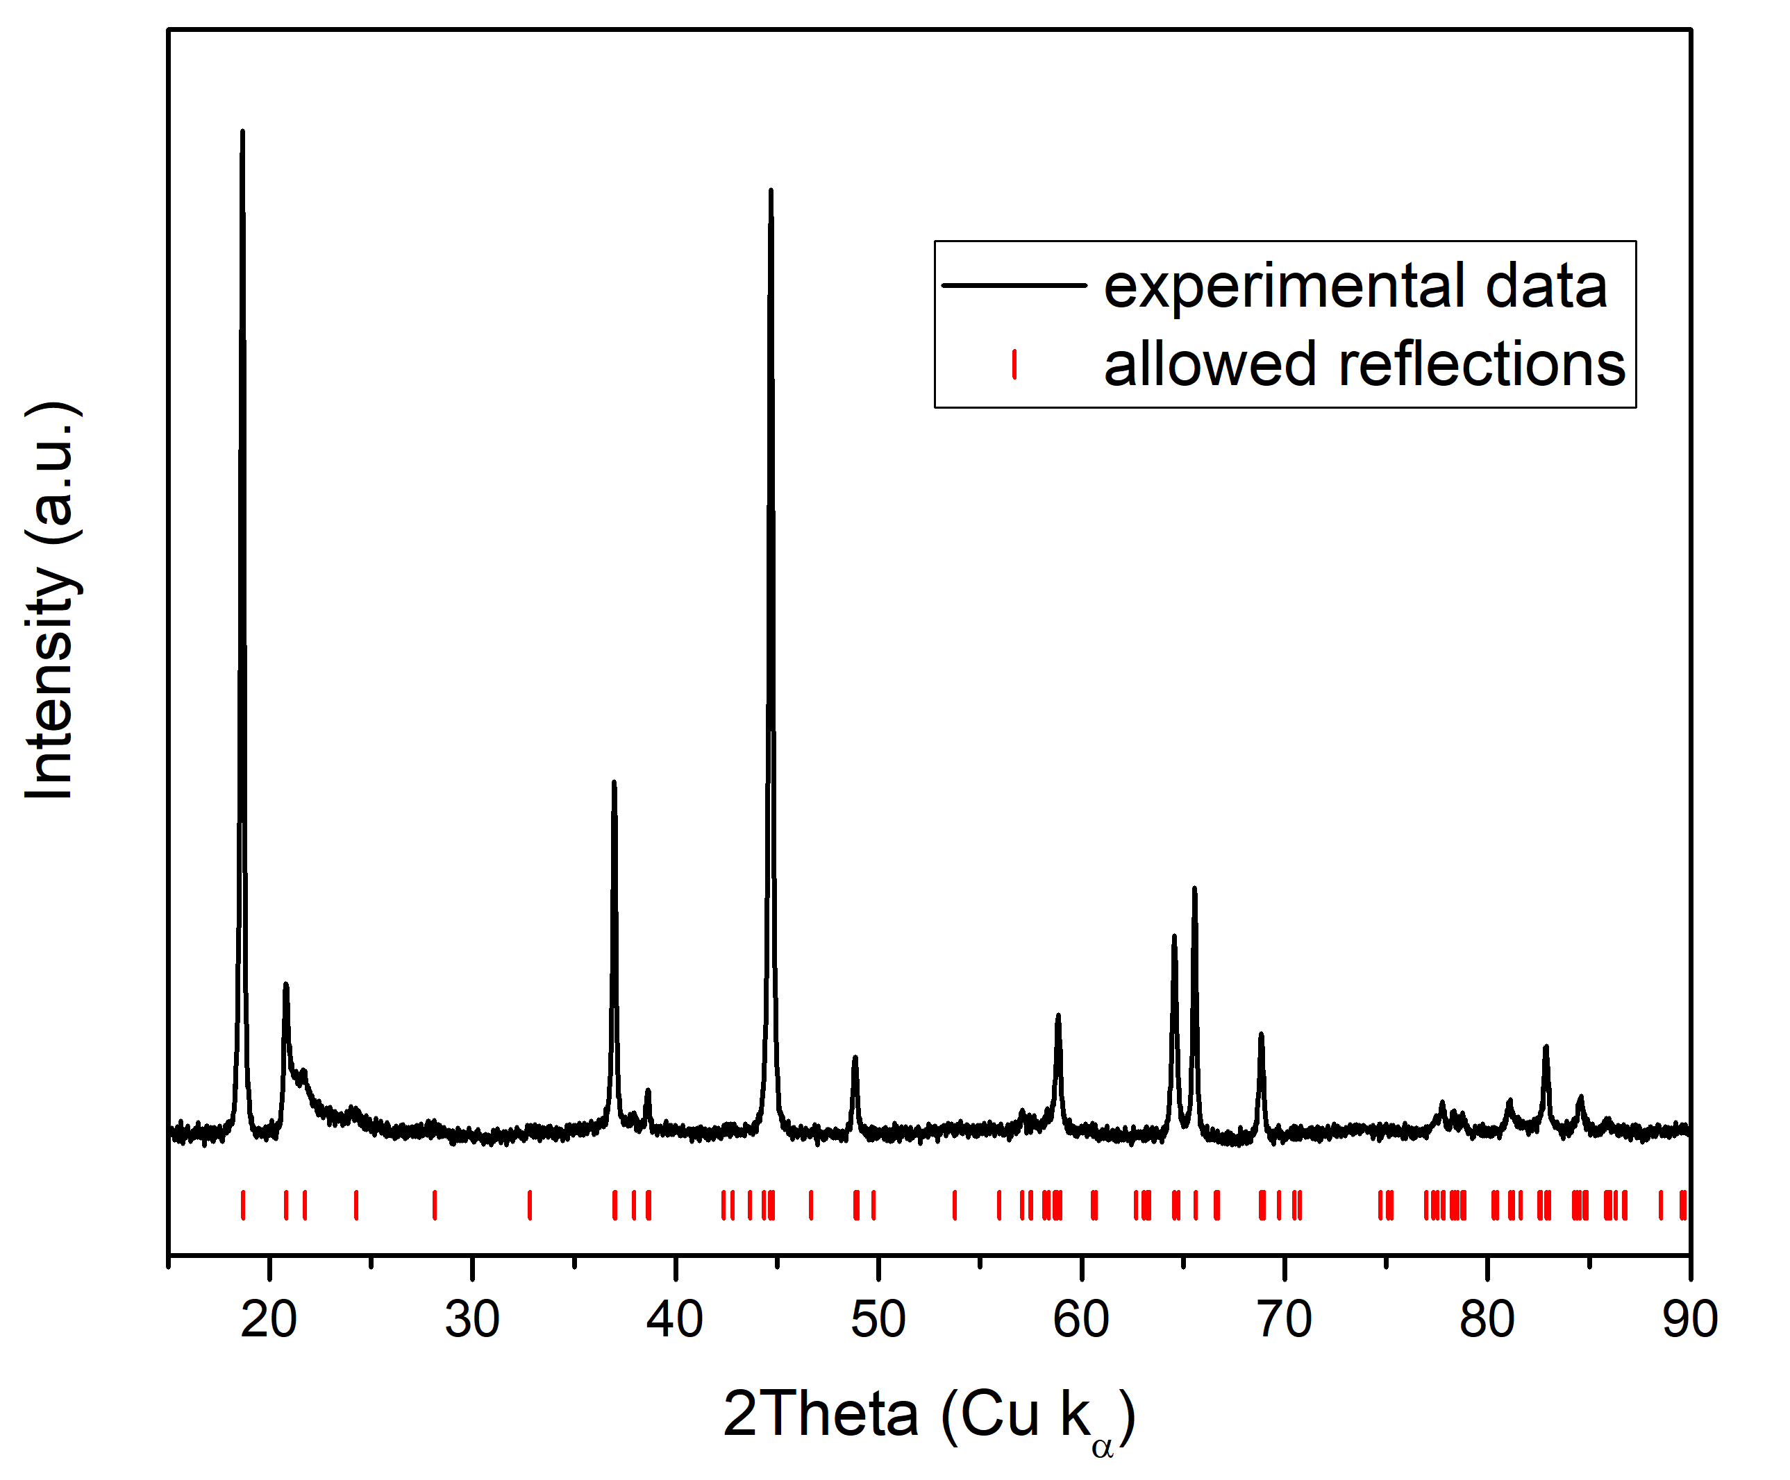
Figure S1 Li₂MnO₃ powder X-ray diffraction pattern collected using Cu-κ_{α}radiation. Tick marks indicate allowed reflections for the monoclinic C2/m space group of Li₂MnO₃.

SEM
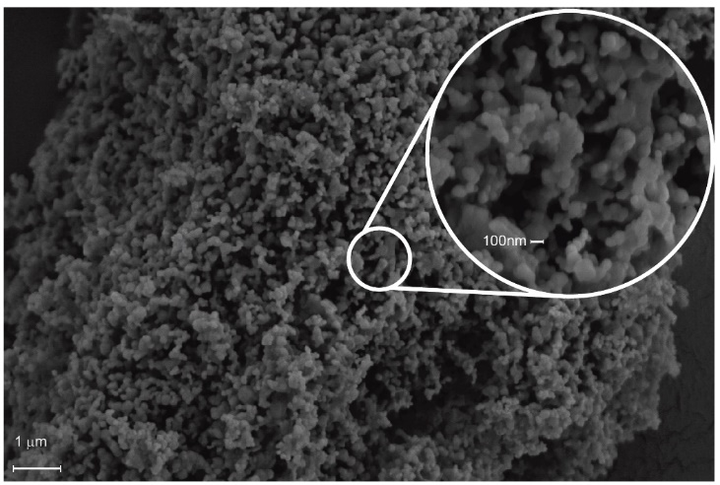
Figure S2 SEM images for Li₂MnO₃ at two different magnifications. The morphology consists of primary particles (50 to 150 nm) agglomerated into 20-50 micron secondary particles.

TGA-MS
The experiment was performed on a ~20 mg sample contained in an alumina crucible under inert atmosphere of Ar. The temperature was increased with a rate of 10 °C/min between room temperature and 1000 °C.
The TGA (cyan line, Fig S4) registered a 2% mass loss for the sample whilst the evolution of O₂ and CO₂ was detected by the mass spectrometer. Even if all the mass loss is accounted for by decomposition of Li₂CO₃ from the material surface, it can be easily calculated that the resulting amount of carbonate would account for less than 10% of the extracted capacity in the galvanostatic cycling. As well oxygen could be released from the material lattice as a consequence of Manganese reduction from 4+ to 3+ oxidation state at high temperature.
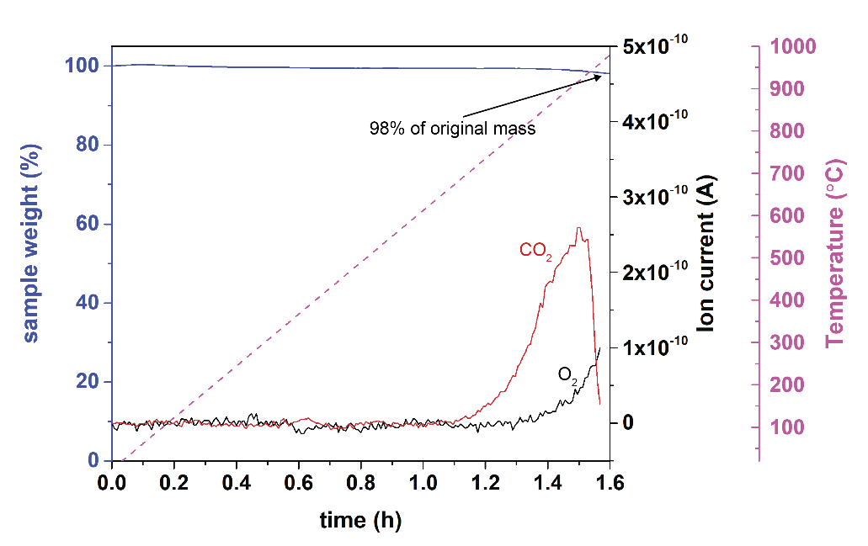
Figure S4 TGA-MS analysis performed on pristine Li₂MnO₃.

Contribution of Li₂CO₃ to the charge and gas loss
From the TG-MS experiment a 2% weight loss is detected. If all the loss is attributed to Li₂CO₃ present along with Li₂MnO₃ in the pristine material, following the equation for Li₂CO₃ electrochemical oxidation reported in the main text, From Faraday’s law it is calculated that 14% of the charge passed in the electrochemical experiment is associated with Li₂CO₃ decomposition of which 2/3 leads to CO₂ formation and 1/3 to O₂.
Combining the information attained from TG-MS and OEMS it is possible to evaluate the amount of charge extracted as gas-loss that is associated respectively with Li₂MnO₃ and Li₂CO₃
Charging Regime | Total charge passed (mAhg⁻¹) | Charge passed minus charge associated with Li₂CO₃ oxidation (mAhg⁻¹) | Charge from O₂ (mAhg⁻¹) | Charge from O₂ corrected for Li₂CO₃ contribution (mAhg⁻¹) | Charge from CO₂ (mAhg⁻¹) | Charge from CO₂ corrected for Li₂CO₃ contribution (mAhg⁻¹) | Total Charge from gas loss (mAhg⁻¹) | Total Charge from gas loss corrected for Li₂CO₃ contribution (mAhg⁻¹)
Galvanostatic | 102 | 87.5 | 44.5 | 39.7 | 55 | 45.3 | 99.5 | 85
GITT | 145 | 130.5 | ~5 | ~0.2 | 142 | 132.3 | 144 | 129.5
Hence, we get the following table.

Calculation:
For 1 gram of pristine material is evaluated that 98% is Li2MnO3 and 2% Li2CO3, hence 0.98g and 0.02g respectively. Employing Faraday’s law Q = nF/3.6MW it is possible to calculate the theoretical capacity of Li₂CO₃ (725.43 mAhg⁻¹). Hence for 0.02g are attained 14.5 mAh, corresponding to the charge contribution of Li₂CO₃ for 1 g of pristine material. Of these 14.5 mAh, 2/3 are associate with CO₂ evolution and 1/3 with O₂.

