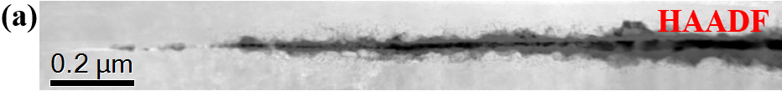
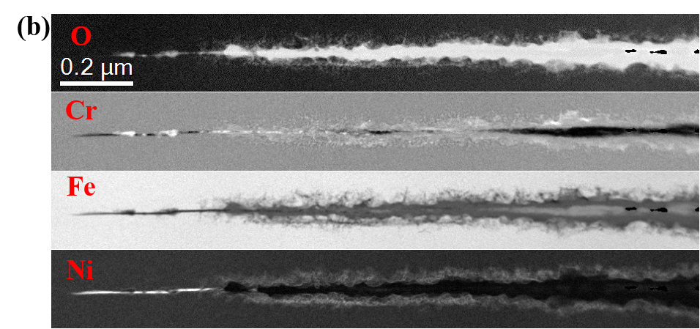
Fig. S1. Crack tip oxidation of 316L SS exposed to simulated PWR primary water at 340ºC: (a) HAADF image; (b) EELS elemental O K edge and Cr/Fe/Ni L edge maps (relative composition).

