Supplementary Information

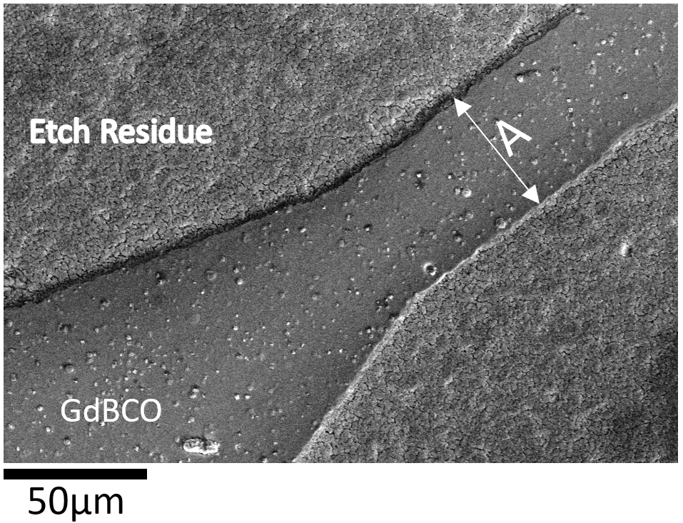
Supplementary Figure 1: SEM images of track C5 before irradiation. The measured track width (dimension A) was 48µm.
Supplementary Figure 2: (a) Temperature versus critical current measurement for sample C5 when pristine and unirradiated. “Expected” values take from RRI database for sample Fujikura FYSC 2G HTS (available at http://htsdb.wimbush.eu/). (b) Measured temperatures of sample C5 during its cold irradiation. Periods where the beam is being applied to the sample are shown in grey. Labels: ‘A’: during this period, the temperature control system malfunctioned; ‘#56’: temperature rise due to the long beam-on pulse.
Quench of Unirradiated versus irradiation sample C4
An additional aspect of the evolution of J_{c} of sample C4 during its first cold irradiation cycle is that C4 suffered from two short resistive quenches during testing; the first during testing prior to irradiation (label A, Supplementary Figure 3) and the second after the sample had been irradiated to about 1 mdpa (labelled B, Supplementary Figure 3). The first quench resulted in a small reduction in J_{c} (15.2 to 14.2 MA cm⁻²) whilst the quench after 1 mdpa of damage resulted in an increase in J_{c} (9.1 to 9.9 MA cm⁻²).
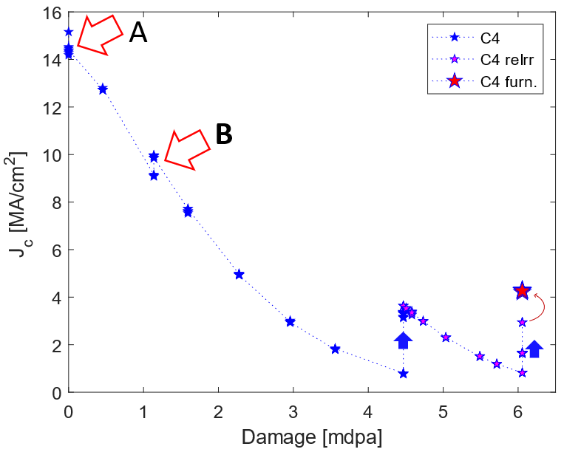
Supplementary Figure 3: A closer look at the critical current density (J_{c}) evolution of sample C4 normalised to its initial value (J_{c}(initial)) with increasing irradiation damage from 2MeV helium ions. Bold blue arrows are included to indicate a change due to room temperature annealing. Red arrow A indicates a resistive quench of the sample before irradiation leads to a reduction in J_{c}. Red arrow B indicates a resistive quench of the sample after it had been further irradiated to ≈1 mdpa leads to an improvement in J_{c}.
Supplementary Table 1: Results from the 2 cold irradiation and room temperature annealing cycles of sample C4.
Sample C4 | First Cold Irradiation |  |  | Second Cold Irradiation
Sample C4 | T_{c} [K] | ΔT_{c} [K] | I_{c}(40K)  [A] | T_{c}  [K] | ΔT_{c}  [K] | I_{c}(40K)  [A]
Initial value | 90.5 | 0.9 | 14.1 | ≈80 | 4.1 | 3.5
Total damage [mdpa] | 4.47 |  |  | 6.1
Post irradiation values | 65.0 | 7.3 | 0.7 | 64.9 | 7.6 | 0.8
Fast recovery period [days] | 3 |  |  | 6
Values after fast recovery period | 75.3 | 4.2 | 3.0 | 69.8 | 6.0 | 1.5
Slow recovery period [days] | 104 |  |  | 106
Values after slow recovery period | ≈80 | 4.1 | 3.5 | 75.8 | 4.5 | 2.7
Values after furnace anneal | - | - | - | 80.1 | 3.8 | 4.0

Model for temperature in REBCO layer due to ion beam heating
Model the REBCO layer as a thin slab of thickness, t, containing a uniform distribution of point heat sources of power per unit volume α Wm⁻³.

Consider the heat flux, q, through a slice of thickness dz. At steady state
$$q+ αdz=q+\frac{dq}{dz}dz$$
$$α=\frac{dq}{dz}$$
By definition, the heat flux is related to the temperature gradient by equation $q=-k\frac{dT}{dz}$ where k is the thermal conductivity of the material. Therefore
$$α=\frac{dq}{dz}=-k\frac{d^{2}T}{dz^{2}}$$
Integrating gives
$$T=-\frac{αz^{2}}{2k}+az+b$$
where a and b are constants.
Assuming for simplicity that the surfaces $\left(z=±\frac{t}{2}\right)$are fixed at temperature $T_{s}$ then $a=0$ and $b=T_{s}+\frac{αt^{2}}{8k}$ and
$$T-T_{s}=\frac{α}{8k}\left(t^{2}-4z^{2}\right)$$
Temperature will be a maximum at the centre of the slab ($z=0$) where
$$T_{max}-T_{s}=\frac{αt^{2}}{8k}$$
α can be estimated from the energy deposited in the REBCO layer per ion (E), the flux of ions ($J$) and the film thickness (t)
$$α=\frac{EJ}{t}$$
Given that $t={10}^{-6} m$, $T_{s}=40 K$, $k\left(at 40 K\right)≈0.5 Wm^{-1}K^{-1}$ [48] and $E=4.8×{10}^{5} eV$ from SRIM calculations), we find
$$T_{max}-T_{s}=\frac{EJt}{8k}≈{10}^{-4} K$$

Energy deposited in REBCO layer by ion beam per unit cell
Supplementary Table 2: Results of SRIM calculations for the average energy transferred into recoils (nuclear collisions) and ionization (electronic interactions) in the REBCO layer from 2 MeV He⁺ ions.
Interaction type | Energy lost to REBCO layer (eV) per ion | Fraction of incident beam energy | Fraction of energy lost in REBCO layer
Recoils (nuclear) | $E_{n}=$410 | 0.02% | 0.01%
Ionisation (electronic) | $E_{e}=$482,170 | 24% | 99.9%

Given that the flux of incident ions, $J=6.25×{10}^{15} m^{-2}s^{-1}$, the energy deposited into REBCO layer per unit area per second $=\left(E_{n}+E_{e}\right)J≈3×{10}^{21} eV m^{-2}s^{-1}$
This can be converted to an energy per unit volume per second of $3×{10}^{27} eV m^{-2}s^{-1}$ by dividing by the thickness of the REBCO layer. Since the unit cell volume is $3.82×3.89×11.68 Å^{3}≈1.7×{10}^{-28} m^{-3}$ the energy deposited per unit cell per second of $0.5 eV s^{-1}$.

