Supporting Information

Direct transformation of bijels into composite electrolytes using a pre-mix containing lithium salt

Dongyu Cai, Felix H. Richter, Job H. J. Thijssen, Peter G. Bruce and Paul S. Clegg*

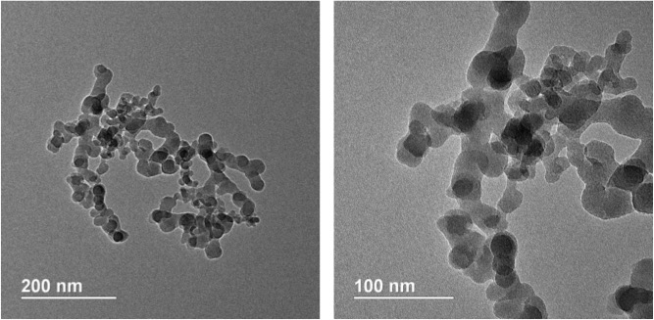

Figure S1. TEM images of raw H30 particles received from Wacker-Chemie

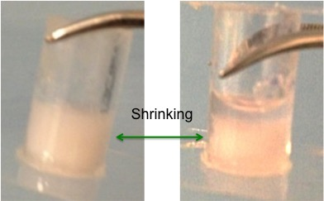

Figure S2. Macroscopic evolution of the bijel scaffold before (left) and after (right) loading with PS/xylene solution for 24 hours. The arrows point out that the bijel slightly shrinks but
rarely collapses.

Figure S3. Temperature dependence of the conductivity for the sample with 5.4 vol% particles and 0.1 M LiTFSI pre-mixed in EC. Thermal history includes (1) cooling; (2) heating and (3) re-cooling. The arrows show the changing direction of testing temperature. In the initial sections one and two, the EC in the composite is solid, suggesting ion conduction through the solid phase, and the activation energy is larger than in section three. Above 30 °C, EC(LiTFSI) is observed to melt, conductivity increases and the activation energy is smaller, indicating a different transport mechanism. Supercooling of liquid EC(LiTFSI) below the melting point is likely to cause the observed hysteresis in section 3. As indicated in the manuscript, total ionic conductivity values are likely to have been increased by ion exchange with silanol groups or the presence of residual moisture adsorbed on the silica particles.

