Supplemental Material

DNA Mismatch Repair Preferentially Protects Genes from Mutation
Eric J. Belfield^{a,e,f}, Zhong Jie Ding^{b,a,e}, Fiona J. C. Jamiesonª, Anne M. Visscher^{a,c}, Shao Jian Zheng^{b}, Aziz Mithani^{d,f}, and Nicholas P. Harberd^{a,f}
ªDepartment of Plant Sciences, University of Oxford, South Parks Road, Oxford OX1 3RB; ^{b}State Key Laboratory of Plant Physiology and Biochemistry, College of Life Sciences, Zhejiang University, Hangzhou, 310058 China; ^{c}Comparative Plant and Fungal Biology, Royal Botanic Gardens, Kew, Wakehurst Place, Ardingly, West Sussex RH17 6TN, UK; ^{d}Department of Biology, Syed Babar Ali School of Science and Engineering, Lahore University of Management Sciences (LUMS), DHA, Lahore 54792, Pakistan; ^{e}Contributed equally to this work; ^{f}Corresponding authors: eric.belfield@plants.ox.ac.uk, aziz.mithani@lums.edu.pk, nicholas.harberd@plants.ox.ac.uk

Table of Contents
1. Supplemental Methods 3
Creation of MMR-deficient mutation accumulation (MA) lines 3
Selection and whole genome sequence (WGS) analysis of MMR-deficient mutation accumulation (MA) lines 4
Bioinformatic and computational mutation-detection methods 5
Mutation rate calculation 7
Detection of larger-scale copy-number variants (CNVs) 8
Analysis of small-scale indel mutations in homopolymeric nucleotide repeat sequences 8
Use of Integrative Genomics Viewer (IGV) to confirm the bell-shaped distribution of indel frequencies with respect to length of homopolymeric regions 9
Detection of non-random spatial clustering of mutations in MMR-deficient MA lines 9
Custom computational scripts 10
2. References 12
3. Supplemental Figures 14
Supplemental Fig. 1. Chromosomal distribution of SNVs and indel mutations identified in MMR deficient Arabidopsis. 14
Supplemental Fig. 2. Supplemental data on A/T indel mutations found in eight Atmsh2-1 MA lines. 15
Supplemental Fig. 3. Supplemental data on C/G indel mutations in Atmsh2-1 MA lines. 17
Supplemental Fig. 4. Copy Number Variant (CNV) analyses of Atmsh2-1 MA line sample genomes. 19
Supplemental Fig. 5. T-DNA insertion structure in AtMSH2-1. 22
Supplemental Fig. 6. Phenotypic abnormalities of plants representative of Atmsh2-1 MA lines. 23
4. Supplemental Tables 24
Supplemental Table 1. Whole genome sequencing data summary table. 24
Supplemental Table 2. Clustered mutations identified in Atmsh2-1 mutant line WGS datasets. 25
Supplemental Table 3. Sequence distribution statistics of the TAIR10 A. thaliana reference genome. 30
Supplemental Table 4. List of representative G5 Atmsh2-1 MA line plants chosen for whole-genome sequencing. 31
Supplemental Table 5. Validation of mutations detected in eight independent G5 Atmsh2-1 MA line plants. 32

Supplemental Methods

Creation of MMR-deficient mutation accumulation (MA) lines
The propagation of mutation accumulation (MA) lines is expected to result in the progressive accumulation of mutations. In the case of a self-pollinating diploid flowering plant such as Arabidopsis thaliana, mutations will arise initially in one of the two homologous chromosomes of a cell lineage fated to form male and/or female gametes. Upon self-pollination, these mutations may be transferred to the progeny, resulting in next-generation plants either heterozygous or homozygous for the new mutation. In subsequent generations, a heterozygous new mutation may become homozygous (“fixed”) in the lineage as a result of self-pollination (due to fusion of mutant male and female gametes). Mutation accumulation is expected to be accelerated in MA lineages lacking MMR function.

To generate MMR-deficient A. thaliana lines, a Columbia-0 line (Salk_002708) carrying a loss-of-function mutant allele of the AtMSH2 gene was obtained from the European Arabidopsis Stock Centre (http://Arabidopsis.info). This mutant allele, previously designated Atmsh2-1 (Hoffman et al. 2004), contains a T-DNA insertion into AtMSH2 (At3G18524). This T-DNA insertion is associated with the deletion of exons 8–12 and of portions of exons 7 and 13 of AtMSH2, thus removing two essential domains (one for ATP-binding, the other a conserved helix-turn-helix domain; Alani et al. 1997; Leonard et al. 2003) from the encoded AtMSH2 protein.

We sequentially backcrossed Atmsh2-1 four times (generations F1-F4) to WT Columbia-0, thus removing from the genome mutations that may have accumulated during previous propagation, as well as other potential T-DNA insertions. Next, F4 Atmsh2-1 heterozygotes were self-pollinated, and a single F5 Atmsh2-1 mutant homozygote (termed Atmsh2-1 Ancestor) was identified for subsequent mutation accumulation (MA) studies. Seeds from this plant were then sown and 44 of the resultant plants used to establish independent MA lines. We collected and saved the seed from each of these plants and from there on used independent single seed descent (single seeds chosen randomly at each generation and planted to give rise to the next generation) to propagate the 44 MA lines over a further 4 generations (Fig. 1A).

As previously reported (Hoffman et al. 2004), we found that a high proportion (relative to AtMSH2 lines) of Atmsh2-1 MA lines became extinct during propagation. For example, MA lines 7, 16, 19 and 37 were lost during propagation of generations 2-5 (G2-5), presumably due to the occurrence in these lines of strongly deleterious mutations (Fig. 1A). Likewise, we observed that ~1/3rd of G5 Atmsh2-1 MA plants had morphological abnormalities not seen in AtMSH2 MA lines grown over 10 successive generations in the same environmental conditions (Jiang et al. 2014). As previously suggested (Hoffman et al. 2004), these phenotypic properties of Atmsh2-1 MA lines indicate that the genome-wide mutation frequency is elevated in plants deficient for MMR function.

Selection and whole genome sequence (WGS) analysis of MMR-deficient mutation accumulation (MA) lines
In order to determine the genome-wide frequency and molecular spectrum of mutations in MMR-deficient A. thaliana plants, we selected single plants (generation 5; G5) from eight different Atmsh2-1 MA lines for whole-genome sequence (WGS) analysis (Supplemental Table 1). Four of these lines (MA-4, MA-5, MA-9, and MA-13) displayed no obvious morphological abnormalities, and exhibited apparently normal fecundity (seed numbers) and seed germination rates. In contrast, the remaining four lines (MA-1, MA-8, MA-11, and MA-15) displayed particular line-specific phenotypic abnormalities (Supplemental Table 4; Supplemental Fig. 6A–D). For example, Atmsh2-1 MA-11 exhibited large vegetative rosettes and delayed flowering (which occurred ~23 days later than in the Atmsh2-1 Ancestor progenitor; Supplemental Table 4; Supplemental Fig. 6C). Subsequent WGS analysis revealed the mutations present in these eight lines, and in some cases revealed mutations that might be causal of the above abnormalities. For example, the late flowering phenotype of Atmsh2-1 MA-11 was likely conferred by a frameshifting 1bp deletion in the eleventh exon of GIGANTEA (Fowler et al. 1999), a key photoperiodic flowering gene regulator in A. thaliana.

Bioinformatic and computational mutation-detection methods
We used mutation-detection methods previously described in Belfield et al. 2012 and Jiang et al. 2014. In brief, sequencing data sets were initially aligned to the TAIR10 reference genome using Stampy (Lunter and Goodson 2011). Five subsequent iterative alignments of unmapped reads used IMR/DENOM (Gan et al. 2011). Only high-quality (phred score ≥20) and uniquely mapped reads were used for variant detection. The lists of variants (SNVs and indels) in each sample were generated by IMR/DENOM (Gan et al. 2011). Following mutation calling, we removed variants (versus TAIR10) that were either shared with the Atmsh2-1 Ancestor or were common between two or more Atmsh2-1 G5 plants. The variant lists were then further filtered to exclude putative false positives (Belfield et al. 2012), and checked manually several times by visually scanning the alignment files (BAM files) using Integrative Genomics Viewer (IGV) (Robinson et al. 2011).

Further, we performed traditional Sanger sequencing to confirm the presence of a sub-set of detected variants. We chose 10 random mutations from each of the eight individual Atmsh2-1 G5 MA plant lines (5 SNVs, 1 each of 2bp deletion, 1bp deletion, 1bp insertion, 2bp insertion, and 1 other indel of any size) to evaluate false positive mutation detection rates with respect to all detected indels. However, for the Atmsh2-1 G5 MA-8 line, no 2bp insertion was identified, and therefore 9 total mutations were chosen. Of the 79 sites selected for confirmation, 75 were successfully amplified by PCR. Sanger sequencing confirmed all of these 75 as containing the expected variant, indicating a negligible false positive detection rate (Supplemental Table 5).

We also re-checked our analyses using an alternative mutation detection methodology (GATK HaplotypeCaller v3.7-0, Van der Auwera et al. 2013), to determine if our bioinformatic pipeline had missed any large indels. HaplotyperCaller performs local de-novo assembly of traditionally difficult to call variant regions and completely reassembles the reads in that region for higher accuracy. HaplotyperCaller initially identified 1,979 putative ≥5bp indels in the eight G5 Atmsh2-1 MA line datasets. However, none of these mutations (when visualized with IGV (Robinson et al. 2011)) were homozygous and unique to a single G5 Atmsh2-1 MA line, suggesting a negligible overall false negative large indel detection rate in our observations.

In order to more stringently address the false negative rate we reanalysed a single Atmsh2-1 MA line dataset (MA-1) with the GATK HaplotypeCaller pipeline (Van der Auwera et al. 2013), looking at all SNV and indel mutations (in addition to the search for ≥5 bp indels described above). The IMR/DENOM pipeline (Gan et al. 2011) originally identified 1,425 unique mutations in line MA-1 (669 SNVs and 756 indels). We next carefully verified all mutations called by HaplotypeCaller with IGV (Robinson et al. 2011). There were no false negative indels (i.e., indels not called by IMR/DENOM but were called by HaplotypeCaller). However, we did find 14 SNV false negatives (i.e., SNVs not called by IMR/DENOM but called by HaplotypeCaller). Interestingly, almost all of these mutations were C-to-T mutations (13 sites), together with one A-to-C mutation site. These observations suggest that, in comparison to HaplotypeCaller, IMR/DENOM has an overall mutation false negative rate of <1%, and therefore confident that false negatives have a negligible effect on our conclusions.

Mutation rate calculation
We calculated the per-generation mutation rate as follows. First, we identified homozygous (not heterozygous) mutations that were unique to each one of the eight independently generated G5 Atmsh2-1 MA lines and that were not inherited from or present in the progenitor (ancestral, G0) line (e.g. as a heterozygous variant). Taking the total number of these mutations (summed across all eight lines), we then divided that total by the number of generations (five), and then again by the average number of TAIR10 reference genome sites that had aligned sequence data coverage of ≥3 and <100 in all MA lines (see Supplemental Table 1). This method, while not the same as that used by Hoffmann et al. (2004), provided a mutation rate that was directly comparable (because calculated in a similar way) with previously published rates e.g., for yeast (Serero et al. 2014) and for A. thaliana (Ossowski et al. 2010). In addition, since this same approach was used to estimate mutation rates in both WT and Atmsh2-1, an accurate estimate of the relative difference in mutation rates between these two genotypes was obtained.

Nevertheless, the above calculations may underestimate the actual absolute mutation rate, due to the limited number of generations involved in our experiments (see Hoffman et al. 2004; Ossowski et al. 2010). Interestingly, Hoffmann et al. (2004) predicted that an Arabidopsis Atmsh2-1 genome of 120Mb should have an average of 400 – 4,000 new SNV mutations after five generations. From our data we can now confirm (for the first time) that this previous prediction was relatively accurate (we find an average of ~500 SNV mutations per plant after five generations). Thus, we can confirm that the mutation rate we have calculated is close to that previously predicted.

Detection of larger-scale copy-number variants (CNVs)
We searched the Atmsh2-1 MA line genome sequence data for large-scale copy-number variants (CNVs) of minimum length 1,000bp, with a view to identifying unique regions of TAIR10 that were present in ≥ 2 copies in one or more G5 Atmsh2-1 MA line plants, but in a single copy in the Atmsh2-1 Ancestor plant. The BAM files generated for each sample were used to detect putative CNV regions, using our own scripts. Briefly, the five chromosomes of the Arabidopsis TAIR10 reference genome were first binned into consecutive 1,000bp windows. Next, the number of sequencing reads covering each bin was summed and divided by the average depth of coverage over the whole genome for each sample (Supplemental Table 1). We then scatter-plotted the log₂ coverage ratios of reads from Atmsh2-1 MA line samples and from met1/+ nrpd2a (a CNV positive-control dataset containing a mobilized transposon; Mirouze et al. 2009) and normalized these with respect to the number of Atmsh2-1 Ancestor reads in corresponding bins. All putative CNVs for which the log₂ coverage ratio score was greater than 0.75 were then checked manually for authenticity using IGV. However, the only verified CNV bins that we detected were for those covering the transposed transposon COPIA93 (At5G17125) on chromosome 5 in met1/+ nrpd2a (Mirouze et al. 2009; see Supplemental Fig. 4). No novel CNVs were detected in any of the eight G5 Atmsh2-1 MA line samples. Nevertheless, we cannot discount the possibilities that CNVs had occurred during propagation of some of the other Atmsh2-1 MA lines, or that CNVs were causal of the strongly deleterious or lethal phenotypes of the four lines that were lost (Fig. 1A).

Analysis of small-scale indel mutations in homopolymeric nucleotide repeat sequences
The frequency of single A/T or C/G indels in homopolymeric A/T or C/G respective repeat sequence regions was normalized with respect to the incidence of those homopolymeric repeat regions of length ≥4bp in the TAIR10 reference genome (calculated using an R script) (Supplemental Fig. 2A, B and Supplemental Fig. 3A, B, respectively).

Use of Integrative Genomics Viewer (IGV) to confirm the bell-shaped distribution of indel frequencies with respect to length of homopolymeric regions
To rule out the possibility that the bell-shaped distribution curves (indel frequencies with respect to homopolymeric region length; Fig. 2E, F) arose from deficiencies in our mutation detection methods, we used Integrative Genomics Viewer (IGV, Robinson et al. 2011). We first selected all of the >4,000 homopolymeric A or T repeat regions of 15–19 nucleotides length (the range of lengths with falling single base indel frequencies; Fig. 2E, F) in the A. thaliana genome. We then visually inspected each of these, confirming any previously detected indels, and searching for any (false negative) indels not previously detected by our bioinformatic mutation detection methods. No such false negatives were identified, indicating that the indel rate does indeed decline as the length of the homopolymer run increases beyond 15 nucleotides.

Detection of non-random spatial clustering of mutations in MMR-deficient MA lines
We searched for localized mutation clustering in the genomes of each individual Atmsh2-1 MA line, using an approach similar to that of Roberts et al. 2012. The median number of genome-wide mutations per haploid genome was 1,140 (data from Table 1A), roughly equivalent to 1 mutation per ~100kb of genome sequence. We identified groups of mutations for which each mutation was no greater than 10kb distant from the next (this distance chosen because it reflects a 10-fold higher mutation density than the expected random genome-wide density). We next calculated the likelihood of obtaining the observed mutation distribution if all mutations were independent and random (Roberts et al. 2012). Mutation groups with p-values <0.01 were regarded as a cluster. A total of 197 clusters were identified. Most clusters (168) contained just 2 mutations, with the largest, but most infrequent cluster-size containing 5 mutations (2 clusters; see Supplemental Table 2). The cluster having the largest genomic span (i.e., distance from the first to the last mutation) was a cluster of 4 mutations spanning 23.3kb. Interestingly, the two clusters containing 5 mutations were of widely differing genomic span, with one being 16.1kb (line MA-15; 2 SNVs and 3 indels) and the other being >1,300-fold smaller, covering 12bp in line MA-5 (and consisting of 5 SNVs; see Supplemental Table 2). In conclusion, we found evidence for infrequent genomic regional clustering of mutations.

Custom computational scripts
Custom Linux shell and R scripts used in this study are listed below (see Methods):
- Flanking sequence motif detection Linux shell script. script:
$ perl -lne 'while ($_ =~ /.(?=[[:alpha:]]{10}C[[:alpha:]]{10})/g) {print substr($_,@+[0],21)}' ColRef.fas > 10bp.flanking.C.txt
$ perl -lne 'while ($_ =~ /.(?=[[:alpha:]]{10}G[[:alpha:]]{10})/g) {print substr($_,@+[0],21)}' ColRef.fas > 10bp.flanking.G.txt
- Small-scale indel mutations in homopolymeric nucleotide repeat sequences R script:
inputFile <- "ColRef.fas"
con <- file(inputFile, open = "r")

Chr <- 1
while (length(oneLine <- readLines(con, n = 1, warn = FALSE)) > 0) {
# read the sequence
oneLine <- readLines(con, n = 1, warn = FALSE)

bases <- c("A","C","G","T")

for (b in 1:length(bases)) {
pos = gregexpr(paste(bases[b],"{4,}", sep=""), oneLine)
if (Chr == 1 && b == 1) {
data <- cbind(Chr, bases[b], as.vector(pos[[1]]), attr(pos[[1]], 'match.length'))
} else {
data <- rbind(data, cbind(Chr, bases[b], as.vector(pos[[1]]), attr(pos[[1]], 'match.length')))
}
}
Chr <- Chr + 1;
}

# add column names and write to the file
colnames(data) <- c("Chr", "Base", "Position", "Length")
write.table(data,"mononucleotide_stretches.txt", row.names=FALSE)

# generate summary
count <- table(strrep(data[,2], data[,4]))
count.data <- cbind(names(count),nchar(count),count)
colnames(count.data) <- c("Stretch", "Length", "Count")
write.table(count,"mononucleotide_stretches_table.txt", row.names=FALSE)

close(con)

References

Alani E, Sokolsky T, Studamire B, Miret JJ, Lahue RS. 1997. Genetic and biochemical analysis of Msh2p-Msh6p: role of ATP hydrolysis and Msh2p-Msh6p subunit interactions in mismatch base pair recognition. Mol Cell Biol 17: 2436-2447.
Belfield EJ, Gan X, Mithani A, Brown C, Jiang C, Franklin K, Alvey E, Wibowo A, Jung M, Bailey K et al. 2012. Genome-wide analysis of mutations in mutant lineages selected following fast-neutron irradiation mutagenesis of Arabidopsis thaliana. Genome Res 22: 1306-1315.
Fowler S, Lee K, Onouchi H, Samach A, Richardson K, Coupland G, Putterill J. 1999. GIGANTEA: a circadian clock-controlled gene that regulates photoperiodic flowering in Arabidopsis and encodes a protein with several possible membrane-spanning domains. EMBO J 18: 4679-4688.
Gan X, Stegle O, Behr J, Steffen JG, Drewe P, Hildebrand KL, Lyngsoe R, Schultheiss SJ, Osborne EJ, Sreedharan VT et al. 2011. Multiple reference genomes and transcriptomes for Arabidopsis thaliana. Nature 477: 419-423.
Hoffman PD, Leonard JM, Lindberg GE, Bollmann SR, Hays JB. 2004. Rapid accumulation of mutations during seed-to-seed propagation of mismatch-repair-defective Arabidopsis. Genes Dev 18: 2676-2685.
Jiang C, Mithani A, Belfield EJ, Mott R, Hurst LD, Harberd NP. 2014. Environmentally responsive genome-wide accumulation of de novo Arabidopsis thaliana mutations and epimutations. Genome Res 24: 1821-1829.
Leonard JM, Bollmann SR, Hays JB. 2003. Reduction of stability of Arabidopsis genomic and transgenic DNA-repeat sequences (microsatellites) by inactivation of AtMSH2 mismatch-repair function. Plant Physiol 133: 328-338.
Lunter G, Goodson M. 2011. Stampy: a statistical algorithm for sensitive and fast mapping of Illumina sequence reads. Genome Res 21: 936-939.
Mirouze M, Reinders J, Bucher E, Nishimura T, Schneeberger K, Ossowski S, Cao J, Weigel D, Paszkowski J, Mathieu O. 2009. Selective epigenetic control of retrotransposition in Arabidopsis. Nature 461: 427-430.
Ossowski S, Schneeberger K, Lucas-Lledo JI, Warthmann N, Clark RM, Shaw RG, Weigel D, Lynch M. 2010. The rate and molecular spectrum of spontaneous mutations in Arabidopsis thaliana. Science 327: 92-94.
Roberts SA, Sterling J, Thompson C, Harris S, Mav D, Shah R, Klimczak LJ, Kryukov GV, Malc E, Mieczkowski PA et al. 2012. Clustered mutations in yeast and in human cancers can arise from damaged long single-strand DNA regions. Mol Cell 46: 424-435.
Robinson JT, Thorvaldsdottir H, Winckler W, Guttman M, Lander ES, Getz G, Mesirov JP. 2011. Integrative genomics viewer. Nat Biotechnol 29: 24-26.
Serero A, Jubin C, Loeillet S, Legoix-Ne P, Nicolas AG. 2014. Mutational landscape of yeast mutator strains. Proc Natl Acad Sci 111: 1897-1902.
Van der Auwera GA, Carneiro MO, Hartl C, Poplin R, Del Angel G, Levy-Moonshine A, Jordan T, Shakir K, Roazen D, Thibault J et al. 2013. From FastQ data to high confidence variant calls: the Genome Analysis Toolkit best practices pipeline. Curr Protoc Bioinformatics 43: 11 10 11-33.

Supplemental Figures

Supplemental Fig. 1. Chromosomal distribution of SNVs and indel mutations identified in MMR deficient Arabidopsis.
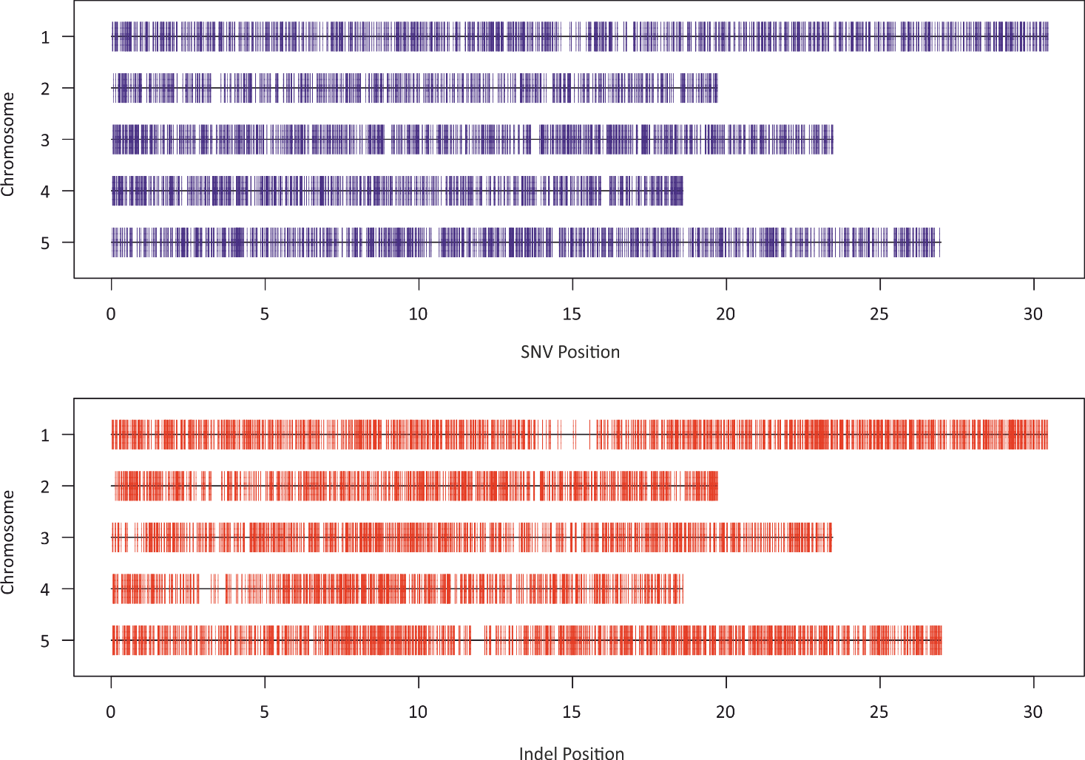
A
Mb
Mb

B

Supplemental Fig. 1. Chromosomal distribution of SNVs (A) and indel (B) mutations identified in MMR deficient Arabidopsis. Individual mutations identified in eight Atmsh2-1 MA lines are represented as single vertical colored lines (4,048 SNVs, blue and 4,663 indels, red) located on the five Arabidopsis chromosomes (represented as horizontal black lines and length in megabases are shown). Peri-centromeric regions of each chromosome are shown by rectangular black boxes.

Supplemental Fig. 2. Supplemental data on A/T indel mutations found in eight Atmsh2-1 MA lines.
A

B

C
D

E

Supplemental Fig. 2. Supplemental data on A/T indel mutations found in eight Atmsh2-1 MA lines. (A, B) Distribution of different lengths of A (in A) or T (in B) homopolymeric repeat regions in the A. thaliana genome. (C) Frequencies of AA or TT deletions in different lengths of homopolymeric A or T repeat regions respectively (values were normalized by the number of the different length categories of homopolymeric A or T repeat regions in the A. thaliana genome (in A and B)). (D, E) The average number of single-base A or T deletions (in D) and A or T insertions (in E) found in the eight Atmsh2-1 MA lines in different length categories of homopolymeric A or T repeat regions, respectively. Error bars (in C–E) indicate SEM from 8 biological repeats.

Supplemental Fig. 3. Supplemental data on C/G indel mutations in Atmsh2-1 MA lines.
A

B

C

D

Supplemental Fig. 3. Supplemental data on C/G indel mutations in Atmsh2-1 MA lines. (A, B) Distribution of different lengths of C (in A) or G (in B) homopolymeric repeat regions in the A. thaliana genome. (C, D) The average number of single-base C or G deletions (in C) and C or G insertions (in D) in different length categories of homopolymeric C or G repeat regions per plant. Error bars (in C, D) indicate SEM from 8 biological repeats.

Supplemental Fig. 4. Copy Number Variant (CNV) analyses of Atmsh2-1 MA line sample genomes.
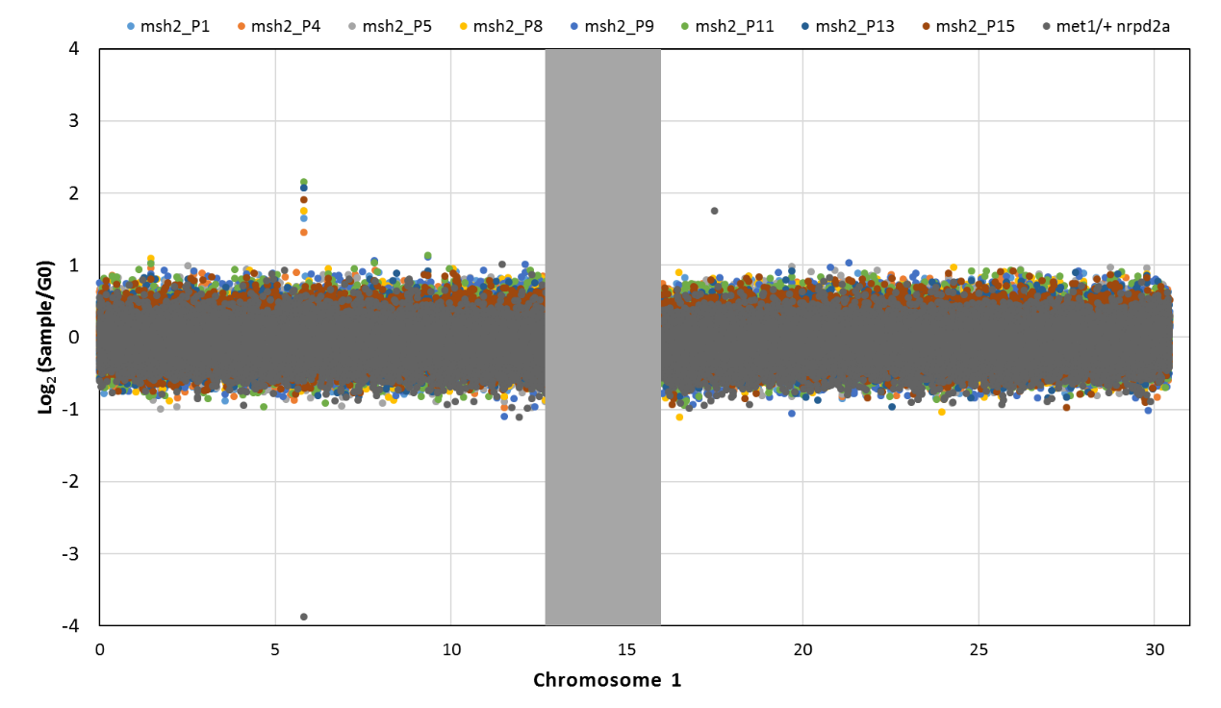
A

B
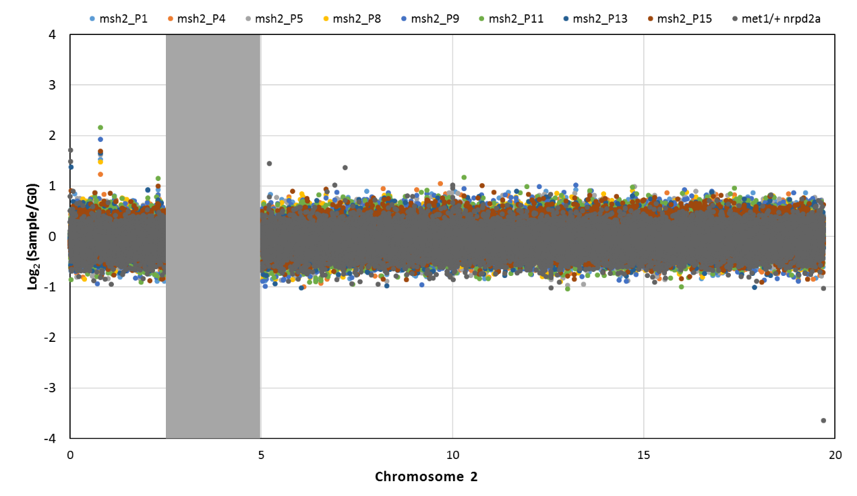

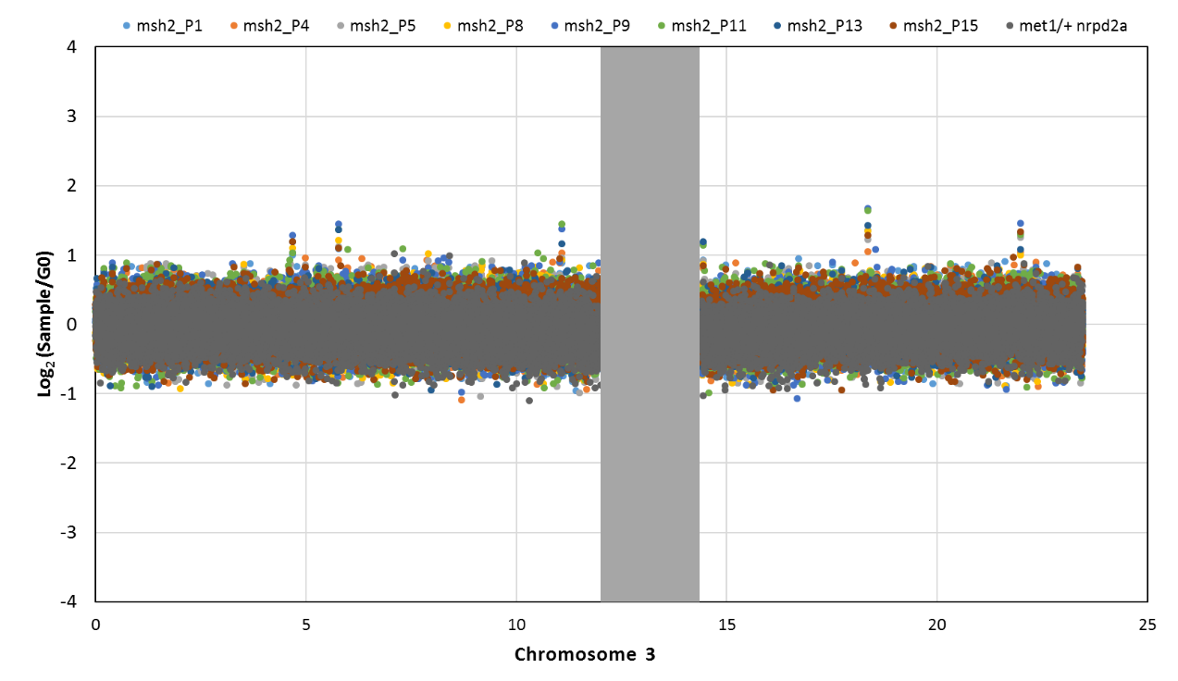
C

D
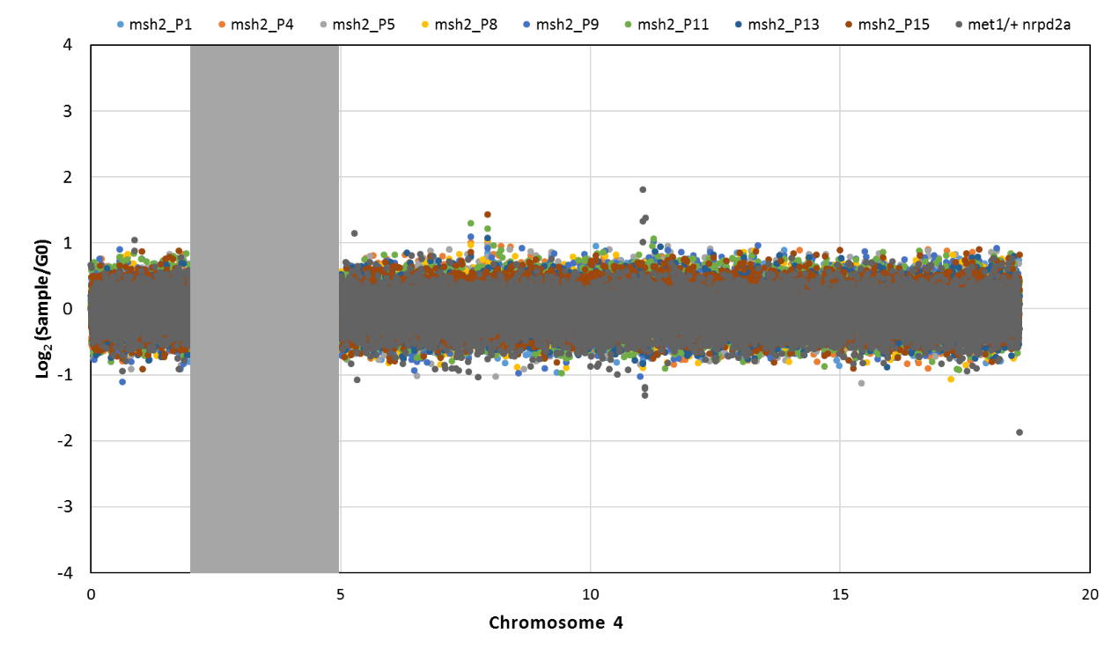

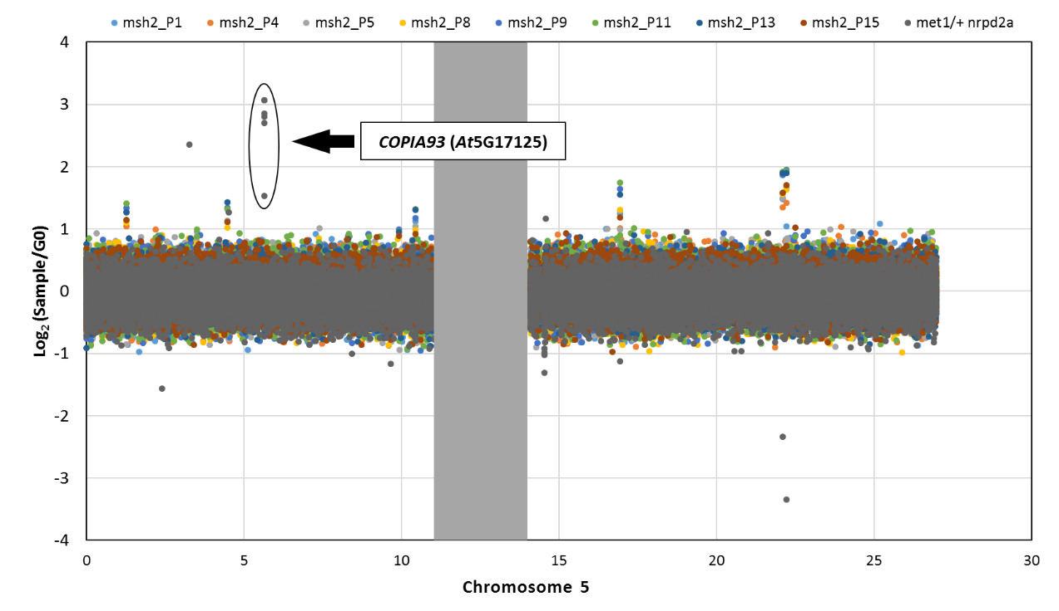
E

Supplemental Fig. 4. Copy Number Variant (CNV) analyses of Atmsh2-1 MA line sample genomes. Dot scatter-plots show log2 coverage ratio of reads from G5 Atmsh2-1 MA line samples and a positive control dataset (met1/+ nrpd2a; Mirouze et al. 2009), versus G0 Atmsh2-1 Ancestor reads, presented on a chromosome by chromosome basis. The grey dots cluster around 0 and predominate because the met1/+ nrpd2a data that they represent were entered last. Dots represent consecutive 1,000 bp windows from across the TAIR10 A. thaliana reference genome. The circled and arrowed dots on Chromosome 5 represent the CNV transposition of AtCOPIA93 (Mirouze et al. 2009). CNVs would be expected to result in a log₂ score value of 1 or higher. Whilst all additional dots with values >0.75 were manually checked in IGV (see Methods), none were verified, indicating that MMR deficiency does not increase the frequency of larger-scale insertion/deletion events during genome replication.

Supplemental Fig. 5. T-DNA insertion structure in AtMSH2-1.
A

TGA
ATG
AtMSH2 4,259bp

Atmsh2-1

T-DNA
Salk_LB
MSH2_For
MSH2_Rev

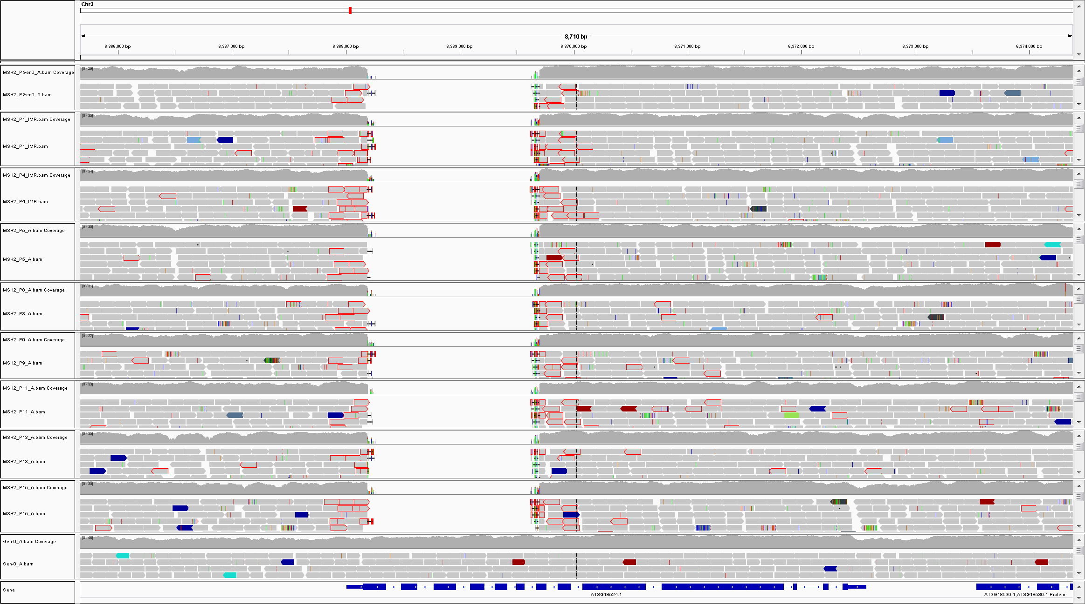
B
msh2_P1
msh2_P4

msh2_P5

msh2_P8

msh2_P9

msh2_P11

msh2_P13

msh2_P15

msh2_Anc.ol
WT
E71
Reference
AtMSH2 (At3G18524)
5’
3’

Supplemental Fig. 5. T-DNA insertion structure in AtMSH2-1. (A) Diagram shows the position within AtMSH2 of the T-DNA insertion in the Atmsh2-1 mutant allele. Green boxes represent exons, blue lines introns, dashed black lines intergenic sequences, and start (ATG) and stop (TGA) codons are shown. The T-DNA is inserted between the 7th and 13th exons of AtMSH2 and is associated with deletions of portions of these exons, together with complete deletion of exons 8–12 (Leonard et al. 2003). The oligonucleotides used to follow the inheritance of the Atmsh2-1 allele are also shown. The forward (MSH2_For) and reverse (MSH2_Rev) oligonucleotides are shown with black arrows. The left border (Salk_LB) T-DNA insertion specific oligonucleotide is shown with a red arrow. The AtMSH2 gene has the locus ID At3G18524. (B) Integrated Genome Viewer (IGV) screenshot of WGS data from the eight G5 Atmsh2-1 MA line samples (msh2_P1, P4, P5, P8, P9, P11, P13, and P15) aligned to the TAIR10 reference genome sequence shown along with the ancestral Atmsh2-1 line (msh2_Anc.) and A. thaliana Col-0 AtMSH2 wild type (WT) line sequencing reads. The 1,510 bp region deleted from AtMSH2 (At3G18524) in Atmsh2-1 shown in (A) can be seen in all Atmsh2-1 genotypes shown in (B) (indicated with green arrows) but is not deleted from AtMSH2 wild type line (WT). Bases that match the reference genome are shown in grey.

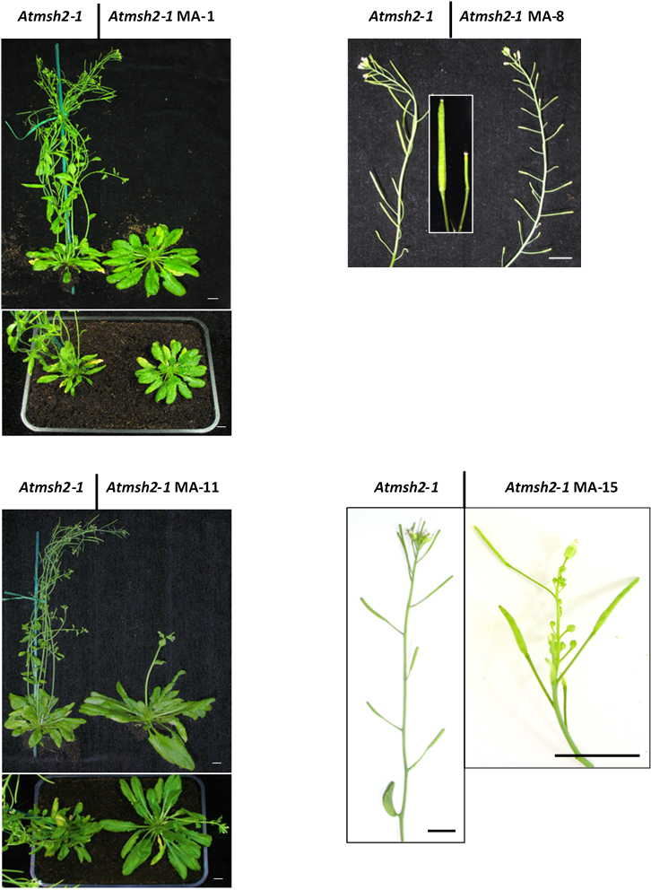
Supplemental Fig. 6. Phenotypic abnormalities of plants representative of Atmsh2-1 MA lines.
A B

C D

Supplemental Fig. 6. Phenotypic abnormalities of plants representative of Atmsh2-1 MA lines. (A) MA-1; large vegetative rosette, increased rosette and cauline leaf number, late flowering, female-sterile. (B) MA-8; male-sterile. (C) MA-11; late flowering, very large vegetative rosette, increased vegetative rosette leaf number. (D) MA-15; abnormal flower development, variable pod-set. All (A-D) shown next to Atmsh2-1 progenitor plants of the same age and grown in the same environmental conditions. Scale bars: 1 cm.

Supplemental Tables

Supplemental Table 1. Whole genome sequencing data summary table.

Line | Illumina paired-end read length (bp) | Raw sequencing data |  |  | Aligned sequencing data
Line | Illumina paired-end read length (bp) | Number of reads | Total number of bases sequenced | Genome fold coverage* | Number of Reads | Total number of bases sequenced | Genome fold coverage* | Total number of sites covered (million)
Atmsh2-1 Ancestor | 125 | 26,538,136 | 3,317,267,000 | 27.8 | 23,603,682 | 2,950,460,250 | 24.8 | 117.6
MA-1 | 125 | 26,497,870 | 3,312,233,750 | 27.8 | 24,777,660 | 3,097,207,500 | 26.0 | 118.1
MA-4 | 125 | 26,434,502 | 3,304,312,750 | 27.7 | 25,076,459 | 3,134,557,375 | 26.3 | 118.7
MA-5 | 125 | 26,480,242 | 3,310,030,250 | 27.8 | 22,945,022 | 2,868,127,750 | 24.1 | 118.5
MA-8 | 125 | 26,385,482 | 3,298,185,250 | 27.7 | 23,795,383 | 2,974,422,875 | 25.0 | 118.4
MA-9 | 125 | 26,491,272 | 3,311,409,000 | 27.8 | 24,262,599 | 3,032,824,875 | 25.5 | 118.2
MA-11 | 125 | 26,515,654 | 3,314,456,750 | 27.8 | 23,550,601 | 2,943,825,125 | 24.7 | 118.4
MA-13 | 125 | 26,429,536 | 3,303,692,000 | 27.7 | 23,448,525 | 2,931,065,625 | 24.6 | 118.3
MA-15 | 125 | 26,370,032 | 3,296,254,000 | 27.7 | 22,236,124 | 2,779,515,500 | 23.3 | 118.4

Supplemental Table 1. Whole genome sequencing data summary table. Genomic DNA from the Atmsh2-1 Ancestor and from eight independent G5 Atmsh2-1 MA line plants (MA-1, MA-4, MA-5, MA-8, MA-9, MA-11, MA-13, and MA-15) was sequenced using 125bp paired-end Illumina sequencing technology. For each sample, >26 million raw sequencing data reads (>3 gigabases of data) were aligned to the TAIR 10 A. thaliana reference genome, resulting in a 23.3–26.0-fold sequencing coverage depth (aligned data) for each genome. The total number of TAIR10 sites having aligned sequence data coverage ≥3 and <100 is shown. *The TAIR10 genome size of 119,146,348 bp was used to determine genome fold coverage.

Supplemental Table 2. Clustered mutations identified in Atmsh2-1 mutant line WGS datasets.
MA line | Chromosome | Start position | End position | Cluster size (bp) | Mutation count | SNV count | INDEL count | P-value*
MA-5 | 5 | 21,481,538 | 21,481,549 | 12 | 5 | 5 | 0 | 3.12E-03
MA-15 | 4 | 935,477 | 951,608 | 16,132 | 5 | 2 | 3 | 3.34E-03
MA-5 | 2 | 10,578,907 | 10,602,229 | 23,323 | 4 | 2 | 2 | 8.83E-04
MA-1 | 1 | 13,108,282 | 13,120,569 | 12,288 | 4 | 0 | 4 | 1.05E-03
MA-4 | 1 | 2,574,434 | 2,587,430 | 12,997 | 4 | 2 | 2 | 7.84E-03
MA-5 | 1 | 6,071,857 | 6,083,344 | 11,488 | 3 | 3 | 0 | 2.21E-04
MA-1 | 2 | 10,119,507 | 10,137,134 | 17,628 | 3 | 1 | 2 | 2.21E-04
MA-1 | 5 | 22,992,591 | 23,002,167 | 9,577 | 3 | 0 | 3 | 3.40E-04
MA-9 | 3 | 216,303 | 227,897 | 11,595 | 3 | 0 | 3 | 5.67E-04
MA-5 | 3 | 747,387 | 763,416 | 16,030 | 3 | 3 | 0 | 7.45E-04
MA-1 | 2 | 5,836,488 | 5,840,192 | 3,705 | 3 | 2 | 1 | 1.31E-03
MA-15 | 1 | 12,559,801 | 12,570,754 | 10,954 | 3 | 2 | 1 | 1.51E-03
MA-4 | 5 | 13,959,577 | 13,970,339 | 10,763 | 3 | 1 | 2 | 2.06E-03
MA-4 | 3 | 12,837,719 | 12,844,384 | 6,666 | 3 | 3 | 0 | 2.21E-03
MA-1 | 5 | 18,889,233 | 18,901,784 | 12,552 | 3 | 3 | 0 | 2.38E-03
MA-4 | 1 | 30,036,519 | 30,054,977 | 18,459 | 3 | 1 | 2 | 2.89E-03
MA-11 | 2 | 445,313 | 451,023 | 5,711 | 3 | 2 | 1 | 3.66E-03
MA-11 | 1 | 20,220,099 | 20,233,777 | 13,679 | 3 | 1 | 2 | 3.68E-03
MA-4 | 3 | 1,301,585 | 1,313,020 | 11,436 | 3 | 2 | 1 | 4.63E-03
MA-1 | 3 | 4,607,322 | 4,617,677 | 10,356 | 3 | 1 | 2 | 4.90E-03
MA-11 | 1 | 4,130,164 | 4,143,998 | 13,835 | 3 | 1 | 2 | 5.17E-03
MA-4 | 5 | 11,267,605 | 11,281,601 | 13,997 | 3 | 1 | 2 | 5.54E-03
MA-4 | 2 | 16,293,807 | 16,308,657 | 14,851 | 3 | 1 | 2 | 6.00E-03
MA-4 | 2 | 6,872,531 | 6,884,741 | 12,211 | 3 | 2 | 1 | 6.28E-03
MA-11 | 5 | 6,102,972 | 6,122,577 | 19,606 | 3 | 2 | 1 | 6.38E-03
MA-11 | 1 | 9,933,768 | 9,939,958 | 6,191 | 3 | 1 | 2 | 6.66E-03
MA-4 | 1 | 26,574,519 | 26,584,807 | 10,289 | 3 | 1 | 2 | 8.28E-03
MA-5 | 4 | 11,957,623 | 11,968,453 | 10,831 | 3 | 1 | 2 | 9.36E-03
MA-4 | 5 | 19,753,943 | 19,754,577 | 635 | 3 | 2 | 1 | 9.38E-03
MA-5 | 3 | 3,744,647 | 3,749,099 | 4,453 | 2 | 0 | 2 | 2.36E-18
MA-1 | 4 | 14,725,274 | 14,726,473 | 1,200 | 2 | 0 | 2 | 4.18E-13
MA-1 | 2 | 1,743,383 | 1,750,992 | 7,610 | 2 | 1 | 1 | 1.35E-11
MA-13 | 5 | 11,537,709 | 11,542,640 | 4,932 | 2 | 1 | 1 | 1.78E-08
MA-4 | 1 | 3,763,383 | 3,771,658 | 8,276 | 2 | 0 | 2 | 1.36E-06
MA-4 | 2 | 2,015,986 | 2,017,790 | 1,805 | 2 | 0 | 2 | 8.52E-06
MA-1 | 4 | 8,524,849 | 8,531,349 | 6,501 | 2 | 1 | 1 | 1.69E-05
MA-8 | 1 | 7,460,704 | 7,461,088 | 385 | 2 | 0 | 2 | 1.79E-05
MA-8 | 3 | 5,929,924 | 5,932,588 | 2,665 | 2 | 1 | 1 | 5.26E-05
MA-4 | 5 | 13,767,865 | 13,774,906 | 7,042 | 2 | 0 | 2 | 9.20E-05
MA-1 | 2 | 4,362,582 | 4,367,262 | 4,681 | 2 | 1 | 1 | 9.21E-05
MA-8 | 1 | 20,245,993 | 20,246,709 | 717 | 2 | 0 | 2 | 1.29E-04
MA-1 | 4 | 5,149,323 | 5,155,995 | 6,673 | 2 | 0 | 2 | 1.59E-04
MA-13 | 5 | 1,021,091 | 1,029,674 | 8,584 | 2 | 1 | 1 | 2.51E-04
MA-1 | 3 | 14,445,116 | 14,453,089 | 7,974 | 2 | 1 | 1 | 2.60E-04
MA-15 | 3 | 3,168,009 | 3,170,759 | 2,751 | 2 | 0 | 2 | 2.83E-04
MA-4 | 2 | 1,258,904 | 1,264,193 | 5,290 | 2 | 0 | 2 | 3.31E-04
MA-5 | 5 | 10,357,838 | 10,367,402 | 9,565 | 2 | 2 | 0 | 3.67E-04
MA-5 | 2 | 15,467,043 | 15,475,621 | 8,579 | 2 | 1 | 1 | 3.91E-04
MA-15 | 1 | 26,055,612 | 26,060,115 | 4,504 | 2 | 0 | 2 | 4.05E-04
MA-1 | 3 | 4,492,372 | 4,501,236 | 8,865 | 2 | 0 | 2 | 4.11E-04
MA-15 | 1 | 21,225,885 | 21,229,400 | 3,516 | 2 | 1 | 1 | 4.23E-04
MA-1 | 2 | 2,554,303 | 2,560,195 | 5,893 | 2 | 0 | 2 | 4.32E-04
MA-4 | 1 | 21,405,731 | 21,409,927 | 4,197 | 2 | 2 | 0 | 4.32E-04
MA-5 | 4 | 5,103,927 | 5,113,823 | 9,897 | 2 | 1 | 1 | 4.33E-04
MA-11 | 1 | 21,387,647 | 21,387,940 | 294 | 2 | 1 | 1 | 4.35E-04
MA-5 | 5 | 20,905,476 | 20,914,456 | 8,981 | 2 | 0 | 2 | 4.87E-04
MA-1 | 5 | 5,409,304 | 5,418,700 | 9,397 | 2 | 0 | 2 | 5.15E-04
MA-5 | 1 | 25,427,945 | 25,437,097 | 9,153 | 2 | 0 | 2 | 7.02E-04
MA-1 | 4 | 18,126,681 | 18,129,284 | 2,604 | 2 | 0 | 2 | 7.08E-04
MA-8 | 2 | 12,463,326 | 12,469,482 | 6,157 | 2 | 0 | 2 | 8.83E-04
MA-4 | 1 | 17,286,082 | 17,294,539 | 8,458 | 2 | 0 | 2 | 8.89E-04
MA-11 | 1 | 3,485,152 | 3,493,141 | 7,990 | 2 | 2 | 0 | 9.06E-04
MA-9 | 3 | 2,534,353 | 2,538,738 | 4,386 | 2 | 1 | 1 | 1.05E-03
MA-8 | 2 | 4,833,918 | 4,842,994 | 9,077 | 2 | 1 | 1 | 1.07E-03
MA-1 | 3 | 6,636,785 | 6,638,349 | 1,565 | 2 | 1 | 1 | 1.11E-03
MA-5 | 3 | 6,766,623 | 6,775,942 | 9,320 | 2 | 2 | 0 | 1.14E-03
MA-9 | 1 | 9,898,142 | 9,902,385 | 4,244 | 2 | 2 | 0 | 1.14E-03
MA-11 | 1 | 28,928,571 | 28,928,756 | 186 | 2 | 1 | 1 | 1.18E-03
MA-5 | 3 | 6,666,132 | 6,672,488 | 6,357 | 2 | 2 | 0 | 1.21E-03
MA-5 | 2 | 15,704,598 | 15,708,594 | 3,997 | 2 | 1 | 1 | 1.24E-03
MA-15 | 3 | 120,314 | 128,403 | 8,090 | 2 | 1 | 1 | 1.27E-03
MA-15 | 4 | 6,687,450 | 6,691,900 | 4,451 | 2 | 0 | 2 | 1.30E-03
MA-5 | 4 | 416,462 | 418,117 | 1,656 | 2 | 2 | 0 | 1.33E-03
MA-5 | 5 | 4,167,883 | 4,173,896 | 6,014 | 2 | 2 | 0 | 1.37E-03
MA-5 | 5 | 9,888,728 | 9,894,613 | 5,886 | 2 | 0 | 2 | 1.40E-03
MA-1 | 5 | 20,894,535 | 20,900,797 | 6,263 | 2 | 0 | 2 | 1.49E-03
MA-1 | 2 | 17,191,059 | 17,192,855 | 1,797 | 2 | 1 | 1 | 1.56E-03
MA-9 | 5 | 9,343,760 | 9,346,838 | 3,079 | 2 | 1 | 1 | 1.58E-03
MA-9 | 5 | 1,891,807 | 1,897,785 | 5,979 | 2 | 1 | 1 | 1.58E-03
MA-8 | 4 | 9,077,842 | 9,084,720 | 6,879 | 2 | 1 | 1 | 1.60E-03
MA-4 | 1 | 26,725,684 | 26,727,344 | 1,661 | 2 | 0 | 2 | 1.70E-03
MA-8 | 3 | 16,082,847 | 16,087,691 | 4,845 | 2 | 1 | 1 | 1.71E-03
MA-11 | 3 | 8,109,723 | 8,116,828 | 7,106 | 2 | 1 | 1 | 1.80E-03
MA-13 | 2 | 19,171,374 | 19,173,334 | 1,961 | 2 | 1 | 1 | 1.96E-03
MA-11 | 5 | 19,444,178 | 19,449,972 | 5,795 | 2 | 1 | 1 | 1.96E-03
MA-5 | 1 | 2,237,121 | 2,241,130 | 4,010 | 2 | 0 | 2 | 2.01E-03
MA-9 | 1 | 28,689,336 | 28,694,869 | 5,534 | 2 | 1 | 1 | 2.09E-03
MA-5 | 1 | 20,045,984 | 20,052,897 | 6,914 | 2 | 0 | 2 | 2.12E-03
MA-5 | 4 | 12,461,924 | 12,465,492 | 3,569 | 2 | 1 | 1 | 2.17E-03
MA-8 | 5 | 1,990,898 | 1,995,840 | 4,943 | 2 | 0 | 2 | 2.18E-03
MA-15 | 3 | 8,687,921 | 8,692,005 | 4,085 | 2 | 1 | 1 | 2.19E-03
MA-9 | 5 | 8,981,088 | 8,983,099 | 2,012 | 2 | 1 | 1 | 2.24E-03
MA-9 | 4 | 2,779,955 | 2,785,968 | 6,014 | 2 | 1 | 1 | 2.25E-03
MA-1 | 1 | 9,697,507 | 9,704,253 | 6,747 | 2 | 0 | 2 | 2.27E-03
MA-8 | 2 | 19,498,174 | 19,498,316 | 143 | 2 | 0 | 2 | 2.32E-03
MA-1 | 5 | 11,366,268 | 11,372,778 | 6,511 | 2 | 2 | 0 | 2.41E-03
MA-8 | 5 | 18,274,847 | 18,279,949 | 5,103 | 2 | 0 | 2 | 2.42E-03
MA-15 | 4 | 5,265,385 | 5,267,721 | 2,337 | 2 | 0 | 2 | 2.43E-03
MA-4 | 2 | 6,781,989 | 6,785,410 | 3,422 | 2 | 1 | 1 | 2.43E-03
MA-4 | 1 | 28,359,438 | 28,366,852 | 7,415 | 2 | 0 | 2 | 2.45E-03
MA-11 | 3 | 6,861,002 | 6,862,409 | 1,408 | 2 | 2 | 0 | 2.48E-03
MA-4 | 3 | 16,219,664 | 16,219,674 | 11 | 2 | 2 | 0 | 2.62E-03
MA-8 | 5 | 14,152,671 | 14,154,042 | 1,372 | 2 | 1 | 1 | 2.64E-03
MA-8 | 1 | 12,736,205 | 12,743,468 | 7,264 | 2 | 0 | 2 | 2.64E-03
MA-15 | 5 | 19,233,475 | 19,235,185 | 1,711 | 2 | 1 | 1 | 2.69E-03
MA-9 | 3 | 22,464,094 | 22,471,833 | 7,740 | 2 | 1 | 1 | 2.70E-03
MA-4 | 1 | 28,437,858 | 28,446,836 | 8,979 | 2 | 0 | 2 | 2.96E-03
MA-1 | 5 | 21,357,574 | 21,363,228 | 5,655 | 2 | 1 | 1 | 3.13E-03
MA-1 | 3 | 17,707,856 | 17,712,947 | 5,092 | 2 | 0 | 2 | 3.26E-03
MA-15 | 2 | 418,878 | 427,805 | 8,928 | 2 | 2 | 0 | 3.31E-03
MA-8 | 5 | 1,486,399 | 1,488,156 | 1,758 | 2 | 0 | 2 | 3.34E-03
MA-5 | 5 | 7,902,644 | 7,906,925 | 4,282 | 2 | 2 | 0 | 3.53E-03
MA-1 | 5 | 17,028,702 | 17,036,626 | 7,925 | 2 | 1 | 1 | 3.60E-03
MA-1 | 3 | 3,741,700 | 3,750,513 | 8,814 | 2 | 1 | 1 | 3.66E-03
MA-11 | 4 | 18,284,109 | 18,285,304 | 1,196 | 2 | 1 | 1 | 3.76E-03
MA-8 | 1 | 7,702,170 | 7,706,592 | 4,423 | 2 | 0 | 2 | 3.80E-03
MA-5 | 4 | 741,092 | 749,926 | 8,835 | 2 | 1 | 1 | 3.84E-03
MA-1 | 5 | 8,168,592 | 8,175,825 | 7,234 | 2 | 0 | 2 | 3.85E-03
MA-11 | 2 | 7,412,911 | 7,422,128 | 9,218 | 2 | 1 | 1 | 3.90E-03
MA-15 | 5 | 22,588,624 | 22,595,529 | 6,906 | 2 | 2 | 0 | 3.95E-03
MA-1 | 2 | 13,968,659 | 13,971,537 | 2,879 | 2 | 0 | 2 | 4.07E-03
MA-5 | 1 | 2,366,675 | 2,374,440 | 7,766 | 2 | 1 | 1 | 4.20E-03
MA-1 | 4 | 14,343,449 | 14,352,062 | 8,614 | 2 | 1 | 1 | 4.25E-03
MA-8 | 1 | 29,264,210 | 29,274,010 | 9,801 | 2 | 1 | 1 | 4.26E-03
MA-1 | 3 | 4,439,214 | 4,444,730 | 5,517 | 2 | 2 | 0 | 4.27E-03
MA-4 | 2 | 5,553,913 | 5,563,782 | 9,870 | 2 | 1 | 1 | 4.42E-03
MA-15 | 1 | 23,075,429 | 23,076,015 | 587 | 2 | 1 | 1 | 4.54E-03
MA-9 | 5 | 7,977,665 | 7,984,283 | 6,619 | 2 | 2 | 0 | 4.59E-03
MA-8 | 1 | 30,333,410 | 30,336,593 | 3,184 | 2 | 0 | 2 | 4.60E-03
MA-4 | 5 | 10,152,388 | 10,152,628 | 241 | 2 | 0 | 2 | 4.61E-03
MA-8 | 4 | 8,400,526 | 8,405,533 | 5,008 | 2 | 1 | 1 | 4.64E-03
MA-5 | 1 | 18,907,613 | 18,913,900 | 6,288 | 2 | 0 | 2 | 4.71E-03
MA-1 | 2 | 807,933 | 808,789 | 857 | 2 | 1 | 1 | 4.75E-03
MA-11 | 1 | 22,888,260 | 22,894,716 | 6,457 | 2 | 0 | 2 | 4.86E-03
MA-9 | 3 | 17,838,543 | 17,840,416 | 1,874 | 2 | 0 | 2 | 4.98E-03
MA-5 | 3 | 1,199,086 | 1,200,293 | 1,208 | 2 | 0 | 2 | 5.12E-03
MA-1 | 4 | 3,855,331 | 3,862,649 | 7,319 | 2 | 1 | 1 | 5.16E-03
MA-11 | 4 | 333,204 | 335,385 | 2,182 | 2 | 1 | 1 | 5.19E-03
MA-1 | 3 | 21,368,348 | 21,377,145 | 8,798 | 2 | 0 | 2 | 5.20E-03
MA-8 | 4 | 8,852,272 | 8,858,524 | 6,253 | 2 | 0 | 2 | 5.20E-03
MA-1 | 1 | 1,879,895 | 1,889,296 | 9,402 | 2 | 1 | 1 | 5.24E-03
MA-1 | 4 | 3,808,990 | 3,811,552 | 2,563 | 2 | 1 | 1 | 5.30E-03
MA-4 | 1 | 26,156,815 | 26,157,585 | 771 | 2 | 1 | 1 | 5.38E-03
MA-13 | 1 | 27,999,787 | 28,005,557 | 5,771 | 2 | 1 | 1 | 5.51E-03
MA-5 | 4 | 6,751,923 | 6,755,930 | 4,008 | 2 | 1 | 1 | 5.52E-03
MA-9 | 1 | 2,969,705 | 2,970,148 | 444 | 2 | 1 | 1 | 5.68E-03
MA-5 | 3 | 2,537,774 | 2,543,318 | 5,545 | 2 | 2 | 0 | 5.71E-03
MA-11 | 1 | 22,476,461 | 22,482,213 | 5,753 | 2 | 2 | 0 | 5.80E-03
MA-8 | 3 | 2,411,654 | 2,419,240 | 7,587 | 2 | 1 | 1 | 5.85E-03
MA-15 | 4 | 4,147,914 | 4,157,896 | 9,983 | 2 | 2 | 0 | 5.90E-03
MA-8 | 4 | 16,908,397 | 16,915,030 | 6,634 | 2 | 0 | 2 | 5.96E-03
MA-8 | 4 | 17,309,943 | 17,319,661 | 9,719 | 2 | 1 | 1 | 6.04E-03
MA-4 | 4 | 1,654,808 | 1,661,978 | 7,171 | 2 | 2 | 0 | 6.15E-03
MA-11 | 3 | 11,177,492 | 11,186,356 | 8,865 | 2 | 2 | 0 | 6.17E-03
MA-5 | 3 | 18,063,318 | 18,065,309 | 1,992 | 2 | 1 | 1 | 6.19E-03
MA-4 | 4 | 18,523,973 | 18,527,860 | 3,888 | 2 | 2 | 0 | 6.40E-03
MA-4 | 1 | 27,876,332 | 27,879,768 | 3,437 | 2 | 0 | 2 | 6.45E-03
MA-11 | 3 | 1,789,926 | 1,794,395 | 4,470 | 2 | 1 | 1 | 6.56E-03
MA-4 | 1 | 1,482,987 | 1,487,030 | 4,044 | 2 | 1 | 1 | 6.56E-03
MA-15 | 5 | 19,508,186 | 19,515,169 | 6,984 | 2 | 1 | 1 | 6.57E-03
MA-5 | 4 | 2,170,961 | 2,179,957 | 8,997 | 2 | 2 | 0 | 6.68E-03
MA-11 | 5 | 13,430,907 | 13,439,480 | 8,574 | 2 | 1 | 1 | 6.70E-03
MA-4 | 1 | 28,421,059 | 28,421,353 | 295 | 2 | 0 | 2 | 6.80E-03
MA-13 | 4 | 4,598,731 | 4,605,417 | 6,687 | 2 | 0 | 2 | 6.89E-03
MA-1 | 2 | 1,669,966 | 1,673,677 | 3,712 | 2 | 2 | 0 | 6.99E-03
MA-15 | 5 | 13,506,866 | 13,510,696 | 3,831 | 2 | 2 | 0 | 7.01E-03
MA-9 | 5 | 14,629,310 | 14,637,084 | 7,775 | 2 | 0 | 2 | 7.06E-03
MA-11 | 2 | 18,985,876 | 18,993,415 | 7,540 | 2 | 1 | 1 | 7.07E-03
MA-15 | 5 | 2,753,219 | 2,754,841 | 1,623 | 2 | 2 | 0 | 7.19E-03
MA-13 | 4 | 70,482 | 77,289 | 6,808 | 2 | 2 | 0 | 7.22E-03
MA-9 | 5 | 25,008,367 | 25,011,413 | 3,047 | 2 | 0 | 2 | 7.28E-03
MA-8 | 4 | 7,641,474 | 7,643,202 | 1,729 | 2 | 0 | 2 | 7.28E-03
MA-13 | 4 | 2,774,372 | 2,776,314 | 1,943 | 2 | 1 | 1 | 7.44E-03
MA-1 | 5 | 5,628,129 | 5,636,603 | 8,475 | 2 | 0 | 2 | 7.51E-03
MA-5 | 1 | 1,409,734 | 1,417,231 | 7,498 | 2 | 2 | 0 | 7.51E-03
MA-11 | 5 | 9,086,319 | 9,092,953 | 6,635 | 2 | 1 | 1 | 7.61E-03
MA-8 | 2 | 915,981 | 923,209 | 7,229 | 2 | 0 | 2 | 7.76E-03
MA-1 | 3 | 22,415,513 | 22,419,614 | 4,102 | 2 | 0 | 2 | 7.79E-03
MA-4 | 3 | 94,417 | 101,205 | 6,789 | 2 | 1 | 1 | 8.09E-03
MA-5 | 3 | 8,725,255 | 8,732,730 | 7,476 | 2 | 1 | 1 | 8.21E-03
MA-4 | 2 | 19,078,046 | 19,084,203 | 6,158 | 2 | 1 | 1 | 8.32E-03
MA-1 | 3 | 8,752,248 | 8,752,907 | 660 | 2 | 1 | 1 | 8.37E-03
MA-15 | 2 | 7,529,919 | 7,537,308 | 7,390 | 2 | 0 | 2 | 8.52E-03
MA-9 | 3 | 12,555,813 | 12,563,198 | 7,386 | 2 | 1 | 1 | 8.67E-03
MA-5 | 1 | 3,309,712 | 3,310,849 | 1,138 | 2 | 1 | 1 | 8.70E-03
MA-11 | 5 | 2,070,871 | 2,071,821 | 951 | 2 | 1 | 1 | 8.83E-03
MA-5 | 3 | 18,392,736 | 18,402,302 | 9,567 | 2 | 1 | 1 | 9.01E-03
MA-4 | 5 | 13,007,076 | 13,013,848 | 6,773 | 2 | 1 | 1 | 9.03E-03
MA-5 | 4 | 15,693,662 | 15,697,614 | 3,953 | 2 | 1 | 1 | 9.17E-03
MA-5 | 5 | 14,253,543 | 14,256,201 | 2,659 | 2 | 1 | 1 | 9.27E-03
MA-13 | 3 | 11,539,521 | 11,549,201 | 9,681 | 2 | 1 | 1 | 9.28E-03
MA-5 | 3 | 4,543,697 | 4,544,320 | 624 | 2 | 0 | 2 | 9.33E-03
MA-4 | 2 | 16,444,758 | 16,445,705 | 948 | 2 | 1 | 1 | 9.44E-03
MA-15 | 5 | 2,898,853 | 2,899,106 | 254 | 2 | 0 | 2 | 9.50E-03
MA-9 | 5 | 8,246,747 | 8,249,960 | 3,214 | 2 | 0 | 2 | 9.76E-03
MA-5 | 4 | 12,007,121 | 12,012,833 | 5,713 | 2 | 1 | 1 | 9.86E-03
MA-1 | 4 | 7,859,995 | 7,860,051 | 57 | 2 | 2 | 0 | 9.94E-03

Supplemental Table 2. Clustered mutations identified in Atmsh2-1 mutant line WGS datasets. *Cluster P-values were calculated using a negative binomial distribution as described in Roberts et al. 2012

Supplemental Table 3. Sequence distribution statistics of the TAIR10 A. thaliana reference genome.

Chromosome | CDS | Intron | UTRs | Intergenic | TE | Other | Total
Chr1 | 8,880,984 | 5,043,662 | 1,983,847 | 12,453,984 | 1,697,874 | 367,320 | 30,427,671
Chr2 | 4,940,325 | 2,882,733 | 1,172,108 | 8,400,565 | 1,969,029 | 333,529 | 19,698,289
Chr3 | 6,599,442 | 3,602,185 | 1,454,635 | 9,354,548 | 2,139,462 | 309,558 | 23,459,830
Chr4 | 5,110,700 | 2,925,686 | 1,112,206 | 7,584,392 | 1,654,301 | 197,771 | 18,585,056
Chr5 | 7,784,761 | 4,411,371 | 1,677,076 | 10,910,497 | 1,901,601 | 290,196 | 26,975,502
Total nucleotides | 33,316,212 | 18,865,637 | 7,399,872 | 48,703,986 | 9,362,267 | 1,498,374 | 119,146,348
Genome proportion | 28.0% | 15.8% | 6.2% | 40.9% | 7.9% | 1.3% | 100.0%
GC content | 44.1% | 32.2% | 34.3% | 30.9% | 41.6% | 38.8% | 36.0%

Supplemental Table 3. Sequence distribution statistics of the TAIR10 A. thaliana reference genome. The number of nucleotides in each annotation category (CDS, intron, UTRs, intergenic, TE and other) of the five Arabidopsis chromosomes are shown along with the corresponding genomic proportions and GC content of each category.

Supplemental Table 4. List of representative G5 Atmsh2-1 MA line plants chosen for whole-genome sequencing.

MA line | Detectable G5 morphological abnormality | Description of abnormalities
MA-1 | Yes | Large rosette, increased rosette and cauline leaf number, late flowering, female-sterile
MA-4 | No | -
MA-5 | No | -
MA-8 | Yes | Male-sterile
MA-9 | No | -
MA-11 | Yes | Late flowering, very large rosette, increased rosette leaf number
MA-13 | No | -
MA-15 | Yes | Abnormal flower development, variable pod-set

Supplemental Table 4. List of representative G5 Atmsh2-1 MA line plants chosen for whole-genome sequencing.

Supplemental Table 5. Validation of mutations detected in eight independent G5 Atmsh2-1 MA line plants.
MA line | Position | Mutation | Forward Primer | Reverse primer | Sequencing primer | Sequencing Results
MA-1 | Chr2:15307651 | C-to-T | tagccgtaccaagcgttctc | gttcaaccggaccaaagaattc | tcttcatcggacctggatctc | Confirmed
MA-1 | Chr3:581956 | G-to-C | ccgccacaacatttacaatcag | acagtgtttcccctgctatc | ccgacatacaagccacatcag | Confirmed
MA-1 | Chr3:19598379 | G-to-C | gttcgtggaggttggctaag | ccacatgcttcttccgactac | cgtcgtaacacttcaaccaaac | Confirmed
MA-1 | Chr4:810400 | G-to-A | tgataggacggtcgtggaagtag | gaagactgcaacgtcattacac | ccgaaacaaagacgacatcatc | Confirmed
MA-1 | Chr1:3976 | Del T | gctctttacccggaaaccattg | cgtagtggaactcgtggataac | accacgaaagccctcactac | Confirmed
MA-1 | Chr1:1979213 | Del TT | ctcgcttccattgctcctattc | gtcactcttcgccaacatatg | aggtcgcttccatgcatttg | Confirmed
MA-1 | Chr1:27835242 | Ins AT | tcggatctcccctctcttttg | acccatcagcagtcaaagttaac | gaactctcaccggaccatttg | Confirmed
MA-1 | Chr2:13016741 | Ins T | caggacagggatggtataagatg | ccttcactgttccgaaccattc | gaagccgtgggataaatagattg | Confirmed
MA-1 | Chr1:23654404 | C-to-T | cgtccgttaagcaagtcaatatg | tcacgacgcataccataaattg | gcatcaaagctcttcatcagtta | Confirmed
MA-1 | Chr5:24759050 | Ins T | cgaaacagaggaggagcttatc | cgagaactcaagactctgtttg | acttgggtttgttcgacatgat | Confirmed
MA-4 | Chr1:2574434 | T-to-A | tcgtagccaccacatgatttg | agtgagacaacttgctgaaatg | agtgagtggagagacagctatc | Confirmed
MA-4 | Chr5:15767118 | A-to-G | agaacagggctaatggtatcg | ccgtggactcgaacttctac | caacgtcgttatgtgaagtactg | Confirmed
MA-4 | Chr4:2569689 | C-to-T | tgttggtcaccgatcatctg | actagcaaatctgaaggcaagag | ggtgaaacgacggtaaatcaatg | Confirmed
MA-4 | Chr1:26584807 | C-to-T | gcaagtctggtgtggatgag | gctaagaccaccgatgtctaag | gttgaagaaatcgcacctagag | Confirmed
MA-4 | Chr2:4483714 | C-to-T | tcttcgaattggtggggatag | tttgctcgtcgatttcatcag | gacactaccgggatgcatag | Confirmed
MA-4 | Chr1:863850 | Del A | tgtcagcatcttcccttgtag | cgacgagcccagatttagtc | cgaagcacatgacggagattc | Confirmed
MA-4 | Chr2:10217812 | Ins A | acagaggtatatgaggggcttac | ggttccgaagtgagtaaccatac | cacaggctatgaaagagagaatg | Confirmed
MA-4 | Chr5:7496723 | Ins TG | ctgtggaggaggagaagaatc | attaagtgagccgcgtactg |  | PCR failure
MA-4 | Chr1:25170125 | Del T | ggcgatcgatgttcttgaatg | tttgcgcccactgtaaattag | ctcaggtcacattaaagcctctt | Confirmed
MA-4 | Chr3:5999661 | Ins CT | acttctcagagctcagcatcatc | tcgaaagttgaggagggtttg | cgaagacatcaacagccctaa | Confirmed
MA-5 | Chr1:3978696 | G-to-A | aaagattcaaccttggaccaatc | ggtgttttgccagacggaattag | agctgaaactgatttgcaactac | Confirmed
MA-5 | Chr1:24096522 | T-to-G | tggaagctttgaccgtgtatc | atggagaacttgatagggaagag | attatccaaccgttcaaccaatc | Confirmed
MA-5 | Chr5:6865586 | G-to-A | atcaagagctggaagttgtttac | ccatggcagaaacggaaac | ggcgttgaaggaaccattattc | Confirmed
MA-5 | Chr1:2374440 | Ins A | acctcctttccccattatcttc | gacatcaaaacgtgcgattttac | agtagccgcataaatcaaatcag | Confirmed
MA-5 | Chr3:2141508 | Ins AG | acatacaccgagaatgagatacc | acagccgttttgttcagtttac | acccatcgcaacaaaagtttc | Confirmed
MA-5 | Chr2:11186160 | Del T | tttgtcgtgtgtgaaggtgc | aagtacctcatttgccgcac |  | PCR failure
MA-5 | Chr2:15357541 | G-to-A | accttacccggctttgaatc | cgacggaggggaaagatg | agctcccgactcagtactc | Confirmed
MA-5 | Chr4:15576545 | C-to-T | acagtgagtttgatgggctcttc | agaagtcaagcgccttatcc | gttgggtcagagtggaagattg | Confirmed
MA-5 | Chr2:10578907 | Del T | gctccagatgctcaggtttaac | ctccattgacgaagccctactc | tgcaaaagcccttcctctac | Confirmed
MA-5 | Chr4:12764565 | Del TT | ggtgccctagaaagaatttactg | tcgcccaaccttagccttag | ttgagtagtttcgtgggtgatta | Confirmed
MA-8 | Chr1:6601537 | A-to-G | ttatgggctgtctcggaaag | ggaatgtggttgaagcatctg | ggtaattagtttccagcggttac | Confirmed
MA-8 | Chr3:20117799 | G-to-A | ttgtacacgcctcacatctc | tcttcttgcggtggttcttc | ggctcttccttcgcttctc | Confirmed
MA-8 | Chr4:14411156 | C-to-A | gacgaattcatcccaaccattg | tgtcggcttaaaccatctctag | ccctccgttggtagtcatatc | Confirmed
MA-8 | Chr5:591528 | G-to-A | tggttgtggttcagacatcag | cggcgagaaagggtaatatcg | ccgccattggagctttgatc | Confirmed
MA-8 | Chr5:3984183 | G-to-A | tgcggagaagatggagattatag | tgtgtacgttcgcaatctttg | tgcaatatccataaccccaaact | Confirmed
MA-8 | Chr5:145887 | Del A | aagagaaacagcaccaaaagatc | gccatgctttccagagatttg | ctgcagagaacagggagaaag | Confirmed
MA-8 | Chr1:3558712 | Del CT | tgctcggtttgttcactatcc | tgttaagagcttgcctggttag | cgacggtttctctccacatt | Confirmed
MA-8 | Chr4:9310883 | Del A | tttcgaccactattctcggtc | ccatcgctacttcttcatggc | tggtcagaactcaacttgca | Confirmed
MA-8 | Chr4:10918378 | Ins G | aggtgggaacttttggaacttac | atgccaacaaccagctttg | atgctgtcggtggaaatctg | Confirmed
MA-9 | Chr3:9744530 | G-to-A | tgatttggagagtcaggagatac | ccacaggttgagcattatgattg | tgatgccttttgatccacctatg | Confirmed
MA-9 | Chr1:27892639 | G-to-A | tcccctttcctcaaaccaaatg | gagcctaccatctttgaatgtac | gctactggacctctcttcaaac | Confirmed
MA-9 | Chr5:15479509 | C-to-T | ccaaaagtttcttgctgctactg | atgctgcactggaaagtacatac | cgcggccaaagagaatcatc | Confirmed
MA-9 | Chr3:19979285 | Del T | cgcatactccaaaggctaatg | aatcttccttgtcccagtgattc | tgcttctcggctttagtgttctc | Confirmed
MA-9 | Chr4:18130894 | Del TT | accaatctccttcttgactcatc | ggtttgtgcctctactactctac | cctgtaagatccacccaaaagat | Confirmed
MA-9 | Chr2:3753032 | Ins C | acgacctaagaagttggttatgg | acaagaacagccttacccattg | cccggttcaatcgacttctc | Confirmed
MA-9 | Chr1:22645401 | Ins A | aaggacttgctctggttatagc | aaacgttcttgtgctctgttac | agacctcgttgaccactagag | Confirmed
MA-9 | Chr2:14033247 | T-to-C | acttcctcgcctaagatcaatg | aggaggagctataggaccatac | aagccttctctgcgggttat | Confirmed
MA-9 | Chr4:10953962 | G-to-T | ccttcaaggttcgtcaatgatc | tgtggtctttgaagtgcagatc | ttggccattttagcaggatca | Confirmed
MA-9 | Chr4:7612193 | Del CT | ccccaagtccgaaatcattagac | tcttgtccacgctatatccatac | gtgatgccctaacgaagatcata | Confirmed
MA-11 | Chr1:5492465 | G-to-A | tgatcatagcgtctgactctttc | gcgtgtaaagttcagccagatc | agtctgcatattcccgatgag | Confirmed
MA-11 | Chr1:22831474 | G-to-A | acgttgaaccatgtcgactatc | ctctctcagcagcttctttatcc | tcacgaaaccaggtcttaatttg | Confirmed
MA-11 | Chr1:30149525 | C-to-T | gacgccccatcgaagtatg | agccctttgagcaacatctc | ggtgtgtgattggaaatggattg | Confirmed
MA-11 | Chr3:15176768 | C-to-T | gggcctgaactgagtaatcttc | tcaggactcgttggaaatctc | ggatagaagctctgccagatg | Confirmed
MA-11 | Chr3:12270213 | Del TA | ccgattaaggcatccatttctag | tagctggtccgtgtgtactc | ggcaaagaaaatcaacggaaagt | Confirmed
MA-11 | Chr4:1278283 | Ins A | attctgggttctgctctatgtag | tgttggcttctggtagatatagc | acctctttgtggtactgacataa | Confirmed
MA-11 | Chr1:712056 | Ins TC | gagtcggggaaatgcttgag | cagagccccatctgaatctg |  | PCR failure
MA-11 | Chr5:17242378 | Del A | ttctttgacacatgggctttac | cgatgccggatttgttgatc | cttctgaggacgcgtgtaat | Confirmed
MA-11 | Chr2:448208 | C-to-T | ctagctgttgtggccatttaag | catccgagaaacccttgacttag | acagtcaaaagcataaccgtatc | Confirmed
MA-11 | Chr2:819055 | Del T | gagtcctccaacttttcttgatc | tcgggccgagcttatgtac | cggtgacagatcgtaggttag | Confirmed
MA-13 | Chr4:70482 | A-to-T | gagctacaacgttccaaacatag | aagcagtcgggtggtcattc | gtgtgattttgtggcaggtttc | Confirmed
MA-13 | Chr4:4517304 | C-to-T | gttgttggactcggccattc | agggctctggtttagacactag | ttcaagccagcaccattacc | Confirmed
MA-13 | Chr5:1717641 | T-to-A | gagggaagaagggaaggttaatg | caactctgtcagcttcaatatcc | tcgctttgttaggctcatcag | Confirmed
MA-13 | Chr4:13578034 | Del T | tcagagatccgggcagaatc | agacgacgaaagctctgagatac | ggtcgtttgctttccacaatg | Confirmed
MA-13 | Chr1:18138223 | Del AG | gtgagtgggcatcaactactatg | cttcgcttcaaatccaacaaac | gcaacggaaagccatgtctac | Confirmed
MA-13 | Chr4:8216217 | Ins A | ggcgacttggacttcttcac | ttgcgacaatacacccatgc | agtttcccttactggcctcc | Confirmed
MA-13 | Chr1:3715160 | Ins TC | tcgtggctcaaagattctgc | cgagtttagtagcagcaccg | actgagatttccacggctct | Confirmed
MA-13 | Chr3:9356868 | Ins T | aagttcaccgagctcctgag | tcctacgacgccagtatcag | aggacgtaacttgcttctcca | Confirmed
MA-13 | Chr3:10252514 | G-to-A | cagaagtcgcatcgggattg | aggccgacgaagataatagc | aacctggaaacgaaaagactaac | Confirmed
MA-13 | Chr2:15465698 | G-to-T | taggcccagcactgagtaag | ctttgagttaagctggcctatg | ttcggaaaaggtgaaggtatgt | Confirmed
MA-15 | Chr2:3126973 | C-to-T | tcgcatcctctcttcgtctag | cagagctacgacgccaatac | tgttagcattcttccgtttacac | Confirmed
MA-15 | Chr5:2147693 | G-to-A | ggaactcaacgctcaggttgatc | ccgtttcttagcactggtttg | gctttcctcggcaagtcaatc | Confirmed
MA-15 | Chr5:9045281 | C-to-T | ccccaggctcccatactc | ggtaaggtagttggggttatctc | agaccgtgaagtgcgatcag | Confirmed
MA-15 | Chr5:15644459 | T-to-C | gactcttctctaccggatgatc | atcttccaagccacatttgaatc | agaaacatccccgcatctag | Confirmed
MA-15 | Chr1:1202638 | Del T | cggtttggttgtagcagaag | tttcgtccgagcttgaacttac | tggtgctctagtaaccttgatct | Confirmed
MA-15 | Chr4:14793246 | Del AA | agtctagtggtttcgtcatatcg | tgatctgactctttccgcatatg | aacttgaaagcggagagtttg | Confirmed
MA-15 | Chr2:16974028 | Ins CT | tggcatagctaggacaaagtatg | tggagtcagcttcgggaattac | gaaacgacaccactccctatg | Confirmed
MA-15 | Chr5:4445328 | Del A | acaaacaatcataggcccatcag | ggactcggtgacttcttttcatc | cttcacttgtggatgctaattca | Confirmed
MA-15 | Chr1:20213668 | C-to-T | ctgagcccttgtgcagtttc | ctcagaccttccaagccaaac |  | PCR failure
MA-15 | Chr3:20914031 | Ins A | ttgcatgttggggttgtact | acgcatcacaatcaactgtacat | catttattcttgcgccaaagatc | Confirmed

Supplemental Table 5. Validation of mutations detected in eight independent G5 Atmsh2-1 MA line plants (MA-1, MA-4, MA-5, MA-8, MA-9, MA-11, MA-13, and MA-15) by traditional Sanger DNA sequencing.

