Supplemental Materials

This supplement includes tables with coverage probabilities for all experiments, as well as plots depicting empirical Type I and Type II errors.

§1 Coverage
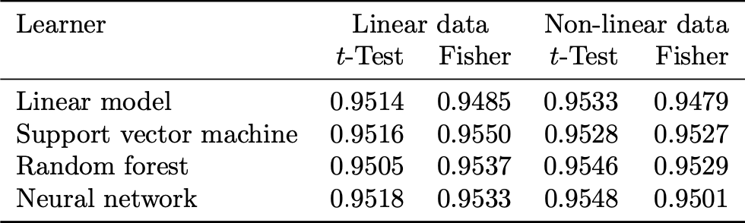
Table 1. Empirical coverage probabilities of $95\%$confidence intervals in the simulation study, calculated from ${10}^{4}$ simulation replicates; continuous outcome with MSE loss; correlated predictors.

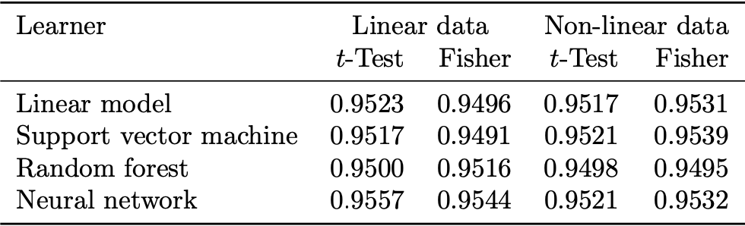
Table 2. Empirical coverage probabilities of $95\%$ confidence intervals in the simulation study, calculated from ${10}^{4}$ simulation replicates; continuous outcome with MAE loss; correlated predictors.

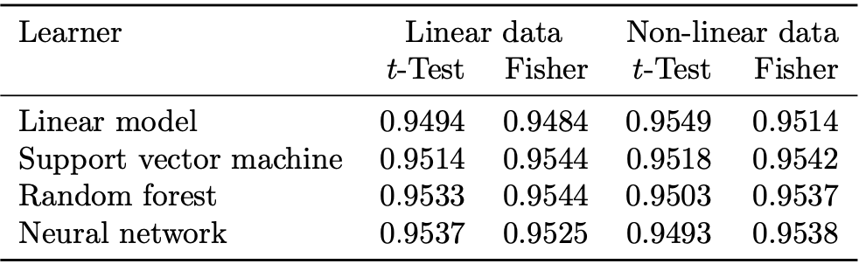
Table 3. Empirical coverage probabilities of $95\%$ confidence intervals in the simulation study, calculated from ${10}^{4}$ simulation replicates; continuous outcome with MSE loss; uncorrelated predictors.

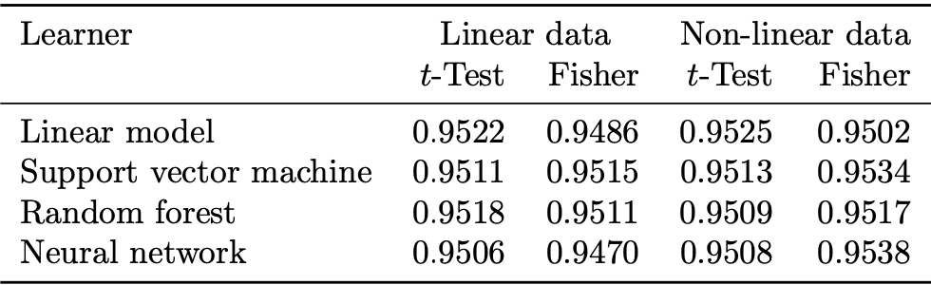
Table 4. Empirical coverage probabilities of $95\%$ confidence intervals in the simulation study, calculated from ${10}^{4}$ simulation replicates; continuous outcome with MAE loss; uncorrelated predictors.

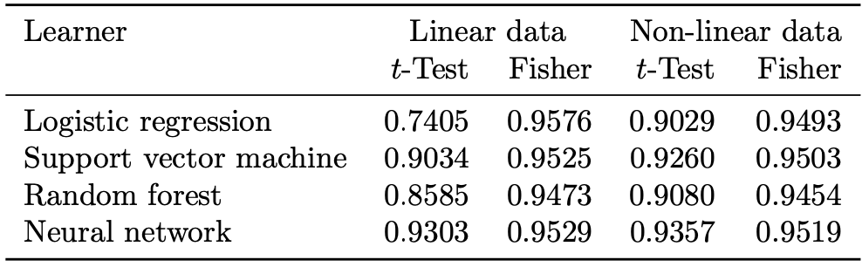
Table 5. Empirical coverage probabilities of $95\%$ confidence intervals in the simulation study, calculated from ${10}^{4}$ simulation replicates; classification outcome with MMCE loss; correlated predictors.

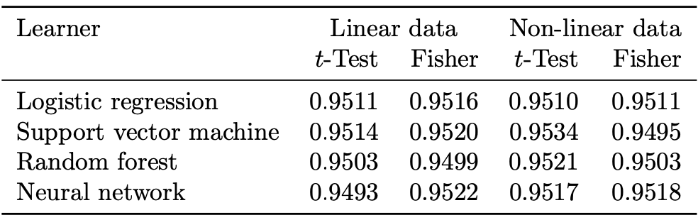
Table 6. Empirical coverage probabilities of $95\%$ confidence intervals in the simulation study, calculated from ${10}^{4}$ simulation replicates; classification outcome with CE loss; correlated predictors.

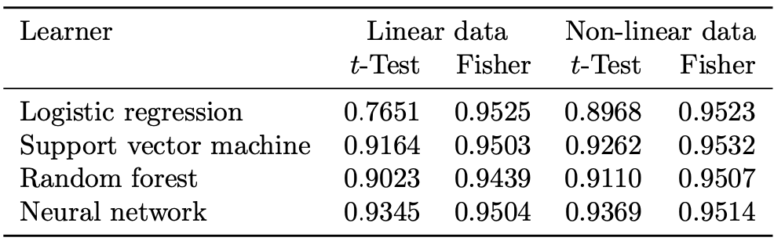
Table 7. Empirical coverage probabilities of $95\%$ confidence intervals in the simulation study, calculated from ${10}^{4}$ simulation replicates; classification outcome with MMCE loss; uncorrelated predictors.

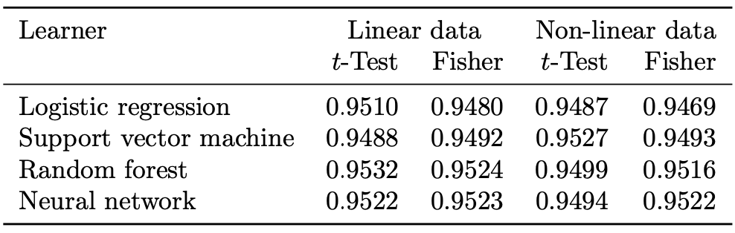
Table 8. Empirical coverage probabilities of $95\%$ confidence intervals in the simulation study, calculated from ${10}^{4}$ simulation replicates; classification outcome with CE loss; uncorrelated predictors.

§2 Errors
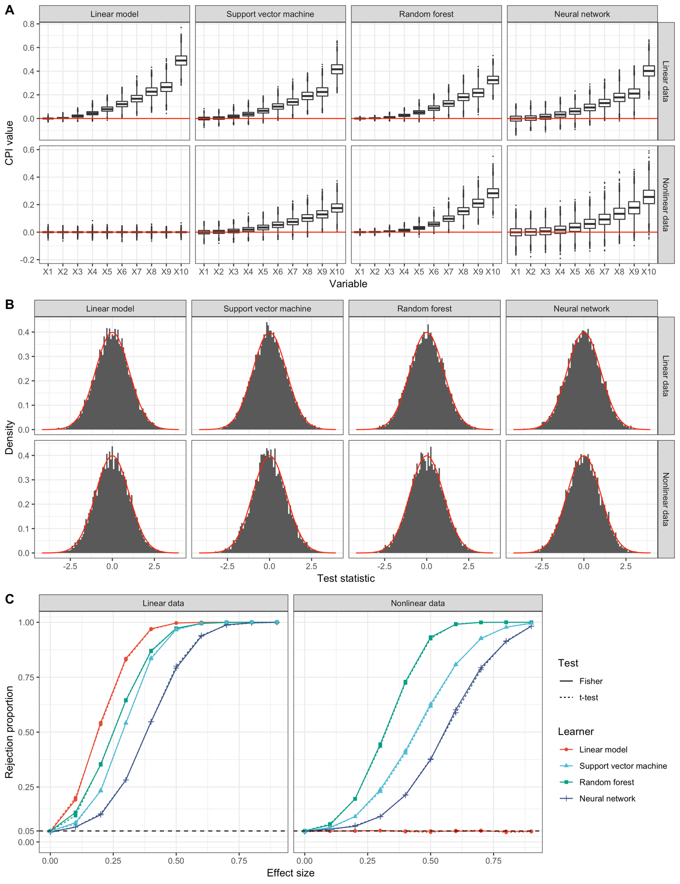
Figure 1. Simulation results for continuous outcome with MAE loss and correlated predictors. A: Boxplots of simulated CPI values of variables $X_{1},…,X_{10}$ with increasing effect size. The red line indicates a CPI value of $0$, corresponding to a completely uninformative predictor. B: Histograms of simulation replications of t-statistics of variables with effect size $0$. The distribution of the expected t-statistic under the null hypothesis is shown in red. C: Proportion of rejected hypotheses at $α=0.05$ as a function of effect size. Results at effect size 0 correspond to the Type I error, at effect sizes $>0$ to statistical power. The dashed line indicates the nominal level, $α=0.05$.
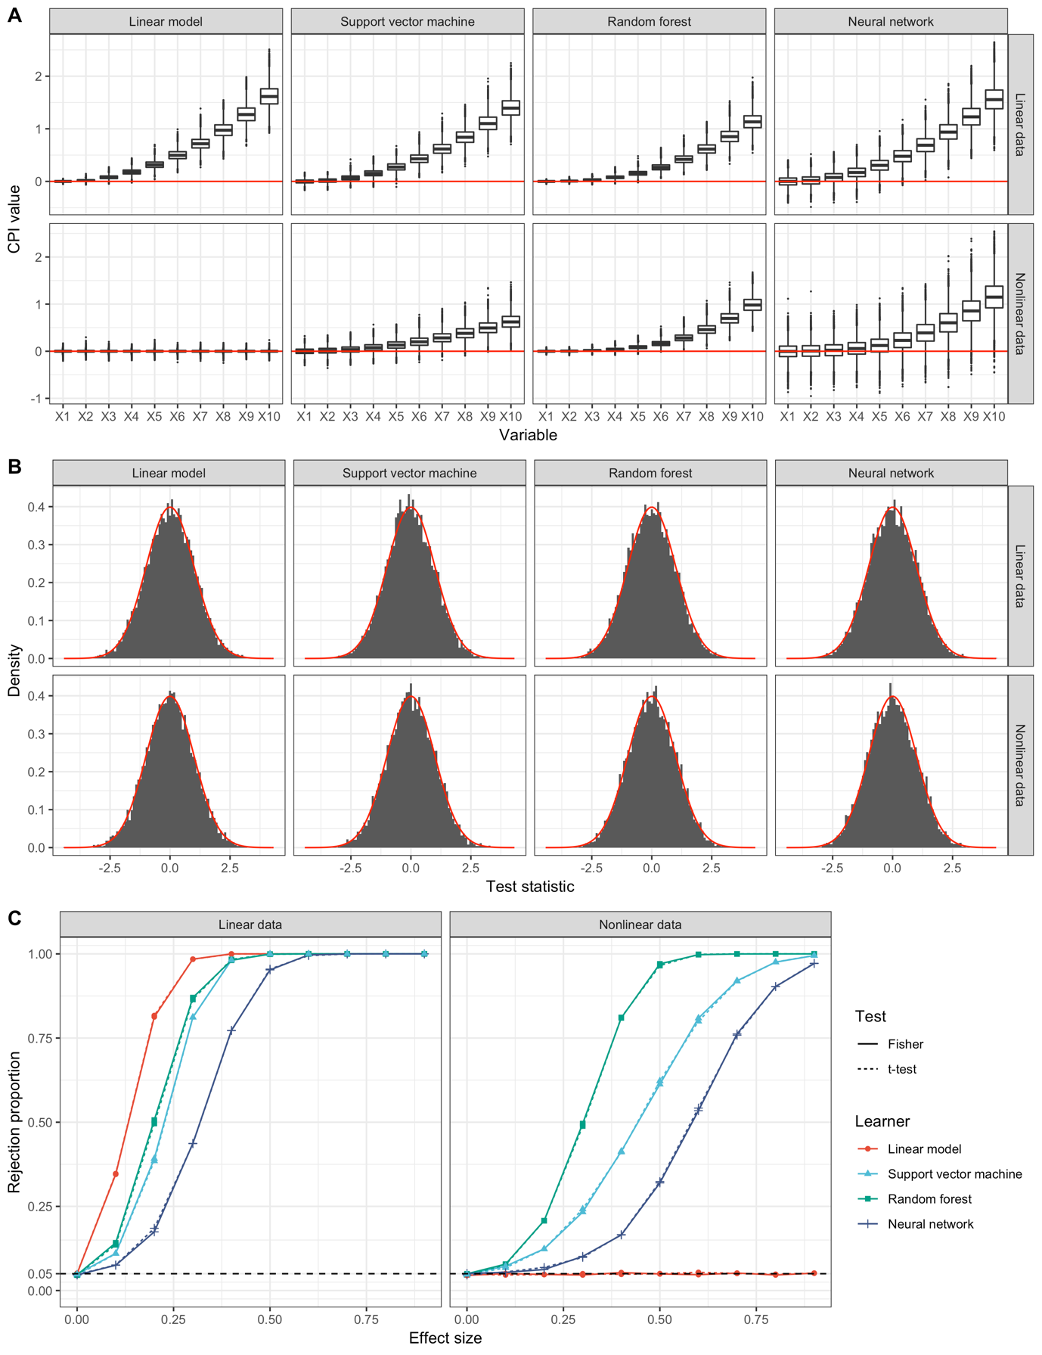
Figure 2. Simulation results for continuous outcome with MSE loss and uncorrelated predictors. A: Boxplots of simulated CPI values of variables $X_{1},…,X_{10}$ with increasing effect size. The red line indicates a CPI value of $0$, corresponding to a completely uninformative predictor. B: Histograms of simulation replications of t-statistics of variables with effect size $0$. The distribution of the expected t-statistic under the null hypothesis is shown in red. C: Proportion of rejected hypotheses at $α=0.05$ as a function of effect size. Results at effect size 0 correspond to the Type I error, at effect sizes $>0$ to statistical power. The dashed line indicates the nominal level, $α=0.05$.

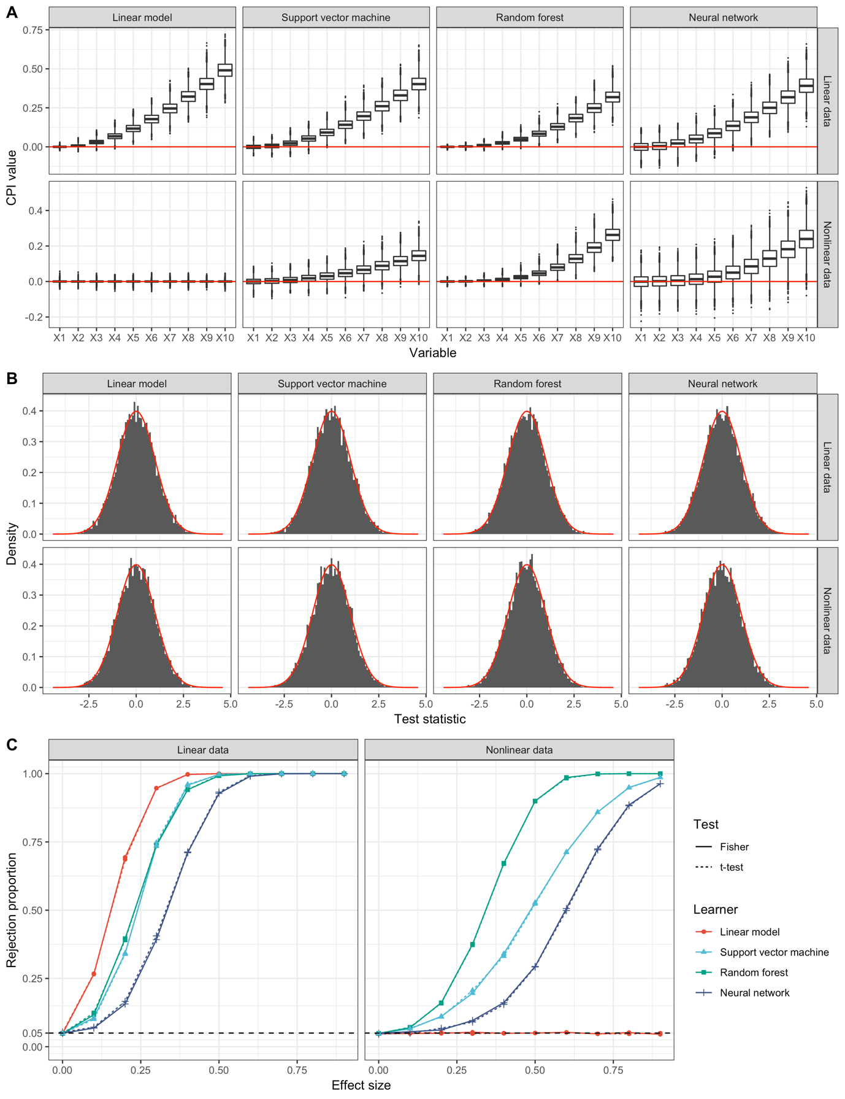
Figure 3. Simulation results for continuous outcome with MAE loss and uncorrelated predictors. A: Boxplots of simulated CPI values of variables $X_{1},…,X_{10}$ with increasing effect size. The red line indicates a CPI value of $0$, corresponding to a completely uninformative predictor. B: Histograms of simulation replications of t-statistics of variables with effect size $0$. The distribution of the expected t-statistic under the null hypothesis is shown in red. C: Proportion of rejected hypotheses at $α=0.05$ as a function of effect size. Results at effect size 0 correspond to the Type I error, at effect sizes $>0$ to statistical power. The dashed line indicates the nominal level, $α=0.05$.

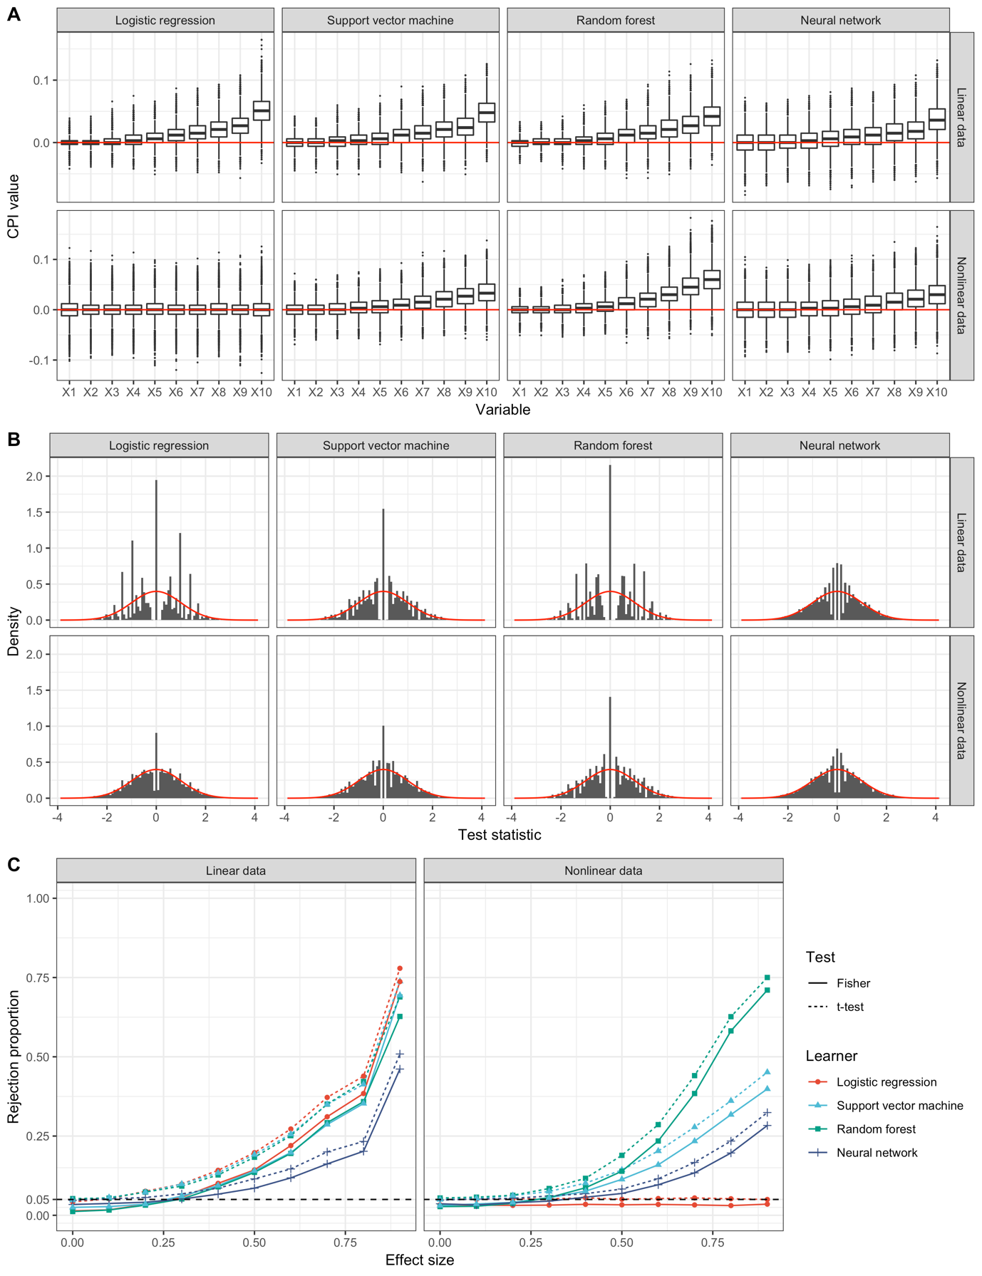
Figure 4. Simulation results for binary outcome with MMCE loss and correlated predictors. A: Boxplots of simulated CPI values of variables $X_{1},…,X_{10}$ with increasing effect size. The red line indicates a CPI value of $0$, corresponding to a completely uninformative predictor. B: Histograms of simulation replications of t-statistics of variables with effect size $0$. The distribution of the expected t-statistic under the null hypothesis is shown in red. C: Proportion of rejected hypotheses at $α=0.05$ as a function of effect size. Results at effect size 0 correspond to the Type I error, at effect sizes $>0$ to statistical power. The dashed line indicates the nominal level, $α=0.05$.

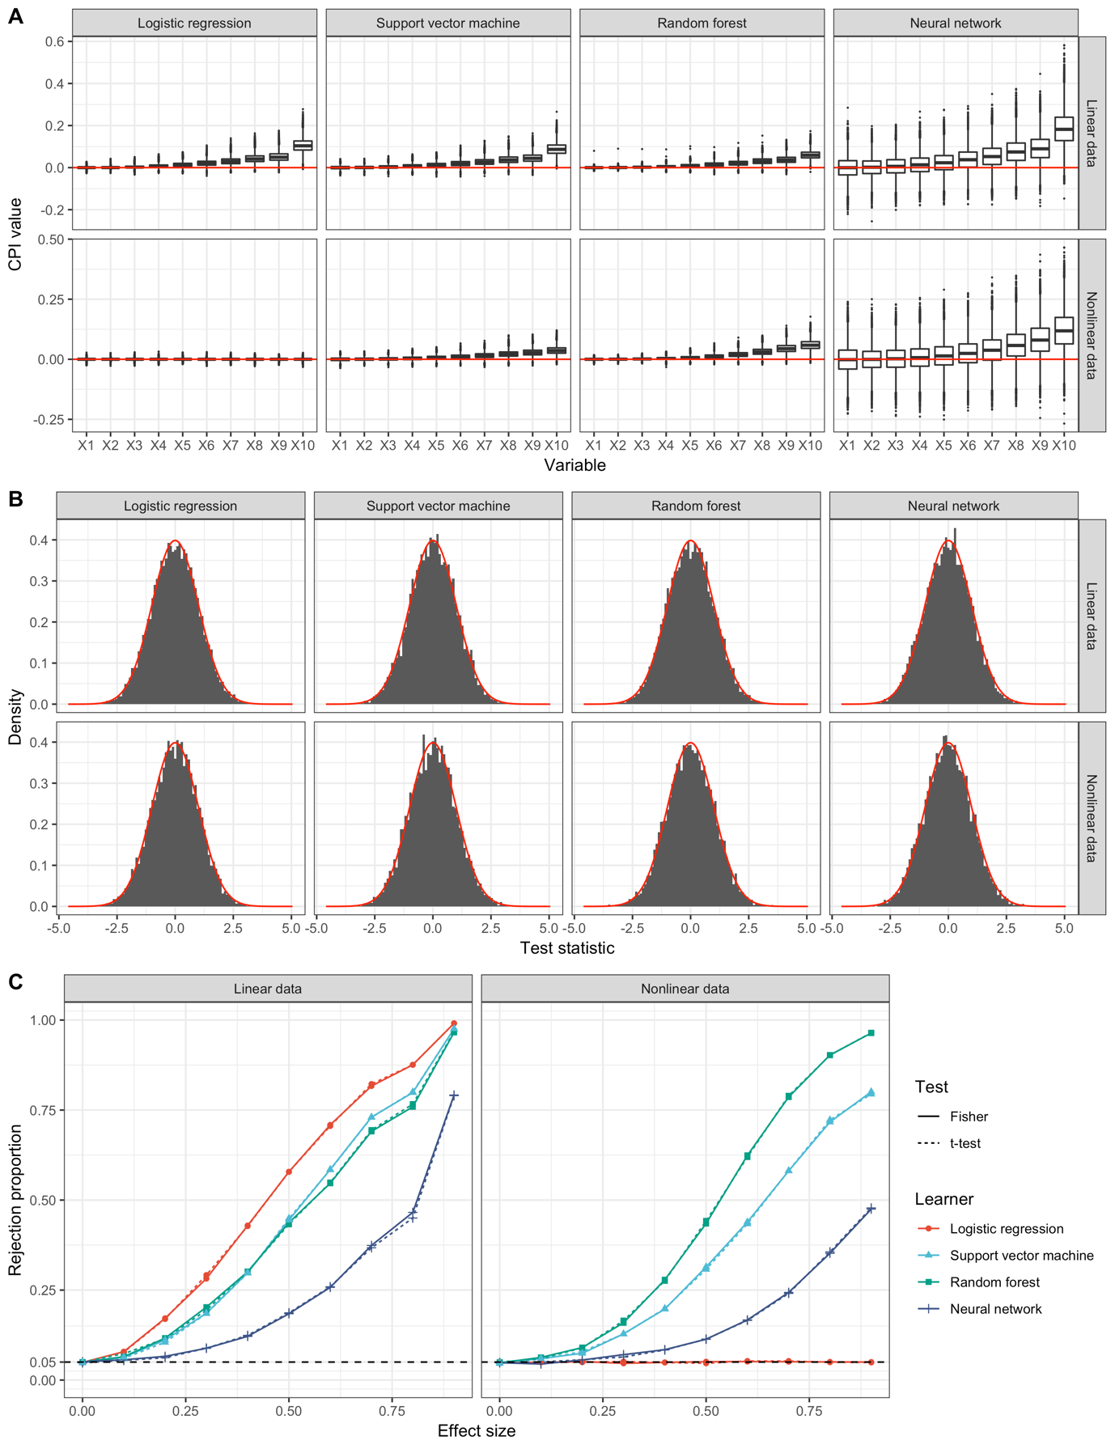
Figure 5. Simulation results for binary outcome with CE loss and correlated predictors. A: Boxplots of simulated CPI values of variables $X_{1},…,X_{10}$ with increasing effect size. The red line indicates a CPI value of $0$, corresponding to a completely uninformative predictor. B: Histograms of simulation replications of t-statistics of variables with effect size $0$. The distribution of the expected t-statistic under the null hypothesis is shown in red. C: Proportion of rejected hypotheses at $α=0.05$ as a function of effect size. Results at effect size 0 correspond to the Type I error, at effect sizes $>0$ to statistical power. The dashed line indicates the nominal level, $α=0.05$.

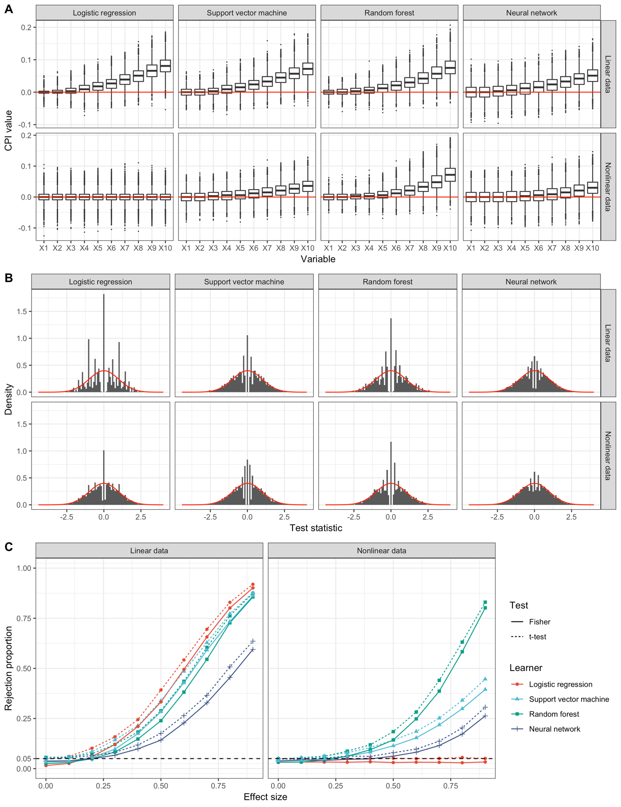
Figure 6. Simulation results for binary outcome with MMCE loss and uncorrelated predictors. A: Boxplots of simulated CPI values of variables $X_{1},…,X_{10}$ with increasing effect size. The red line indicates a CPI value of $0$, corresponding to a completely uninformative predictor. B: Histograms of simulation replications of t-statistics of variables with effect size $0$. The distribution of the expected t-statistic under the null hypothesis is shown in red. C: Proportion of rejected hypotheses at $α=0.05$ as a function of effect size. Results at effect size 0 correspond to the Type I error, at effect sizes $>0$ to statistical power. The dashed line indicates the nominal level, $α=0.05$.

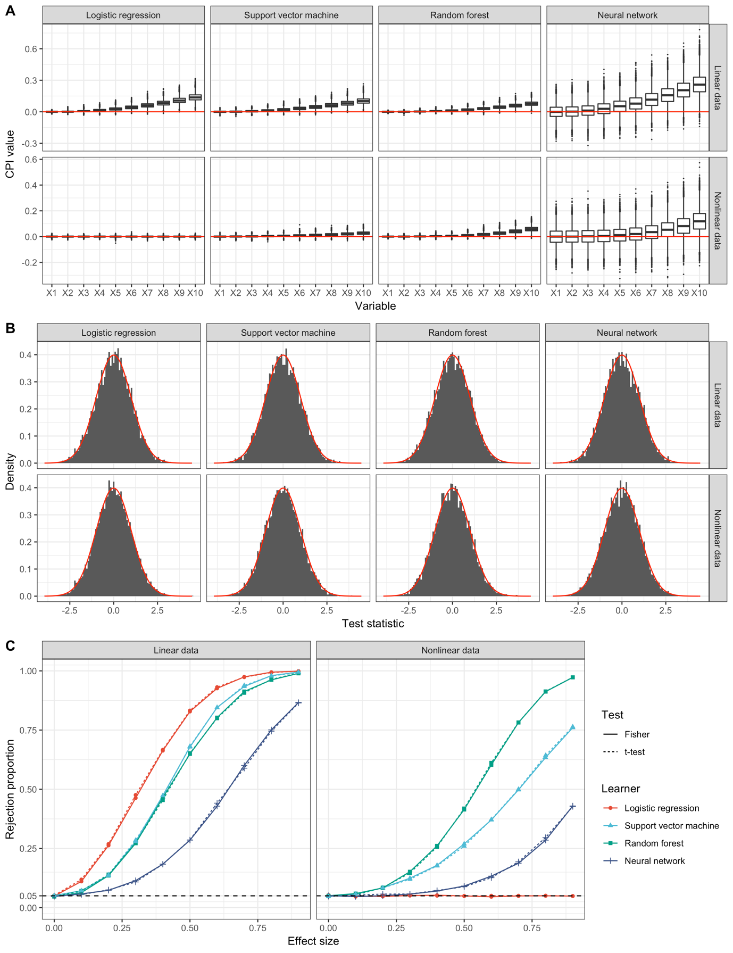
Figure 7. Simulation results for binary outcome with CE loss and uncorrelated predictors. A: Boxplots of simulated CPI values of variables $X_{1},…,X_{10}$ with increasing effect size. The red line indicates a CPI value of $0$, corresponding to a completely uninformative predictor. B: Histograms of simulation replications of t-statistics of variables with effect size $0$. The distribution of the expected t-statistic under the null hypothesis is shown in red. C: Proportion of rejected hypotheses at $α=0.05$ as a function of effect size. Results at effect size 0 correspond to the Type I error, at effect sizes $>0$ to statistical power. The dashed line indicates the nominal level, $α=0.05$.

§3 Comparative Performance

Figure 8. Comparative performance of VI measures across different simulations and algorithms, computed with training and test samples of $n = 100, p = 10$ and correlated predictors. Plots depict the rejection rate at $α=0.05$ as a function of effect size. Results at effect size $0$ correspond to Type I error, at effect sizes $>0$ to statistical power. The dashed line indicates the nominal level of $α=0.05$.

Figure 9. Comparative performance of VI measures across different simulations and algorithms, computed with training and test samples of $n = 500, p = 10$ and correlated predictors. Plots depict the rejection rate at $α=0.05$ as a function of effect size. Results at effect size $0$ correspond to Type I error, at effect sizes $>0$ to statistical power. The dashed line indicates the nominal level of $α=0.05$.

Figure 10. Comparative performance of VI measures across different simulations and algorithms, computed with training and test samples of $n = 1000, p = 10$ and correlated predictors. Plots depict the rejection rate at $α=0.05$ as a function of effect size. Results at effect size $0$ correspond to Type I error, at effect sizes $>0$ to statistical power. The dashed line indicates the nominal level of $α=0.05$.

§4 Knockoff Sampler
Figure 11. Power and FDR as a function of effect size and autocorrelation for CPI and knockoff filter. Target FDR is $10\%$. Results are from a lasso regression with $n = 300, p = 2000$. Each point represents 10,000 replications.

