
Spectrum processing :
Peaks possibly omitted : 0.270, 0.525, 0.693, 0.940, 4.524, 8.051 keV

Quantitation method : Cliff Lorimer thin ratio section.
Processing option : All elements analyzed (Normalised)
Number of iterations = 2

Standardless

Element | Weight% | Atomic%
S K | -4.05 | -33.61
Pb L | 104.05 | 133.61
Totals | 100.00

26/11/2013 15:29:51
Project 1

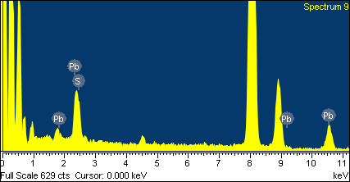
Comment:

