
Spectrum processing :
Peaks possibly omitted : 0.938, 4.529, 6.885, 8.051 keV

Quantitation method : Cliff Lorimer thin ratio section.
Processing option : All elements analyzed (Normalised)
Number of iterations = 2

Standardless

Element | Weight% | Atomic%
S K | 1.36 | 7.28
Cd L | 16.03 | 24.42
Pb L | 82.61 | 68.29
Totals | 100.00

26/11/2013 15:01:43
Project 1

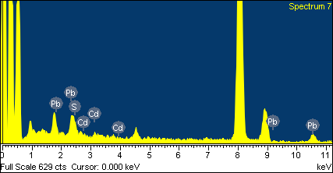
Comment:

