Influence of Shell Thickness and Surface Passivation on PbS/CdS Core/Shell Colloidal Quantum Dot Solar Cells
Darren C. J. Neo¹‡, Cheng Cheng¹, Samuel D. Stranks², Simon M. Fairclough¹, Judy S. Kim¹, Angus I. Kirkland¹, Jason M. Smith¹, Henry J. Snaith², Hazel E. Assender ¹‡, Andrew A. R. Watt¹ ‡*
¹ Department of Materials, University of Oxford, 16 Parks Road
Oxford OX1 3PH, UK
² Department of Physics, Clarendon Laboratory, Parks Road,
Oxford OX1 3PU, UK
* Corresponding author
KEYWORDS: core/shell colloidal quantum dot $∙$ solution-processed solar cell $∙$ surface defect passivation $∙$ lead sulfide $∙$ ligand exchange

ABSTRACT: Cation-exchange has been used to synthesize PbS/CdS core/shell colloidal quantum dots from PbS starting cores. These were then incorporated as the active material in solar cell test devices using a solution-based, air-ambient, layer-by-layer spin coating process. We show that core/shell colloidal quantum dots can replace their unshelled counterparts with a similar band-gap as the active layer in a solar cell device, leading to an improvement in open circuit voltage from 0.42 V to 0.66 V. This improvement is attributed to a reduction in recombination as a result of the passivating shell. However, this increase comes at the expense of short circuit current by creating a barrier for transport. To overcome this, we first optimize the shell thickness by varying the conditions for cation-exchange to form the thinnest shell layer possible that provides sufficient surface passivation. Next, ligand exchange with a combination of halide and bi-functional organic molecules is used in conjunction with the core/shell strategy. Power conversion efficiencies of 5.6 ± 0.4 % have been achieved with a simple heterojunction device architecture.

INTRODUCTION
Colloidal Quantum Dots (CQDs) are a promising material for use in photovoltaic (PV) technology. They allow low cost versatile device processing^{1–3} and might be used to exploit new ideas in quantum physics^{4–8} and materials chemistry^{9,10} in a bid to overcome the Shockley-Quessier Limit^{11,12}. Lead sulfide (PbS) CQDs currently top the photovoltaic efficiency tables¹³ in this class, with great developments being made by improving junction architecture¹³, carrier properties^{14–16} and solution deposition chemistry^{17,18}. However, efficiencies still lag behind competing technologies, like dye-sensitized solar cells, largely due to comparatively poor electronic properties.
The limiting factor for the current generation of CQD devices are the lower than expected open-circuit voltage (V_{OC})¹⁹ values, which are attributed to the high density of defect states²⁰. Electronically active CQD thin films are produced by exchanging the long-chain ligands used to synthesize and stabilize the CQD for a shorter linker ligand which allows electronic coupling between neighboring CQDs in the film. Currently a post-deposition solid state treatment is used to produce the best devices^{21–23}. However, despite the improvements made, this exchange process has been shown to be imperfect, causing surface defects which increase recombination and non-radiative losses, thus directly reducing V_{OC}²¹. These defects are caused by incomplete ligand coverage²⁴ or the inherent instability of the more labile shorter ligands²⁵. In addition, post-deposition exchange is highly dependent on optimizing ligand concentration, solvation, impurity elimination, and processing environment^{17,26,27}. Ip et al. recently investigated the role of ligand coverage and demonstrated that a combination of short bi-functional organic and atomic halide ligands results in nearly complete CQD surface passivation. Using transient photovoltage measurements, the authors showed a reduction in defect density as compared to an organic ligand-only treatment²¹. However this strategy is strongly dependent on the stability of ligands.
In photoluminescent applications of CQD such as bio-labelling²⁸, the issue of surface passivation is addressed by having a shell of another wider band-gap semiconductor (forming a type I heterostructure) grown around the CQD. This shell passivation method has been shown to be stable and effective^{29–32}, giving rise to higher photoluminescence quantum yields, longer decay lifetimes and even greater chemical and environmental stability^{29,33,34}. While employing a coating of a wider band-gap material on a nanocrystal sensitizer is a well-established procedure in quantum dot-sensitized solar cells³⁵, reports of using core/shell quantum dots as both the light absorber and the active transport material are scarce. This is possibly because a thick shell layer of a type I heterostructure impedes exciton dissociation, charge extraction and transport³⁶. Zamkov and co-workers showed that having a CdS shell on PbS quantum dot improves passivation and that the distance between PbS quantum dots and hence the thickness of CdS layer impact carrier mobility and device performance^{37,38}. Etgar et al. also showed that a type II lead selenide/lead sulfide core/shell quantum dot can improve exciton dissociation³⁹. This paper builds upon these studies to increase device efficiencies, and to investigate the effect of shell thickness and surface chemistry on device performance. This is done by developing a passivation strategy that uses the synergistic effect of a core/shell structure and ligands coordination to passivate CQD surfaces.

EXPERIMENTAL SECTION
Material. Lead oxide yellow (PbO, 99.9%) was purchased from Acros Organics. Oleic acid (OA, 90%), 1-octadecene (ODE, 90%), bis(trimethylsilyl) sulfide ((TMS)₂S, synthesis grade), cadmium acetate hydrate (Cd(Ac)₂, 99.99%), Poly(3,4-ethylenedioxythiophene)-poly(styrenesulfonate) (PEDOT:PSS, 1.3wt% in water, conductive grade), 1,2-ethanedithiol (EDT, >98%), cetyltrimethylammonium bromide (CTAB, >98% ) and anhydrous cadmium chloride (CdCl₂, 99%) were purchased from Sigma Aldrich. Hexane (98.25%), acetone (99.98%), methanol (99.99%) and toluene (99.99%) were purchased from the Fischer Scientific. All chemicals were used as-received.
PbS CQD synthesis. The synthesis of 1.3 eV PbS CQDs was adapted from the procedure developed by Hines and Scholes⁴⁰, and was performed under inert conditions using standard Schlenk line techniques. Details of synthesis are described in the supplementary information.
PbS/CdS core/shell CQD synthesis. The synthesis of PbS/CdS core/shell CQD is adapted, with modifications, from the procedure developed by M. S. Neo et al.³¹ To prepare 0.1 nm (one monolayer) CdS shell-thick PbS/CdS core/shell CQD, 0.395 mL of ODE, 0.115mL of OA and 0.030 g of Cd(Ac)₂, were mixed in a 25 mL three-neck flask, connected to a Schlenk line assembly. The mixture was heated and stirred continuously under vacuum at 100°C for at least 1 hour, forming a clear cadmium-oleate solution. The temperature was then reduced to 80°C and the vacuum environment was swapped to an argon atmosphere. 2 mL of the prepared PbS 50 mg/mL solution was swiftly injected into the flask and allowed to react under stirring for 10 minutes. The heating was then turned off and the reaction was quenched by adding 5ml of cold hexane and the resultant solution was then added to 30 mL of acetone to precipitate out the CQDs. The same washing step for PbS CQDs was applied and the prepared CQDs were re-dissolved in toluene to a concentration of 50 mg/mL. Details of the conditions used to vary the CdS shell thickness are described in the supplementary information.
ZnO nanoparticle colloidal solution synthesis. ZnO nanoparticles were synthesized using the method adapted from Pacholski et al. as described elsewhere⁴¹.
Fabrication of solar cell devices. PbS and PbS/CdS CQD ﬁlms were deposited using a layer-by-layer spin-coating process with an in-situ solid-state ligand exchange process, carried out in an ambient atmosphere. Substrates were prepared by pre-patterning ITO on glass, spin coating a layer of PEDOT:PSS at 5000 rpm and then annealing at 150°C for at least 5 minutes before use. For each layer, a drop of CQD solution (50 mg/ml in toluene) was deposited onto the spinning substrate, with a spin rate of 2000 rpm, followed by two drops of 1% v/v EDT in methanol. While spinning, 3 drops of methanol were added followed by 3 drops of toluene to wash off unbound ligands and CQDs. This cycle was repeated to build up to the required thickness. In our study, all samples were standardized to have 6 layers of CQD deposited, which gave a thickness of about 150$± 17$±17 nm as measured by surface profilometry. Finally, the n-type layer was deposited by spin coating ZnO colloidal solution on top of the as-prepared film at 1000 rpm and post- deposition annealing was not required.
In the halide treatment approach, solid-state ligand exchange was performed by covering the surface of PbS/CdS film with saturated CdCl₂ in methanol for Cl exchange and 10 mg/ml CTAB in methanol for Br exchange, over a period of one minute. The sample was then spun dry at 2000 rpm before 3 drops of methanol were added to wash off excess CTAB. For each layer of PbS/CdS CQD deposited, this procedure was repeated three times before the next layer was deposited, so as to ensure comprehensive ligand exchange.
In the hybrid ligand exchange approach, the same flooding procedure is followed as above but was carried out once instead of three times for each PbS/CdS layer. After one minute of the halide treatment, the sample was spun dry and 3 drops of methanol were added. While spinning, this procedure was followed by one drop of 1% v/v EDT in methanol and then 3 drops of methanol and 3 drops of toluene. This completes one layer of PbS/CdS CQD film for the hybrid ligand exchange approach.
Finally top electrodes were formed by depositing aluminum by thermal evaporation in an Edwards 306 evaporator at 10⁻⁶ Torr to a thickness of 100 nm, with an evaporation rate of 0.1 nm/s. A shadow mask was used to pattern the electrodes.
Morphological and structural characterization of CQD. A morphological study of CQDs was performed using a JEOL 2010 transmission electron microscope (TEM), with EDX capability, operating at 200 kV and the Oxford JEOL 2200MCO Aberration Corrected, Monochromated FEG-TEM operating at 80 kV. The mean particle sizes were fitted with a Gaussian distribution curve to the experimental size histogram. TEM samples were prepared by making dilute solutions of CQD, then briefly dipping the TEM grids into the solution and the letting them dry in ambient conditions. For powder X-ray diffraction (Philips theta/2theta), samples were prepared by drop casting PbS or PbS/CdS CQD solutions onto glass.

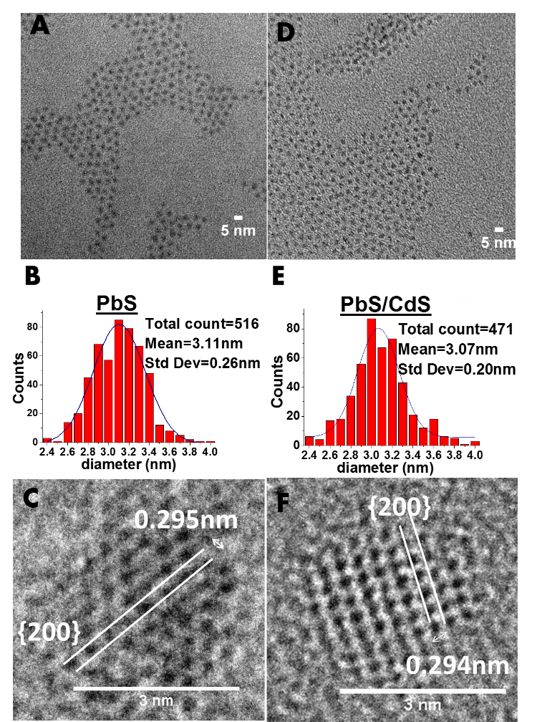
Figure 1. TEM images of PbS and PbS/CdS core/shell CQDs. (a, d) Low magnification images of 1.26eV PbS CQD and 1.34eV PbS/CdS CQD, respectively. PbS/CdS CQDs have a calculated 0.1nm CdS shell and is synthesized from the same batch as the PbS CQDs. (b, e) Histograms of the size distribution, with a Gaussian fit, of 1.26eV PbS CQDs and 1.34eV PbS/CdS CQDs, respectively. (c, f) High magnification images of 1.26eV PbS CQD and 1.34eV PbS/CdS CQD respectively.

XRD simulation. Simulated XRD patterns were calculated using a modified procedure described elsewhere⁴². In outline, a core/shell atomistic model was built by simulating the epitaxial growth of a CdS zinc blende shell around PbS core with a rock salt structure using the common simple cubic positions of the rock salt and zinc blende crystal structure. Whilst the core diameter and shell thickness varied, the overall diameter of the core/shell particle was kept constant at 3.2 nm. Strain was incorporated into the atomistic model through continuum elasticity in a core/shell spherical geometry previously described^{42,43}.
The XRD pattern of the atomistic model was then simulated from the Debye equation for kinematic diﬀraction using the program ‘DISCUS’⁴⁴ for a Cu K_{α} X-ray source and accounting for the thermal dependence of the scattering with Debye-Waller factors. Instrument broadening was not considered in the simulations. The parameters used for the simulation are given in the supporting information

Optical characterization of CQD. Optical absorption spectroscopy of the CQDs was measured on a Cary Varian 4000 UV-VIS-NIR spectrophotometer with diluted CQD solution in a quartz cuvette. Steady-state photoluminescence (PL) measurements were taken using an automated spectrofluorometer (Fluorolog, Horiba Jobin-Yvon), with a 450 W Xenon lamp excitation source and an InGaAs NIR detector. The excitation wavelength was 500 nm. All spectra were corrected for instrumental response using a calibration lamp of known emissivity. Time-resolved PL measurements were acquired using a time-correlated single photon counting (TCSPC) apparatus (FluoTime 300, PicoQuant GmbH). Film samples were photo-excited using a 507 nm laser head (LDH-P-C-510, PicoQuant GmbH) pulsed at 300 kHz (for PbS-OA and PbS/CdS-OA samples) or 8 MHz, with a pulse duration of 117 ps and fluence of ~0.5 µ/cm². The PL at the peak emission (~1100 nm) was collected using a high resolution monochromator and NIR-PMT detector assembly (H10330A-45, Hamamatsu). Mono or bi-exponential fits to the data were carried out using commercial fitting software (FluoFit v4.5.3, PicoQuant GmbH). CQD films were prepared on PEDOT:PSS-coated glass, with and without a ZnO top coat.
Device characterization. All devices were loaded into a sealed testing chamber flushed with N₂ to minimize sample degradation. Current-voltage (I-V) measurement was performed using a Keithley 2400 Source Meter. The voltage was swept from -0.5 V to 1.0 V at a step size of 0.025 V. AM1.5 solar spectrum illumination was produced by a Newport solar simulator fitted with an AM1.5 filter. The power density of the light source was calibrated with a Thorlabs D3MM thermal sensor.

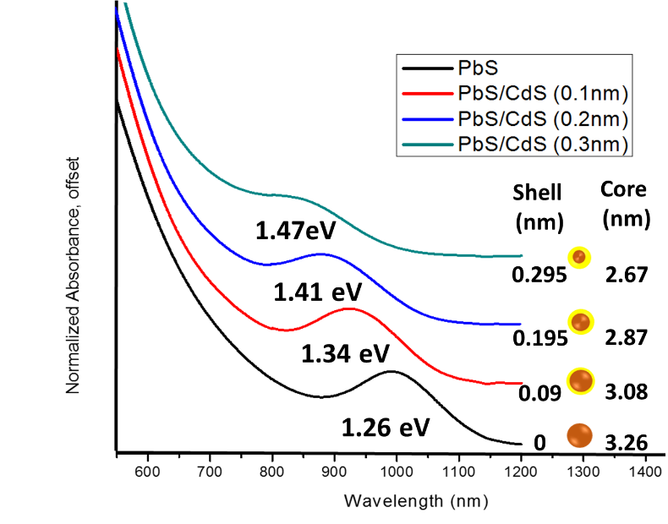
Figure 2. Normalized absorbance curve of PbS CQDs and PbS/CdS CQDs with increasing shell thickness, synthesized from the same PbS batch. Absorption was carried out with CQDs dissolved in toluene with oleic acid as ligands. The schematic inset serves as a visual aid, displaying the calculated shell thickness and core diameter displayed. A systematic blueshift of peaks with thicker shell layer implies a decrease in PbS core diameter.

RESULTS AND DISCUSSION
Synthesis and characterization of core/shell PbS/CdS. With a low temperature cation- exchange method, we have been able to synthesize PbS/CdS core/shell CQD from 1.3 eV PbS CQD using the method reported by Neo et al.³¹. The choice of a cation-exchange approach to produce core/shell nanocrystals as opposed to conventional repeated hot injection methods is important as it uses a relatively low temperature that minimizes the effect of Ostwald ripening, which would otherwise increase the size distribution⁴⁵. A key feature is that the anionic framework of the CQD is preserved and the incoming cation is incorporated into a similar crystal structure⁴⁶. CdS has a similar lattice constant to PbS and the ability to form a face-centered cubic (FCC) structure and thus, using CdS as a shell layer via cation exchange reduces strain-related defects that negate the benefits of a passivating shell layer. A unique feature of this technique is that the synthesized PbS/CdS core/shell colloidal quantum dots preserve the initial diameter of the original PbS CQD, whilst the PbS core decreases in size during the shell formation. The thickness of the CdS shell is hence governed by the concentration of the Cd source added for cation-exchange as described in the methods section and in supplementary information.

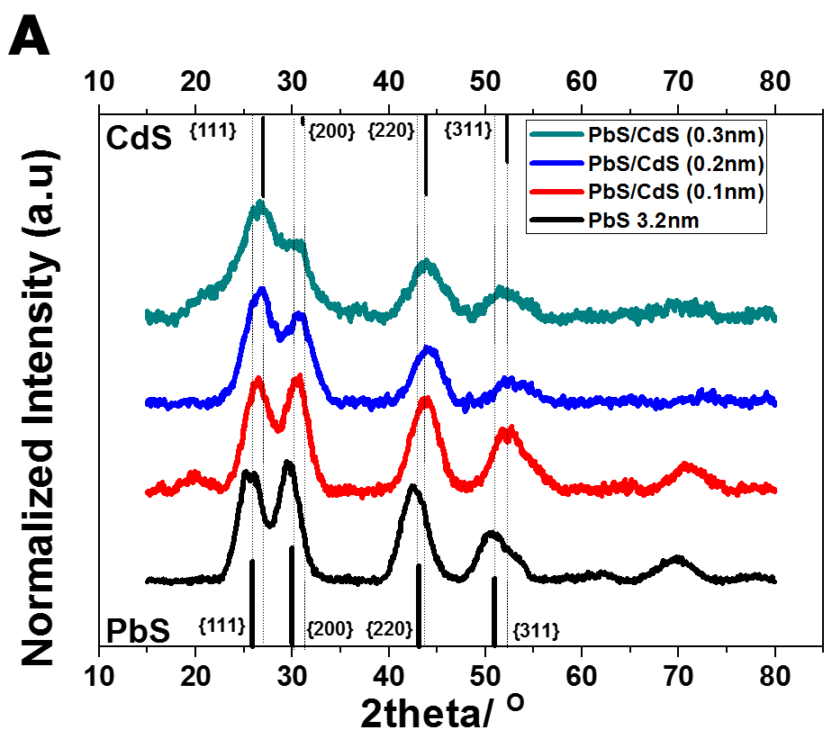
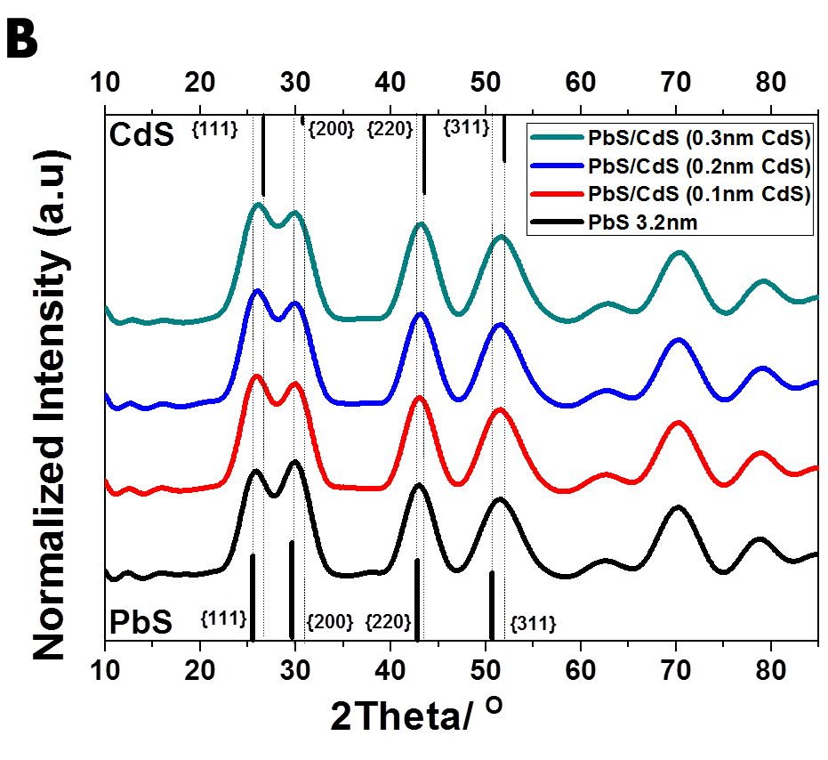
Figure 3. (a) Experimental X-ray diffraction patterns of PbS and PbS/CdS CQDs drop cast on glass substrates. PbS and CdS peaks are referenced from JCPDS file: #01-078-1057 and #00-001-0647 respectively. Main peaks of both PbS and CdS phases are labelled and guidelines to peaks are drawn to highlight the subtle shifts in peak position and relative intensity from PbS to CdS with increasing CdS shell thickness. (b) Simulated X-ray diffraction pattern of PbS and PbS/CdS CQD with varying shell thicknesses with an overall diameter of 3.2 nm.

In addition, an energy dispersive X-ray spectroscopy (EDX) and a simulation study done by Zhao et al.²⁹ backed the formation of a pure phase CdS shell rather than an alloyed Cd and Pb sulfide when PbS/CdS core/shell CQD are formed by cation-exchange method.
The preservation of the overall CQD diameter is supported by TEM images (size distribution statistics are shown in Fig.1) while the reduction in PbS core diameter is reflected by a blueshift in the excitonic peak as shown in Fig. 2. The core diameter and the shell thickness has been estimated using the empirical relationship of the PbS CQD size to its band-gap as proposed by Moreels et al.⁴⁷:
$E_{g}=0.41+{(0.0252d^{2}+0.283d)}^{-1}$$E_{g}=0.41+{(0.0252d^{2}+0.283d)}^{-1}$ (1)
where E_{g} is the band-gap of the PbS CQD as determined by the excitonic peak feature in the absorption spectrum and d is the diameter of particle in nm. From the crystal structure of CdS (zinc blende), a good gauge of the thickness of a monolayer of CdS would be the nearest cadmium to sulfur atom distance, which is about 0.25 nm⁴⁸. Our thinnest CdS shell thickness for the core/shell CQD was calculated to be 0.1 nm, using the band-gap approach. Similar sub-monolayer CdS has been deduced in other work using this approach⁴⁹. This discrepancy might be due to the fact that the thickness of shell layer is determined by subtracting the total CQD diameter from the diameter of the PbS core, which is only an estimation using the excitonic peak feature, and Eq. 1 assumes a spherical shaped-CQD. Furthermore, the PbS core has a common shared outer layer of sulfur atoms with the CdS layer. Thus, a simple subtraction of diameters may result in an apparent sub-monolayer value of CdS.
Due to the similarity in crystal structure and lattice constant of CdS and PbS, it is difficult to image the thin layer of CdS using high resolution TEM.⁵⁰ However, evidence for an epitaxial CdS shell can be determined using XRD. The presence of an increasing CdS phase composition with increasing CdS shell thickness implies that the CdS only exists as part of the core/shell heterostructure and, eliminating the possibility of the nucleation of separate CdS phases and homogenous alloying. As illustrated in Fig. 3a, the relative peak heights of the PbS/CdS core/shell CQD sample and positions are influenced by the CdS shell on the PbS core. Taking the most obvious peaks as an example, pure bulk CdS zinc blende has a higher peak intensity for the {111} reflections compared to the {200} reflections whereas both PbS CQD and pure PbS bulk phase (rocksalt structure) have almost equal intensities for these reflections. For a core/shell structure with a constant diameter, a thicker shell layer would increase its overall composition with respect to the amount of PbS left in this heterostructure. This model is consistent with our XRD results, showing an increasing {111} intensity while the {200} peak decreases as the CdS shell thickness increases. In addition, Fig. S1 excludes the possibility of a hexagonal phase of CdS. A pure phase CdS shell rather than an alloyed Cd-PbS is also supported by a theoretical work by Zhao et al. that proposed an observation of a much smaller band gap if shell layer exists as an alloy.²⁹
Our observation is supported by XRD simulations as illustrated in Fig. 3b, which is based on an atomistic model of PbS/CdS rock salt/zinc blende core/shell nanoparticle using the Debye equation for kinematic diﬀraction⁵¹. The transition of peak heights from PbS to CdS reveals the close proximity of the core and shell atoms, causing the scattered X-rays to constructively interfere between the two materials giving rise to a perceived average of the two diffraction patterns. Quantitative analysis using EDX on TEM samples indicates not only the presence of cadmium, but yields an atomic composition as that in PbS/CdS core/shell CQDs with a 0.1 nm CdS shell (Supplementary Information Fig. S2). Raman spectra (Supplementary Information Fig. S3) also indicates the presence of CdS and shows that the CdS peaks are slightly red-shifted. This latter observation is consistent with the effect of a material under tensile strain, which is expected for CdS epitaxially grown on the surface of PbS. At this juncture, it is important to note that this cationic exchange approach differs from the hybrid passivation scheme developed by Ip et al., which utilizes a long chain phosphonic acid molecule to selectively deliver cadmium cations to the PbS surface site. They observed no obvious change in excitonic absorption peak wavelength and showed, using X-ray photoelectron spectroscopy (XPS), an atomic ratio of Pb to Cd atom of 1 to less than 0.05²¹. However, in our study we observed a sizable blueshift in absorbance peak and EDX results backing up theoretical composition calculations of 1 Pb to 0.25 Cd atoms. Together with the observations that there is no separate CdS evident in TEM images and that the band-gap increases with no apparent decrease in CQD size, we conclude that an epitaxial CdS shell forms on the PbS core.

Incorporation of PbS/CdS CQD into devices. The PbS/CdS core/shell quantum dots have been used to form the p-type layer of a heterojunction device as shown in Fig.4a with the full procedure described in the methods section. It should be noted that all PbS/CdS CQD were derived from the same batch of PbS. Briefly, each layer of CQD film was formed by spin coating followed by a solid state ligand exchange with a bi-functional linker molecule, 1,2-ethanedithiol (EDT). Each test device consisted of 6 layers of CQD films, which gives an overall layer thickness of 150±18 nm as measured by surface profilometry, which are then capped with colloidal ZnO to a thickness of 100±24 nm, without any post-deposition anneal treatment. This test device architecture is kept consistent throughout this study. We performed photovoltaic performance testing under AM 1.5 illumination and we first compare devices made using PbS and PbS/CdS with 0.1 nm shell thickness. The current density-voltage (J-V) characteristic curves in Fig. 4b reveal that although the short-circuit current (J_{SC}) is substantially lower for the PbS/CdS device, V_{OC} exceeds that of the non-shelled PbS device by more than 0.2 V.

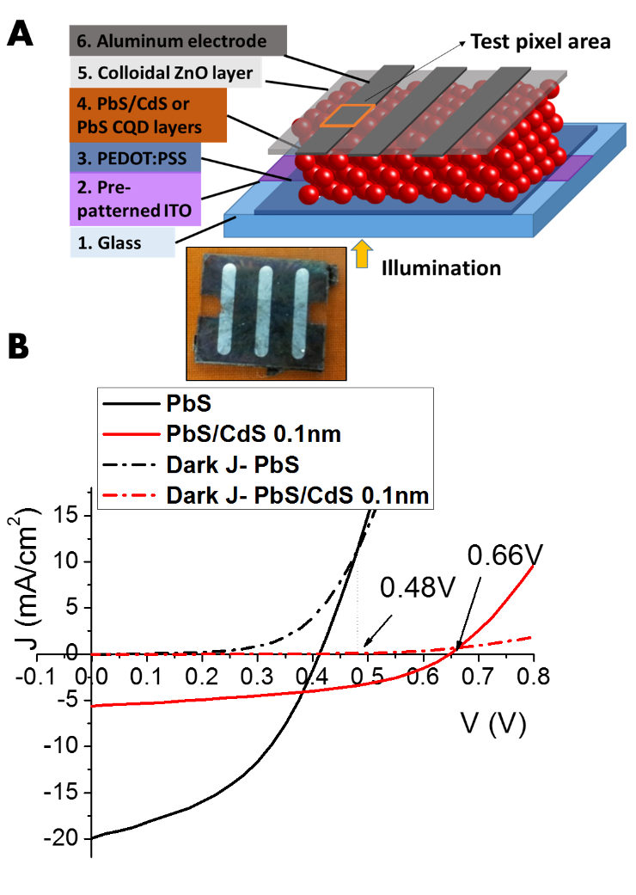
Figure 4. (a) Model showing the device architecture of the solar cell used for performance testing. Inset shows the actual sample device. (b) Current density versus voltage performance testing of best performing devices under dark and AM1.5 illumination conditions. Both devices have the same structure, with similar thickness and underwent the same solid state ligand exchange process using EDT. Arrows indicate the voltage points where light generated current equals the dark current and gives an estimate of the built in potential of the device. Refer to Table 1 for a summary of the average performance statistics.

A PbS band-gap change of 0.08 eV from 1.26 eV to 1.34 eV (as would be predicted using the method of Yoon et al.¹⁹ , in this work moving from a PbS to a PbS/CdS CQD with 0.1 nm shell thickness) would result in only a 0.044 V change in V_{OC} if it were due only to an increase in band offset. Hence, the greater increase of V_{OC} observed must be due to additional factors. Using dark and illuminated J-V curves to estimate the built-in potential and comparing it with V_{OC}, it is clear that the PbS devices suffer a greater voltage loss than the PbS/CdS devices, as shown in Fig. 4b. Zhao et al.⁵² have reported a similar improvement in V_{OC} resulting from a post-deposition annealing treatment of a PbS CQD film, which forms a thin layer of oxide on the surface of PbS. We postulate that the thin CdS shell layer effectively passivates surface defects of the PbS core because cation-exchange relies on the replacement of the original host cationic species resulting in the complete bonding of every PbS surface atom. Therefore, deleterious deep traps that promote non-radiative recombination are minimized and this gives a rise in V_{OC}⁹. To confirm that the improvement in V_{OC} originates from the core/shell passivation strategy, a set of CQD devices fabricated using an aluminum metal Schottky junction instead of ZnO were tested. Results from these show that even without a p-n junction that shell passivation is effective (supplementary information, Fig. S4).

The effect of shell thickness and passivation. To maximize the benefit of shell passivation, in the context of solar cell devices, the shell thickness has to be optimized such that it is sufficiently thick for complete passivation, yet sufficiently thin for charges to be transported dot to dot. Using the same starting core PbS CQD, a series of core/shell CQDs with increasing shell thicknesses were examined using the same procedure. Fig. 5 shows four device performance metrics that demonstrate the effect of shell passivation and J-V curves versus shell thickness are illustrated in Fig S5.
These experiments show an increase in V_{OC} with increasing shell thickness, with the most substantial change between no shell and a 0.1 nm shell. Ip et al.²¹ showed that a reduction of surface related trap density increases V_{OC} by exploring the effect of mid-gap trap states using density functional theory simulations. It is most likely, that at 0.1 nm shell thickness, surface passivation is complete, i.e. each PbS core surface atom is fully bonded. Thus, additional layers do not lead to a substantial increase in passivation and the subsequent rise in V_{OC} is small and attributed to the increase in band-gap due to the decrease in PbS core diameter¹⁹.
Figure 5. (a) Open circuit voltage, (b) Reverse saturation current, (c) Series resistance, (d) Shunt resistance versus thickness of CdS shell layer on PbS/CdS core/shell CQDs. 0 nm shell thickness refers to unshelled PbS CQD and all PbS/CdS CQDs are synthesized from the same batch of PbS. Devices have the structure shown in Fig. 4a.

To investigate carrier recombination characteristics, we have measured the shunt resistance (R_{sh}) and the reverse saturation current (J₀) of our devices. J₀ is a direct measure of recombination whereas, R_{sh} measures the amount of photocurrent leakage when the cell is under load, which, in part, is due to recombination of charges. Thus, the better the passivation of defects, the lower the recombination current and hence J₀ should decrease while shunt resistance should increase. As expected we have observed a lower J₀ and higher R_{sh} for shell passivation and as the shell thickness increases, J₀ and R_{sh} continue this trend, likely associated with a reduction in overall charge transport, due to the increased quantum confinement imposed by a pure-phase CdS shell and hence reduced delocalization of electronic wavefunctions across neighboring quantum dots³⁷. This is also evident from the rise in series resistance (R_{s}).

Passivation of defect states can also lead to a lower carrier concentration as the CQD becomes more intrinsic in nature, thereby reducing conductivity and hence increasing the overall series resistance⁵². It has also been reported that cation-exchange tends to be less uniform when thicker shells are formed, i.e. shell growth may be preferential at a certain crystal facet, giving rise to a broader excitonic peak²⁹ as observed in Fig. 2, and this could be detrimental to device performance⁵³. Core/shell CQDs with CdS shells less than 0.1 nm were also synthesized and evaluated as possible solar cell devices but gave no distinct improvement to V_{OC}. Therefore, we conclude that 0.1nm CdS shell is the thinnest shell layer that can achieve sufficient surface passivation, which is regarded as optimal and further investigation was carried out using this particular core/shell PbS/CdS size.
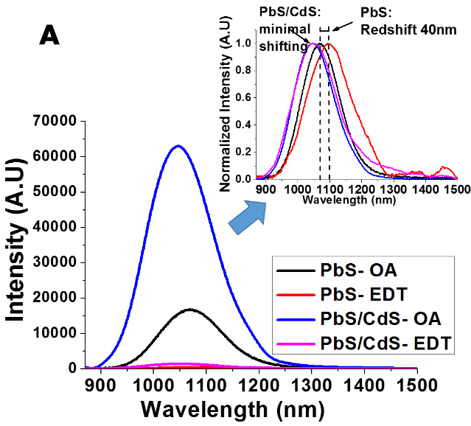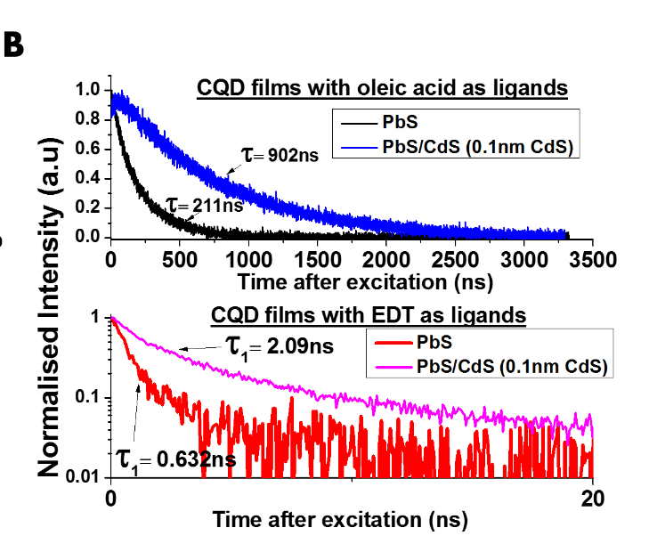
Figure 6. (a) Photoluminescence spectra of CQD films, showing significantly higher photoluminescence intensity of core/shell CQDs and the quenching effects of ligand exchange from OA to EDT. Inset shows the normalized intensity of the curves illustrating the extent of redshift of the photoluminescence peaks. (b) Photoluminescence decay curves of the same samples described in (a). Detection wavelength for each decay curve is based on the peak emission shown in (a). The fitted decay time constants are displayed alongside the graphs and are based on mono-exponential decay for OA samples. For EDT samples, fitting is based on bi-exponential decay and the faster decay time constant is displayed as τ₁. The corresponding τ₂ is 7.45 ns and 15.97 ns for PbS and PbS/CdS respectively.

To further understand the nature of passivation provided by a shell material with a larger band gap, we have both steady-state and time-resolved photoluminescence (Figs. 6a and b). Photoluminescence yield in this study is not absolute but can be used comparatively across the sample sets since they are all prepared in a similar fashion with approximately the same thickness of CQD layer following the approach used by Pietryga et al.³⁰ The effect of shell passivation manifests in two ways:
- Passivation should lead to a reduction in trap states, especially deep traps, which are responsible for non-radiative recombination²¹. This is directly reflected in radiative recombination by an increase in photoluminescence intensity for the core/shell sample compared to a core-only CQD sample. Furthermore, for both oleic acid (OA) and EDT as ligands, core/shell CQDs display much longer decay lifetimes, typically 3 to 4 times longer than core-only PbS (Fig. 6b and Supplemental Information Fig. S6). A prolonged excitonic lifetime is an indicator that the faster, non-radiative, recombination channels are suppressed.
- The addition of a CdS shell enhances the quantum confinement effect (both carriers for type I), therefore buffering the effects of surface chemistry changes. When OA is replaced by EDT, a small bi-functional ligand, which is known to physically link and energetically couple neighboring CQDs, the overlap of their wavefunctions is enhanced, resulting in a relaxation of charge carrier confinement²⁶. This results in a lower energy first excitonic transition, which is observed as a redshift in the exciton peak of the absorption or photoluminescence spectra^{54,55}. However, when PbS CQD is over-coated with a CdS shell, the extent of emission peak redshift is lower, as shown in Fig 6a.
In light of these findings, we could surmise that employing a CdS shell is not only a surface trap passivation strategy, but also buffers the PbS core electronic states from changes in the surface states due to ligand exchange. The benefits of having a passivating CdS shell is illustrated on the band diagrams in Fig. 7a. The alignment and the subsequent band bending results in electron injection from PbS CQD into ZnO conduction band. Charge carriers might be lost through recombination via traps cause by surface defects, which occurs between the quantum dots as well as across the heterointerface. Therefore, employing core/shell PbS/CdS CQDs may well be an important step forward in addressing the issues with solid state ligand exchanges as mentioned in the introduction, like incomplete passivation or ligand instability, which are thought to be the main source of surface defects in quantum dot solar cells.

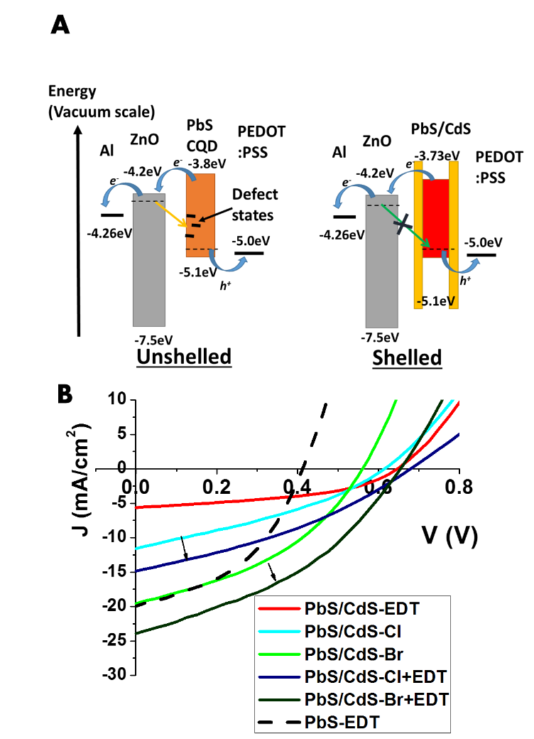
Figure 7. (a) Schematic diagram showing the proposed band alignment of the heterojunction cell and the defect mediation effect of a CdS shell on the PbS electronic structure. Defect states promotes non-radiative recombination when charges moves between CQDs or between PbS and ZnO interface. Adding a CdS shell reduces recombination, thus improving V_{OC}.. (b) Current density versus voltage performance testing of the best PbS/CdS devices formed from different ligand exchange treatments with a PbS device performance shown as reference. Arrows highlight the improvement of hybrid treatment over standalone halide treatment for ligand exchange. Refer to Table.1 for the device performance statistics.

Relaxation of the charge transport barrier imposed by the shell layer. Our preliminary results (Fig. 4b) reveal that shell passivation comes at the price of lowering charge transport capacity as shown by the lower overall photocurrent harnessed and the greater series resistance. Charges now have to tunnel through both the shell and the ligand matrix to neighboring CQDs to get to their respective electrodes. EDT, being a bi-functional linker, draws the CQDs closer together and enhances coupling between the quantum dots²⁶. However, even with EDT ligands, our observation from photoluminescence studies imply that energetic coupling amongst core/shell CQDs is less significant compared to their non-shelled counterparts as shown by the minimal redshift of the photoluminescence emission peak. Therefore, to improve charge transport in an array of core/shell CQDs it is necessary to further decrease inter-dot distance or to relax the confinement potential of CdS shell by changing its surface chemistry.
Recently, two new classes of inorganic ligands have been reported to produce CQD films with high carrier mobility, namely metal chalcogenide complexes^{56,57} and small molecular^{58,59} or atomic ligands^{60–62}. Here, we investigate halide atomic ligands since they have recently been shown to increase the efficiency of PbS CQD devices⁶³. The use of these halide ligands requires a cadmium cation and a long chain phosphonic acid molecule conjugation to deliver the halide ligand to the PbS surface. It was noted through absorption studies that a complete cadmium shell is not formed as cadmium binds only to exposed sulfur atoms and the rest of the exposed lead atoms are bonded to the halide atoms. These methods gave record efficiency CQD solar cell devices at the time of publication and results were attributed to effective passivation and increased carrier mobility⁶³.
Tang et al. have also shown that different halide ligands gave different mobility results with the trend being that mobility increases from chlorine, through bromine to iodine. Interestingly, more recent studies have shown that when halide treatment was performed on PbS without cadmium, PbS with n-type character is produced²⁷. With cadmium incorporation, the formation of donor states seems to be suppressed while carrier mobility is improved, in similar fashion to atomic ligand passivation⁶³. From this we hypothesized that with a cadmium sulfide layer on PbS for our core/shell CQD, there could be a similar effect of improving carrier mobility while minimizing the chances of introducing donor states in the PbS band structure.
To maximize device performance we carried out a halide surface treatment^{21,63}, using cadmium chloride (CdCl₂) for chlorine (Cl) source and cetyltrimethylammonium bromide (CTAB) for the bromine (Br) source, on our PbS/CdS (0.1 nm CdS shell) CQD films. The performance of the devices with halide ligand exchange demonstrates an improvement in efficiency. Fig. 7b shows that there is a major improvement in current density for both halides treatment but V_{OC} shows a decrease from the reference EDT-passivated PbS/CdS device. It is evident that the increase of J_{SC} for a CTAB treatment is higher than that for CdCl₂ and accordingly the drop in V_{OC} is more significant. The improvement in J_{SC} improvement is consistent with the mobility studies performed by Tang et al. for different halide passivation where Br gives higher mobility than Cl, improving charge transport and leading to overall increase in extracted photocurrent.
To further improve charge transport, we seek to exploit the linking properties of EDT and to use it in conjunction with halide treatment. Ip et al. have reported that the average spacing between quantum dots is much smaller when organic bi-functional linkers are used as compared to purely inorganic halide ligands²¹. We also note that despite similar film thicknesses, our halide treated films look optically less dense than EDT treated films. While thiols, such as EDT, provide good surface passivation^{64,65}, together with the passivation provided by the CdS shell, carrier mobility would be hampered. Thus, we propose that optimizing the performance of the CQD film requires a balance of mobility improvement and passivation. Mobility is improved by introducing halide ligands and can be used together with EDT that decreases the separation of the CQDs.
We carried out our hybrid treatment by reducing the ligand exchange time for halide treatment to only one cycle to avoid total replacement with halide ligands and then used EDT to swap out the remaining oleic acid ligands. Results in Fig. 5a and Table 1 show the improvement when both halide and EDT ligands are used for passivation, with V_{OC} increased compared to a halide-only treatment with a concomitant increase in J_{SC}.
To investigate the effect of having both EDT and halide species as ligands, we employed photoluminescence studies. PbS films were produced on Poly(3,4-ethylenedioxythiophene)-poly(styrenesulfonate) (PEDOT:PSS)-coated glass, with and without a ZnO top coat. Photoluminescence quenching is a useful measure for determining whether charge separation is occurring at an interface⁶⁶. Steady state spectra of our core/shell CQD films treated with the respective halides (Fig. 8a) reveals no quenching and minimal redshift of the 1st exciton transition peak energy with reference to the EDT-treated sample. However, when a heterojunction is formed with the n-type ZnO, the photoluminescence spectra reveal quenching of photoluminescence peaks for both halide-treated films with greater quenching in the case of Br (Fig. 8b). The heterojunction formation results in band bending, providing an internal electric field to drift the charge carriers thus aiding charge separation. In summary, our observations suggest that:
- The decrease in V_{OC} values obtained for halide-treated devices might be due a change in the surface chemistry of the CdS shell caused by halide ligands. This may lower the confinement effect, lowering the barrier to charge transport.
- CTAB treatment has a greater effect on lowering the confinement barrier compared to CdCl₂, as reflected by the greater extent of photoluminescent quenching and larger decrease in V_{OC}.

Further EDX experiments reveals that CdCl2 treatment might have increase the CdS shell thickness slightly by increasing Cd composition, thereby enforcing passivation and minimizing the drop in Voc. (see Fig. S7)
For both Cl+EDT and Br+EDT hybrid treatment, energetic coupling should be more significant compared to EDT treatment alone due to the combined effect of closer inter-dot spacing and reduced quantum confinement brought about by halide ligands. This is indicated by a slight redshift of the photoluminescence peak, using the EDT treated sample peak as the reference, which is observed both with and

without the ZnO layer (Fig. 8a and 8b respectively). However, photoluminescence quenching was not observed for hybrid treated samples when a ZnO layer was added and instead, a higher photoluminescence yield was recorded. This is also the case for EDT-only treated samples. The passivation brought about by EDT ligands may influence the radiative recombination rate as it was shown to alter the valence band level in lead selenide nanocrystals when forming a heterojunction with ZnO⁶⁷. However, further studies are needed to fully understand why photoluminescence quenching is not observed.

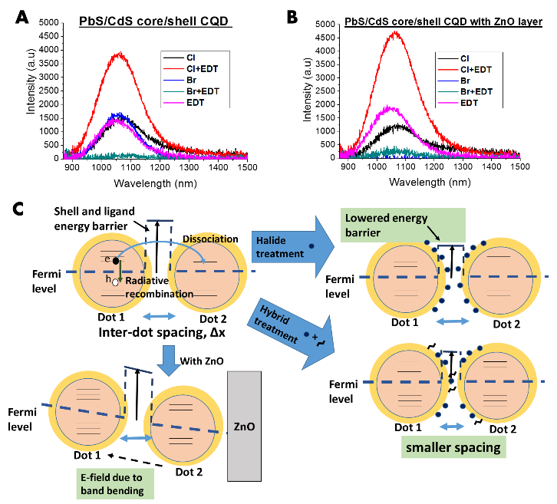

Figure 8. (a) Photoluminescence spectra of CQD films, prepared with similar thicknesses, after halide or hybrid ligand treatment. (b) Photoluminescence spectra of CQD films prepared in the same way as (a) but with an extra layer of n- type ZnO deposited (as in test device fabrication) (c) Schematic diagram illustrating the competing effect between radiative recombination and electron-hole pair dissociation. Dissociation is aided by a lowering of energy barrier for transport, the reduction of inter-particle spacing and also the band bending effect resulting from a heterojunction formation.

Table 1. Performance data for heterojunction CQD solar cells (ITO/PEDOT:PSS/CQDs/ZnO/Al) under AM 1.5 Spectral illumination (100 mW/cm²).
 | Ligand | Jsc (mA/cm²) | Voc (V) | FF | PCE (%) | Jo (mA/cm²) | Rs (Ωcm²) | Rsh (Ωcm²)
PbS | EDT | 17.9±3.5  (19.8) | 0.41± 0.09  (0.42) | 0.45± 0.06  (0.44) | 3.40± 0.22  (3.66) | (1.2±0.7)  $×$ 10-3 | 6.52±0.93 | 55.5±14.2
PbS/CdS | EDT | 5.9±1.4  (6.2) | 0.65± 0.04  (0.65) | 0.42± 0.06  (0.42) | 1.37± 0.28  (1.69) | (1.3±0.3)  $×$ 10-5 | 23.9±4.3 | 324±14
PbS/CdS | Cl | 11.2±2.3  (11.8) | 0.63± 0.03  (0.61) | 0.33± 0.04  (0.33) | 2.16± 0.14  (2.38) | (6.3±0.4)  $×$10-5 | 23.6±3.5 | 69.9±6.3
PbS/CdS | Br | 17.4±1.2  (19.4) | 0.54± 0.04  (0.55) | 0.39± 0.02  (0.39) | 3.83± 0.30  (4.16) | (5.0±0.4)  $×$10-4 | 10.1±2.4 | 61.0±4.8
PbS/CdS | Cl+  EDT | 13.8±1.9  (14.8) | 0.66± 0.03  (0.68) | 0.34± 0.03  (0.34) | 3.12± 0.22  (3.42) | (9.4±0.5)  $×$ 10-5 | 24.9±3.3 | 76.2±5.4
PbS/CdS | Br+  EDT | 21.9±2.4  (23.9) | 0.63± 0.04  (0.65) | 0.38± 0.03  (0.39) | 5.61± 0.38  (6.05) | (2.0±0.4)  $×$ 10-4 | 11.8±2.6 | 58.1±3.9
PbS/CdS CQD is with 0.1 nm CdS shell. Results are averaged with standard deviation across 12 samples on 4 different substrates. The Jsc Voc, FF and PCE of champion devices are quoted in brackets.

In summary, the addition of EDT with halide ligands improves passivation but also improves charge transport, giving rise to both improved V_{OC} and J_{SC} when compared to a bare halide treatment.

CONCLUSIONS AND FUTURE OUTLOOK
The studies reported here have shown that by using PbS/CdS core/shell CQDs, V_{OC} can be enhanced and in conjunction with a combination of passivation strategies, J_{SC} can be held at a level that increases PV device efficiency. A CdS shell layer not only provides effective surface passivation but also buffers the core electronic energies from the surface chemistry. This resulted in improved V_{OC} at the expense of Jsc. To mitigate this we have showed that it is possible to alter the energy barrier imposed by the shell material by the use of halide ligands and that the extent of passivation can be regulated by a synergistic use of both halide and bi-functional EDT ligands. Using this approach, we were able to boost the photocurrent without losing the effect of shell passivation and our best device demonstrated an impressive 6% power conversion efficiency. The device architecture presented here is comparatively simple and there is substantial capacity for further efficiency improvements with more complex architectures.

ASSOCIATED CONTENT
Supporting Information Available. Details of PbS and PbS/CdS CQD synthesis, XRD simulation, EDX, Raman spectra, Schottky cells performance and additional photoluminescence data are given. This material is available free of charge via the Internet at http://pubs.acs.org.
AUTHOR INFORMATION
Corresponding Author
* Prof. Andrew Watt (andrew.watt@materials.ox.ac.uk)
Associate Professor
Department of Materials
University of Oxford

Contact details:
Tel: +44 1865 613455 (Office room 352.10.45)
Tel: +44 7828 598301
Fax: +44 1865 273789 (general fax)
Author Contributions
The manuscript was written through contributions of all authors. All authors have given approval to the final version of the manuscript. ‡These authors contributed equally.
Funding Sources
We acknowledge funding from EPSRC (Platform Grant EP/F048009/1)
ACKNOWLEDGMENT
D.C.J.N would like to thank A*STAR for PhD overseas research scholarship.
REFERENCES
(1) Maenosono, S.; Okubo, T.; Yamaguchi, Y. Overview of Nanoparticle Array Formation by Wet Coating. J. Nanoparticle Res. 2003, 5, 5–15.
(2) Tekin, E.; Smith, P. J.; Schubert, U. S. Inkjet Printing as a Deposition and Patterning Tool for Polymers and Inorganic Particles. Soft Matter 2008, 4, 703.
(3) Choi, K.-H.; Jeong, J.-A.; Kang, J.-W.; Kim, D.-G.; Kim, J. K.; Na, S.-I.; Kim, D.-Y.; Kim, S.-S.; Kim, H.-K. Characteristics of Flexible Indium Tin Oxide Electrode Grown by Continuous Roll-to-Roll Sputtering Process for Flexible Organic Solar Cells. Sol. Energy Mater. Sol. Cells 2009, 93, 1248–1255.
(4) Beard, M. C.; Luther, J. M.; Semonin, O. E.; Nozik, A. J. Third Generation Photovoltaics Based on Multiple Exciton Generation in Quantum Confined Semiconductors. Acc. Chem. Res. 2013, 46, 1252–1260.
(5) Nozik, A. J. Photovoltaics: Separating Multiple Excitons. Nat. Photonics 2012, 6, 272–273.
(6) Wu, J.; Mangham, S. C.; Reddy, V. R.; Manasreh, M. O.; Weaver, B. D. Surface Plasmon Enhanced Intermediate Band Based Quantum Dots Solar Cell. Sol. Energy Mater. Sol. Cells 2012, 102, 44–49.
(7) Hyeon-Deuk, K.; Prezhdo, O. V. Photoexcited Electron and Hole Dynamics in Semiconductor Quantum Dots: Phonon-Induced Relaxation, Dephasing, Multiple Exciton Generation and Recombination. J. Phys. Condens. Matter 2012, 24, 363201.
(8) Pandey, A.; Guyot-Sionnest, P. Slow Electron Cooling in Colloidal Quantum Dots. Science 2008, 322, 929–932.
(9) Talapin, D. V.; Lee, J.-S.; Kovalenko, M. V.; Shevchenko, E. V. Prospects of Colloidal Nanocrystals for Electronic and Optoelectronic Applications. Chem. Rev. 2010, 110, 389–458.
(10) Lesnyak, V.; Gaponik, N.; Eychmüller, A. Colloidal Semiconductor Nanocrystals: The Aqueous Approach. Chem. Soc. Rev. 2013, 42, 2905.
(11) Semonin, O. E.; Luther, J. M.; Beard, M. C. Quantum Dots for next-Generation Photovoltaics. Mater. Today 2012, 15, 508–515.
(12) Hillhouse, H. W.; Beard, M. C. Solar Cells from Colloidal Nanocrystals: Fundamentals, Materials, Devices, and Economics. Curr. Opin. Colloid Interface Sci. 2009, 14, 245–259.
(13) Kramer, I. J.; Sargent, E. H. The Architecture of Colloidal Quantum Dot Solar Cells: Materials to Devices. Chem. Rev. 2013, 130920103133002.
(14) Jeong, K. S.; Tang, J.; Liu, H.; Kim, J.; Schaefer, A. W.; Kemp, K.; Levina, L.; Wang, X.; Hoogland, S.; Debnath, R.; et al. Enhanced Mobility-Lifetime Products in PbS Colloidal Quantum Dot Photovoltaics. ACS Nano 2012, 6, 89–99.
(15) Ehrler, B.; Musselman, K. P.; Böhm, M. L.; Morgenstern, F. S. F.; Vaynzof, Y.; Walker, B. J.; MacManus-Driscoll, J. L.; Greenham, N. C. Preventing Interfacial Recombination in Colloidal Quantum Dot Solar Cells by Doping the Metal Oxide. ACS Nano 2013, 7, 4210–4220.
(16) Gao, J.; Jeong, S.; Lin, F.; Erslev, P. T.; Semonin, O. E.; Luther, J. M.; Beard, M. C. Improvement in Carrier Transport Properties by Mild Thermal Annealing of PbS Quantum Dot Solar Cells. Appl. Phys. Lett. 2013, 102, 043506.
(17) Klem, E. J. D.; Shukla, H.; Hinds, S.; MacNeil, D. D.; Levina, L.; Sargent, E. H. Impact of Dithiol Treatment and Air Annealing on the Conductivity, Mobility, and Hole Density in PbS Colloidal Quantum Dot Solids. Appl. Phys. Lett. 2008, 92, 212105.
(18) Fischer, A.; Rollny, L.; Pan, J.; Carey, G. H.; Thon, S. M.; Hoogland, S.; Voznyy, O.; Zhitomirsky, D.; Kim, J. Y.; Bakr, O. M.; et al. Directly Deposited Quantum Dot Solids Using a Colloidally Stable Nanoparticle Ink. Adv. Mater. 2013, 25, 5742–5749.
(19) Yoon, W.; Boercker, J. E.; Lumb, M. P.; Placencia, D.; Foos, E. E.; Tischler, J. G. Enhanced Open-Circuit Voltage of PbS Nanocrystal Quantum Dot Solar Cells. Sci. Rep. 2013, 3.
(20) Bakulin, A. A.; Neutzner, S.; Bakker, H. J.; Ottaviani, L.; Barakel, D.; Chen, Z. Charge Trapping Dynamics in PbS Colloidal Quantum Dot Photovoltaic Devices. ACS Nano 2013, 7, 8771–8779.
(21) Ip, A. H.; Thon, S. M.; Hoogland, S.; Voznyy, O.; Zhitomirsky, D.; Debnath, R.; Levina, L.; Rollny, L. R.; Carey, G. H.; Fischer, A.; et al. Hybrid Passivated Colloidal Quantum Dot Solids. Nat. Nanotechnol. 2012, 7, 577–582.
(22) Liu, H.; Zhitomirsky, D.; Hoogland, S.; Tang, J.; Kramer, I. J.; Ning, Z.; Sargent, E. H. Systematic Optimization of Quantum Junction Colloidal Quantum Dot Solar Cells. Appl. Phys. Lett. 2012, 101, 151112.
(23) Ning, Z.; Zhitomirsky, D.; Adinolfi, V.; Sutherland, B.; Xu, J.; Voznyy, O.; Maraghechi, P.; Lan, X.; Hoogland, S.; Ren, Y.; et al. Graded Doping for Enhanced Colloidal Quantum Dot Photovoltaics. Adv. Mater. 2013, 25, 1719–1723.
(24) Moreels, I.; Fritzinger, B.; Martins, J. C.; Hens, Z. Surface Chemistry of Colloidal PbSe Nanocrystals. J. Am. Chem. Soc. 2008, 130, 15081–15086.
(25) Turyanska, L.; Elfurawi, U.; Li, M.; Fay, M. W.; Thomas, N. R.; Mann, S.; Blokland, J. H.; Christianen, P. C. M.; Patanè, A. Tailoring the Physical Properties of Thiol-Capped PbS Quantum Dots by Thermal Annealing. Nanotechnology 2009, 20, 315604.
(26) Law, M.; Luther, J. M.; Song, Q.; Hughes, B. K.; Perkins, C. L.; Nozik, A. J. Structural, Optical, and Electrical Properties of PbSe Nanocrystal Solids Treated Thermally or with Simple Amines. J. Am. Chem. Soc. 2008, 130, 5974–5985.
(27) Zhitomirsky, D.; Furukawa, M.; Tang, J.; Stadler, P.; Hoogland, S.; Voznyy, O.; Liu, H.; Sargent, E. H. N-Type Colloidal-Quantum-Dot Solids for Photovoltaics. Adv. Mater. Deerfield Beach Fla 2012, 24.
(28) Dai, N.; Chen, J. CdSe/ZnS Core/shell Quantum Dots for Bio-Application. In; Lu, W.; Young, J., Eds.; 2006; pp. 602904–602904–6.
(29) Zhao, H.; Chaker, M.; Wu, N.; Ma, D. Towards Controlled Synthesis and Better Understanding of Highly Luminescent PbS/CdS Core/shell Quantum Dots. J. Mater. Chem. 2011, 21, 8898.
(30) Pietryga, J. M.; Werder, D. J.; Williams, D. J.; Casson, J. L.; Schaller, R. D.; Klimov, V. I.; Hollingsworth, J. A. Utilizing the Lability of Lead Selenide to Produce Heterostructured Nanocrystals with Bright, Stable Infrared Emission. J. Am. Chem. Soc. 2008, 130, 4879–4885.
(31) Neo, M. S.; Venkatram, N.; Li, G. S.; Chin, W. S.; Ji, W. Synthesis of PbS/CdS Core−Shell QDs and Their Nonlinear Optical Properties. J. Phys. Chem. C 2010, 114, 18037–18044.
(32) Ghosh Chaudhuri, R.; Paria, S. Core/Shell Nanoparticles: Classes, Properties, Synthesis Mechanisms, Characterization, and Applications. Chem. Rev. 2012, 112, 2373–2433.
(33) Fern e, M. J.; Watt, A.; Warner, J.; Cooper, S.; Heckenberg, N.; Rubinsztein-Dunlop, H. Inorganic Surface Passivation of PbS Nanocrystals Resulting in Strong Photoluminescent Emission. Nanotechnology 2003, 14, 991–997.
(34) Lifshitz, E.; Brumer, M.; Kigel, A.; Sashchiuk, A.; Bashouti, M.; Sirota, M.; Galun, E.; Burshtein, Z.; Le Quang, A. Q.; Ledoux-Rak, I.; et al. Air-Stable PbSe/PbS and PbSe/PbSexS1-X Core-Shell Nanocrystal Quantum Dots and Their Applications. J. Phys. Chem. B 2006, 110, 25356–25365.
(35) Ning, Z.; Tian, H.; Yuan, C.; Fu, Y.; Qin, H.; Sun, L.; Ågren, H. Solar Cells Sensitized with Type-II ZnSe–CdS Core/shell Colloidal Quantum Dots. Chem. Commun. 2011, 47, 1536.
(36) Vinayakan, R.; Shanmugapriya, T.; Nair, P. V.; Ramamurthy, P.; Thomas, K. G. An Approach for Optimizing the Shell Thickness of Core-Shell Quantum Dots Using Photoinduced Charge Transfer. J. Phys. Chem. C 2007, 111, 10146–10149.
(37) Kinder, E.; Moroz, P.; Diederich, G.; Johnson, A.; Kirsanova, M.; Nemchinov, A.; O’Connor, T.; Roth, D.; Zamkov, M. Fabrication of All-Inorganic Nanocrystal Solids through Matrix Encapsulation of Nanocrystal Arrays. J. Am. Chem. Soc. 2011, 133, 20488–20499.
(38) Moroz, P.; Kholmicheva, N.; Mellott, B.; Liyanage, G.; Rijal, U.; Bastola, E.; Huband, K.; Khon, E.; McBride, K.; Zamkov, M. Suppressed Carrier Scattering in CdS-Encapsulated PbS Nanocrystal Films. ACS Nano 2013, 7, 6964–6977.
(39) Etgar, L.; Yanover, D.; Čapek, R. K.; Vaxenburg, R.; Xue, Z.; Liu, B.; Nazeeruddin, M. K.; Lifshitz, E.; Grätzel, M. Core/Shell PbSe/PbS QDs TiO ₂ Heterojunction Solar Cell. Adv. Funct. Mater. 2013, 23, 2736–2741.
(40) Hines, M. A.; Scholes, G. D. Colloidal PbS Nanocrystals with Size-Tunable Near-Infrared Emission: Observation of Post-Synthesis Self-Narrowing of the Particle Size Distribution. Adv. Mater. 2003, 15, 1844–1849.
(41) Willis, S. M.; Cheng, C.; Assender, H. E.; Watt, A. A. R. The Transitional Heterojunction Behavior of PbS/ZnO Colloidal Quantum Dot Solar Cells. Nano Lett. 2012, 12, 1522–1526.
(42) Fairclough, S. M.; Tyrrell, E. J.; Graham, D. M.; Lunt, P. J. B.; Hardman, S. J. O.; Pietzsch, A.; Hennies, F.; Moghal, J.; Flavell, W. R.; Watt, A. A. R.; et al. Growth and Characterization of Strained and Alloyed Type-II ZnTe/ZnSe Core–Shell Nanocrystals. J. Phys. Chem. C 2012, 116, 26898–26907.
(43) Balasubramanian, S.; Ceder, G.; Kolenbrander, K. D. Three-Dimensional Epitaxy: Thermodynamic Stability Range of Coherent Germanium Nanocrystallites in Silicon Host. MRS Proc. 2011, 405.
(44) Proffen, T.; Neder, R. B. DISCUS : A Program for Diffuse Scattering and Defect-Structure Simulation. J. Appl. Crystallogr. 1997, 30, 171–175.
(45) Liu, T.-Y.; Li, M.; Ouyang, J.; Zaman, M. B.; Wang, R.; Wu, X.; Yeh, C.-S.; Lin, Q.; Yang, B.; Yu, K. Non-Injection and Low-Temperature Approach to Colloidal Photoluminescent PbS Nanocrystals with Narrow Bandwidth. J. Phys. Chem. C 2009, 113, 2301–2308.
(46) Rivest, J. B.; Jain, P. K. Cation Exchange on the Nanoscale: An Emerging Technique for New Material Synthesis, Device Fabrication, and Chemical Sensing. Chem. Soc. Rev. 2013, 42, 89.
(47) Moreels, I.; Lambert, K.; Smeets, D.; De Muynck, D.; Nollet, T.; Martins, J. C.; Vanhaecke, F.; Vantomme, A.; Delerue, C.; Allan, G.; et al. Size-Dependent Optical Properties of Colloidal PbS Quantum Dots. ACS Nano 2009, 3, 3023–3030.
(48) Wyckoff, R. W. G. Crystal Structures; Wiley, 1971; Vol. 1.
(49) Zhao, H.; Chaker, M.; Ma, D. Effect of CdS Shell Thickness on the Optical Properties of Water-Soluble, Amphiphilic Polymer-Encapsulated PbS/CdS Core/shell Quantum Dots. J. Mater. Chem. 2011, 21, 17483.
(50) Zhao, H.; Wang, D.; Zhang, T.; Chaker, M.; Ma, D. Two-Step Synthesis of High-Quality Water-Soluble near-Infrared Emitting Quantum Dots via Amphiphilic Polymers. Chem. Commun. 2010, 46, 5301.
(51) Neder, R. B. Diffuse Scattering and Defect Structure Simulations: A Cook Book Using the Program DISCUS; International Union of Crystallography book series; Oxford University Press: Oxford, 2008.
(52) Zhao, N.; Osedach, T. P.; Chang, L.-Y.; Geyer, S. M.; Wanger, D.; Binda, M. T.; Arango, A. C.; Bawendi, M. G.; Bulovic, V. Colloidal PbS Quantum Dot Solar Cells with High Fill Factor. ACS Nano 2010, 4, 3743–3752.
(53) Zhitomirsky, D.; Kramer, I. J.; Labelle, A. J.; Fischer, A.; Debnath, R.; Pan, J.; Bakr, O. M.; Sargent, E. H. Colloidal Quantum Dot Photovoltaics: The Effect of Polydispersity. Nano Lett. 2012, 12, 1007–1012.
(54) Xu, F.; Ma, X.; Haughn, C. R.; Benavides, J.; Doty, M. F.; Cloutier, S. G. Efficient Exciton Funneling in Cascaded PbS Quantum Dot Superstructures. ACS Nano 2011, 5, 9950–9957.
(55) Foos, E. E. The Complex Interaction of Spectroscopic Shifts and Electronic Properties in Semiconductor Nanocrystal Films. J. Phys. Chem. Lett. 2013, 4, 625–632.
(56) Kovalenko, M. V.; Scheele, M.; Talapin, D. V. Colloidal Nanocrystals with Molecular Metal Chalcogenide Surface Ligands. Science 2009, 324, 1417–1420.
(57) Kovalenko, M. V.; Bodnarchuk, M. I.; Zaumseil, J.; Lee, J.-S.; Talapin, D. V. Expanding the Chemical Versatility of Colloidal Nanocrystals Capped with Molecular Metal Chalcogenide Ligands. J. Am. Chem. Soc. 2010, 132, 10085–10092.
(58) Nag, A.; Kovalenko, M. V.; Lee, J.-S.; Liu, W.; Spokoyny, B.; Talapin, D. V. Metal-Free Inorganic Ligands for Colloidal Nanocrystals: S^{2–}, HS–, Se^{2–}, HSe–, Te^{2–}, HTe–, TeS₃^{2–}, OH– , and NH₂– as Surface Ligands. J. Am. Chem. Soc. 2011, 133, 10612–10620.
(59) Fafarman, A. T.; Koh, W.; Diroll, B. T.; Kim, D. K.; Ko, D.-K.; Oh, S. J.; Ye, X.; Doan-Nguyen, V.; Crump, M. R.; Reifsnyder, D. C.; et al. Thiocyanate-Capped Nanocrystal Colloids: Vibrational Reporter of Surface Chemistry and Solution-Based Route to Enhanced Coupling in Nanocrystal Solids. J. Am. Chem. Soc. 2011, 133, 15753–15761.
(60) Bae, W. K.; Joo, J.; Padilha, L. A.; Won, J.; Lee, D. C.; Lin, Q.; Koh, W.; Luo, H.; Klimov, V. I.; Pietryga, J. M. Highly Effective Surface Passivation of PbSe Quantum Dots through Reaction with Molecular Chlorine. J. Am. Chem. Soc. 2012, 134, 20160–20168.
(61) Ning, Z.; Ren, Y.; Hoogland, S.; Voznyy, O.; Levina, L.; Stadler, P.; Lan, X.; Zhitomirsky, D.; Sargent, E. H. All-Inorganic Colloidal Quantum Dot Photovoltaics Employing Solution-Phase Halide Passivation. Adv. Mater. 2012, 24, 6295–6299.
(62) Zanella, M.; Maserati, L.; Pernia Leal, M.; Prato, M.; Lavieville, R.; Povia, M.; Krahne, R.; Manna, L. Atomic Ligand Passivation of Colloidal Nanocrystal Films via Their Reaction with Propyltrichlorosilane. Chem. Mater. 2013, 25, 1423–1429.
(63) Tang, J.; Kemp, K. W.; Hoogland, S.; Jeong, K. S.; Liu, H.; Levina, L.; Furukawa, M.; Wang, X.; Debnath, R.; Cha, D.; et al. Colloidal-Quantum-Dot Photovoltaics Using Atomic-Ligand Passivation. Nat. Mater. 2011, 10, 765–771.
(64) Wuister, S. F.; de Mello Donegá, C.; Meijerink, A. Influence of Thiol Capping on the Exciton Luminescence and Decay Kinetics of CdTe and CdSe Quantum Dots. J. Phys. Chem. B 2004, 108, 17393–17397.
(65) Barkhouse, D. A. R.; Pattantyus-Abraham, A. G.; Levina, L.; Sargent, E. H. Thiols Passivate Recombination Centers in Colloidal Quantum Dots Leading to Enhanced Photovoltaic Device Efficiency. ACS Nano 2008, 2, 2356–2362.
(66) Greenham, N. C.; Peng, X.; Alivisatos, A. P. Charge Separation and Transport in Conjugated Polymer/cadmium Selenide Nanocrystal Composites Studied by Photoluminescence Quenching and Photoconductivity. Synth. Met. 1997, 84, 545–546.
(67) Cai, C. F.; Zhang, B. P.; Li, R. F.; Wu, H. Z.; Xu, T. N.; Zhang, W. H.; Zhu, J. F. Band Alignment Determination of ZnO/PbSe Heterostructure Interfaces by Synchrotron Radiation Photoelectron Spectroscopy. EPL Europhys. Lett. 2012, 99, 37010.

Table of content
Darren C. J. Neo, Cheng Cheng, Samuel D. Strank², Simon M. Fairclough, Judy S. Kim, Angus I. Kirkland, Jason M. Smit¹, Henry J. Snaith, Hazel E. Assender, Andrew A. R. Watt *  Core/Shell Colloidal Quantum Dot Solar Cells | A shell material reduces surface defects and also buffers incomplete passivation during ligand exchange. While this results in an improvement of open-circuit voltage, charge transport is impeded. A strategy that combines shell passivation with ligand treatment offers a balance between defect mediation and charge transport, thus improving overall device performance. | 