Supporting Information

Dental Resin Monomer Enables Unique NbO₂/Carbon Lithium-Ion Battery Negative Electrode with Exceptional Performance
Qing Ji, Xiangwen Gao, Qiuju Zhang, Liyu Jin, Da Wang, Yonggao Xia,* Shanshan Yin, Senlin Xia, Nuri Hohn, Xiuxia Zuo, Xiaoyan Wang, Shuang Xie, Zhuijun Xu, Liujia Ma, Liang Chen, George Chen, Jin Zhu,* Binjie Hu,* Peter Müller-Buschbaum, Peter G Bruce, Ya-Jun Cheng*

Qing Ji, Dr. Qiuju Zhang, Prof. Yonggao Xia, Dr. Xiuxia Zuo, Xiaoyan Wang, Shuang Xie, Zhuijun Xu, Liujia Ma, Prof. Liang Chen, Prof. Jin Zhu and Prof. Ya-Jun Cheng
Ningbo Institute of Materials Technology and Engineering, Chinese Academy of Sciences, 1219 Zhongguan West Road, Zhenhai District
Ningbo 315201, People’s Republic of China
Email: xiayg@nimte.ac.cn, jzhu@nimte.ac.cn, chengyj@nimte.ac.cn

Qing Ji, Prof. George Chen and Dr. Binjie Hu
The University of Nottingham Ningbo China, 199 Taikang East Road
Ningbo 315100, People’s Republic of China
Email: Binjie.hu@nottingham.edu.cn

Dr. Xiangwen Gao, Dr. Liyu Jin, Dr. Da Wang, Prof. Peter G Bruce and Prof. Ya-Jun Cheng
Department of Materials, University of Oxford, Parks Rd
Oxford, OX1 3PH, United Kingdom

Prof. Yonggao Xia
Center of Materials Science and Optoelectronics Engineering，University of Chinese Academy of Sciences, 19A Yuquan Rd, Shijingshan District
Beijing 100049, P. R. China

Shanshan Yin, Dr. Senlin Xia, Dr. Nuri Hohn and Prof. Peter Müller-Buschbaum
Physik-Department, Lehrstuhl für Funktionelle Materialien, Technische Universität München, James-Franck-Str. 1
Garching 85748, Germany

Dr. Xiaoyan Wang, Shuang Xie and Zhuijun Xu
University of Chinese Academy of Sciences, 19A Yuquan Rd, Shijingshan DistrictBeijing 100049, People’s Republic of China

Liujia Ma
State Key Laboratory of Separation Membranes and Membrane Processes, Tianjin Polytechnic University
Tianjin 300387, People’s Republic of China

Prof. George Chen
University of Nottingham, University Park
Nottingham NG7 2RD, United Kingdom

Prof. Peter Müller-Buschbaum
Heinz Maier-Leibnitz Zentrum (MLZ), Technische Universität München, Lichtenbergstr. 1,
Garching 85748, Germany

Prof. Peter G Bruce
The Henry Royce Institute, Parks Road, Oxford, OX1 3PH, United Kingdom
The Faraday Institution, Quad One, Becquerel Avenue, Harwell Campus, Didcot, OX11 0RA, United Kingdom

Qing Ji, Dr. Xiangwen Gao, Dr. Qiuju Zhang, and Dr. Liyu Jin contribute equally to this work.

Synthesis of niobium oxide/carbon samples with different Bis-GMA/NbETO mass ratios
Control samples were prepared with similar procedures to the NbO₂/carbon nanohybrids. Bis-GMA and NbETO were mixed with different mass ratios (1:0, 4:1, 2:1, 1:1 and 1:1.5 by stirring (ca. 800 rpm) and heating at around 100 °C until a clear solution was observed. TBPB (2 %, mass fraction) was then dropped into the solution mixture and homogenized by a Fisherbrand analog vortex mixer at 1500 rpm for 30 seconds. The as-prepared solution was cured under 150 °C for 2 h. The calcination process was applied on the polymerized samples at 900 °C under argon/hydrogen flow (volume ratio: 95:5) for 4 hours in a tube furnace with a ramp rate of 5 °C min⁻¹ from room temperature. After calcination, the samples were cooled down to room temperature with the same ramp rate. The calcined niobium oxide/carbon nanohybrid powder was then ball-milled with a speed of 550 rpm for 30 min (Retsch, PM 100).

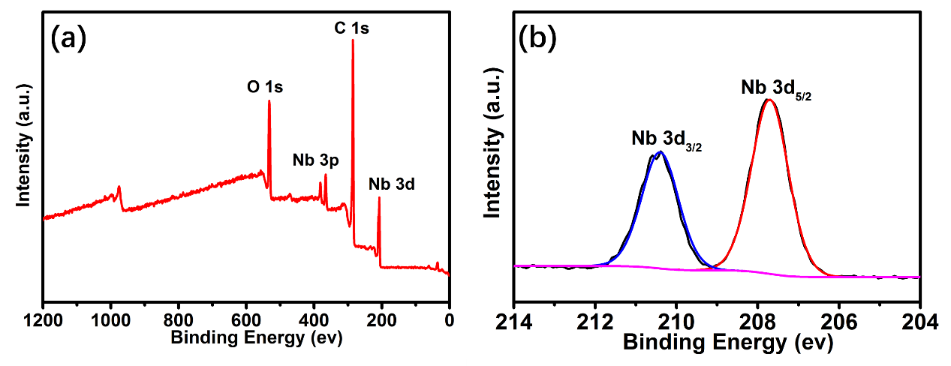
Figure S1. a) Survey and b) high resolution Nb_{3d} X-ray photon spectroscopy (XPS) spectra of the NbO₂/carbon nanohybrids.
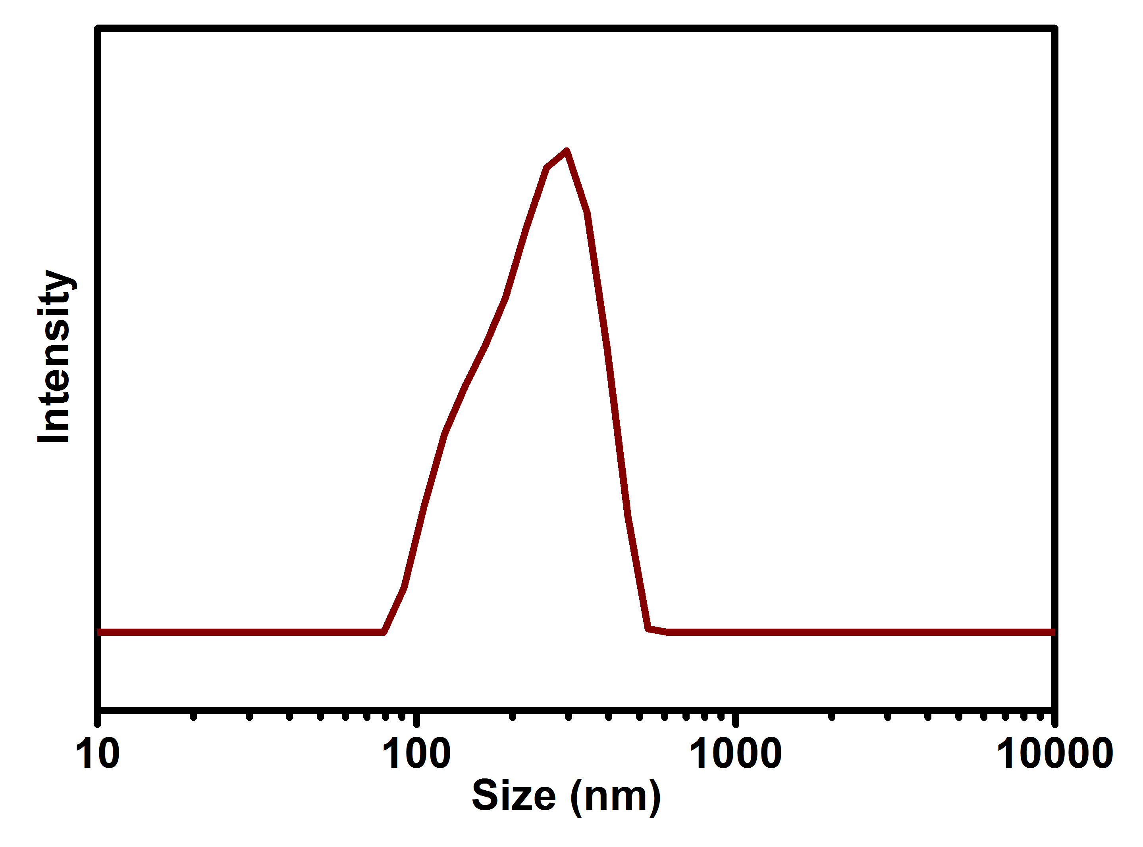
Figure S2. Particle size distribution curve of the NbO₂/carbon nanohybrids with the average size peak located at 334 nm (D₉₀).
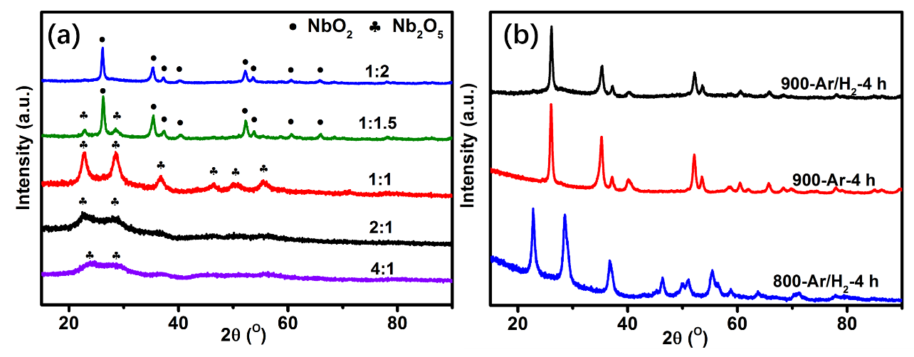
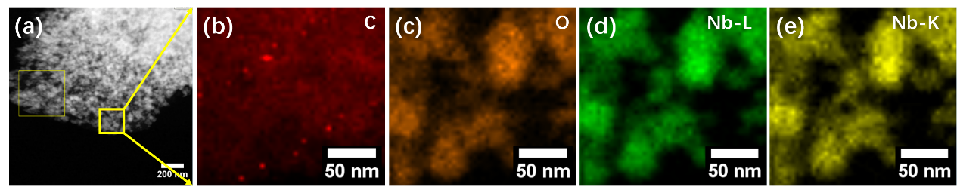
Figure S3. Element distribution profiles of the NbO₂/carbon nanohybrids characterized with STEM. a) Morphology image; element distribution images: b) carbon; c) oxygen; d) Nb-L; e) Nb-K.
Figure S4. a) XRD patterns of the Niobium oxide/carbon nanohybrids prepared with different Bis-GMA/NbETO mass ratios and b) XRD patterns of the niobium oxide/carbon nanohybrids after different calcination processes.

In case of the Bis-GMA/NbETO mass ratios of 4:1, 2:1 and 1:1, broad Bragg peaks of hexagonal Nb₂O₅ are observed, indicating a poor crystallization, while the peaks become sharp with increasing NbETO content. Niobium oxide/carbon nanohybrids with a mass ratio of 1:1.5 present both hexagonal Nb₂O₅ and tetragonal NbO₂ phases. According to a reference intensity ratio (RIR) method, the quantities of NbO₂ and Nb₂O₅ are 72.1 % and 27.9 %, respectively.
Figure S5. N₂ adsorption/desorption isotherms (a, b, d and e) and corresponding Barret-Joyner-Halenda (BJH) pore size distribution curves (c, e, and f) of the niobium oxide/carbon nanohybrids prepared with different Bis-GMA/NbETO mass ratios: 4:1 (a), 2:1 (b, c), 1:1 (d, e) and 1:1.5 (f, g).

The samples synthesized with the Bis-GMA/NbETO mass ratio of 4:1, 2:1 and 1:1 (Figure S5a, b and d) present type I adsorption/desorption isotherms. Vast hysteresis throughout the all pressures between the adsorption and desorption cycles are found for the samples with mass ratio of 4:1 2:1 and 1:1, indicating a microporous structure inherited from the glassy carbon. Based on the BJH method, the average pore size of the three samples is less than 2 nm, which further confirms the microporous structure. Typical type IV isotherms are displayed in the samples with the mass ratio of 1:1.5 (Figure S5f). An H2 hysteresis loop is present, indicating capillary condensation from the mesopores. Average pore size of around 3 nm is revealed with the BJH method, which is consistent with the adsorption/desorption profiles.

Table S1. BET surface area of the niobium oxide/carbon nanohybrids prepared with different Bis-GMA/NbETO mass ratios.
Sample code | bare carbon | 4:1 | 2:1 | 1:1 | 1:1.5 | 1:2
BET Surface area (m²g⁻¹) | 1.4 | 7.1 | 33.8 | 157 | 207 | 175
carbon content (%) | 100 | 70 | 55 | 40 | 29 | 21
carbon based BET surface area(m²g⁻¹)^{a)} | 1.4 | 10.2 | 61.4 | 392 | 714 | 833
pore volume (cm³g⁻¹) | 0.0012 | 0.00031 | 0.0023 | 0.042 | 0.10 | 0.15
^{a)}Note: carbon based specific surface area is estimated by dividing the experimental BET specific surface area with the actual carbon content.

The BET surface area data shows an increased specific surface area with decreased Bis-GMA/NbETO mass ratio down to 1:1.5. The reduced specific surface area of the sample with the mass ratio of 1:2 is due to the reduced carbon content. The specific surface areas of the niobium oxide/carbon nanohybrids mainly have three origins: the carbon matrix, the niobium oxide nanoparticles, and the interface between the niobium oxide nanoparticle and carbon matrix. It is well recognized that the mesopores residing in the carbon matrix make a major contribution to the overall specific surface area; while the solid niobium oxide particles contributes less to the surface area. Therefore, when considering the specific surface area is derived against the mass of the carbon only, it can be found that the BET surface area increases monotonically from 1.4 m²g⁻¹ to 833 m²g⁻¹ with the increasing NbETO content.
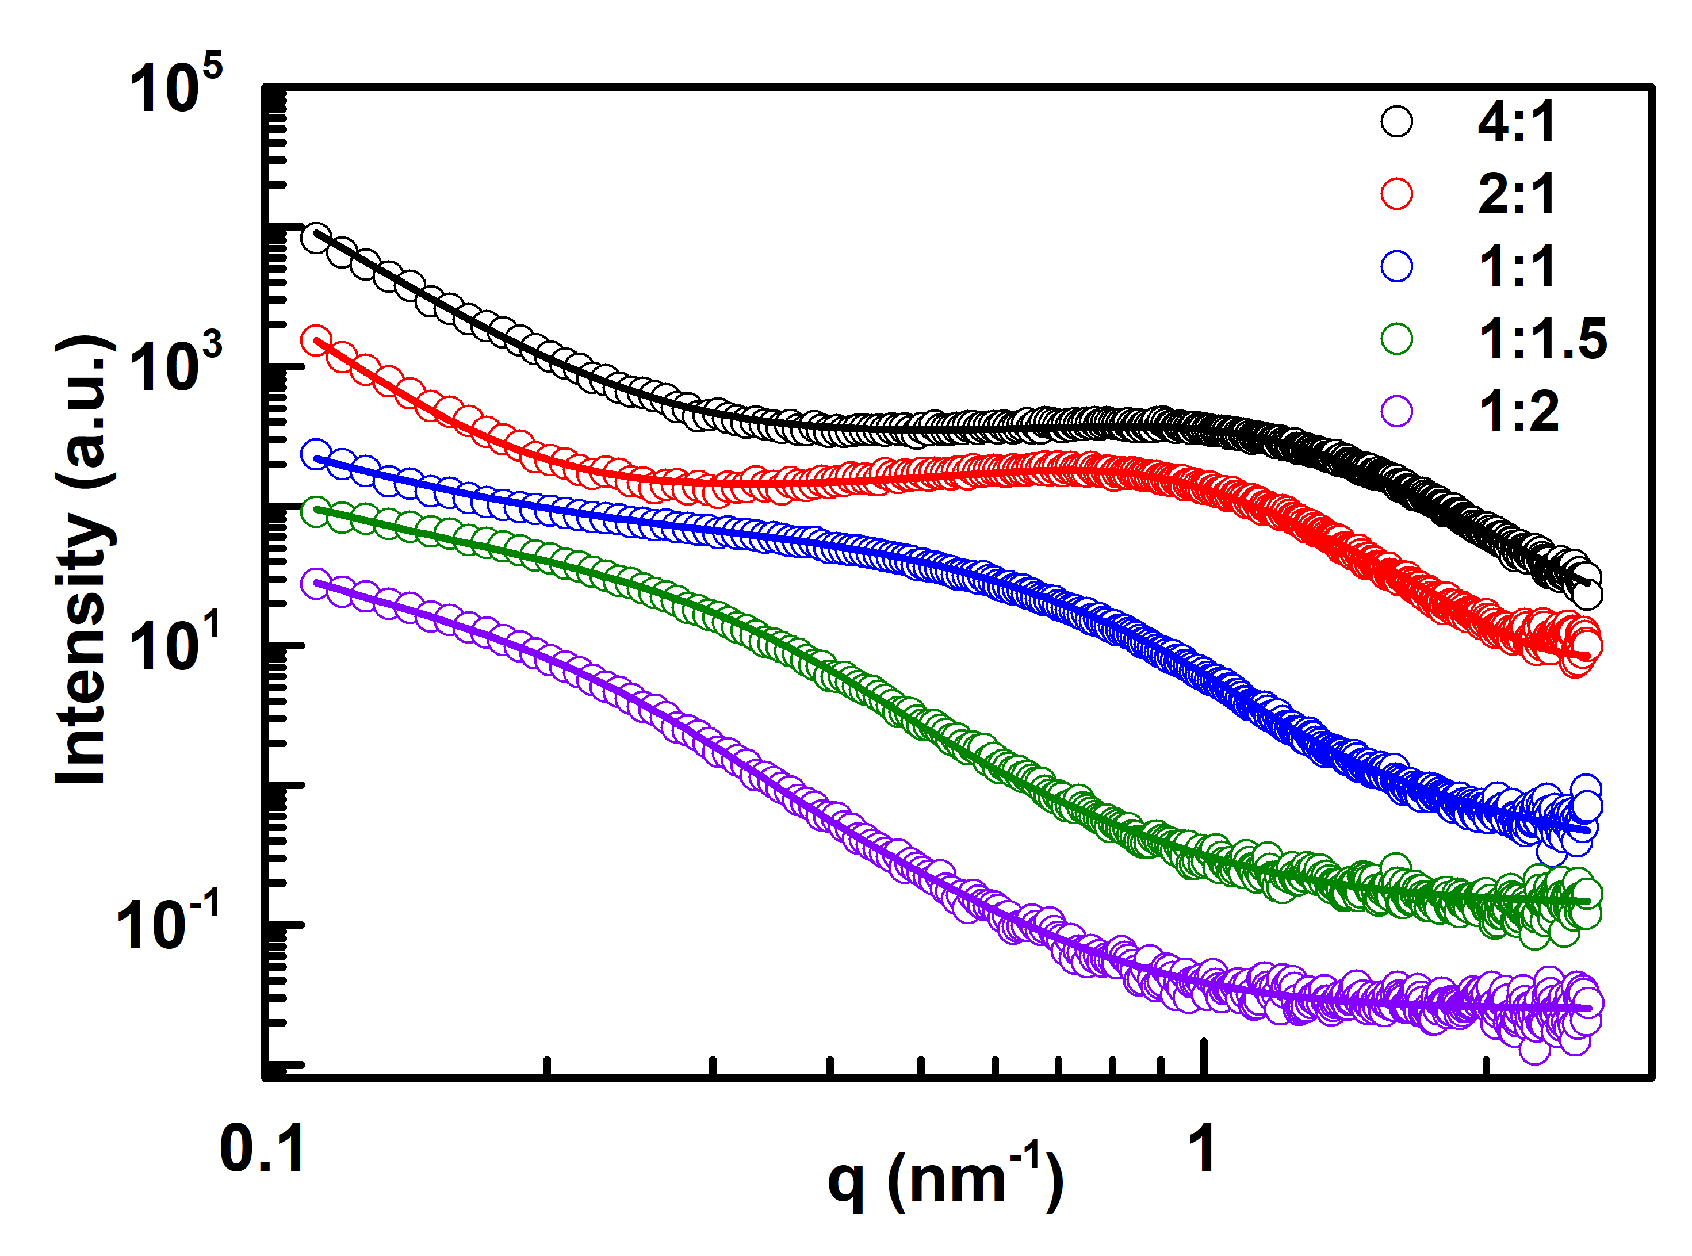
Figure S6. SAXS data (circles) with fits (solid lines) of the niobium oxide/carbon nanohybrids prepared with different Bis-GMA/NbETO mass ratios as indicated.

The SAXS data are fitted with a spherical form factor assuming a Gaussian distribution function (Table S2). Furthermore, a hard sphere structure factor is used with a monodisperse approximation to account for the average center-to-center distances of the scattering objects. The form factor is steadily increasing with decreasing the carbon content. This behavior matches the observed tendency of forming larger crystals as seen in the X-ray diffraction (XRD) and transmission electron microscopy (TEM) data. However, note that the absolute values do not match the determined sizes of crystals from XRD and TEM data, because SAXS is as well sensitive to the amorphous material in the sample and not limited to the crystalline constitutes. Thus, from the comparison with XRD and TEM the fraction of amorphous materials can be estimated. The structure factor is as well increasing with decreasing carbon content. However, the contribution of the structure factor is very small for the sample with a mass ratio of 1:1 (as can be seen by the according volume fraction of 0.03 used for the fitting) and fully disappears for an even smaller NbETO content.

Table S2. Form factor and structure factor of the niobium oxide/carbon nanohybrids after modelling with Gaussian distribution function.
Sample | Form Factor (nm) |  |  | Structure Factor (nm)
Sample | x₀ª | s^{b} | N^{c} | RHS^{d} | fp^{e}
4:1 | 0.9 | 0.5 | 27 | 2.4 | 0.1
2:1 | 1.6 | 0.4 | 19 | 3.2 | 0.11
1:1 | 2.1 | 0.9 | 3 | 5.9 | 0.03
1:1.5 | 4.2 | 2.5 | 0.18 | / | /
1:2 | 4.8 | 4.1 | 0.01 | / | /
ªx_{0:} sphere radius. ^{b}s: sigma of Gaussian distributed radius. ^{c}N: amplitude of Gaussian distribution. ^{d}RHS: hard sphere repulsion radius. ^{e}fp: volume fraction.

Figure S7. Schematic process of formation of a) glassy carbon and b) NbO₂/carbon nanohybrids.

Bis-GMA is first cured to form cross-linking network through double bonds. When heated at 300 °C - 400 °C, internal condensation occurs between cured Bis-GMA chains through dehydration, which induces the formation of aromatic ribbon molecules (Figure S7a). With further pyrolysis, intermolecular crosslinks are formed between condensed benzene rings and thus, glassy carbon forms. However, the incorporation of NbETO occupies the dehydration point (hydroxyl groups) (Figure S7b), which precludes the intermolecular condensation of Bis-GMA chains. Consequently, formation of glassy carbon is restricted.
Figure S8. ¹H NMR (a, b) and FT-IR spectra (c) of Bis-GMA and mixture of Bis-GMA and NbETO.

NMR was conducted with chloroform-d (CDCl₃) as the solvent. The broad peak at 2.5 ppm from NMR and 3501 cm⁻¹ from FT-IR of Bis-GMA present the hydroxyl groups, respectively.^{[1]} After incorporation of NbETO, the peaks of hydroxyl groups vanish both in NMR and FT-IT spectra, which confirms alcoholysis reaction takes place between Bis-GMA and NbETO.
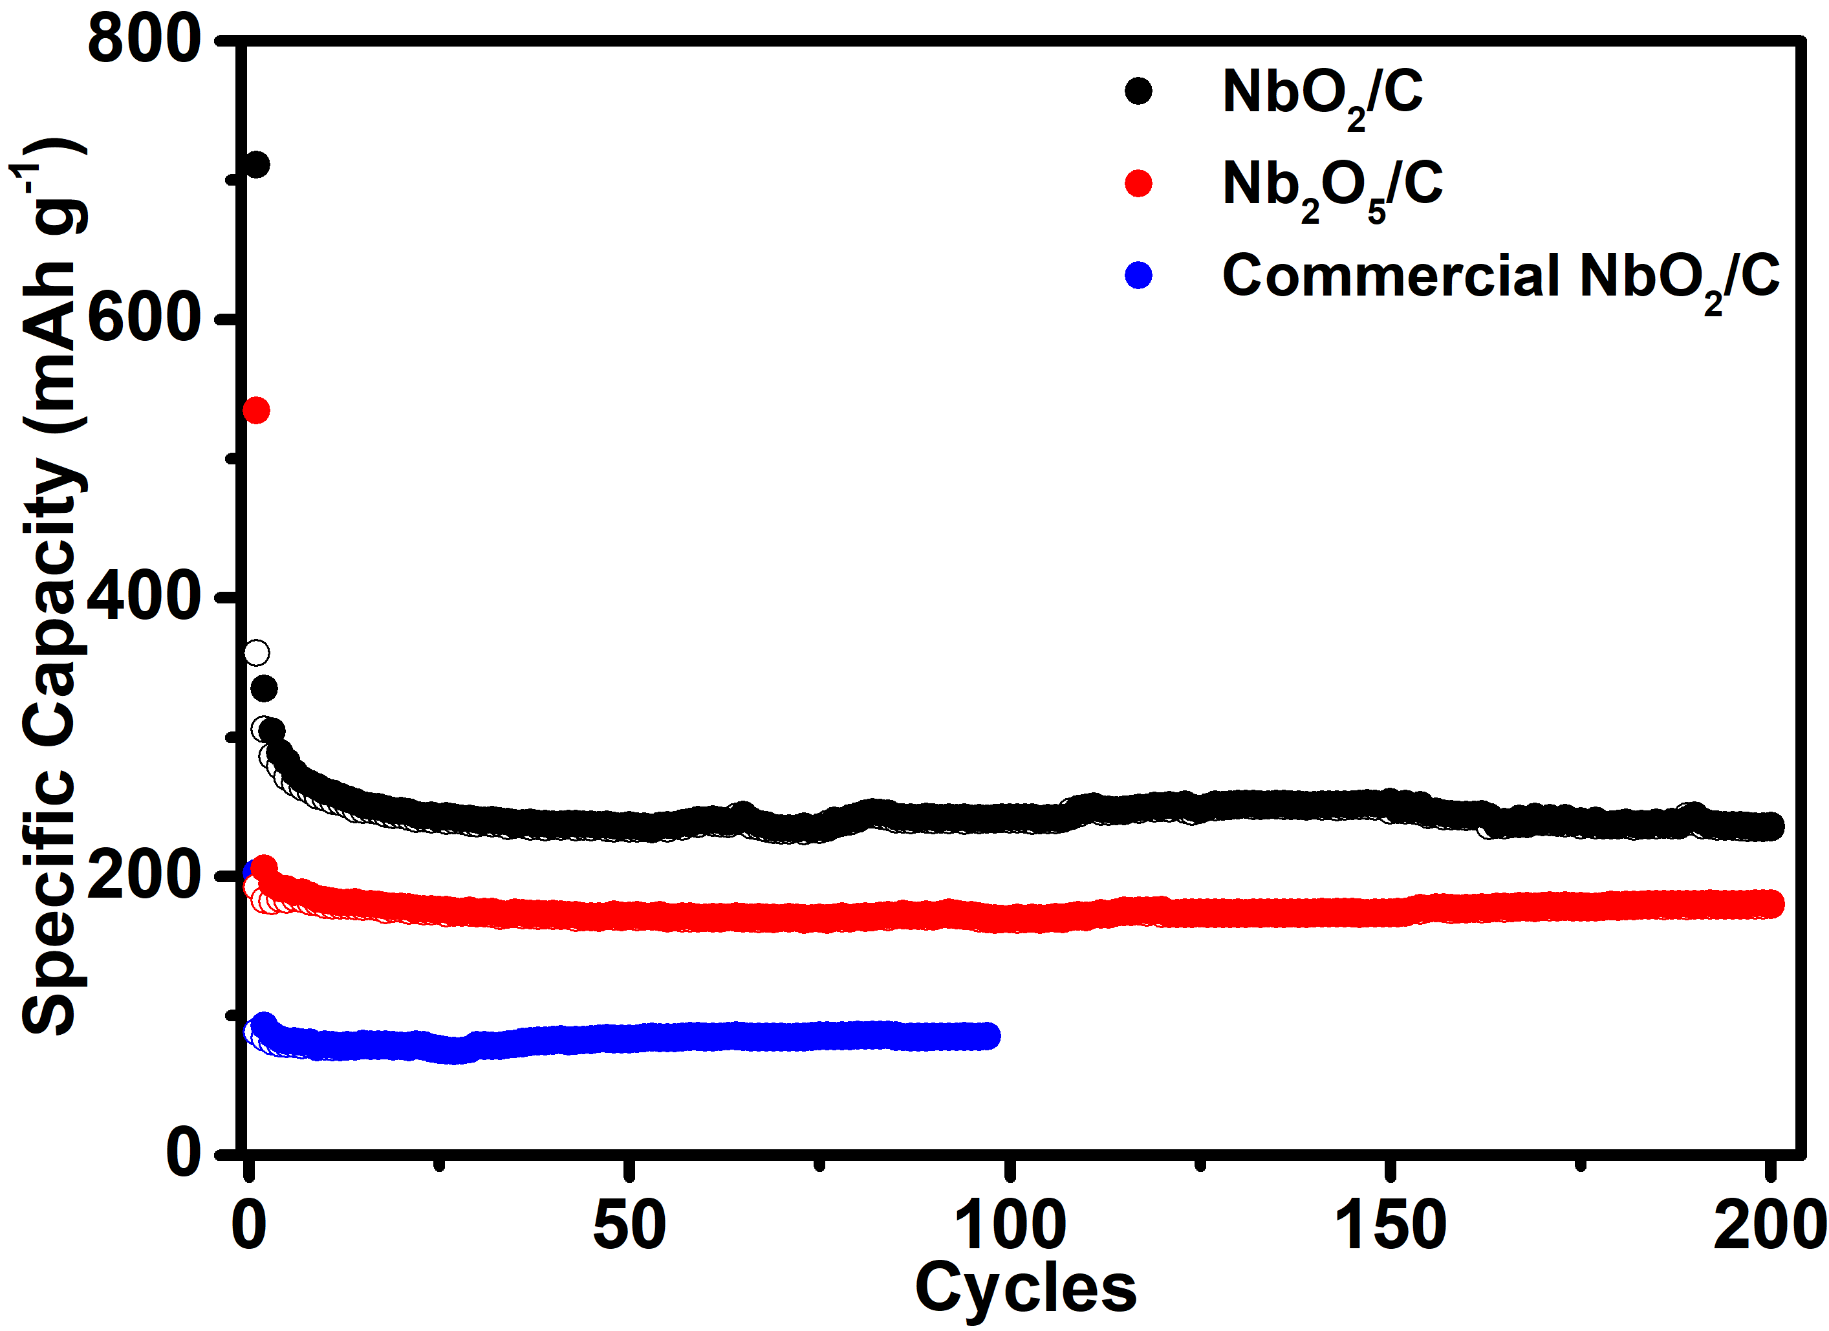
Figure S9. Cycling performance comparison of niobium oxides/carbon nanohybrids at a current density of 40 mA g⁻¹. Black: NbO₂/C nanohybrids from this work. Red: Nb₂O₅/C synthesized from Bis-GMA/NbETO mass ratio of 1:1. Blue: Commercial NbO₂/C composites (NbO₂ and carbon were mixed by balling milling with carbon content of 21 %).

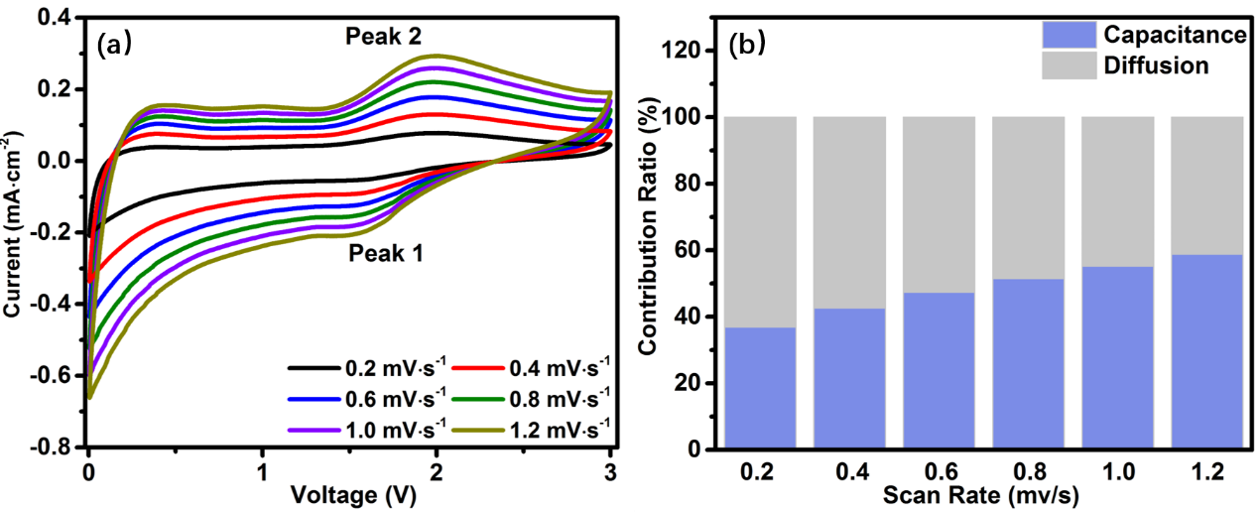
Figure S10. Kinetic analysis of lithium ion storage mechanism. a) CV profiles at various scan rates (0.2, 0.4, 0.6, 0.8, 1.0 and 1.2 mV s⁻¹₎ after the three initial cycles at 0.1 mV s⁻¹. b) Contribution ratio of capacitive and diffusion-controlled capacities at different scan rates. The contribution of diffusion process and capacitance process could be extracted from the following equation:^{[2]}
$i=k_{1}ν+k_{2}ν^{1/2}$ (3)
where $k_{1}ν$ stands for the contribution of surface capacitance and $k_{2}ν^{1/2}$ stands for the contribution of diffusion-controlled process. The contribution of capacitance is less 30 % at a scan rate of 0.2 mV s⁻¹, indicating a diffusion control process.
In addition, the lithium diffusion coefficient (D_{Li}⁺, cm² s⁻¹) is extracted from the Randles Sevcik equation based on peak current (I_{p}, A) from CV curves:^{[3]}
$$I_{p}=2.69×{10}^{5}n^{3/2}AD^{1/2}v^{1/2}C$$
Where n is the number of electrons involved in the lithium insertion process, A is the area of electrode (cm²), v is the scan rate (V s⁻¹) and C is the molar concentration of lithium ions. D_{Li+} is estimated as$1.26×{10}^{-11}{cm}^{2}s^{-1}$.

Table S3. Capacity comparison of the NbO₂ based negative electrodes to literature.
Electrode | Electrolyte | Cycling Stability |  |  | Ref.
Electrode | Electrolyte | Discharge Capacity (mAh g⁻¹) | After n^{th} cycle | Current Density (mAh g⁻¹) | Ref.
Etched NbO₂ | 1M LiClO₄ EC/DEC | 200 | 3 | 42.9 | ^{[4]}
Carbon-coated NbO₂ | 1M LiClO₄ EC/DEC | 200 | 5 | 42.9 | ^{[5]}
NbO₂@C hollow spheres | 1M LiPF₆ EC/DMC/  EMC | 140 | 1 | / | ^{[6]}
NbO₂ nanoparticles | 1M LiPF₆ EC/DEC | 0.65  (mAh cm⁻²) | 20 | / | ^{[7]}
Li₄Ti₅O₁₂/carbon^{a)} nanohybrid | 1M LiPF₆ EC/DMC | 185 | 1000 | 175 | ^{[8]}
NbO₂/C nanohybrid | 1M LiPF₆ EC/DMC | 225 | 500 | 200 | This Work
^{a)}Note: The Li₄Ti₅O₁₂/Carbon nanohybrids are synthesized in similar way to this work.

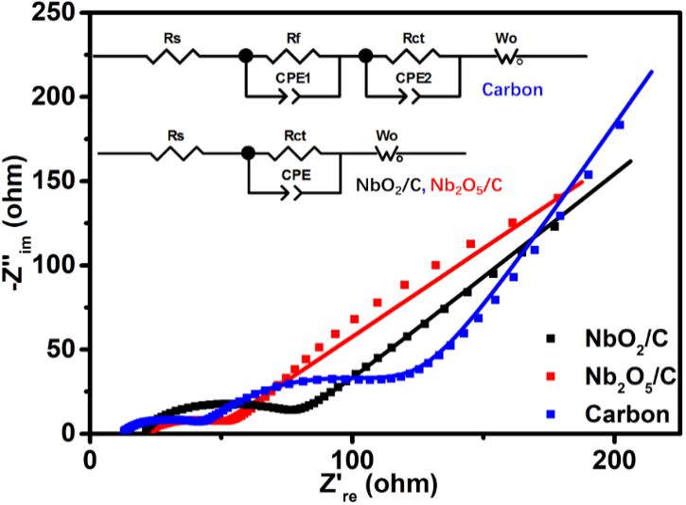
Figure S11. Electrochemical impedance spectra (EIS) after 20 cycles. Black: NbO₂/C nanohybrids from this work (synthesized from Bis-GMA/NbETO mass ratio of 1:2). Red: Nb₂O₅/C synthesized from Bis-GMA/NbETO mass ratio of 1:1. Blue: Pure carbon derived from Bis-GMA.

The NbO₂/carbon nanohybrid presents a low R_{ct} (charge transfer resistance) less than 100 Ω. The low R_{ct} could be mainly assigned to the high conductivity from glassy-carbon structured matrix. However, it is higher than those of the Nb₂O₅/C nanohybrid and pure carbon as well, which are prepared with higher Bis-GMA/NbETO mass ratios. The increased NbETO content partially suppresses the formation of glassy carbon through alcoholysis reaction between NbETO and hydroxyl group. In addition, pure carbon presents additional semicircles, which could be attributed to the formation of solid electrolyte interphase (SEI).
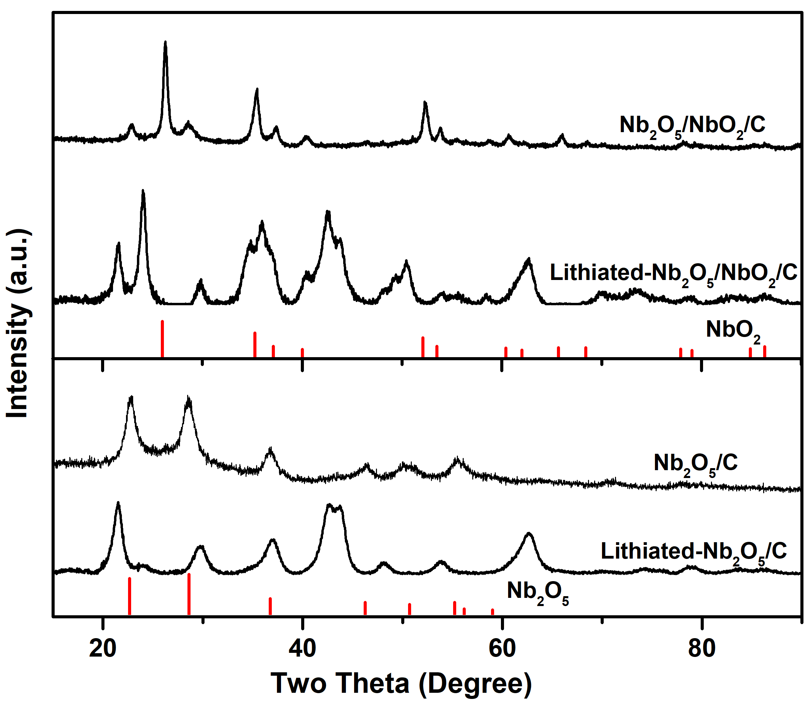
Figure S12. Ex-situ XRD patterns of pristine and lithiated Nb₂O₅/C and NbO₂/Nb₂O₅/C nanohybrids.

[1] a) K.-D. Ahn, C.-M. Chung, Y.-H. Kim, J. Appl. Polym. Sci. 1999, 71, 2033; b) R. Wang, M. Zhu, S. Bao, F. Liu, X. Jiang, M. Zhu, J. Mater. Sci. Res. 2013, 2.
[2] V. Augustyn, J. Come, M. A. Lowe, J. W. Kim, P.-L. Taberna, S. H. Tolbert, H. D. Abruña, P. Simon, B. Dunn, Nature materials 2013, 12, 518.
[3] J. R. Dahn, J. Jiang, L. M. Moshurchak, M. D. Fleischauer, C. Buhrmester, L. J. Krause, Journal of The Electrochemical Society 2005, 152, A1283.
[4] Y. H. Cho, S. K. Jeong, Y. S. Kim, Adv. Mater. Res. 2015, 1120-1121, 115.
[5] C. S. Kim, Y. H. Cho, K. S. Park, S. K. Jeong, Y. S. Kim, presented at Key Eng. Mater. 2017.
[6] L. Kong, C. Zhang, J. Wang, W. Qiao, L. Ling, D. Long, Sci. Rep. 2016, 6, 21177.
[7] H. D. Asfaw, C.-W. Tai, L. Nyholm, K. Edström, ChemNanoMat 2017, 3, 646.
[8] L. Zheng, X. Wang, Y. Xia, S. Xia, E. Metwalli, B. Qiu, Q. Ji, S. Yin, S. Xie, K. Fang, S. Liang, M. Wang, X. Zuo, Y. Xiao, Z. Liu, J. Zhu, P. Muller-Buschbaum, Y. J. Cheng, ACS Appl. Mater. Interfaces 2018, 10, 2591.
Reference

