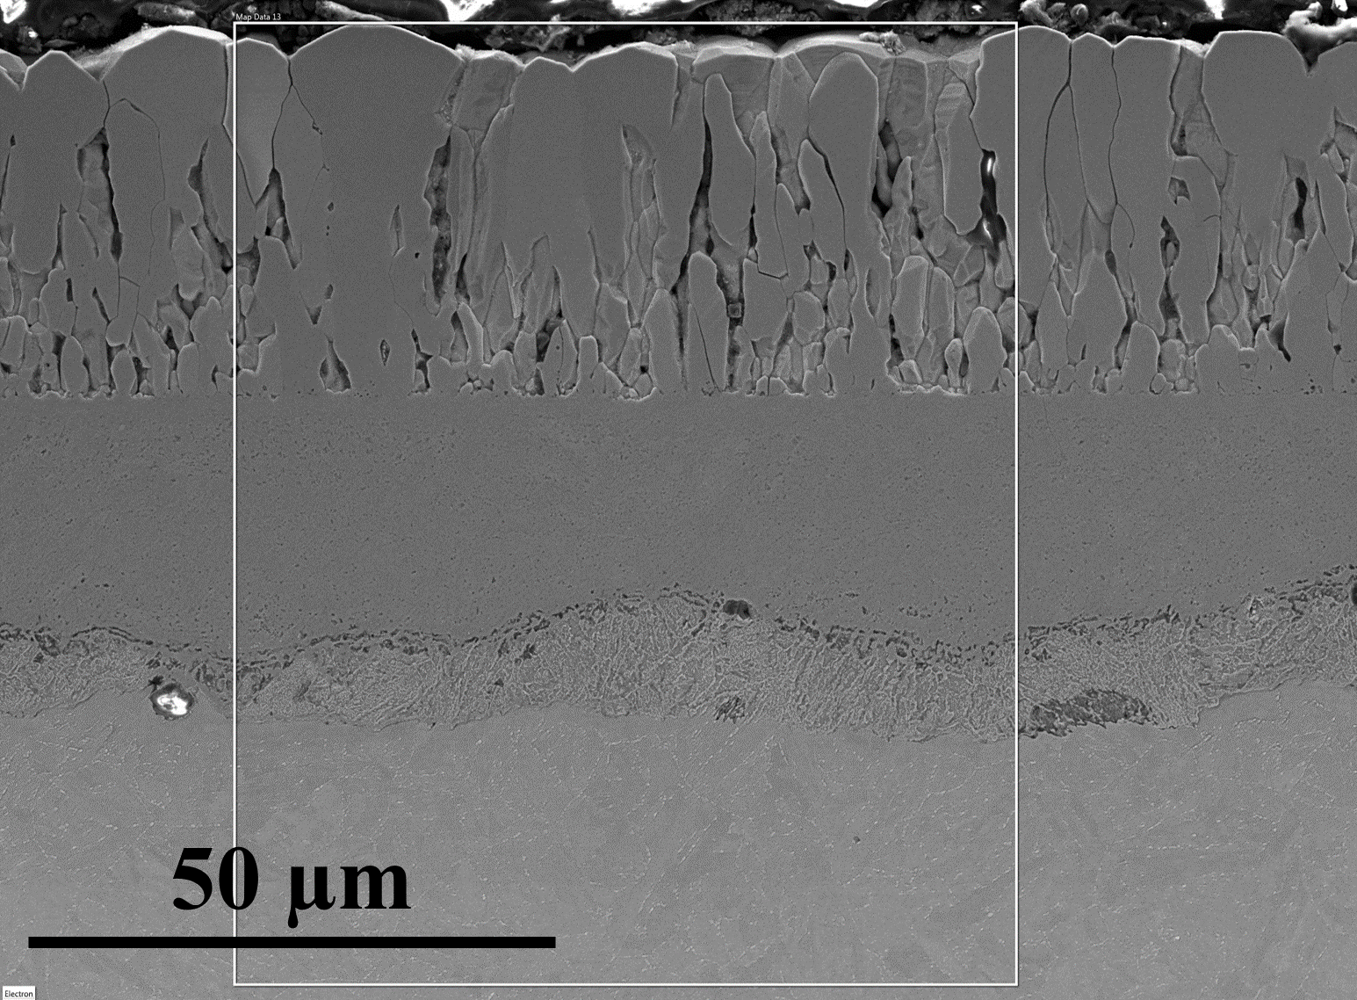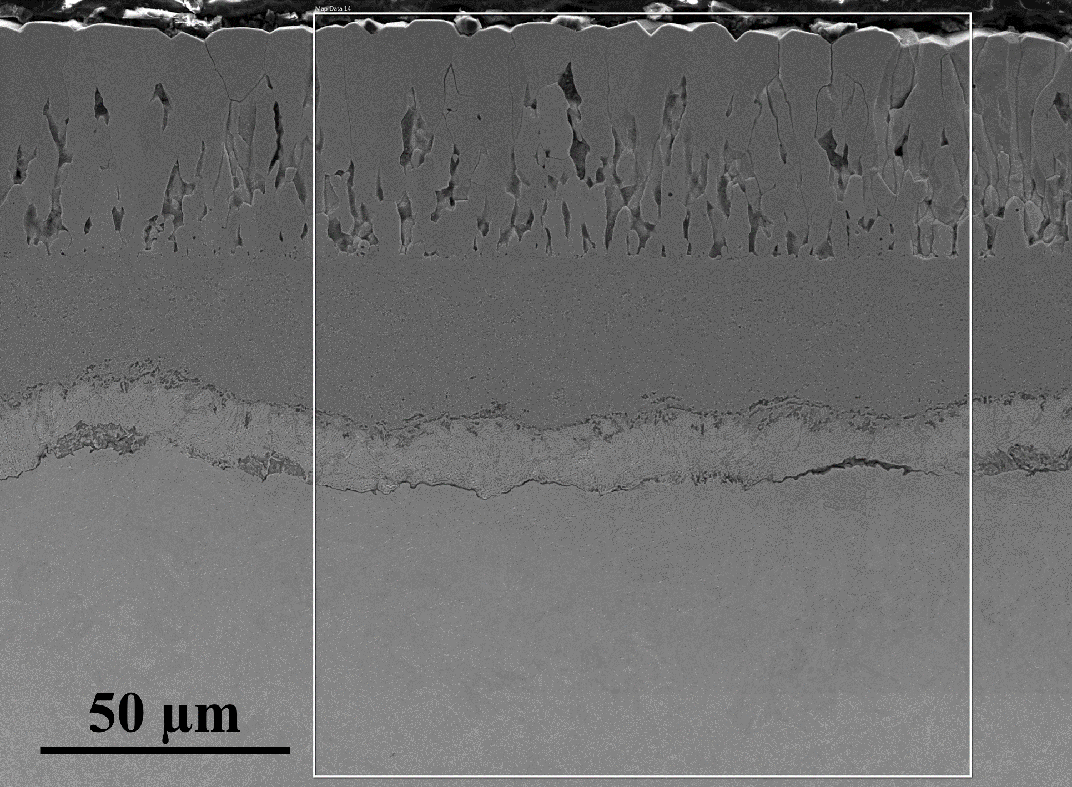
(a) (b)
Fig. S1. SEM SE images showing the porous outer oxide layer after exposure to high-temperature steam for (a) 600h and (b) 1500h.

