Supporting Information

Group 4 constrained geometry complexes for olefin (co)polymerisation

Thomas J. Williams, Alexander D. H. Smith, Jean-Charles Buffet, Zoë R. Turner and Dermot O'Hare*

Chemistry Research Laboratory, Department of Chemistry, University of Oxford, 12 Mansfield Road, OX1 3TA, UK

Corresponding author: dermot.ohare@chem.ox.ac.uk

Table of Contents
1. Experimental techniques, physical methods and synthesis S2
1.1 General procedure and physical methods S2
1.2 Additional experimental synthetic data S4
2. NMR spectroscopy S9
2.1 Solution NMR spectroscopy S9
2.2 Solid-state NMR spectroscopy S23
3. Additional ethylene polymerisation data S32
4. Additional X-ray crystallography data S50
4.1 Experimental crystallographic data S50
5. References S52

Experimental techniques, physical methods and synthesis
1.1 General procedures and physical methods.
General procedures. Air- and moisture-sensitive techniques were undertaken in an inert atmosphere of nitrogen, using standard Schlenk techniques, on a dual manifold nitrogen/vacuum line or in an MBraun Unilab glovebox. Pentane, hexane, toluene and benzene were dried using an MBraun SPS 800 solvent purification system. Tetrahydrofuran (THF) and diethyl ether were distilled from purple Na/benzophenone. Tert-butylamine and cyclohexylamine were dried over CaH₂ and then freeze-pump-thaw degassed three times. The amines and THF were stored over pre-activated 3 Å molecular sieves; hexane, pentane, benzene and toluene were stored on a potassium mirror. Deuterated solvents were dried over potassium (C₆D₆) or CaH₂ (C₅D₅N), freeze-pump-thaw degassed, vacuum transferred and stored over pre-activated 4 Å molecular sieves. I*SiMe₂Cl was synthesised using a literature procedure from hexamethylindene (Ind#H).¹ Lithium amides were prepared via lithiation of an amine with 1.1 equivalents of ^{n}BuLi. TiCl₄·2THF was synthesised via a literature procedure from TiCl₄.²
Solution phase NMR spectroscopy. NMR spectra were recorded on either a 400 MHz Bruker Avance III HD nanobay spectrometer or a 500 MHz Bruker Avance III HD nanobay spectrometer. ¹H and ¹³C{¹H} NMR spectra were recorded at 298 K unless otherwise stated, referenced internally to the residual protio-solvent resonance in the deuterated solvent. Air-sensitive samples were prepared in a glovebox under an inert atmosphere, using dried deuterated solvents in Young’s tap NMR tubes.
Solid-state NMR spectroscopy. All experiments were carried out by Dr. Nicholas Rees (University of Oxford). Compounds were prepared in a glovebox under a nitrogen atmosphere and sealed in 5 mm zirconia rotors. Spectra were recorded on a Bruker Avance III HD NanoBay 400.2 MHz Solid-state NMR spectrometer, samples were spun at the magic angle (54.71°) at spin rates 10 kHz for ¹³C CP-MAS, ²⁷Al DP-MAS, and ²⁹Si CP-MAS. ¹³C NMR spectra were referenced to adamantane, ²⁷Al to Al(NO₃)₃.
X-ray crystallography. X-ray crystallography was carried out by Dr. Zöe Turner (University of Oxford). Crystals were mounted on MiTeGen MicroMounts using perfluoropolyether oil and rapidly transferred to a goniometer head on a diffractometer fitted with an Oxford Cryosystems Cryostream open-flow nitrogen cooling device.³ Data collections were carried out at 150 K using an Oxford Diffraction Supernova diffractometer using mirror-monochromated Cu Kα radiation (λ = 1.54178 Å) and data were processed using CrysalisPro.⁴ The structures were solved using direct methods (SIR-92)⁵ or a charge flipping algorithm (SUPERFLIP)⁶ and refined by full-matrix least-squares procedures using the Win-GX software suite.⁷ Solid state structural data have been deposited in the Cambridge Crystallographic Data Centre (1966405-1966407).
Elemental analysis. Samples were prepared in a glovebox and analysed by Mr Stephen Boyer (London Metropolitan University).
Differential scanning calorimetry (DSC). Samples were run on a DSC3+ (Mettler Toledo, Ltd) using 5 mg of polymer in a sealed aluminium 100 μL crucible. An empty crucible was used as a reference, and the DSC was calibrated using indium. Samples were heated from 25 to 250 °C and cooled back again at a rate of 5 °C per minute, a total of three cycles were run. Polymer melt temperature values were taken from the third heating cycle.

1.2 Additional experimental synthetic data.

Synthesis of ^{3-Et}I*SiMe₂Cl
^{3-Et}I*Li (2.00 g, 9.07 mmol) was dissolved in THF. This was then added dropwise to a THF solution of three equivalents of SiMe₂Cl₂ (3.28 mL, 27.2 mmol) and the reaction mixture was stirred for 3 hours at 23 °C. The volatiles were removed under vacuum and the product was extracted in pentane. The solution was concentrated and a yellow solid precipitated at −20 °C. The solid melted to form a yellow oil at room temperature and was isolated in 83% yield (2.30 g, 7.49 mmol).
¹H NMR (C₆D₆, 298 K, 400 MHz): δ (ppm) 3.50 (1H, s, I*H), 2.66 (2H, m, I*-CH₂-CH₃), 2.44 (3H, s, I*-Me), 2.14 (3H, s, I*-Me), 2.13 (3H, s, I*-Me), 2.12 (3H, s, I*-Me), 2.12 (3H, s, I*-Me), 1.13 (3H, dd, I*-CH₂-CH₃, ³J_{H-H} = 7.5 Hz, ³J_{H-H} = 7.5 Hz), 0.20 (3H, s, Si-Me), −0.08 (3H, s, Si-Me).

Synthesis of ^{Me2}SB(^{tBu}N,^{3-Et}I*)H₂
^{3-Et}I*SiMe₂Cl (1.16 g, 3.78 mmol) was added to 1.05 equivalents of LiN(H) ^{t}Bu (0.310 g, 3.97 mmol), and the mixture was cooled in an ice bath. THF (30 ml) was added, and the reaction mixture was allowed to warm to 23 °C and stirred for 2 hours. The volatiles were removed under vacuum and the product then extracted in pentane. The solution was dried in vacuo to yield ^{Me2}SB(^{tBu}N,^{3-Et}I*)H₂ a pale yellow oil in a quantitative yield.
¹H NMR (C₆D₆, 298 K, 400 MHz): δ (ppm) 3.32 (1H, s, I*H), 2.77 (2H, m, I*-CH₂-CH₃), 2.52 (3H, s, I*-Me), 2.30 (3H, s, I*-Me), 2.22 (3H, s, I*-Me), 2.19 (3H, s, I*-Me), 2.13 (3H, s, I*-Me), 1.24 (3H, dd, I*-CH₂-CH₃, ³J_{H-H} = 7.5 Hz, ³J_{H-H} = 7.5 Hz), 1.08 (9H, s, N-^{t}Bu), 0.47 (1H, s, N-H), 0.16 (3H, s, Si-Me) and −0.13 (3H, s, Si-Me). ¹³C{¹H} NMR (C₆D₆, 298 K, 125 MHz): δ (ppm) 143.03 (I*), 140.91 (I*), 140.20 (I*), 138.59 (I*), 132.03 (I*), 129.50 (I*), 127.01 (I*), 125.64 (I*), 50.15 (I*-Si), 49.54 (N-C-(CH₃)₃), 33.85 (N-C-(CH₃)₃), 21.26 (I*-CH₂-CH₃), 19.51 (I*-Me), 16.50 (I*-Me)16.44 (I*-Me), 16.13 (I*-Me), 15.37 (I*-Me), 15.19 (I*-CH₂-CH₃), 3.71 (Si-Me) and 0.22 (Si-Me).

Synthesis of ^{Me2}SB(^{tBu}N,^{3-Et}I*)Li₂.1.5THF
^{Me2}SB(^{tBu}N,^{3-Et}I*)H₂ (1.30 g, 3.78 mmol) was dissolved in THF (30 mL) and cooled to 5 °C. 2.2 equivalents of ^{n}BuLi (1.6 M in hexanes; 5.2 mL, 8.32 mmol) was added dropwise to the solution and the reaction mixture allowed to warm to 23 °C and was stirred for 30 minutes. The mixture was dried under vacuum and the residue was washed with cold pentane (4 x 25 mL). The resulting pale yellow solid was then dried in vacuo to yield ^{Me2}SB(^{tBu}N,^{3-Et}I*)Li₂.1.5THF in a 43% yield (0.760 g, 1.64 mmol)
¹H NMR (C₆D₅N, 298 K, 400 MHz): δ (ppm) 3.68 (6H, m, O-CH₂-CH₂), 3.43 (2H, quartet, I*-CH₂-CH₃, ³J_{H-H} =7.2 Hz), 3.19 (3H, s, I*-Me), 3.02 (3H, s, I*-Me), 2.93 (3H, s, I*-Me), 2.53 (3H, s, I*-Me), 2.52 (3H, s, I*-Me), 3.68 (6H, m, O-CH₂-CH₂), 1.47 (3h, t, I*,-CH₂-CH₃, ³J_{H-H} =7.2 Hz), 1.38 (9H, s, N-^{t}Bu) and 0.82 (6H, s, Si-Me₂). ⁷Li NMR (C₆D₅N, 298 K, 155.5 MHz): δ (ppm) 1.84.

Synthesis of ^{Me2}SB(^{Cy}N,I*)H₂
I*SiMe₂Cl (2.00 g, 6.82 mmol) was mixed with an equimolar amount of LiN(H)Cy (0.720 g, 6.82 mmol) and cooled to 5 °C. The mixture was dissolved in THF, allowed to warm to 23 °C and stirred for 2 hours. The reaction mixture was dried under vacuum and the product extracted in pentane as a pale yellow solution. The pentane was removed in vacuo to yield ^{Me2}SB(^{Cy}N,I*)H₂ as a yellow oil in quantitative yield.
¹H NMR (C₆D₆, 298 K, 400 MHz): δ (ppm) 3.35 (1H, s, I*-H), 2.53 (3H, s, I*-Me), 2.45 (1H, m, N-CyH_{ipso}), 2.30 (3H, s, I*-Me), 2.30 (3H, s, I*-Me), 2.22 (3H, s, I*-Me), 2.20 (3H, s, I*-Me), 2.08 (3H, s, I*-Me), 1.71 (2H, m, N-CyH_{ortho}), 1.58 (2H, m, N-CyH_{meta}), 1.46 (1H, m, N-CyH_{para}), 1.14 (2H, m, N-CyH_{meta}), 1.03 (1H, m, N-CyH_{para}), 0.89 (2H, m, N-CyH_{ortho}), 0.26 (1H, m, N-H), 0.08 (3H, s, Si-Me) and −0.08 (3H, s, Si-Me). ¹³C{¹H} NMR (C₆D₆, 298 K, 125 MHz): δ (ppm) 142.60 (I*), 142.00 (I*), 139.73 (I*), 132.20 (I*), 131.82 (I*), 129.53 (I*), 126.78 (I*), 126.09 (I*), 51.01 (N-Cy_{ipso}), 50.24 (I*-Si), 38.95 (N-Cy_{ortho}), 38.86 (N-Cy_{ortho}), 26.19 (N-Cy_{para}), 25.88 (2 x N-Cy_{meta}), 19.34 (I*-Me), 16.51 (I*-Me), 16.40 (I*-Me), 16.37 (I*-Me), 15.65 (I*-Me), 13.37 (I*-Me), −0.84 (Si-Me) and −1.18 (Si-Me).

Synthesis of ^{Me2}SB(^{Cy}N,I*)Li₂
^{Me2}SB(^{Cy}N,I*)H₂ (2.43 g, 6.82 mmol) was dissolved in THF and then cooled in an ice bath. 2.2 equivalents of ^{n}BuLi (1.6 M in hexanes; 9.38 mL, 15.0 mmol) was added dropwise, and the reaction mixture allowed to warm to 23 °C and stirred for 30 minutes. The reaction mixture was dried under vacuum and the dark yellow solid product was washed with cold pentane (4x25 mL) to yield ^{Me2}SB(^{Cy}N,I*)Li₂ as a pale yellow solid in 48% yield (3.27 mmol). ¹H NMR (C₆D₅N, 298 K, 400 MHz): δ (ppm) 3.17 (3H, s, I*-Me), 3.13 (1H, m, N-Cy), 3.07 (3H, s, I*-Me), 3.05 (3H, s, I*-Me), 2.87 (3H, s, I*-Me), 2.51 (3H, s, I*-Me), 2.51 (3H, s, I*-Me), 2.13 (2H, m, N-Cy), 1.67 (2H, m, N-Cy), 1.47 (1H, m, N-Cy), 1.26 (4H, m, N-Cy), 1.11 (1H, m, N-Cy) and 0.79 (6H, s, Si-Me). ⁷Li NMR (C₆D₅N, 298 K, 155.5 MHz): δ (ppm) 2.21.

Synthesis of I*SiMePrCl
Ind#Li (5.00 g, 24.3 mmol) was dissolved in THF (25 mL) and added dropwise over 30 minutes to a solution of 1.5 equivalents of SiMePrCl₂ (5.46 mL, 36.5 mmol) in THF at 23 °C. The reaction mixture was stirred for 3 hours and the volatiles were removed under vacuum. The product was extracted in pentane as a pale orange solution, the solution was concentrated and I*SiMePrCl precipitated as a pale orange solid at −20 °C in a 73% yield (7.28 g, 17.4 mmol) as two isomers.
¹H NMR (C₆D₆, 298 K, 500 MHz): δ (ppm) 3.55 (1H, s, I*-H), 1.29 (2H, s, Si-CH₂-CH₂-CH₃), 0.75 (3H, t, Si-CH₂-CH₂-CH₃), 0.53 (2H, m, Si-CH₂-CH₂-CH₃), 0.21 (3H, s, Si-Me). 3.52 (1H, s, I*-H), 1.09 (2H, m, Si-CH₂-CH₂-CH₃), 0.80 (3H, t, Si-CH₂-CH₂-CH₃), 0.32 (2H, m, Si-CH₂-CH₂-CH₃), −0.01 (3H, s, Si-Me). 2.44 (6H, s, I*-Me), 2.22 (3H, s, I*-Me), 2.19 (3H, s, I*-Me), 2.18 (6H, s, I*-Me), 2.13 (6H, s, I*-Me), 2.12 (6H, s, I*-Me), 2.11 (3H, s, I*-Me) and 2.09 (3H, s, I*-Me). Resonances cannot be specifically assigned to either isomer.

Synthesis of ^{Me,Pr}SB(^{tBu}N,I*)H₂
I*SiMePrCl (2.00 g, 6.23 mmol) was added to 1.05 equivalents of LiN(H)^{t}Bu (0.520 g, 6.59 mmol) and the mixture was cooled to 5 °C. THF (30 mL) was added and the reaction mixture was allowed to warm to 23 °C and stirred for 2 hours. The volatiles were removed under vacuum and the product extracted in pentane as a pale yellow solution. The mixture was dried in vacuo to yield ^{Me,Pr}SB(^{tBu}N,I*)H₂, a dark yellow oil, in a quantitative yield.
¹H NMR (C₆D₆, 298 K, 500 MHz): δ (ppm) 2.53 (6H, s, I*-Me), 2.33 (6H, s, I*-Me), 2.30 (6H, s, I*-Me), 2.22 (6H, s, I*-Me), 2.18 (6H, s, I*-Me), 2.14 (3H, s, I*-Me), 2.11 (3H, s, I*-Me). Major Isomer (55%): δ (ppm) 3.45 (1H, s, I*-H), 1.14 (2H, m, Si-CH₂-CH₂-CH₃), 1.11 (9H, s, N-^{t}Bu), 0.87 (3H, t, Si-CH₂-CH₂-CH₃, ³J_{H-H} = 7.12), 0.68 (2H, m, Si-CH₂-CH₂-CH₃), 0.41 (1H, s, N-H), 0.18 (3H, s, Si-Me). Minor isomer (45%): δ (ppm) 3.41 (1H, s, I*-H), 1.22 (2H, m, Si-CH₂-CH₂-CH₃), 1.06 (9H, s, N-^{t}Bu), 0.93 (3H, t, Si-CH₂-CH₂-CH₃, ³J_{H-H} = 7.36), 0.57 (2H, m, Si-CH₂-CH₂-CH₃), 0.36 (1H, s, N-H) and −0.02 (3H, s, Si-Me).

Synthesis of ^{Me,Pr}SB(^{tBu}N,I*)Li₂
^{Me,Pr}SB(^{tBu}N,I*)H₂ (2.23 g, 6.23 mmol) was dissolved in THF and cooled in an ice bath. 2.2 equivalents of ^{n}BuLi (1.6 M in hexanes; 8.60 mL, 13.7 mmol) was added dropwise, and the reaction mixture allowed to warm to 23 °C and stirred for 30 minutes. The reaction mixture was dried under vacuum and the dark yellow solid was washed with cold pentane (4 x 25 mL) to yield ^{Me,Pr}SB(^{tBu}N,I*)Li₂.1.2THF as a pale yellow solid in 31% yield (1.93 mmol).
¹H NMR (C₆D₅N, 298 K, 500 MHz): δ (ppm) 3.69 ( 4.8H, m, O-CH₂-CH₂), 3.20 (3H, s, I*-Me), 2.05 (3H, s, I*-Me), 3.05 (3H, s, I*-Me), 2.90 (3H, s, I*-Me), 2.52 (3H, s, I*-Me), 2.50 (3H, s, I*-Me), 1.70 (2H, m, CH₂-CH₂-CH₃), 1.65 ( 4.8H, m, O-CH₂-CH₂), 1.40 (9H, s, N-^{t}Bu), 1.25 (2H, m, CH₂-CH₂-CH₃), 1.06 (3H, m, CH₂-CH₂-CH₃) and 0.84 (3H, s, Si-Me). ⁷Li NMR (C₆D₅N, 298 K, 155.5 MHz): δ (ppm) 2.21.

NMR Spectroscopy

2.1 Solution NMR Spectroscopy
Figure S2.1. ¹H NMR spectrum (C₆D₆, 298 K, 500 MHz) of ^{Me2}SB(^{tBu}N,I*)TiMe₂. Solvent resonance omitted for clarity.
Figure S2.2. ¹H NMR spectrum (C₆D₆, 298 K, 500 MHz) of ^{Me2}SB(^{tBu}N,I*)Ti(CH₂Ph)₂ .
Figure S2.3. ¹³C{¹H} NMR spectrum (C₆D₆, 298 K, 125 MHz) of ^{Me2}SB(^{tBu}N,I*)Ti(CH₂Ph)₂.
Figure S2.4. ¹H NMR spectrum (C₆D₆, 298 K, 500 MHz) of ^{Me2}SB(^{tBu}N,I*)Ti(CH₂SiMe₃)₂.
Figure S2.5. ¹³C{¹H} NMR spectrum (C₆D₆, 298 K, 125 MHz) of ^{Me2}SB(^{tBu}N,I*)Ti(CH₂SiMe₃)₂.
Figure S2.6. ¹H NMR spectrum (C₆D₆, 298 K, 500 MHz) of ^{Me2}SB(^{tBu}N,I*)Ti(Cl)CH₂SiMe₃.

Figure S2.7. ¹³C{¹H} NMR spectrum (C₆D₆, 298 K, 125 MHz) of ^{Me2}SB(^{tBu}N,I*)Ti(Cl)CH₂SiMe₃.
Figure S2.8. ¹H NMR spectrum (C₆D₆, 298 K, 500 MHz) of ^{Me2}SB(^{Cy}N,I*)H₂. Solvent resonance omitted for clarity.
Figure S2.9. ¹³C{¹H} NMR spectrum (C₆D₆, 298 K, 125 MHz) of ^{Me2}SB(^{Cy}N,I*)H₂.
Figure S2.10. ¹H NMR spectrum (C₆D₅N, 298 K, 500 MHz) of ^{Me2}SB(^{Cy}N,I*)Li₂.
Figure S2.11. ¹H NMR spectrum (C₆D₆, 298 K, 500 MHz) of ^{Me2}SB(^{Cy}N,I*)TiCl₂. Solvent resonance omitted for clarity.

Figure S2.12. ¹³C{¹H} NMR spectrum (C₆D₆, 298 K, 125 MHz) of ^{Me2}SB(^{Cy}N,I*)TiCl₂.
Figure S2.13. ¹H NMR spectrum (C₆D₆, 298 K, 400 MHz) of ^{3-Et}I*SiMe₂Cl. Solvent resonance omitted for clarity.
Figure S2.14. ¹H NMR spectrum (C₆D₆, 298 K, 400 MHz) of ^{Me2}SB(^{tBu}N,^{3-Et}I*)H₂. Solvent resonance omitted for clarity.
Figure S2.15. ¹³C{¹H} NMR spectrum (C₆D₆, 298 K, 125 MHz) of ^{Me2}SB(^{tBu}N,^{3-Et}I*)H₂.
Figure S2.16. ¹H NMR spectrum (C₆D₅N, 298 K, 400 MHz) of ^{Me2}SB(^{tBu}N,^{3-Et}I*)Li₂. Solvent resonances omitted for clarity.
Figure S2.17. ¹H NMR spectrum (C₆D₆, 298 K, 400 MHz) of ^{Me2}SB(^{tBu}N,^{3-Et}I*)TiCl₂. Solvent resonance omitted for clarity.
Figure S2.18. ¹³C{¹H} NMR spectrum (C₆D₆, 298 K, 125 MHz) of ^{Me2}SB(^{tBu}N,^{3-Et}I*)TiCl₂.

Figure S2.19. ¹H NMR spectrum (C₆D₆, 298 K, 400 MHz) of I*SiMePrCl. Solvent resonance omitted for clarity.
Figure S2.20. ¹H NMR spectrum (C₆D₆, 298 K, 400 MHz) of ^{Me,Pr}SB(^{tBu}N,I*)H₂. Solvent resonance omitted for clarity.
Figure S2.21. ¹H NMR spectrum (C₆D₅N, 298 K, 400 MHz) of ^{Me,Pr}SB(^{tBu}N,I*)Li₂. Solvent resonances omitted for clarity.
Figure S2.22. ¹H NMR spectrum (C₆D₆, 298 K, 500 MHz) of ^{Me,Pr}SB(^{tBu}N,I*)TiCl₂. Solvent resonance omitted for clarity.
Figure S2.23. ¹³C{¹H} NMR spectrum (C₆D₆, 298 K, 125 MHz) of ^{Me,Pr}SB(^{tBu}N,I*)TiCl₂.
Figure S2.24. ¹H NMR spectrum (C₆D₆, 298 K, 400 MHz) of ^{Me2}SB(^{tBu}N,I*)ZrCl₂. Solvent resonance omitted for clarity, resonances at 1.22 and 0.88 ppm correspond to residual pentane.
Figure S2.25. ¹³C{¹H} NMR spectrum (C₆D₆, 298 K, 125 MHz) of ^{Me2}SB(^{tBu}N,I*)ZrCl₂.
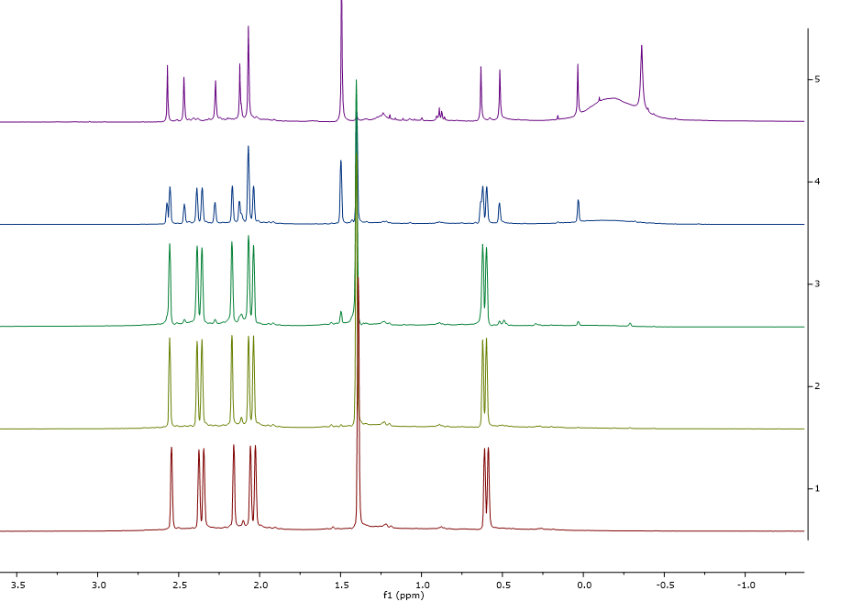
Figure S2.26. ¹H NMR spectrum (C₆D₆, 298 K, 400 MHz) of the reaction of ^{Me2}SB(^{tBu}N,I*)TiCl₂ with from bottom to top: 0, 1, 2, 5 and 10 equivalents of MAO.

Solid State NMR Spectroscopy
Figure S2.27. ¹³C CP-MAS (100.6 MHz) NMR spectrum of sMAO-^{Me2}SB(^{tBu}N,I*)TiMe₂.
Figure S2.28. ²⁷Al DP-MAS hahnecho (104.2 MHz) NMR spectrum of sMAO-^{Me2}SB(^{tBu}N,I*)TiMe₂.
Figure S2.29. ²⁹Si CP-MAS (79.4 MHz) NMR spectrum of sMAO-^{Me2}SB(^{tBu}N,I*)TiMe₂.
Figure S2.30. ¹³C CP-MAS (100.6 MHz) NMR spectrum of sMAO-^{Me2}SB(^{tBu}N,I*)Ti(CH₂Ph)₂.
Figure S2.31. ²⁷Al DP-MAS hahnecho (104.2 MHz) NMR spectrum of sMAO-^{Me2}SB(^{tBu}N,I*)Ti(CH₂Ph)₂.
Figure S2.32. ²⁹Si CP-MAS (79.4 MHz) NMR spectrum of sMAO-^{Me2}SB(^{tBu}N,I*)Ti(CH₂Ph)₂.
Figure S2.33. ¹³C CP-MAS (100.6 MHz) NMR spectrum of sMAO-^{Me2}SB(^{tBu}N,I*)Ti(Cl)CH₂SiMe₃.
Figure S2.34. ²⁷Al DP-MAS hahnecho (104.2 MHz) NMR spectrum of sMAO-^{Me2}SB(^{tBu}N,I*)Ti(Cl)CH₂SiMe₃.
Figure S2.35. ²⁹Si CP-MAS (79.4 MHz) NMR spectrum of sMAO-^{Me2}SB(^{tBu}N,I*)Ti(Cl)CH₂SiMe₃.
Figure S2.36. ¹³C CP-MAS (100.6 MHz) NMR spectrum of sMAO-^{Me2}SB(^{tBu}N,I*)Ti(CH₂SiMe₃)₂.
Figure S2.37. ²⁷Al DP-MAS hahnecho (104.2 MHz) NMR spectrum of sMAO-^{Me2}SB(^{tBu}N,I*)Ti(CH₂SiMe₃)₂.
Figure S2.38. ²⁹Si CP-MAS (79.4 MHz) NMR spectrum of sMAO-^{Me2}SB(^{tBu}N,I*)Ti(CH₂SiMe₃)₂.
Figure S2.39. ¹³C CP-MAS (100.6 kHz) NMR spectrum of sMAO-^{Me2}SB(^{tBu}N,Cp*)TiCl₂.
Figure S2.40. ²⁷Al DP-MAS hahnecho (104.2 kHz) NMR spectrum of sMAO-^{Me2}SB(^{tBu}N,Cp*)TiCl₂.
Figure S2.41. ²⁹Si CP-MAS (79.4 MHz) NMR spectrum of sMAO-^{Me2}SB(^{tBu}N,Cp*)TiCl₂.

Figure S2.42. ¹³C CP-MAS (100.6 kHz) NMR spectrum of sMAO-^{Me2}SB(^{tBu}N,^{3-Et}I*)TiCl₂.
Figure S2.43. ²⁷Al DP-MAS hahnecho (104.2 kHz) NMR spectrum of sMAO-^{Me2}SB(^{tBu}N,^{3-Et}I*)TiCl₂.
Figure S2.44. ²⁹Si CP-MAS (79.4 MHz) NMR spectrum of sMAO-^{Me2}SB(^{tBu}N,^{3-Et}I*)TiCl₂.

Additional ethylene polymerisation data
Table S3.1. Polymerisation activities, mass of catalyst used, and mass of polymer produced. Polymerisation conditions: 10 mg catalyst, 2 bar ethylene, 50 mL hexane, 150 mg TiBA and 30 minutes.
Temperature (°C) | Mass Catalyst (mg) |  | Mass Polymer (g) |  | Activity  (kg_{PE}/mol_{Ti}/h/bar) |  | Average Activity (kg_{PE}/mol_{Ti}/h/bar)
 | A | B | A | B | A | B
sMAO-^{Me2}SB(^{tBu}N,I*)TiCl₂
50 | 9.9 | 10.2 | 2.216 | 2.530 | 2806 | 3110 | 2958
60 | 9.8 | 10.1 | 2.743 | 2.977 | 3509 | 3696 | 3602
70 | 9.8 | 9.8 | 2.602 | 2.907 | 3328 | 3719 | 3524
80 | 10.3 | 10.1 | 2.354 | 2.495 | 2865 | 3097 | 2981
90 | 9.8 | 10.1 | 1.984 | 2.088 | 2538 | 2592 | 2565
sMAO-^{Me2}SB(^{tBu}N,I*)Ti(CH₂Ph)₂
50 | 10.0 | 10.3 | 3.70 | 3.87 | 5651 | 5739 | 5695
60 | 9.9 | 9.5 | 3.55 | 3.80 | 5477 | 6109 | 5793
70 | 10.2 | 10.1 | 3.97 | 3.71 | 5945 | 5610 | 5777
80 | 9.5 | 9.8 | 3.18 | 3.36 | 5112 | 5236 | 5174
90 | 9.7 | 10.0 | 2.37 | 2.71 | 3732 | 4139 | 3935
sMAO-^{Me2}SB(^{tBu}N,I*)TiMe₂
50 | 10.2 | 9.7 | 4.42 | 4.42 | 4937 | 5191 | 5064
60 | 10.2 | 10.0 | 4.77 | 4.76 | 5328 | 5423 | 5375
70 | 10.3 | 9.6 | 4.37 | 4.23 | 4834 | 5020 | 4927
80 | 10.0 | 10.3 | 3.61 | 3.45 | 4113 | 3816 | 3964
90 | 10.0 | 10.2 | 2.44 | 2.75 | 2780 | 3072 | 2926
sMAO-^{Me2}SB(^{tBu}N,I*)Ti(CH₂SiMe₃)₂
50 | 10.1 | 10.0 | 4.54 | 4.63 | 6944 | 7152 | 7048
60 | 10.5 | 10.0 | 4.64 | 4.47 | 6826 | 6905 | 6866
70 | 10.0 | 10.0 | 3.98 | 4.01 | 6148 | 6195 | 6171
80 | 10.4 | 9.9 | 3.07 | 2.57 | 4560 | 4010 | 4285
90 | 10.0 | 10.0 | 1.26 | 1.30 | 1946 | 2008 | 1977
sMAO-^{Me2}SB(^{tBu}N,I*)Ti(Cl)SiMe₃
50 | 10.4 | 10.4 | 1.863 | 1.748 | 2506 | 2351 | 2429
60 | 10.5 | 10.7 | 2.085 | 2.376 | 2778 | 3107 | 2943
70 | 10.1 | 9.5 | 1.730 | 1.641 | 2397 | 2416 | 2407
80 | 9.3 | 9.5 | 1.104 | 0.916 | 1661 | 1349 | 1505
90 | 10.0 | 10.0 | 0.618 | 0.616 | 865 | 862 | 863
sMAO-^{Me2}SB(^{Cy}N,I*)TiCl₂
50 | 10.4 | 10.1 | 0.557 | 0.514 | 808 | 768 | 788
60 | 9.8 | 10.0 | 0.477 | 0.506 | 735 | 764 | 749
70 | 9.6 | 9.6 | 0.464 | 0.494 | 730 | 777 | 753
80 | 9.8 | 10.0 | 0.402 | 0.457 | 619 | 690 | 655
90 | 10.2 | 10.1 | 0.228 | 0.216 | 337 | 323 | 330
sMAO-^{Me,Pr}SB(^{tBu}N,I*)TiCl₂
50 | 10.1 | 10.3 | 2.899 | 3.292 | 3954 | 4403 | 4178
60 | 9.7 | 10.0 | 2.988 | 3.013 | 4243 | 4151 | 4197
70 | 10.0 | 10.1 | 2.939 | 3.100 | 4049 | 4228 | 4138
80 | 9.9 | 10.2 | 2.329 | 2.100 | 3241 | 2836 | 3038
90 | 10.2 | 10.1 | 1.965 | 1.938 | 2680 | 2617 | 2649
sMAO-^{Me2}SB(^{tBu}N,^{3-Et}I*)TiCl₂
50 | 10.5 | 10.5 | 3.134 | 3.470 | 3860 | 4272 | 4067
60 | 9.6 | 9.8 | 2.825 | 3.047 | 38.05 | 4021 | 3913
70 | 9.6 | 9.4 | 2.750 | 2.531 | 3704 | 3482 | 3593
80 | 9.6 | 9.6 | 2.034 | 1.972 | 2740 | 2656 | 2698
90 | 10.0 | 10.4 | 1.948 | 1.710 | 2519 | 2126 | 2323
sMAO-^{Me2}SB(^{tBu}N,I*)ZrCl₂
50 | 10.6 | 10.1 | 0.078 | 0.085 | 105 | 120 | 112
60 | 9.7 | 9.7 | 0.068 | 0.064 | 100 | 94 | 97
70 | 9.5 | 9.5 | 0.068 | 0.071 | 102 | 106 | 104
80 | 9.6 | 10.5 | 0.048 | 0.062 | 71 | 84 | 78
90 | 9.5 | 9.5 | 0.062 | 0.057 | 83 | 85 | 89

Table S3.2. Polymerisation activities, mass of catalyst used, and mass of polymer produced. Polymerisation conditions: 10 mg catalyst, 2 bar ethylene, 50 mL hexane, 150 mg TiBA and 30 minutes.
Time (minutes) | Mass Catalyst (mg) |  | Mass Polymer (g) |  | Activity  (kg_{PE}/mol_{Ti}/h/bar) |  | Average Activity (kg_{PE}/mol_{Ti}/h/bar)
 | A | B | A | B | A | B
sMAO-^{Me2}SB(^{tBu}N,I*)TiCl₂
5 | 9.6 | 9.8 | 0.677 | 0.758 | 5305 | 5819 | 5562
15 | 10.0 | 9.9 | 1.871 | 1.764 | 4692 | 4468 | 4580
30 | 9.8 | 9.8 | 2.602 | 2.907 | 3328 | 3719 | 3524
60 | 9.8 | 9.8 | 4.495 | 4.801 | 2875 | 3071 | 2973
sMAO-^{Me2}SB(^{tBu}N,I*)Ti(CH₂Ph)₂
5 | 10.1 | 9.8 | 1.20 | 1.24 | 10888 | 11595 | 11241
15 | 10.3 | 10.5 | 2.65 | 2.72 | 7859 | 7913 | 7886
30 | 10.2 | 10.1 | 3.97 | 3.71 | 5945 | 5610 | 5777
60 | 10.0 | 10.5 | 6.13 | 6.1 | 4681 | 4436 | 4559
sMAO-^{Me2}SB(^{tBu}N,I*)TiMe₂
5 | 10.4 | 9.7 | 1.37 | 1.25 | 9004 | 8809 | 8907
15 | 10.2 | 9.7 | 2.79 | 2.54 | 6232 | 5966 | 6099
30 | 10.3 | 9.6 | 4.37 | 4.23 | 4834 | 5020 | 4927
60 | 10.0 | 9.7 | 6.98 | 6.54 | 3976 | 3840 | 3908
sMAO-^{Me2}SB(^{tBu}N,I*)Ti(CH₂SiMe₃)₂
5 | 10.1 | 9.8 | 1.19 | 1.20 | 10920 | 11349 | 11135
15 | 9.7 | 9.9 | 2.42 | 2.43 | 7708 | 7583 | 7646
30 | 10.0 | 10.0 | 3.98 | 4.01 | 6148 | 6195 | 6171
60 | 10.2 | 9.8 | 5.73 | 5.47 | 4339 | 4311 | 4325
sMAO-^{Me2}SB(^{tBu}N,I*)Ti(Cl)SiMe₃
5 | 9.1 | 9.1 | 0.703 | 0.711 | 6485 | 6559 | 6522
15 | 10.1 | 10.1 | 1.351 | 1.373 | 3743 | 3804 | 3774
30 | 10.1 | 9.5 | 1.730 | 1.641 | 2397 | 2416 | 2407
60 | 9.7 | 9.5 | 3.034 | 3.056 | 2188 | 2250 | 2219
sMAO-^{Me2}SB(^{Cy}N,I*)TiCl₂
5 | 10.1 | 10.2 | 0.290 | 0.305 | 2601 | 2709 | 2655
15 | 9.6 | 9.8 | 0.448 | 0.427 | 1409 | 1316 | 1362
30 | 9.6 | 9.6 | 0.464 | 0.494 | 730 | 777 | 753
60 | 9.6 | 9.4 | 0.580 | 0.501 | 456 | 402 | 429
sMAO-^{Me,Pr}SB(^{tBu}N,I*)TiCl₂
5 | 10.5 | 10.3 | 0.901 | 0.866 | 7092 | 6949 | 7021
15 | 10.4 | 10.3 | 1.694 | 1.866 | 4488 | 4991 | 4739
30 | 10.0 | 10.1 | 2.939 | 3.100 | 4049 | 4228 | 4138
60 | 9.3 | 9.6 | 4.028 | 4.154 | 2983 | 2980 | 2982
sMAO-^{Me2}SB(^{tBu}N,^{3-Et}I*)TiCl₂
5 | 10.5 | 10.5 | 0.813 | 0.814 | 6008 | 6015 | 6012
15 | 10.5 | 10.3 | 1.752 | 1.528 | 4316 | 3764 | 4040
30 | 9.6 | 9.4 | 2.750 | 2.531 | 3704 | 3482 | 3593
60 | 9.5 | 9.6 | 3.640 | 3.669 | 2478 | 2497 | 2487
sMAO-^{Me2}SB(^{tBu}N,I*)ZrCl₂
5 | 11.0 | 10.8 | 0.024 | 0.03 | 186 | 237 | 212
15 | 9.7 | 10.0 | 0.043 | 0.041 | 126 | 117 | 121
30 | 9.5 | 9.5 | 0.068 | 0.071 | 102 | 106 | 104
60 | 9.7 | 10.5 | 0.187 | 0.159 | 137 | 108 | 122

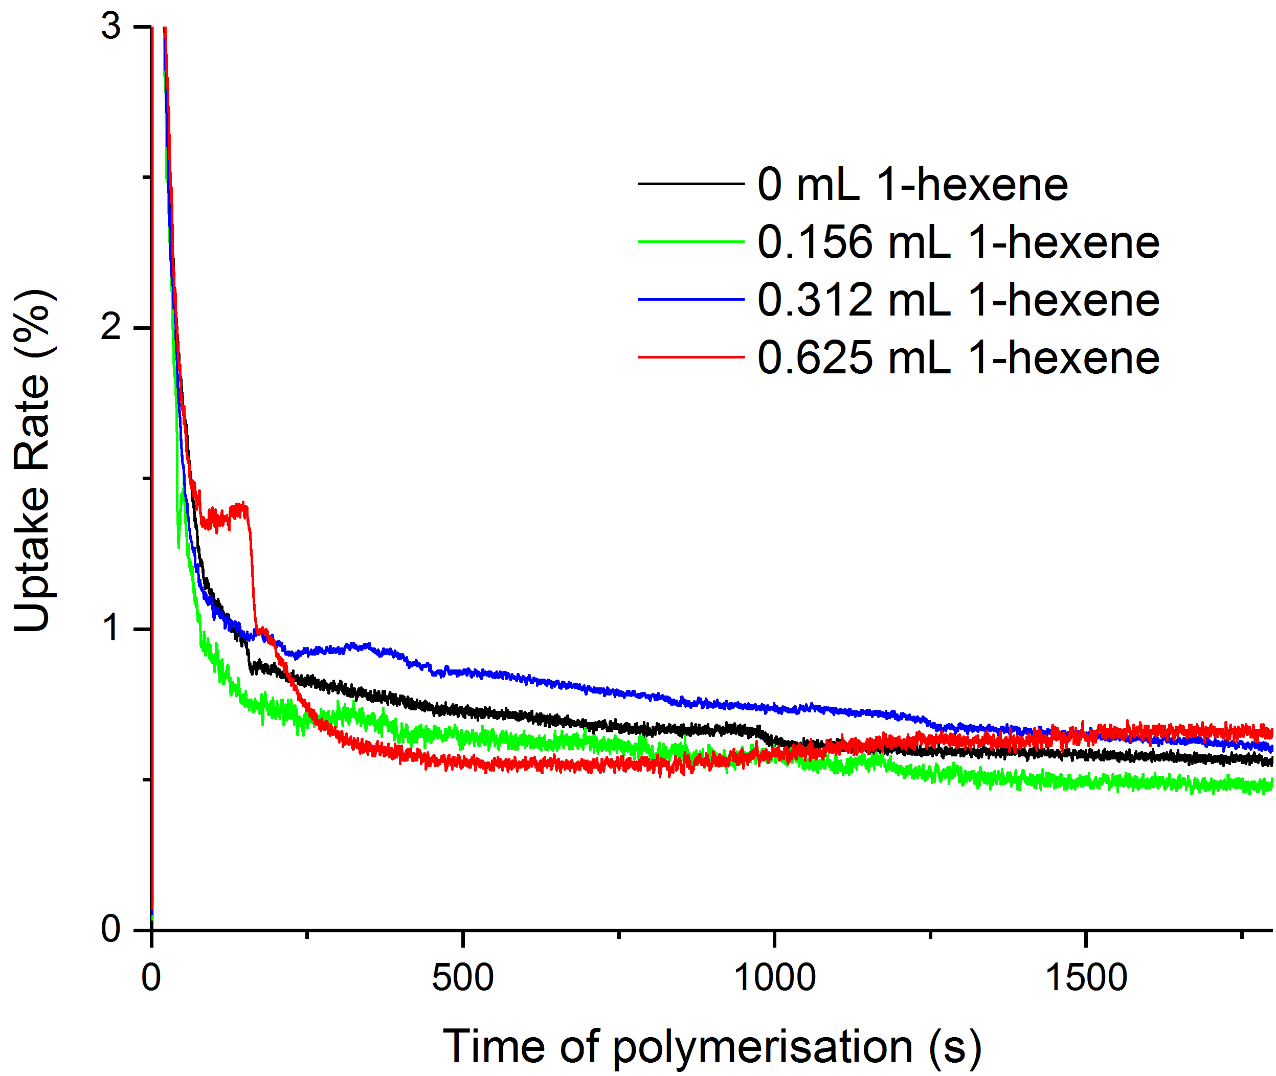
Figure S3.1. Ethylene uptake rate plots for sMAO-^{Me2}SB(^{tBu}N,I*)TiCl₂ at 70 °C. (Co)polymerisations run for 30 minutes, 10 mg catalyst, 150 mg TiBA, 2 bar of ethylene pressure and 10 mg of catalyst. Y-axis is a guide with percentage value providing a quantitative measure of uptake.
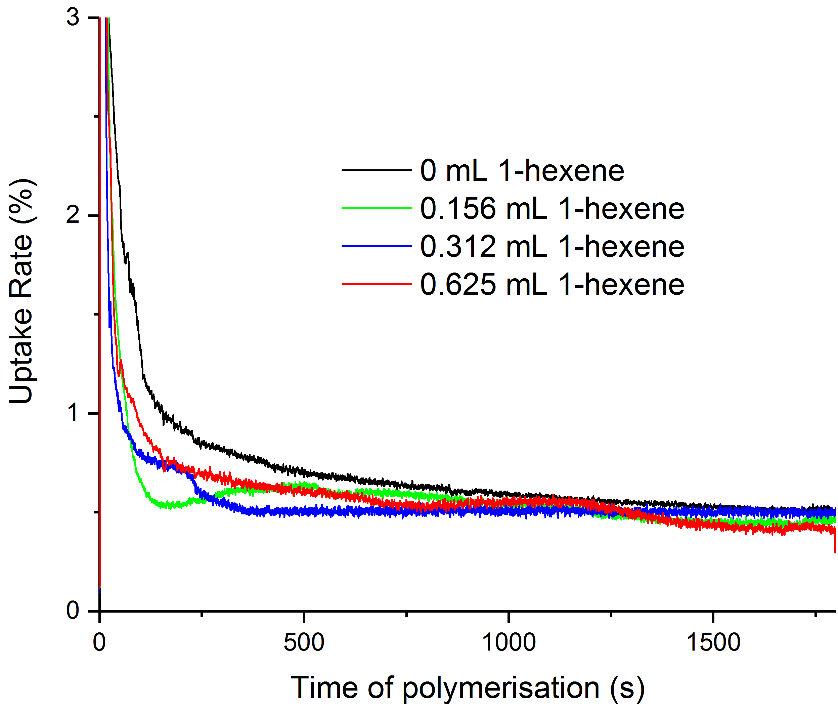
Figure S3.2. Ethylene uptake rate plots for sMAO-^{Me2}SB(^{tBu}N,I*)TiCl₂ at 80 °C. (Co)polymerisations run for 30 minutes, 10 mg catalyst, 150 mg TiBA, 2 bar of ethylene pressure and 10 mg of catalyst. Y-axis is a guide with percentage value providing a quantitative measure of uptake.
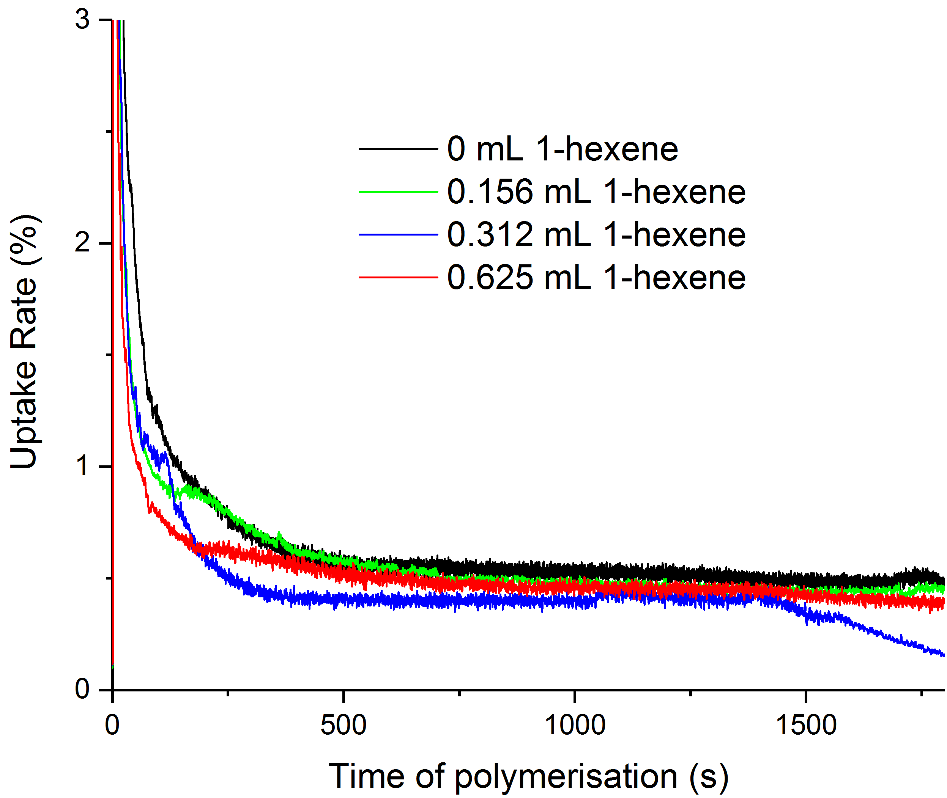
Figure S3.3. Ethylene uptake rate plots for sMAO-^{Me2}SB(^{tBu}N,I*)TiCl₂ at 90 °C. (Co)polymerisations run for 30 minutes, 10 mg catalyst, 150 mg TiBA, 2 bar of ethylene pressure and 10 mg of catalyst. Y-axis is a guide with percentage value providing a quantitative measure of uptake.

Table S3.3 Polymerisation activities, mass of catalyst used, and mass of polymer produced. (Co)polymerisation conditions: 10 mg catalyst, 2 bar ethylene, 0, 0.156, 0.312 or 0.625 mL 1-hexene, 50 mL hexane, 150 mg TiBA and 30 minutes.
Volume of 1-hexene (mL) | Mass Catalyst (mg) |  | Mass Polymer (g) |  | Activity  (kg_{PE}/mol_{Ti}/h/bar) |  | Average Activity (kg_{PE}/mol_{Ti}/h/bar)
 | A | B | A | B | A | B
30 °C
0 | 10.0 | 10.5 | 0.985 | 0.918 | 1352 | 1200 | 1276
0.156 | 9.0 | 10.0 | 0.469 | 0.582 | 716 | 799 | 757
0.312 | 10.5 | 10.2 | 0.508 | 0.475 | 664 | 639 | 652
0.625 | 10.2 | 10.0 | 0.476 | 0.468 | 641 | 643 | 642
40 °C
0 | 9.5 | 9.8 | 1.945 | 1.869 | 2811 | 2619 | 2715
0.156 | 9.8 | 10.2 | 1.011 | 0.911 | 1416 | 1226 | 1321
0.312 | 10.2 | 9.8 | 10.38 | 0.918 | 1397 | 1286 | 1342
0.625 | 10.5 | 10.2 | 1.166 | 1.127 | 1525 | 1517 | 1520
50 °C
0 | 9.5 | 9.5 | 2.673 | 2.545 | 3863 | 3678 | 3771
0.156 | 10.0 | 9.6 | 1.526 | 1.357 | 2095 | 1941 | 2018
0.312 | 9.5 | 9.8 | 1.367 | 1.259 | 1976 | 1763 | 1870
0.625 | 10.2 | 9.6 | 2.311 | 2.337 | 3111 | 3343 | 3226
60 °C
0 | 9.7 | 9.7 | 2.490 | 2.637 | 3525 | 3733 | 3629
0.156 | 9.8 | 10.2 | 1.143 | 1.084 | 1601 | 1459 | 1530
0.312 | 10.0 | 10.0 | 1.256 | 1.411 | 1725 | 1937 | 1831
0.625 | 9.5 | 9.4 | 2.154 | 2.049 | 3113 | 2993 | 3053
70 °C
0 | 9.8 | 10.2 | 2.410 | 2.607 | 3377 | 3509 | 3443
0.156 | 9.5 | 10.2 | 2.415 | 2.759 | 3490 | 3714 | 3602
0.312 | 9.8 | 9.7 | 2.925 | 3.107 | 4098 | 4398 | 4248
0.625 | 9.5 | 9.9 | 2.604 | 2.615 | 3764 | 3627 | 3695
80 °C
0 | 9.7 | 10.2 | 2.337 | 2.457 | 3308 | 3307 | 3308
0.156 | 9.9 | 10.1 | 1.955 | 1.804 | 2711 | 2452 | 2582
0.312 | 9.5 | 9.7 | 1.932 | 1.985 | 2792 | 2810 | 2801
0.625 | 9.7 | 10.3 | 2.053 | 2.229 | 2906 | 2971 | 2939
90 °C
0 | 9.5 | 9.9 | 2.064 | 2.190 | 2983 | 2037 | 3010
0.156 | 9.5 | 10.0 | 1.877 | 1.733 | 2713 | 2380 | 2546
0.312 | 10.1 | 9.5 | 1.825 | 1.668 | 2481 | 2410 | 2446
0.625 | 9.7 | 10.0 | 1.736 | 1.689 | 2457 | 2319 | 2388

Table S3.4. Polymer melt and crystallisation enthalpies for the polyethylenes/ poly(ethylene-co-1-hexene) produced between 30 and 90 °C.
Temperature  (°C) | Volume 1-hexene added (mL)
 | 0 |  | 0.156 |  | 0.312 |  | 0.625
 | ΔH_{m} | ΔH_{c} | ΔH_{m} | ΔH_{c} | ΔH_{m} | ΔH_{c} | ΔH_{m} | ΔH_{c}
30 | 111 | 109 | 80 | 79 | 70 | 74 | 70 | 56
40 | 111 | 105 | 92 | 86 | 89 | 79 | 62 | 56
50 | 133 | 137 | 84 | 87 | 73 | 72 | 67 | 60
60 | 136 | 134 | 88 | 89 | 77 | 73 | 67 | 67
70 | 157 | 156 | 106 | 106 | 109 | 103 | 68 | 85
80 | 164 | 164 | 93 | 97 | 82 | 75 | 43 | 48
Note: ΔH_{m} and ΔH_{c} correspond to melt enthalpy and crystallisation enthalpy respectively. Values given as J g⁻¹.

Table S3.5. Polymer melt and crystallisation temperatures for the polyethylenes/poly(ethylene-co-1-hexene) produced between 30 and 90 °C.
Temperature  (°C) | Volume 1-hexene added (mL)
 | 0 |  | 0.156 |  | 0.312 |  | 0.625
 | T_{m} | T_{c} | T_{m} | T_{c} | T_{m} | T_{c} | T_{m} | T_{c}
30 | 134.8 | 117.8 | 126.1 | 114.5 | 122.6 | 111.5 | 113.9 | 103.9
40 | 134.7 | 118.3 | 124.5 | 113.4 | 119.4 | 109.9 | 112.5 | 100.2
50 | 135.9 | 117.7 | 124.7 | 112.8 | 119.7 | 108.4 | 114.2 | 100.4
60 | 136.1 | 117.5 | 123.0 | 112.1 | 116.1 | 106.8 | 115.4 | 102.0
70 | 137.7 | 116.3 | 125.3 | 111.4 | 121.9 | 110.6 | 122.3 | 108.1
80 | 135.5 | 118.3 | 122.9 | 111.6 | 119.0 | 107.0 | 121.7 | 108.1
T_{m} and T_{c} in °C; DSC run for 3 cycles between 25 and 250 °C; T_{m} taken on third heating cycle and T_{c} from first cooling cycle.
Table S3.6. Polymerisation activities, mass of catalyst used, and mass of polymer produced. (Co)polymerisation conditions: 10 mg catalyst, 2 bar ethylene, 0, 0.156, 0.312 or 0.625 mL 1-hexene, 50 mL hexane, 150 mg TiBA, 70 °C and 30 minutes.
Volume of 1-hexene (mL) | Mass Catalyst (mg) |  | Mass Polymer (g) |  | Activity  (kg_{PE}/mol_{Ti}/h/bar) |  | Average Activity (kg_{PE}/mol_{Ti}/h/bar)
 | A | B | A | B | A | B
sMAO-^{Me2}SB(^{tBu}N,I*)TiCl₂
0 | 9.8 | 10.2 | 2.410 | 2.607 | 3377 | 3509 | 3443
0.156 | 9.5 | 10.2 | 2.415 | 2.759 | 3490 | 3714 | 3602
0.312 | 9.8 | 9.7 | 2.925 | 3.107 | 4098 | 4398 | 4248
0.625 | 9.5 | 9.9 | 2.604 | 2.615 | 3764 | 3627 | 3695
sMAO-^{Me2}SB(^{tBu}N,^{3-Et}I*)TiCl₂
0 | 9.6 | 9.5 | 2.534 | 2.877 | 3614 | 4146 | 3880
0.156 | 9.9 | 9.7 | 1.805 | 1.661 | 2496 | 2344 | 2420
0.312 | 9.5 | 9.8 | 1.627 | 1.655 | 2345 | 2312 | 2328
0.625 | 9.5 | 10.2 | 1.944 | 2.309 | 2801 | 3099 | 2950
sMAO-^{Me,Pr}SB(^{tBu}N,I*)TiCl₂
0 | 10.0 | 10.1 | 2.939 | 3.100 | 4056 | 4236 | 4146
0.156 | 10.1 | 10.2 | 2.030 | 1.957 | 2774 | 2648 | 2711
0.312 | 10.3 | 10.3 | 2.137 | 2.063 | 2863 | 2764 | 2814
0.625 | 9.7 | 10.1 | 2.300 | 2.397 | 3272 | 3275 | 3274
sMAO-^{Me2}SB(^{tBu}N,I*)Ti(CH₂Ph)₂
0 | 9.7 | 10.0 | 3.004 | 3.230 | 4285 | 4469 | 4377
0.156 | 9.7 | 10.4 | 1.856 | 1.970 | 2647 | 2621 | 2634
0.312 | 9.8 | 9.8 | 1.684 | 1.772 | 2378 | 2502 | 2440
0.625 | 9.9 | 9.5 | 2.037 | 1.824 | 2847 | 2657 | 2751
sMAO-^{Me2}SB(^{tBu}N,Cp*)TiCl₂
0 | 10.0 | 9.6 | 1.658 | 1.525 | 2273 | 2178 | 2226
0.156 | 9.9 | 9.9 | 1.382 | 1.291 | 1914 | 1788 | 1851
0.312 | 10.0 | 9.9 | 1.559 | 1.630 | 2137 | 2257 | 2197
0.625 | 9.7 | 10.2 | 1.179 | 1.402 | 1666 | 1884 | 1775

Table S3.7. Polymer melt and crystallisation temperatures for the polyethylenes/poly(ethylene-co-1-hexene) produced for the catalysts (A) sMAO-^{Me2}SB(^{tBu}N,I*)TiCl₂, (B) sMAO-^{Me2}SB(^{tBu}N,^{3-Et}I*)TiCl₂, (C) sMAO-^{Me,Pr}SB(^{tBu}N,I*)TiCl₂, (D) sMAO-^{Me2}SB(^{tBu}N,I*)Ti(CH₂Ph)₂, and (E) sMAO-^{Me2}SB(^{tBu}N,Cp*)TiCl₂. (Co)polymerisation conditions: 10 mg catalyst, 2 bar ethylene, 0, 0.156, 0.312 or 0.625 mL 1-hexene, 50 mL hexane, 150 mg TiBA and 30 minutes.
Complex | Volume 1-hexene added (mL)
 | 0 |  | 0.156 |  | 0.312 |  | 0.625
 | T_{m} | T_{c} | T_{m} | T_{c} | T_{m} | T_{c} | T_{m} | T_{c}
A | 137.7 | 116.3 | 125.3 | 111.4 | 121.9 | 110.6 | 122.3 | 108.1
B | 132.7 | 119.1 | 121.7 | 111.07 | 117.2 | 106.6 | 113.8 | 98.5
C | 133.2 | 119.4 | 122.8 | 110.9 | 117.3 | 107.4 | 113.8 | 101.0
D | 133.5 | 118.8 | 122.3 | 112.2 | 117.0 | 106.1 | 114.3 | 102.2
E | 133.7 | 118.2 | 120.0 | 109.9 | 116.9 | 104.9 | 107.0 | 94.4
T_{m} and T_{c} in °C; DSC run for 3 cycles between 25 and 250 °C; T_{m} taken on third heating cycle and T_{c} from first cooling cycle.
Table S3.8. Polymer melt and crystallisation enthalpies for the polyethylenes/ poly(ethylene-co-1-hexene) produced for the catalysts (A) sMAO-^{Me2}SB(^{tBu}N,I*)TiCl₂, (B) sMAO-^{Me2}SB(^{tBu}N,^{3-Et}I*)TiCl₂, (C) sMAO-^{Me,Pr}SB(^{tBu}N,I*)TiCl₂, (D) sMAO-^{Me2}SB(^{tBu}N,I*)Ti(CH₂Ph)₂, and (E) sMAO-^{Me2}SB(^{tBu}N,Cp*)TiCl₂. (Co)polymerisation conditions: 10 mg catalyst, 2 bar ethylene, 0, 0.156, 0.312 or 0.625 mL 1-hexene, 50 mL hexane, 150 mg TiBA and 30 minutes.
Complex | Volume 1-hexene added (mL)
 | 0 |  | 0.156 |  | 0.312 |  | 0.625
 | ΔH_{m} | ΔH_{c} | ΔH_{m} | ΔH_{c} | ΔH_{m} | ΔH_{c} | ΔH_{m} | ΔH_{c}
A | 157 | 156 | 106 | 106 | 109 | 103 | 68 | 85
B | 145 | 145 | 99 | 95 | 83 | 83 | 60 | 56
C | 129 | 130 | 89 | 82 | 79 | 76 | 60 | 62
D | 153 | 142 | 94 | 87 | 56 | 55 | 70 | 62
E | 159 | 150 | 98 | 96 | 78 | 77 | 48 | 50
Note: ΔH_{m} and ΔH_{c} correspond to melt enthalpy and crystallisation enthalpy respectively. Values given as J g⁻¹.
Table S3.9. Polymerisation activities, mass of catalyst used, and mass of polymer produced. (Co)polymerisation conditions: 10 mg catalyst, 2 bar ethylene, 0, 0.156, 0.312 or 0.625 mL styrene, 50 mL hexane, 150 mg TiBA, 70 °C and 30 minutes.
Volume of styrene (mL) | Mass Catalyst (mg) |  | Mass Polymer (g) |  | Activity  (kg_{PE}/mol_{Ti}/h/bar) |  | Average Activity (kg_{PE}/mol_{Ti}/h/bar)
 | A | B | A | B | A | B
sMAO-^{Me2}SB(^{tBu}N,I*)TiCl₂
0 | 9.8 | 10.2 | 2.410 | 2.607 | 3377 | 3509 | 3443
0.156 | 9.9 | 9.7 | 0.824 | 0.878 | 1143 | 1243 | 1193
0.312 | 10.4 | 9.4 | 0.918 | 0.862 | 1212 | 1259 | 1236
0.625 | 9.7 | 10.1 | 1.401 | 1.537 | 1983 | 2089 | 2036
sMAO-^{Me2}SB(^{tBu}N,^{3-Et}I*)TiCl₂
0 | 9.6 | 9.5 | 2.534 | 2.877 | 3614 | 4146 | 3880
0.156 | 10.1 | 10.2 | 1.103 | 1.019 | 1495 | 1368 | 1431
0.312 | 9.8 | 10.0 | 0.980 | 0.934 | 1369 | 1279 | 1324
0.625 | 9.8 | 10.3 | 0.912 | 0.956 | 1274 | 1271 | 1272
sMAO-^{Me,Pr}SB(^{tBu}N,I*)TiCl₂
0 | 10.0 | 10.1 | 2.939 | 3.100 | 4056 | 4236 | 4146
0.156 | 9.5 | 9.8 | 0.574 | 0.763 | 834 | 1074 | 954
0.312 | 10.4 | 9.9 | 0.652 | 0.603 | 865 | 841 | 853
0.625 | 9.5 | 10.1 | 0.472 | 0.542 | 686 | 741 | 713
sMAO-^{Me2}SB(^{tBu}N,I*)Ti(CH₂Ph)₂
0 | 9.7 | 10.0 | 3.004 | 3.230 | 4285 | 4469 | 4377
0.156 | 9.8 | 10.1 | 0.527 | 0.691 | 744 | 947 | 845
0.312 | 10.5 | 9.5 | 0.777 | 0.542 | 1024 | 789 | 907
0.625 | 9.3 | 10.2 | 0.423 | 0.610 | 629 | 827 | 728
sMAO-^{Me2}SB(^{tBu}N,Cp*)TiCl₂
0 | 10.0 | 9.6 | 1.658 | 1.525 | 2273 | 2178 | 2226
0.156 | 9.7 | 9.8 | 1.660 | 1.881 | 2346 | 2632 | 2488
0.312 | 9.8 | 9.8 | 1.255 | 1.449 | 1756 | 2027 | 1891
0.625 | 10.2 | 10.2 | 1.065 | 1.035 | 1432 | 1391 | 1411

Table S3.10. Polymer melt and crystallisation temperatures for the polyethylenes/poly(ethylene-co-styrene) produced for the catalysts (A) sMAO-^{Me2}SB(^{tBu}N,I*)TiCl₂, (B) sMAO-^{Me2}SB(^{tBu}N,^{3-Et}I*)TiCl₂, (C) sMAO-^{Me,Pr}SB(^{tBu}N,I*)TiCl₂, (D) sMAO-^{Me2}SB(^{tBu}N,I*)Ti(CH₂Ph)₂, and (E) sMAO-^{Me2}SB(^{tBu}N,Cp*)TiCl₂. (Co)polymerisation conditions: 10 mg catalyst, 2 bar ethylene, 0, 0.156, 0.312 or 0.625 mL styrene, 50 mL hexane, 150 mg TiBA and 30 minutes.
Complex | Volume styrene added (mL)
 | 0 |  | 0.156 |  | 0.312 |  | 0.625
 | T_{m} | T_{c} | T_{m} | T_{c} | T_{m} | T_{c} | T_{m} | T_{c}
A | 137.7 | 116.3 | 119.4 | 109.7 | 115.5 | 105.5 | 97.9 | 109.7
B | 132.7 | 119.1 | 120.1 | 108.9 | 114.6 | 104.2 | 107.8 | 96.4
C | 133.2 | 119.4 | 121.7 | 111.6 | 119.0 | 108.9 | 113.1 | 103.2
D | 133.5 | 118.8 | 119.6 | 109.0 | 115.6 | 105.3 | 110.1 | 99.9
E | 133.7 | 118.2 | 115.2 | 105.2 | 108.7 | 96.7 | 98.4 | 86.7

T_{m} and T_{c} in °C; DSC run for 3 cycles between 25 and 250 °C; T_{m} taken on third heating cycle and T_{c} from first cooling cycle.

Table S3.11. Polymer melt and crystallisation for the polyethylenes/poly(ethylene-co-styrene) produced for the catalysts (A) sMAO-^{Me2}SB(^{tBu}N,I*)TiCl₂, (B) sMAO-^{Me2}SB(^{tBu}N,^{3-Et}I*)TiCl₂, (C) sMAO-^{Me,Pr}SB(^{tBu}N,I*)TiCl₂, (D) sMAO-^{Me2}SB(^{tBu}N,I*)Ti(CH₂Ph)₂, and (E) sMAO-^{Me2}SB(^{tBu}N,Cp*)TiCl₂. (Co)polymerisation conditions: 10 mg catalyst, 2 bar ethylene, 0, 0.156, 0.312 or 0.625 mL styrene, 50 mL hexane,150 mg TiBA and 30 minutes.
Complex | Volume styrene added (mL)
 | 0 |  | 0.156 |  | 0.312 |  | 0.625
 | ΔH_{m} | ΔH_{c} | ΔH_{m} | ΔH_{c} | ΔH_{m} | ΔH_{c} | ΔH_{m} | ΔH_{c}
A | 157 | 156 | 88 | 89 | 85 | 87 | 64 | 59
B | 145 | 145 | 87 | 87 | 74 | 74 | 61 | 60
C | 129 | 130 | 91 | 82 | 79 | 75 | 79 | 71
D | 153 | 142 | 76 | 89 | 75 | 67 | 57 | 63
E | 159 | 150 | 80 | 82 | 61 | 60 | 45 | 41
Note: ΔH_{m} and ΔH_{c} correspond to melt enthalpy and crystallisation enthalpy respectively. Values given as J g⁻¹.

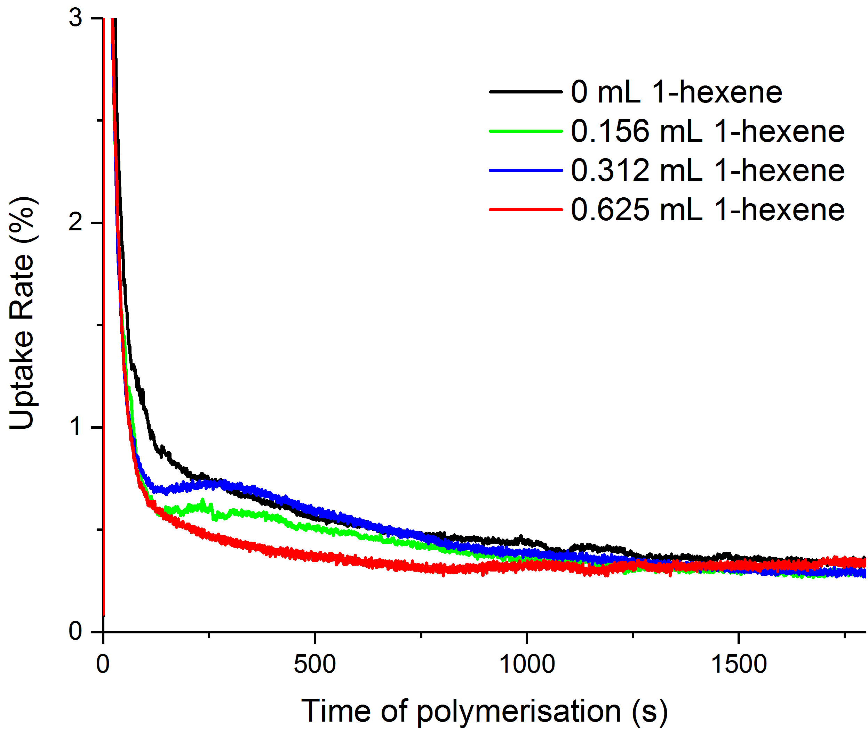
Figure S3.4. Ethylene uptake rate plots for sMAO-^{Me2}SB(^{tBu}N,Cp*)TiCl₂. (Co)polymerisations run for 30 minutes, 10 mg catalyst, 150 mg TiBA, 2 bar of ethylene pressure and 10 mg of catalyst at 70 °C. Y-axis is a guide with percentage value providing a quantitative measure of uptake.
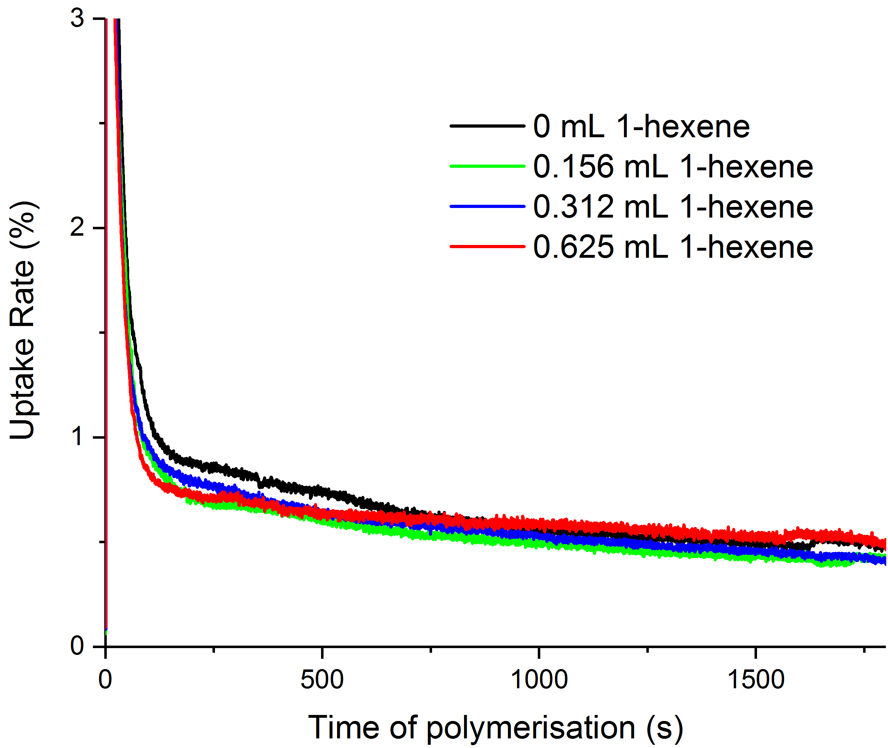
Figure S3.5. Ethylene uptake rate plots for sMAO-^{Me,Pr}SB(^{tBu}N,I*)TiCl₂. (Co)polymerisations run for 30 minutes, 10 mg catalyst, 150 mg TiBA, 2 bar of ethylene pressure and 10 mg of catalyst at 70 °C. Y-axis is a guide with percentage value providing a quantitative measure of uptake.
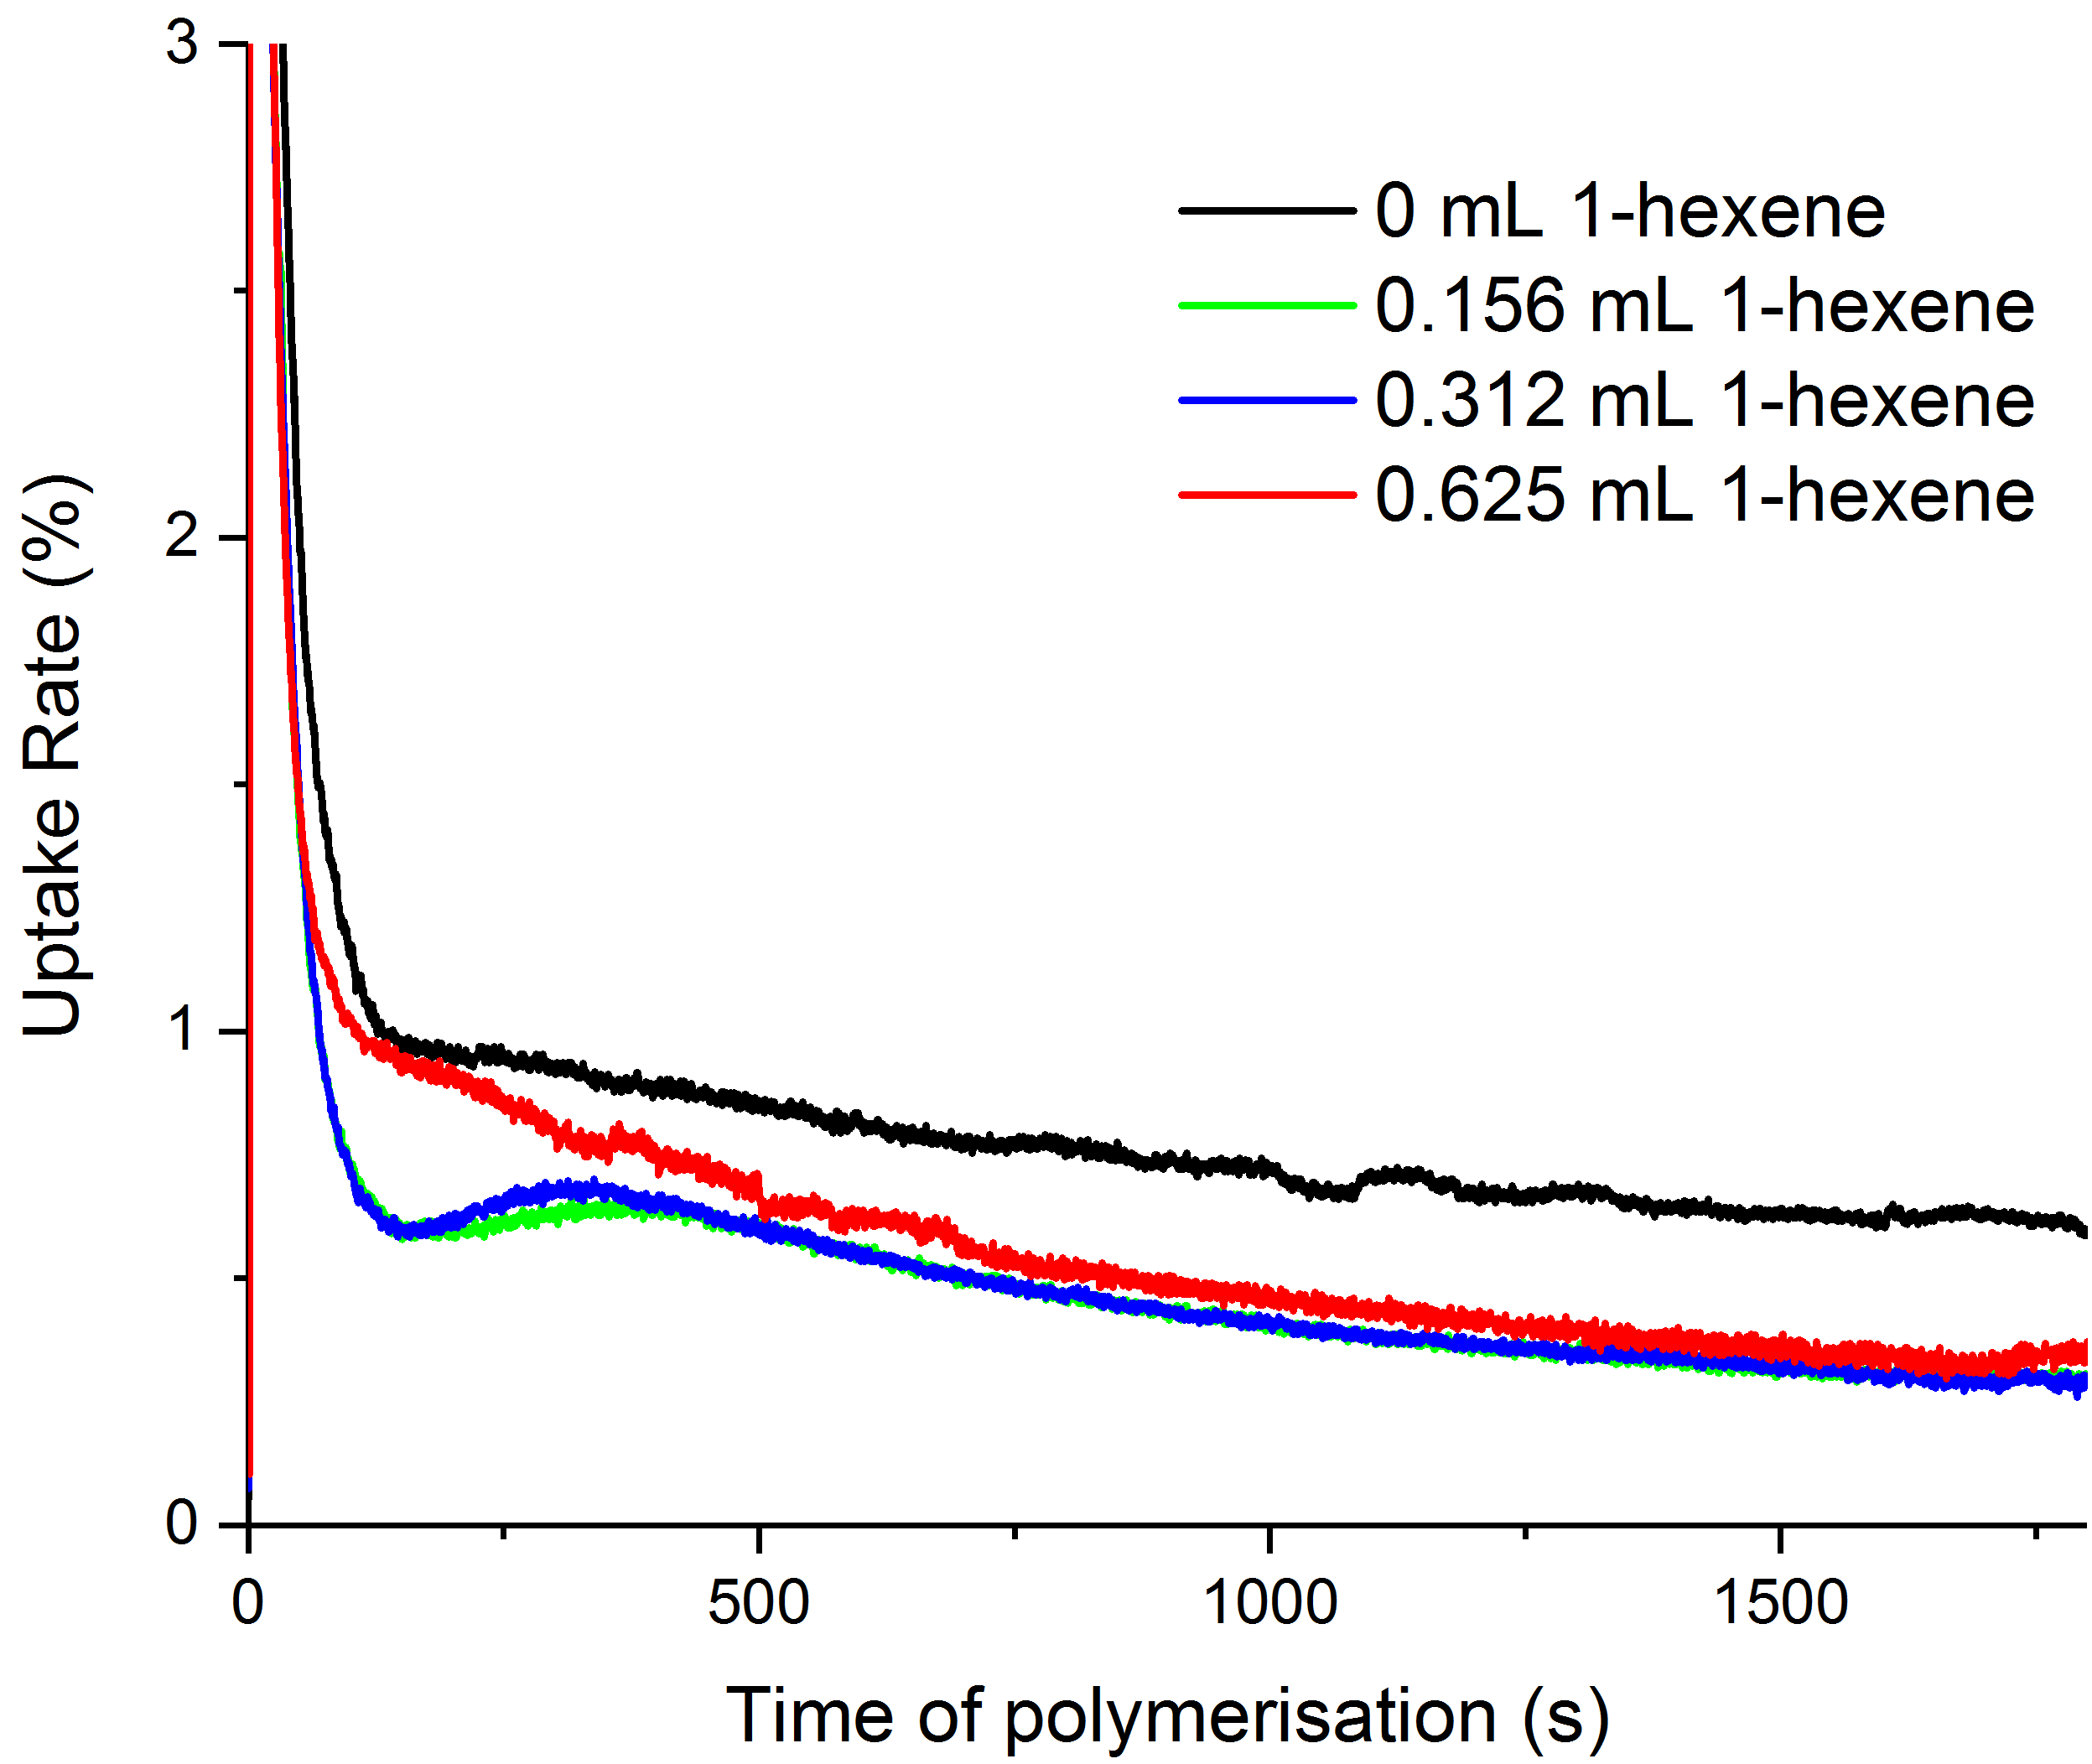
Figure S3.6. Ethylene uptake rate plots for sMAO-^{Me2}SB(^{tBu}N,I*)Ti(CH₂Ph₂). (Co)polymerisations run for 30 minutes, 10 mg catalyst, 150 mg TiBA, 2 bar of ethylene pressure and 10 mg of catalyst at 70 °C. Y-axis is a guide with percentage value providing a quantitative measure of uptake.
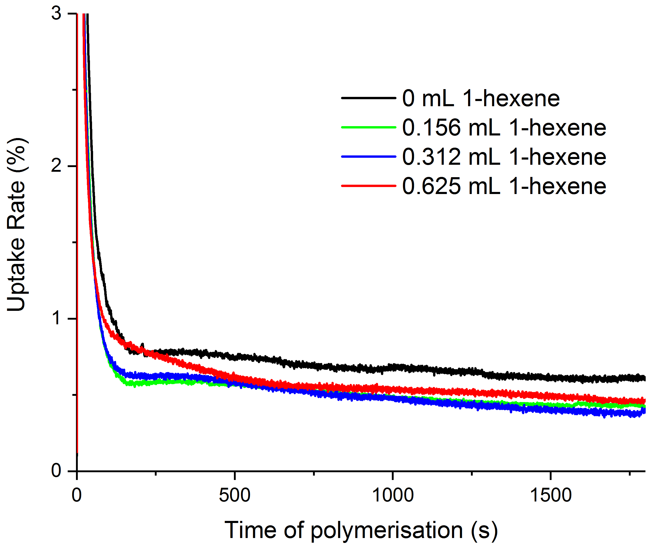
Figure S3.7. Ethylene uptake rate plots for sMAO-^{Me2}SB(^{tBu}N,^{3-Et}I*)TiCl₂. (Co)polymerisations run for 30 minutes, 10 mg catalyst, 150 mg TiBA, 2 bar of ethylene pressure and 10 mg of catalyst at 70 °C. Y-axis is a guide with percentage value providing a quantitative measure of uptake.
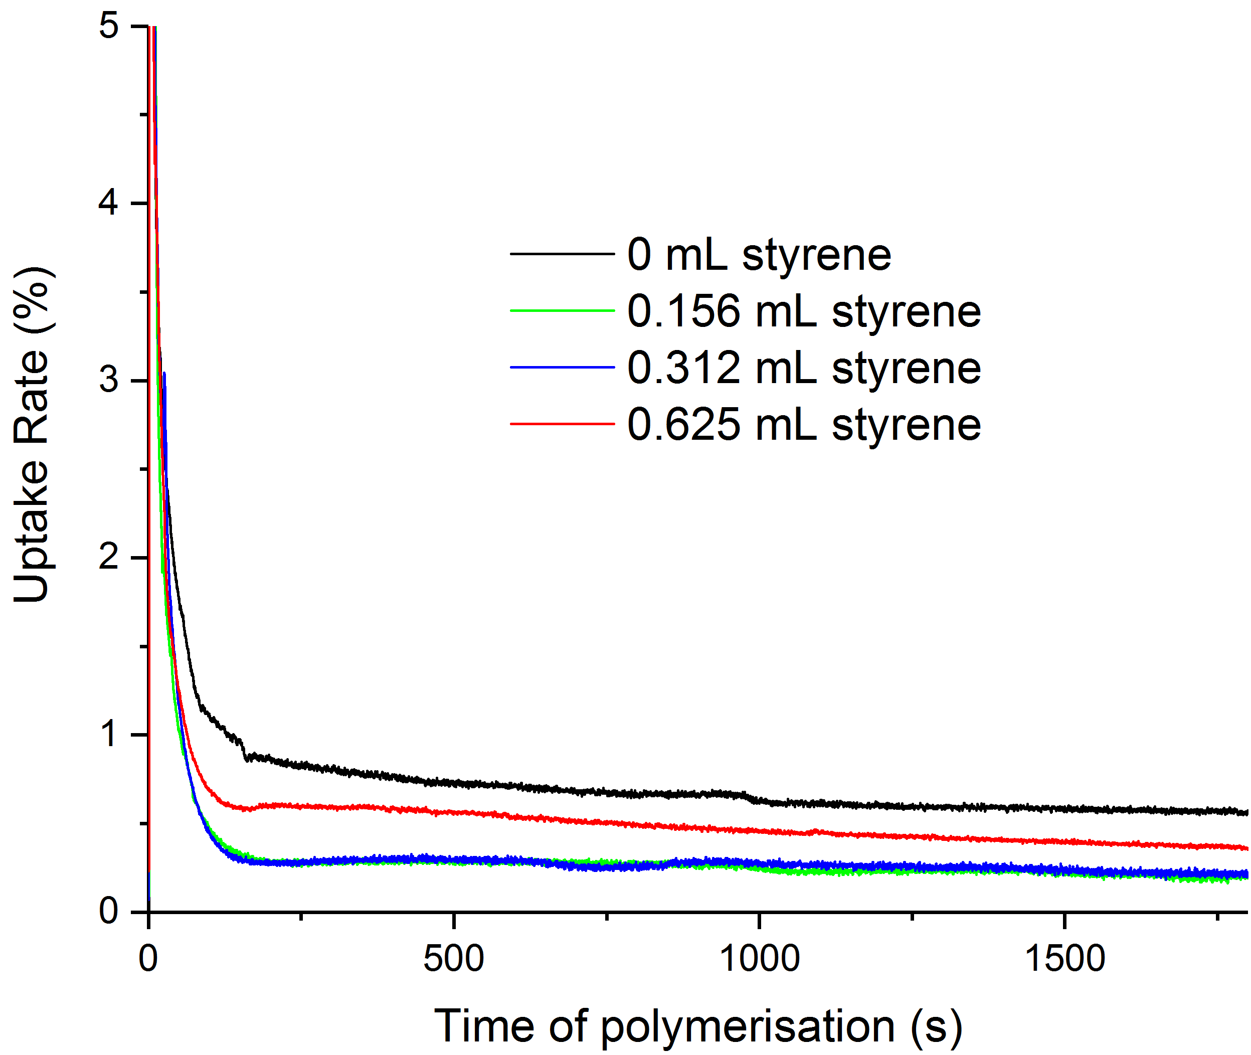
Figure S3.8. Ethylene uptake rate plots for sMAO-^{Me2}SB(^{tBu}N,I*)TiCl₂ at 70 °C. (Co)polymerisations run for 30 minutes, 10 mg catalyst, 150 mg TiBA, 2 bar of ethylene pressure and 10 mg of catalyst at 70 °C. Y-axis is a guide with percentage value providing a quantitative measure of uptake.
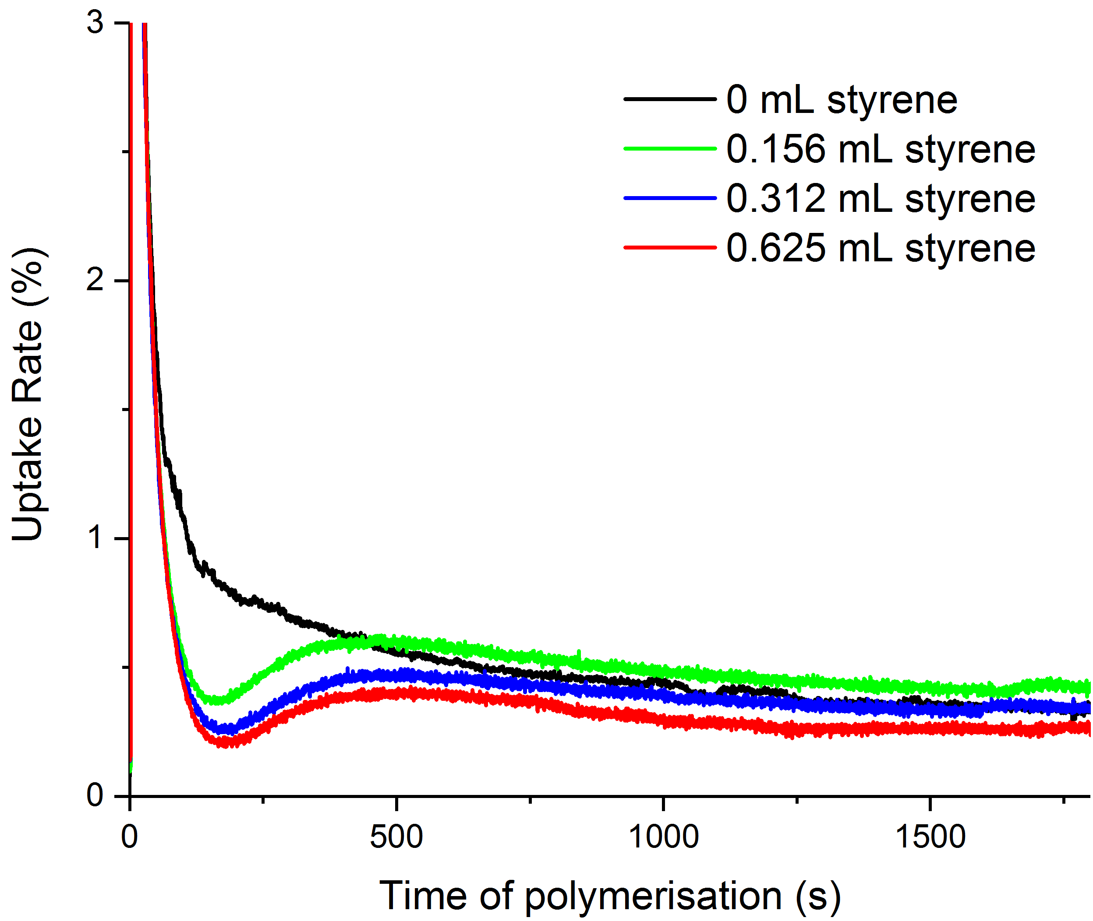
Figure S3.9. Ethylene uptake rate plots for sMAO-^{Me2}SB(^{tBu}N,Cp*)TiCl₂. (Co)polymerisations run for 30 minutes, 10 mg catalyst, 150 mg TiBA, 2 bar of ethylene pressure and 10 mg of catalyst at 70 °C. Y-axis is a guide with percentage value providing a quantitative measure of uptake.
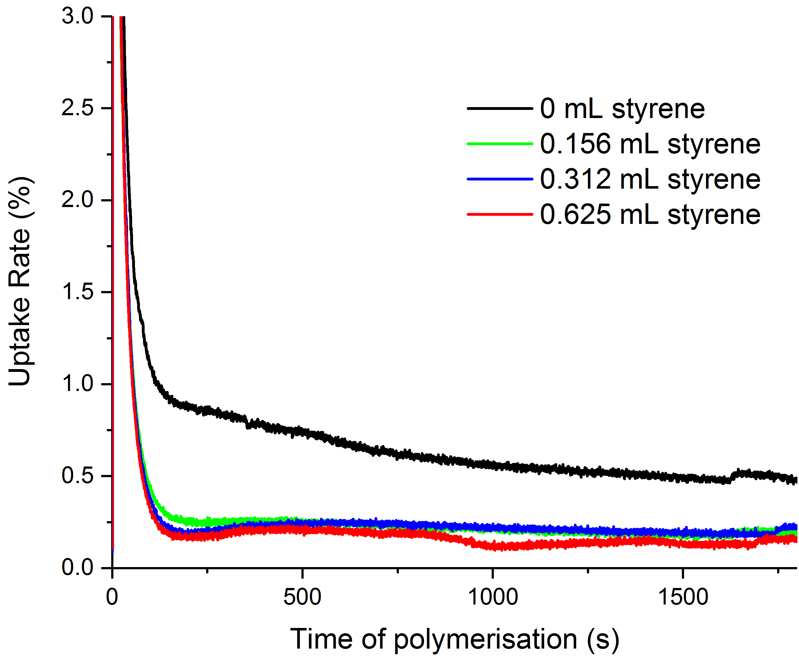
Figure S3.10. Ethylene uptake rate plots for sMAO-^{Me,Pr}SB(^{tBu}N,I*)TiCl₂. (Co)polymerisations run for 30 minutes, 10 mg catalyst, 150 mg TiBA, 2 bar of ethylene pressure and 10 mg of catalyst at 70 °C. Y-axis is a guide with percentage value providing a quantitative measure of uptake.

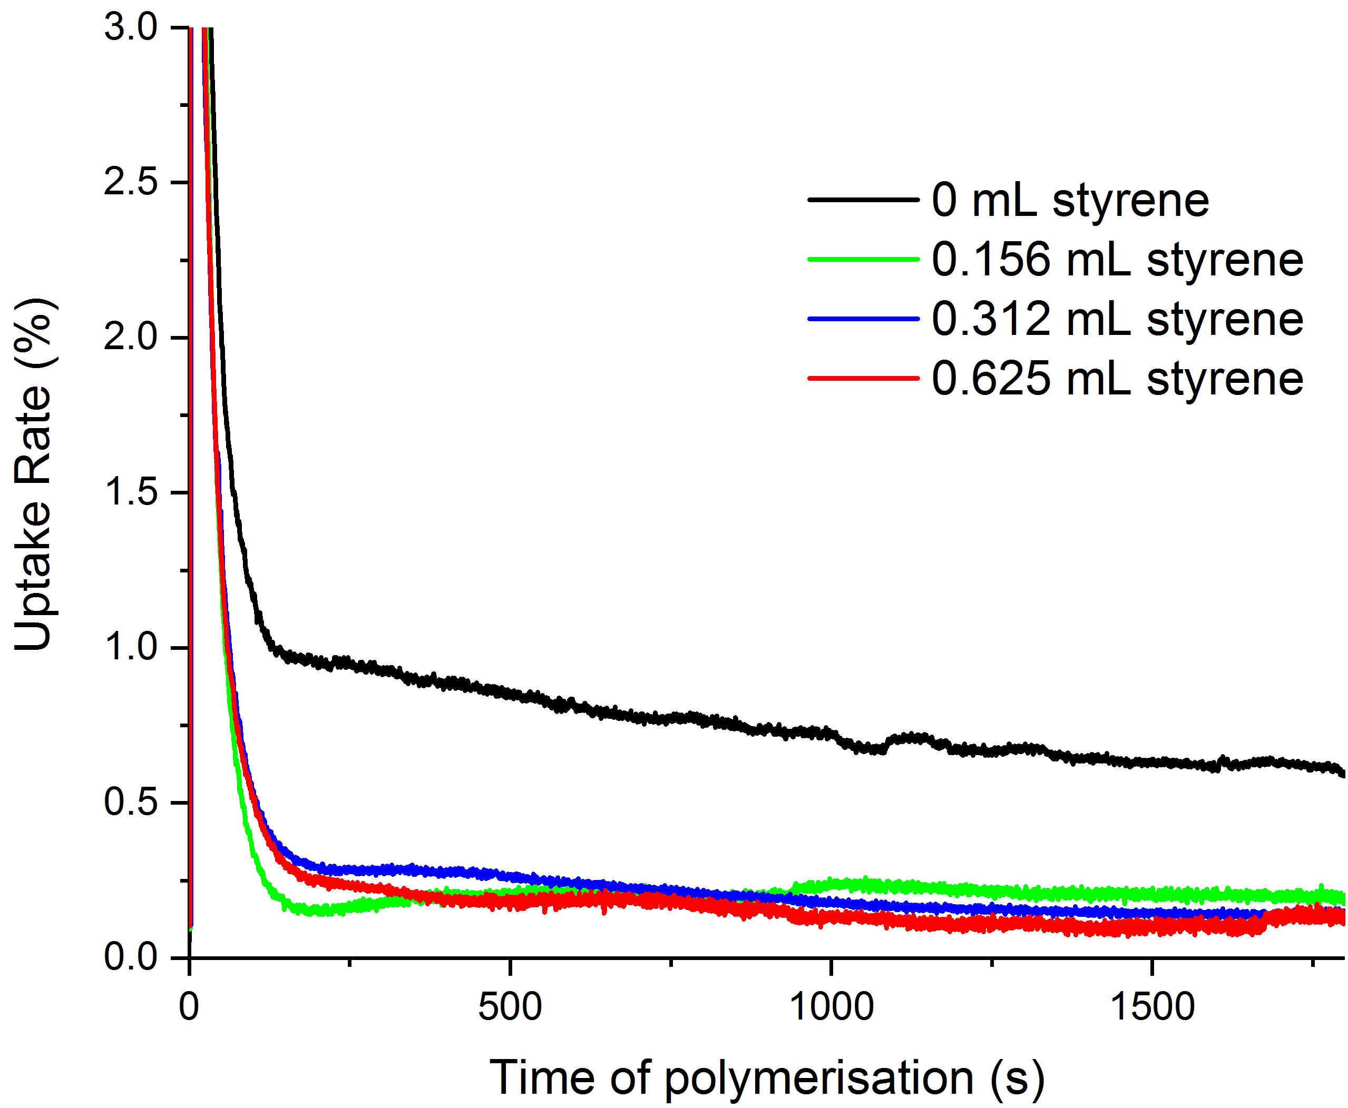
Figure S3.11. Ethylene uptake rate plots for sMAO-^{Me2}SB(^{tBu}N,I*)Ti(CH₂Ph₂). (Co)polymerisations run for 30 minutes, 10 mg catalyst, 150 mg TiBA, 2 bar of ethylene pressure and 10 mg of catalyst at 70 °C. Y-axis is a guide with percentage value providing a quantitative measure of uptake.
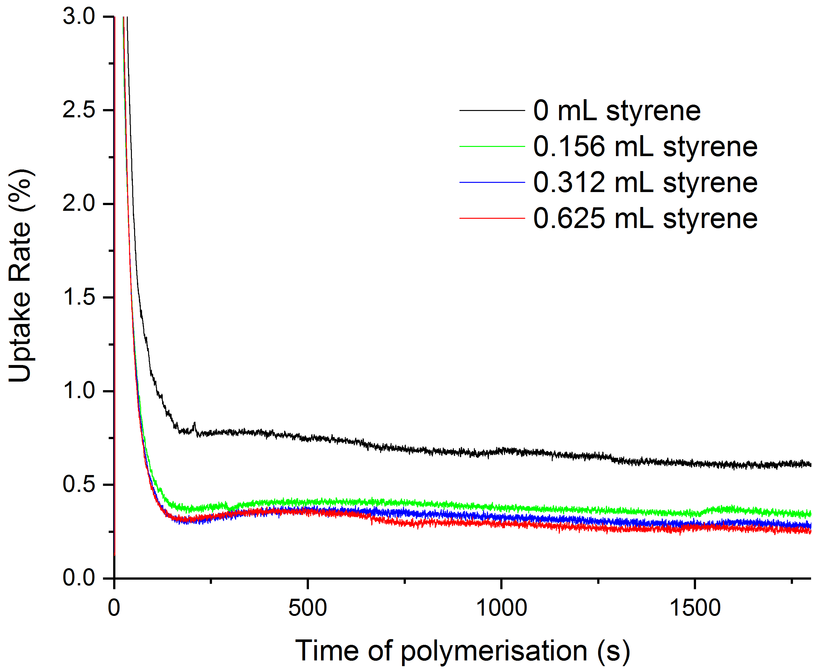
Figure S3.12. Ethylene uptake rate plots for sMAO-^{Me2}SB(^{tBu}N,^{3-Et}I*)TiCl₂. (Co)polymerisations run for 30 minutes, 10 mg catalyst, 150 mg TiBA, 2 bar of ethylene pressure and 10 mg of catalyst at 70 °C. Y-axis is a guide with percentage value providing a quantitative measure of uptake.

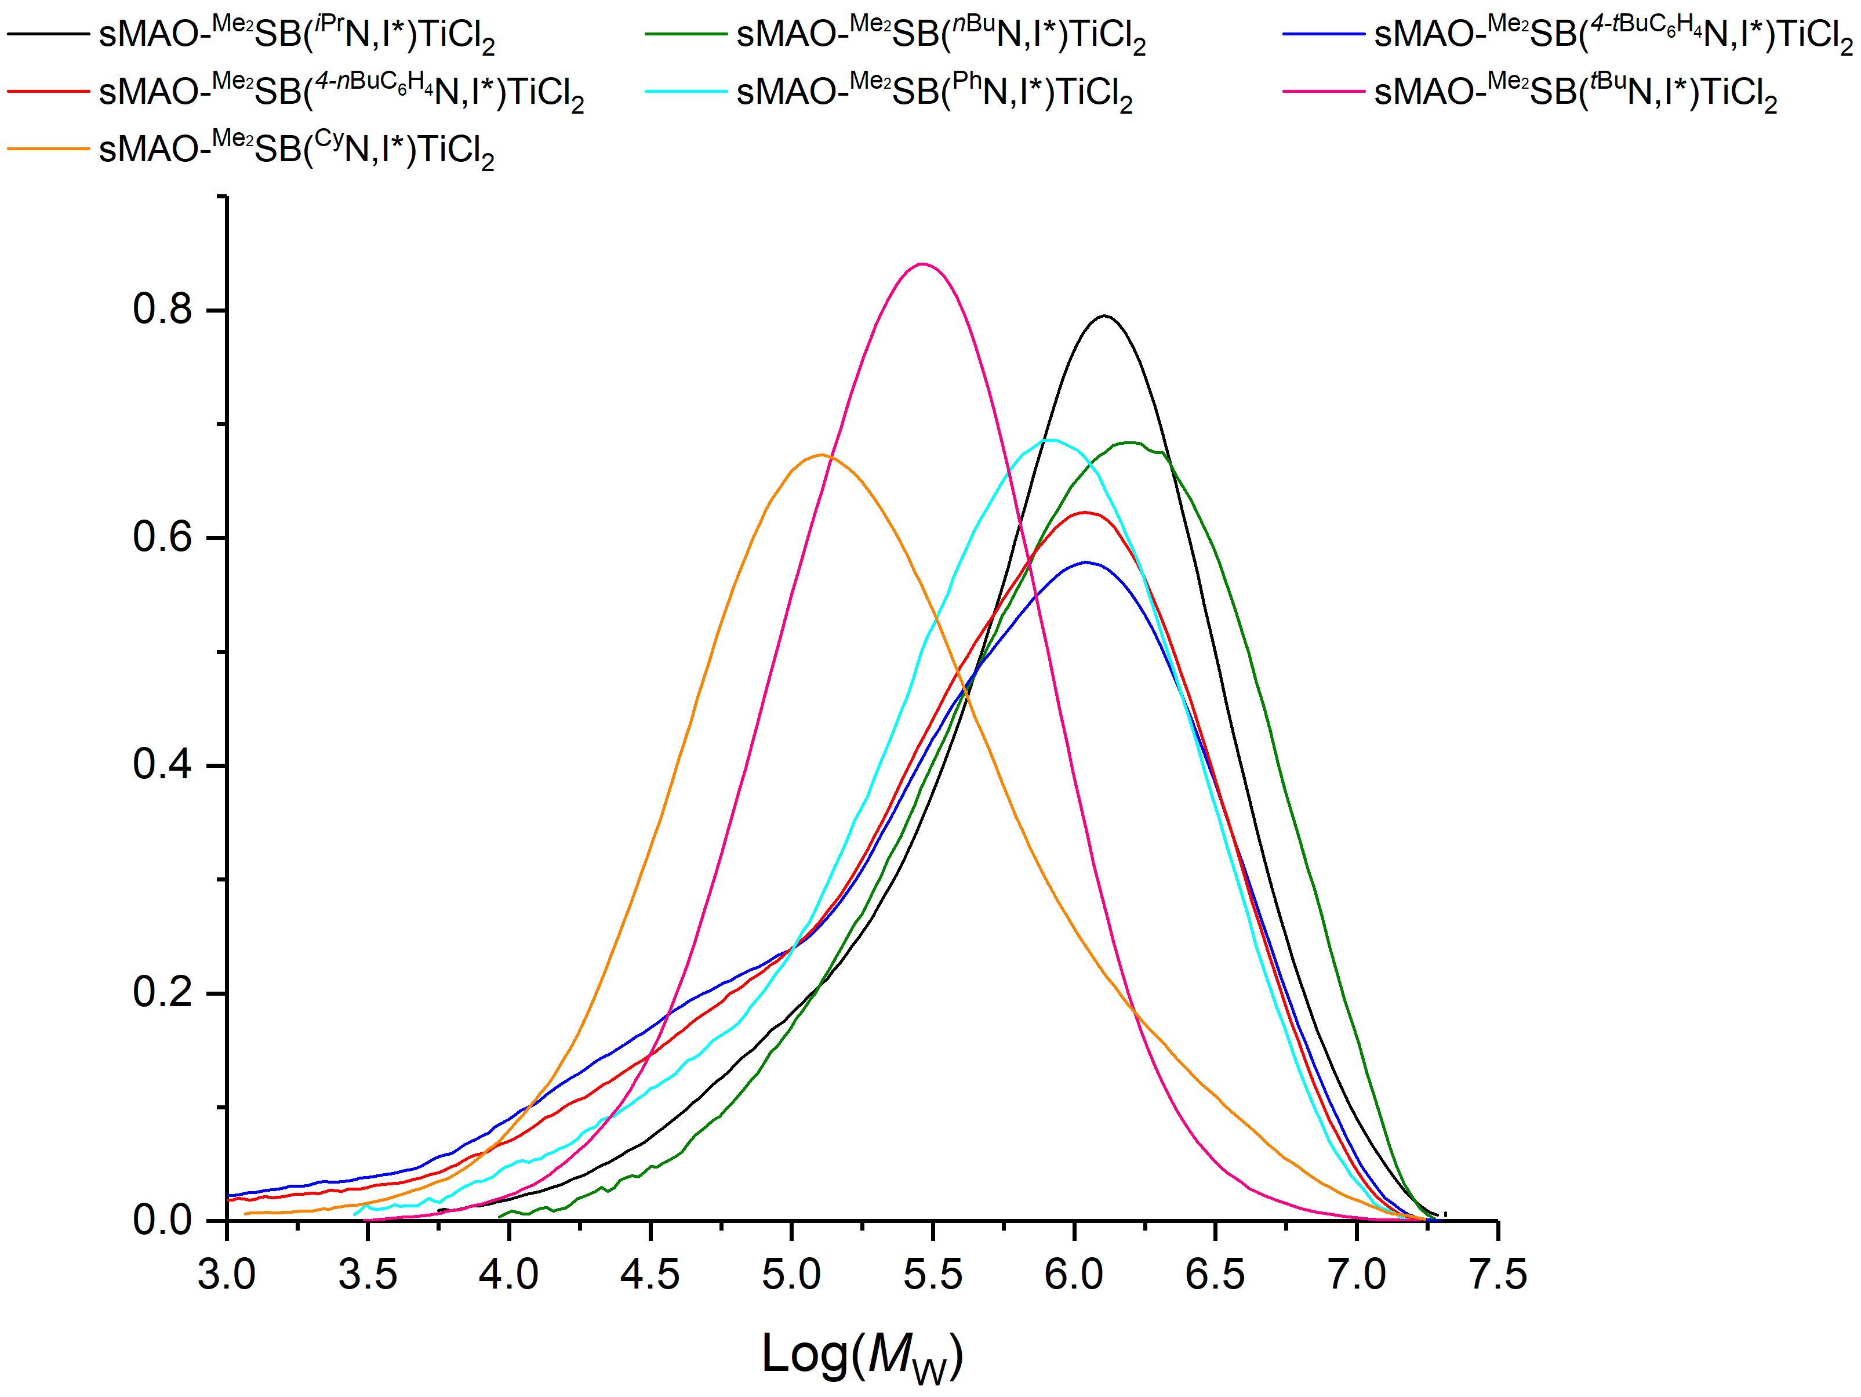
Figure S3.13. GPC traces for sMAO-^{Me2}SB(^{R}N,I*)TiCl₂. Polymerisations run for 30 minutes, 10 mg catalyst, 150 mg TiBA, 2 bar of ethylene pressure and 10 mg of catalyst at 70 °C. Y-axis is a guide with percentage value providing a quantitative measure of uptake.
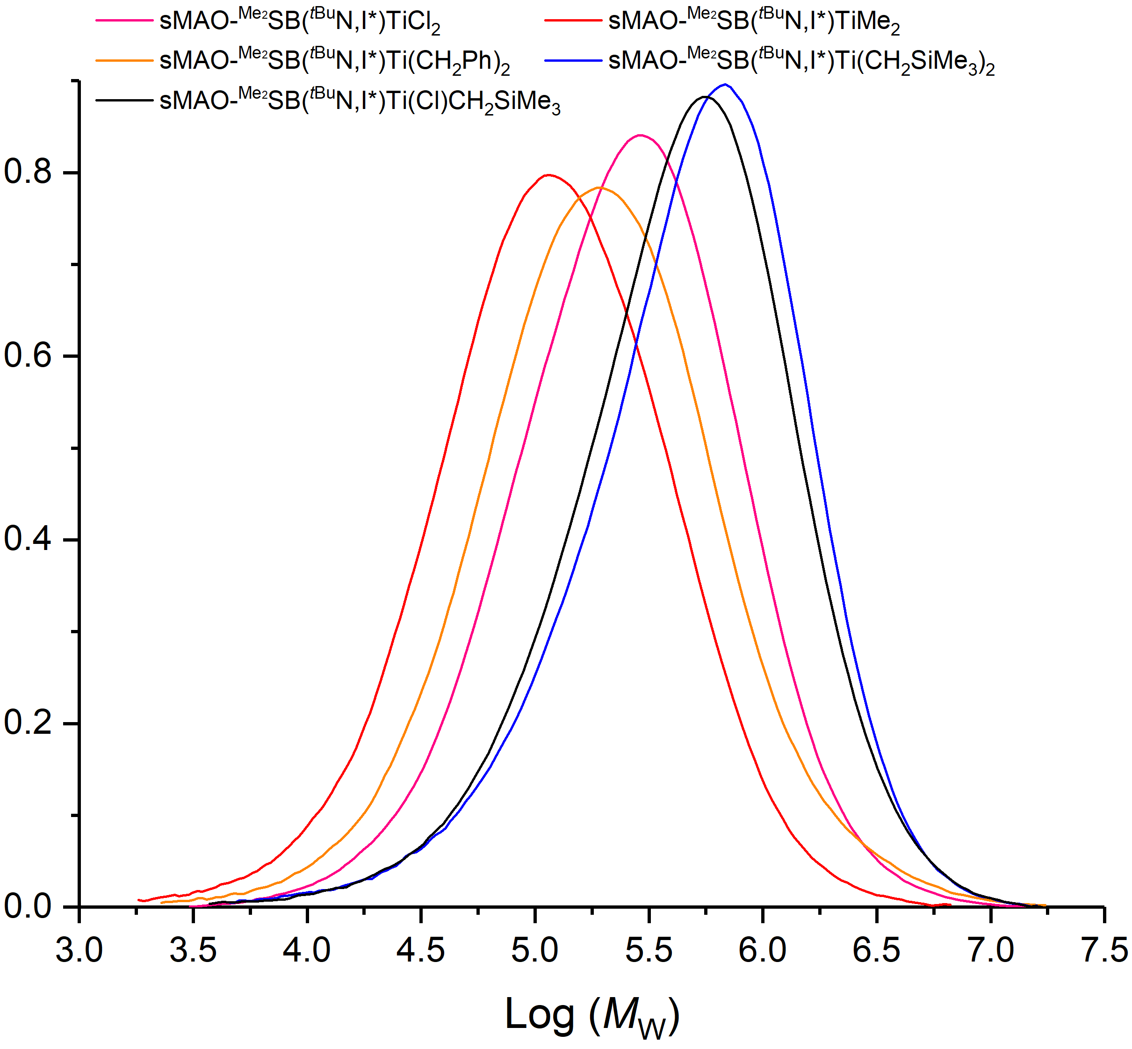
Figure S3.14. GPC traces for sMAO-^{Me2}SB(^{tBu}N,I*)TiX₂. Polymerisations run for 30 minutes, 10 mg catalyst, 150 mg TiBA, 2 bar of ethylene pressure and 10 mg of catalyst at 70 °C. Y-axis is a guide with percentage value providing a quantitative measure of uptake.
Polymer molecular weights decrease with increased polymerisation temperature (868 to 247 kDa), due to the relative rates of chain propagation and termination changing with temperature, and chain transfer reactions increasing at higher temperatures. In addition, there are greater values of polydispersities (M_{w}/M_{n}) for the less active catalysts; at 70 ºC, M_{w}/M_{n} for sMAO-^{Me2}SB(^{tBu}N,I*)TiCl₂ is 3.9 compared with 8.4, 7.6 and 5.7 for sMAO-^{Me2}SB(^{Cy}N,I*)TiCl₂, sMAO-^{Me2}SB(^{iPr}N,I*)TiCl₂ and sMAO-^{Me2}SB(^{nBu}N,I*)TiCl₂ respectively.
The polymer molecular weight distributions of the polymers produced by aromatic amido complexes are in general much greater than those of the aliphatic amido complexes, with values up to 30.8. The ²⁹Si CP-MAS ssNMR of sMAO-^{Me2}SB(^{Ph}N,I*)TiCl₂ shows multiple resonances at 6, 2, −4, −16, −98 ppm. In contrast, the ²⁹Si CP-MAS ssNMR of sMAO-^{Me2}SB(^{tBu}N,I*)TiCl₂ shows one resonance at −19 ppm which would imply the presence of multiple silicon species in the aromatic CGC and one in sMAO-^{Me2}SB(^{tBu}N,I*)TiCl₂. These broad molecular weight distributions and the multiple resonances observed in the ssNMR would imply poor control of the polymerisation mechanism with aromatic CGCs, and the possibility of multiple active sites.

4. Additional X-ray crystallography data
4.1 Experimental crystallographic data
Table S4.1. Selected experimental crystallographic data.
Complex | ^{Me2}SB(^{tBu}N,I*)TiMe₂ | ^{Me2}SB(^{tBu}N,I*)Ti(CH₂SiMe₃)₂ | ^{Me2}SB(^{tBu}N,I*)Ti(Cl)CH₂SiMe₃
Crystal data
Chemical formula | C₂₃H₃₉NSiTi | C₂₉H₅₅NSi₃Ti | C₂₅H₄₄ClNSi₂Ti
M_{r} | 405.54 | 549.91 | 498.14
Crystal system, space group | Triclinic, P¯1 | Monoclinic, P2₁/c | Triclinic, P¯1
Temperature (K) | 150 | 150 | 150
a, b, c (Å) | 8.3867 (3), 11.9189 (3), 13.1122 (4) | 15.8252 (1), 17.4377 (2), 11.7547 (1) | 11.5116 (4), 15.3678 (4), 17.0621 (3)
α, β, γ (°) | 71.317 (3), 77.382 (3), 70.280 (3) | 90, 100.355 (1), 90 | 74.727 (2), 82.480 (2), 72.304 (3)
V (Å³) | 1159.83 (7) | 3190.94 (5) | 2769.80 (14)
Z | 2 | 4 | 4
Radiation type | Cu Ka | Cu Ka | Cu Ka
µ (mm⁻¹) | 3.65 | 3.46 | 4.41
Crystal size (mm) | 0.23 × 0.17 × 0.14 | 0.32 × 0.19 × 0.17 | 0.19 × 0.14 × 0.05
Data Collection
Diffractometer | SuperNova, Dual, Cu at zero, Atlas | SuperNova, Dual, Cu at zero, Atlas | SuperNova, Dual, Cu at zero, Atlas
Absorption correction | Gaussian  CrysAlis PRO 1.171.38.41 (Rigaku Oxford Diffraction, 2015) Numerical absorption correction based on gaussian integration over a multifaceted crystal model Empirical absorption correction using spherical harmonics, implemented in SCALE3 ABSPACK scaling algorithm. | Multi-scan  CrysAlis PRO 1.171.38.41 (Rigaku Oxford Diffraction, 2015) Empirical absorption correction using spherical harmonics, implemented in SCALE3 ABSPACK scaling algorithm. | Multi-scan  CrysAlis PRO 1.171.39.46 (Rigaku Oxford Diffraction, 2018) Empirical absorption correction using spherical harmonics, implemented in SCALE3 ABSPACK scaling algorithm.
T_{min}, T_{max} | 0.738, 0.837 | 0.771, 1.000 | 0.870, 1.000
No. of measured, independent and  observed [I > 2σ(I)] reflections | 23597, 4738, 4648 | 62395, 6525, 6322 | 30077, 11479, 10137
R_{int} | 0.019 | 0.027 | 0.032
Refinement
R[F² > 2σ(F²)], wR(F²), S | 0.029, 0.087, 1.11 | 0.027, 0.076, 1.07 | 0.036, 0.097, 1.03
No. of reflections | 4738 | 6525 | 11479
No. of parameters | 248 | 324 | 569
No. of restraints | 0 | 0 | 0
(Δ/σ)_{max} | 0.002 | 0.002 | 0.002
Δρ_{max}, Δρ_{min} (e Å⁻³) | 0.27. -0.27 | 0.27, -0.29 | 0.79, -0.34

Computer programs: CrysAlis PRO 1.171.38.41 (Rigaku OD, 2015), CrysAlis PRO 1.171.39.46 (Rigaku OD, 2018), SUPERFLIP-Palatinus, L.; Chapuis, G. J. Appl. Cryst. 2007, 40, 786-790., SHELXL2014/7 (Sheldrick, 2014), Burnett, M. N.; Johnson, C. K. ORTEP-III Report ORNL-6895. Oak Ridge National Laboratory, Tennessee, USA 1996.

5. References
1 J.-C. Buffet, T. A. Q. Arnold, Z. R. Turner, P. Angpanitcharoen and D. O’Hare, RSC Adv., 2015, 5, 87456–87464.
2 J. P. Fackler, Inorganic Syntheses, John Wiley & Sons, Inc., Hoboken, NJ, USA, 1982, vol. 21.
3. J. Cosier and A. M. Glazer, J. Appl. Crystallogr., 1986, 19, 105-107.
4. CrysAlisPRO, Oxford Diffraction /Agilent Technologies UK Ltd, Yarnton, England.
5. A. Altomare, G. Cascarano, C. Giacovazzo and A. Guagliardi, J. Appl. Crystallogr., 1993, 26, 343-350.
6. L. Palatinus and G. Chapuis, J. Appl. Crystallogr., 2007, 40, 786-790.
7. L. Farrugia, J. Appl. Crystallogr., 1999, 32, 837-838.

