Visualising Plating-Induced Cracking in Lithium Anode Solid Electrolyte Cells

Ziyang Ning¹, Dominic Spencer Jolly¹, Guanchen Li^{3,4}, Robin De Meyere¹, Shengda D. Pu¹, Yang Chen¹, Jitti Kasemchainan^{1,3}, Johannes Ihli⁵, Chen Gong¹, Boyang Liu^{1,3}, Dominic Melvin^{1,3}, Anne Bonnin⁵, Oxana Magdysyuk⁶, Paul Adamson^{1,3}, Gareth O. Hartley^{1,3}, Charles W. Monroe^{3,4}, T. James Marrow¹, Peter G. Bruce^{1,2,3}

- Department of Materials. University of Oxford, Oxford, UK
- Department of Chemistry, University of Oxford, Oxford, UK
- The Faraday Institution, Harwell Campus, Didcot, UK
- Department of Engineering Science, University of Oxford, Oxford, UK
- Paul Scherrer Institut, Villigen PSI, Switzerland
- Diamond Light Source, Harwell Campus, Didcot, UK

Supplementary Information
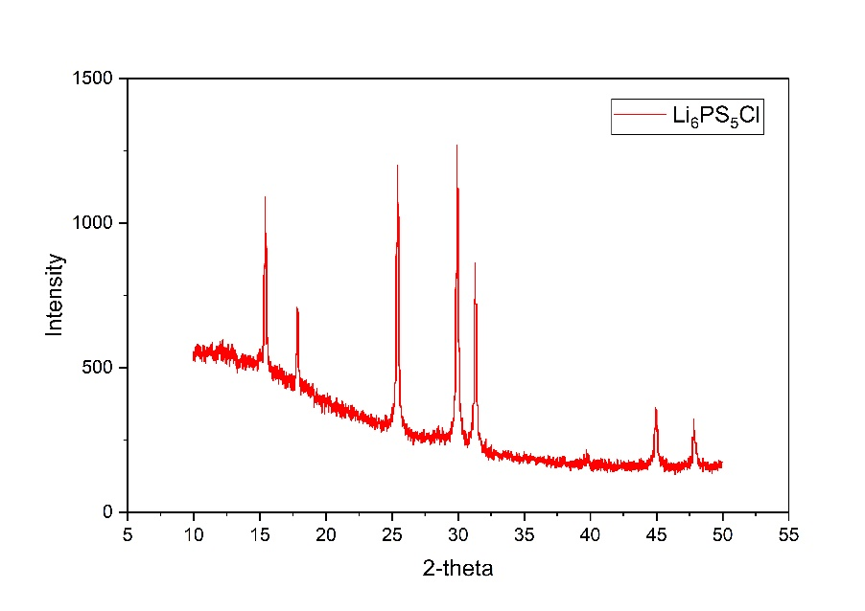
Fig. S1. Powder X-ray diffraction pattern of Li₆PS₅Cl: after sintering at 300 °C.

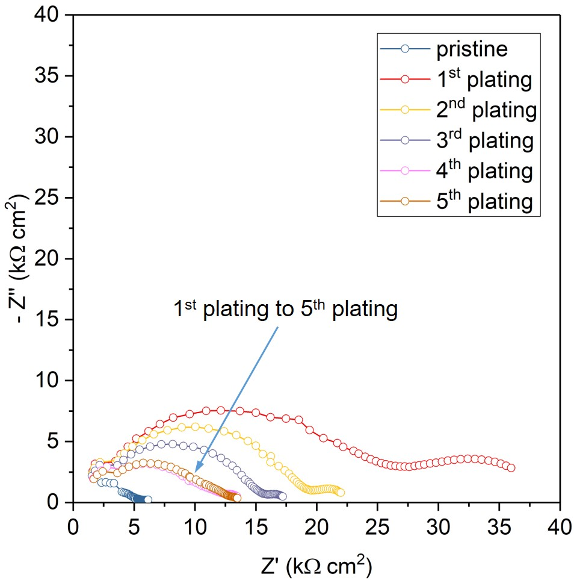
Fig. S2. The impedance of the cell measured at pristine, and after the 1st, 2nd, 3rd, 4th, and 5th plating of the initially plated electrode. The impedance increases significantly after 1st plating due to void formation at the initially stripped electrode; and decreases gradually in the subsequent cycles as the number of spallations increases, until reaching a steady state after the 4th plating.

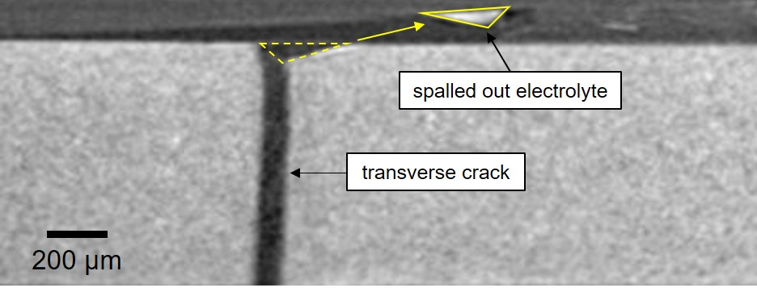

Fig. S3. Virtual cross-sectional image slice from ex-situ X-ray CT on a cycled Na/Na-beta’’-Alumina/Na symmetric cell. It clearly reveals a piece of electrolyte (cone-shaped piece) completely spalled out from the bulk electrolyte, and a transverse crack propagation underneath the spallation.

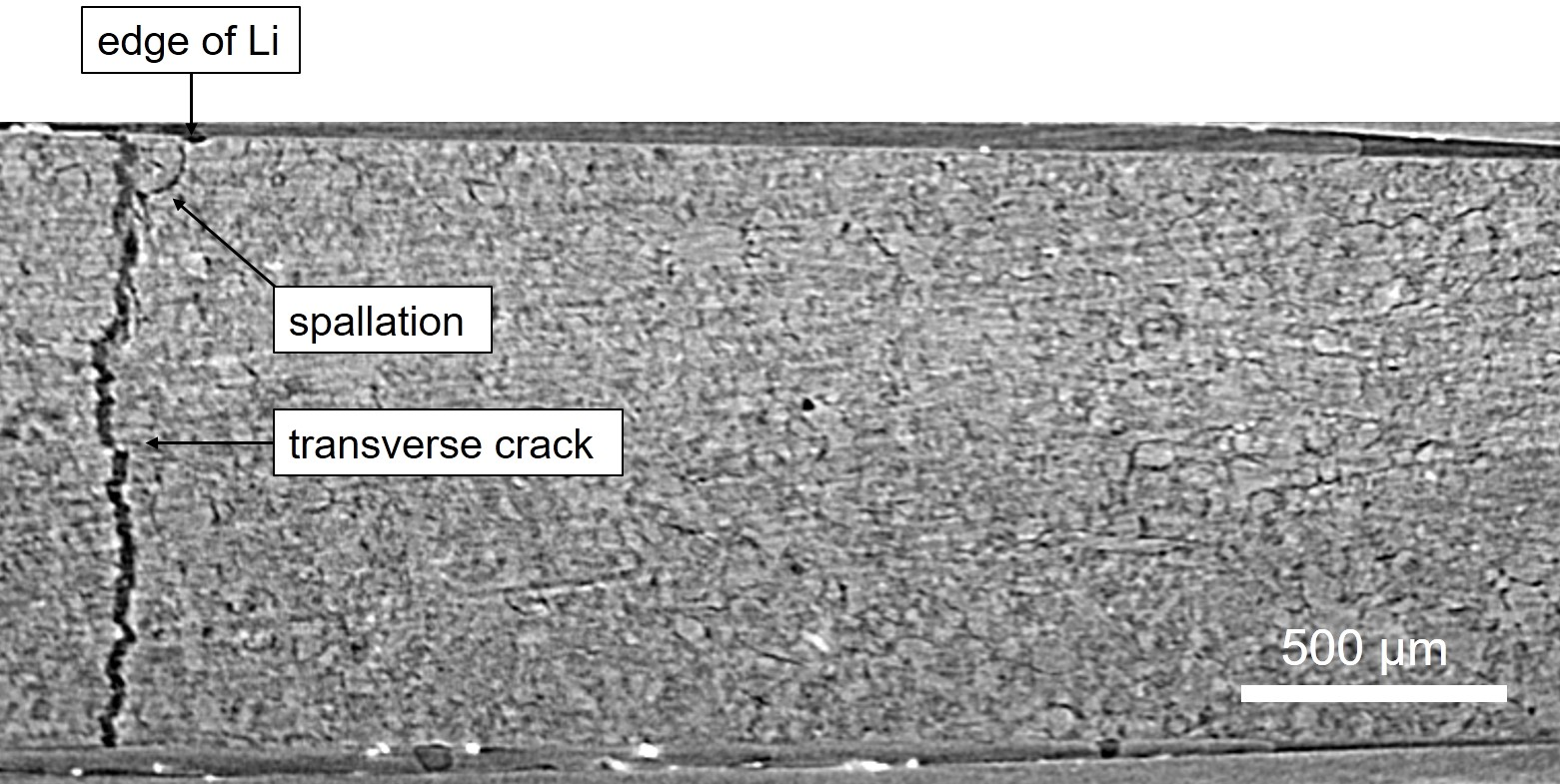
Fig. S4. Virtual cross-sectional image slice from ex-situ XCT scan of a cycled Li/Li₃N/Li symmetric cell. A spallation and associated transverse crack propagation were observed at the edge of the lithium electrode.

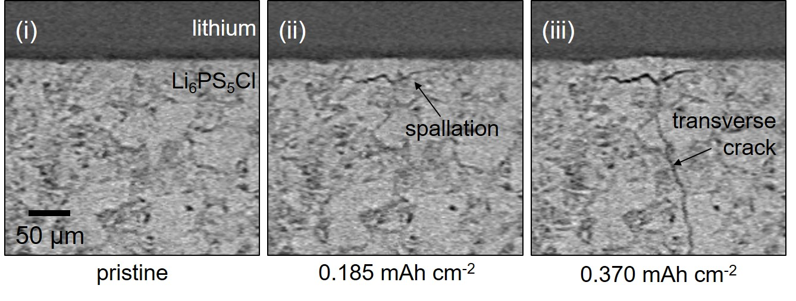

Fig. S5. In-situ X-ray CT virtual cross-setions from a different region during a single plating of a Li/Li₆PS₅Cl/Li cell showing the early stages of spallation formation. Virtual cross-sectional image slices of (i) the pristine cell and after (ii) 0.185 mAh cm⁻², (iii) 0.370 mAh cm⁻² of charge passed.

Fig. S6. SEM cross-section showing spallation within Li₆PS₅Cl electrolyte.

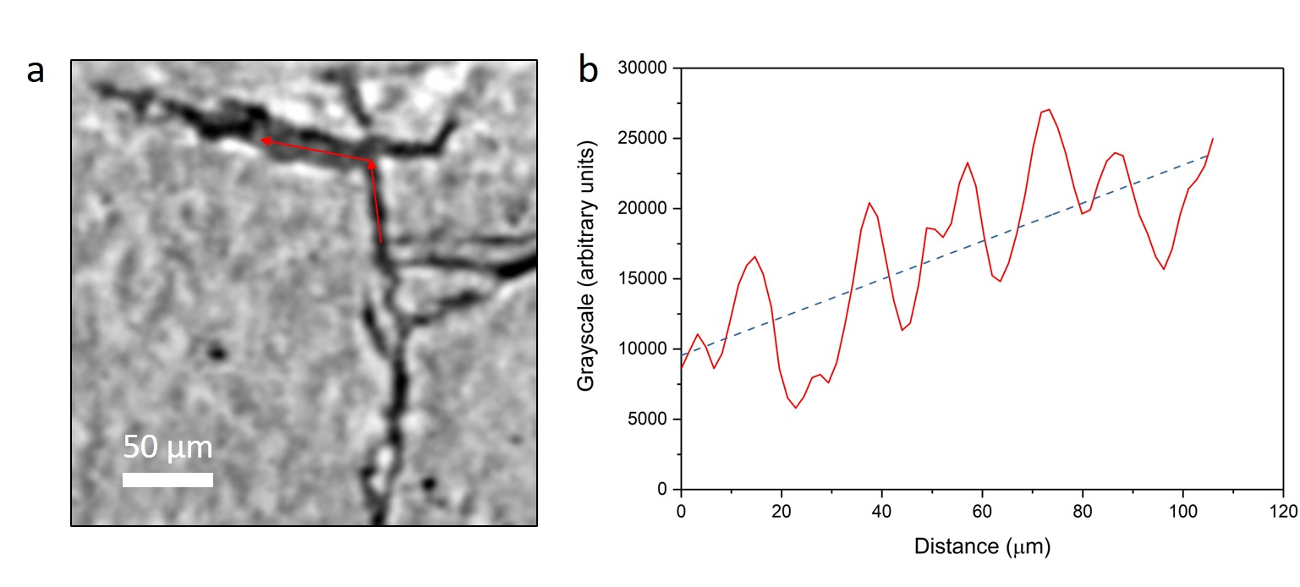
Fig. S7. Continuous grayscale line profile of lithium from inside the vertical crack to inside the spallation crack, showing an increase in the average attenuation coefficient when moving towards the plated electrode. a. magnified virtual cross-sectional image slice of the cell, after 1.0 mAh cm⁻² of charge passed. The position and direction of the grayscale line profile are shown (red arrows). b. measured grayscale profile of lithium inside the crack along the red arrows (red curve), linear fitting of the grayscale profile (blue dashed line), showing the average attenuation coefficient increases vertically towards the plated electrode.

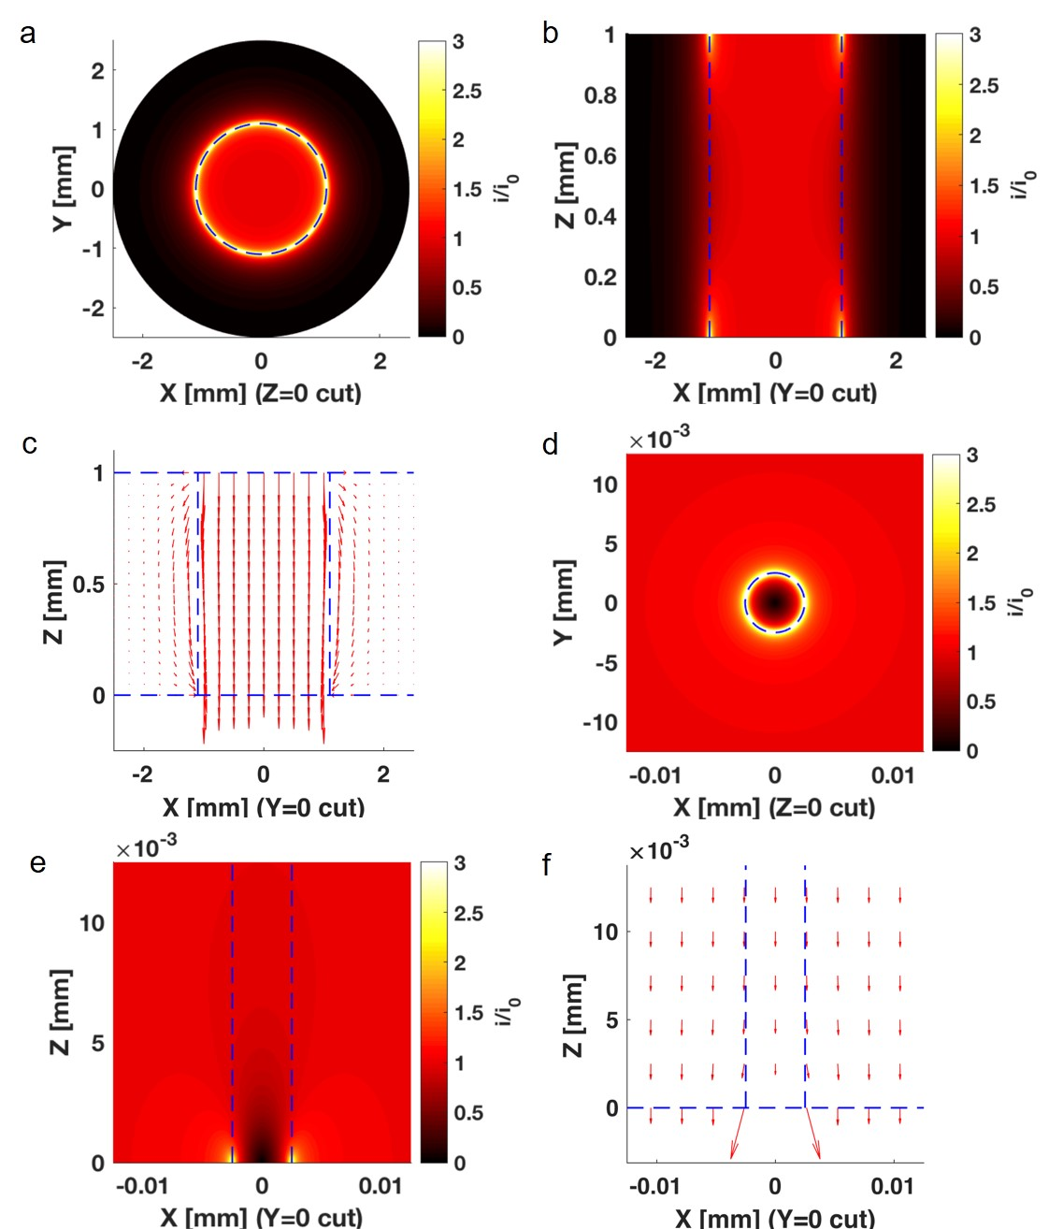
Fig. S8. Current density contour plots for a symmetric Li/Li₆PS₅Cl/Li cell with a lithium electrode diameter 2 mm, electrolyte diameter 5 mm, and thickness 1 mm, representing our practical cell dimensions. A void is introduced to the Li/Li₆PS₅Cl interface at the centre of electrode to simulate the effect of poor local contact on current flux distribution. a. current density distribution inside the electrolyte viewed perpendicular to the Li/Li₆PS₅Cl interface. b. current density distribution viewed in cross-section. c. distribution of electric field lines with the plated electrode shown at the bottom and stripped electrode at the top. d. current density distribution inside the electrolyte around the void at the Li/Li₆PS₅Cl interface viewed perpendicular to the interface. e. current density distribution viewed in cross-section around the void at the Li/Li₆PS₅Cl interface. f. distribution of electric field lines around the void with the plated electrode on the bottom.

The figure shows the current density contour plots and the distribution of electric field lines within a cylindrical solid electrolyte, sandwiched between two voltage-biased concentric lithium electrodes whose diameters are smaller than the electrolyte. To model the effect of voids on the current-density distribution, a void of 5 µm in diameter was introduced at the centre of plated electrode. Electric potential in the electrolyte is governed by Laplace’s equation. Dirichlet boundary conditions (constant potential) are imposed on the surface in contact with electrodes. Surfaces not in contact with the electrode take no-flux Neumann conditions (). The current density is proportional to the gradient of electric potential according to Ohm’s law . Fig. S4a shows the distribution of current density across the top (adjacent to stripped electrode) or bottom (adjacent to plated electrode) surface of the electrolyte (these are the same due to symmetry). Due to the sharp change between constant-potential and insulting behaviour at the outer edge of the lithium electrode, the current density near the electrode edge is significantly greater (> 3 fold) than that at its centre (i₀). Fig. S4b shows that the current distribution is also non-uniform in the axial direction. Traversing the electrolyte axially from one of the high-current areas at the electrolyte edge, the current density decays rapidly. The current density at the edge becomes comparable to the current density at the centre at a depth of about 100 μm into the electrolyte and away from the interface, which suggests that spallations are unlikely to form far away from the interface. Fig. S4c shows the distribution of electric field lines in cross-section. The electric field lines spread out in the middle of the electrolyte and incline away from the axial near the electrode’s edges. Consequently, lithium plating near the electrode edge may create inclined cracks and form inclined filaments, which would be favourable for forming spallations. Fig. S4d shows the current density distribution near a void. The edge of a surface void has a high local current density much like the electrode edge, but the influence is more limited due to the small void size. Spallations induced by surface voids would be expected to be smaller than those induced by the electrode edge. Fig. S4e indicates that the distortion of the current density near the void is also restricted to a shallow surface region, not deep into the bulk of the electrolyte (~5 μm). Fig. S4f plots the distribution of electric field lines near the central void. Due to the insulating nature of the void, electric field lines have to incline to bypass it, a possible cause of the inclined edges of spallations.

