Supplemental References- cohort profiles

1. Boyd A, Golding J, Macleod J, Lawlor DA, Fraser A, Henderson J, Molloy L, Ness A, Ring S, Davey Smith G. Cohort Profile: The ‘Children of the 90s’—the index offspring of the Avon Longitudinal Study of Parents and Children. International Journal of Epidemiology. 2013; 42(1):111-127
2. Klebanoff MA. The Collaborative Perinatal Project: a 50-year retrospective. Paediatric and Perinatal Epidemiology 2009; 23:2-8. [CPP]
3 Olsen J, Melbye M, Olsen SF, Sorensen TI, Aaby P, Andersen AM, et al. The Danish National Birth Cohort-its background, structure and aim. Scandinavian Journal of Public Health 2001; 29:300-307. [DNBC]
4. Harlap S, Davies AM, Deutsch L, Calderon-Margalit R, Manor O, Paltiel O, et al. The Jerusalem Perinatal Study cohort, 1964-2005: methods and a review of the main results. Paediatric and Perinatal Epidemiology 2007; 21:256-273. [JPS]
5. Magnus P, Irgens LM, Haug K, Nystad W, Skjaerven R, Stoltenberg C. Cohort profile: the Norwegian Mother and Child Cohort Study (MoBa). International Journal of Epidemiology 2006; 35:1146-1150. [MoBA]
6. Dwyer T, Ponsonby AL, Blizzard L, Newman NM, Cochrane JA. The contribution of changes in the prevalence of prone sleeping position to the decline in sudden infant death syndrome in Tasmania. Journal of American Medical Association 1995; 273:783-789. [TIHS]

ALSPAC - Description of study numbers
ALSPAC recruited 14,541 pregnant women resident in Avon, UK with expected dates of delivery 1st April 1991 to 31st December 1992. 14,541 is the initial number of pregnancies for which the mother enrolled in the ALSPAC study and had either returned at least one questionnaire or attended a “Children in Focus” clinic by 19/07/99. Of these initial pregnancies, there were a total of 14,676 fetuses, resulting in 14,062 live births and 13,988 children who were alive at 1 year of age.
Please note that the study website contains details of all the data that is available through a fully searchable data dictionary" and reference the following webpage:
http://www.bris.ac.uk/alspac/researchers/data-access/data-dictionary/

Ethical approval for the study was obtained from the ALSPAC Ethics and Law Committee and the Local Research Ethics Committees.
Supplementary Table 1: Degree of missingness in baseline variables of study population (N = 180,549)

Variable | Number and % missing
Variable | N | %
Paternal age | 18,948 | 10.5
Maternal age | 662 | 0.4
Maternal education ≥ 12 years | 6,999 | 3.9
Any maternal smoking | 64,685 | 35.8
Birth-order | 11,711 | 6.5
Later born | 2,066 | 1.1
Birth weight | 732 | 0.4
Sex of child | 0 | 0.0
Supplementary Table 2- Interaction models with birth weight (continuous, in kg) and paternal age (continuous, in years) for association between childhood cancer risk and birth order (later-born vs. first- born)

Cox proportional hazard models | Coefficient | Standard  error | t | P>|t| | Coefficient  95% CI
Model 1: Later born and continuous birth weight main effects and interaction
Later-born | -2.390 | 0.937 | -2.550 | 0.011 | -4.227 | -0.552
Birth weight | -0.027 | 0.202 | -0.140 | 0.893 | -0.423 | 0.368
Later-born by birth weight interaction | 0.592 | 0.263 | 2.250 | 0.024 | 0.077 | 1.107
Model 2: Later-born and paternal age main effects and interaction
Later-born | 1.266 | 0.833 | 1.520 | 0.128 | -0.366 | 2.898
Paternal age | 0.021 | 0.020 | 1.020 | 0.305 | -0.019 | 0.061
Later-born by paternal age interaction | -0.048 | 0.026 | -1.830 | 0.067 | -0.100 | 0.003
Model 3: Later-born , birth weight and paternal age main effects and interactions
Later-born | -0.799 | 1.193 | -0.670 | 0.503 | -3.137 | 1.538
Birth weight | -0.042 | 0.201 | -0.210 | 0.835 | -0.435 | 0.352
Paternal age | 0.025 | 0.020 | 1.250 | 0.210 | -0.014 | 0.065
Later-born by birth weight interaction | 0.642 | 0.263 | 2.440 | 0.015 | 0.126 | 1.158
Later-born by paternal age interaction | -0.056 | 0.026 | -2.130 | 0.033 | -0.108 | -0.005

Supplementary Figure 1. Hazard ratios (●) and 95% confidence interval for successive birth order (N = 180,549). Panel A shows unadjusted leukemia, panel B shows unadjusted acute lymphoblastic leukemia (ALL), panel C shows adjusted leukemia, and panel D shows adjusted ALL. Hazard ratios in panels C and D are adjusted for sex of child, continuous birth weight, continuous maternal age, and maternal secondary education (yes vs. no).

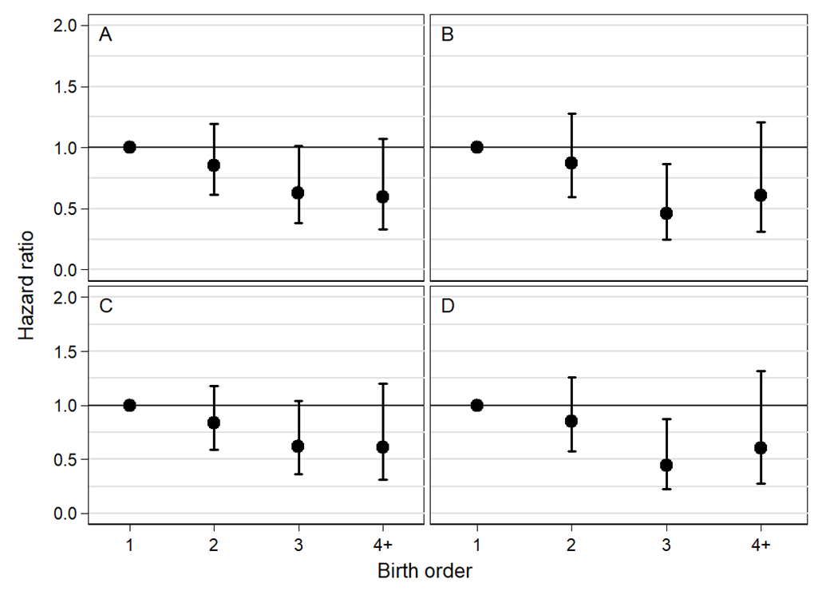

P-values for linear trend in birth order hazard ratios

Panel A = 0.047
Panel B = 0.055
Panel C = 0.105
Panel D = 0.093

\
Supplementary Figure 2. Hazard ratios (●) and 95% confidence interval for successive birth order (N = 112,943) adjusted for sex of child, continuous gestational age and continuous birth weight. Panel A shows leukemia (P for linear trend=0.131) and panel B shows acute lymphoblastic leukemia (ALL) (P for linear trend=0.079)
