Equations used for the MRK gas speciation:

Chlorine
Chloride capacity (this study):
$logC_{Cl}=1.15+\frac{4359X_{Ca}-3055X_{Si}+2059X_{Fe}-3875X_{K}+163X_{Mg}-514P}{T}$
T in Kelvin, P in GPa, X_{M} on single cation basis.
HCl fugacity (this study):
$f_{HCl}=K_{HCl}×\frac{\left(f_{H_{2}O})^{0.5}\right.}{\left(K_{H_{2}O})^{0.5}\right.}×\frac{Cl (wt.\%)}{C_{Cl}}$
$\log_{10}{K_{H_{2}O}}= \frac{12850}{T}-2.8675$
$\log_{10}{HCl}= \frac{4894.6}{T}+0.3436$

Water
Moore (1998):
a = 2565; b_Al₂O3 = -1.997; b_FeO_{tot} = -0.9275; b_Na₂O = 2.736; c = 1.171; d = -14.21;
$\ln{fH_{2}O}=\frac{2\log{XH_{2}O}- \frac{a}{T}- \sum_{i}{bX_{i}}\frac{P}{T}-d}{c}$
P in bars, T in Kelvin, X_{i} on anhydrous basis.
Burnham (1994):
$({a_{w}^{m})}_{P, T, X_{w}^{m}≤0.5}=k_{w}{(X_{w}^{m})}^{2}$
$({a_{w}^{m})}_{P, T, X_{w}^{m}>0.5}={0.25k}_{w}exp⁡(\frac{6.52-\frac{2667}{T}}{X_{w}^{m}-0.5})$
$lnk_{w}=5.00+lnP\left(4.481×{10}^{-8}T^{2}-1.51×{10}^{-4}T-1.137\right)+{\left(lnP\right)}^{2}\left(1.831×{10}^{-8}T^{2}-4.882×{10}^{-5}T+0.04656\right)+7.8×{10}^{-3}{(lnP)}^{3}-5.012×{10}^{-4}{\left(lnP\right)}^{4}+T(4.754×{10}^{-3}-1.621×{10}^{-6}T)$
P in bars, t in Kelvin, X on eight oxygen basis.

Sulphur
Sulphide and sulphate capacities (Gorojovsky and Wood 2025)
${logC}_{S^{2-}}=0.65+\left(-3368X_{Si_{0.5}O}-1233X_{Al_{0.6}O}+1295X_{CaO}+44885X_{K_{2}O}+10914X_{FeO}∙X_{Si_{0.5}O}-871864X_{FeO}∙X_{K_{2}O}-225569X_{FeO}∙X_{Na_{2}O}+54392X_{FeO}∙X_{Al_{0.5}O}-7585\right) / T+3.9\operatorname{erf}\left[X_{FeO}\right]$
$logC_{S^{6+}}=196.0+\left(-7633X_{Si_{0.5}O}-{10670}_{Ti_{0.5}O}-6901X_{Al_{0.6}O}-4625X_{FeO_{T}}+19114X_{MnO}+11740X_{CaO}+33267X_{Na_{2}O}-4095\right) / T -57.3log⁡(T)$
Reaction constants (Bouillung and Wood 2021, 2023)
$\log_{10}{K_{{SO}_{2}}}= \frac{18880}{T}-3.8018$
$\log_{10}{K_{H_{2}S}}= \frac{27103}{T}-4.1973$
Effect of P (Thomas and Wood 2026)
$\frac{δ{logC}_{S^{2-}}}{δP}=\frac{-0.056(±0.008)}{T}$
$\frac{δ{logC}_{S^{6+}}}{δP}=\frac{-0.165(±004)}{T}$
T in Kelvin, P in bars, X_{M} on single oxygen basis.

Oxygen
FMQ base (Frost 1991)
$logfO_{2}= \frac{-25096.3}{T}+8.735+0.110\frac{(P-1)}{T}$
NNO base (Frost 1991)
$logfO_{2}= \frac{-24930}{T}+9.36+0.046\frac{(P-1)}{T}$
CCO base (Jakobsson and Oskarsson 1994)
$logfO_{2}= \frac{-21803}{T}+4.325+0.171\frac{(P-1)}{T}$
P in bars, T in Kelvin.

Carbon
CH4 equilibrium (Ohmoto and Kerrick 1977)
${CH}_{4}+{2O}_{2}={CO}_{2}+{2H}_{2}O$
$\log_{10}{K_{{CH}_{4}}}= \frac{41997}{T}+0.719\log_{10}T-2.404$
$Ptrans \left(kbar\right)=0.025T+12.592$ (Day 2012)
if Pkbar<Ptrans
$\log_{10}{K1}=40.07639-2.53932×{10}^{-2}T+5.27096×{10}^{-6}T^{2}+0.0267\frac{(P\left(kbar\right)-1)}{T}$ (Holloway et al. 1992)
If Pkbar >= Ptrans:
$\log_{10}{K1}=0.2450-\frac{2.027×{10}^{4}}{T}-\frac{4.730×{10}^{4}}{T^{2}}+0.0267\frac{(1.949×{10}^{-7}P\left(Pa\right)-{10}^{6})}{T}$ (Duncan and Dasgupta 2017)
$lnX{CO}_{3}^{2-}=-\frac{2.384×{10}^{-5}P\left(Pa\right)}{RT}+\frac{-1.6448×{10}^{5}}{RT}+\frac{1.4732×{10}^{3}lnf{CO}_{2}}{T}+\frac{-43.6385}{R}+3.291NBO+\frac{(1.68×{10}^{5}XCaO+1.7590×{10}^{5}{XNa}_{2}O+2.1085×{10}^{5}XK_{2}O)}{RT}$
Dissolved carbon (Eguchi and Dasgupta 2018)
$lnX{CO}_{2}=-\frac{1.9244×{10}^{-5}P\left(Pa\right)}{RT}+\frac{-9.0212×{10}^{4}}{RT}+\frac{1.1149×{10}^{3}f{CO}_{2}}{T}+\frac{-43.0815}{R}-7.0937NBO$
$wt. \% {CO}_{3}^{2-}=[\frac{44.01×X{CO}_{3}^{2-}}{44.01×X{CO}_{3}^{2-}+(1-\left(X{CO}_{3}^{2-}+X{CO}_{2}\right)FWone}]×100$
$wt. \% {CO}_{2}=[\frac{44.01×X{CO}_{2}}{44.01×X{CO}_{2}+(1-\left(X{CO}_{3}^{2-}+X{CO}_{2}\right)FWone}]×100$
FWone = one-oxygen formula weight of one mol of volatile free melt in g/mol
NBO = non bridging oxygens
If NBO > 0.5, wt. % CO₂ = 0
$wt. \% {{CO}_{2}}_{tot}=wt. \%{CO}_{3}^{2-}+wt. \%{CO}_{2}$

Day, H. W. (2012). A revised diamond-graphite transition curve. American Mineralogist, 97(1), 52-62. https://doi.org/10.2138/am.2011.3763
Duncan, M. S. and R. Dasgupta. (2017) Rise of Earth’s atmospheric oxygen controlled by efficient subduction of organic carbon. Nat. Geosci., 10, 387. https://doi.org/10.1038/ngeo2939
Eguchi, J., & Dasgupta, R. (2018). A CO₂ solubility model for silicate melts from fluid saturation to graphite or diamond saturation. Chemical Geology, 487, 23-38. https://doi.org/10.1016/j.chemgeo.2018.04.012
Frost, B. R. (1991). Introduction to oxygen fugacity and its petrologic importance. In Oxide minerals (pp. 1-10). De Gruyter. https://doi.org/10.1515/9781501508684-004
Gorojovsky, L. R., & Wood, B. J. (2025). Solubility and speciation of sulfur in silicate melts under crustal conditions. EarthArxiv https://doi.org/10.31223/X5T755
Holloway, J. R., Pan, V., & Gudmundsson, G. (1992). High-pressure fluid-absent melting experiments in the presence of graphite: oxygen fugacity, ferric/ferrous ratio and dissolved CO2. European Journal of Mineralogy, 4(1), 105-114. 10.1127/ejm/4/1/0105
Jakobsson, S., & Oskarsson, N. (1994). The system CO in equilibrium with graphite at high pressure and temperature: An experimental study. Geochimica et Cosmochimica Acta, 58(1), 9-17. https://doi.org/10.1016/0016-7037(94)90442-1
Kress, V. C., & Carmichael, I. S. (1991). The compressibility of silicate liquids containing Fe₂O₃ and the effect of composition, temperature, oxygen fugacity and pressure on their redox states. Contributions to Mineralogy and Petrology, 108(1), 82-92. https://doi.org/10.1007/BF00307328
Moore, G., Vennemann, T., & Carmichael, I. S. E. (1998). An empirical model for the solubility of H₂O in magmas to 3 kilobars. American Mineralogist, 83(1-2), 36-42. https://doi.org/10.2138/am-1998-1-203
Ohmoto, H., & Kerrick, D. M. (1977). Devolatilization equilibria in graphitic systems. American Journal of Science, 277(8), 1013–1044. https:/​/​doi.org/​10.2475/​ajs.277.8.1013
Thomas, R.W, Wood, B.J. Sulfur speciation in silicate melts at high pressure. Under Review in GCA

Attainment of equilibrium
Figure illustrating homogenous distribution of Cl in the experimental glass sample. The profile (red line) on the right panel corresponds with composition profile in the left panel (red line on the SE image). Sample DCB-2, Brothers volcano dacite, 1200 °C, 1.63 GPa, 2 hours.
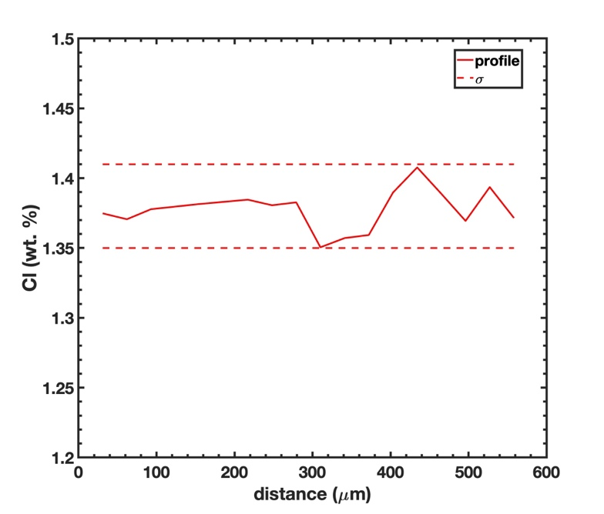
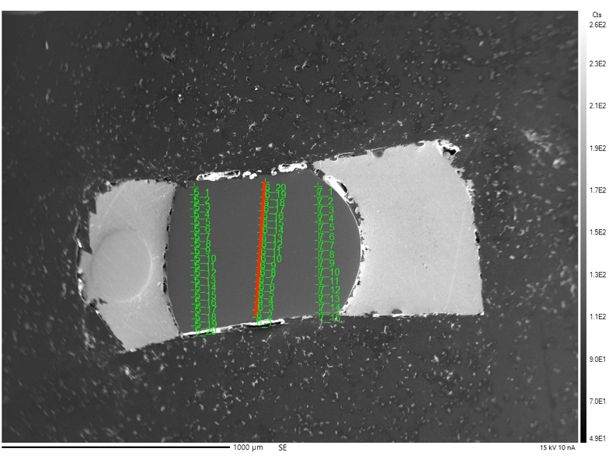

Table showing representative analyses of the AgI/Cl buffer
Na | Mg | Si | Al | K | Ca | Fe | Cl | Ag | I | Pt | Total
-0.0106 | -0.565 | 0.0439 | 0.108 | -0.071 | -0.05 | -0.005 | 4.411 | 62.17 | 37.03 | -0.086 | 102.97
0.032 | -0.527 | 0.007 | 0.124 | -0.057 | -0.07 | -0.048 | 4.37 | 58.92 | 38.89 | 0.0856 | 101.73
0.1325 | -0.503 | 0.0325 | 0.145 | -0.076 | -0.01 | -0.008 | 3.613 | 56.6 | 41.27 | 0.1243 | 100.48
0.2356 | -0.437 | 0.0223 | 0.08 | -0.088 | -0.05 | 0.063 | 3.479 | 57.89 | 41.89 | 0.1105 | 99.235
0.2405 | -0.534 | 0.0367 | 0.091 | -0.02 | 0 | -0.01 | 3.536 | 57.26 | 41.79 | 0.2627 | 97.989

