Landscape connectivity prioritization
Landscape connectivity prioritization was implemented based on the probability of connectivity (PC) index using Conefor 2.6 software. PC can be defined as the probability that two animals randomly placed within the landscape fall into habitat areas that are reachable from each other (interconnected) given the set of habitat patches and the connections among them. We used Conefor 2.6 software to calculate PC index as following equation (Saura and Pascual-Hortal 2007):
Where a_{i} and a_{j} are the habitat quality (here extent of suitable habitats) of the conservation area i and j, A is the sum of the habitat quality of all the conservation areas in the landscape, and $p_{ij}^{*}$ is the maximum product probability of all of the possible paths between conservation area i and j which follows a negative exponential function of effective distance sets in the study. We calculated Euclidean edge-to-edge distances among all the ICNs using the Conefor extension in ArcGIS software. Conefor also needs to specify distance-probability values corresponding to the dispersal ability of the target species. Given the measured dispersal distances of the species in previous studies (Farhadinia et al., 2016; Farhadinia et al., 2018), we chose 50 km as a median dispersal distance and 200 km as a maximum dispersal distance. Accordingly, as recommended by Saura and Torne (2009), we set distance-probability values of 0.5 and 0.05 for median and maximum dispersal distances, respectively.
PC is an absolute variable of patch quality without any guidance on their relative importance for connectivity, and consequently, could not be inherently used for patch prioritization. The prioritization of the ICNs for the species range dynamic was calculated from the percentage of the variation in PC (dPC) caused by the removal of each individual conservation area from the landscape (Saura & Pascual-Hortal, 2007):
Where dPC is the relative importance of each conservation area and, PC and PCʹ are the PC values before and after the removal of it.

References
Farhadinia MS et al. (2016) Wandering the barren deserts of Iran: illuminating high mobility of the Asiatic cheetah with sparse data. Journal of Arid Environments 134:145-149
Farhadinia MS, Johnson PJ, Macdonald DW, Hunter LT (2018b) Anchoring and adjusting amidst humans: Ranging behavior of Persian leopards along the Iran-Turkmenistan borderland. PLoS ONE 13:e0196602
Saura S, Pascual-Hortal L (2007) A new habitat availability index to integrate connectivity in landscape conservation planning: comparison with existing indices and application to a case study. Landscape and Urban Planning 83:91-103
Saura S, Torne J (2009) Conefor Sensinode 2.2: a software package for quantifying the importance of habitat patches for landscape connectivity. Environmental Modelling & Software 24:135-139

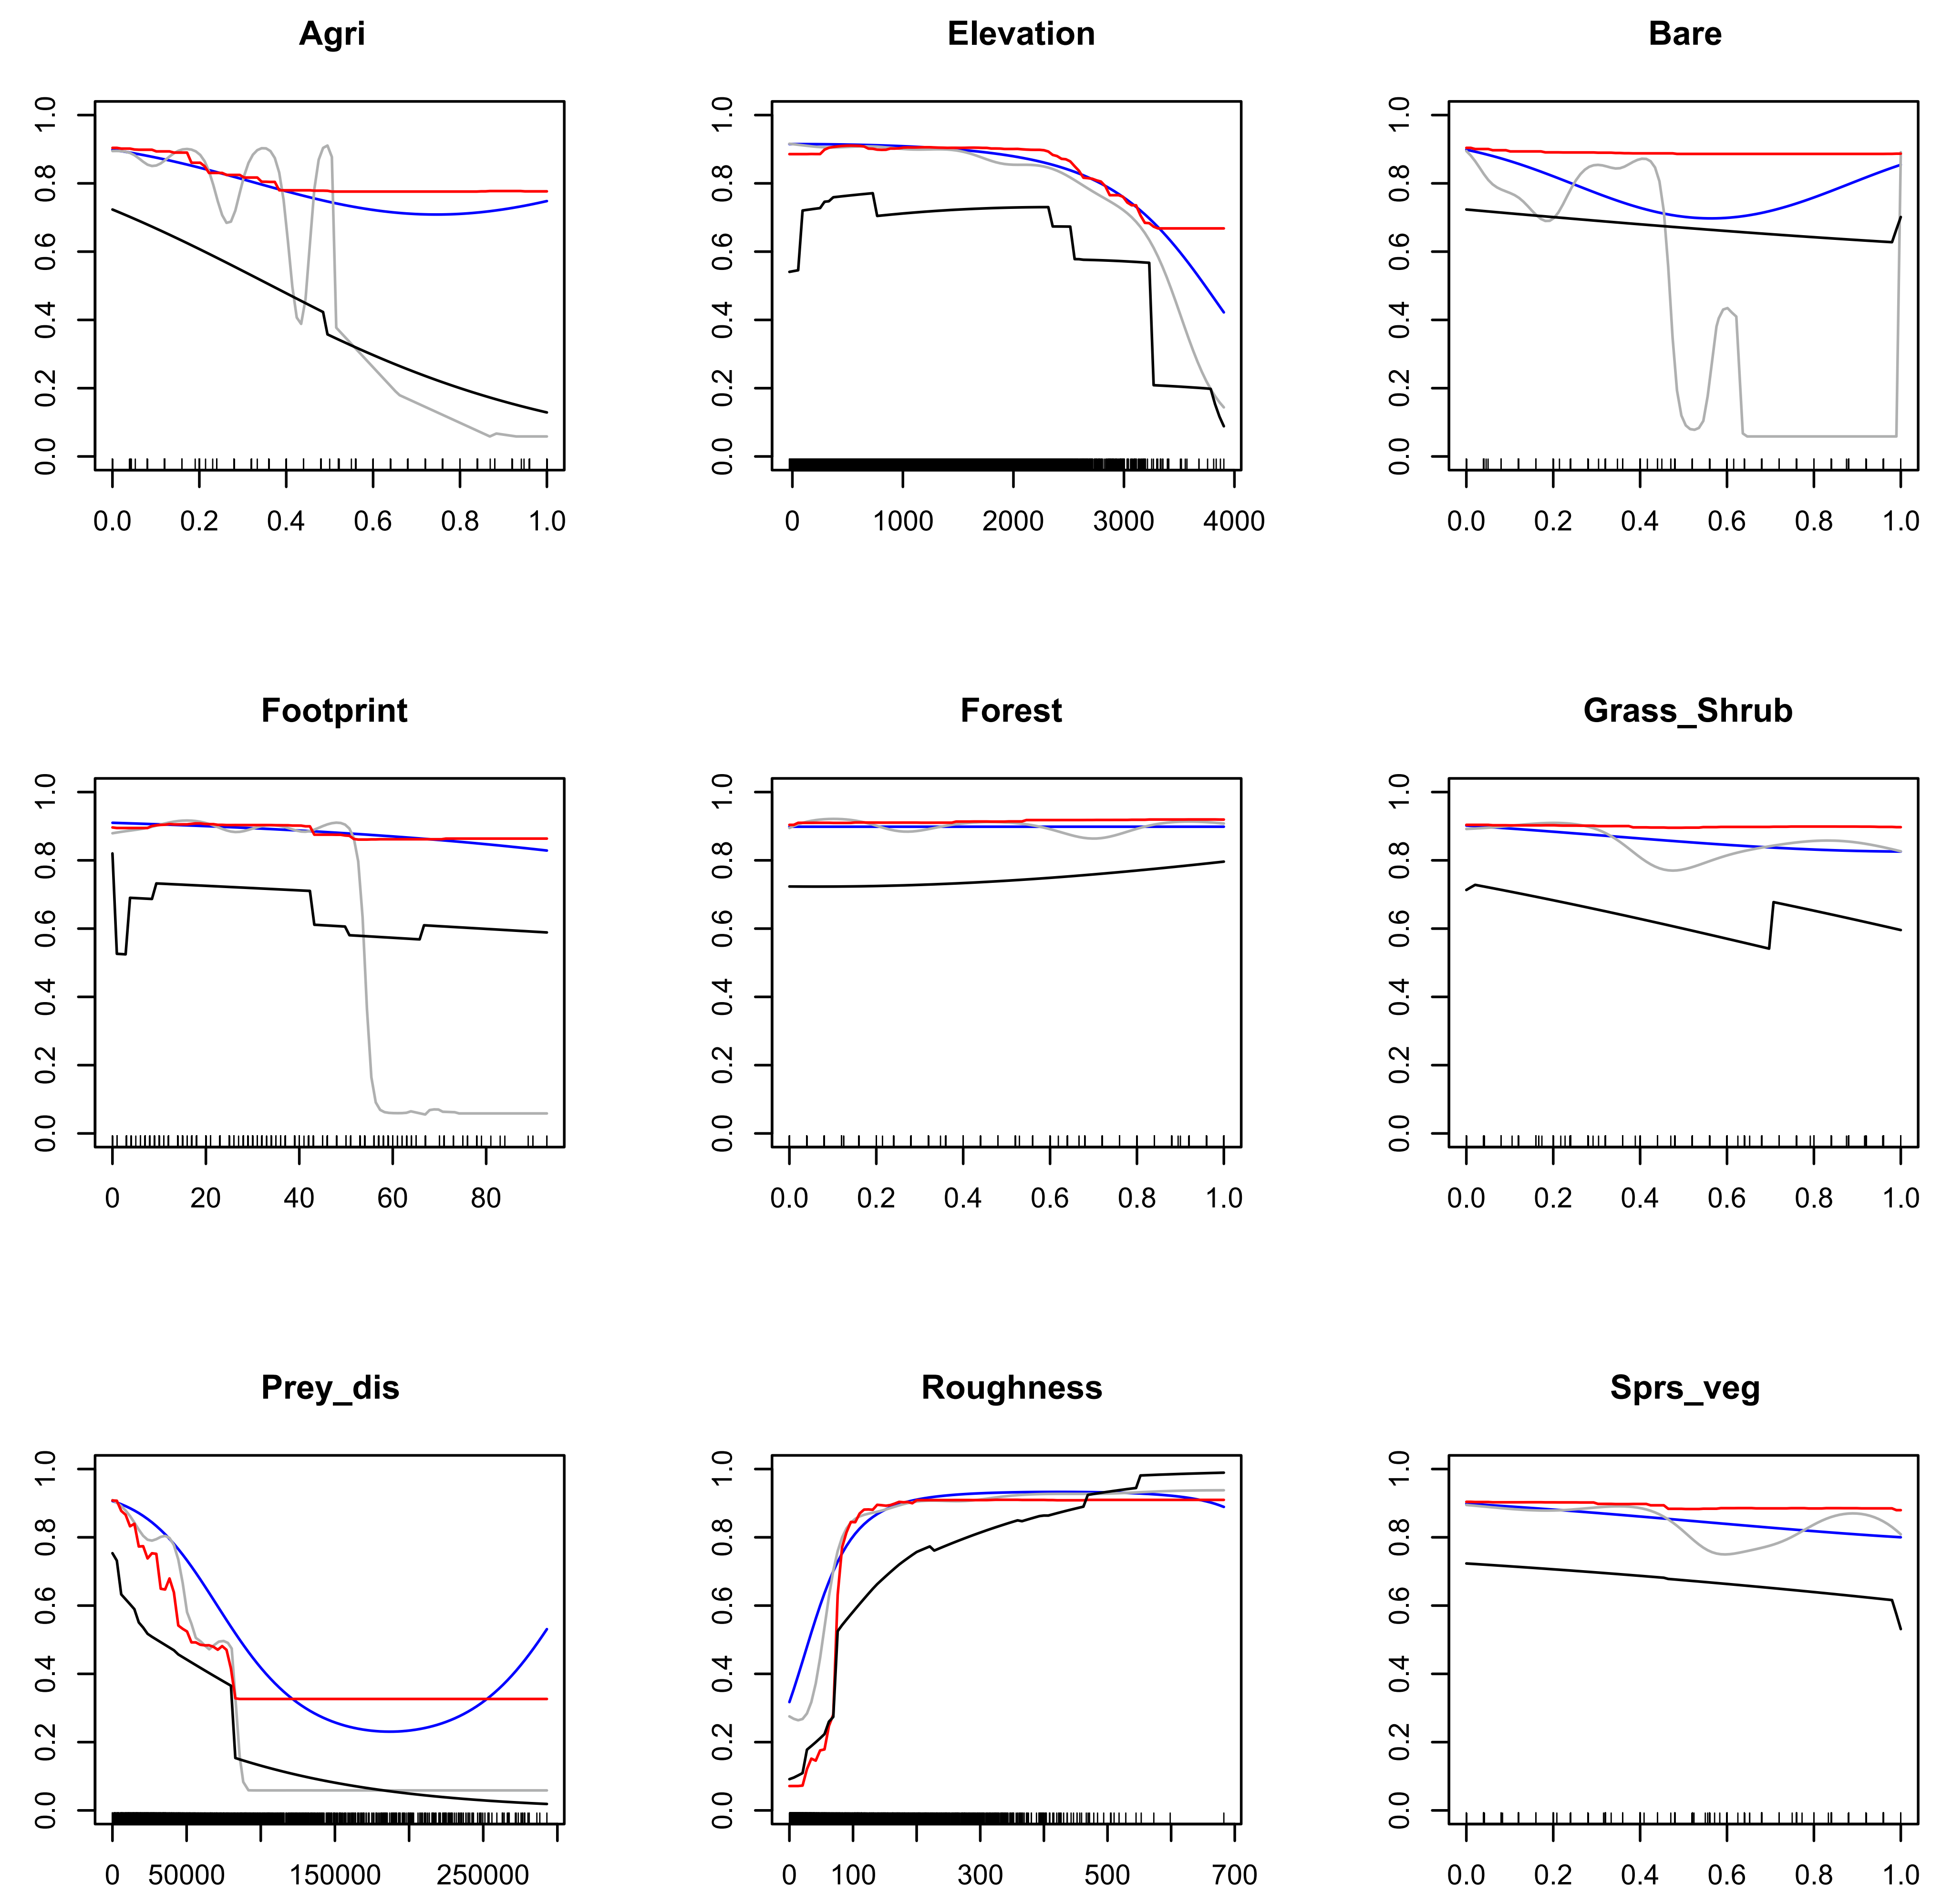
Fig. S1. Response curves of the environmental variables influencing the distribution of Persian leopard produced by GLM (blue), GAM (grey), GBM (black) and MaxEnt (red). Variables gradient is depicted on the x axis, and the y axis show the probability of presence. Agri: density of croplands and orchards, elevation: elevation from sea level (meter), bare: density of non-vegetation salt land and sand dunes, footprint: human footprint, forest: density of forest cover, grass_shrub: density of the patches covered by a mixture of grass and shrubs, Prey_dis: distance to prey species (meter), Roughness: topographic roughness (meter), sprs_veg, density of patches with open and sparse vegetation.
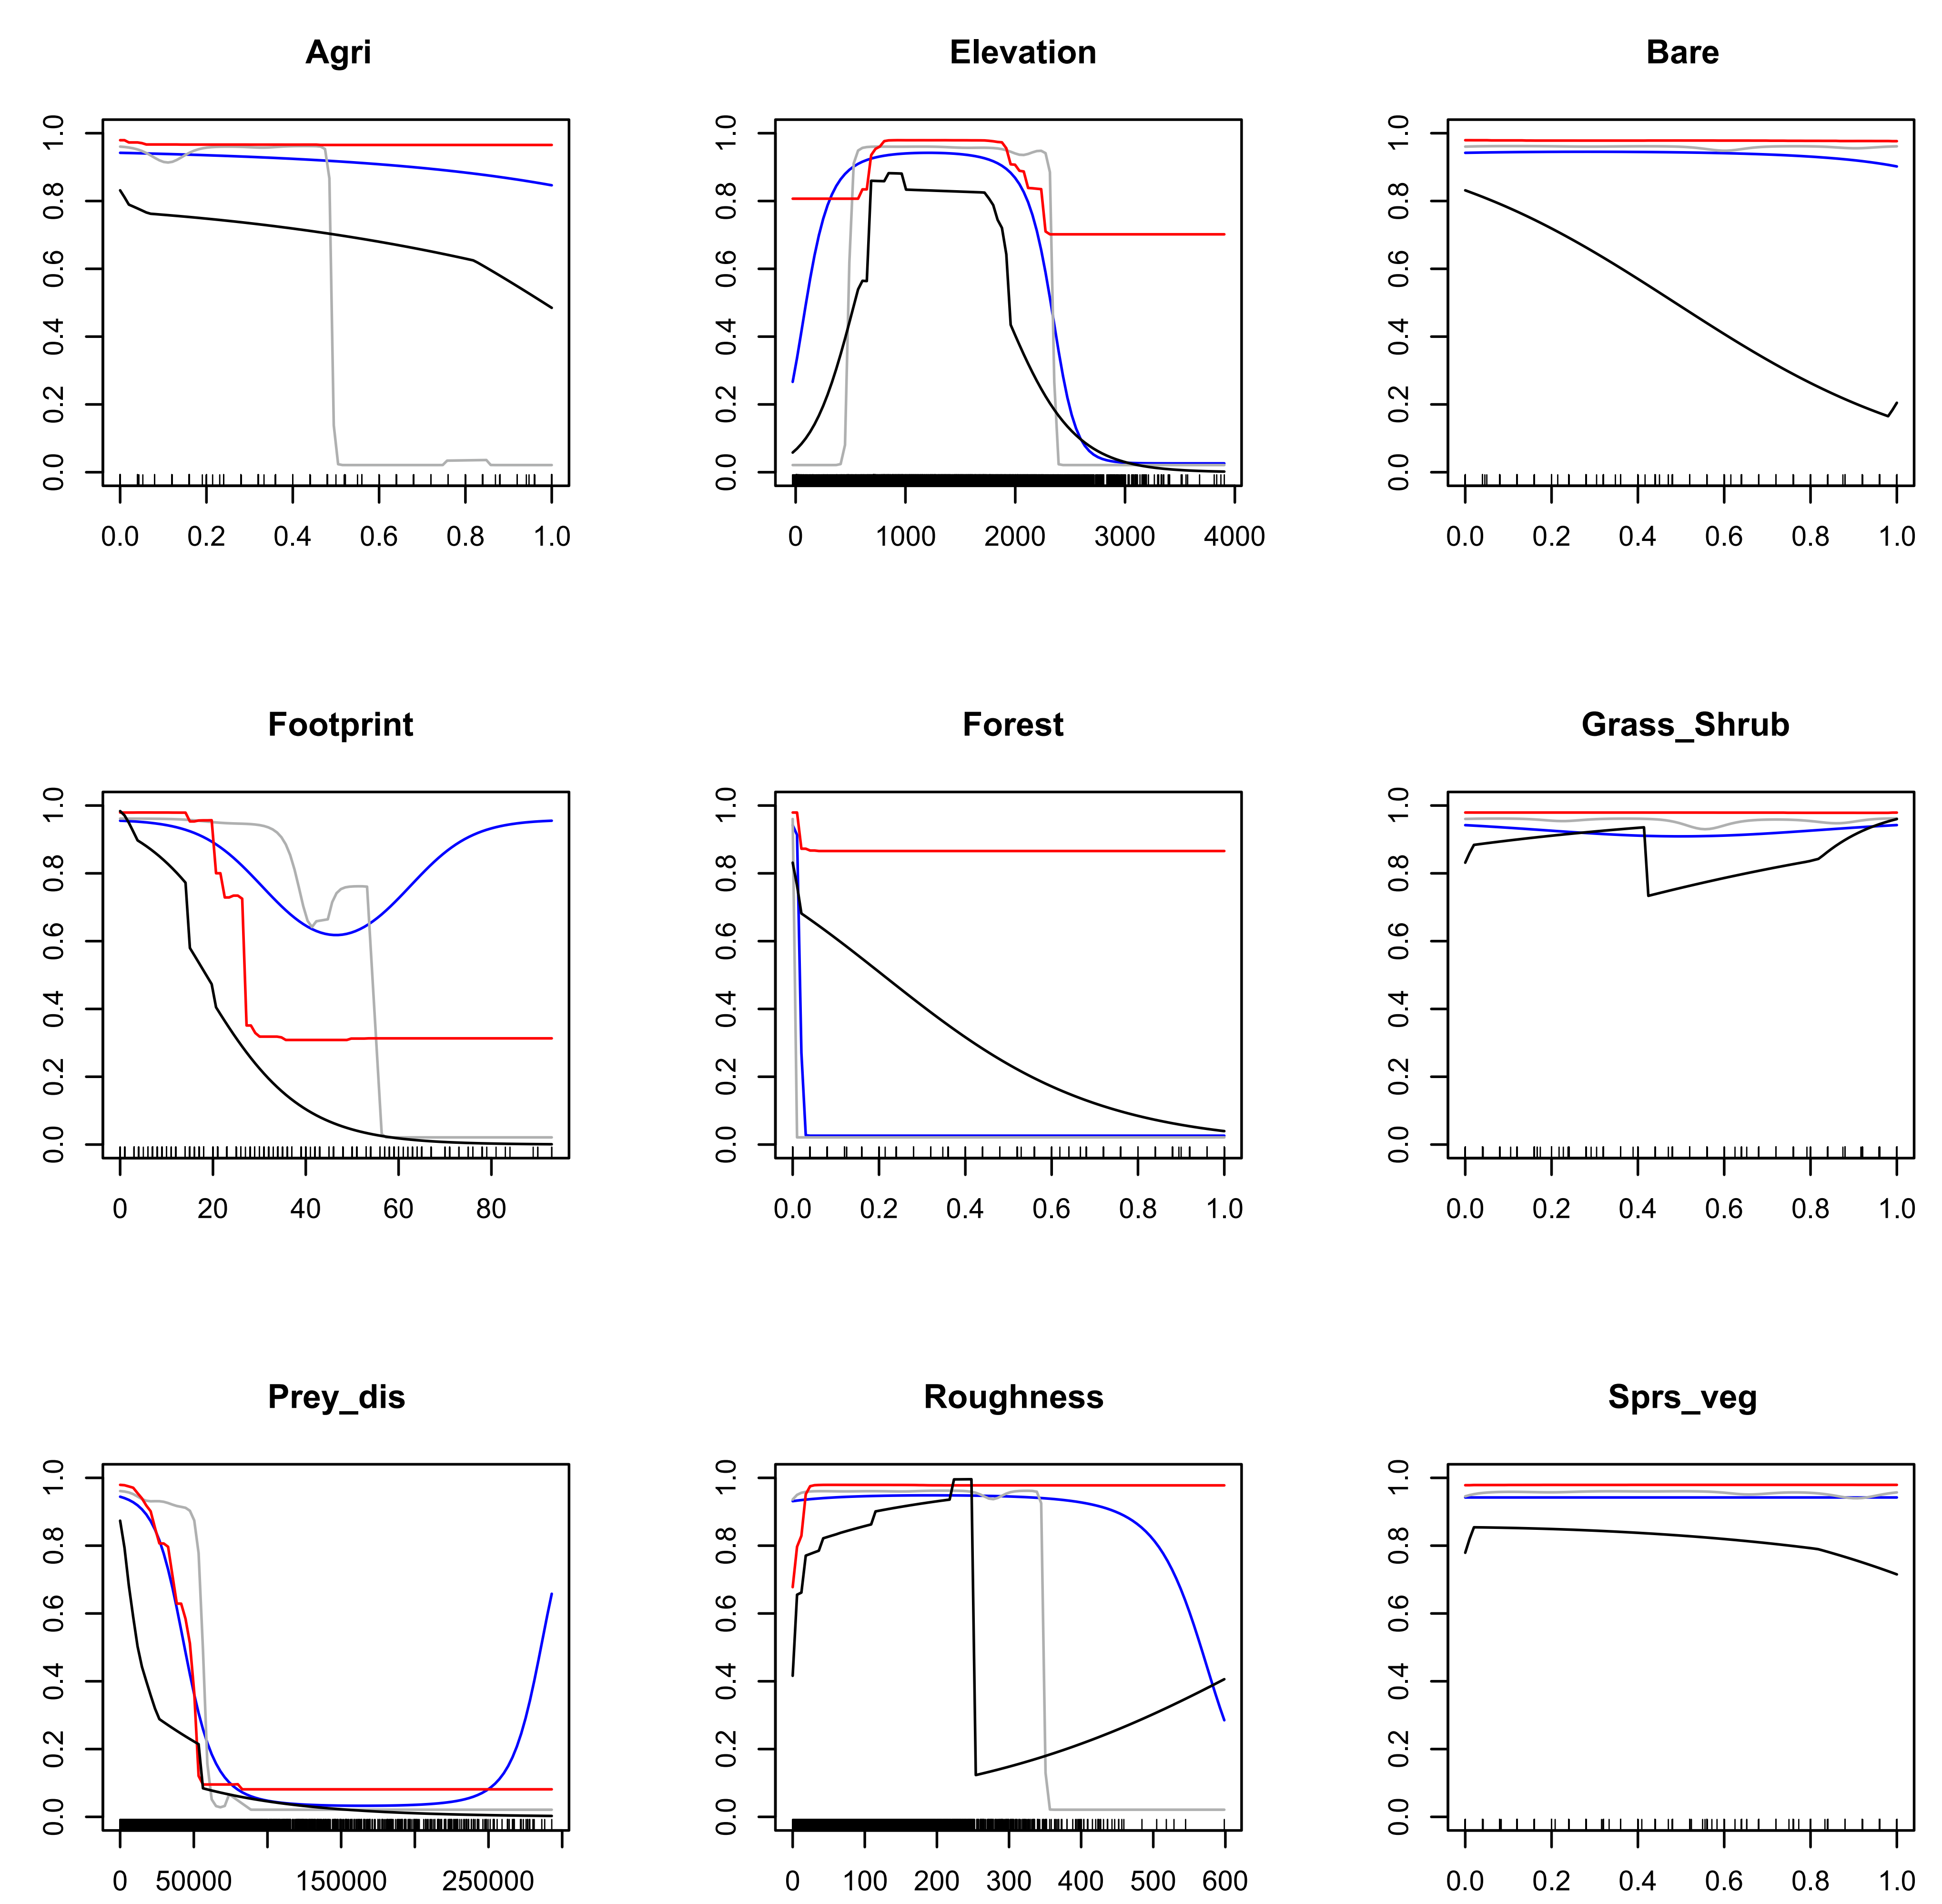
Fig. S2. Response curves of the environmental variables influencing the distribution of Asiatic cheetah produced by GLM (blue), GAM (grey), GBM (black) and MaxEnt (red). Variables gradient is depicted on the x axis, and the y axis show the probability of presence. Agri: density of croplands and orchards, elevation: elevation from sea level (meter), bare: density of non-vegetation salt land and sand dunes, footprint: human footprint, forest: density of forest cover, grass_shrub: density of the patches covered by a mixture of grass and shrubs, prey_dis: distance to prey species (meter), roughness: topographic roughness (meter), sprs_veg, density of patches with open and sparse vegetation.

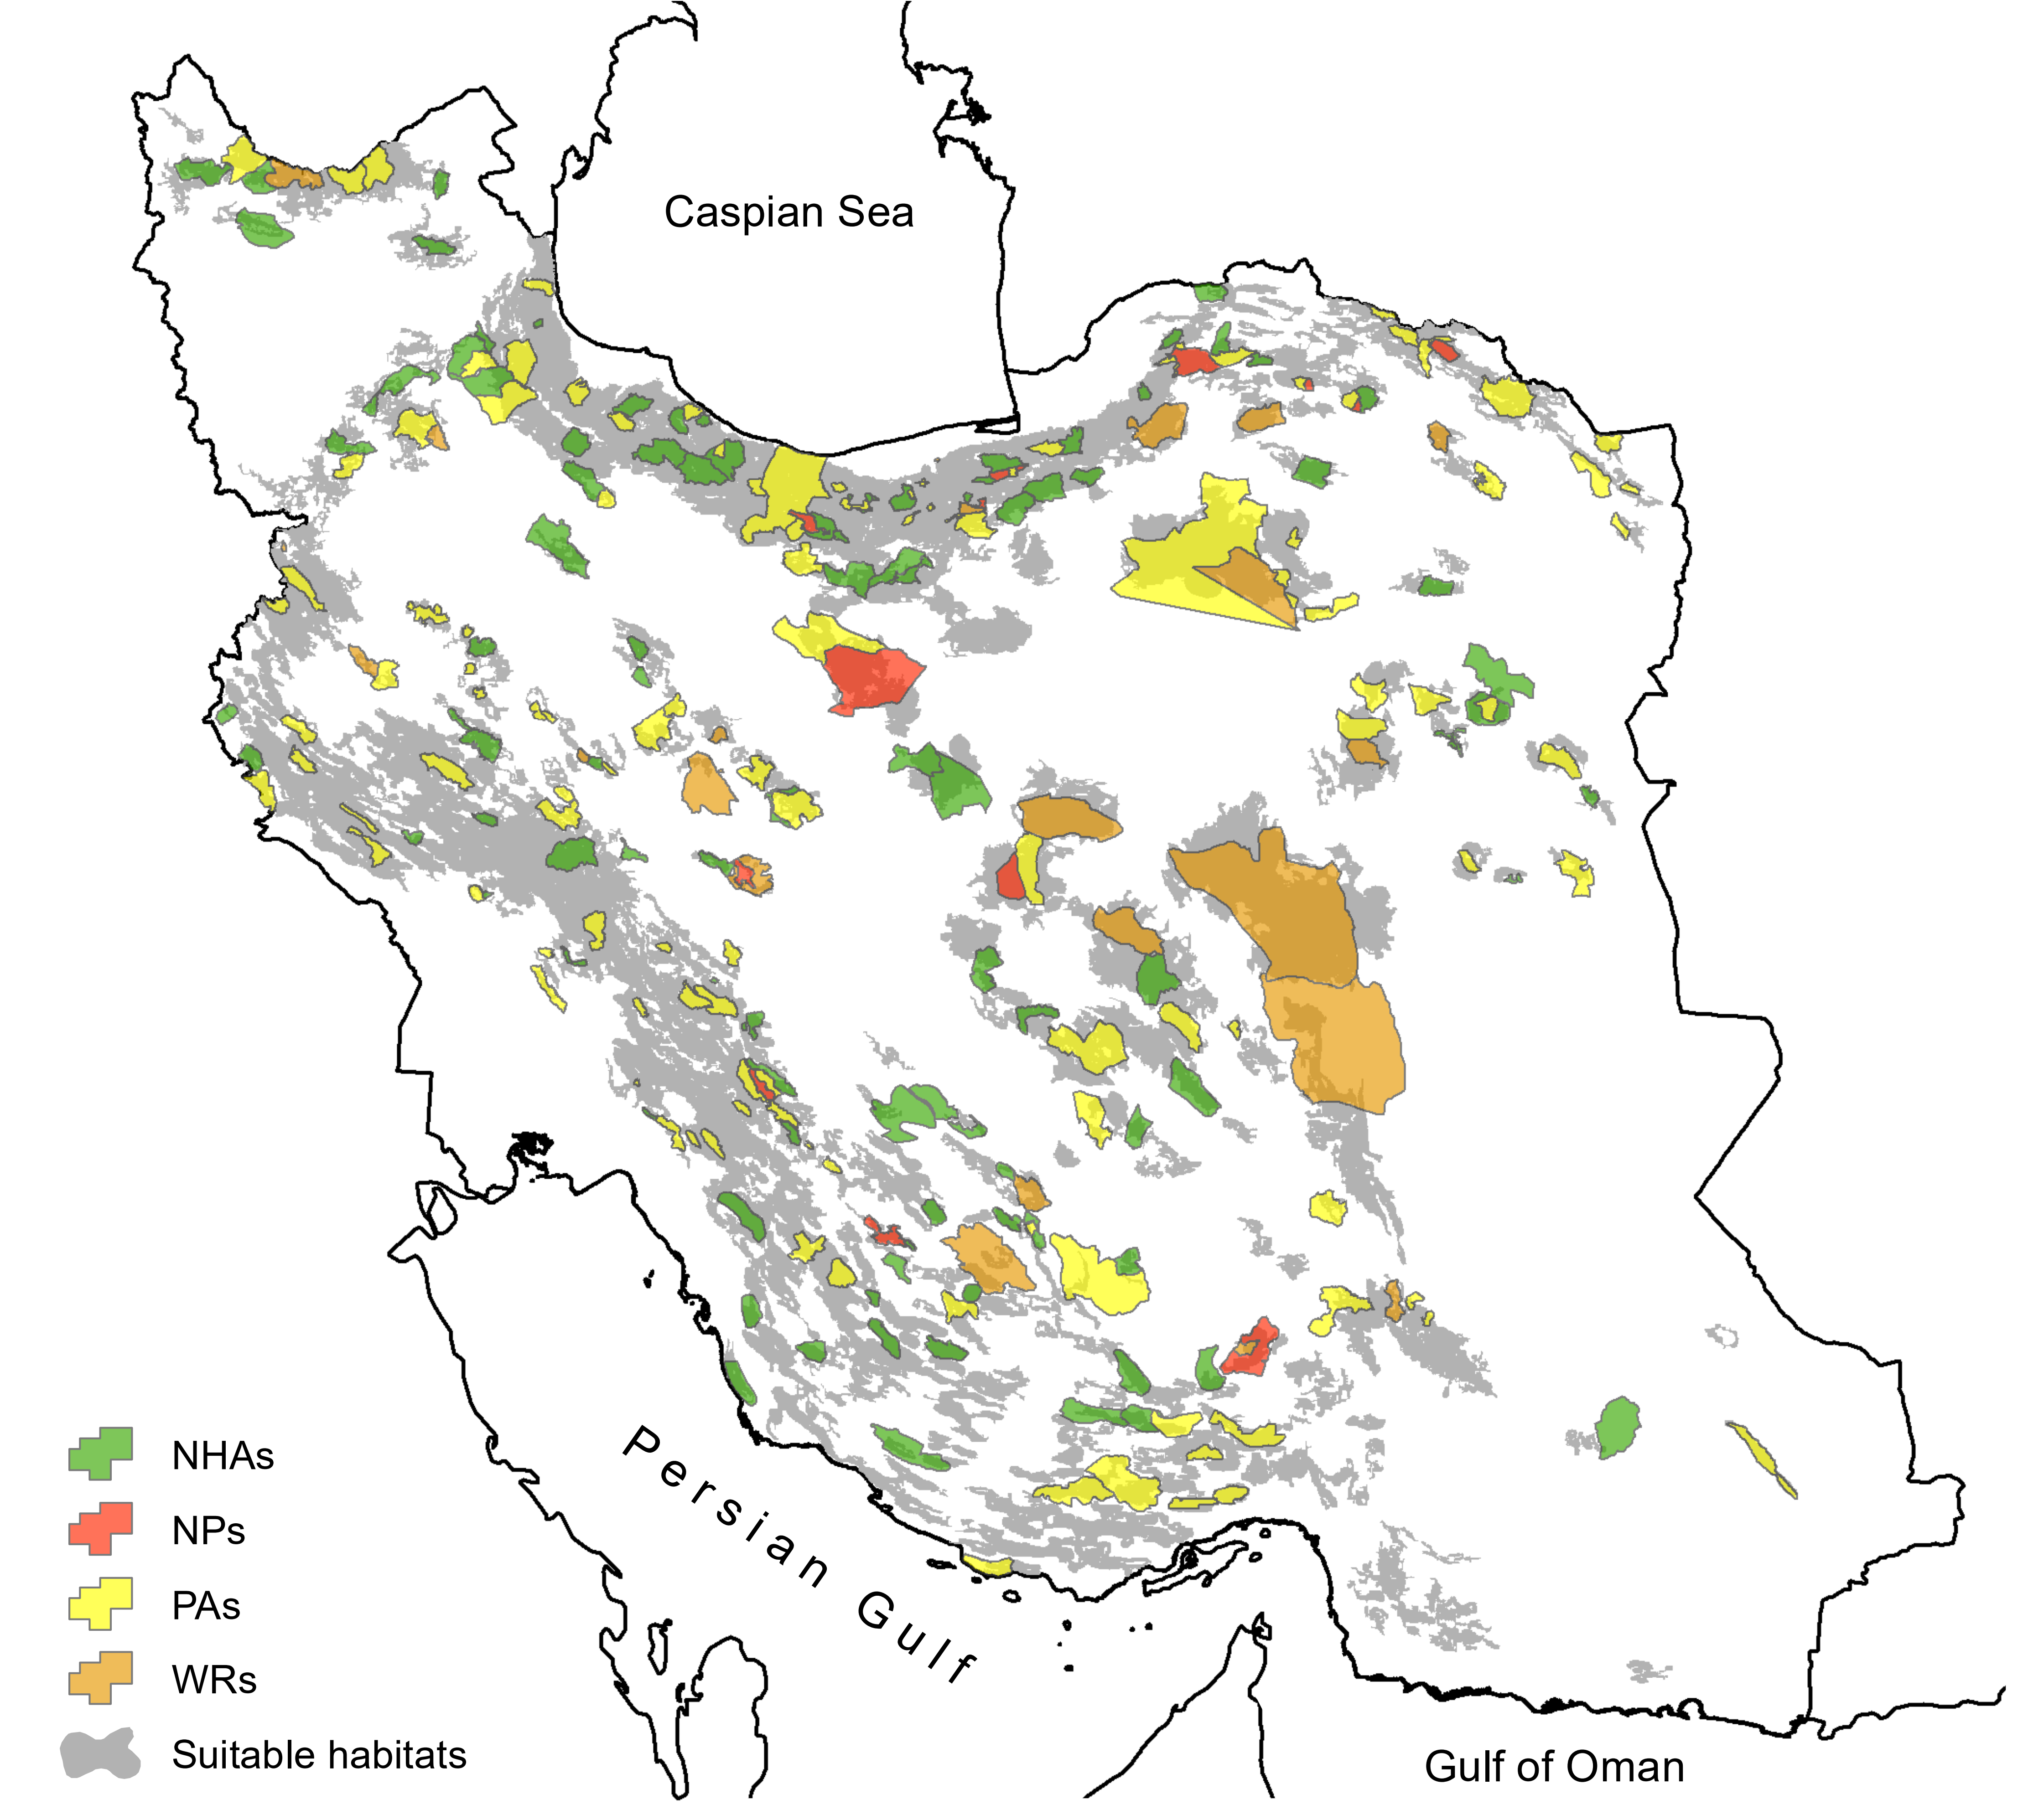

Fig. S3. The intersection between suitable habitats and Iranian conservation network. Suitable habitats derived based on merging the ensemble models of Persian leopard and Asiatic cheetah. NHAs: No-hunting Areas, NPs: National Parks, PAs: Protected Areas, WRs: Wildlife Refuges.

