
Journal of Geophysical Research: Solid Earth
Supporting Information for
Seismicity properties of the Chain Transform Fault inferred using data from the PI-LAB experiment
K. Leptokaropoulos^{1,2}, C. Rychert^{1,3}, N. Harmon^{1,3}, and J. M. Kendall⁴
¹Ocean and Earth Science, University of Southampton, Southampton, UK.
² The MathWorks, Cambridge, UK.
³ Geology and Geophysics, Woods Hole Oceanographic Institution.
^{4s} School of Earth Sciences, University of Oxford, Oxford, UK.

Contents of this file

Text S1 to S3
Figures S4 to S20

Introduction
Text S1 Magnitude estimates
Text S2 b-value evaluation
Text S3 Schuster test
Figure S4 CDF of the original parameters
Figure S5 Cluster Analysis – Application of K-means
Figures S6-S18 Cluster Analysis – Different parameter combination
Figure S19 Location comparison
Figure S20 Spatio-temporal event distribution in west, central and east segments

Text S1. Magnitude estimates

The calculation of magnitudes is described in Schlaphorst et al. (2022). We note here that the amplitude estimates and associated b-values, are somewhat affected by the depth estimates, which are a source of uncertainty. However, as an example, for events that have an epicentral distance of 100 km, a change from 5 km to 30 km depth (assuming straight ray paths) would change the length of the ray path by about 5 km. This value increases for closer station. But, since we always use multiple stations to calculate the amplitude, most of these stations will be 100 km away or even further. Therefore, the overall effect of depth error on magnitude is small. We also performed tests in which we forced some events to a shallower depth. the magnitude values seem to normally stay very close (all within 0.3 of the old values).

Text S2. b-value evaluation
Earthquake magnitudes are typically assumed to follow an exponential distribution, modelled by the Gutenberg-Richter law. Given the validity of exponentiality, the magnitude distribution above M_{C}, is parameterized by the well-known b-value, which can be evaluated by the Aki (1965) maximum likelihood estimator (MLE) as:
$b=\frac{1}{\ln\left(10\right)\left(〈M〉-{(M}_{c}-\frac{∆M}{2})\right)}$ (1),
where $〈M〉$, is the sample mean of the events above M_{C}. The term ΔM/2 accounts for the finite binning width correction of the magnitudes, which is equal to the round-off interval (0.1 in this study). Given N events with M ≥ M_{C}, the standard error of equation (1) is estimated as (Aki, 1965):
$σ_{b}=\frac{b}{\sqrt{N}}$ (2).
The Anderson-Darling Test (e.g., Marsaglia & Marsaglia, 2004; Leptokaropoulos, 2020) as well as the goodness of fit test (Wiemer & Wyss, 2000, modified by Leptokaropoulos et al., 2013) are applied to verify the exponentiality of the magnitude distribution and determine M_{C}. Both techniques return M_{C} = 2.3, suggesting that above this threshold the hypothesis of exponential magnitude distribution cannot be rejected at 0.05 significance. Therefore, the complete data for the study area (Figure 1b, c) is comprised of 370 events with M_{L} ≥ 2.3 with a mean activity rate of ~ 1 event/day. The relatively small data size along with the considerable instability of the b-values calculated by MLE (0.75 < b < 0.90 for 2.3 ≤ M_{C} ≤ 3.0) lead to large uncertainties and violate the unique b-value condition predicted by the GR law. Therefore, we applied the non-parametric, repeated medians technique (RM, Siegel, 1982) to evaluate the b-values, which has been shown to return more stable results and is highly resistant to the presence of outliers and uncertainties (Amorèse et al., 2010). Given n magnitude intervals between two points, i and j, we calculate n-1 slopes (b-values) between these points (i.e., magnitude values) as:
$b_{ij}=\frac{\log_{10}(N_{i})-\log_{10}(N_{j})}{M_{j}-M_{i}}$ (3),
Where M_{i} and M_{j} and magnitudes with M_{j}>M_{i} and N_{i}, N_{j} are the cumulative number of events with M≥M_{i} and M≥M_{j}, respectively. For each point, i, the median slopes (i.e., n median values) are calculated and consequently, b_{RM} is calculated as:
b_{RM}=median(median(b_{ij})) (4).
The standard errors, SE, of the calculated b_{RM} are estimated by a bootstrap procedure as described in the work of Amorèse et al., (2010). The t-test is performed to evaluate the significance of whether the b-values from two datasets, e.g., A and B, differ from each other. The t statistic is defined as:
$t=\frac{|b_{A}^{RM}-b_{B}^{RM}|}{\sqrt{{SE}_{A}^{2}+{SE}_{B}^{2}}}$ (5).

A |t| > 1.96, indicates that the b-value difference is significant at the 0.05 level. This approach results in b = 0.83 ± 0.09, with this value being practically unchanged regardless of applied magnitude cut-off value (b = 0.82 - 0.84 for trials with 2.0 ≤ M_{L} ≤ 3.0). For this reason, we apply the RM approach to calculate all b-values in this study (for M_{C}=2.3), with the corresponding SE, evaluated by 10,000 bootstrap resampling trials, unless stated otherwise.

Text S3. Schuster test
After defining the tidal phase of each event, we count the number of events that occurred at diverse phase bins to identify whether there is a preference for specific phase ranges. To quantify the significance of the results, we apply the Schuster (1897) test, calculating the probability, p, that the earthquake occurrence times introduced as tidal phase angles, are distributed around the unit circle in random occurrences. The parameter R, is thus defined as:
$$R^{2}={\left(\sum_{i=1}^{N}{\cos{ϕ_{i}}}\right)}^{2}+{\left(\sum_{i=1}^{N}{\sin{ϕ_{i}}}\right)}^{2} \left(6\right)$$
with $ϕ_{i}$ being the tidal phase of the i^{th} earthquake in a population of N events. Then, the probability that a given tidal phase distribution is random is given by:
$p_{S}=e^{-\frac{R^{2}}{N}}⁡$ (7)

Lower p_{S} values correspond to a higher significance of rejecting the null hypothesis of random phase distribution and vice versa.

Figure S4. CDF of the 7 parameters used for cluster analysis before their transformation to equivalent dimensions.
Figure S5. 3 realizations of partitioning clustering (K-means, N=3) which provides unstable results. The hierarchical clustering we applied in the study is based on the linkage distance between events and families (clusters), which returns stable results.

Figure S6. Spatial distribution of 8 clusters derived by the hierarchical cluster analysis in the 7-parameter phase space.

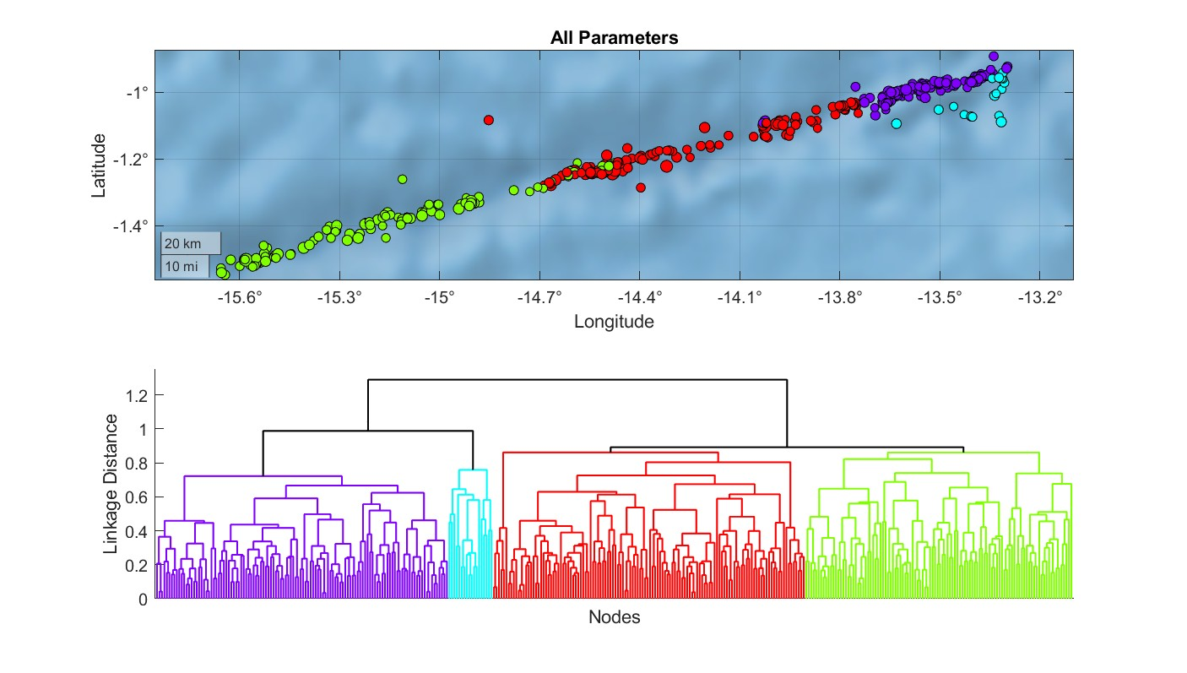

Figure S7. Upper frame: Spatial distribution of 4 major clusters derived by the hierarchical cluster analysis in the 7-parameter phase space. Lower frame: dendrogram showing the interconnection among the earthquakes. The colors in the dendrogram correspond to the colors of the clusters in the map.

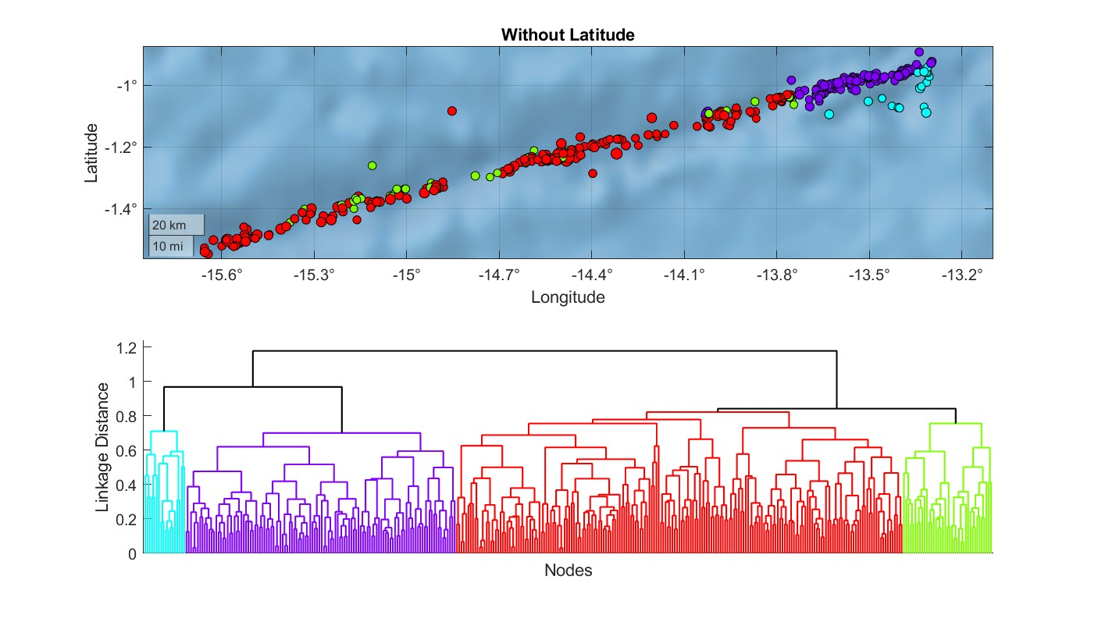

Figure S8. Upper frame: Spatial distribution of 4 major clusters derived by the hierarchical cluster analysis in 6-parameter phase space (discarding latitude). Lower frame: dendrogram showing the interconnection among the earthquakes. The colors in the dendrogram correspond to the colors of the clusters in the map.

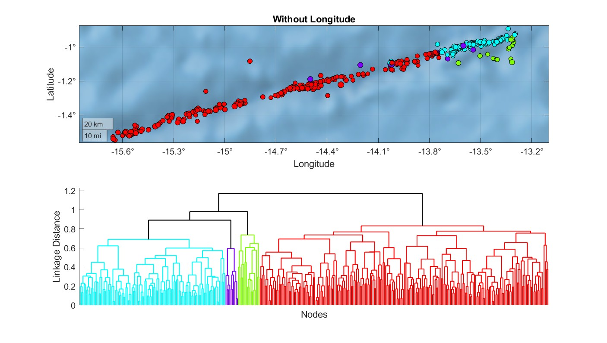

Figure S9. Upper frame: Spatial distribution of 4 major clusters derived by the hierarchical cluster analysis in 6-parameter phase space (discarding longitude). Lower frame: dendrogram showing the interconnection among the earthquakes. The colors in the dendrogram correspond to the colors of the clusters in the map.

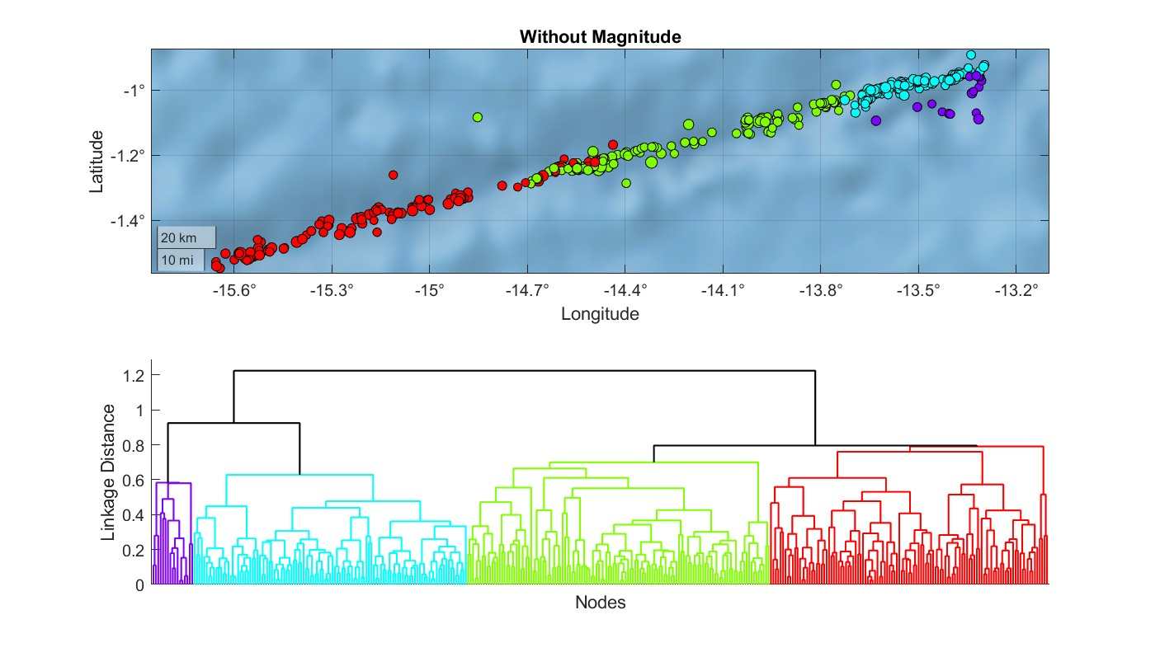

Figure S10. Upper frame: Spatial distribution of 4 major clusters derived by the hierarchical cluster analysis in 6-parameter phase space (discarding magnitude). Lower frame: dendrogram showing the interconnection among the earthquakes. The colors in the dendrogram correspond to the colors of the clusters in the map. The b-values for the west, central and east segments, based on this clustering are: b_{W}=0.90±0.11, b_{C}=0.73±0.14, b_{E}=0.95±0.17, respectively

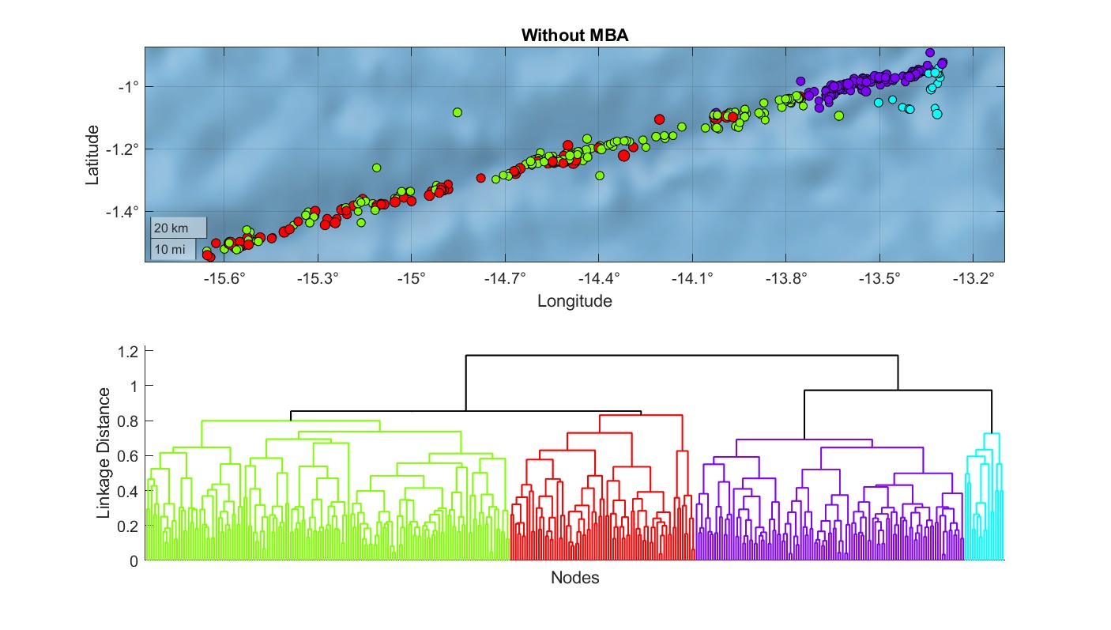

Figure S11. Upper frame: Spatial distribution of 4 major clusters derived by the hierarchical cluster analysis in 6-parameter phase space (discarding MBA). Lower frame: dendrogram showing the interconnection among the earthquakes. The colors in the dendrogram correspond to the colors of the clusters in the map.

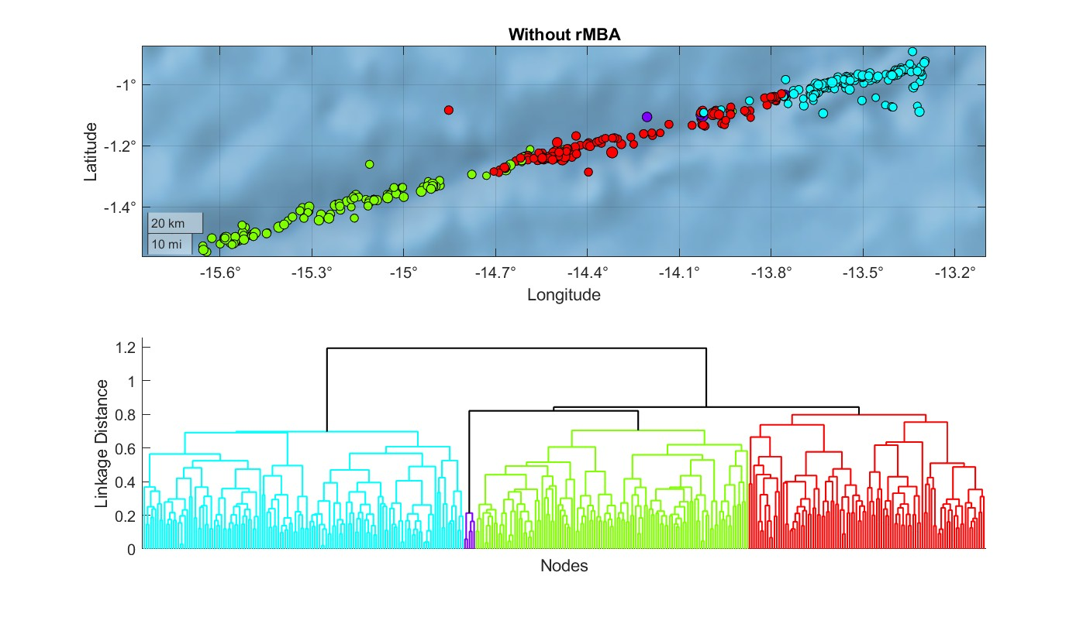

Figure S12. Upper frame: Spatial distribution of 4 major clusters derived by the hierarchical cluster analysis in 6-parameter phase space (discarding rMBA). Lower frame: dendrogram showing the interconnection among the earthquakes. The colors in the dendrogram correspond to the colors of the clusters in the map.

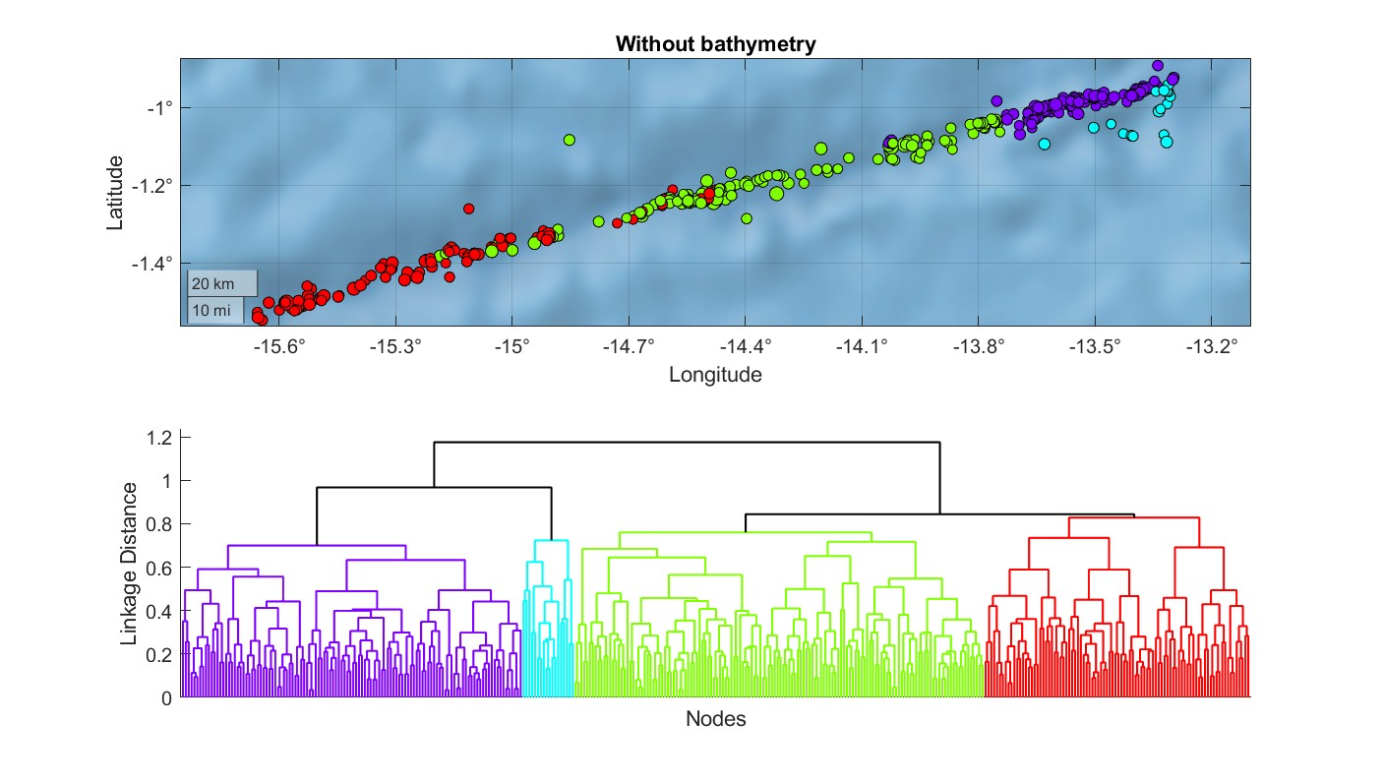

Figure S13. Upper frame: Spatial distribution of 4 major clusters derived by the hierarchical cluster analysis in 6-parameter phase space (discarding bathymetry). Lower frame: dendrogram showing the interconnection among the earthquakes. The colors in the dendrogram correspond to the colors of the clusters in the map.

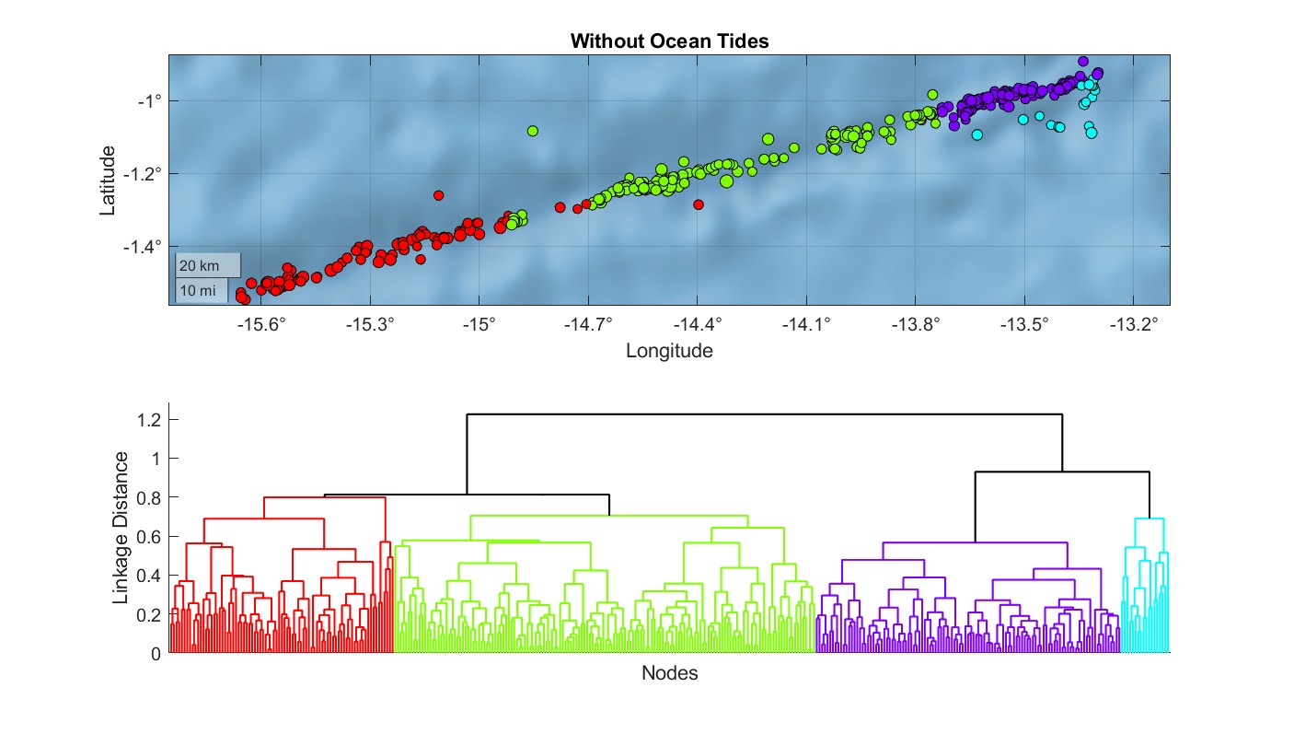

Figure S14. Upper frame: Spatial distribution of 4 major clusters derived by the hierarchical cluster analysis in 6-parameter phase space (discarding ocean tides). Lower frame: dendrogram showing the interconnection among the earthquakes. The colors in the dendrogram correspond to the colors of the clusters in the map.

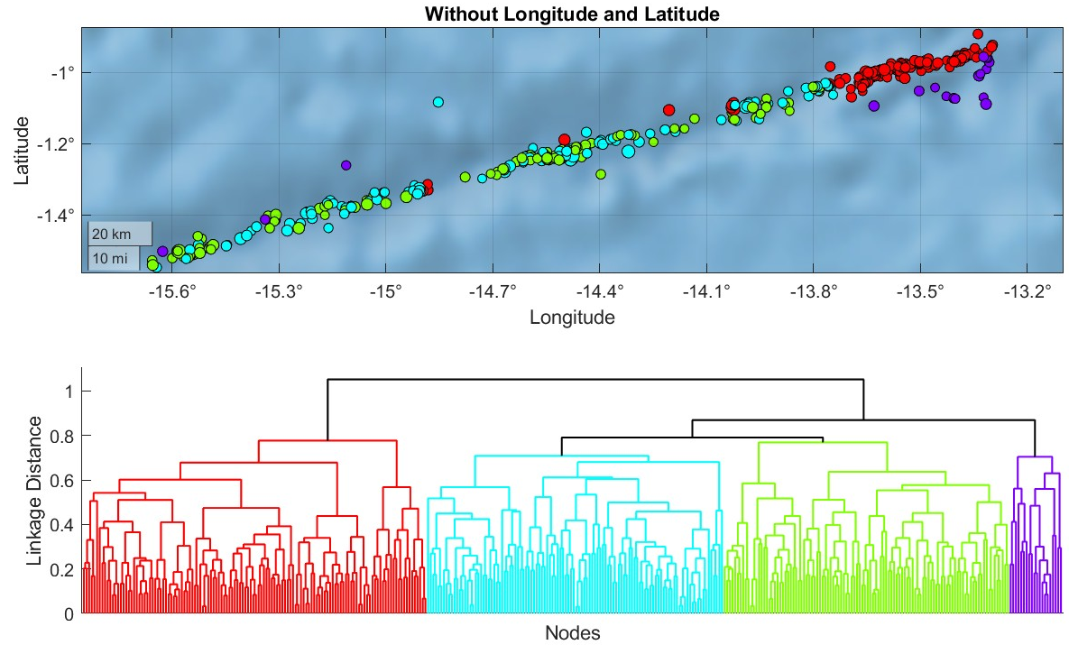

Figure S15. Upper frame: Spatial distribution of 4 major clusters derived by the hierarchical cluster analysis in 5-parameter phase space (discarding longitude and latitude). Lower frame: dendrogram showing the interconnection among the earthquakes. The colors in the dendrogram correspond to the colors of the clusters in the map.

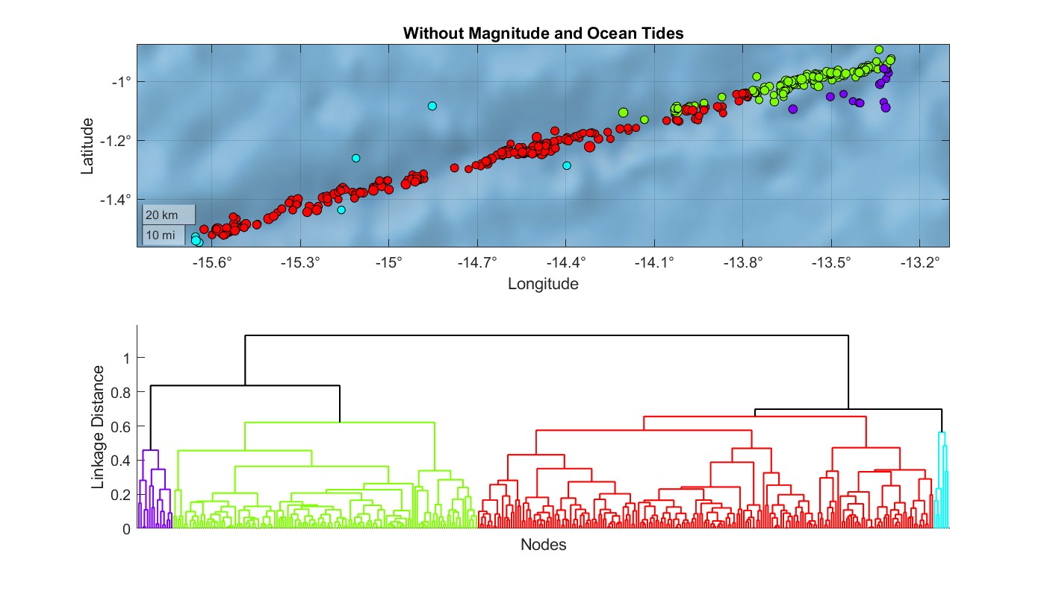

Figure S16. Upper frame: Spatial distribution of 4 major clusters derived by the hierarchical cluster analysis in 5-parameter phase space (discarding M_{L} and ocean tides). Lower frame: dendrogram showing the interconnection among the earthquakes. The colors in the dendrogram correspond to the colors of the clusters in the map.

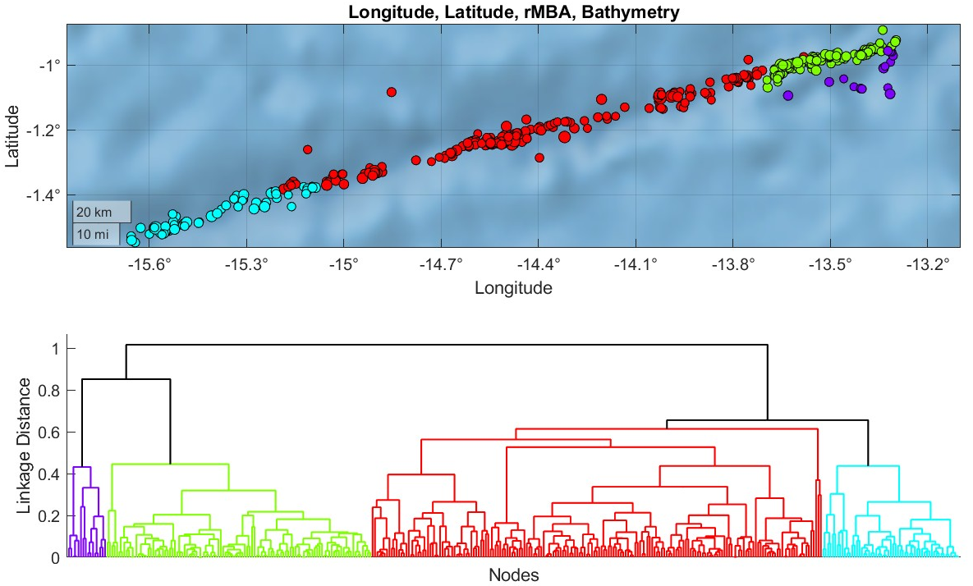

Figure S17. Upper frame: Spatial distribution of 4 major clusters derived by the hierarchical cluster analysis in 4-parameter phase space including latitude, longitude, rMBA and bathymetry. Lower frame: dendrogram showing the interconnection among the earthquakes. The colors in the dendrogram correspond to the colors of the clusters in the map.

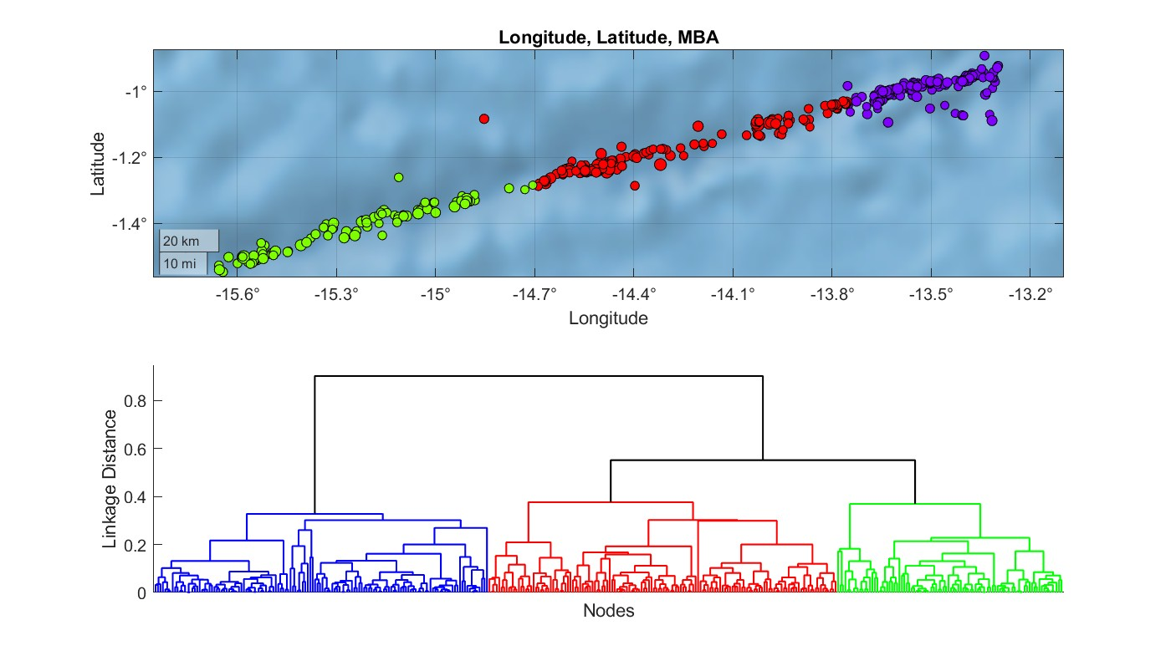

Figure S18. Upper frame: Spatial distribution of 3 major clusters derived by the hierarchical cluster analysis in 3-parameter phase space including latitude, longitude and MBA. Lower frame: dendrogram showing the interconnection among the earthquakes. The colors in the dendrogram correspond to the colors of the clusters in the map. The b-values for the west, central and east segments, based on this clustering are: b_{W}=0.89±0.12, b_{C}=0.74±0.12, b_{E}=0.96±0.18, respectively.

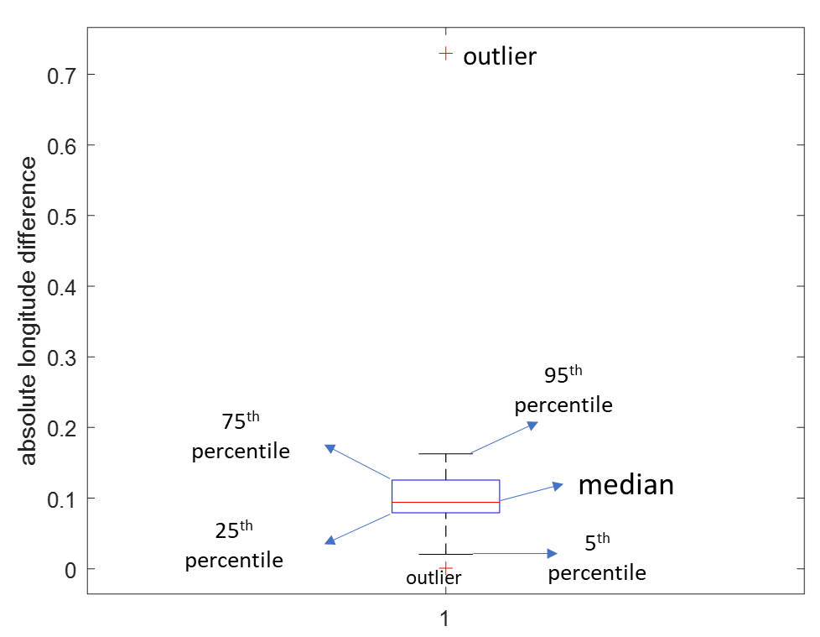

Figure S19. We compared the ISC locations to those of Shi. The mean absolute longitude difference value is ~ 0.10 ̊. There is one outlier (> 0.17 ̊). However, all other events have differences in longitude < 0.17 ̊. Although uncertainties before 1993 are larger, the 1992 event likely occurred within G3. In this case the segment would be characterized as relatively locked, with large magnitude earthquakes after long time periods. However, we also cannot rule out the possibility that it occurred outside of G3, and in this case the segment would be characterized by weak coupling and creep.

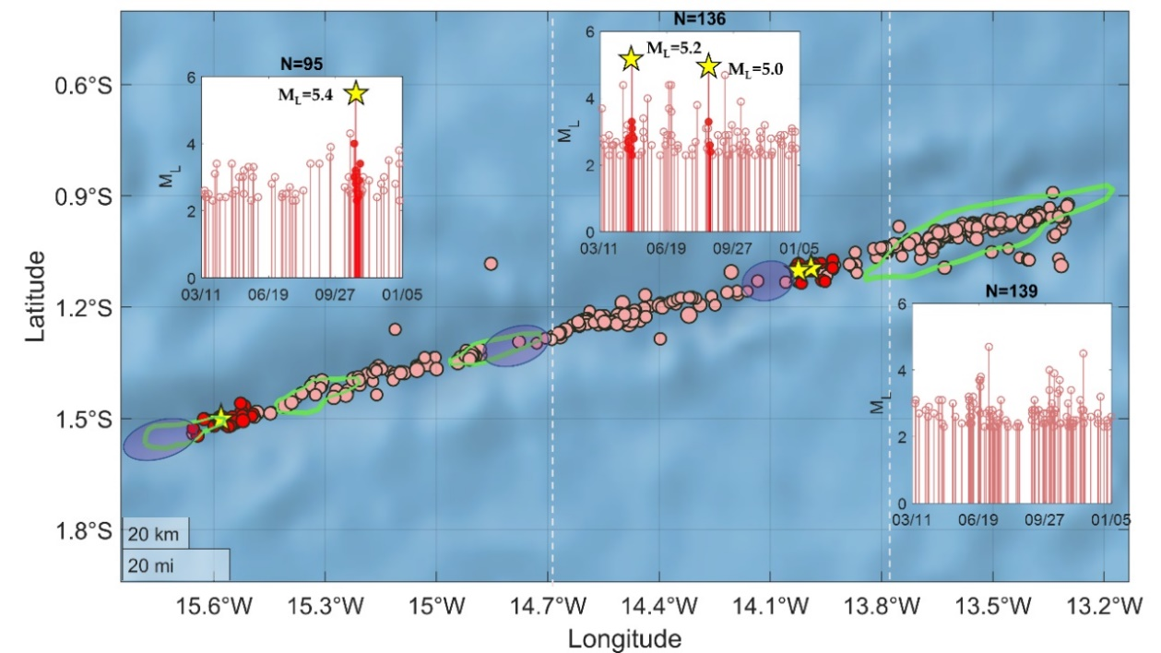

Figure S20. Seismicity above M_{C} = 2.3 (pink dots) along Chain, delineates 3 distinct segments (west, central, east, separated by the vertical dashed lines), as derived by the cluster analysis. Seismicity gaps, i.e., areas with sparse OBS seismicity are indicated by the purple ellipses. The red dots indicate the seismicity that occurred 1 week before and 1 week after the three strongest events (M_{L} ≥ 5.0, depicted by yellow stars). The inset stem plots show the temporal distribution of events’ occurrence times for each area, with their corresponding order (from left to right), with the data highlighted in red corresponding to 2 - week foreshock and aftershock activity related with the M_{L} ≥ 5.0 events. The green curves indicate the positive flower structures.

