Current Density Dependent Electroplating in Ca Electrolytes: From Globules to Dendrites
Shengda D. Pu^{1†}, Chen Gong^{1†}, Xiangwen Gao¹, Ziyang Ning¹, Sixie Yang¹, John-Joseph Marie^{1,2}, Boyang Liu^{1,2}, Robert A. House^{1,2}, Gareth O. Hartley^{1,2}, Jun Luo³, Peter G. Bruce^{1,2,4,5*}, Alex W. Robertson^{1*}
¹ Department of Materials, University of Oxford, Parks Road, Oxford OX1 3PH, United Kingdom
² The Faraday Institution, Quad One, Becquerel Avenue, Harwell Campus, Didcot, OX11 0RA, United Kingdom
³ Center for Electron Microscopy and Tianjin Key Lab of Advanced Functional Porous Materials, Institute for New Energy Materials, School of Materials, Tianjin University of Technology, Tianjin, 300384, China
⁴ Department of Chemistry, University of Oxford, South Parks Road, Oxford OX1 3QZ, United Kingdom
⁵ The Henry Royce Institute, Parks Road, Oxford, OX1 3PH, United Kingdom
† These authors contributed equally to the manuscript.
* alex.w.robertson@gmail.com peter.bruce@materials.ox.ac.uk
Electrolyte selection
A Ca-ion based electrolyte was prepared as 1 M Ca(BH₄)₂ dissolved in tetrahydrofuran (THF), as per the work of Wang et al.¹ This electrolyte has the highest reported coulombic efficiency at room temperature and forms minimal by-products compared with other Ca-ion based systems.^{2–5} The electrolyte was tested using cyclic voltammetry in a standard 3-electrode cell (Ca as the reference electrode, Pt as the working and the counter electrode). The result is shown in Figure S1. Despite being lower than the reported 94% by Wang ¹ (possibly the result of using a lower concentration^{5,6} or skipping the pre-reduction process), a relatively high coulombic efficiency of almost 90 % was achieved. This indicates our electrolyte has good cyclability and can give representative results for our plating morphology study. The same set-up is used for our other plating and stripping experiments on Ca plates or Pt foils.

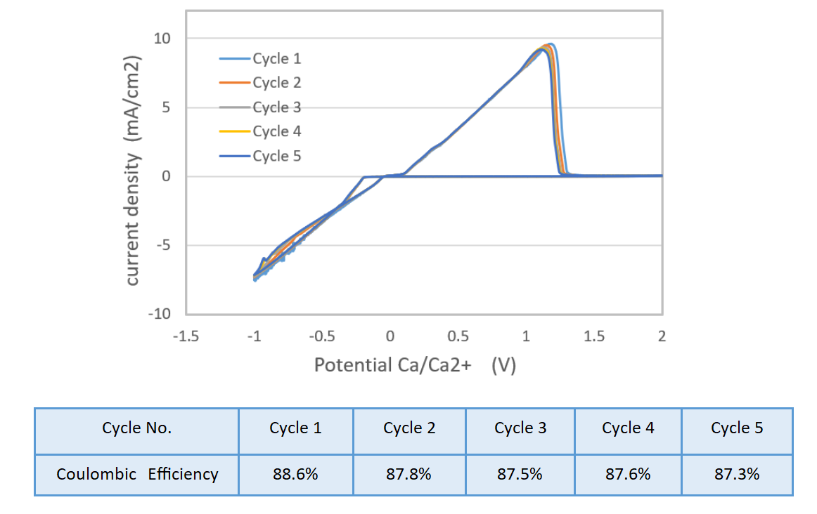
Figure S1. Coulombic efficiency evaluation of the Ca-electrolyte. Five-cycle CV curves and accompanying table showing the CE of each cycle.

In-situ TEM liquid-cell method details
We employed a Protochips Poseidon 510 liquid-cell electrochemical transmission electron microscopy (TEM) holder for the in-situ TEM experiments. The details of this system are discussed by Unocic et al.⁷ In Figure S2 we show schematics of the in-situ TEM liquid-cell. Two silicon chips seal the liquid electrolyte, screening it from the TEM column vacuum (Figure S2a). The chips are pre-fabricated with an electron transparent SiN window. A thin layer of electrolyte was confined between the two windows with a 120 nm spacer. A flow rate of 400 µl h⁻¹ was used during system purging and a flow rate of 80 µl h⁻¹ was used during TEM imaging. After the TEM imaging, the cell was then purged with tetrahydrofuran (THF) for 2 hours before taken back to the glovebox and disassembled. The post-mortem chip was then studied using SEM. It is to be noticed that during the disassembly, some Ca pieces can become detached from the chip with the electrodes, either because they became loose and came off or because the deposit adhered to the other chip.
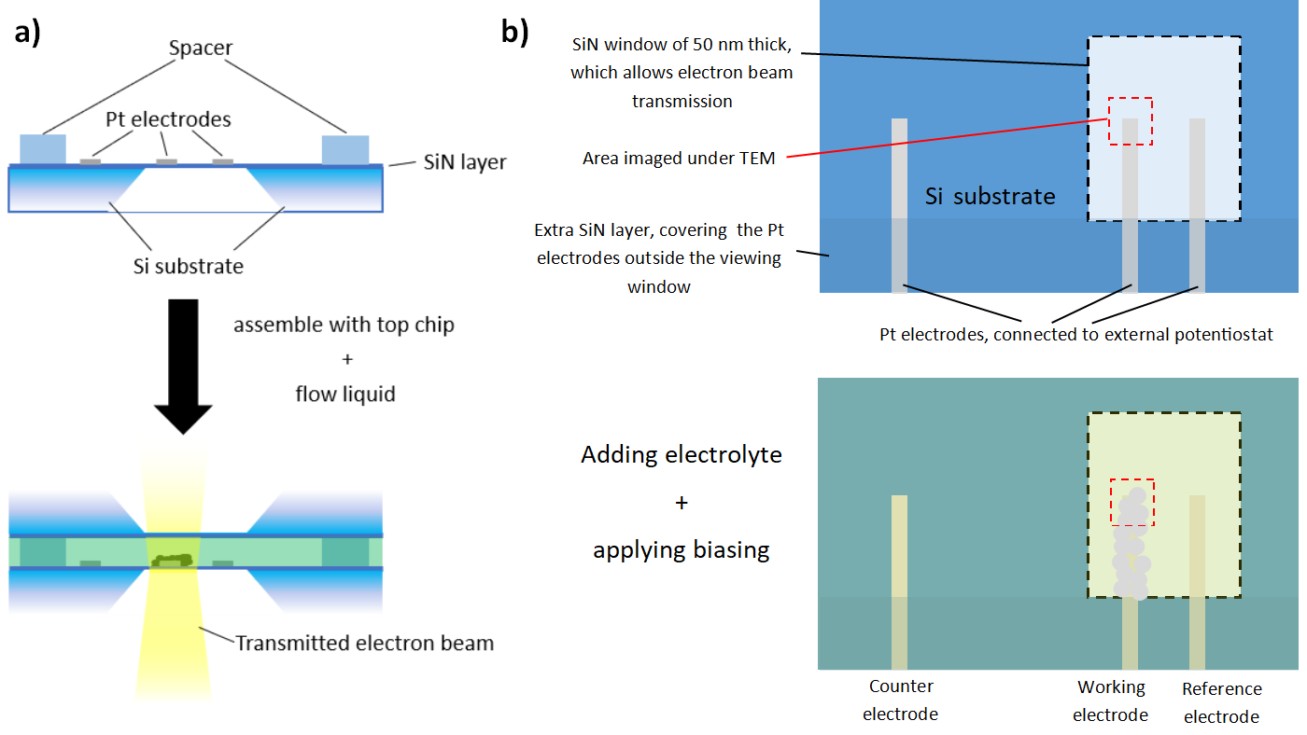
Figure S2. Illustrative schematics of the in-situ TEM liquid-cell. (a) Side-on cross-section views of the cell assembly. One Si chip has patterned electrodes. (b) Top-down view of the electrode geometry, showing the working and reference electrodes situated on the electron-transparent SiN window.

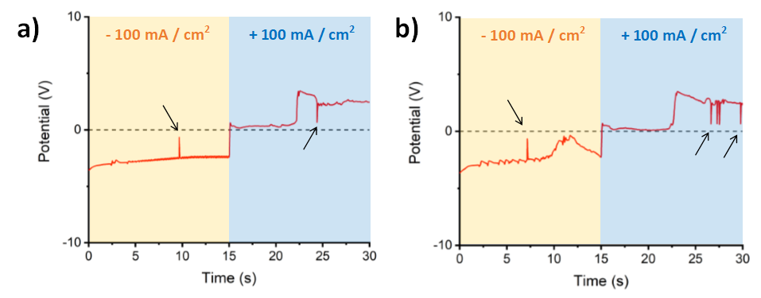
Figure S3. Third and fourth cycles of high current density cell. (a) Third and (b) fourth galvanostatic cycles for the cell cycled at - 100 mA cm⁻² for 15 s then + 100 mA cm⁻² for 15 s. Black arrows indicate short-circuit events. Each plating/stripping had a total passed charge of 18 $μ$C.

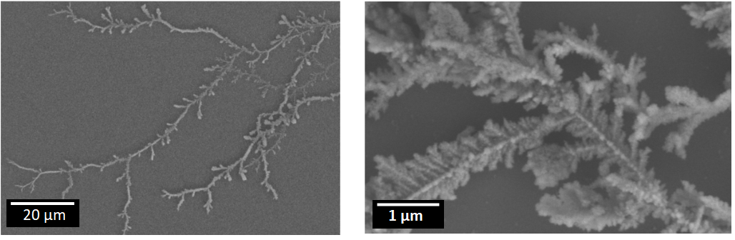
Figure S4. SEM images showing the dendrite morphology plated at 100 mA cm⁻².

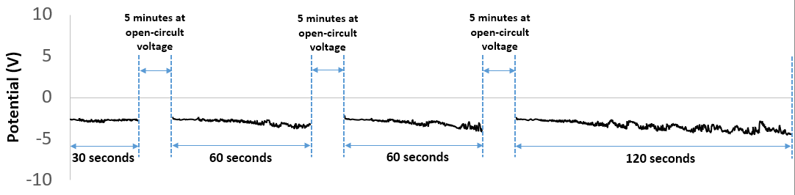Figure S5. Galvanostatic plating at -1 mA cm⁻² with a total plating time of 270 seconds and total passed charge of 0.8 $μ$C.

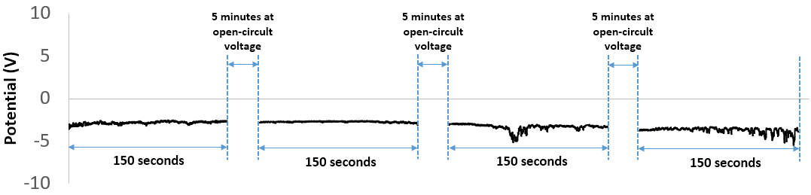
Figure S6. Galvanostatic plating at -10 mA cm⁻² with a total plating time of 600 seconds and total passed charge of 18 $μ$C.
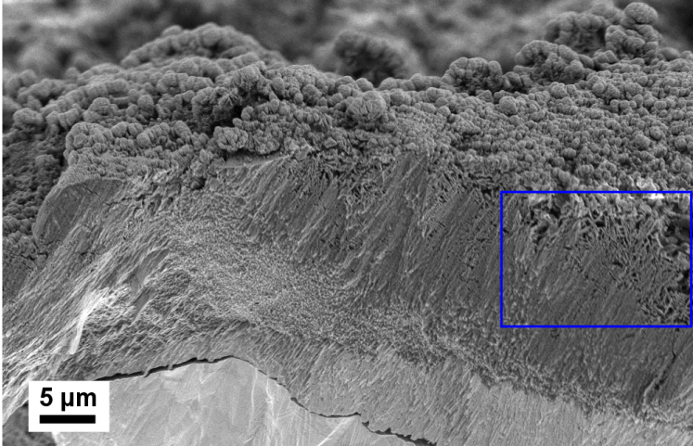
Figure S7. Post-mortem cross-section SEM image of a working electrode after potentiostatic plating (-1 V for 5 hr). The blue area is magnified in Figure 4 of the main text, and shows a cross-section view of densely packed dendritic structures found at parts of the foil surface. Mossy dendrites can also be seen decorating parts of the surface.
Supporting Movie Files
Supporting Movie S1 – High current density (100 mA/cm²) Ca electrolyte cycling in-situ TEM
Supporting Movie S2 – Low current density (1 mA/cm²) Ca electrolyte cycling in-situ TEM
Supporting Movie S3 – Medium current density (10 mA/cm²) Ca electrolyte cycling in-situ TEM

Reference
(1) Wang, D.; Gao, X.; Chen, Y.; Jin, L.; Kuss, C.; Bruce, P. G. Plating and Stripping Calcium in an Organic Electrolyte. Nat. Mater. 2018, 17 (1), 16–20.
(2) Staniewicz, R. J. A Study of the Calcium-Thionyl Chloride Electrochemical System. J. Electrochem. Soc. 1980, 127 (4), 782–789.
(3) Meitav, A.; Peled, E. Calcium-Ca(AICI4)2-Thionyl Chloride Cell: Performance and Safety. J. Electrochem. Soc. 1982, 129 (3), 451–457.
(4) Aurbach, D.; Skaletsky, R.; Gofer, Y. The Electrochemical Behavior of Calcium Electrodes in a Few Organic Electrolytes. J. Electrochem. Soc. 1991, 138 (12), 3536–3545.
(5) Ponrouch, A.; Frontera, C.; Bardé, F.; Palacín, M. R. Towards a Calcium-Based Rechargeable Battery. Nat. Mater. 2016, 15 (2), 169–172.
(6) Sa, N.; Rajput, N. N.; Wang, H.; Key, B.; Ferrandon, M.; Srinivasan, V.; Persson, K. A.; Burrell, A. K.; Vaughey, J. T. Concentration Dependent Electrochemical Properties and Structural Analysis of a Simple Magnesium Electrolyte: Magnesium Bis(Trifluoromethane Sulfonyl)Imide in Diglyme. RSC Adv. 2016, 6 (114), 113663–113670.
(7) Unocic, R. R.; Sacci, R. L.; Brown, G. M.; Veith, G. M.; Dudney, N. J.; More, K. L.; Walden, F. S.; Gardiner, D. S.; Damiano, J.; Nackashi, D. P. Quantitative Electrochemical Measurements Using In Situ Ec-S/TEM Devices. Microsc. Microanal. 2014, 20 (02), 452–461.

