TUTORIAL: Interviewing and Recording people over the internet
ON OCTOBER 13, 2017 BY LIBRARYCACTUSBLOGIN UNCATEGORIZED
Greetings reader! Welcome to my blog. This is my first post addressing some of the prickly issues I turned up when doing my dissertation.
First question I kept getting was
How did you manage to interview people in Orkney? Especially when they couldn’t use Skype?
Well gentle reader. I used this marvellous tool called the internet! I joke, I joke (or at least I hope so, if you don’t know what the internet is then what are you doing here?)
Here’s a few quick pointers for how I went about interviewing and recording people online. Rather than write a complete Tutorial I thought I’d link to the people I found while doing my research as they have more tech skills than I do!

1. Get the hardware
I have a pretty impressive desktop (no I don’t know the specs, I’m a librarian, I had a friend build it for me) so this technique may kill low-end laptops. For which I apologise.
TIP:
Get a headset with mic. I went to my local Claus Olson and grappled a cheap headset after two weeks worth of failed tests. It made everything so much easier.

2. Can’t use Skype? Find another tool!
Many of the libraries I contacted straight-out told me they couldn’t get Skype through their firewall. So I had to think outside the traditional contact box.
After a brief session of GoogleFu, I found AppearIn.
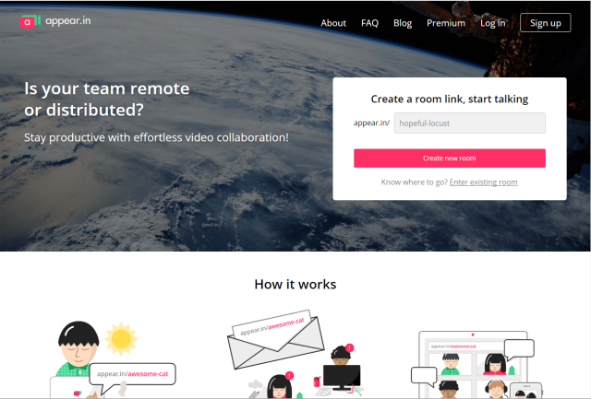
It had several advantages:
- Free
- Easy to share with the interviewee
- Private (you can ‘lock’ rooms once you’ve claimed them)
- Easy to use (no download as it runs through the browser or even your mobile!)
- Limited ‘chat’ function (handy for when the voice bit goes wrong!)
I used it with little-to-no issues.

3. That’s great, but how do I record it?
Many readers will know that you can record Skype calls. However, I had to create some tech workarounds for my interviews. I discovered the technical term for what I was doing was Voice Over Internet Protocol (“VoIP”) calls. Which helped make my GoogleFu stronger when researching.
If you want to follow what I did you’ll need these two tools:

Voicemeeter
(Download at: www.vb-audio.com/Voicemeeter/index.htm you’ll also need the digital cable too)
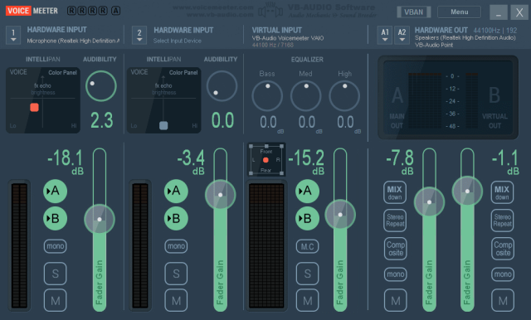A donation-ware programme
Rather than try to explain what I did I’ll link to the Youtube video (warning: he occasionally swears) I used. In short it links the mic back round to the headphones. This DOES mean you can hear yourself (note my comments about a headset – it just plain doesn’t work with speakers) but it means you can also record yourself.

Audacity
(Download at: www.audacityteam.org/download/)
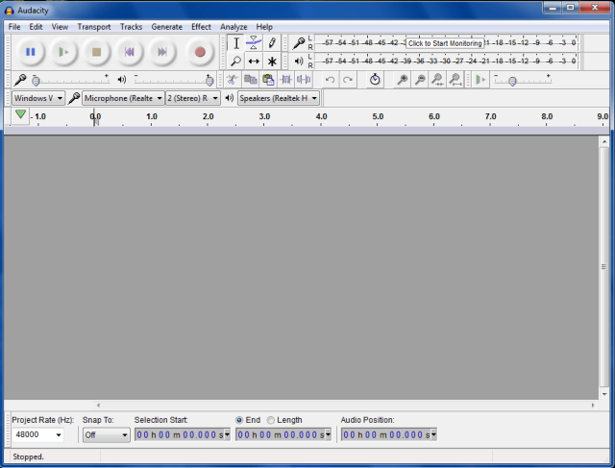An open source sound editing tool
Once you’ve done all the finangling with Soundmeeter all you have to do is hit the ‘record’ button on Audacity and it records. If it’s not working check that the input is the correct thing (I found it sometimes reverted and ignored the audio coming through Soundmeeter)
I used their MP3 function to export and save my audio as an MP3 which then allowed me to auto-transcribe it – the subject for the next blogpost.
There we have it, this is my Frankenstein’s monster version of online recording, I’m sure there’s slicker ways to do it, but this worked for non-tech me so…
Hope all these links help out, do contact me if you notice any issues/have any more tips!
Sarah Out

