Toward low cost grid scale energy storage: supercapacitors based on up-cycled industrial mill scale waste
Chaopeng Fu,* Patrick S. Grant
Department of Materials, University of Oxford, Oxford, United Kingdom, OX1 3PH.
* E-mail: chaopeng.fu@materials.ox.ac.uk

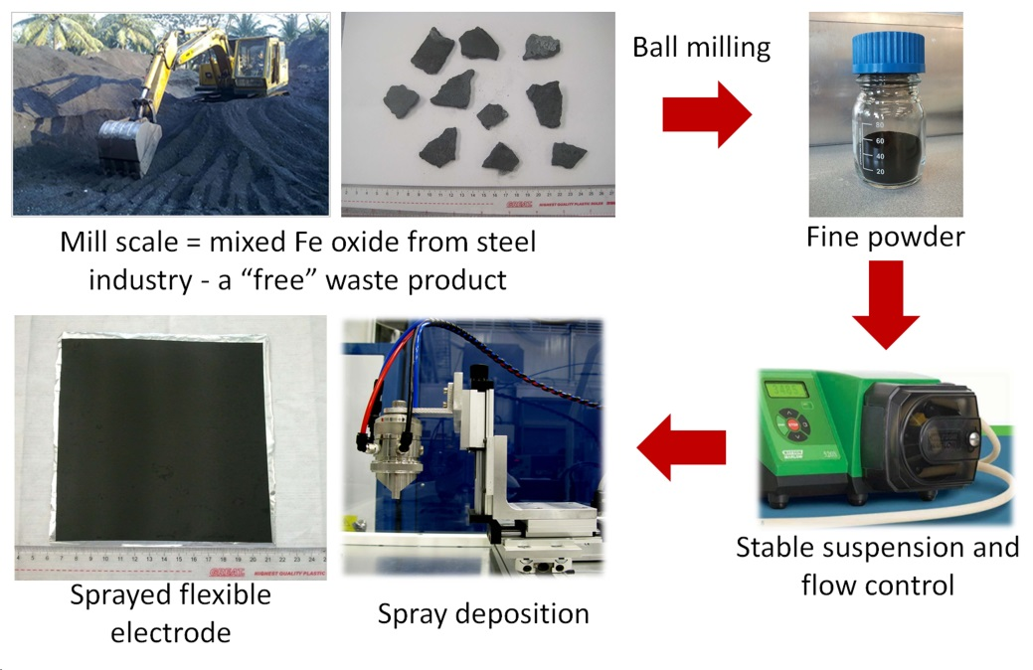
Figure 1 Schematic diagram of the various processing stages to convert mill scale waste from the steel plant to sprayed, large area, 30 µm thick FeO_{x} based supercapacitor electrodes.
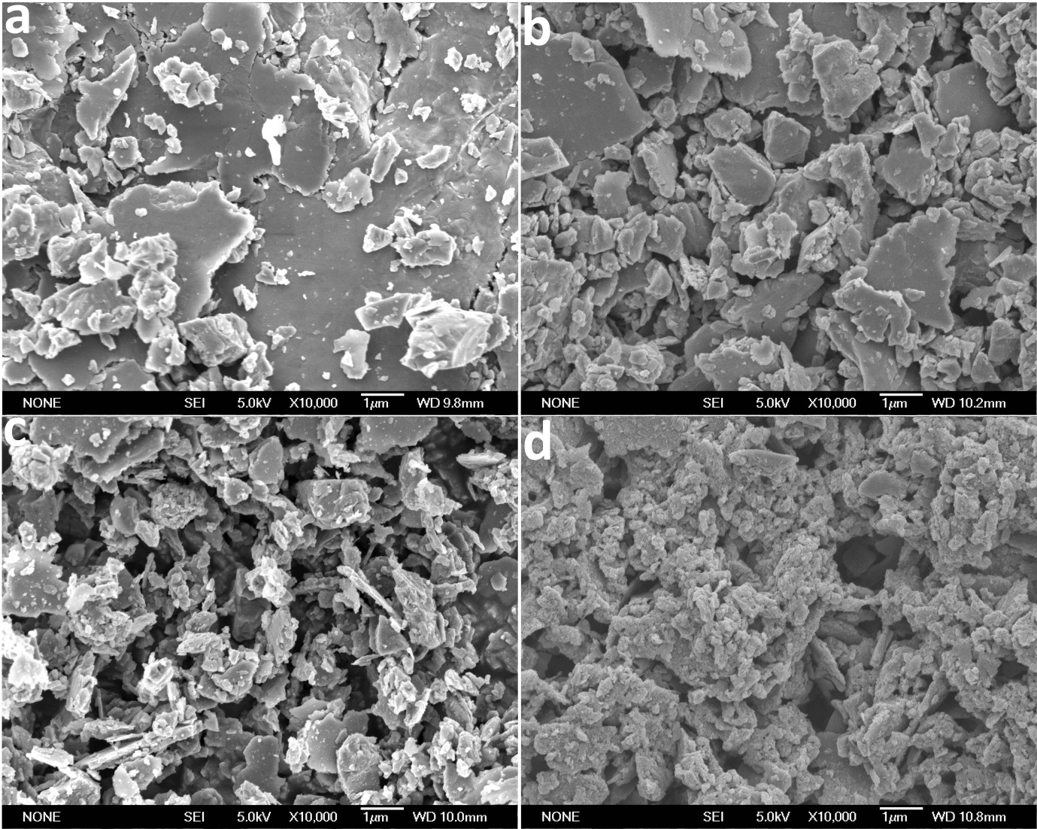
Figure 2 SEM images of the mill scale processed by ball milling for (a) 4 hr, (b) 8 hr, (c) 12 hr, and (d) after chemical etching in HCl

Table 1 BET surface area of the mill scale at different stages of processing
Milling time | 4 hr | 8 hr | 12 hr | Chemical etching in HCl
BET surface area  (m²g⁻¹) | 4.0 | 5.7 | 8.4 | 9.5
Standard error | 0.15 | 0.05 | 0.16 | 0.14

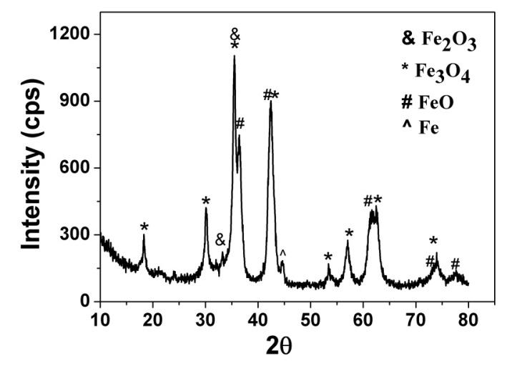
Figure 3 XRD pattern of the ball milled and then HCl etched mill scale.

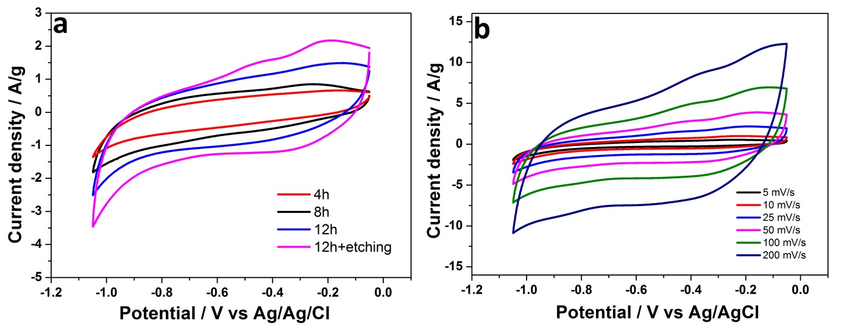
Figure 4 (a) CV curves of the mill scale ball milled at 4, 8, 12 hr and then HCl etched at a scan rate of 25 mV s⁻¹, and (b) CV curves of the HCl etched mill scale at various scan rates.

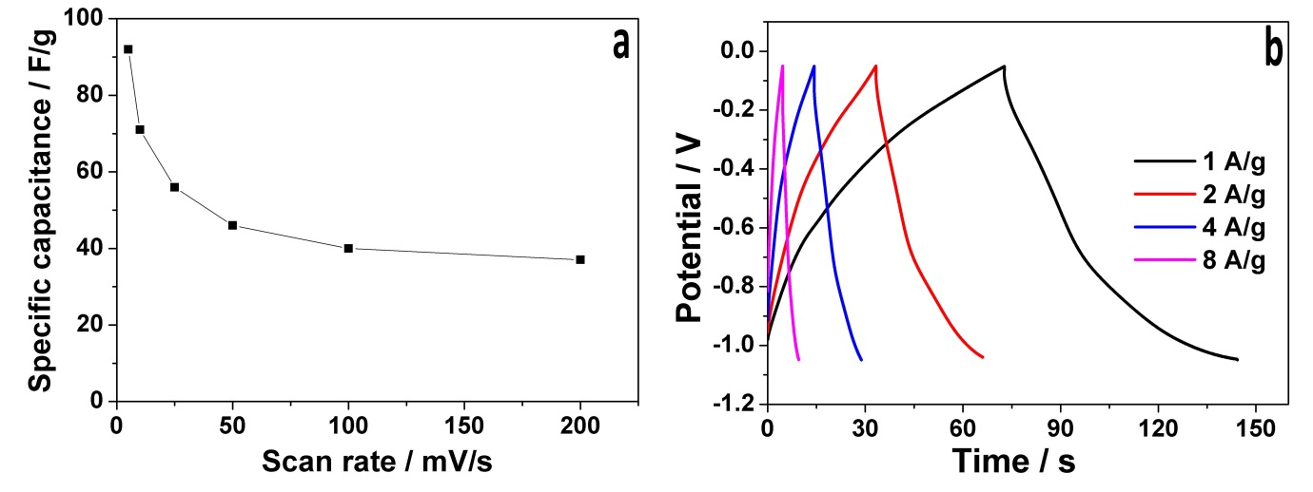
Figure 5 (a) Specific capacitance as a function of scan rate, and (b) galvanostatic charge/discharge curves at various current densities, each for 12 hr ball milled mill scale followed by HCl etching.

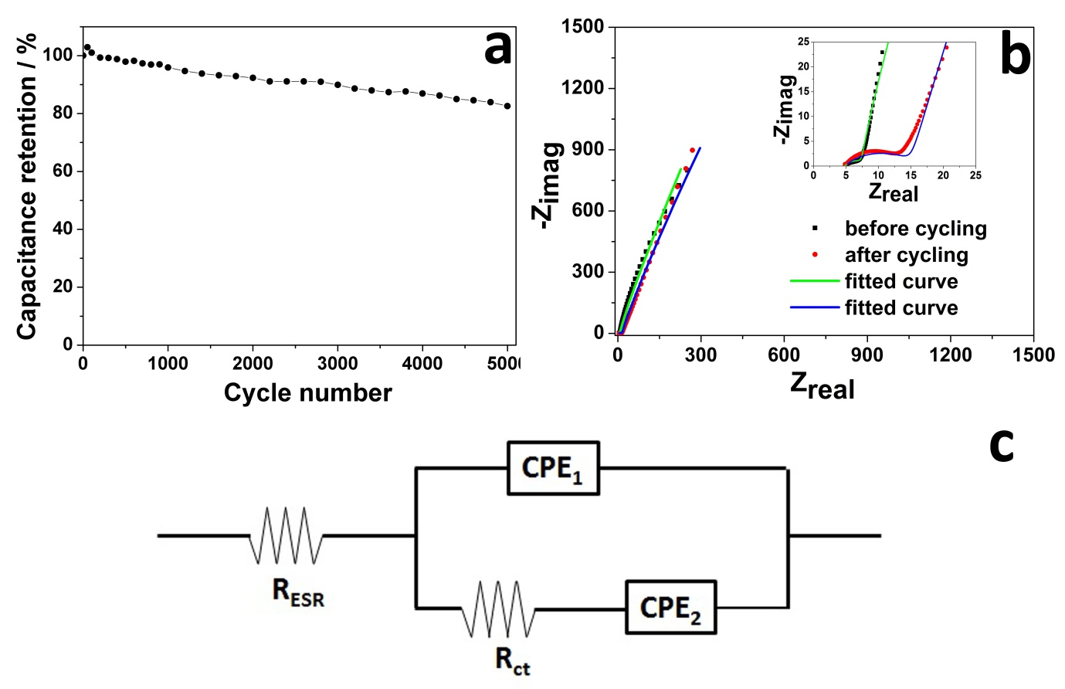
Figure 6 (a) Cycling performance of the FeO_{x} electrode, (b) experimental and fitted Nyquist plots of the FeO_{x} electrode in a Na₂SO₃ electrolyte, and (c) the equivalent circuit used to fit the data.

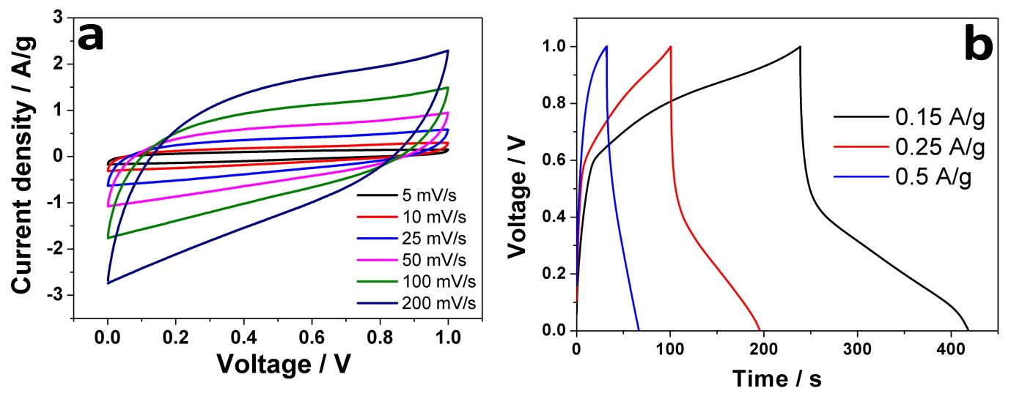
Figure 7 (a) CV curves of a full cell supercapacitor based on FeO_{x} at various scan rates, (b) galvanostatic charge/discharge curves of the same full cell supercapacitor at various current densities.

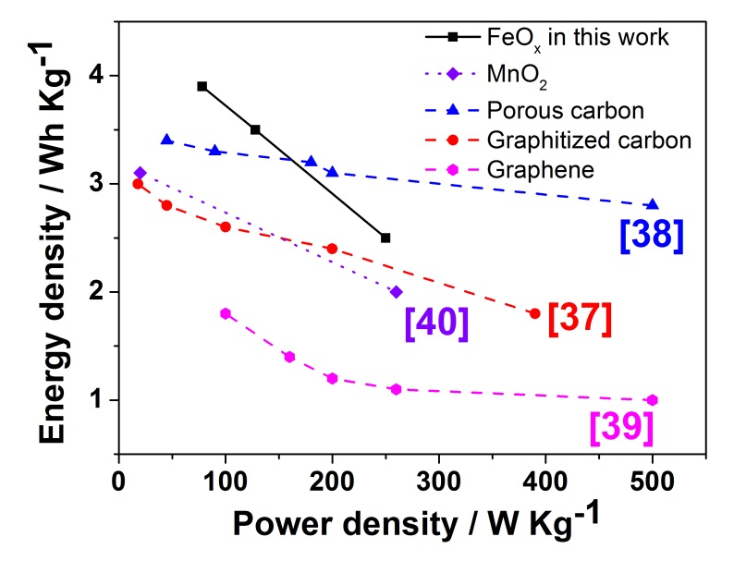
Figure 8 A Ragone plot constructed from data in Figure 7b, together with some comparative re-plotted data of aqueous-based symmetric supercapacitors.

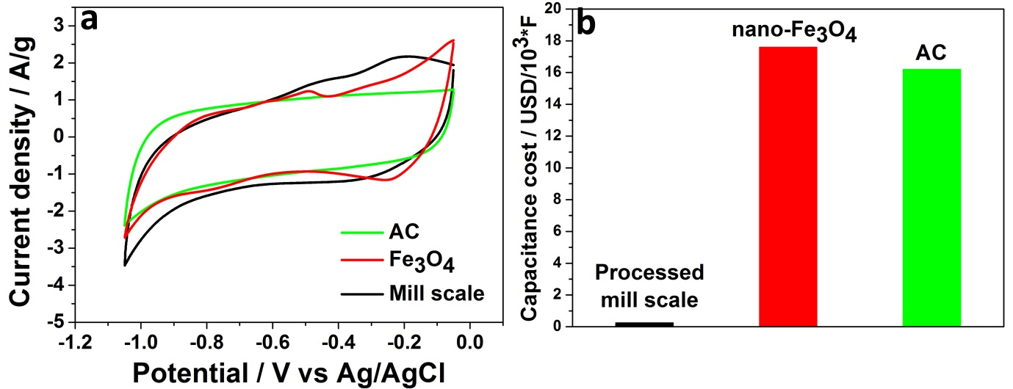Figure 9 (a) CV curves of the processed mill scale (FeO_{x}), commercial Fe₃O₄ nanoparticles and activated carbon (AC) electrodes in the same Na₂SO₃ electrolyte and produced in the same way; and (b) approximate capacitance cost for the same electrode materials.

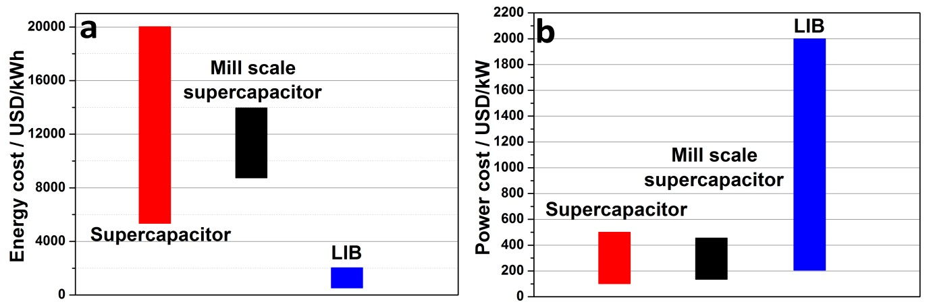
Figure 10 (a) Energy and (b) power cost estimations for mill scale supercapacitors, and commercial LIBs and supercapacitors.

