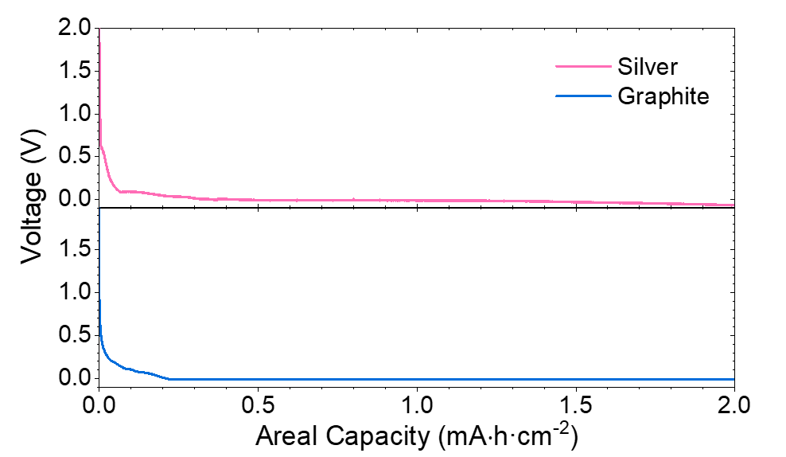
Supplementary Figure 1: Charging voltage profiles of cells with Ag-only and graphite-only anode layers.
Top (pink) shows charging of a silver layer, and bottom (blue) shows charging of a graphite layer. Charge was passed at a rate of 30 µA·cm⁻².

Supplementary Figure 2: Evidence for Li deposition during charge at 30 µA·cm⁻².
a) PXRD showing the absence of a Li peak in the pristine cell (teal), and the presence of the Li peak after passing 2 mA·h·cm⁻² capacity (pink); b) SEM and EDX map of Ag signal of Ag-graphite layer surface after charging to reach the final voltage plateau. Top view images after removal of the current collector. Left shows an SEM after charging, and right shows the corresponding EDX map of Ag signal (teal). Darker in colour deposits are observed which correspond with regions of poor or negligible Ag signal (yellow arrows).

Supplementary Figure 3: Cross-sectional SEM and EDX showing failure of Ag-graphite composite layer cell at 4 mA·cm⁻² charge rate after moving 6 mA·h·cm⁻² capacity at 60 °C
a) Secondary electron image showing Li metal nucleation and Li-Ag alloying at the interface between the composite layer and Li₆PS₅Cl solid electrolyte; b) C signal mapped by EDX, helping identify the position of the composite interlayer; c) S signal mapped by EDX, helping identify the position of Li₆PS₅Cl; and d) Ag signal mapped by EDX, helping identify the position of Li-Ag alloy and Ag nanoparticles.

Supplementary Figure 4: Cross-sectional SEM/EDX of a Ag-graphite composite layer and a graphite-only layer with Li₆PS₅Cl electrolyte.
Figures show a) pristine Ag-graphite composite layer with Li₆PS₅Cl; b) after charging to a capacity of 2 mA·h·cm⁻²; c) pristine graphite layer with Li₆PS₅Cl; and d) after charging to a capacity of 2 mA·h·cm⁻². Each shows secondary electron scanning electron micrographs and EDX maps showing silver (teal), carbon (orange), and sulfur (blue). For the Ag-graphite composite layer, after charge, a Ag-containing layer can be observed to form between the interlayer and the current collector. For the graphite layer, a layer with no EDX signal (Li metal) can be observed to form between the interlayer and the current collector. Note that the current collectors have been carefully removed prior to imaging. In Figures a and c the layer above the graphite interlayer is carbon adhesive tape used in sample mounting. In b and d the layer above the graphite interlayer is entirely deposited Li/Ag or Li.
Supplementary Figure 5: Schematic showing set-up for the PXRD used in reflection.

