Supplementary Information

Shifting-reference concentration cells to refine composition-dependent transport characterization of binary lithium-ion electrolytes

Andrew A. Wang ª, Tianhong Hou ª, Minnie Karanjavala ª, Charles W. Monroe ^{a, b, *}

ª ﻿Department of Engineering Science, University of Oxford, Parks Road, Oxford, OX1 3PJ, United Kingdom.
^{b} ﻿ ﻿The Faraday Institution, Harwell Campus, Didcot, OX11 0RA, United Kingdom.
* Corresponding Author – Email: charles.monroe@eng.ox.ac.uk

Table S1. Summary of density-composition calibration measurements for LiPF₆:EMC solutions. Recorded under an argon atmosphere in a glovebox. Temperatures are accurate within 0.02 $\text{°C}$.

${\text{m}}_{{\text{LiPF}}_{\text{6}}}$ [g] | ${\text{m}}_{\text{EMC}}$ [g] | $$ω$$ | $ρ_{20\text{°C}}$ [g/L] | $ρ_{25\text{°C}}$ [g/L] | $ρ_{30\text{°C}}$ [g/L]
0.0000 | 10.0523 | 0.00000E+00 | 1013.1 | 1007.1 | 1001.1
0.0466 | 10.0145 | 4.63170E-03 | 1016.5 | 1010.5 | 1004.5
0.1502 | 10.0020 | 1.47948E-02 | 1023.2 | 1017.3 | 1011.2
0.4981 | 9.3821 | 5.04145E-02 | 1049.6 | 1043.7 | 1037.8
0.8075 | 9.9860 | 7.48135E-02 | 1068.5 | 1062.6 | 1056.7
1.0395 | 9.9670 | 9.44442E-02 | 1084.6 | 1078.8 | 1073.0
1.5037 | 9.9434 | 1.31361E-01 | 1114.7 | 1108.9 | 1103.1
1.9668 | 11.0127 | 1.51531E-01 | 1131.4 | 1125.7 | 1119.9
2.1150 | 10.0013 | 1.74558E-01 | 1150.6 | 1144.9 | 1139.2
2.5535 | 10.0793 | 2.02133E-01 | 1175.3 | 1169.6 | 1164.0
2.7691 | 10.0052 | 2.16771E-01 | 1189.1 | 1183.5 | 1177.9
3.0231 | 10.0040 | 2.32062E-01 | 1202.3 | 1196.8 | 1191.2
3.1650 | 10.2081 | 2.36669E-01 | 1205.3 | 1199.8 | 1194.2
3.3133 | 9.8747 | 2.51236E-01 | 1219.1 | 1213.6 | 1208.0
3.4413 | 9.6132 | 2.63610E-01 | 1230.8 | 1225.3 | 1219.8
4.2843 | 10.3339 | 2.93080E-01 | 1255.5 | 1250.0 | 1244.6

Table S2. Summary of Hittorf-cell measurements for LiPF₆:EMC solutions. Transference numbers were calculated following section 2.4 in the main text.

$ρ_{20\text{°C}}^{initial}$ [g/L] | $I_{pulse}T_{pulse}$ [C] | $ρ_{20\text{°C}}^{anodic}$ [g/L] | $ρ_{20\text{°C}}^{cathodic}$ [g/L] | $$t_{+}^{0} anodic$$ | $$t_{+}^{0} cathodic$$
1033.7 | 14.1316 | 1036.1 | 1031.3 | 0.388 | 0.389
1033.7 | 14.2718 | 1036.1 | 1031.2 | 0.394 | 0.370
1033.8 | 14.4155 | 1036.2 | 1031.3 | 0.400 | 0.376
1065.7 | 17.03 | 1068.6 | 1062.7 | 0.358 | 0.338
1065.9 | 16.32 | 1068.8 | 1063.1 | 0.330 | 0.355
1067.4 | 14.1701 | 1069.9 | 1065.0 | 0.334 | 0.362
1067.6 | 14.3684 | 1070.1 | 1065.1 | 0.343 | 0.344
1119.2 | 14.4239 | 1121.7 | 1116.7 | 0.304 | 0.305
1119.1 | 14.389 | 1121.6 | 1116.7 | 0.303 | 0.332
1119.2 | 14.355 | 1121.6 | 1116.8 | 0.329 | 0.330
1170.6 | 14.4125 | 1173.1 | 1168.0 | 0.262 | 0.233
1170.8 | 14.2758 | 1173.3 | 1168.2 | 0.255 | 0.226
1171.8 | 14.3714 | 1174.4 | 1169.3 | 0.229 | 0.260
1220.4 | 14.4157 | 1222.8 | 1218.0 | 0.250 | 0.251
1220.3 | 14.412 | 1222.7 | 1217.9 | 0.250 | 0.251
1220.2 | 14.277 | 1222.6 | 1217.9 | 0.243 | 0.275
1268.3 | 14.3747 | 1270.5 | 1266.0 | 0.270 | 0.238
1268.3 | 14.3747 | 1270.6 | 1266.0 | 0.237 | 0.238
1268.2 | 14.4146 | 1270.4 | 1266.0 | 0.272 | 0.273
1268.3 | 14.4146 | 1270.6 | 1266.0 | 0.239 | 0.240

Table S3. Summary liquid-junction potentials in concentration cells for LiPF₆:EMC at 25 $\text{°C}$. Data presented in figure 4 (a) is arrived at by interchanging $ρ_{25 °C}^{A}$ and $ρ_{25 °C}^{B}$ between reference and test concentrations to achieve a full matrix of results.

$ρ_{25 °C}^{A}$ [g/L] | $ρ_{25 °C}^{B}$ [g/L] | U [mV] | SD [mV]
1008.3 | 1012.6 | 19.73 | 0.40
1008.3 | 1017.6 | 25.47 | 1.37
1012.6 | 1017.6 | 6.46 | 0.40
1012.6 | 1027.8 | 12.24 | 0.70
1017.6 | 1027.8 | 4.03 | 0.08
1017.6 | 1048.7 | 15.65 | 0.22
1027.8 | 1048.7 | 6.73 | 0.24
1027.8 | 1072.2 | 10.37 | 0.15
1048.7 | 1072.2 | 4.01 | 0.32
1048.7 | 1093.9 | 8.30 | 0.08
1072.2 | 1093.9 | 4.70 | 0.35
1072.2 | 1114.8 | 10.06 | 0.40
1093.9 | 1114.8 | 5.89 | 0.58
1093.9 | 1136.3 | 11.98 | 0.47
1114.8 | 1136.3 | 6.11 | 0.85
1114.8 | 1155.6 | 14.43 | 0.26
1136.3 | 1155.6 | 7.32 | 0.11
1136.3 | 1165.9 | 12.65 | 0.33
1155.6 | 1165.9 | 4.14 | 0.28
1155.6 | 1193.0 | 21.27 | 0.30
1165.9 | 1193.0 | 15.99 | 0.27
1165.9 | 1209.0 | 24.41 | 2.53
1193.0 | 1209.0 | 11.61 | 1.01
1193.0 | 1229.5 | 30.87 | 0.31
1209.0 | 1229.5 | 18.99 | 0.23
1209.0 | 1246.3 | 37.62 | 0.21
1229.5 | 1246.3 | 15.48 | 0.44
1229.5 | 1268.1 | 35.33 | 1.31
1246.3 | 1268.1 | 20.50 | 0.26
1246.3 | 1285.4 | 41.12 | 0.92
1268.1 | 1285.4 | 20.75 | 0.16
1268.1 | 1299.8 | 37.79 | 0.13
1285.4 | 1299.8 | 16.87 | 0.63
1285.4 | 1317.0 | 38.41 | 0.26
1299.8 | 1317.0 | 21.52 | 0.07
1299.8 | 1333.6 | 43.61 | 0.20
1317.0 | 1333.6 | 22.12 | 0.68
1317.0 | 1361.4 | 61.83 | 0.43
1333.6 | 1361.4 | 39.82 | 0.16
Table S4. Summary liquid-junction potentials in concentration cells for LiPF₆:PC at 25 $\text{°C}$. Data presented in figure 4 (b) is arrived at by interchanging $ρ_{25 °C}^{A}$ and $ρ_{25 °C}^{B}$ between reference and test concentrations to achieve a full matrix of results.

$ρ_{25 °C}^{A}$ [g/L] | $ρ_{25 °C}^{B}$ [g/L] | U [mV] | SD [mV]
1203.4 | 1203.8 | 19.44 | 0.51
1203.4 | 1204.6 | 55.30 | 1.46
1203.8 | 1204.6 | 20.89 | 0.55
1203.8 | 1205.6 | 44.40 | 1.17
1204.6 | 1205.6 | 13.93 | 0.55
1204.6 | 1207.1 | 32.76 | 0.87
1205.6 | 1207.1 | 15.22 | 0.40
1205.6 | 1208.7 | 38.49 | 1.02
1207.1 | 1208.7 | 9.19 | 0.24
1207.1 | 1210.7 | 21.99 | 0.58
1212.2 | 1219.9 | 23.50 | 0.62
1212.2 | 1227.4 | 44.78 | 0.80
1219.9 | 1227.4 | 17.35 | 0.26
1219.9 | 1234.7 | 28.26 | 1.17
1227.4 | 1234.7 | 12.74 | 0.40
1227.4 | 1243.2 | 22.17 | 0.25
1234.7 | 1243.2 | 10.99 | 0.26
1234.7 | 1251.3 | 17.92 | 0.08
1243.2 | 1251.3 | 11.04 | 0.14
1243.2 | 1260.0 | 17.12 | 0.04
1248.2 | 1257.3 | 9.61 | 0.35
1248.2 | 1270.5 | 19.36 | 0.61
1257.3 | 1264.6 | 8.67 | 0.01
1257.3 | 1273.6 | 17.38 | 0.09
1264.6 | 1273.6 | 9.48 | 0.20
1264.6 | 1283.8 | 19.38 | 0.14
1273.6 | 1283.8 | 11.79 | 0.52
1273.6 | 1291.0 | 18.40 | 0.09
1283.8 | 1291.0 | 7.31 | 0.24
1283.8 | 1298.6 | 14.57 | 1.00
1291.0 | 1298.6 | 8.35 | 0.64
1291.0 | 1306.6 | 17.20 | 0.24
1298.6 | 1306.6 | 8.39 | 0.42
1298.6 | 1314.3 | 16.67 | 0.72
1306.6 | 1314.3 | 8.17 | 0.41
1306.6 | 1322.2 | 16.30 | 0.14
1314.3 | 1322.2 | 8.75 | 0.21
1314.3 | 1329.9 | 14.01 | 0.18

Table S4. Continued

$ρ_{25 °C}^{A}$ [g/L] | $ρ_{25 °C}^{B}$ [g/L] | U [mV] | SD [mV]
1322.2 | 1329.9 | 7.30 | 0.11
1322.2 | 1338.2 | 16.36 | 0.27
1329.9 | 1338.2 | 9.71 | 0.30
1329.9 | 1346.9 | 18.28 | 0.32
1338.2 | 1346.9 | 8.76 | 0.06
1338.2 | 1353.5 | 20.13 | 0.30
1346.9 | 1353.5 | 8.91 | 0.15
1346.9 | 1361.9 | 19.55 | 0.47
1353.5 | 1361.9 | 8.23 | 0.38
1353.5 | 1368.9 | 18.14 | 0.13
1361.9 | 1368.9 | 9.69 | 0.23
1361.9 | 1376.7 | 17.14 | 0.08
1368.9 | 1376.7 | 7.74 | 0.08
1368.9 | 1382.7 | 15.01 | 0.11

Table S5. Summary of ionic conductivity measurements for LiPF₆:EMC solutions.

$ρ_{20 °C}$ [g/L] | $κ_{20 °C}$ [$\text{μ}$S/cm] | $κ_{25 °C}$ [$\text{μ}$S/cm] | $κ_{30 °C}$ [$\text{μ}$S/cm]
1018.9 | 0.349 | 0.503 | 0.668
1023.2 | 5.995 | 6.321 | 6.568
1034.6 | 117.3 | 119.8 | 121.0
1049.6 | 611.1 | 634.6 | 655.1
1068.5 | 1492 | 1563 | 1632
1084.6 | 2406 | 2533 | 2654
1114.7 | 4045 | 4294 | 4536
1131.4 | 4760 | 5100 | 5433
1175.3 | 5705 | 6212 | 6688
1205.3 | 5452 | 5996 | 6560
1230.8 | 4836 | 5401 | 5983

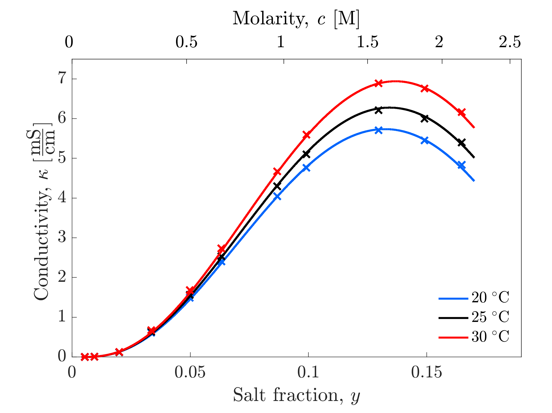

Figure S1 measured ionic conductivities (x) of LiPF₆:EMC at $\text{20, 25, and 30 °C}$.

Fitting process for equivalent conductance
A power series in $y^{1/4}$ was used to fit equivalent-conductance data. The general form studied with the optimization algorithm was

$$Λ=Λ_{0}+{\left[\sum_{k=1}^{7}{Λ_{k}{\left(\sqrt{y}\right)}^{\frac{k}{2}}}\right]}^{2}.$$ | (S1)
By minimizing number of parameters, maximizing R², and minimizing the root-mean-squared error (RMSE) in the 95% confidence interval, it was found that a 3-parameter fit with average R² = 0.9997 and average confidence interval RMSE = 0.077 was optimal, using the programmatic Curve Fitting Toolbox by MathWorks, which returned best-fit parameter values as a vector $\left(Λ_{k},{CI}_{left,k},{CI}_{right,k}\right)$, where ${CI}_{left,k}$ and ${CI}_{right,k}$ respectively represent the lower and upper bounds of the 95% confidence interval (CI) on $Λ_{k}$.

For each possible collection of nonzero parameters in equation S1, CI RMSE was calculated with the formula

${RMSE}_{CI}=\sqrt{\frac{1}{n_{terms≠0}}\sum_{k:Λ_{k}≠0}{{\left(\frac{{`CI}_{right,k}-{CI}_{left,k}}{Λ_{k}}\right)}^{2}}}$. | (S2)
We note that 0 always fell between the confidence intervals for the constant term $Λ_{0}$, and so it was not included in the final correlation. The presence of $Λ_{0}$ has physical meaning for strong electrolytes, which would be expected to obey Onsager–Fuoss conductance law at limiting dilution, but does not appear to be justified for LiPF₆:EMC based on our experimental data.

This process identified the error-minimizing final functional form to be

 | $$Λ = {\left({Λ_{1}\sqrt{y}}^{1/2}+Λ_{2}y+{Λ_{3}\sqrt{y}}^{5/2}\right)}^{2},$$ | (S3)

equation 19 in the main-body text.

Table S6. Summary of dynamic viscosity measurements for LiPF₆:EMC solutions.

$ρ_{20 °C}$ [g/L] | $η_{20 °C}$ [$\text{mPa}$•s] | $η_{25 °C}$ [$\text{mPa}$•s] | $η_{30 °C}$ [$\text{mPa}$•s]
1013.1 | 0.724 | 0.680 | 0.639
1015.8 | 0.745 | 0.686 | 0.644
1025.6 | 0.778 | 0.743 | 0.701
1041.9 | 0.916 | 0.877 | 0.808
1064.5 | 1.143 | 1.063 | 1.000
1093.9 | 1.524 | 1.405 | 1.294
1119.6 | 1.994 | 1.825 | 1.673
1169.9 | 3.570 | 3.176 | 2.860
1215.6 | 6.726 | 5.807 | 5.104
1245.2 | 10.650 | 9.797 | 8.648

Table S7. Summary of dynamic viscosity measurements for LiPF₆:PC solutions.

$ρ_{20 °C}$ [g/L] | $η_{20 °C}$ [$\text{mPa}$•s] | $η_{25 °C}$ [$\text{mPa}$•s] | $η_{30 °C}$ [$\text{mPa}$•s]
1204.9 | 2.74 | 2.47 | 2.24
1213.3 | 3.008 | 2.707 | 2.449
1216.0 | 3.362 | 3.038 | 2.734
1237.7 | 4.229 | 3.766 | 3.374
1253.6 | 5.394 | 4.75 | 4.218
1269.9 | 7.899 | 6.132 | 5.373
1285.8 | 9.461 | 8.129 | 7.04
1300.0 | 12.48 | 10.59 | 9.033
1316.8 | 17.89 | 14.83 | 12.36
1332.0 | 25.08 | 20.43 | 16.85
1361.0 | 55.72 | 42.93 | 34.02

Table S8. Summary of restricted-diffusion measurements for LiPF₆:EMC solutions. $κ_{eff}$was obtained using electrochemical impedance spectroscopy (EIS)

$ρ_{20 °C}$ [g/L] | slope fit [s⁻¹] | $D_{eff}$ [cm²/s] | $κ_{eff}$ [mS/cm] | b
1020.1 | 1.18E-03 | 4.77E-06 | 9.34E-04 | 0.58
1020.1 | 1.29E-03 | 5.22E-06 | 9.24E-04 | 0.65
1020.1 | 1.04E-03 | 4.21E-06 | 8.52E-04 | 1.15
1020.1 | 7.88E-04 | 3.19E-06 | 7.70E-04 | 1.77
1025.3 | 1.16E-03 | 4.69E-06 | 1.23E-02 | 0.32
1025.3 | 9.41E-04 | 3.81E-06 | 1.02E-02 | 1.45
1025.3 | 1.02E-03 | 4.13E-06 | 1.20E-02 | 0.45
1025.3 | 9.51E-04 | 3.85E-06 | 1.17E-02 | 0.58
1049.3 | 6.13E-04 | 2.49E-06 | 0.398 | 2.79
1049.3 | 7.09E-04 | 2.87E-06 | 0.490 | 1.51
1049.3 | 5.42E-04 | 2.20E-06 | 0.395 | 2.84
1049.3 | 8.41E-04 | 3.41E-06 | 0.521 | 1.14
1094.7 | 6.47E-04 | 2.62E-06 | 2.51 | 1.07
1094.7 | 5.29E-04 | 2.14E-06 | 2.03 | 2.36
1094.7 | 7.42E-04 | 3.01E-06 | 2.87 | 0.25
1094.7 | 5.42E-04 | 2.20E-06 | 2.09 | 2.20
1094.7 | 5.42E-04 | 2.19E-06 | 2.18 | 1.92
1117.9 | 6.55E-04 | 2.65E-06 | 3.58 | 1.03
1117.9 | 5.11E-04 | 2.07E-06 | 3.32 | 1.49
1117.9 | 5.49E-04 | 2.23E-06 | 3.80 | 0.66
1117.9 | 5.97E-04 | 2.42E-06 | 4.01 | 0.34
1117.9 | 5.31E-04 | 2.15E-06 | 3.38 | 1.39
1117.9 | 5.72E-04 | 2.32E-06 | 3.53 | 1.11
1178.8 | 4.47E-04 | 1.81E-06 | 4.52 | 1.46
1178.8 | 3.97E-04 | 1.61E-06 | 4.26 | 1.83
1178.8 | 5.43E-04 | 2.20E-06 | 5.09 | 0.73
1178.8 | 4.40E-04 | 1.78E-06 | 4.76 | 1.14
1215.3 | 4.32E-04 | 1.75E-06 | 4.12 | 1.38
1215.3 | 3.45E-04 | 1.40E-06 | 4.63 | 0.66
1215.3 | 5.18E-04 | 2.10E-06 | 5.01 | 0.18
1215.3 | 3.39E-04 | 1.37E-06 | 4.59 | 0.72
1215.3 | 2.62E-04 | 1.06E-06 | 4.74 | 0.52
1255.5 | 3.85E-04 | 1.56E-06 | 4.38 | 0.29
1255.5 | 2.46E-04 | 9.99E-07 | 3.66 | 1.38
1255.5 | 2.06E-04 | 8.35E-07 | 3.07 | 2.47
1255.5 | 2.07E-04 | 8.41E-07 | 3.04 | 2.54
1255.5 | 2.36E-04 | 9.56E-07 | 3.32 | 1.98
1255.5 | 2.21E-04 | 8.97E-07 | 3.85 | 1.07
1255.5 | 3.23E-04 | 1.31E-06 | 4.05 | 0.76

MacMullin geometry correction
EIS measurements made following the bulk impedance section in Hou and Monroe [1] with this equation:
$κ_{eff}=\frac{L}{Ω_{bulk}A}$, (S4)
Where $Ω_{bulk}$ is the bulk impedance measured with EIS, $L$ is the PEEK spacer thickness (0.2 cm) and A is the PEEK spacer cross sectional area (0.503 cm²).

The MacMullin number $α$ depends on pore geometry and is found by scaling the effective conductivity $κ_{eff}$with the pure liquid electrolyte conductivity $κ$:
$α=\frac{κ_{eff}}{κ}$. (S5)
By taking the manufacturer specification for porosity $ε=0.85$, one may then calculate the Bruggeman exponent b based on effective medium theory via:
$α=ε^{b}$. (S6)
Figure S1 reports the spread in b, and an average of b = 1.23 with a standard deviation of 0.74 is found. This wide variability in the Bruggeman exponent suggests a correspondingly wide variability in the pore structure of the glass fiber.

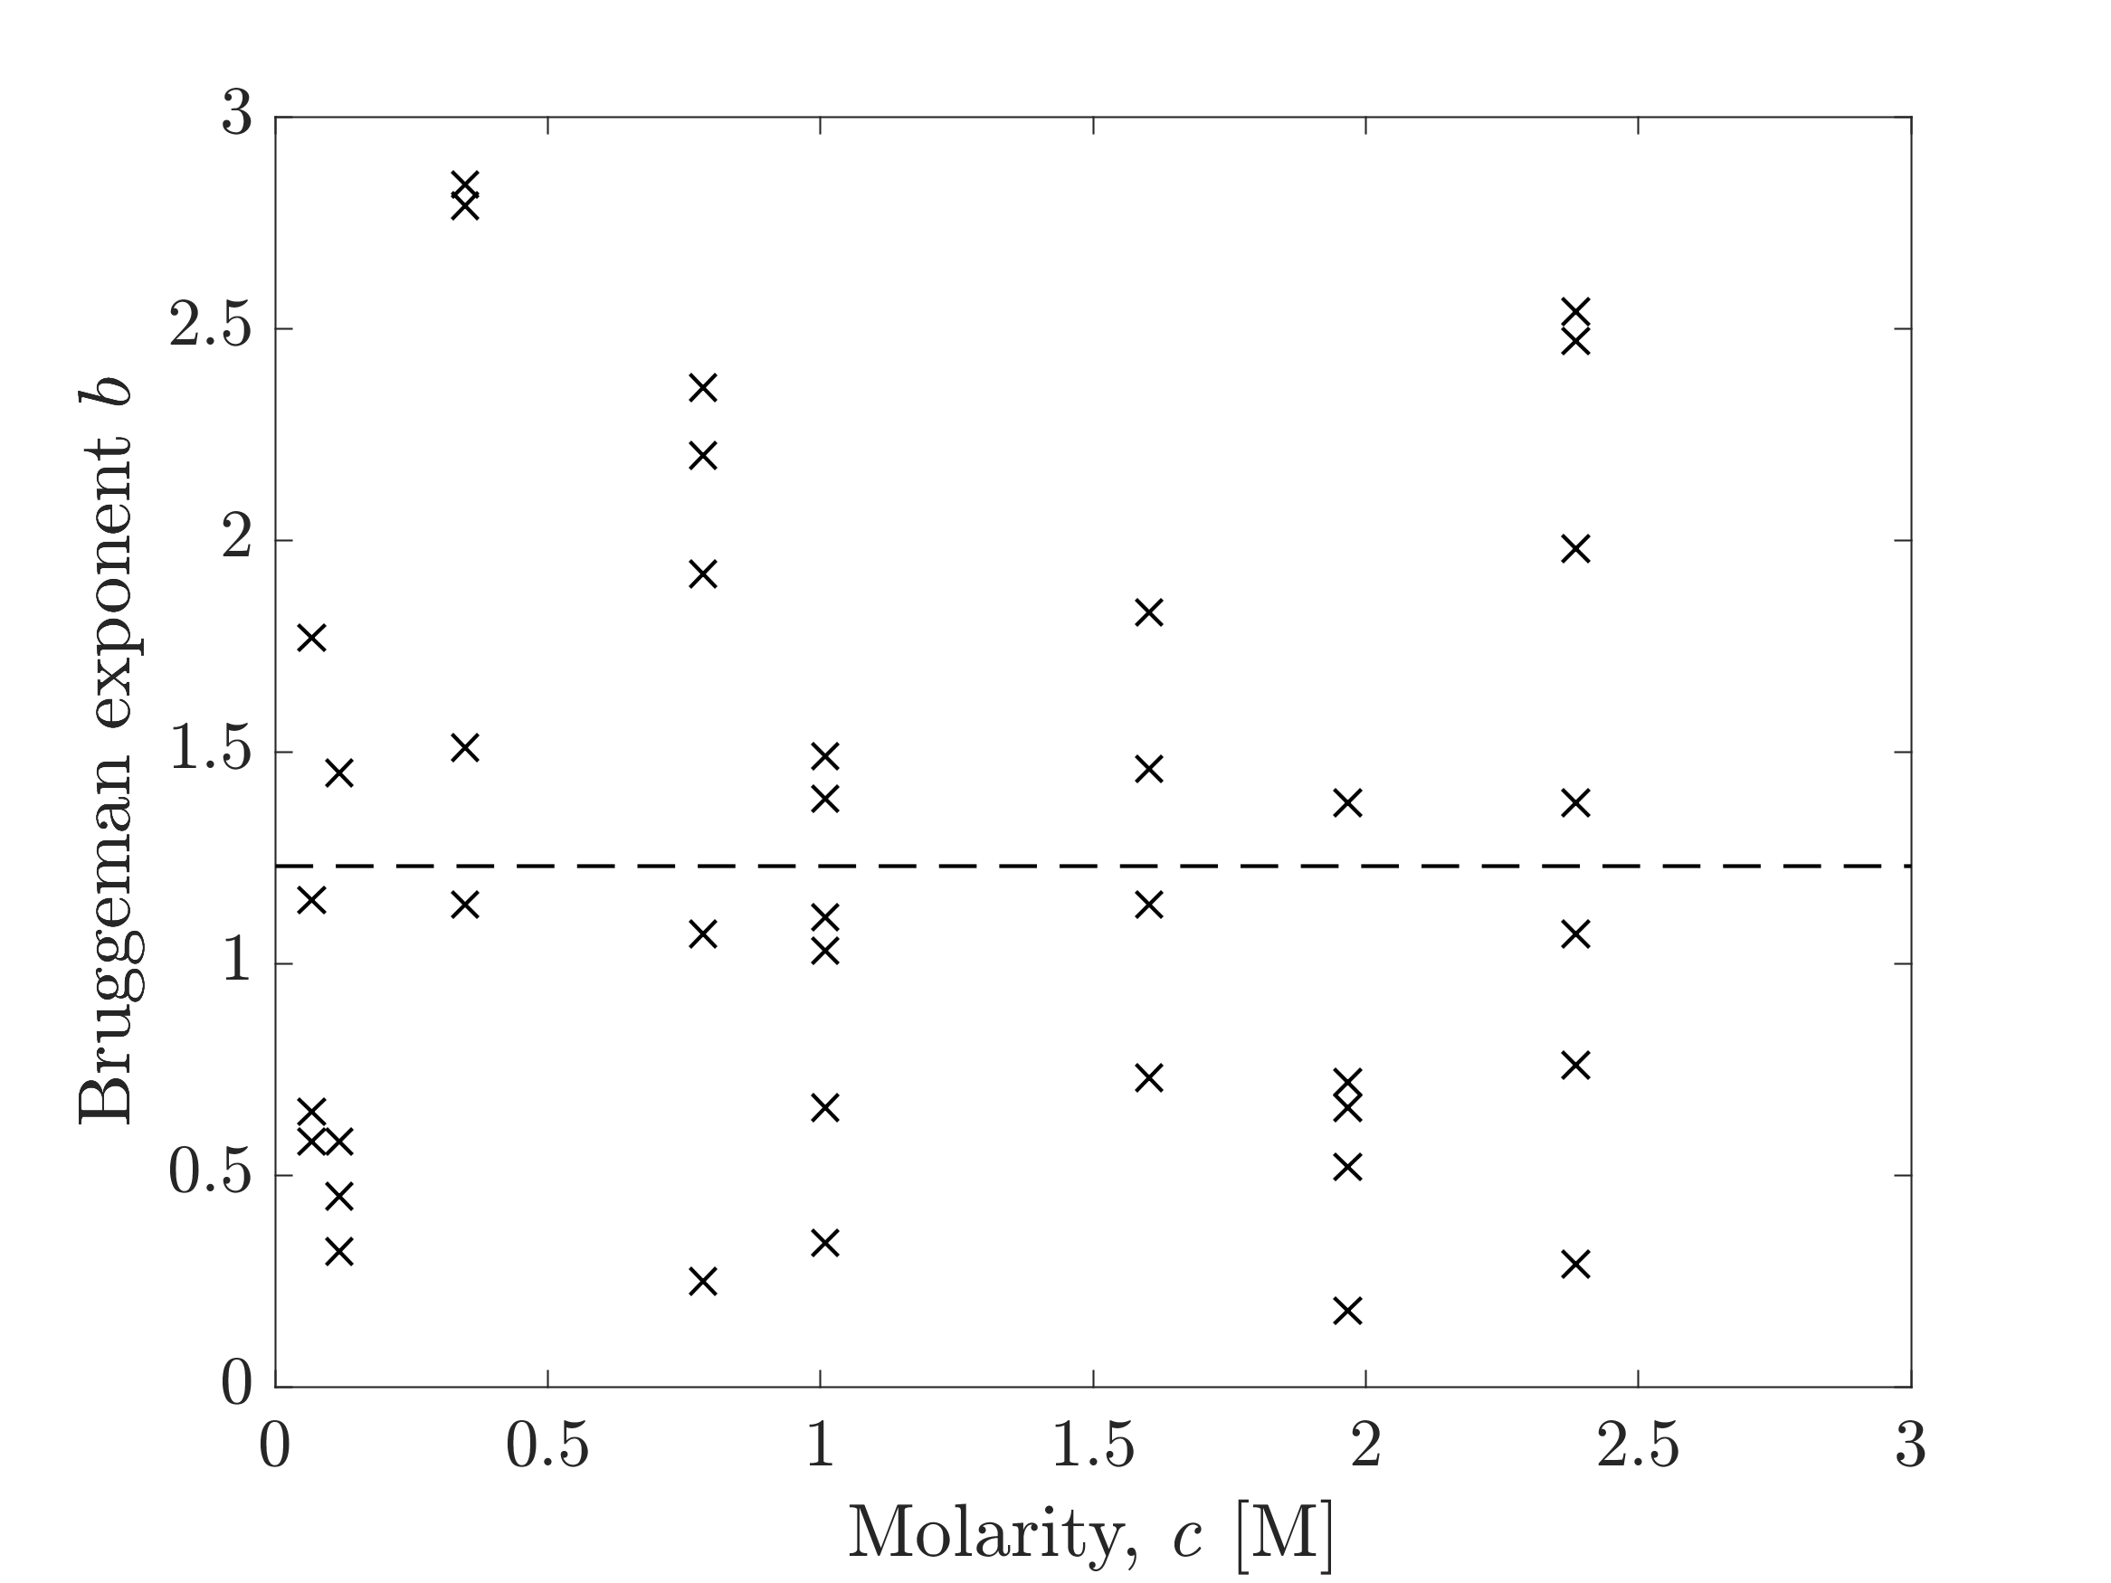
Figure S2. Bruggeman exponent b (x) calculated for each individual restricted-diffusion measurement for LiPF₆:EMC. An average value of 1.23 with standard deviation 0.74 is indicated (- - -).

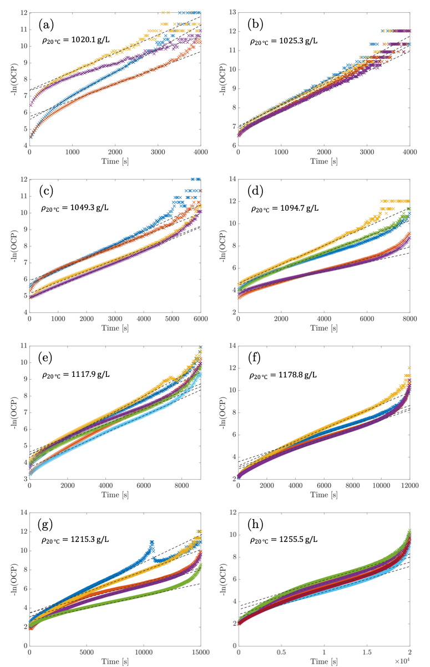
Figure S3. Individual voltage relaxation data from all restricted diffusion measurements for LiPF₆:EMC. Dashed lines (- - -) indicate region of slope used to compute $D_{eff}$.

Table S9. Parameters and 95% confidence intervals to accompany correlations presented in table 2 from main text.

Electrolyte | Property | T / $\text{°C}$ | Fit parameters & confidence intervals
LiPF₆:EMC | $$ρ(c [M])$$ | 20 | $$1013.1$$ | $$113.19$$ | $$-7.8842$$
LiPF₆:EMC | $$ρ(c [M])$$ | 20 | — | $$±2.70$$ | $$±1.998$$
LiPF₆:EMC | $$ρ(c [M])$$ | 25 | $$1007.1$$ | $$114.20$$ | $$-8.1212$$
LiPF₆:EMC | $$ρ(c [M])$$ | 25 | — | $$±2.80$$ | $$±2.029$$
LiPF₆:EMC | $$ρ(c [M])$$ | 30 | $$1001.1$$ | $$115.13$$ | $$-8.3005$$
LiPF₆:EMC | $$ρ(c [M])$$ | 30 | — | $$±2.70$$ | $$±2.04$$
LiPF₆:EMC | $$η(y)$$ | 20 | $$0.724$$ | $$43.80$$ | $$5.964×{10}^{5}$$
LiPF₆:EMC | $$η(y)$$ | 20 | — | $$±1.02$$ | $$±8800$$
LiPF₆:EMC | $$η(y)$$ | 25 | $$0.680$$ | $$36.01$$ | $$5.655×{10}^{5}$$
LiPF₆:EMC | $$η(y)$$ | 25 | — | $$±4.2000$$ | $$±36500$$
LiPF₆:EMC | $$η(y)$$ | 30 | $$0.639$$ | $$32.17$$ | $$4.917×{10}^{5}$$
LiPF₆:EMC | $$η(y)$$ | 30 | — | $$±4.49$$ | $$±39000$$
LiPF₆:EMC | $$Λ(y)$$ | 20 | $$-9.273$$ | $$33.39$$ | $$-58.50$$
LiPF₆:EMC | $$Λ(y)$$ | 20 | $$±0.558$$ | $$±1.336$$ | $$±1.981$$
LiPF₆:EMC | $$Λ(y)$$ | 25 | $$-9.631$$ | $$34.46$$ | $$-59.64$$
LiPF₆:EMC | $$Λ(y)$$ | 25 | $$±0.600$$ | $$±1.437$$ | $$±2.125$$
LiPF₆:EMC | $$Λ(y)$$ | 30 | $$-9.970$$ | $$35.47$$ | $$-60.66$$
LiPF₆:EMC | $$Λ(y)$$ | 30 | $$±0.602$$ | $$±1.442$$ | $$±2.127$$
LiPF₆:EMC | $$χ_{EMC}(y)$$ | 25 | $$1$$ | $$-18.38$$ | $$155.3$$
LiPF₆:EMC | $$χ_{EMC}(y)$$ | 25 | — | $$±4.330$$ | $$±48.35$$
LiPF₆:EMC | $$t_{+}^{0}(y)$$ | 25 | $$0.4240$$ | $$-1.858$$ | $$4.880$$
LiPF₆:EMC | $$t_{+}^{0}(y)$$ | 25 | $$±0.020$$ | $$±0.467$$ | $$±2.179$$
LiPF₆:EMC | $$D(y)$$ | 25 | $$504.8$$ | $$-6.064$$ | $$11.35$$
LiPF₆:EMC | $$D(y)$$ | 25 | $$±27.05$$ | $$±1.417$$ | $$±7.345$$

Table S9. Continued Parameters and 9% confidence intervals to accompany correlations presented in table 2 from main text.

Electrolyte | Property | T / $\text{°C}$ | Fit parameters & confidence intervals
LiPF₆:PC | $$η(y)$$ | 20 | $$2.74$$ |  | $$287.9$$ |  | $$1.702×{10}^{7}$$
LiPF₆:PC | $$η(y)$$ | 20 | $$±0.353$$ |  | $$±22.15$$ |  | $$±545000$$
LiPF₆:PC | $$η(y)$$ | 25 | $$2.47$$ |  | $$246.7$$ |  | $$1.245×{10}^{7}$$
LiPF₆:PC | $$η(y)$$ | 25 | $$±0.234$$ |  | $$±14.75$$ |  | $$±365000$$
LiPF₆:PC | $$η(y)$$ | 30 | $$2.24$$ |  | $$212.3$$ |  | $$9.382×{10}^{6}$$
LiPF₆:PC | $$η(y)$$ | 30 | $$±0.184$$ |  | $$±11.50$$ |  | $$±283000$$
LiPF₆:PC | $$χ_{PC}(y)$$ | 25 | $$1$$ | $$-2.655$$ |  | $$26.23$$ |  | $$1490$$
LiPF₆:PC | $$χ_{PC}(y)$$ | 25 | — | $$±1.209$$ |  | $$±5.075$$ |  | $$±336.5$$

