Figure S1 | Association of the 43 identified loci on NEB and childlessness. The direction of effect has been reversed for childless to show a risk increasing odds-ratio for easier interpretation of effect magnitude.
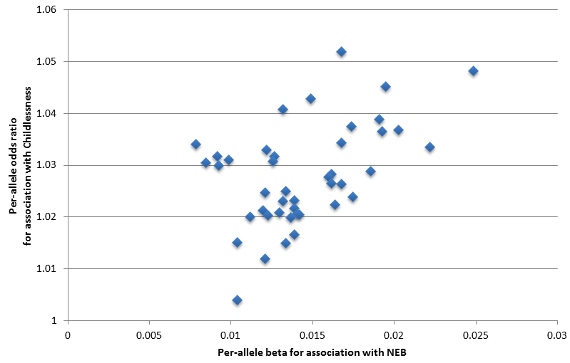

Figure S2 | Candidate genes in the 43 NEB and childlessness associated loci. Information for 54 genes prioritized in loci identified by GWAS for number of children ever born (NEB) and/or childlessness (CLN) that are located within 1 million bp of lead SNPs. Blue and orange indicate transitions from one locus to the next. From left to right, panels indicate: 1) if the locus was identified for NEB and/or CLN; 2) which bioinformatic approaches highlighted the gene as a candidate; 3) the cell types in brain, glands, female reproductive organs, and male reproductive organs in which the genes are expressed at a low, moderate or high level (small, medium and large circles) based on data from the Human Protein Atlas; 4) gene functions as extracted from Entrez, Uniprot and GeneCards; 5) which phenotypes were observed in mutant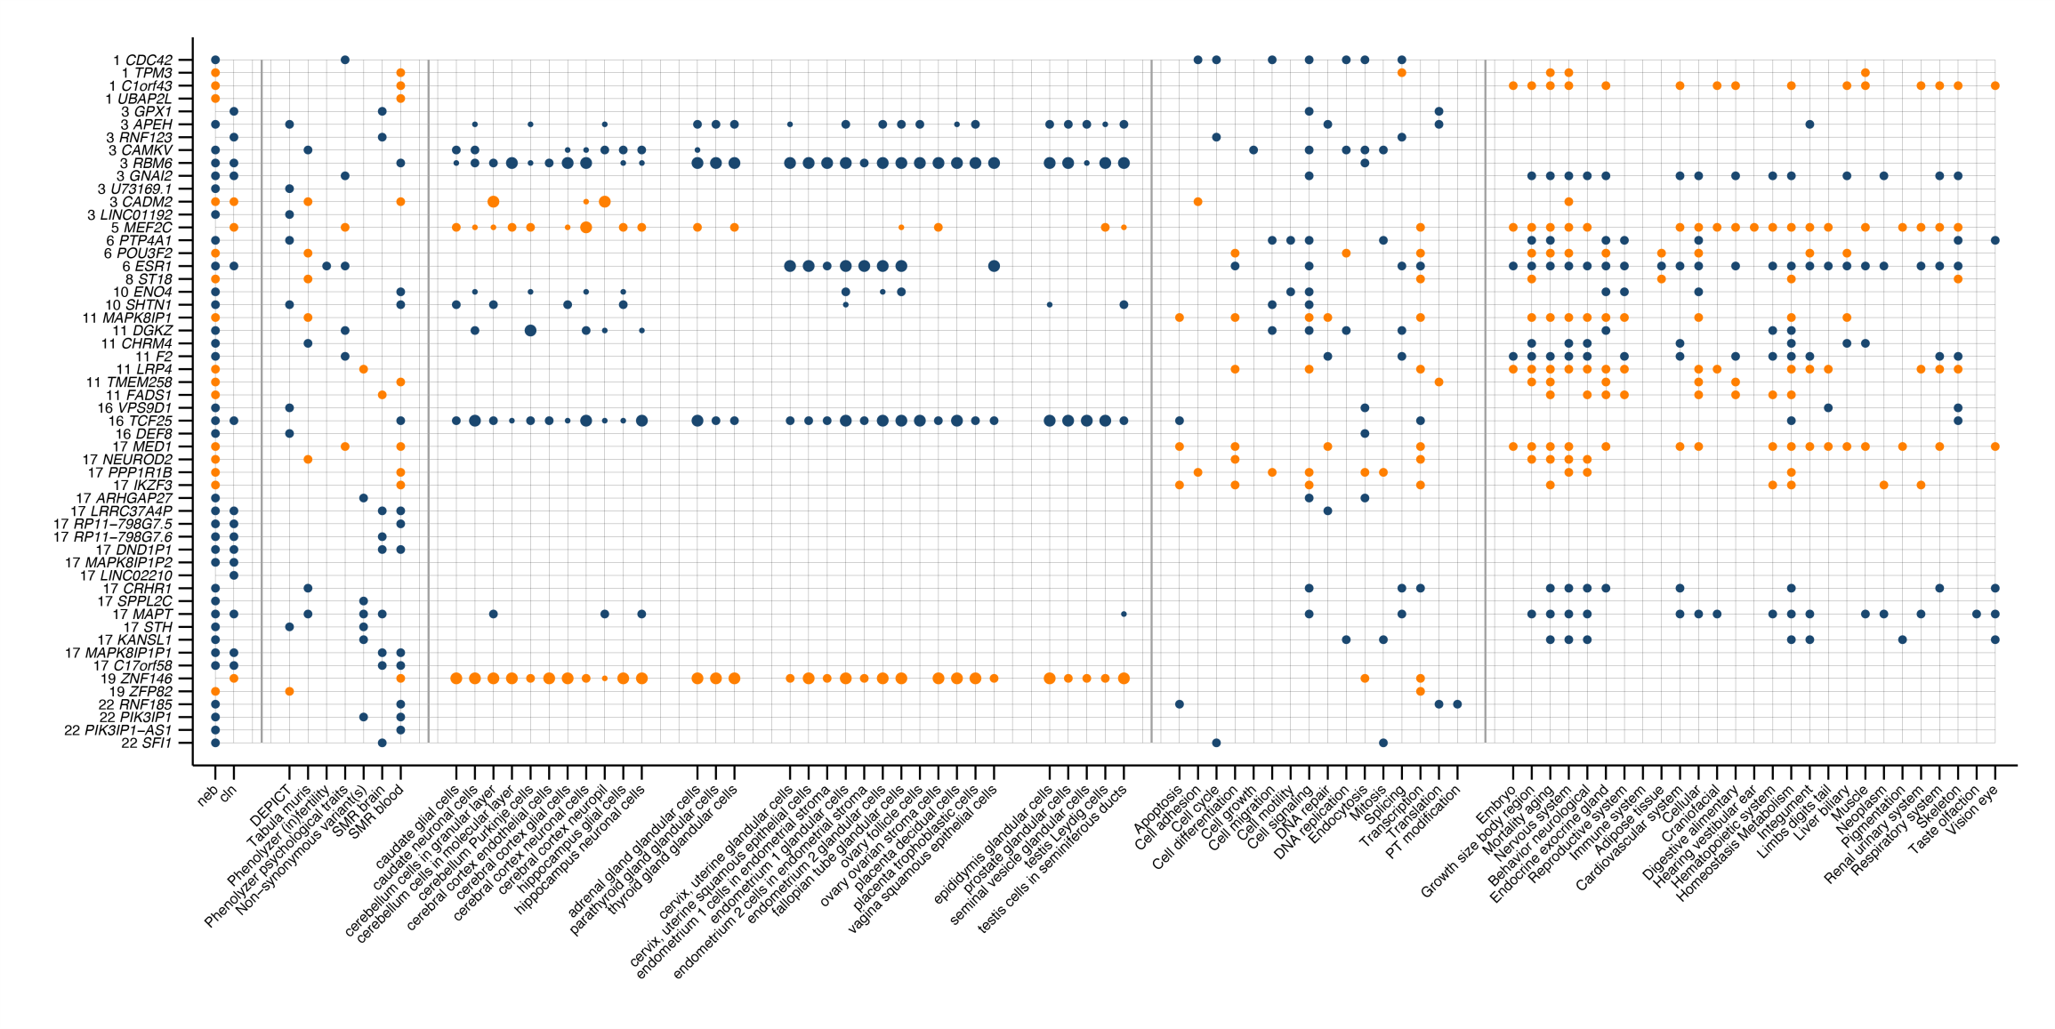
Figure S3 | Change in polygenic risk score (PGS) for NEB by birth year in the HRS study. Polygenic risk score scaled to have a mean of 0 and standard deviation of 1.
