Additional file 1: Example of an unannounced simulated patient telephone call data collection sheet
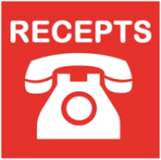
VIGNETTE
Version 6 dated 05/03/2013
Receptionist recognition and referral of patients with stroke (RECEPTS) study

Intro blurb: I think my Mum's having a stroke…..
Her mouth is drooping
Her speech is slurred
She can't use her right arm
Vignette ID | XXX
Your role | Adult child
Practice details
Practice name | XXX
Practice phone no. | XXX
Practice address | XX  XX
Name of doctor patient is registered with | XXX
Name of Practice Manager | XXX
Patient details
Name | XXX
Age | XX
Date of birth | XX/XX/19XX
Address | XX  XX  XX  XX
Telephone Number | XX
Time since symptom onset | 2 hours

Thank you. This phone call was part of the University of Birmingham RECEPTS study and you don’t need to do anything else today.

(Please tick box when you have said this to the receptionist)
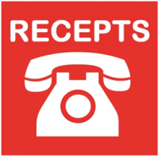
VIGNETTE DATA COLLECTION FORM
Version 5 dated 05/02/2013
Receptionist recognition and referral of patients with stroke (RECEPTS) study

Vignette ID
Date of call

Time of first call
No. calls made

Action taken by receptionist (please tick ONE):
Advised to call 999
Put through to GP immediately
Advised to attend A&E
Advised to attend out of hours service
Advised to attend GP practice immediately
Advised that GP will call patient back later that same day
Advised to attend practice later that same day
Offered/given an appointment with GP for the next day
Offered/given and appointment with GP more than one day away
Other (please specify)

Reaction of receptionist when fake call revealed to them:

Other notes (optional)

Name of role player: _____________________

