SUPPLEMENTARY MATERIAL

TABLE OF CONTENTS

1. Spanish data
1.1. Table with haplogroup frequencies and STR variances………………...2
1.2. Haplogroup colour coding…………………….......…………….….….….3
1.3. Median joining networks and descent clusters of Spanish surnames based on SNPs and 15 STRs...……………………………………….....4

2. Comparative data
2.1. Median joining networks and descent clusters of comparative data surnames, based on SNPs and 10 STRs.......…….……….……….….23
2.1.1. Spain………………………………………………………….…23
2.1.2. Britain……….……………………….……….…………………42
2.1.1. Ireland…………………………………………………………..62

2.2. Descent surname clusters and estimated TMRCA ages………….…….73
2.2.1. Table 1 Suppl. Material: Spain…………………………….…..73
2.2.2. Table 2 Suppl. Material: Britain………………………………74
2.2.3. Table 3 Suppl. Material: Ireland……………………..………..76

Table summarising the number of samples per surname and control population, their different haplogroup frequencies and STR variance values of the dominant haplogroup

MEDIAN-JOINING NETWORKS

NETWORKS OF SPANISH SURNAMES BASED ON SNPs AND 15 STRs, SHOWING ALL DESCENT CLUSTERS (IN ALPHABETICAL ORDER).
(Networks of the Spanish control samples are located at the end)
R1b-M269
I-M170
R1a-1532
J1-M62
J2-M172
T-M70
E-M96
E1b-M34
E1b-M78
G-M201
L-M22
K-M9
H-M213
J-M304
I2-M26
E1b-M123
E1b-M81
E1b-M35
P-92R7
A*
Haplogroups

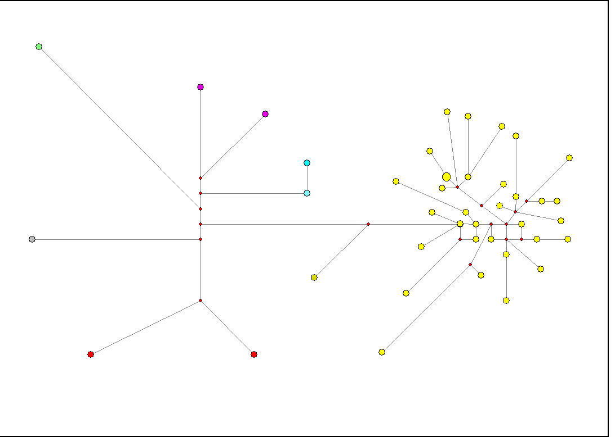
Aguirre
Category: Frequent

Category: Very Rare
Albiol

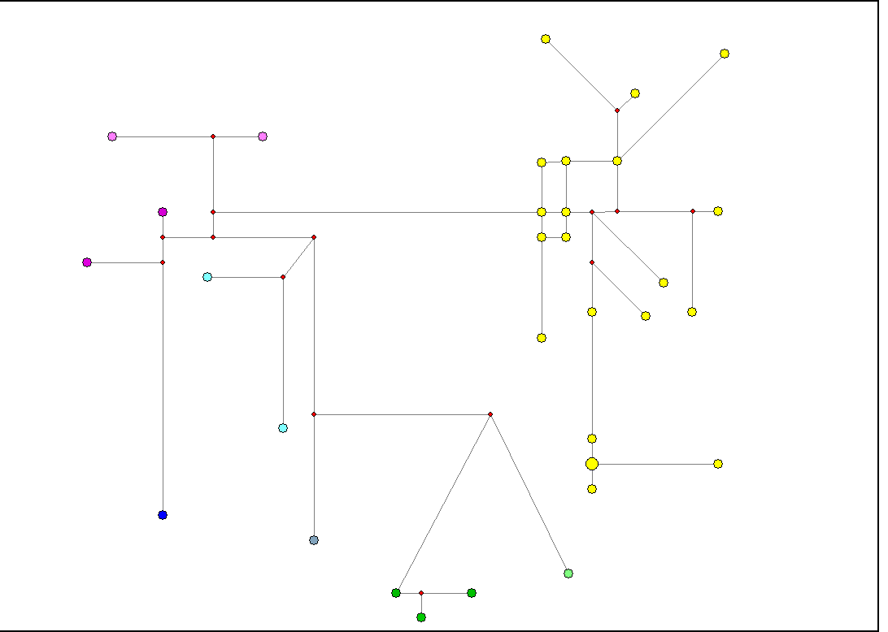
Category: Medium
Alegre

Category: Frequent
Andreu

Category: Very Rare

Ansotegui / Ansuategui

Artola
Category: Very Rare

Category: Very Rare

Babiloni / Bibiloni

Category: Very Rare
Baigorri

Balaguer
Category: Medium

Bengoechea

Category: Rare

Category: Very Rare
Bennasar

Category: Very Rare
Boluda

Category: Rare
Cadenas

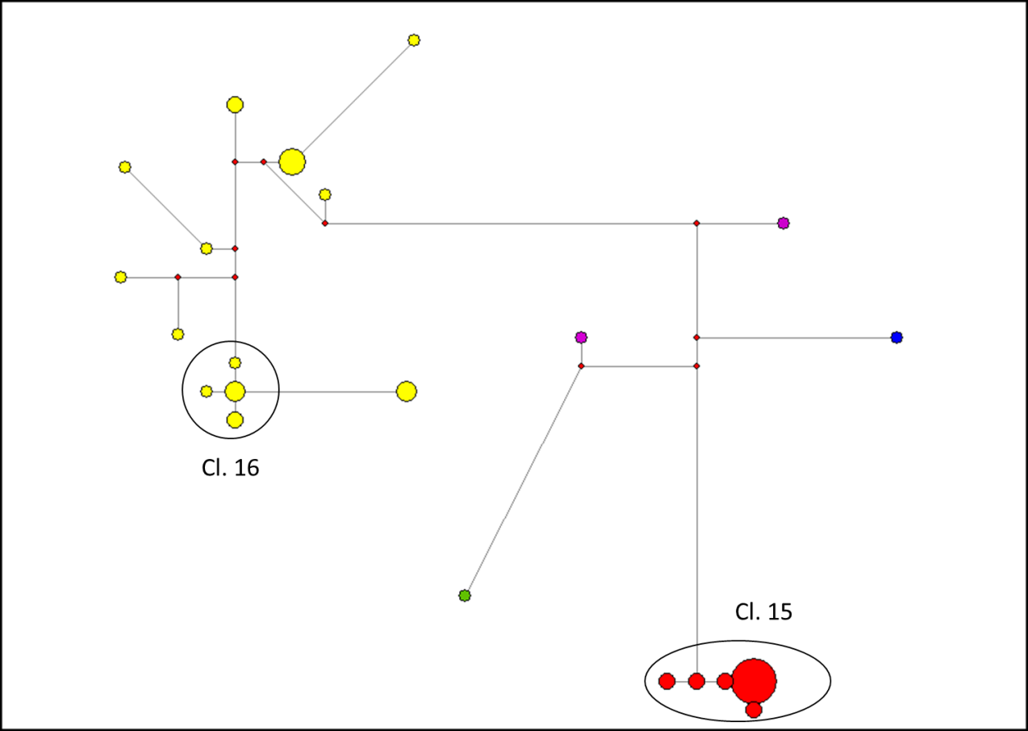
Castell

Category: Medium

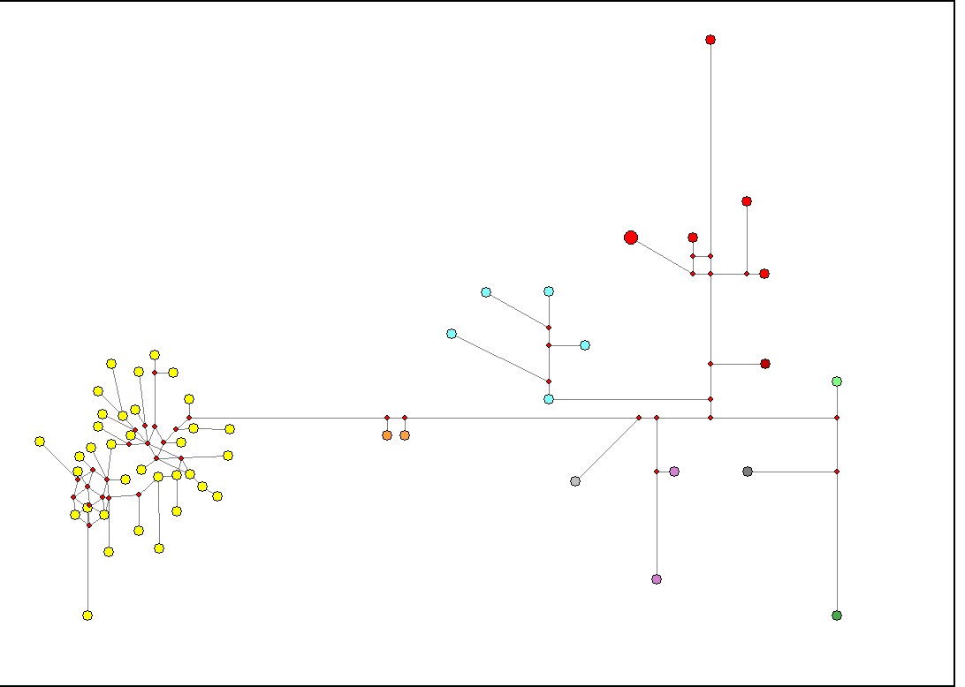
Category: Frequent
Diez

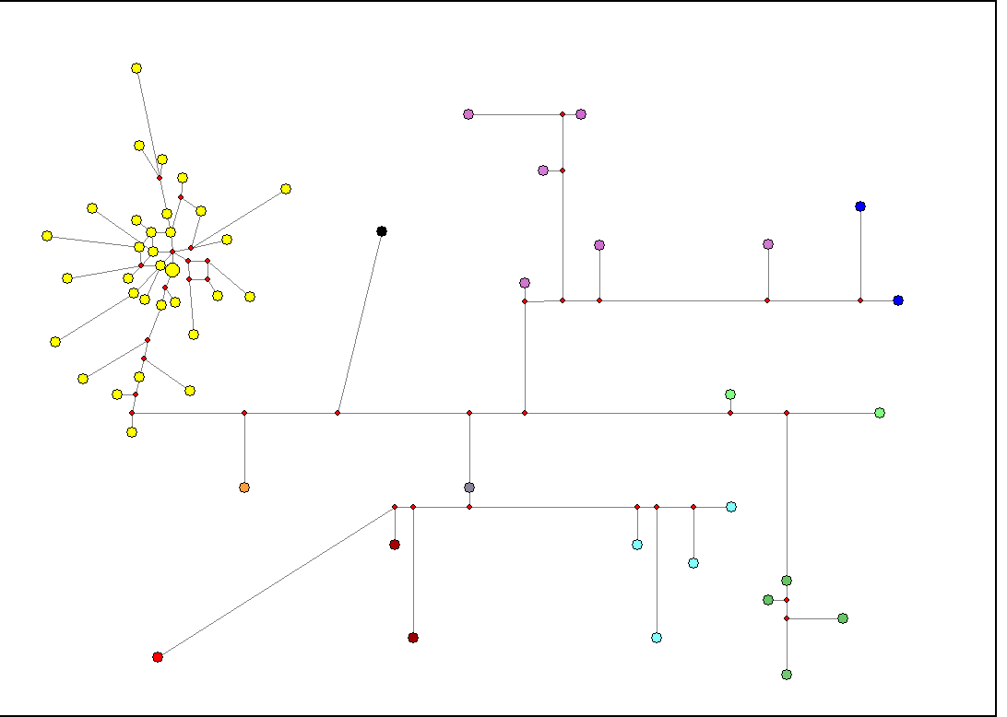
Category: Extr. Frequent
Fernandez

Category: Very Rare
Gordon

Category: Rare

Granell

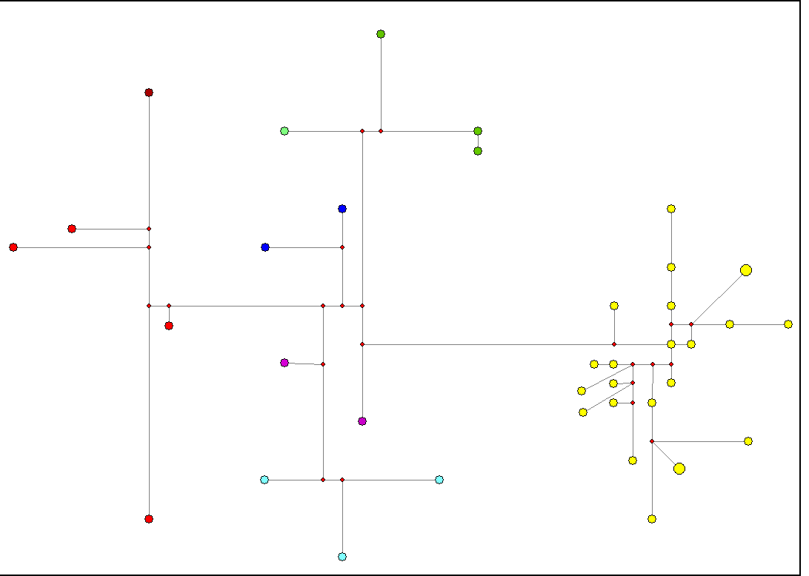
Category: Frequent
Herrero

Category: Rare

Huguet

Category: Medium

Ibarra

Category: Very Rare
Japon

Category: Frequent
Juarez

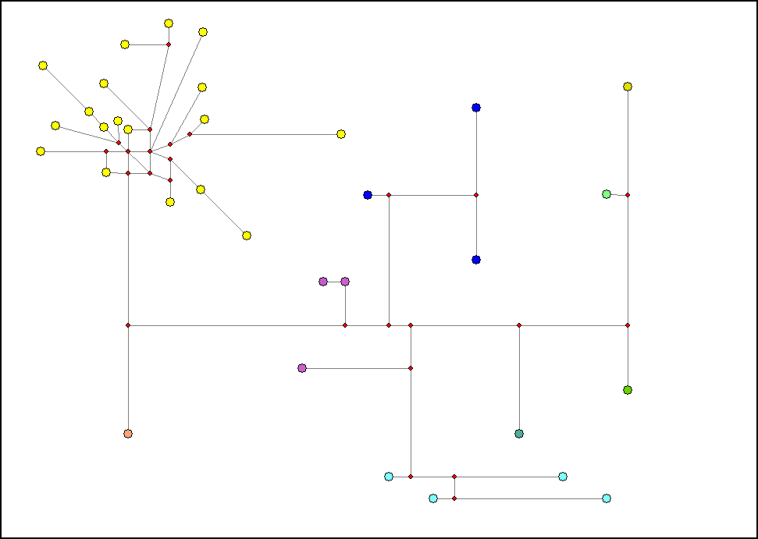
Category: Frequent

Marques

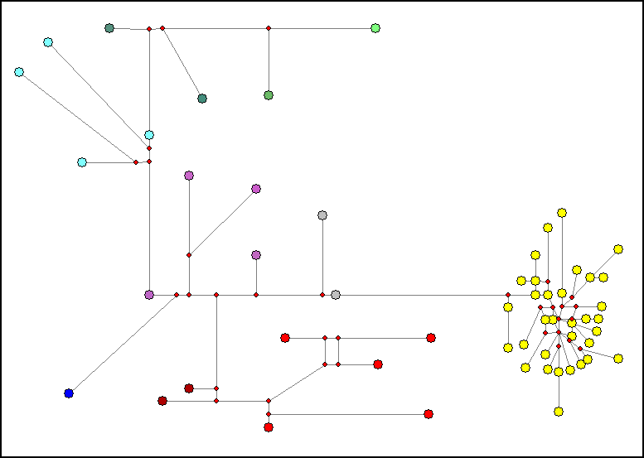
Martinez
Category: Extr. Frequent

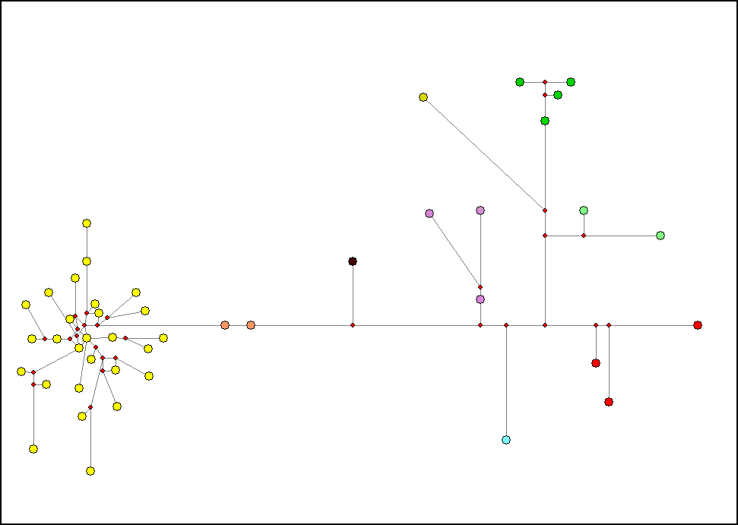
Category: Frequent
Mateos

Moliner

Category: Rare

Category: Very Rare
Nortes

Olaizola
Category: Very Rare

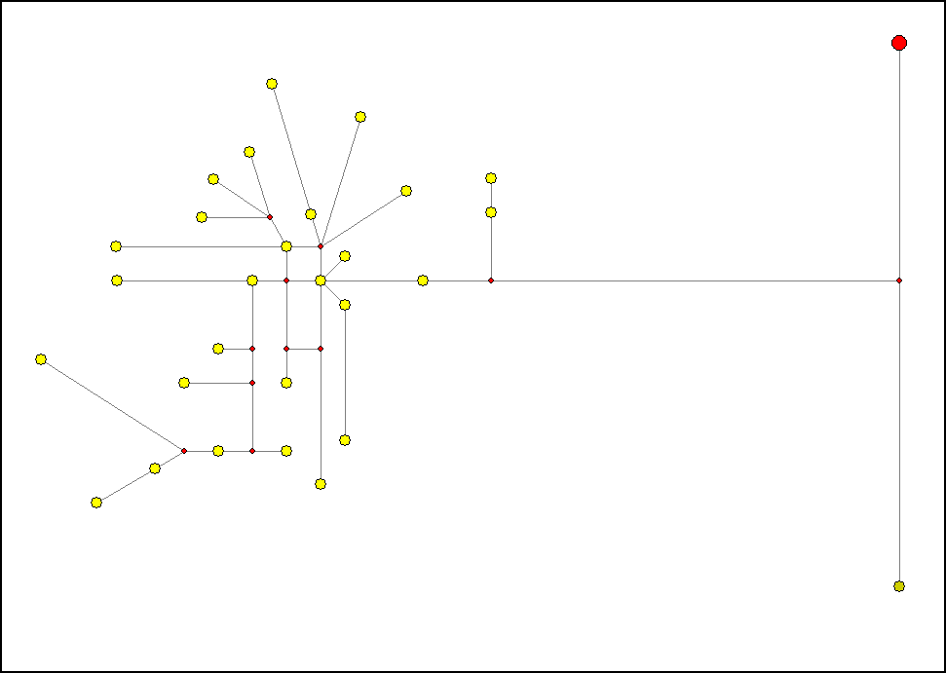

Pascual
Category: Frequent

Category: Medium
Quevedo

Category: Very Rare
Renau

Ribalta
Category: Very Rare

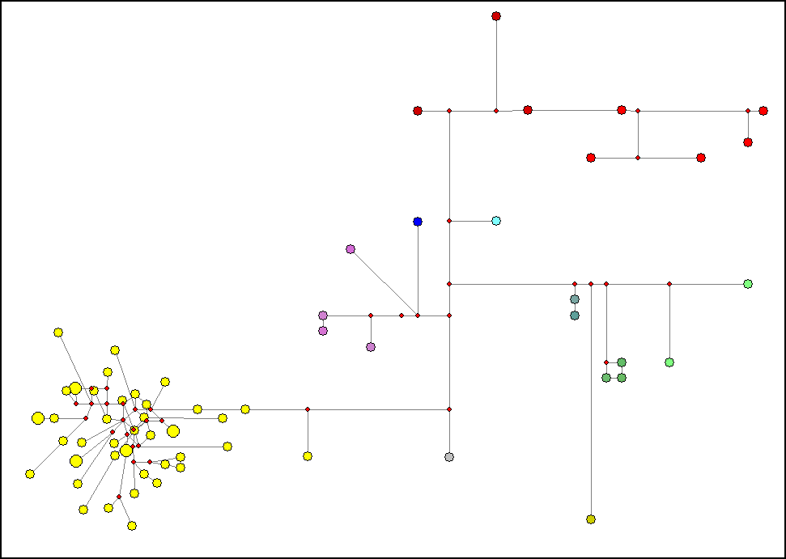
Category: Frequent
Rubio

Tirado
Category: Medium

Category: Rare

Valbuena

Villarroel
Category: Rare

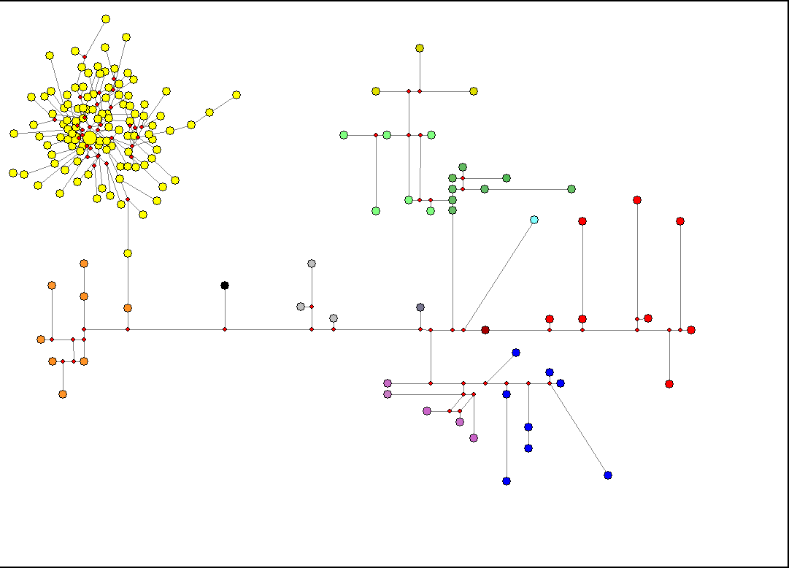

Spanish Controls

MEDIAN-JOINING NETWORKS
NETWORKS OF COMPARATIVE DATA (SPANISH, ENGLISH AND IRISH SURNAMES, IN THAT ORDER) BASED ON SNPs AND 10 SHARED STRs, SHOWING ALL DESCENT CLUSTERS (IN ALPHABETICAL ORDER).
R1b-M269
I-M170
R1a-1532
J1-M62
J2-M172
T-M70
E-M96
E1b-M34
E1b-M78
G-M201
L-M22
K-M9
H-M213
J-M304
I2-M26
E1b-M123
E1b-M81
E1b-M35
P-92R7
A*
Haplogroups

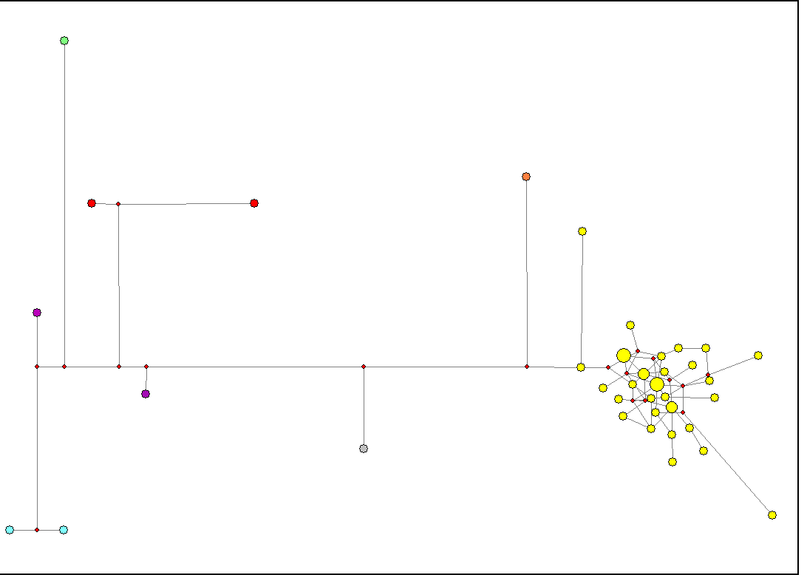
SPAIN
Aguirre

Albiol

Alegre
Andreu

Ansotegui / Ansuategui

Artola

Baigorri

Balaguer

Bengoechea

Bennasar

Bibiloni / Babiloni

Boluda

Cadenas

Castell

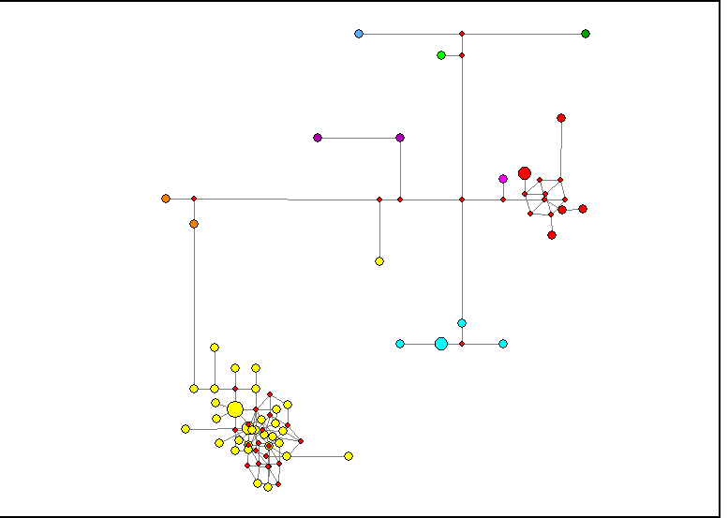
Diez

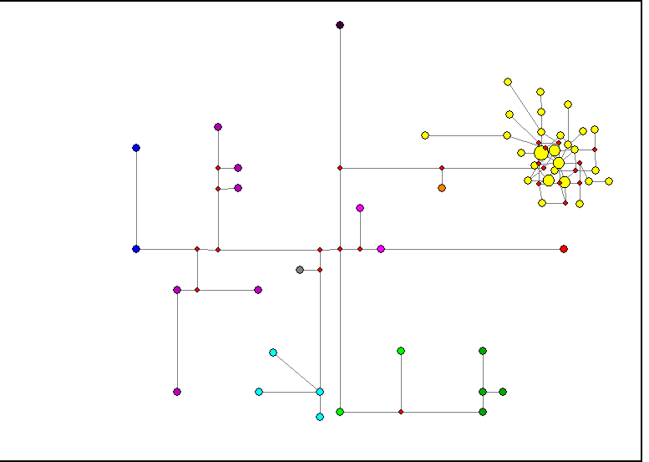
Fernandez

Gordon

Granell

Herrero

Huguet

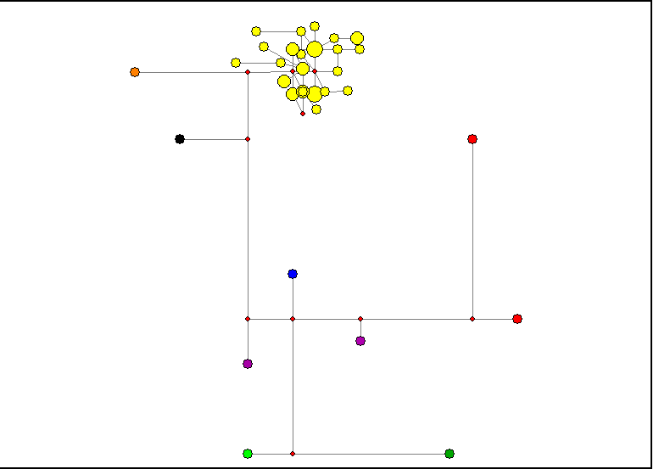
Ibarra

Japon

Juarez

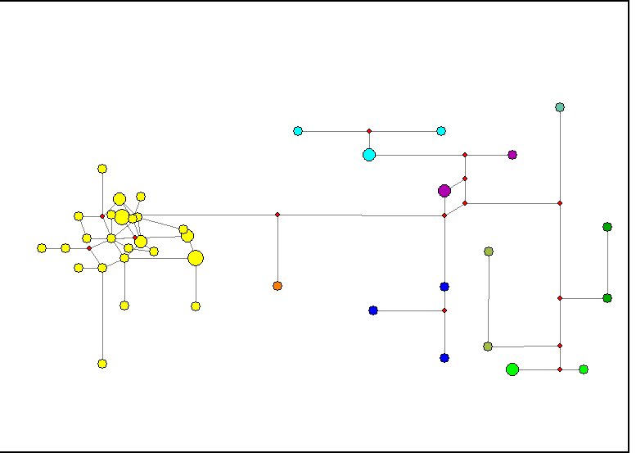
Marques

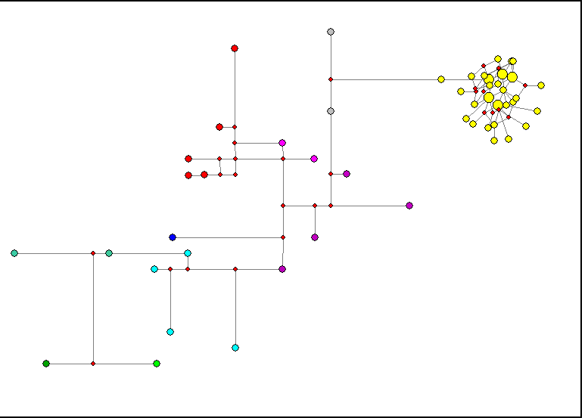

Martinez

Mateos

Moliner

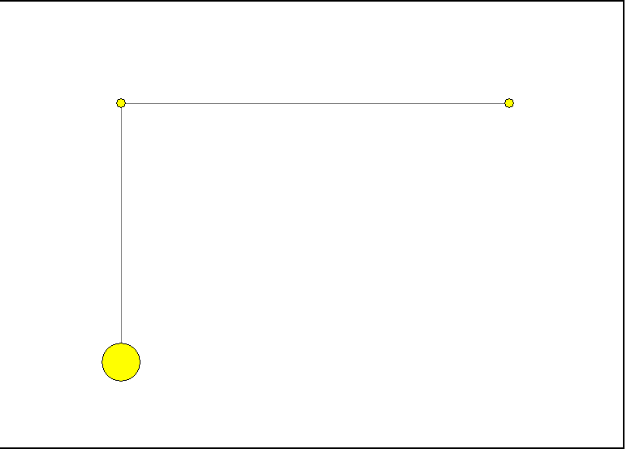

Nortes

Olaizola

Pascual

Quevedo

Renau

Ribalta

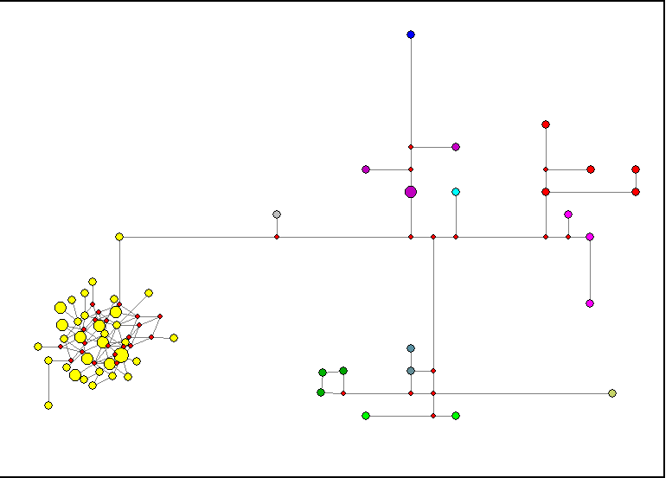
Rubio

Tirado

Valbuena

Villarroel
ENGLAND
Attenborough

Beckham

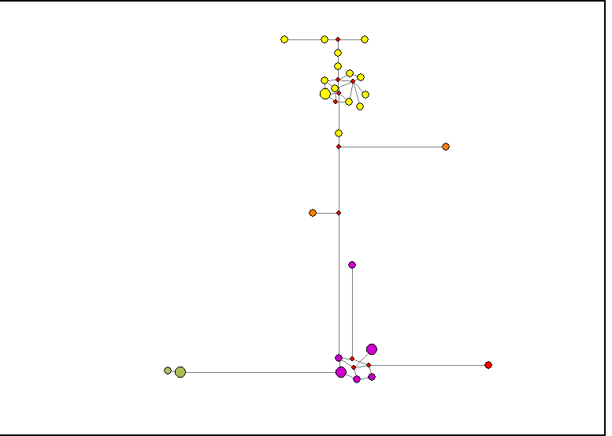
Bray

Butterfield

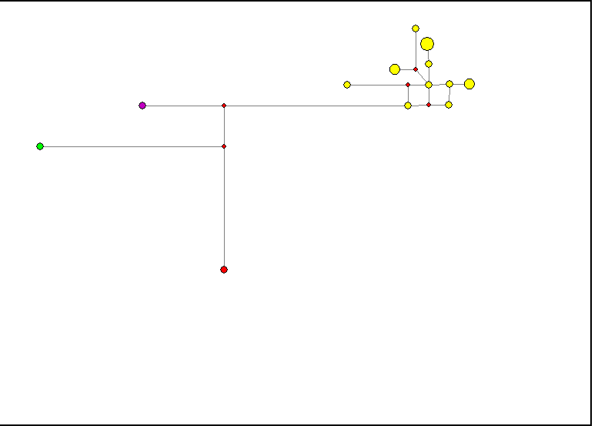

Chubb

Clare

Clemo

Dalgleish
Feakes

Grewcock

Haythornthwaite

Herrick

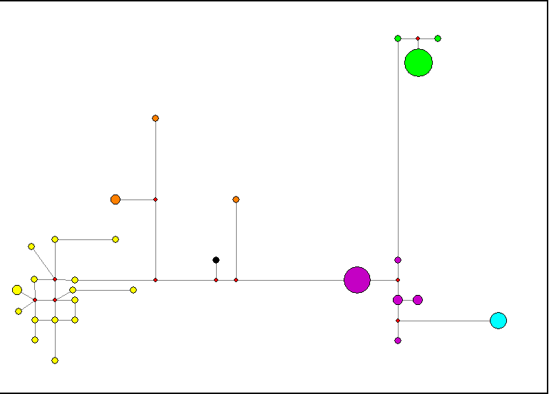
Hey

Jefferson
Jeffreys

Jobling

Ketley

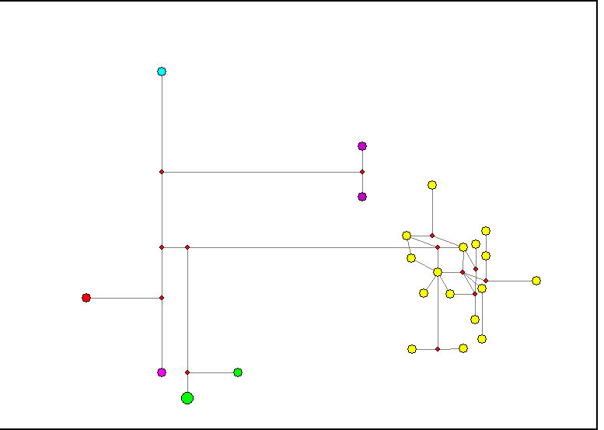
King

Lauder

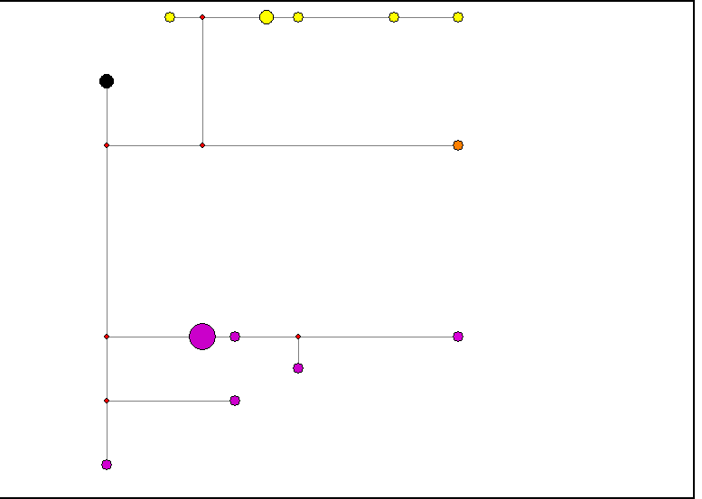

Mallinson

Northam

Pitchford

R.

Ravenscroft

Secker

Slingsby

Slinn

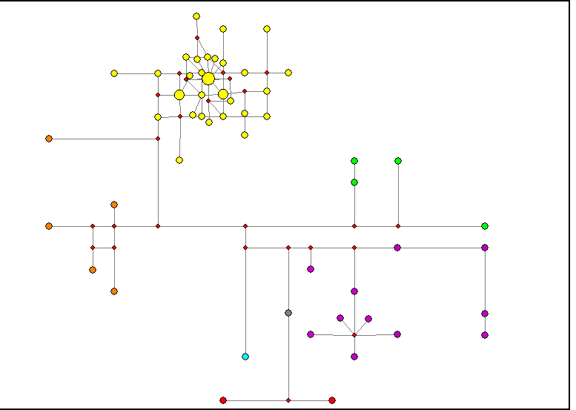
Smith

Starbuck

Stead

Stribling
Swindlehurst

Titchmarsh

Titmus

Wadsworth

Werrett

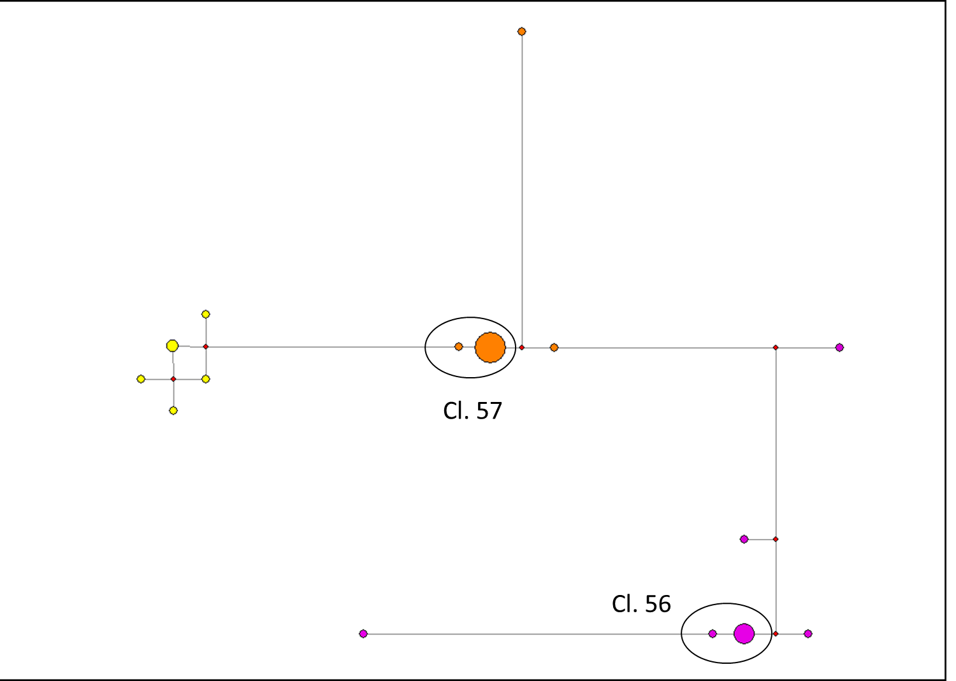
Widdowson

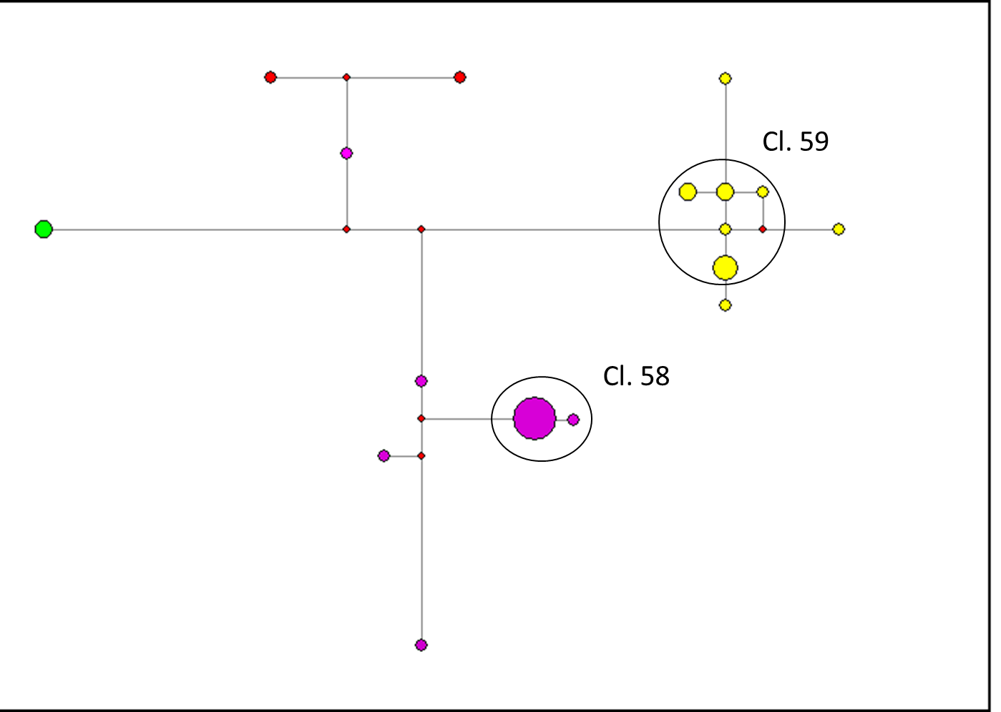
Winstone

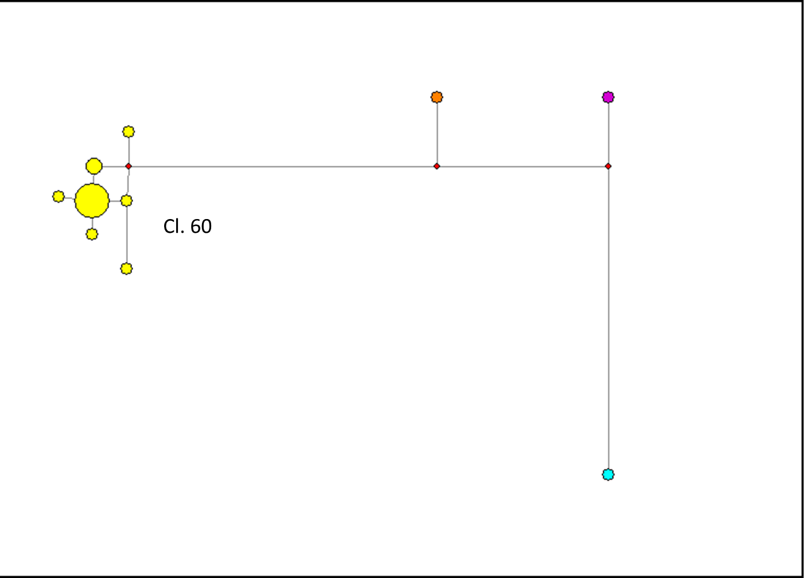

Wordsworth

IRELAND
Bradley

Byrne

Donohue

Egan

Haughey

Heaney

Kelly

Kennedy

McCarthy

McEvoy

McGillycuddy

McGinley

McGinn

McGuinness

Murphy

O’Gara

O’Hare

O’Neill

O’Sullivan

Rooney

Ryan

Table 1 Suppl. Material: Descent clusters and estimated ages. Comparative data: SPAIN

 |  |  |  | MRCA | 95% CIs |  | TMRCA | 95% CIs
Cluster | Surname | Men in cluster | oASD* | T in gens. | Lower | Upper | 31 y/gen | Lower | Upper
1 | Albiol | 28 | 0.114 | 43.37 | 29.06 | 61.62 | 1344 | 901 | 1910
2 | Albiol | 12 | 0.033 | 12.65 | 4.16 | 30.16 | 392 | 129 | 935
3 | Alegre | 15 | 0.047 | 17.71 | 7.74 | 35.30 | 549 | 240 | 1094
4 | Alegre | 8 | 0.025 | 9.49 | 1.97 | 32.98 | 294 | 61 | 1022
5 | Andreu | 7 | 0.057 | 21.68 | 7.07 | 56.08 | 672 | 219 | 1738
6 | Andreu | 12 | 0.067 | 25.30 | 11.58 | 49.08 | 784 | 359 | 1521
7 | Ansotegui | 8 | 0.013 | 4.74 | 0.75 | 23.43 | 147 | 23 | 726
8 | Artola | 12 | 0.042 | 15.81 | 6.10 | 34.74 | 490 | 189 | 1077
9 | Artola | 9 | 0.022 | 8.43 | 1.51 | 26.42 | 261 | 47 | 819
10 | Baigorri | 13 | 0.031 | 11.68 | 4.14 | 28.25 | 362 | 128 | 876
11 | Balaguer | 9 | 0.011 | 4.22 | 0.71 | 19.45 | 131 | 22 | 603
12 | Bengoechea | 12 | 0.05 | 18.97 | 8.27 | 41.87 | 588 | 256 | 1298
13 | Bengoechea | 6 | 0.017 | 6.32 | 0.99 | 30.15 | 196 | 31 | 935
14 | Benasar | 18 | 0.039 | 14.76 | 6.25 | 28.82 | 457 | 194 | 893
15 | Bibiloni | 15 | 0.033 | 12.65 | 4.88 | 28.10 | 392 | 151 | 871
16 | Boluda | 17 | 0.035 | 13.39 | 5.40 | 28.22 | 415 | 167 | 875
17 | Cadenas | 21 | 0.086 | 32.53 | 19.00 | 52.93 | 1008 | 589 | 1641
18 | Cadenas | 10 | 0.11 | 41.74 | 21.18 | 76.25 | 1294 | 657 | 2364
19 | Castell | 28 | 0.032 | 12.20 | 5.95 | 22.68 | 378 | 184 | 703
20 | Castell | 9 | 0.056 | 21.08 | 8.07 | 48.10 | 654 | 250 | 1491
21 | Gordon | 10 | 0.01 | 3.80 | 0.65 | 16.23 | 118 | 20 | 503
22 | Gordon | 14 | 0.114 | 43.37 | 24.75 | 72.86 | 1344 | 767 | 2259
23 | Granell | 29 | 0.014 | 5.23 | 1.66 | 12.59 | 162 | 51 | 390
24 | Herrero | 5 | 0.02 | 7.59 | 1.34 | 40.38 | 235 | 41 | 1252
25 | Huguet | 16 | 0.063 | 23.72 | 11.95 | 42.15 | 735 | 370 | 1307
26 | Japon | 14 | 0.014 | 5.42 | 1.17 | 18.23 | 168 | 36 | 565
27 | Juarez | 15 | 0.067 | 25.30 | 12.22 | 46.31 | 784 | 379 | 1436
28 | Mateos | 7 | 0.057 | 21.68 | 7.13 | 52.00 | 672 | 221 | 1612
29 | Mateos | 5 | 0.04 | 15.18 | 3.19 | 49.96 | 471 | 99 | 1549
30 | Mateos | 8 | 0.05 | 18.97 | 6.53 | 46.32 | 588 | 203 | 1436
31 | Mateos | 7 | 0.086 | 32.53 | 13.38 | 71.58 | 1008 | 415 | 2219
32 | Moliner | 13 | 0.054 | 20.43 | 8.72 | 41.66 | 633 | 270 | 1291
33 | Moliner | 4 | 0.025 | 9.49 | 1.47 | 45.27 | 294 | 46 | 1403
34 | Moliner | 17 | 0.088 | 33.48 | 18.82 | 56.04 | 1038 | 583 | 1737
35 | Olaizola | 33 | 0.021 | 8.05 | 3.47 | 16.13 | 250 | 108 | 500
36 | Pascual | 9 | 0.044 | 16.87 | 5.44 | 40.14 | 523 | 169 | 1244
37 | Quevedo | 5 | 0.02 | 7.59 | 1.33 | 33.30 | 235 | 41 | 1032
38 | Quevedo | 9 | 0.067 | 25.30 | 10.85 | 54.63 | 784 | 336 | 1694
39 | Renau | 23 | 0.035 | 13.20 | 6.31 | 25.44 | 409 | 195 | 789
40 | Renau | 7 | 0.029 | 10.84 | 2.31 | 34.72 | 336 | 71 | 1076
41 | Renau | 7 | 0.043 | 16.26 | 4.11 | 45.46 | 504 | 128 | 1409
42 | Renau | 8 | 0.062 | 23.35 | 10.74 | 47.01 | 724 | 333 | 1424
 |  |  |  | MRCA | 95% CIs |  | TMRCA | 95% CIs
Cluster | Surname | Men in cluster | oASD* | T in gens. | Lower | Upper | 31 y/gen | Lower | Upper
43 | Ribalta | 12 | 0.083 | 31.62 | 16.22 | 58.39 | 980 | 503 | 1810
44 | Ribalta | 20 | 0.035 | 13.28 | 5.79 | 26.33 | 412 | 179 | 816
45 | Tirado | 10 | 0.05 | 18.97 | 6.91 | 55.01 | 588 | 214 | 1705
46 | Valbuena | 27 | 0.063 | 23.89 | 14.16 | 38.13 | 741 | 439 | 1182
47 | Valbuena | 8 | 0.025 | 9.49 | 1.91 | 30.55 | 294 | 59 | 947
48 | Villarroel | 16 | 0.025 | 9.49 | 3.41 | 22.89 | 294 | 106 | 710
49 | Villarroel | 8 | 0.013 | 4.74 | 0.82 | 22.66 | 147 | 26 | 702
 |  |  | Avg. | 17.30 | 7.37 | 39.12 | 536 | 228 | 1212
TMRCA estimates differ from those in table 3 of the text due to fewer STRs, different cluster definitions, and different mutation rates. * oASD: observed Average Square Distance (average square difference between a sample of chromosomes and the MRCA)
Table 2 Suppl. Material: Descent clusters and estimated ages. Comparative data: BRITAIN
 |  |  |  | MRCA | 95% CIs |  | TMRCA | 95% CIs
Cluster | Surname | Men in cluster | oASD* | T in gens. | Lower | Upper | 31 y/gen | Lower | Upper
1 | Attenborough | 26 | 0.015 | 5.84 | 1.96 | 13.47 | 181 | 61 | 417
2 | Beckham | 16 | 0.138 | 52.18 | 31.84 | 83.90 | 1617 | 987 | 2601
3 | Butterfield | 14 | 0.05 | 18.97 | 7.70 | 37.49 | 588 | 239 | 1162
4 | Butterfield | 17 | 0.065 | 24.55 | 12.48 | 44.55 | 761 | 387 | 1381
5 | Clare | 41 | 0.054 | 20.36 | 12.94 | 30.67 | 631 | 401 | 951
6 | Clare | 10 | 0.03 | 11.38 | 2.68 | 29.21 | 353 | 83 | 906
7 | Clare | 6 | 0.033 | 12.65 | 2.60 | 41.89 | 392 | 81 | 1299
8 | Clare | 5 | 0.05 | 18.97 | 5.61 | 52.33 | 588 | 173 | 1622
9 | Clare | 15 | 0.027 | 10.12 | 2.59 | 24.72 | 314 | 80 | 766
10 | Clare | 26 | 0.069 | 26.27 | 15.57 | 41.36 | 814 | 483 | 1282
11 | Clemo | 16 | 0.069 | 26.09 | 12.86 | 45.89 | 809 | 399 | 1423
12 | Dalgleish | 5 | 0.02 | 7.59 | 1.10 | 34.70 | 235 | 34 | 1076
13 | Dalgleish | 22 | 0.055 | 20.70 | 10.86 | 36.30 | 642 | 337 | 1125
14 | Feakes | 5 | 0.02 | 7.59 | 1.21 | 36.20 | 235 | 37 | 1122
15 | Feakes | 7 | 0.014 | 5.42 | 0.89 | 23.45 | 168 | 28 | 727
16 | Grewcock | 20 | 0.015 | 5.69 | 1.69 | 15.19 | 176 | 52 | 471
17 | Grewcock | 7 | 0.043 | 16.26 | 4.01 | 43.78 | 504 | 124 | 1357
18 | Haythornthwaite | 32 | 0.013 | 4.74 | 1.53 | 11.48 | 147 | 48 | 356
19 | Herrick | 17 | 0.018 | 6.70 | 1.50 | 17.29 | 208 | 47 | 536
20 | Jefferson | 6 | 0.017 | 6.32 | 1.20 | 27.16 | 196 | 37 | 842
21 | Jefferson | 14 | 0.121 | 46.08 | 26.55 | 76.42 | 1428 | 823 | 2369
22 | Jefferson | 7 | 0.014 | 5.42 | 0.92 | 25.03 | 168 | 28 | 776
23 | Jefferson | 8 | 0.038 | 14.23 | 3.52 | 37.84 | 441 | 109 | 1173
24 | Jeffreys | 9 | 0.022 | 8.43 | 1.97 | 28.76 | 261 | 61 | 892
25 | Jeffreys | 5 | 0.02 | 7.59 | 1.42 | 32.29 | 235 | 44 | 1001
26 | Jeffreys | 14 | 0.143 | 54.21 | 31.53 | 86.62 | 1680 | 977 | 2685
 |  |  |  | MRCA | 95% CIs |  | TMRCA | 95% CIs
Cluster | Surname | Men in cluster | oASD* | T in gens. | Lower | Upper | 31 y/gen | Lower | Upper
27 | Jobling | 15 | 0.007 | 2.53 | 0.43 | 10.97 | 78 | 13 | 340
28 | Jobling | 7 | 0.029 | 10.84 | 2.40 | 33.81 | 336 | 74 | 1048
29 | Ketley | 7 | 0.029 | 10.84 | 2.54 | 37.55 | 336 | 79 | 1164
30 | Ketley | 26 | 0.012 | 4.38 | 1.31 | 11.86 | 136 | 41 | 368
31 | Lauder | 8 | 0.063 | 23.72 | 8.82 | 54.18 | 735 | 273 | 1679
32 | Northam | 5 | 0.02 | 7.59 | 1.37 | 34.38 | 235 | 42 | 1066
33 | Northam | 27 | 0.104 | 39.35 | 25.31 | 57.35 | 1220 | 785 | 1778
34 | Pitchford | 9 | 0.056 | 21.08 | 7.35 | 47.34 | 654 | 228 | 1468
35 | Pitchford | 26 | 0.019 | 7.30 | 2.80 | 16.09 | 226 | 87 | 499
36 | R. | 7 | 0.043 | 16.26 | 4.30 | 47.07 | 504 | 133 | 1459
37 | Ravenscroft | 14 | 0.029 | 10.84 | 3.78 | 26.76 | 336 | 117 | 829
38 | Ravenscroft | 21 | 0.095 | 36.14 | 21.33 | 56.18 | 1120 | 661 | 1742
39 | Secker | 11 | 0.046 | 17.25 | 6.42 | 42.12 | 535 | 199 | 1306
40 | Slingsby | 11 | 0.055 | 20.70 | 8.80 | 42.92 | 642 | 273 | 1331
41 | Slingsby | 21 | 0.086 | 32.53 | 19.54 | 51.77 | 1008 | 606 | 1605
42 | Slinn | 14 | 0.079 | 29.82 | 15.51 | 52.66 | 924 | 481 | 1633
43 | Slinn | 6 | 0.017 | 6.32 | 1.08 | 27.29 | 196 | 33 | 846
44 | Starbuck | 16 | 0.044 | 16.60 | 7.34 | 32.99 | 515 | 227 | 1023
45 | Stead | 6 | 0.033 | 12.65 | 2.81 | 41.50 | 392 | 87 | 1287
46 | Stead | 13 | 0.031 | 11.68 | 3.95 | 28.19 | 362 | 122 | 874
47 | Stead | 6 | 0.05 | 18.97 | 5.62 | 52.30 | 588 | 174 | 1621
48 | Stead | 8 | 0.064 | 24.27 | 11.23 | 47.85 | 752 | 348 | 1483
49 | Stribling | 21 | 0.138 | 52.40 | 34.24 | 76.45 | 1624 | 1061 | 2370
50 | Swindlehurst | 41 | 0.055 | 20.87 | 13.35 | 31.28 | 647 | 414 | 970
51 | Titchmarsh | 14 | 0.036 | 13.55 | 4.92 | 30.25 | 420 | 153 | 938
52 | Titmus | 12 | 0.008 | 3.16 | 0.59 | 15.60 | 98 | 18 | 484
53 | Wadsworth | 14 | 0.021 | 8.13 | 2.55 | 21.59 | 252 | 79 | 669
54 | Werrett | 19 | 0.021 | 7.99 | 2.79 | 19.39 | 248 | 87 | 601
55 | Werrett | 31 | 0.073 | 27.60 | 17.53 | 41.50 | 856 | 543 | 1287
56 | Widdowson | 7 | 0.014 | 5.42 | 0.92 | 25.74 | 168 | 28 | 798
57 | Widdowson | 14 | 0.013 | 4.65 | 1.10 | 17.36 | 144 | 34.5 | 538
58 | Winstone | 12 | 0.008 | 3.16 | 0.60 | 13.67 | 98 | 18 | 424
59 | Winstone | 10 | 0.18 | 68.30 | 38.97 | 115.43 | 2117 | 1208 | 3578
60 | Wordsworth | 13 | 0.039 | 14.60 | 5.18 | 31.69 | 452 | 161 | 982
 |  |  | Avg. | 17.60 | 8.09 | 37.85 | 545 | 254 | 1173
TMRCA estimates may differ from those previously published in British samples due to fewer STRs, different cluster definitions, and different mutation rates. * oASD: observed Average Square Distance (average square difference between a sample of chromosomes and the MRCA)
Table 3 Suppl. Material: Descent clusters and estimated ages. Comparative data: IRELAND
 |  |  |  | MRCA | 95% CIs |  | TMRCA | 95% CIs
Cluster | Surname | Men in cluster | oASD* | T in gens. | Lower | Upper | 31 y/gen | Lower | Upper
1 | Bradley | 7 | 0.014 | 5.42 | 0.96 | 25.61 | 168 | 30 | 794
2 | Bradley | 11 | 0.064 | 24.15 | 10.13 | 50.30 | 749 | 314 | 1559
3 | Byrne | 22 | 0.05 | 18.97 | 9.76 | 33.70 | 588 | 303 | 1045
4 | Byrne | 9 | 0.067 | 25.30 | 9.64 | 52.92 | 784 | 299 | 1641
5 | Donohoe | 14 | 0.064 | 24.39 | 12.34 | 45.40 | 756 | 382 | 1408
6 | Donohoe | 22 | 0.091 | 34.50 | 20.97 | 54.99 | 1069 | 650 | 1705
7 | Donohoe | 14 | 0.05 | 18.97 | 7.78 | 38.51 | 588 | 241 | 1194
8 | Egan | 14 | 0.136 | 51.50 | 29.91 | 81.67 | 1596 | 927 | 2532
9 | Haughey | 10 | 0.05 | 18.97 | 6.99 | 42.32 | 588 | 217 | 1312
10 | Heaney | 5 | 0.02 | 7.59 | 1.29 | 36.00 | 235 | 40 | 1116
11 | Kelly | 10 | 0.06 | 22.77 | 9.07 | 48.13 | 706 | 281 | 1492
12 | Kelly | 19 | 0.105 | 39.94 | 24.09 | 62.94 | 1238 | 747 | 1951
13 | Kennedy | 28 | 0.046 | 17.62 | 9.62 | 29.96 | 546 | 298 | 929
14 | Kennedy | 7 | 0.086 | 32.53 | 12.90 | 74.98 | 1008 | 400 | 2324
15 | McCarthy | 21 | 0.048 | 18.07 | 9.15 | 32.47 | 560 | 284 | 1007
16 | McCarthy | 24 | 0.129 | 49.01 | 32.77 | 71.33 | 1519 | 1016 | 2211
17 | McEvoy | 20 | 0.09 | 34.15 | 20.71 | 55.33 | 1059 | 642 | 1715
18 | McEvoy | 18 | 0.072 | 27.41 | 14.87 | 47.54 | 850 | 461 | 1474
19 | McGillycuddy | 20 | 0.07 | 26.56 | 15.09 | 45.01 | 823 | 468 | 1395
20 | McGinley | 13 | 0.062 | 23.35 | 10.71 | 47.09 | 724 | 332 | 1460
21 | McGinn | 14 | 0.114 | 43.37 | 24.45 | 70.91 | 1344 | 758 | 2198
22 | McGuiness | 28 | 0.061 | 23.04 | 13.50 | 36.38 | 714 | 419 | 1128
23 | McGuiness | 6 | 0.017 | 6.32 | 1.04 | 31.78 | 196 | 32 | 985
24 | McGuiness | 5 | 0.02 | 7.59 | 1.47 | 36.01 | 235 | 46 | 1116
25 | McGuiness | 23 | 0.083 | 31.35 | 18.71 | 49.84 | 972 | 580 | 1545
26 | McGuiness | 13 | 0.154 | 58.38 | 35.20 | 94.17 | 1810 | 1091 | 2919
27 | Murphy | 28 | 0.111 | 42.01 | 27.86 | 60.16 | 1302 | 864 | 1865
28 | Murphy | 6 | 0.033 | 12.65 | 2.55 | 40.62 | 392 | 79 | 1259
29 | O'Gara | 5 | 0.02 | 7.59 | 1.37 | 35.37 | 235 | 43 | 1096
30 | O'Gara | 14 | 0.079 | 29.82 | 15.68 | 53.24 | 924 | 486 | 1650
31 | O'Hare | 10 | 0.06 | 22.77 | 9.09 | 49.14 | 706 | 282 | 1523
32 | O'Neill | 41 | 0.095 | 36.10 | 25.47 | 50.41 | 1119 | 790 | 1563
33 | O'Sullian | 43 | 0.061 | 22.94 | 15.81 | 33.95 | 711 | 490 | 1052
34 | Rooney | 18 | 0.117 | 44.27 | 26.35 | 69.83 | 1372 | 817 | 2165
35 | Ryan | 35 | 0.034 | 13.01 | 7.16 | 21.94 | 403 | 222 | 680
36 | Ryan | 10 | 0.11 | 41.23 | 24.37 | 66.45 | 1278 | 756 | 2060
 |  |  | Avg. | 26.76 | 14.41 | 49.34 | 829 | 447 | 1529
TMRCA estimates may differ from those previously published in Irish samples due to fewer STRs, different cluster definitions, and different mutation rates. * oASD: observed Average Square Distance (average square difference between a sample of chromosomes and the MRCA)

